Assessment 5: Transcription Exercise

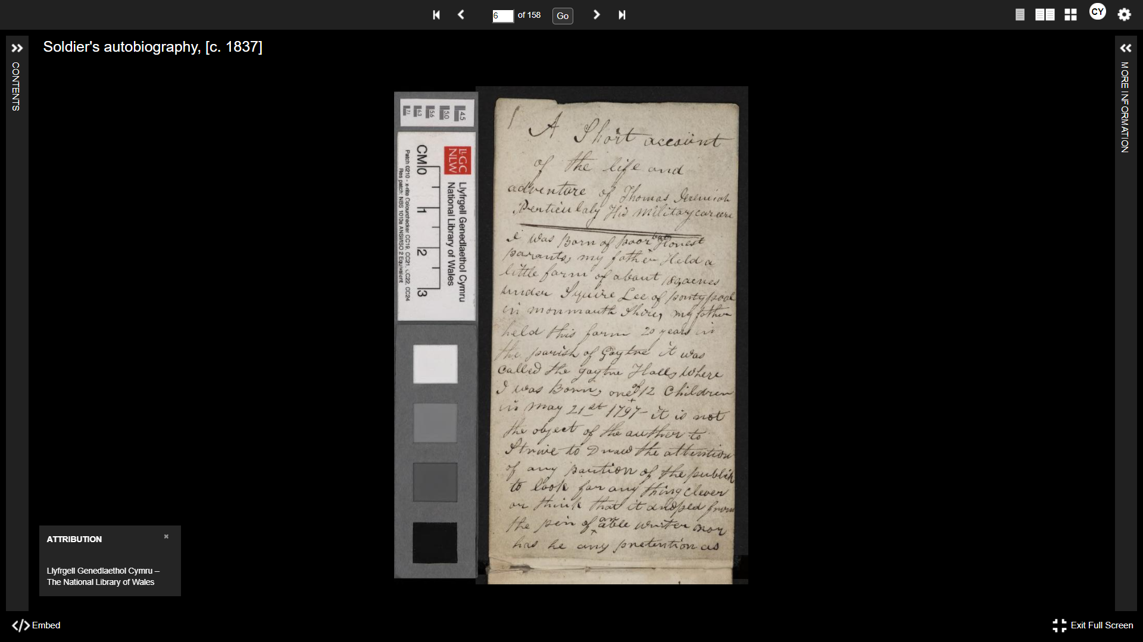
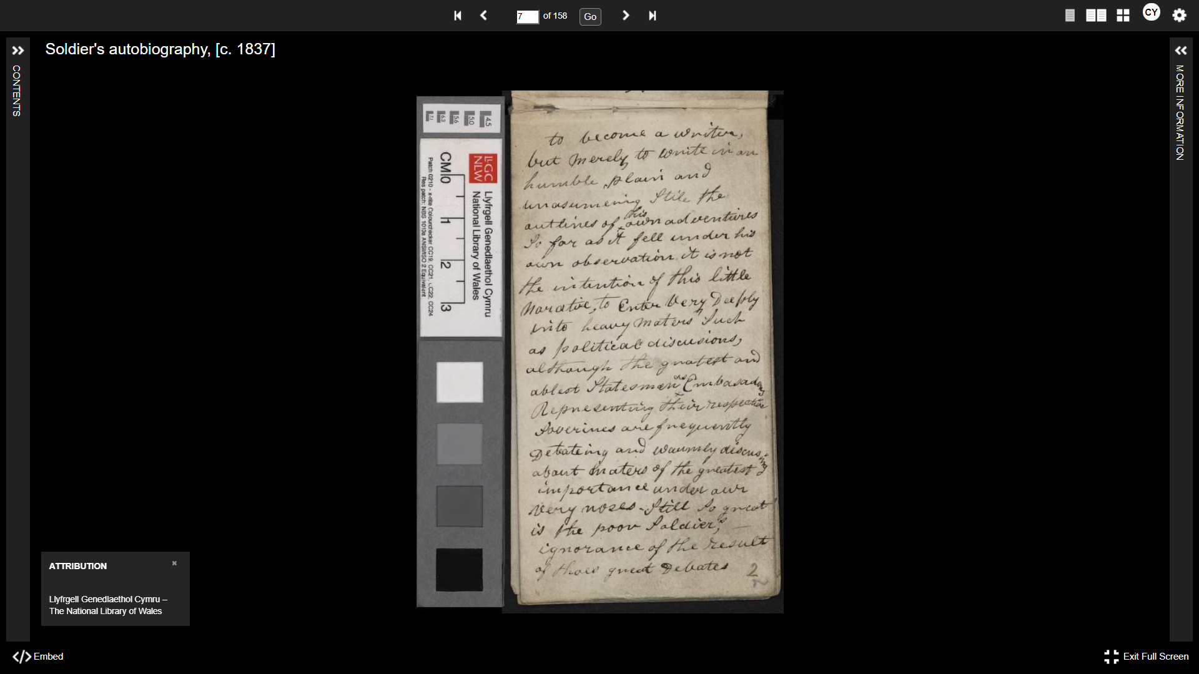
The above are pages 6 and 7 of the Autobiography of Private Thomas Jeremiah, which are where the autobiography begins. He served with the Royal Welch Fusiliers from 27th November 1812 to 26th June 1837. These pages were chosen for the transcription exercise as they offer a little bit of background as to where he came from and help understand the autobiography's continuity. The transcription methods included reading these pages, using slides and tutorials provided by the University of Wales Trinity Saint David to help understand the text. In addition, a printed copy of the autobiography was used to compare what was transcribed by myself and what had been carried out before. This helped to correct the mistakes that had initially been made while transcribing.
The transcription for these pages are as follows:

A Short account of the life and adventure of Thomas Jeremiah, Particularly his military career.
I was Born of poor but Honest parents, my father Held a little farm about 180, acres under Squire Lee of Pontypool in Monmouth Shire, my father held this farm 20 years in the parish of Gaytre it was called the Gaytre Halls where I was born, one of 12 children on May 21st 1797 – it is not the object of the author to strive to draw the attention of any paution of the public to look for anything clever or to think that it adopted from the pain of any able writer nor has he any pretention as

To become a writer, but merely to write in an humble, plain and unassuming stile the outlines of his own adventures so far as it fell under his own observation. It is not the intention of this narrative, to Enter Very Deeply into heavy maters such as political discussions, although the greatest and ablest Statesman as Embasadors representing their respective soverines are frequently Debating and warmly discussing about maters of the greatest importance under our very noses. Still so great is the poor soldier; ignorance of the result of thoes great Debates

Below is a link where the full autobiography can be accessed:
The Autobiography of Private Thomas Jeremiah | The National Library of Wales

The autobiography is thought to have been written around 1837. It is leather-bound, hand-written in pencil and it is kept at the National Library of Wales where it is easily accessible online. The autobiography also includes details of Private Jeremiah’s experiences at the battle of Waterloo, which took place on 18th June 1815. Private Thomas Jeremiah was about 16 years old when he joined the Royal Welch Fusiliers and was roughly 18 when he went into the Battle of Waterloo. He served 25 years and 210 days as a soldier for the Royal Welch Fusiliers and received a medal for his duties in the Battle of Waterloo.
The Royal Welch Fusiliers fought on the front at The Battle of Waterloo, which took place on 18th June 1815. According to Davies (2012), the Battle of Waterloo was just as much of a military victory as it was a political one. Davies continues, arguing that Napoleon Bonaparte had to be defeated and this was accomplished because of the cleaver political and military manoeuvres by the allies of Britain, including Prussia, and by other countries, such as Belgium, Russia, and Austria. Indeed, Wellington attributes much of the success of the Battle of Waterloo to the support from Marshal Blücher and the Prussian army. Certainly, Waterloo was seen as a great victory for peace and cooperation of political ideals at the time. This was as Waterloo was not only about stopping France from becoming an imperial force again, but also about ensuring that the peace was kept from 1814, where a treaty was made in Paris.
Although the treaty favoured Britain at the time, it did not have any details as to the plans for the rest of Europe. This was seen to, in part, lead up to the turmoil in Europe and for Prussia the promise of being returned to Saxony was not enough. As a result, there was seen to be two viable options for a peaceful settlement in Europe at the time. These were ‘a union of the two Great German Powers, supported by Great Britain’ with a combination of the smaller states of Germany, Holland as ‘an intermediary system between Russia and France’ or ‘a union of Austria, France and Southern States against Northern Powers with Russia and Prussia’ being close allies.
The bond between Russia and Prussia tried to be broken by Castlereagh, who was the Secretary of State for Foreign, Commonwealth and Developmental Affairs during the build-up to the Battle of Waterloo. This is as he persuaded Metternich, who was the Interior Minister of the Austrian Empire, to accept the demands of Prussia in return for Prussia’s support for Poland. Unfortunately, the British public did not care too much about Poland and was enraged about what was happening in Saxony and as Prussia would not be allowed to annex all of Saxony, this was how war very much became a possibility.
However, it was the power that Prussia exerted that led to further tensions in Europe. Although Prussia was small in size, it could have easily sided with Russia, and it was this that became a major threat to the stability of Europe. This is why Castlereagh subsidised German forces as opposed to Russian ones. The politics of Waterloo therefore involved a balancing of Russian and Prussian expanses while at the same time ensured Britain had a major role to play.
The part of the Royal Welch Fusiliers in the Battle of Waterloo has been highlighted by Private Jeremiah’s account. There is also some further information on this provided by Michael Glover and Jonathon Rile, who compiled a concise, yet comprehensive history of the Royal Welch Fusiliers. In their chapter on ‘Victory Against Napoleon’, they use quotes from the men who fought in the Battle of Waterloo to highlight the plight that the soldiers faced, while at the same time emphasised the proficiency of the men. According to Michael Glover and Rile, the 23rd Regiment were the most experienced and the way they were organised helped the success at the Battle of Waterloo.
The person responsible for the regiment at the time was Lieutenant Colonel Ellis, who there are accounts of in Michael Glover and Rile’s book, and in Private Jeremiah’s account. Ellis was regarded as popular amongst his men, however, although the men looked up to Ellis, they also feared him. This was probably because he was not only regarded with respect but also due to the nature of the treatment and punishment of his men. According to Private Jeremiah, some of the soldiers were kicked and thrashed; and in some cases, they were put to death. However, Private Jeremiah points out that this treatment was not as harsh perhaps compared to the treatment given by other Lieutenant Colonels.
Private Thomas Jeremiah was wounded three times while in action and was confirmed as medically unfit in 1837. He was therefore discharged from the Royal Welch Fusiliers at this time. In addition, as he and his family held some properties, perhaps he was not as poor as he had suggested. It is also thought that he was well educated, considering he could write. After being discharged in 1841, Private Jeremiah married a lady named Elizabeth, and they had five children together. Private Jeremiah later obtained a position as a Superintendent police officer for Brynmawr in Breconshire in 1847. Unfortunately, in 1856, he was attacked by some thugs, resulting in him losing the ability to walk. He remained lame for the remainder of his life. His wife is said to have died in 1856, and Thomas Jeremiah died in 1868. However, Private Jeremiah’s legacy still lives on as his medal for his efforts in Waterloo is visible at the regimental museum in Caernarfon Castle. Indeed, it is possible to read his account on the National Library of Wales Website, though it requires some skill to decipher Private Jeremiah’s handwriting. Thankfully a fully typed-up copy has been published, which has been gratefully received and was extremely helpful in this exercise.
In going forward with research, this exercise was used solely for the purposes of this piece of work. It is unlikely that it will be used for future research, however, the theme of future pieces will be on Welsh history and Heritage; to which the Royal Welch Fusiliers has a vast amount. This is particularly the case for the books which have been used for the exercise and the information made available on the National Library of Wales website. The National Library of Wales is quite likely to be used for future research and other places, such as archives and other libraries.
(Word Count: 1925)

REFERENCES:

Davies, H, J. ‘Wellington’s Waterloo: The Battle for the Balance and Power in Europe, 1814-1815’, Chapter 9. (Yale University Press:2012): <Wellington’s Waterloo: (uwtsd.ac.uk)> [accessed 29th December 2021]
Glover, G. ‘A Short Account of the Life and Adventures of Private Thomas Jeremiah, 23rd or Royal Welch Fusiliers 1812-1837, including his experiences at the Battle of Waterloo’ (Ken Trotman Publishing: 2008)

Glover, M, and Rile, J. ‘‘That Astonishing Infantry’: The History of the Royal Welch Fusiliers, 1689-2006’ (Leo Cooper: 1989; Pen and Sword Military: 2008).

The National Library of Wales. ‘The Autobiography of Private Thomas Jeremiah’ (2021): <The Autobiography of Private Thomas Jeremiah | The National Library of Wales> [accessed 20th December 2021]

The National Library of Wales, ‘The Autobiography of Private Thomas Jeremiah’ (2021): < The Autobiography of Private Thomas Jeremiah | The National Library of Wales >[accessed 20th December]
Gareth Glover, ‘A Short Account of the Life and the Adventures of Private Thomas Jeremiah, 23rd or Royal Welch Fusiliers 1812-1837, including his experiences at the Battle of Waterloo’ (Ken Trotman Publishing: 2008)
The National Library of Wales (2021): <The Autobiography of Private Thomas Jeremiah | The National Library of Wales> [accessed 20th December 2021]
The National Library of Wales (2021): <The Autobiography of Private Thomas Jeremiah | The National Library of Wales> [accessed 20th December 2021]
The National Library of Wales (2021): <The Autobiography of Private Thomas Jeremiah | The National Library of Wales> [accessed 20th December 2021]
The National Library of Wales (2021): <The Autobiography of Private Thomas Jeremiah | The National Library of Wales> [accessed 20th December 2021]
Huw J. Davies, ‘Wellington’s Waterloo: The Battle for the Balance and Power in Europe, 1814-1815’, Chapter 9. (Yale University Press:2012) pp. 214-215: <Wellington’s Waterloo: (uwtsd.ac.uk)> [accessed 29th December 2021]
Huw J. Davies, ‘Wellington’s Waterloo: The Battle for the Balance and Power in Europe, 1814-1815’, Chapter 9. (Yale University Press:2012) pp. 214-215: <Wellington’s Waterloo: (uwtsd.ac.uk)> [accessed 29th December 2021]
Huw J. Davies, ‘Wellington’s Waterloo: The Battle for the Balance and Power in Europe, 1814-1815’, Chapter 9. (Yale University Press:2012) pp. 218-219: <Wellington’s Waterloo: (uwtsd.ac.uk)> [accessed 29th December 2021]
Huw J. Davies, ‘Wellington’s Waterloo: The Battle for the Balance and Power in Europe, 1814-1815’, Chapter 9. (Yale University Press:2012) pp. 219-220: <Wellington’s Waterloo: (uwtsd.ac.uk)> [accessed 29th December 2021]
Michael Glover and Jonathon Rile, ‘‘That Astonishing Infantry’: The History of the Royal Welch Fusiliers, 1689-2006’ (Leo Cooper: 1989; Pen and Sword Military: 2008).
Michael Glover and Jonathon Rile, ‘‘That Astonishing Infantry’: The History of the Royal Welch Fusiliers, 1689-2006’ (Leo Cooper: 1989; Pen and Sword Military: 2008).
Michael Glover and Jonathon Rile, ‘‘That Astonishing Infantry’: The History of the Royal Welch Fusiliers, 1689-2006’ (Leo Cooper: 1989; Pen and Sword Military: 2008); Gareth Glover, ‘A Short Account of the Life and Adventures of Private Thomas Jeremiah, 23rd or Royal Welch Fusiliers 1812-1837, including his experiences at the Battle of Waterloo’ (Ken Trotman Publishing: 2008)
Gareth Glover, ‘A Short Account of the Life and Adventures of Private Thomas Jeremiah, 23rd or Royal Welch Fusiliers 1812-1837, including his experiences at the Battle of Waterloo’ (Ken Trotman Publishing: 2008)
The National Library of Wales (2021): <The Autobiography of Private Thomas Jeremiah | The National Library of Wales> [accessed 20th December 2021]
Gareth Glover, ‘A Short Account of the Life and Adventures of Private Thomas Jeremiah, 23rd or Royal Welch Fusiliers 1812-1837, including his experiences at the Battle of Waterloo’ (Ken Trotman Publishing: 2008)

