Activity worksheet- heart
Below you will find a work sheet to support your learning, work your way through the activities and research areas you need to develop your understanding.

- What are Mr beats arms correct name?
……………………………………………………………………………………………………………….
- What are his legs correct name?
……………………………………………………………………………………………………………….
- What is Mr beats hair correct name?
……………………………………………………………………………………………………………….
- What stops back flow? How many and correct names?
……………………………………………………………………………………………………………….
- What system provides the pressure/ causes contraction?
……………………………………………………………………………………………………………….
- How many chambers does the heart have ?
………………………………………………………………………………………………………………..
- How many sides does the heart have?
………………………………………………………………………………………………………………..
- What is located in each chamber?
…………………………………………………………………………………………………………….


Now if you have not do so already, label your Mr/ Mrs beat

Fill in the missing words
deoxygenated blood comes into the s……… and i……… v…… c…. (blood vessels/ veins) then into the r……. atrium, electricity signals from the SA node is fired and contracts the atriums. Blood is forced down as the t……. valve opens into the rights ventricle
AV nodes spreads through the bundles between both ventricles and then travels down and around the muscular walls- causing the muscular walls to c……t.
Blood is forced up through the p……….. valve through the p……… artery. Exchange of gases takes place in the l……..s and returns as o………… blood through the p………. vein, through the m…… v……. into the left atrium.
Signals contract the left atrium, push the blood through in to the left v…., bundles cause ventricles to contract pushing blood up through the a…….. valve through the a…….. – to the rest of the body.


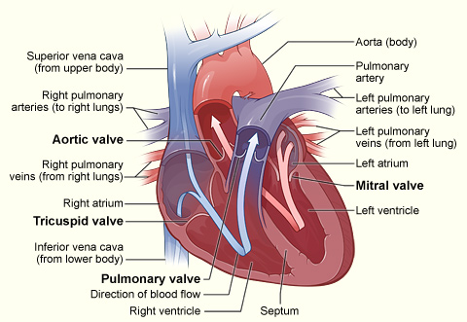

Now test your knowledge and label the heart above, remember the colours red and blue should help you identify blood flow.
This Photo by Unknown Author is licensed under CC BY

