Module: Employability and Career Development Code: LCLM4005

Student name: Olena Ustuianova
Student ID number: 2515321
Module Leads: Vicky Giannaka

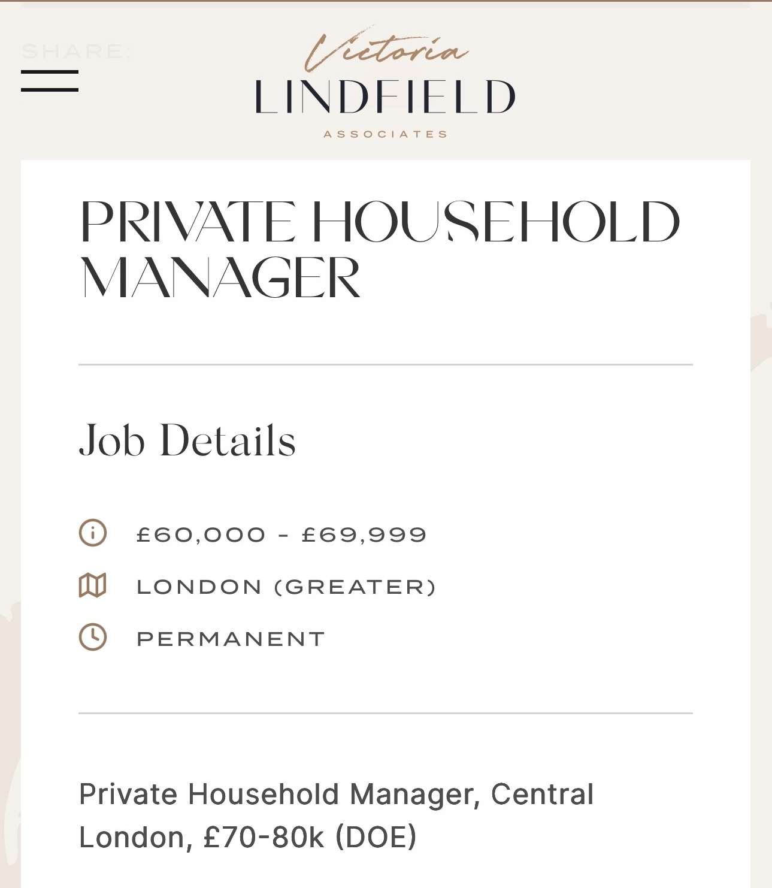
CV
CV
Olena Ustuianova Phone: +44 7481092370 Email: elena.ustuyanova96@gmail.com Location: London

Personal Profile

Dedicated and highly organised Housekeeper with over three years of experience working within a high-standard private household in London. Experienced in managing the day-to-day upkeep of a large family residence occupied by two adults and three children. Skilled in luxury housekeeping, VIP wardrobe management, laundry, ironing, household organisation and maintaining exceptional standards of Seeking to progress into a Private Household Manager role where I can contribute my practical experience, organisational ability and commitment to first-class service.
Key Skills
Luxury Housekeeping
VIP Wardrobe Care
Inventory Management
Time Management
Working independently
Health & Safety
High Cleaning Standards
Education
2025-pRESENT UWTSD London CertHE Higher Education (CertHE) – Business Skills for the Workplace
2003 - 2014 Secondary Vocational Education (High School Diploma)
Ukraine
Work Experience
Housekeeper
Private Family, London
2022 – Present
Maintaining a large private residence occupied by two adults and three children.
Complete housekeeping to luxury standards.
Caring for an extensive VIP wardrobe.
Professional laundry and ironing.
Wardrobe organisation and seasonal rotation.
Managing household supplies.
Organising storage areas.
Maintaining kitchens, bathrooms and living areas.
Working with complete confidentiality.
Prioritising daily tasks independently.
Supporting the smooth running of the household.
Languages
Russian — Native
Ukrainian — Native
English — Intermediate (currently improving)
IT Skills
Microsoft Word
Microsoft Outlook
Microsoft Excel
Google Calendar
WhatsApp

REFERENCE on request

Cover Letter
Dear Hiring Manager,
I am writing to express my interest in the position of Private Household Manager.
For the past three years I have been working as a Housekeeper in a private household in London, maintaining a large family home occupied by two adults and three children. During this time, I have developed excellent organisational skills, discretion and attention to detail while consistently maintaining exceptionally high standards.
My daily responsibilities include luxury housekeeping, professional care of a VIP wardrobe, laundry and ironing, organising household supplies and ensuring the smooth day-to-day running of the home. Working in a private household has taught me the importance of confidentiality, flexibility and anticipating the family’s needs while always maintaining professionalism.
I am a hardworking, reliable and trustworthy person who enjoys taking responsibility and creating a well-organised environment. I work well independently, manage my time effectively and always aim to deliver the highest standard of service.
I am now looking to progress into a Private Household Manager role where I can use my practical experience and continue developing my career within a professional private household.
Thank you for considering my application. I would welcome the opportunity to discuss how my experience and skills would contribute to your household.
Yours faithfully,
Olena Ustuianova

