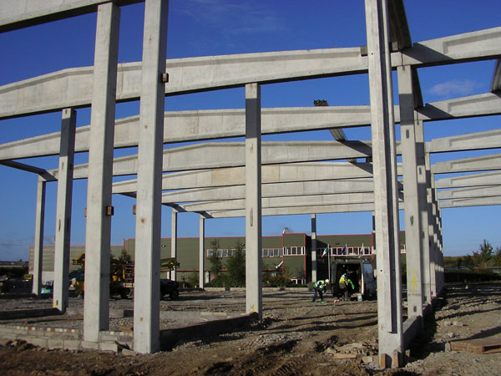

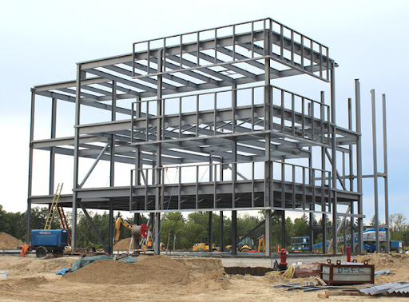

Materials Science and building services assignment 1
Sam Davies – 2115596
UWTSD University
Hand in date – 09/12/2021

In this assignment I will be picking a habitable concrete frame building and a habitable steel frame building to report on and go into detail about their design planning, construction method and potential impact in consideration of social and environmental sustainability. I will then be comparing and contrasting between steel frame and concrete frame strengths and weaknesses in the environment as well as their properties. I will also be doing this for their impact on the environment through their manufacturing processes. Workability of both of the frames will also be compared and contrasted.
My building of choice for a steel frame building will be Ystalyfera secondary school. The building is located in the town of Ystalyfera in the Swansea Valley. The building approximately costs £7,500,000. It is a two-storey high building which includes teaching areas, canteens and a performance hall. It was constructed in 2021 and hit the BREEAM excellent rating for its sustainability. Steel construction started in January 2021 and was finished by February 2021. The full building completion is targeted for this December. Andrew Scott ltd built the building with Morgan’s of Usk supplying and installing the steel frame. The building had to be designed to suit the environment it was going to be in which was wet/cold weather over winter periods and be able to cool itself down during the summer period. It includes features like I-beams that work very well under the heavy loads of the buildings. Even staircases and internal walls are made from steel. The ground floor is a reinforced concrete slab which is supported by the steel. First floor uses a stud welded sheet to form the reinforced concrete framework.

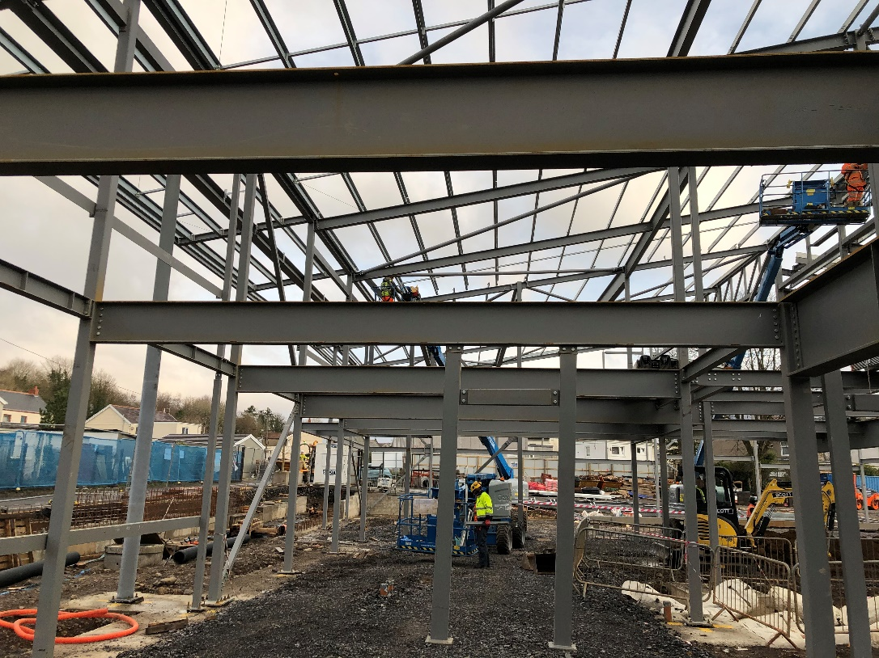

My building of choice for concrete frame building is the Burj Khalifa in Dubai. It is the tallest building in the world with a height of 830 meters tall. It was constructed in 2009 and later opened in 2010 to the public. The foundations for the frame to be placed on were reinforced concrete piles that went down many meters into ground. The building is admired all around the world for its fantastic architecture and its uniqueness of being the tallest building in the world. The building also had to be thoughtfully designed as it has to withstand the environment of hot weather/sandstorms etc. As the building is so tall concrete is the perfect frame for the building as it is great under compression (withstanding the forces from all the floors above). The buildings cost was £1.13 billion.
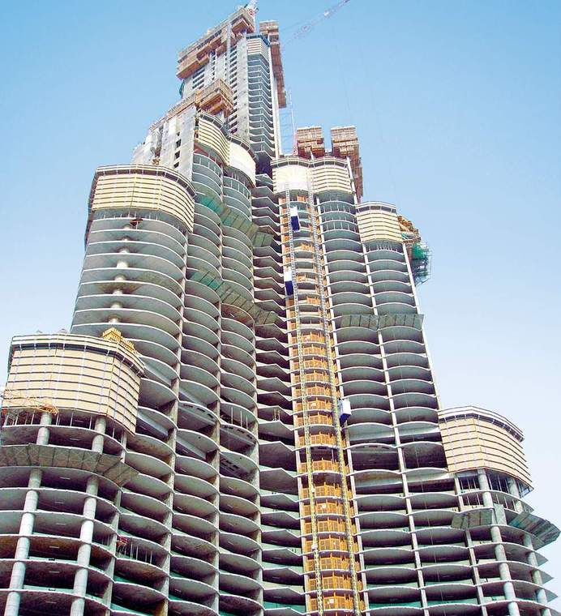
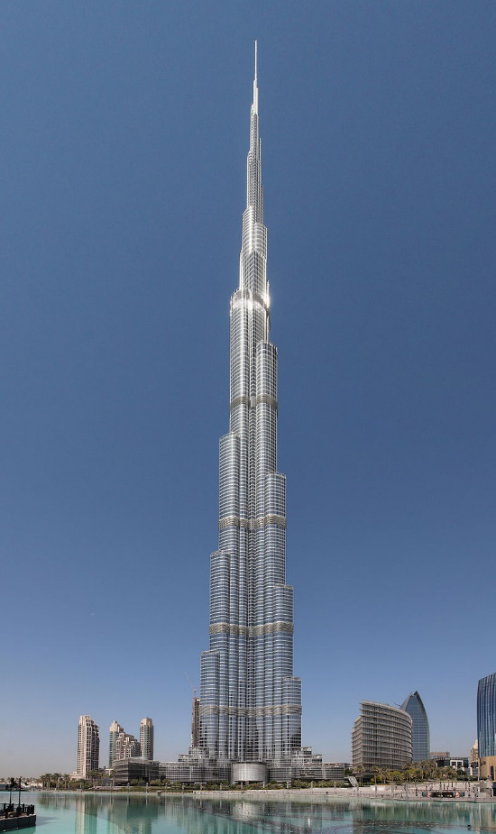

Design Planning –
Drawings of the bolt setting out, purlin plans, elevation drawings, section drawings, and roof plans were used during the design stage. Bearing plate tests also had to be carried out by structural engineers to ensure the baseplates could withstand the load of the steel frame. Setting out also has to be carried out before the steel goes up to ensure it is placed safely/correctly.
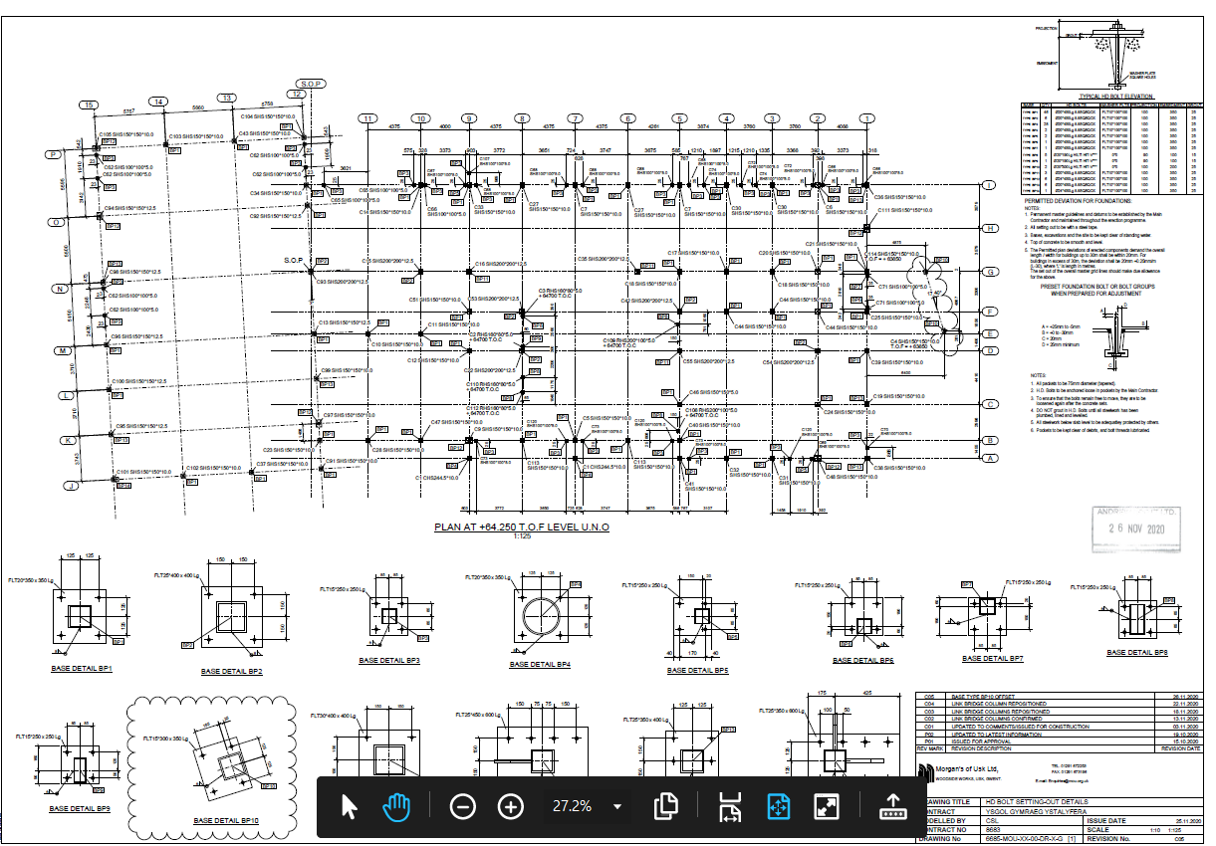
Typical example of a bolt setting out drawing –

Designing of a concrete frame would need to be carried out by engineers. Strength of concrete would need to be considered during the design stage to account for the loading pressure the concrete would be under. For example, a typical ground floor slab will be RC 28/35. Movement joints will likely be considered in the design stage. They allow the concrete to expand and contract under temperature movement to eradicate cracking in the concrete. Typical movement joint drawing shown below -
Construction method –
The construction method of the steel was to install baseplates on the foundation that the steel could be fixed to. The steel was prefabricated and manufactured to size off site. This made workability easy and made the process a lot quicker when installing it. Cross sectional beams and the roof trusses were bolted together to create a sturdy structure that is great under compression and tensile forces. The steel frame roughly took three weeks to assemble when comparing this to a concrete frame it would’ve taken much longer.
Structurally both frames are great under compression however concrete is very poor in tension whereas steel is very good.
Construction method of a concrete frame would be to excavate and back blind a trench for your foundation. Your concrete frame would then need to be shuttered and casted to finalise your frame. Irregular shapes could also be shuttered and poured. Concrete would need to be pumped from a mixer into the frame. Elevator shafts are much easier to build out of concrete frame as an elevator needs to be fire protected. As concrete is a fireproof material it would be much more cost effective than installing a steel frame elevator and having the materials to fire proof it with labour constructing it.
The steel can be re-used/recycled at the end of the buildings life cycle which would be cost effective.
- The frames likely durability and climatic resistance, given the environmental conditions the site is exposed to.

Steel Frame – Steel frame buildings are susceptible to weathering under wet or cold conditions. Rust can occur to exposed steel and visual appearance can be damaged. When compared to concrete frame buildings steel is superior due to the fact weathering doesn’t have an as large effect on it structurally. For example, concrete can crack under weathering. Despite this it is very good in conditions where it is exposed to high winds, hurricanes, earthquakes etc, in-fact a well-maintained concrete structure can last up to thirty years. Reinforced concrete can crack if the steel re – bars are exposed to water at any point (also known as concrete cancer). Steel frame loses its structural properties under high temperatures and can buckle, taken this into consideration concrete has a much stronger frame and is more durable. Steel can also withstand below-freezing temperatures. Concrete has a high thermal mass which means it will keep buildings cool in warm weather and warm in cool weather. You can see the link between this and my buildings of choice as the Burj Khalifa is in warm weather, whereas Ystalyfera school is often in cold weather as it is located in higher ground in a generally colder country. Concrete can be casted with bubbles in it to ensure it is protected from freeze-thaw, although protecting it from weathering is possible it’s not as practical as steel frame.
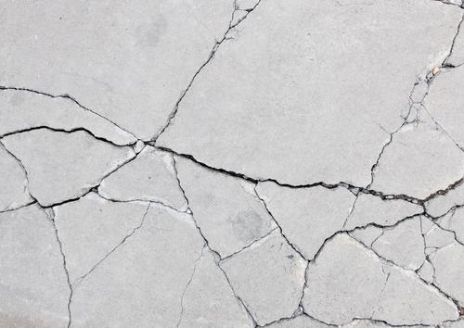

(Image taken from concrete renovations)

This image shows one of the defects to weathering which is cracking.
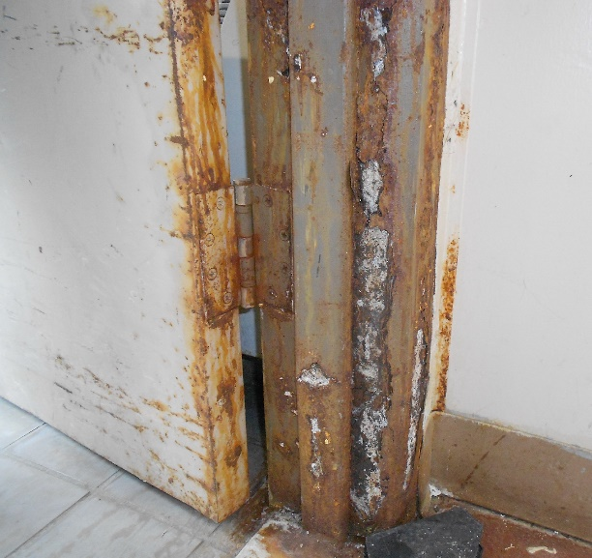
(Image taken from “steel door institute)

This shows one of the defects that happens to steel under weathering which is rusting.

- The likely impact the framing materials original production process would have had on the environment, with particular reference to resource use in manufacture and in bi-products used –

Steel has a better environmental standard than concrete as it is generating less waste than concrete. Due to net-zero carbon emissions being introduced steel frame buildings will be preferred by designers and clients in the near future. Concrete also creates a worse environment in the manufacture process. Steel industries around the world having been trying to make the manufacture of steel net-zero Carbon which also enforces my point on why it will probably be more widely used in the future. On the other hand, concrete frame buildings retain heat better due to their structural properties and its general mass over steel. Concrete frames can also include admixtures, so plastic will also have to be included in the manufacture process in some cases. Plastic and other chemically harmful admixtures could see concrete not being used as much in the future due to its carbon footprint being higher than steels in the manufacture process. Concrete is produced at a much higher rate than steel, the cement industry actually produces more than 2,800,000,000 tonnes of carbon dioxide a year which would be more than most countries use a year. The only countries to emit more Carbon Dioxide would be China and the USA. On the opposing side, steel productions emit around 3,300,000 tonnes of Carbon dioxide per year. This means concrete produces 848x more Carbon per annum.

Concrete is also worse than steel in the fact that it can kick up harmful silica dusts when being used in the construction and refurbishment industries which is way steel is sometimes preferred over it. For certain builds concrete has it’s on advantages over steel, for example for a building that needs good acoustic properties such as stadiums/concert halls/nightclubs etc. will need to both block sound and not allow sound to be lost so concrete has an advantage over steel in this regard. Concrete frame buildings are also favoured when building laboratories and places that use sensitive equipment as there is an estimated 67% vibration reduction between concrete and steel frame. In regards to infection control concrete is superior to steel in the fact that it doesn’t need any corrosion protection or fire – proof protection. This stops the opportunity for allergens or contaminants to get stuck over time, reacting with humidity and airflow and eroding into the air ultimately leading to infection and building users feeling unwell.

Concrete has to be transported to site in a mixing lorry and pumps also have to be used. This can make it hard to transport and also have a bad impact on the environment due to heavy/specialized having to be used.

At the end of the building’s life steel can be recycled and out into the manufacture process to avoid the production of new steel being processed (it’s designed in consideration of it being re-used in the future). On steel that is going to be recycled, longer beams are predominantly preferred as they can be cut to size if needed in the future without the need to re-mould the steel.

In regards to the social environment, steel buildings can often be better for light as the exterior frame is often built-in conjunction with materials like glass. Concrete frame buildings seem to just account for casting windows and doors in frame so the concrete itself cannot be seen visually. Here is an example below –

Concrete bi-products/Admixtures –

Water to cement ratio contributes massively when determining the workability of concrete. This can be measured when doing a slump test. If a strong concrete is required aggregates can be reduced and cement can be increased, however this can obviously lead to higher costs as cement costs more than the aggregates concrete is usually mixed with e.g. Sand, stone etc. Concrete can also be used in conjunction with retardants. Retardants can slow down the hydration process of concrete. Retardants are often used in high temperatures as concrete can set to quickly and create poor bonds between surfaces and can create voids. Commonly used admixtures include, Calcium Sulphate, Gypsum, sugars and salts. Water retarding admixtures can also be used and these go by the name of retarding plasticizers.

Accelerating admixtures can also be used. The purposed of these are to increase the hydration process. A great use of this would be in low-temperature areas. Emergency repairs are also much simpler when the concrete curing process can be sped up.
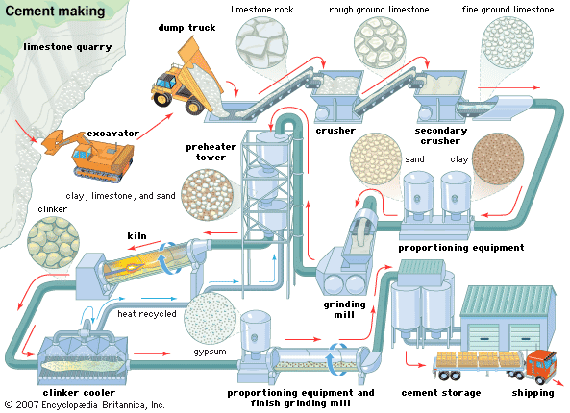

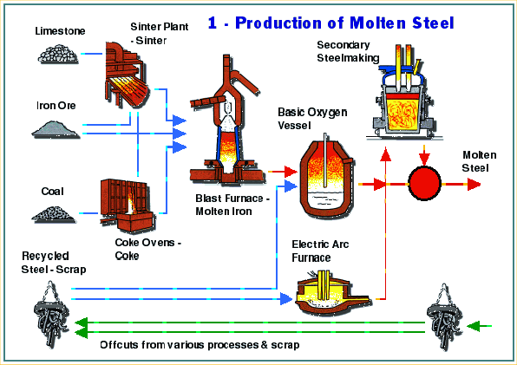
This image is showing the stages within the manufacture process for concrete. (Image from “Britannica”)

This image shows the manufacturing process of steel. (Image from “Construction how”).

Even the images above indicate that both materials do not undergo an eco-friendly manufacture process however both will have to adapt their process to abide by government net-zero carbon rules in the near future.

- The frames ease of assembly, and the potential ease of its adaptation to different building shape and use, within the total life cycle of the building. -

Concrete is a more workable material as it can be shuttered and poured into a frame which makes it much more adaptable than steel. Furthermore, concrete frames do not have to be fire proofed like steel and this can result in big cost savings as steel needs to be boxed in and fire protected to certain time frames. From another perspective steel frames however can be installed much quicker than concrete frames as they are prefabricated off site. If steel frame is exposed to visual representation, it can be painted with polyester paint, this cannot be done with concrete. Steel is set instantaneity whereas concrete will take time to set. This is both an advantage and disadvantage to concrete as it is workable and can be changed while in the drying process however construction cannot further continue until dry whereas steel frame buildings can be built on instantly. Concrete frames also need to be cured which can take up to one week before construction starts on them. Steel is a very adaptable material it can almost be moulded into any shape; it can be converted into wires or sheets if needed. When steel is erected, it needs a much more specialized workforce when opposed to casting concrete, this could mean defects in the steel frame would take much longer to get resolved as usually sub-contractors will have to rectify them. If the steel reinforcement fails in a concrete frame building repairs can be very expensive and it would take a specialized workforce to repair. Depending on the damage to the reinforcement this could take a very long time to repair which would likely affect programme implications and prove to be even more costly in the long run.

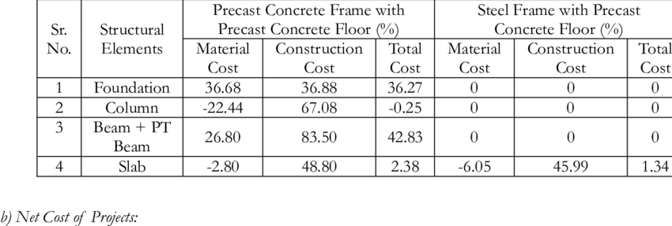

This graph was made by “ReSearchGate” indicating to us the cost difference between a steel frame structure and a concrete frame structure. We can clearly see from this that steel is the cheaper alternative to concrete. The reason for this is because there are shorter labour times required which results in cost savings.

After reviewing, analysing, comparing and contrasting steel and concrete frame buildings my personal choice between the two would be a steel frame building as the steel industry is striving to become net-zero carbon. This will be favoured by governing bodies in the future. It is also more cost effective than concrete and has quicker installation times. In addition, from an environmental point of view, I have come to a conclusion that steel is more environmentally friendly and sustainable for the environment than a concrete frame building. On the other hand, designing must be done with thought as the location of the site and the surrounding environment is the most important aspect as well as the type of building being done.
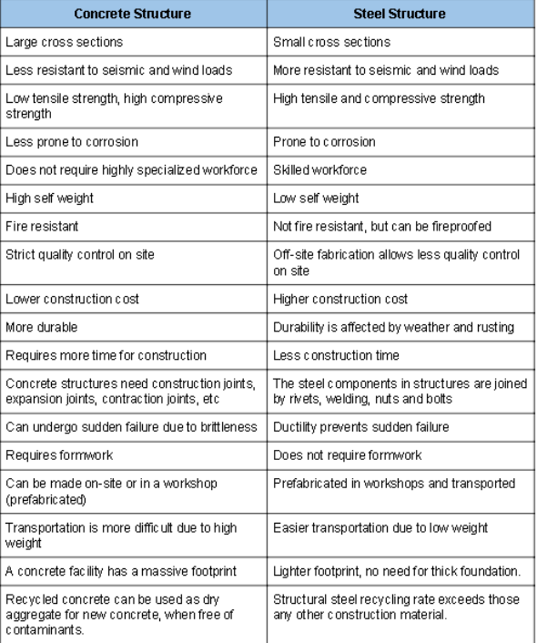
This table from https://www.ny-engineers.com/blog/comparing-steel-construction-and-concrete-construction shows a direct comparison to both concrete and steel, like anything in the industry they both come with their advantages and disadvantages.

References –

Superior Sheds. (2020). Are Steel Buildings Safe in a Hurricane? [online] Available at: https://www.superiorsheds.com/are-steel-buildings-safe-in-a-hurricane/ [Accessed 9 Dec. 2021].

Watts, J. (2019). Concrete: the most destructive material on Earth. [online] The Guardian. Available at: https://www.theguardian.com/cities/2019/feb/25/concrete-the-most-destructive-material-on-earth.

S3DA DESIGN Structural & MEP Design. (2017). The Advantages of Concrete Structures | S3DA Design. [online] Available at: https://s3da-design.com/advantages-concrete-structures/.

Edmonton Structural Steel Fabrication. (2018). Advantages and Disadvantages of Structural Steel Structures. [online] Available at: https://northern-weldarc.com/advantages-disadvantages-structural-steel-structures/.

The Constructor. (2018). 15 Types of Admixtures Used in Concrete. [online] Available at: https://theconstructor.org/concrete/types-concrete-admixtures/5558/.

https://www.superiorsheds.com/are-steel-buildings-safe-in-a-hurricane/

https://www.theguardian.com/cities/2019/feb/25/concrete-the-most-destructive-material-on-earth

https://s3da-design.com/advantages-concrete-structures/

https://northern-weldarc.com/advantages-disadvantages-structural-steel-structures/

https://theconstructor.org/concrete/types-concrete-admixtures/5558/

