

Strategic Management (LCMB7003)

Strategic Analysis of Apple Technology Company
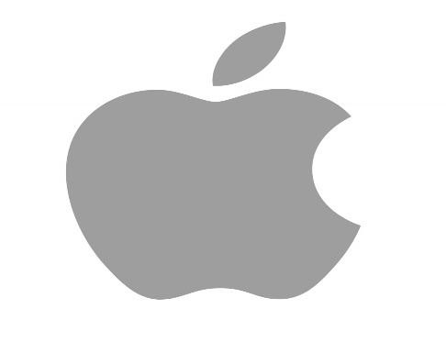

Student Name : Relin Reji Baby
Student Number: 2228653

Lecturer: Dr Hossein Shokri
Word count: 5000 Words
Submission Date: 1st September 2023

Table of Contents
Introduction 2
XXX Background 2
XXX’s Mission and Objectives 2
Macro-Environment Analysis 2
PESTEL Analysis 2
Micro-Environment Analysis 2
Industry Life Cycle 2
Porter’s Industry Five Forces Analysis 2
Internal Analysis 3
XX’s Strategic Resources and Capabilities 3
Value Chain Analysis 3
Primary Activities 3
Secondary Activities 3
VRIO Analysis of Distinctive Resources and Capabilities 3
SWOT Analysis 3
Strategies to Sustain Competitive Advantage 4
Growth Strategies 4
Green Strategy and CSR 4
Conclusion 4
Recommendation 4
References 4
Appendix 5
Appendix 1: 5
Appendix 2: 5

Introduction
One of the most crucial management procedures in a company is strategic management, which should be applied strategically by managers to ensure greater performance and a competitive edge for their own business. The capacity to manage and assess the sector in which the business operates and to take proactive steps to embrace the future is one of the main objectives of strategic management. This report is a strategic study of the Apple Technology Company that focuses on the ways in which how innovative steps can be taken that might raise awareness of their brand quality and along with improving consumer satisfaction. It also covers how Apple became one of the most successful technological companies in the world and how they manage and assess the customer experience by utilising the chances available to them to meet their objectives nd future goals.

Background
Apple Inc, originally known as Apple Computer, Inc. is a worldwide company that produces and sells consumer gadgets, related computer software, and digital media content. The iPhone smartphone, iPad tablet, and Macintosh personal computer are Apple's three main product categories. The business operates an Apple site retail chain in addition to its online site. To commercialise Wozniak's Apple I desktop computer, Steve Jobs, Steve Wozniak, and Ronald Wayne founded Apple Computer Co. on April 1, 1976. On January 3, 1977,[3] Jobs and Wozniak officially incorporated the business in Cupertino, California. (apple company, 2023).
With a market worth of over $2 trillion, Apple is one of the biggest corporations in the world. Apple products are renowned for their elegant styling and meticulous attention to detail. Their systems outperform rivals with identical specs thanks to the close hardware and software integration. Apple has dominated the market thanks to careful product placement. Personal computers, graphical user interfaces (GUI), mp3 players, cell phones, smartwatches, and tablets were not invented by them. Instead, they created several early models of these goods that were svelte, simple to use, and exquisitely designed, spurring market uptake. When it was originally released in 2007, the iPhone quickly gained popularity. The App Store was introduced the next year, enabling independent developers to distribute and sell their programmes to customers. The well-liked iPhone 4 and iPad debuted in 2010 after the iPhone. In recent years, Apple has continued to introduce new goods and increase its service offerings. Apple started employing its own-designed microprocessors with the iPhone and has now expanded to the Macintosh line of PCs. Additionally, it provides media streaming services via Apple Music and Apple TV+. With rumours that self-driving cars and virtual/augmented reality headsets are in development, it is anticipated that Apple may soon enter new areas. (Gavin Wright, 2023).Apple's most current statistics indicates that it employs about 2,000,000 people in the country directly and indirectly. This covers both full- and part-time employment, app developers, and vendors. Apple reported having roughly 80,000 direct workers in the nation, 36,786 of whom are based in California. There are 164,000 full-time people working at Apple in different countries at any one moment. Apple provides a wide number of employment options and positions, including those for construction workers, designers, manufacturers, scientists, marketers, retail salespeople, and customer service representatives. (Kelly Indah, 2023).
Except for Antarctica, Apple operates on practically all the continents. In addition to the US, UK, France, Brazil, India, China, Singapore, Australia, Germany, Sweden, and many more nations, Apple has offices, design studios, manufacturing facilities, development centres, sales offices, and marketing offices worldwide. In comparison to its US operations, Apple's global operations are incredibly complex (World HQ). The above-mentioned nations where Apple has operations differ greatly in terms of their current state of economic development and projected course for future economic growth. (Parag Deshpande, 2017)

Figure.1 Apple Technology Company Logo
Source: (edigitalagency.com.au)
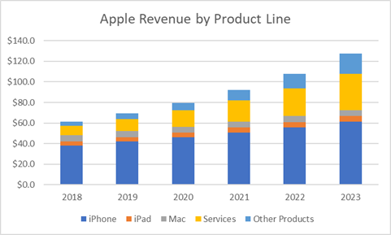
Figure: Revenue of Apple Company from 2018- 2023
Source: (seekingalpha.com)

Mission and Objectives

The main goal of every firm or organisation is its mission that is decided and been focused throughout the workings of the company. It offers an overview of the objectives and guiding principles. Also, it explains in detail what the company performs for its clients which helps us stand out from other organisations by being both comprehensive and narrowly focused. Its an excellent tool for creating corporate goals and deciding objectives in advance.
“To bringing the best user experience to customers through innovative hardware, software, and services.” (Apple Inc, n.d.)
Objectives
Business objectives are the precise and quantifiable outcomes that organisations seek to sustain as they expand. A strong objective monitors performance across the board to ensure that their organisations are headed in the correct path. Also, they serve as a compass for the firm, directing how it should distribute its strengths, shortcomings, and potential opportunities. As we know future is uncertain sudden attacks can be reduced and be prepared.
Apple Inc. Company mainly concentrates on key factors of creativity, innovation, and added value. Gaining a competitive edge over its primary rivals is the company's major aim. Apple can provide customers distinctive items that are in line with their shifting wants by being innovative and mainly focusing on customer satisfaction and after sales services.

Macro-Environment Analysis
Macro-Environmental Analysis means identifying and analysing possible opportunities and threats that develop in the macro-environment are part of macro environment analysis, which is a component of strategic management in many organisations. Its fundamental objective is to give management reliable data to aid in operational choices. This analysis on organisation is made up of all significant, uncontrolled outside factors that either directly or indirectly affect decision-making. (Anon., n.d.).

PESTEL Analysis
The acronym PESTLE Analysis stands for Political, Economic, Sociological, Technological, Legal, and Environmental elements that have an influence on every business organization's macroenvironment. This analysis is a source of pertinent data for the efficient operation of technology businesses like Apple Inc. Company in the conditions surrounding operational obstacles in real-world scenarios rather than challenges caused by competing businesses.
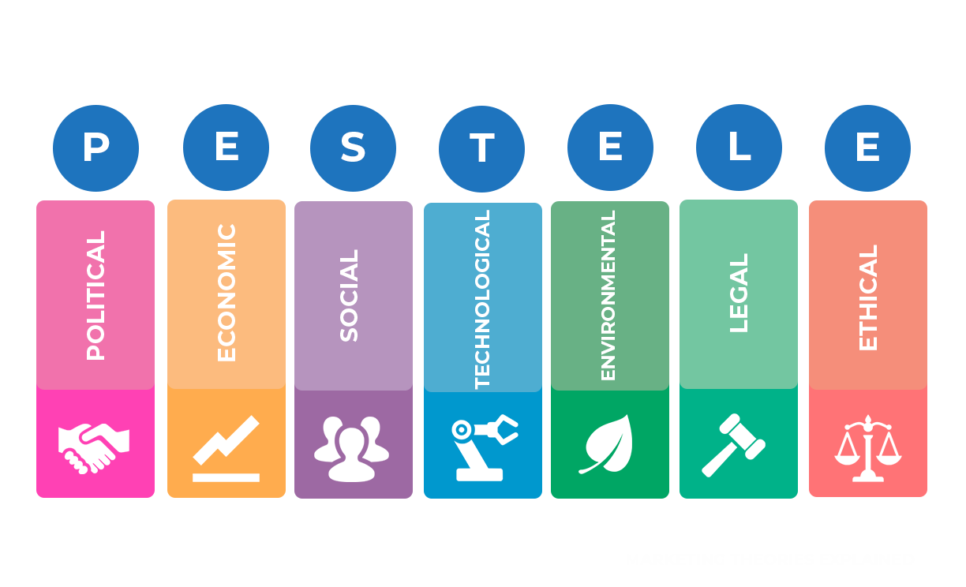
PESTELE FRAMEWORK Source:(Professional Academy.n.d.)

Political Factors

The political stability of industrialized countries is a development possibility for Apple because there are no substantial political difficulties impacting the current countries' economic performance. The company's future growth and income from the sale of its products on the Internet are in jeopardy due to the external political aspect of the trade conflict, notably the one between the United States and China. For instance, rising hostilities between China and the United States may lead China to impose higher taxes on imported electronic components used to make the company's goods. From this we can understand that Apple may improve performance by making use of political possibilities in the macro or distant environment, although vigilance is required to guarantee stability despite trade tensions. ( JESSICA LOMBARDO, 2023).

Economic Factors

A technology company like Apple can benefit from the stability of many rich countries around the world. Apple has excellent opportunities to improve market share and financial success thanks to the higher growth rates of Asian countries. A strong US dollar can negatively impact exchange rates, making it difficult for Apple to do business in countries like China, India, and Pakistan. Apple cannot penetrate the Asian market as efficiently as Samsung and Huawei using a premium pricing model. Apple also faces fierce competition from top tech companies like Lenovo and Samsung. (Umar Farooq, n.d.).

Social Factors

Things like customer attitudes, trends, and preferences are examples of social influences. Due to their potential to change consumer demand for Apple's goods and services, these variables may directly affect the company's financial success.
Many young people adore technology and regard it as an integral element of their life. This is undoubtedly advantageous for Apple. It is also true, though, that many Americans and citizens of various other nations are currently worried about the expanding influence of digital giants. Their purchasing choices might be impacted by this. So social factors are one of the important factors to be considered while operating in a market.

Technological Factors

Technology breakthroughs and present technologies are evaluated to analyse business possibilities and dangers. One of the key elements is the growing influence of technology in business, which offers Apple the chance to expand by offering its technology services to more people and organizations. But because technology is so quickly outdated, Apple needs to upgrade its goods more frequently to easily outperform its rivals. For instance, although Apple lost ground in the PC industry, companies like Lenovo maintained their position. It is a result of these competitors offering inexpensively priced, innovatively advanced products. The growing popularity of cloud computing presents Apple with yet another significant potential.

Environmental Factors

Environmental factors plays a vital role in operating business environment. Climate change Businesses are increasingly required to manage their impacts on the environment as climate change becomes a significant global issue. Apple must consider how climate change could affect its manufacturing, supply chain, and energy consumption when developing methods to mitigate these consequences and reduce emissions. To reduce its environmental impact and comply with regulations, the company must focus on improving energy efficiency, using renewable energy sources, and producing energy-efficient goods. Resource scarcity and ethical sourcing of system followed in company uses a variety of components and materials, including rare earth metals, in its products to reduce its environmental impact and Apple must focus on sustainable sourcing, reduce reliance on non-renewable resources, and develop alternative products to have a healthy business environment. The priority areas according to the environment Act 2022 in the UK are Air Quality, Water, Biodiversity, resource efficiency, and waste management, elements that Apple must keep in mind. (Environmental Act , 2022)

Legal Factors

A trend that gives Apple the opportunity to grow its business through considering legal factors is providing better privacy practices. The company also faced legal difficulties due to its after-sales service processes and procedures, among other business-related issues. For example, the company has faced legal challenges and criticism over third-party repair service procedures in Australia, the European Union and the United States. Apple should prioritize privacy and regulatory compliance in all of its products and consider changing its policies and procedures to meet legal requirements and prioritize after sales services according to the current law relating to business that prevails in the country. ( JESSICA LOMBARDO, 2023)

Ethical Factors

Apple Company must surely follow the ethical conducts and practises in honestly, morally, and in complete accordance with all relevant laws and regulations. This holds true for every business choice made across the board by the corporation. Demonstrate honesty and high ethical standards in all business operations, is one of Apple's business practises must be followed. Respect Show consideration and respect for others, including customers, partners, suppliers, workers, and others. Protection of Apple's sensitive information as well as the information of our partners, customers, suppliers, and employees through confidentiality. what compliance Make sure all company choices adhere to all relevant rules and regulations. When delivering products and services to Apple or representing us, suppliers, contractors, consultants, and other business partners are expected to adhere to these standards. Additionally, Apple demands that its suppliers adhere to the Apple Supplier Code. (Apple Policy, 2022).

Micro-Environment Analysis
Microenvironment Analysis means the factors that are near to an organisation and have an impact on how it serves clients. It is also known as a task environment that is somewhat impacted by organisational activities. The external environmental forces that are a part of a company's marketing system make up the micro-environment. Despite being categorised as non-controllable factors, management can have a bigger impact on these forces.

Industry Life Cycle
The

Porter’s Industry Five Forces Analysis

The Five Forces model is frequently used to evaluate a company's corporate strategy as well as its industry structure. This analysis refers to a framework that assesses the degree of competition within a market by examining five crucial forces are competitive Rivalry, supplier Power, buyer Power, threats of substitution, threats of new entry.

Threats of New Entry:

Companies own sales volume and market share may be threatened by new competitors. It is simpler to hold onto a market position the more challenging it is to enter. Due to the high price of production, marketing, and R&D, there are also significant obstacles to entry. This has made it possible for long-standing industry leaders like Apple and Samsung to hold onto their dominant positions. Entry fees, brand loyalty, governmental regulations, and specialised expertise. These are some of the elements that are thought to be crucial in the development of new entrants.
Threats of Substitution:
Due to their limited capabilities, alternatives to Apple goods pose a very low danger. Owning a DSLR camera instead of an iPhone 12 is an example of this, however the iPhone 12 has an advantage over a DSLR camera since it can do more than just capture excellent photographs. There is currently no technology available that could totally replace the use of cell phones. Additionally, the Apple operating system (OS), which has no close equivalent, gives Apple goods a competitive advantage on the market. Because of this, Apple's ability to use the threat of replacement is limited.
Buyer Power:
Purchasers have access to information and customer reviews, product characteristics, and other information are now readily available to customers. Apple specifically combats this by continuously investing in research and development, which has resulted in the creation of several items that are exclusive to Apple, such Air pods and the Apple watch, increasing existing customer loyalty and luring new ones. As a result, buyer power is a powerful force for Apple because of the readily available information and low switching costs.

Supplier Power:
Apple has access to a wide range of component suppliers on a worldwide scale, which makes it harder for individual suppliers to impose demands on Apple. Apple can also replace component suppliers quickly, cheaply, and without any difficulty. The unwillingness of component part suppliers to lose a significant client like Apple to competing parts suppliers strengthens Apple's position when negotiating a contract with a supplier. This demonstrates the little negotiating leverage and precarious position component suppliers have in relation to Apple's strategic plans.
Competitive Rivalry:
Apple faces intense competition from companies like Samsung, Google Inc., and Amazon Inc., among others, in the technology sector. When it comes to innovation, the creation of new products, and marketing, these businesses are just as aggressive as Apple. As a result, they give Apple a strong industry competitive force when it comes to product differentiation. Their rivals provide customers with similar types of products that serve the same purpose. The low switching costs between goods are another important factor in fostering competitiveness in the technology sector. Because there are many identical items available that provide the same functions, switching from an Apple product to one from another brand requires little commitment on the part of the user.

Industry competition

Internal Analysis
The

XX’s Strategic Resources and Capabilities
The

Value Chain Analysis
The

Primary Activities
The

Secondary Activities
The

VRIO Analysis of Distinctive Resources and Capabilities
The

SWOT Analysis
The

Strategies to Sustain Competitive Advantage
use different strategic analyses here, such as porter’s generic strategy

Growth Strategies
use different strategic analyses here, such as the Ansoff metrix / international strategies / entry mode strategies

Green Strategy and CSR
The

Conclusion
The

Recommendation
The

References

References
JESSICA LOMBARDO, 2023. Panmore Institute. [Online]
Available at: https://panmore.com/apple-inc-pestel-pestle-analysis-recommendations
[Accessed 10 8 2023].
JESSICA LOMBARDO, 2023. Panmore Institute. [Online]
Available at: https://panmore.com/apple-inc-pestel-pestle-analysis-recommendations
[Accessed 11 8 2023].
Anon., n.d. IPL. [Online]
Available at: https://www.ipl.org/essay/Apple-Macro-Environment-Analysis-FCP4UJWAQG
[Accessed 10 8 2023].
apple company, 2023. wikipedia. [Online]
Available at: https://en.wikipedia.org/wiki/History_of_Apple_Inc.
[Accessed 9 8 2023].
Apple Inc, n.d. Product Feedback. [Online]
Available at: https://www.apple.com/feedback/
[Accessed 10 8 2023].
Apple Policy, A. B. C., 2022. Business Conduct, s.l.: Apple.
Doyle, P. & Stern, P., 2006. Marketing Management and Strategy. 4 ed. Essex: Pearson Education Limited.
Environmental Act , 2022. Environmental progress report, s.l.: s.n.
Gavin Wright, 2023. tech target. [Online]
Available at: https://www.techtarget.com/
[Accessed 9 8 2023].
John Dudovskiy, 2023. Business Research Methodogy. [Online]
Available at: https://research-methodology.net/apple-pestel-analysis
[Accessed 10 8 2023].
John Dudovskiy, 2023. Busniess Research Methodology. [Online]
Available at: https://research-methodology.net/apple-pestel-analysis
[Accessed 10 8 2023].
Kelly Indah, 2023. Earth Web. [Online]
Available at: https://earthweb.com/apple-employees/
[Accessed 9 8 2023].
Parag Deshpande, 2017. Linked In. [Online]
Available at: https://www.linkedin.com/pulse/apple-inc-strategic-analysis-global-context-parag-deshpande#
[Accessed 9 8 2023].
Umar Farooq, n.d. Marketing Tutor. [Online]
Available at: https://www.marketingtutor.net/apple-pestle-analysis/
[Accessed 10 8 2023].
Wood, M. B., 2013. Essential Guide to Marketing Planning. 3 ed. Harlow: Pearson Education Limited.

Appendix (if any)

Appendix 1:

Appendix 2:

