What is evidence based practice? AC 1.1
Evidence based practice (EBP) is the process in which a decision is made ensuring that it is fair and considered. By looking at trusted evidence, we can inform our decision making and hopefully reach the best possible outcome. Waite et al, (2021, pg. 47) describes it as ‘a process where evidence from reliable sources is used to develop knowledge and understanding to inform practice’. By looking at the model, six steps to evidence-based decision making, Young (2024) shows a guide to help people professionals navigate the process of evidence based decision making.
Asking – what is it you want to know and how do you phrase it as a question?
Acquiring – discovering the relevant evidence that will help you.
Appraising – Carefully investigating how reliable and trustworthy the data is.
Aggregating – Setting the evidence out in useful formats.
Applying – Implementing the evidence into process of your final decision.
Assessing – Looking critically at the success of your decision.
Looking at this model we can deduce that decision making within an organisation should not be an ‘off the cuff’ or simply instinctual process but rather more considered. By looking at evidence, it can be ensured that not just one person’s opinion is used, and that factual, tangible evidence is considered. People professionals have a responsibility to ensure organisations treat individuals fairly and justly and by using evidence they can avoid biases and stereotyping for example. In the report evidence based management: the basic principles, Barends, Rousseau and Briner (CEBMa 2014) state we can use EBP to “distinguish science from folklore, data from assertions, and evidence from beliefs, anecdotes or personal opinions”.

The Importance of using data in organisations AC 1.2
People practitioners need to make decisions which effect the whole organisation, these decisions can be unpopular or going against the status quo. There are several pitfalls decision makers can fall into deriving from our own human nature. Young (2024) highlights issues such as ‘authority bias’, ‘conformity bias’ and ‘confirmation bias’ as examples of this. People professionals have an ethical responsibility to be aware of these pit falls and actively search out the truth so that your decisions solve the real problem at hand.
By using accurate data to inform your decision making you will build trust and credibility within the workforce, employees will feel a sense of psychological safety in the knowledge that future policies and procedures were constructed via sound judgement calls and ethical practises. This will of course encourage a healthy work culture impacting productiveness and efficiencies. By not using sound data you run the risk of misdiagnosing the issue and coming to the incorrect conclusion. An example of this could be looking at staff survey results and only concentrating on one response. You need to delve deeper into all responses, survey uptake as a whole and specific contributing factors.

The data measurements that people professionals use AC 1.3
There are two types of data measurements that people professionals use to enable decision making, they are quantitative data and qualitative data. Waite et al. (2021 pg. 50) defines quantitative data as something that can be ‘expressed as numbers and can be counted and measured’ and it defines qualitative data as ‘non-statistical and based on meanings that come from words’. Some examples of what each mean can be seen in the table below:
Quantitative data examples | Absence records  Employee turnover rates  Length of service records  Response rate of employee survey  Feedback scores from customers (net promoter score)  Recruitment metrics  Head count data  Training metrics  Key performance indicators  Employee productivity  Financial Data  Business costs
Qualitative data examples | Written employee feedback (e.g. survey)  Employee reflections on a project or onboarding experience  Records of conversation or performance reviews  Exit interviews  Interview records  360 appraisals  Accident reports  Investigation statements

Looking in more depth at quantitative data we can take the example of absence records. If company absences are recorded following a set process, employee reports an absence, company records it then that data is available to look back on should the need arise. Organisations usually have a threshold of absences that if passed, can trigger a disciplinary meeting. Another area is head count data as this will show the total number of employees and enable you to fully understand recruitment needs and possible staff pressures.
Examining qualitative data, exit interview can provide valuable insight into many working practises. An exit interview may raise questions such as whether the rate of pay needs review or whether management techniques are fair and equitable.

Applying agreed policies and procedures to inform decisions AC 1.6
As a people professional, there will be many ethical dilemmas that will arise within an organisation. It is easy to see why this happens when dealing with human nature and individuals with different backgrounds and opinions. We all have biases and can often be prone to stereotyping. Applying agreed policies and procedures to follow within an organisation helps mitigate issues arising from the above and foster fairer and ethical decision making in this regard. It is important to regularly review and update policies and procedures to ensure they are legally compliant and align correctly with the company goals and aspirations.
An example of a policy that should be used to aid a decision making is the right to request flexible working arrangements. According to the Government (2024) ‘employees can make a request for flexible working from the first day in a job’ and that ‘employers must deal with requests in a ‘reasonable manner’’. A policy for managers to follow which clearly sets out how to handle a flexible working request and how to reach a decision on whether it is reasonable, is needed to ensure employees are treated fairly and within the law but is also reasonable for the business.
Another important policy is that of parental leave. As a recent article (PM Daily, 2024) highlights ‘hardly any dads have used shared parental leave since scheme was introduced’ and also explains that research has shown ‘barriers of “gendered attitudes around caregiving and fears about career progression” inhibit men from taking parental leave’.
These are the biases that as a people professional you should be aware of and actively seek to eradicate.
By applying agreed policies and procedures an organisation can promote a consistent approach to issues and life events as they arise. People professionals can lean on them when faced with ethical dilemmas and ensure they are compliant with the law and the values of the organisation they represent.

How people professionals can create value AC 2.1
The influence a people professional can have on an organisation cannot be underestimated and the areas they can positively impact are numerous. By creating and implementing policies and procedures, making informed decisions and modelling ethical and empathetic behaviour people professionals can have a positive impact on people, organisations and wider stakeholders. They can create value by positively improving the working lives and wellbeing of employees creating a positive work based culture which in turn can foster higher productivity, a desire and motivation to perform well. The knock on effect of this is that the service the employees provide to customers and wider stakeholders will be of higher quality. The organisation as a whole will have a more attractive brand thus attracting and retaining better quality workers and also customers. The influence a people professional can have on an organisation can not be underestimated and the areas they can positively impact are numerous.
By competitively monitoring and implementing a fair pay system for example, can foster attraction of talent and improved staff retention. (Forbes, 2022) recommends 13 techniques to ensure employees feel fairly compensated which include staying ‘on top of the market’ and being ‘fair and equitable in your pay practices’. The brand reputation of the organisation will grow positively encouraging repeat and new custom. Employees will feel valued and more motivated to perform well and attend work.
The importance of successful onboarding of employees can not be underestimated. Ensuring that a thorough and well thought out induction and training program, along with introductions and socialisation, creates strong foundations of retaining employees whilst enhancing the overall culture. It is an opportunity to educate the new hire on the company values and mission and encourages alignment of this from the very beginning.

How I am customer focussed and standards driven AC 2.2
Integrity within my role is important to me as is ensuring high customer satisfaction. As a people professional I can refer to the CIPD Profession Map which ‘captures the knowledge and behaviours you need to learn, progress and make an impact at work’. Continuous personal development is something that has struck me as very important, in an ever changing world I feel the need to keep abreast of changes to laws and society in order to provide the best possible service to my customers.
To be successful in my role there are many areas where being customer focused and standards driven are very important. My internal customers are potential new hires, new employees, colleagues, managers and directors. I also work closely with a people services business partner. Although I do not have a guest facing role, pleasing the guests who stay on resort is also my focus and they are my external customers.
I can be customer focused by always having the company goals in the forefront of my mind (make people happy, be the most loved UK holiday destination), having respect and understanding towards my colleagues (by ensuring I am knowledgeable on acts such as The Equality Act 2010) and embracing the 5 star guest experience we are trying to offer. By adhering to our company policies and procedures I hope to create a trust in my work that protects the business as well as promoting a good work based culture where standards are upheld.

Section 2. AC 1.4

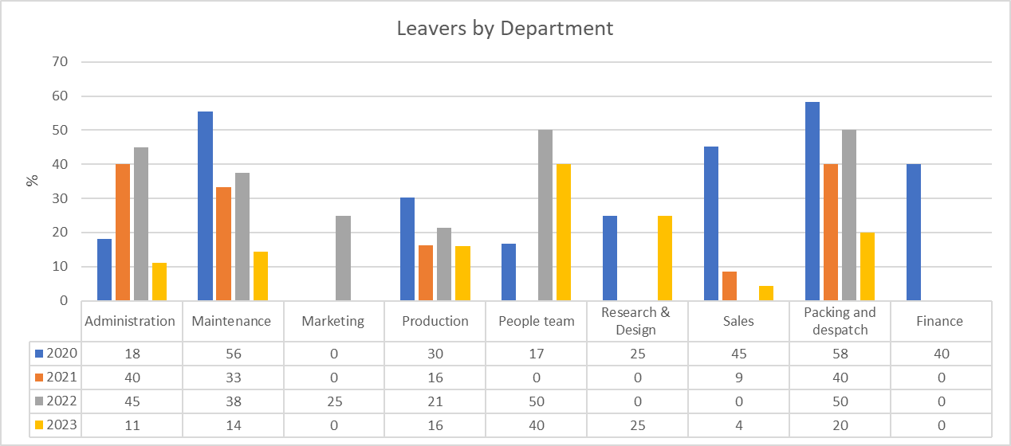
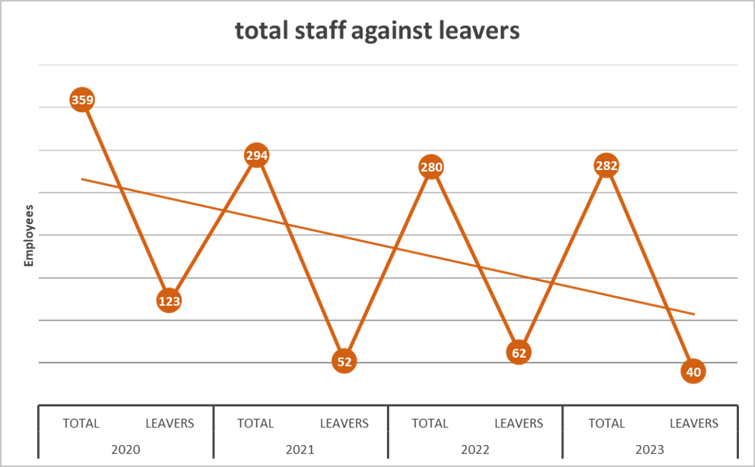
When looking at the data available for leavers of this organisation we can deduce the following:
- The percentage of leavers has fallen since 2020
- 2020 was the highest year for leavers in the data available, however this could be explained by the COVID-19 pandemic. The highest percentage being packaging and dispatch at 58%.
- The general trend over the four years available is a reduction in leavers.
- Marketing seems to have the highest retention, only losing 1 person in 4 years. Likewise, finance is a close second having lost 2 people in 4 years.
- Production has the highest number of leavers, 169 people in 4 years.
- The highest leaver percentages come from the manual labour type of roles (possibly lower paid).
- The traditionally more specialist roles like research, finance and marketing have better retention rates (roles which are more career based).
Potential solutions
Design and implement an employee survey asking questions about job satisfaction, pay and conditions. After reviewing responses, use appropriate data evidence to implement changes.
Survey staff in departments with low leaver rates and identify the differences between departments. Ask what works well and what is a problem?
Exit interviews could also be scrutinised to see if there are any patterns or trends such as low wage, competition, managerial issues, commuting costs and shift patterns.
Research pay rates in like for like roles in other organisations to ensure that the manual workers are on a fair rate of pay.
Implementing an incentivised, problem solving, idea generator for greater staff engagement. This would hopefully capture those who do not feel listened to. Employees could be rewarded if their ideas are implemented as a quality improvement or an efficiency saving.
A clear career path with training opportunities could be offered to individuals desiring to make a career within the company.
Develop a training programme for line managers to train them how to motivate and engage their team members.

References

Young, J. (2024) Evidence-based practice for effective decision-making. Available at: Evidence-based practice for effective decision-making | Factsheets | CIPD (Accessed: 5 December 2024)
Hague, W. (2024) The profession map. Available at: The Profession Map | CIPD (Accessed: 16 December 2024)
The Equality Act 2010, chapter 1, section 4. Available at: http://www.legislation.gov.uk/ukpga/2010/15/section/4 (Accessed: 16 December 2024)
GOV.UK (2024) Available at: Flexible working: Overview - GOV.UK (Accessed: 16 December 2024)
Barends, E., Rousseau, D and Briner, R. (2014) Evidence-based management: the basic principles. Available at: Evidence-Based-Practice-The-Basic-Principles.pdf (Accessed: 5 December 2024)
Forbes Human Resources Council 2022 13 Techniques To Ensure Employees Feel Fairly Compensated accessed on 5 December 2024

Clemo, F. (2024) Hardly any dads have used shared parental leave since scheme was introduced 10 years ago. Available at: Hardly any dads have used shared parental leave since scheme was introduced 10 years ago, research finds (accessed: 16 December 2024)
Waite, K., Beevers, K., Small, N., Tomlinson, K. and Hussain, S. (2021) People Practice. London: Kogan Page.

