https://www.london.edu/think/the-ultimate-green-reading-list
The environment, that is, the ecological environment could be one of our themes.
More from our friends at London Business School…….does business care? What incentives do we need to create real action? Is it all too late? Are we and our children and certainly or grandchildren doomed?
Steve

The ultimate green reading list
Can profit and purpose co-exist? Our five recommended sustainability books go a long way to help answer that all-important question
LIZZIE HUDSON
13 NOVEMBER 2023
Personal development Creativity Leadership Learning Sustainability
Save to my profile

Businesses are faced with many challenges, and perhaps the biggest for the 21st century is climate change and the need to secure the future of our planet. There is no question about it, business needs to become more environmentally responsible, but where to start?
We asked an esteemed few of our London Business School community to share a sustainability book they have read recently, that offers better understanding and deeper engagement. Here are their picks…
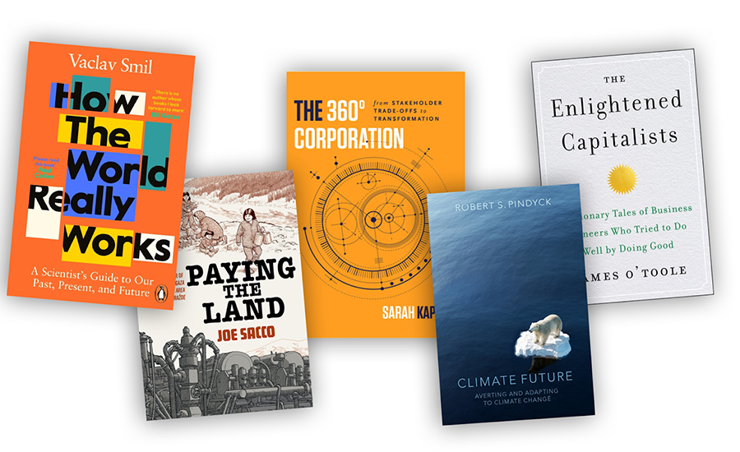

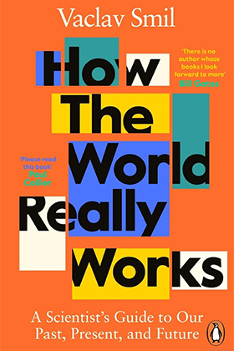

How the World Really Works: A Scientist’s Guide to Our Past, Present and Future by Vaclav Smil

Recommended by Alex Edmans, Professor of Finance
Climate change is a hot topic, and so many gurus start writing about it regardless of expertise. By making extreme claims, backed by selectively-quoted evidence, they can attract attention. The prevailing narrative is that decarbonisation would be easy if we just stop focusing on profits.
Smil, an environmental scientist, points out that it’s not that simple. Steel, ammonia, cement, and plastics are “the four material pillars of modern civilization” and they are inevitably carbon intensive.
We face a difficult trade-off between stunting the economic growth of developing countries, potentially permanently, and allowing the planet to warm, likely irreversibly.

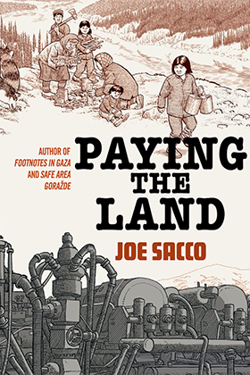
Paying the Land by Joe Sacco
Recommended by Tiago Ivo Martinho, Executive Director, Wheeler Institute for Business and Development
In Paying the Land, Joe Sacco shines a spotlight on the indigenous people in the remote Canadian Northwest territories and how the mining boom impacted their culture, lives and relationship with the natural environment. With mining, came jobs and investment, but also new infrastructure, pipelines and waste, which changed the landscape and way of life.
Both the nuanced writing and sophisticated drawings stand out in a masterful craft of comics journalism exploring the conflict over the costs and benefits of development by one of the greatest cartoonist reporters alive.

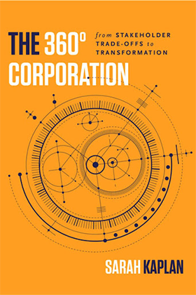
The 360 Corporation by Sarah Kaplan
Recommended by Julian Birkinshaw, Vice Dean and Professor of Strategy
Of the many books I have read recently on sustainability, the one I have enjoyed most is The 360 Corporation by University of Toronto Professor, Sarah Kaplan.
Many sustainability books become quite preachy – they say business needs to pursue a higher-order purpose and accept a lower level of profitability. Others argue that we need to reconcile the conflicting goals of profit and purpose through innovative win-win solutions.

Kaplan says these and other solutions are too simplistic, because every company faces a different situation. Instead, we have to recognise there are four different modes of thinking, different ways of approaching the tension between profit and purpose, and that each is likely to lead to a different course of action.
This is a refreshing approach, as it shows the power of careful analytical reasoning and it is a helpful guide to any company that is grappling with its response to climate change.

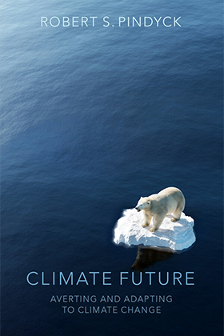
Climate Future: Averting and Adapting to Climate Change by Robert Pindyck
Recommended by: Xia Li, Assistant Professor of Strategy and Entrepreneurship
If you desire to understand what we know and don’t know about climate change, why we don’t know (the nature and implication of uncertainty), and what we can do to mitigate and adapt to climate change, then this book is the perfect starting point.
It explains scientific knowledge and mathematical analyses in straightforward terms without sacrificing depth. Moreover, it emphasises climate change adaptation, an area that has historically received limited policy attention.

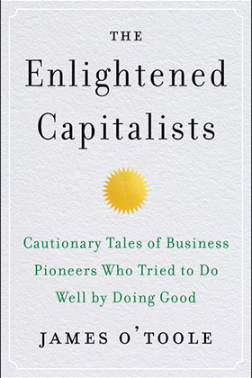
The Enlightened Capitalists by James O’Toole
Recommended by Tom Gosling, Executive Fellow in the Department of Finance
Subtitled “cautionary tales of business pioneers who tried to do well by doing good”, this book goes to prove that there is nothing new in the world, including business leaders who want to pursue a more responsible and sustainable form of capitalism.
Through an entertaining and accessible series of stories and case studies going back over 200 years, O’Toole describes the efforts of mill-owners, retailers, soap-makers, confectioners and technology entrepreneurs to make money while making the world a better place.
The stories are inspiring and insightful, but also bring home the challenge, very relevant to today, of staying true to sustainability principles when economic signals point in a different direction.
Discover fresh perspectives and research insights from LBS
Sign up to Think

