
Skills for the Workplace
Module Assignment Submission
Student Name: | Seren Murphy
Student Number: | 1917785
Module No: | BMSK4005
Module Title: | Professional Career Development

Statement of Confirmation of Authenticity
By the act of making this submission, the student declares that this is the work of the student named above. The work has not, in whole or in part, been knowingly presented elsewhere for assessment, or where assessment has been built on a previous assessment, this has been identified. Where materials have been used from other sources it has been properly acknowledged. If this statement is untrue, the student acknowledges that an assessment offence has been committed.
Attention is drawn to the plagiarism and unfair practice policies of both the University and of ILM.

Table of Contents
Section 1: Know how to identify development needs 3
1.1 Identify learning styles for self and another 3
1.2 Use a simple technique for identifying development needs for self & another 4
1.3 Identify potential barriers to learning for self and another. 5
1.4 Explain how these barriers to learning can be overcome. 6
Section 2: Know how to develop self & others to achieve organisational objectives 6
2.1 Analyse learning/development options to meet needs of self & another. 6
2.2 Identify support mechanisms for the development of self & another 6
2.3 Prepare development plans for yourself and another person 7
2.4 Method used to monitor the development of self & another. 8
Section 3: Know how to prepare for the recruitment process 8
Reflection on the recruitment process 8
3.1 Description 8
3.2 Feelings 9
3.3 Evaluation 9
3.4 Analysis 9
3.5 Conclusion 9
3.6 Action Plan 9
References 10
Appendix A 10
Appendix B 10
Appendix C 10
Appendix D 10

Section 1: Know how to identify development needs
In this section I will be using three different tools to discover development needs for myself and a colleague.

Identify learning styles for self and another
The first tool that I used was the Honey & Mumford questionnaire, Honey, P. and Mumford, A. (1986a), Through this I have discovered that I am a theorist. My colleague on the other hand, is a reflector. (See Appendix A)
I thoroughly agree with these results, as some of the main strengths listed concur with some of my personal strengths. For example, I am very rational, like to get to the point and enjoy asking probing questions to encourage discussions to go my way of thinking. I also have a disciplined approach to any work or study and will make lists to give myself something to work from, and then enjoy ticking them off once I have completed each task. I have learnt from experience doing previous assignments and my job that if I am not disciplined, I tend to get off track and overwhelmed, so have learnt that I must stick with how I know I operate well.
I also agree that some of my weaknesses are in line with that of a theorist. For example, I do have a low tolerance for uncertainty and disorder. I like to know that everybody has a job to do and are doing it to the best of their ability. I become very frustrated if I feel that colleagues are beginning to go off track from a previously agreed way to reach a target. Also, if something is not going well, I will always think back and wish I had done it another way instead of just moving forward.
In the workplace, I do not enjoy anything unstructured or without purpose, always feeling that it is a waste of time. I enjoy learning something, understanding it and then doing it, without letting emotions or feelings override common sense and logic.
Regarding my colleague being a reflector, I also highly agree with this result. She takes her time with many decisions and likes to observe more than participate in any group discussion or meeting. She is most comfortable with informal discussions where she has a chance to reflect. She has many strengths, including being extremely thorough with any task she is given. She is incredibly thoughtful and very good at listening to other people’s thoughts and opinions and is very emotionally driven to help people. She is a great listener and very rarely jumps to conclusions.
However, her weaknesses are that she takes a long time to come to a decision as she likes to weigh up all her options repeatedly. She is very cautious with any decision making and will usually follow another’s actions or decisions. She is very unassertive and will hardly ever participate any of her original ideas, instead tending to just agree with another person’s ideas that she likes instead of creating her own. She is very uncomfortable with taking charge and does not like to be rushed into any task or given any pressing deadlines as she likes to take her time with any job she is given as she is extremely methodical.
In comparison, in my opinion we work together so well because we are so different. I am very quick to take charge and come up with a plan, whereas my colleague likes to take a back seat, observe and take her time deciding on the best course of action and how to get a job done properly. She will always ask me to take a minute and take in all the options available, whereas I will always encourage her to be positive in her ideas and decisions. I like to get the job done as fast and logical as possible, whereas she likes to take her time and ensure that we are doing things the right way.
After taking the honey and Mumford questionnaire, we then both completed the VARK questionnaire. The VARK questionnaire aims to distinguish between Visual, Auditory and Kinaesthetic learners. My results were that I am a mild kinaesthetic, and my colleagues were that she is a very strong read/write (See Appendix A) These are agreeable with our previous results from Honey and Mumford, as a kinaesthetic learner is described as a practical person who enjoys trying new things, and a read/write learner is described as a visual person who likes to take all information in and tends to be quiet and reserved.
The other tool I used, for only myself, was the Dantec questionnaire. My results for this were again that I am a kinaesthetic learner and learn by doing. I also had a point for visual learning, which again matches my habit of having to write everything down.
These tools are not an exact science and are used to try and make the person aware of their tendency to lean towards a particular style of learning. Once they are aware, they can use this information to make their development in education and the workplace easier by using styles that benefit and help them.

Use a simple technique for identifying development needs for self & another
I am going to use SWOT analysis to discover the development needs of myself and my colleague, who is also a dental nurse at my place of work. She is also in the middle of studying for her ILM qualification, although we are studying through different courses. I decided she was a good person to use for my assignment as we are doing the same job and course, however, are such different people, with many different strengths and weaknesses, I decided that she would be good to evaluate as she will almost certainly give me different results to myself and enable me to show my understanding for different techniques.

SWOT Person 1

STRENGTHS  Planning  Organising  Leading people  Admin  Clinical knowledge  Strong minded | WEAKNESSES  Taking on too much  Burning out  Expecting too much from others  Business knowledge  Strong minded
OPPORTUNITIES  Furlough  Extra responsibility  Build confidence | THREATS  Covid- PPE very difficult  Only able to see half the patients- half the income to the practice

SWOT Person 2

STRENGTHS  Clinical knowledge  Business knowledge  Laid back  Hard worker  Dedicated  Resourceful  Nice person- good relationships with all team members | WEAKNESSES  Does not speak up  Takes on too much  Time management  Burns out
OPPORTUNITIES  Furlough-  Extra responsibility at work  Build confidence | THREATS  Covid- PPE- very uncomfortable/difficult to work in  Half the patients- half the income- no bonus

For my SWOT analysis, I have used myself for person 1 and my colleague for person 2.
My SWOT has identified my weaknesses which are that I tend to take on too much at once causing me to burn out due to overloading myself. I know I can expect too much from others and I am very strong minded. When I have come to a decision it will take a lot for me to change my mind. These weaknesses may be holding me back in my career progression as they could make me look unorganised and not a team player.
A conversion strategy I could use to turn these weaknesses into strengths is simply by being aware of them. I must be conscious not to take on too much, and complete one task at a time instead of trying to do everything at once. I must always consider that others are also trying their best and not judge their way of working if it is different to mine.
My colleague has some weaknesses like mine, and some very different. She also takes on too much at once putting her in danger of burning out. However, she is opposite to me in the way that she does not speak up often, whereas I tend to be quite stubborn if I think I am right and do not listen to others. My colleague also struggles with time management, largely due to taking on too much at once.
She could turn these weaknesses into strengths also, like myself, by ensuring that she does not take on too much at once and that she finishes one task at a time. This will also help her improve her time management.
Although it is difficult for her, she should also make a conscious effort to participate and get her opinion across. These weaknesses could hold her back in her career progression as they could also make her look unorganised and not time effective. She could also be misunderstood as not caring to participate, instead of having the ideas but not having the confidence to voice them.
The Johari window can also be used to discover strengths and weaknesses within ourselves that we are not aware of, for example how others view us.
There are four parts to the Johari window. The first is called the arena and is what is known to us and known to others. This involves basic information like our names, personality, looks, gender and age. The second is our Blindspot. This is what is known by others but unknown to us. To discover this, we must ask for feedback from trusted friends, colleagues or family. The third is the Façade. This is what is known to us but unknown to others. This includes controversial opinions, values, beliefs and secrets. The last is the Future, which is unknown to us and unknown to others, including opportunities, threats, medical conditions and government legislations.
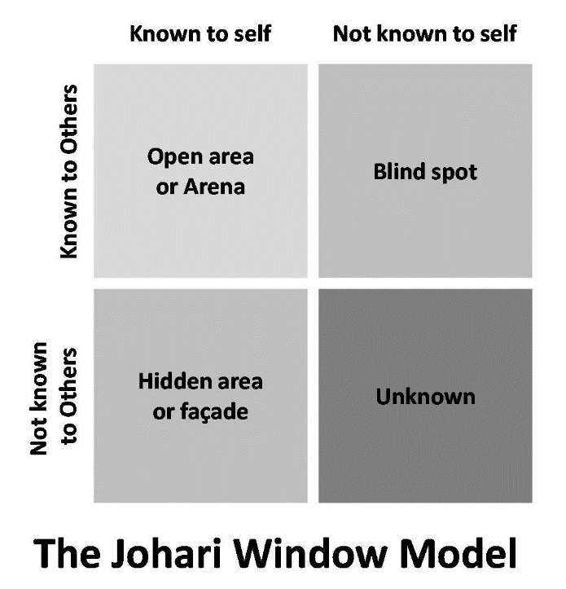
The Johari Window (1955)

Identify potential barriers to learning for self and another.
Myself and my colleague have both similar and different barriers to learning.
The external pressures I am facing are the extra working hours I now have since the covid 19 pandemic. This extra workload affects my time I previously set aside to study and complete my assignments, which in turn has affected my time management.
This affects my attitude, as it can make me feel overwhelmed and I struggle with prioritising between my work responsibilities and studying.
I have also noticed in myself regularly, that my perceived ability is never quite right. I tend to think that I am going to do well and find something easy and end up struggling, whilst the tasks I think I will struggle with I complete better than expected.
My colleague has the external pressures of an incredibly overcrowded schedule, including two young teenagers at home to care for, along with her additional studies and extra paperwork and admin that must be completed outside of working hours. She also is a scout leader at her local community hall and has a second job triaging emergency patients at an out of hours dental helpline.
She struggles greatly with her work/life/study balance, as previously mentioned she always tends to take on too much and ends up feeling guilty in some way for not being able to complete everything at once.
Her internal barriers are largely due to her perceived ability. She continually doubts herself and constantly feels guilty for not being at home more with due to all her extra commitments.
However, we are both lucky in the sense that we both have very supportive partners and families. We are both the first in our families to go onto higher education, and they are both extremely proud. We both study online at the moment so do not have to worry about attending classes

1.4 Explain how these barriers to learning can be overcome.
To overcome my external barriers, I must try my utmost to manage my time more effectively. I must set aside certain times or days dedicated to my studies or my extra work responsibilities.
By being more time efficient I will be able to reduce the amount of stress I feel at having too much to do. I must complete each task and move straight onto the next without procrastinating.
I must overcome my internal barriers of my perceived ability by facing my challenges head on and not doubting myself. I should also ask for help if I am struggling and learn to complete each task to the best of my ability and just move on, instead of procrastinating and second guessing myself.
To overcome her external barriers, my colleague must learn to prioritise. Although she thoroughly enjoys her hobby as Scout leader and has been involved in the group since her own children were very young, I would advise her to give her notice in for this. I would also advise her to give up her second job, as although the extra income is favourable, the added stress it puts on her just does not seem worth the pressure and stress. She can then use this extra time for her studies and family and will be able to prioritise more as she will not have so many additional responsibilities to attempt to juggle.
The main internal barrier she has is her guilt for not having enough time for her family. I feel that, although it would be daunting, if she does give up her hobby and second job, she will find that her work/life/study balance will become much more manageable. In turn, as she can now manage her time and efforts more effectively, she will gain a new sense of confidence and her perceived ability will be more positive.
In comparison, I have more internal barriers whilst my colleague has more external barriers.

Section 2: Know how to develop self & others to achieve organisational objectives

2.1 Analyse learning/development options to meet needs of self & another.
Looking at our SWOT analysis, we have mainly the same threats and opportunities, largely because we work together in the same job role. However, we have different strengths and weaknesses as this relates to our own personalities and learning styles.
We could use our threats and worry of family not understanding our amount of work and turn it into strengths of support. We could also use the opportunity of furlough for rest and recuperation, and extra responsibility at work to work towards receiving a pay raise or bonus.

2.2 Identify support mechanisms for the development of self & another
Following on from barriers discussed above, I feel that the person who can help me the most is myself. My time management will always be up to me. I must plan and prioritise at the beginning of every task or project and then stick with that plan to ensure I get the best results I could possibly get. I will also need continued support from my partner and boss, by having help at home with usual home chores to free up my time to study, and from my boss by having the understanding that sometimes my assignments will have to be prioritised above my additional administrative duties.
My college will also need the continued support from her family and our boss. However, she will need to make some external changes to her situation if she ever wants to really be able to find a balance in her work and life.
2.3 Prepare development plans for yourself and another person
Part 1: Personal Analysis
See SWOT Analysis in 1.2

Part 2: Setting Goals

What do I want to learn? | What do I have to do? | What support and resources will I need? | How will I measure success? | Target Date for Review
Time management | Make managing my time the most important part of my study preparation | Support from work, calendars, reminders, planning | By managing my time efficiently and completing everything by the time I plan to | March 2021
Perceived ability | Believe more in my abilities | Family and friends | By becoming more confident in my abilities | March 2021
Confidence | Gain the assurance to confidently be able to out my point across | Participate more in practice meetings, give presentations and speeches | Request feedback from colleagues | March 2021

Part 3: Personal Objectives

Short Term Goals (next 12 months)
Complete Level 4 certificate and achieve an 80% pass rate.

Medium Term Goals (2-3 years)
Degree completed
Internal promotion
Increased Wage

Long Term Goals (3-5 years)
I will be a successful and respected practice manager of a dental practice
Increased wage and recognition

2.4 Method used to monitor the development of self & another.
Monitoring my development will be instrumental in achieving and keeping track of my progress. I can do this by keeping a detailed learning log and Personal Development plan. A PDP is a detailed summary of what I want to do, how I am going to do it, with what resources and by when. If followed, this will keep me on track to success and enable me to have a clear path of what I need to do by when to achieve my goals. A PDP can always be amended or added too and will grow along with my success.

Section 3: Know how to prepare for the recruitment process

Reflection on the recruitment process
I will be reflecting on my experience and skills developed during this assignment by using Graham Gibbs Model of Reflection (1988).
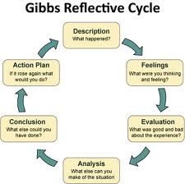

3.1 Description
Before starting this assignment, I can now see that I had no idea about what the recruitment process is like, from an applicant’s point of view. My experiences of the recruitment process are different to most peoples as I have never had a formal interview. I have had two jobs in my life, the first I started when I was 16 years old and I barely remember the very informal interview. The second, for my current job, I started 3 years ago, and my Boss is a friend that I have known for 10 years. I did not have an interview, he called me and offered me the job outright.
He had the unusual advantage of knowing me as a person. He knew he liked me and that I would fit in. He also knew previous associates that I had worked with and knew I had the qualifications and skill that he desired. For the purpose of this assignment, I asked him why he did not conduct a formal interview with me, and he reported that he was more interested in me fitting in with the rest of his team. In effect he had an insight into my personality that most interviewers try to gauge within a 30-40-minute interview.
Although I have never been on the receiving end of a formal interview, I have been a part of interviewing newly qualified Dentists, every year for 10 years with my previous Boss and practice manager. These interviews were to find a new dentist that would work with us under a year’s contract, as we would get a new one annually.

3.2 Feelings
During my previous experience of interviewing and recruiting staff for my previous job, looking back I found the interviews boring, with the value placed on the wrong element in my opinion. The aim was to find the most clinically gifted dental surgeon, whereas I felt that personality and the ability to fit in with the rest of the team should have been the most important attribute from a candidate. All candidates were equally qualified, so without seeing their clinical work first-hand, in my opinion we were never going to find in a 30-minute interview the clinical excellence that my boss so desperately craved.
These interviews were often a few days on end, consisting of 20 to 30 dentists, all with similar CVS and equal qualifications. Looking back, if it were my decision, I would have completely changed the process. I would have cut the number of applicants in half, by finding the applicants with a 1st in their degree to appease my boss, and then go on to then interview them with a mind to gage their personalities, instead of hoping for excellence in their clinical skills and that they fit in with the rest of the team.
However, on the other hand, it is very difficult to decide on an applicant’s personality during an interview, as I believe everybody is trying to show what they believe the interviewer wants to see.
This assignment has also opened my eyes to the value of being skilled in writing a C.V (See Appendix C), cover letter (See Appendix D) and filing out an application form (See Appendix B). I did not know the hard work that was involved in doing either, and that an interesting and personal cover letter can be the difference between a potential employer calling you for an interview or not.

3.3 Evaluation
When filing out a job application for this assignment, I found it an invaluable experience as I have never filed one out before. I was surprised at the sheer volume of information needed to apply for a job, along with an interesting cover letter to entice the reader to want to read my cv and consider me for a job. Previously, when looking through other people’s cover letter and CVs, I must admit that I did not realise the amount of work that went into them.
I have also learnt that a cv is used to earn an interview and preparation is the key to success. Manners, facial expressions and a happy personality are all incredibly important in gaining a memorable first impression. Dressing smart and professionally, being prompt, polite and knowledgeable about the company I would be interviewing for are all key elements involved in a successful interview.

3.4 Analysis
I will now use gap analysis to show what level I now currently feel I am at the previously mentioned recruitment skills.
Scoring 1-10 (1 meaning complete lack of confidence and understanding- to 10 meaning experienced and easily accomplishable)

Skill | Score now | Score I want to be
Self-Awareness | 5 | 8
Communication | 6 | 8
Job applications | 4 | 9
CV writing | 5 | 9
Cover letter writing | 5 | 9

3.5 Conclusion
This assignment has made me realise how hard and time consuming the recruitment process actually is. It has given me the chance to evaluate, and looking back on my experiences, I had very limited first-hand knowledge and experience of the recruitment process.
I now feel confident that I could apply for a new position professionally, using the new skills I have learnt. I will be a lot more prepared when applying, will have a strong C.V and cover letter, and be able to complete a job application thoroughly and well.

3.6 Action Plan
The following is my personal development plan using SMART objectives to ensure I can carry forth the improvements I have found I need using my gap analysis.
Activity | What? | How? | Resources? | Success? | By when?
Self-awareness | To be completely aware of how others perceive my abilities and personality | Work on my self-awareness | Exercises, continually develop by being aware | To be self-aware | Dec 2021
Communication | To be able to communicate effectively and wholly with all colleagues and patients | Stop and think before speaking. Be aware of my tendency to jump in headfirst without thinking | Feedback from colleagues and friends | To have excellent communication | Dec 2021
Job applications | To be able to complete any job application I make in the future | To practice with online templates | Online cv library, Indeed | To be confident in my ability to fill out a job application | Dec 2021
CV writing | To be confident in my CV | To update continually moving forward | Resources from this assignment, online templates | To have a strong CV that highlights all my attributes | Dec 2021
Cover letter writing | To be confident in writing a personal cover letter | To be able to write a cover letter that shows my personality and guarantees me an interview | Practice, online templates for different jobs | To have the ability to write a cover letter personal to each different application | Dec

References
Honey, P. and Mumford, A. (1986a) The Manual of Learning Styles, Peter Honey
Associates.
Gibbs, G. (1988) Learning by doing: A guide to teaching and learning methods. London: FEU
The Johari window (Luft & Ingham, 1955)
Vark – Flemming, N.D. & Mills, C. (1992)
Appendix A
Honey & Mumford questionnaire results
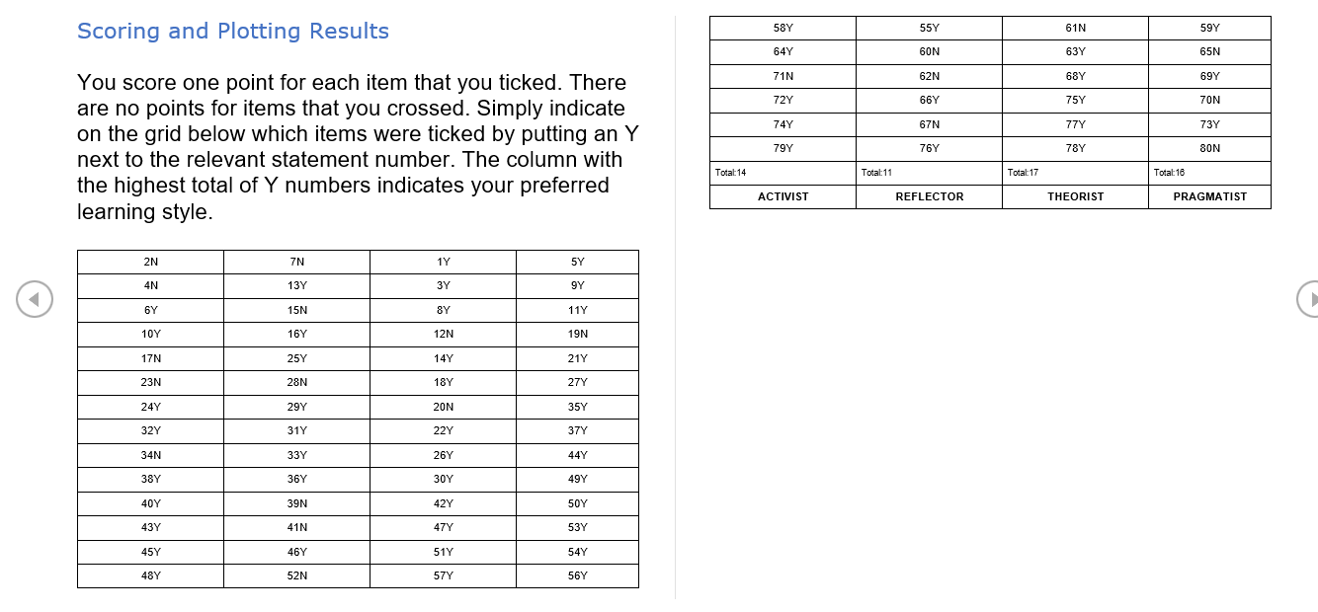
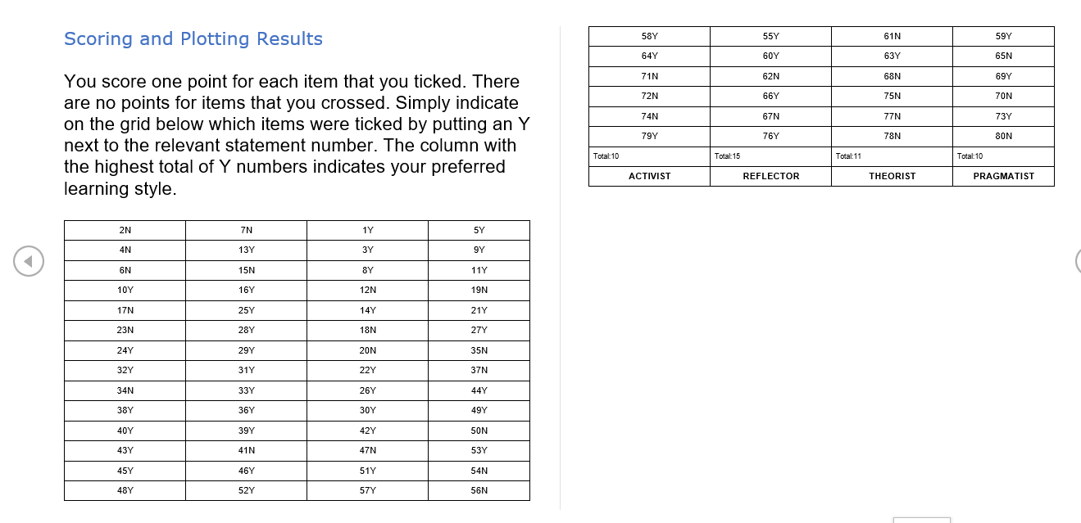
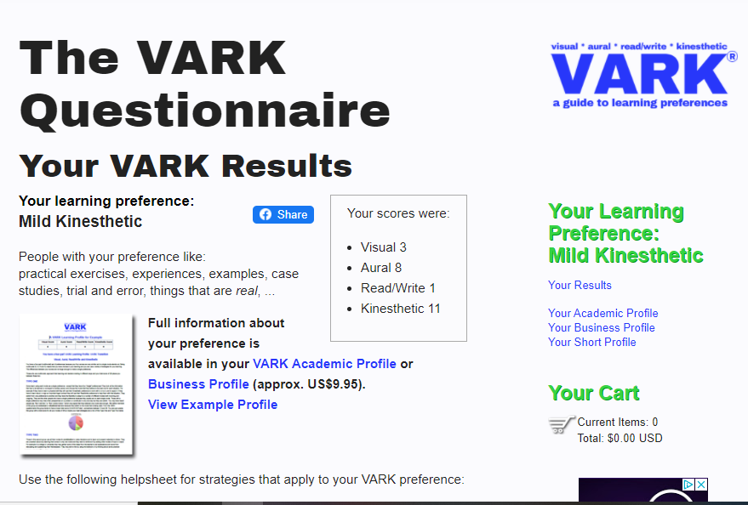
VARK questionaaire results
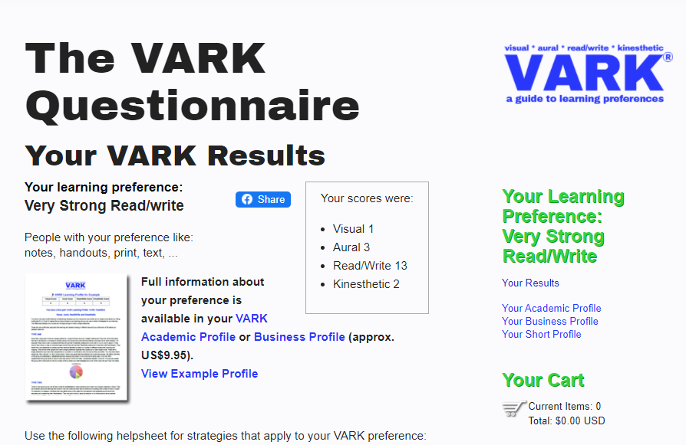
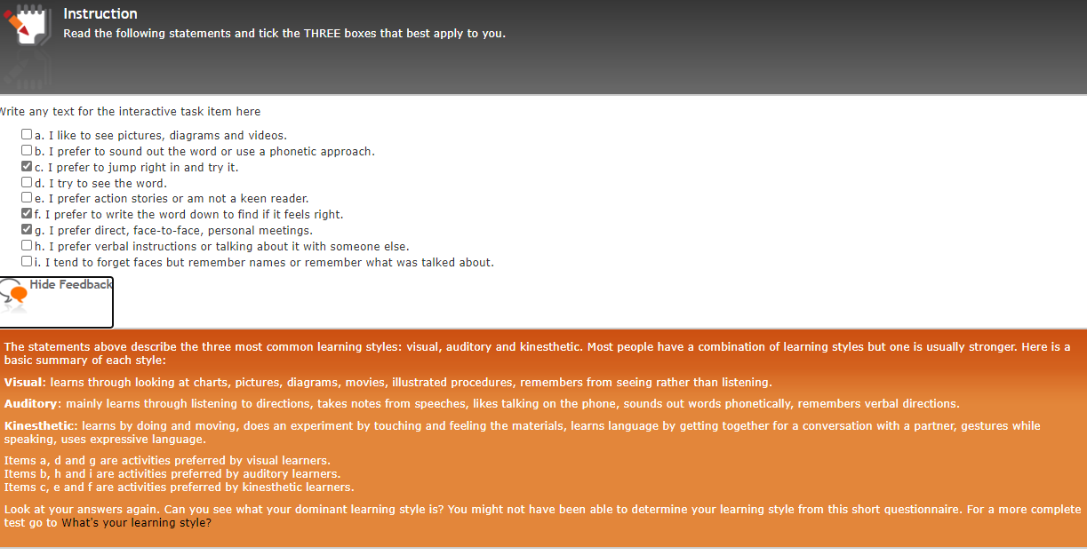
DANTEC Questionnaire

Appendix B
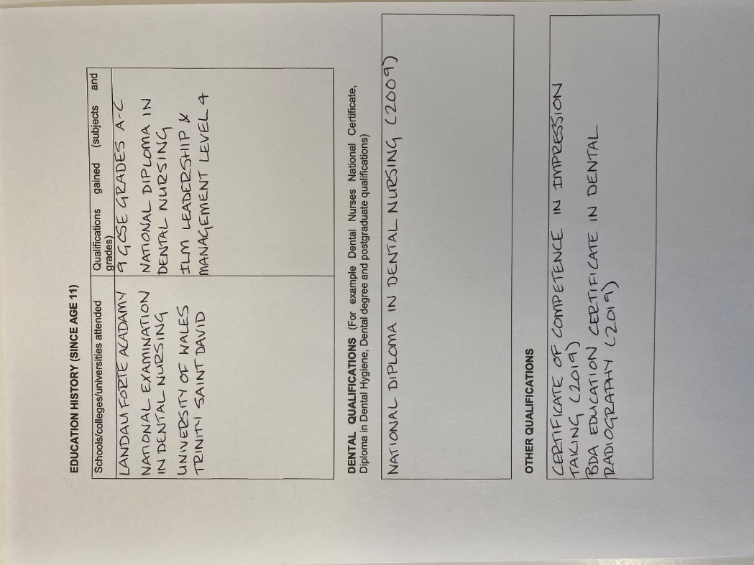
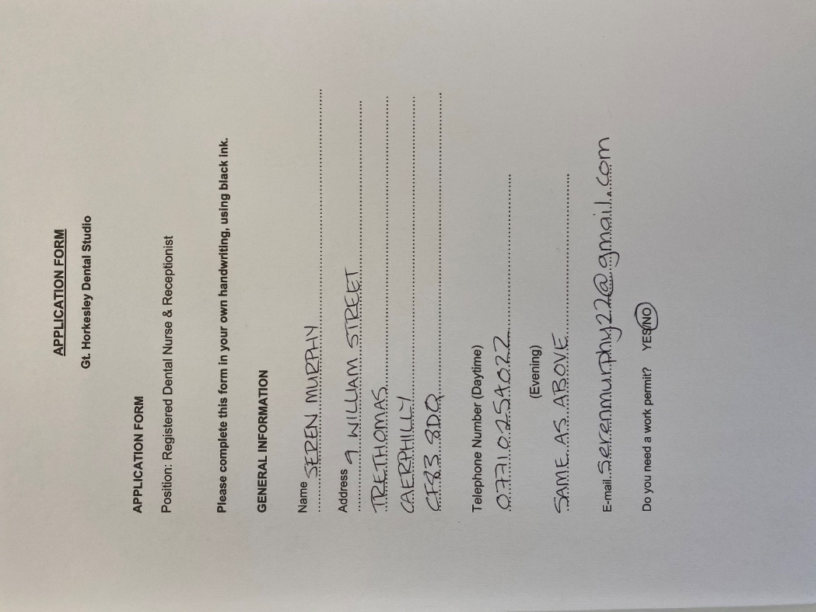

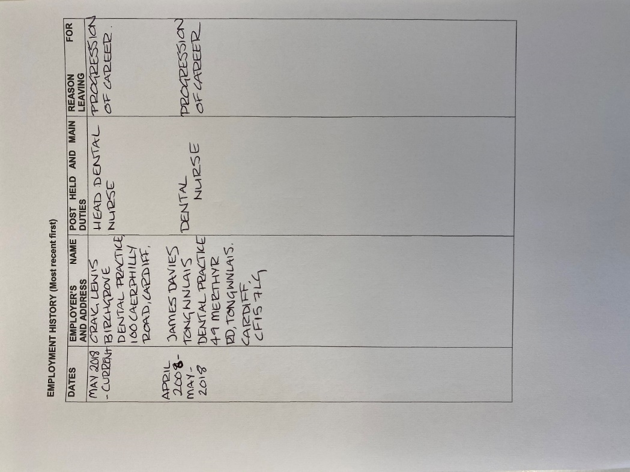
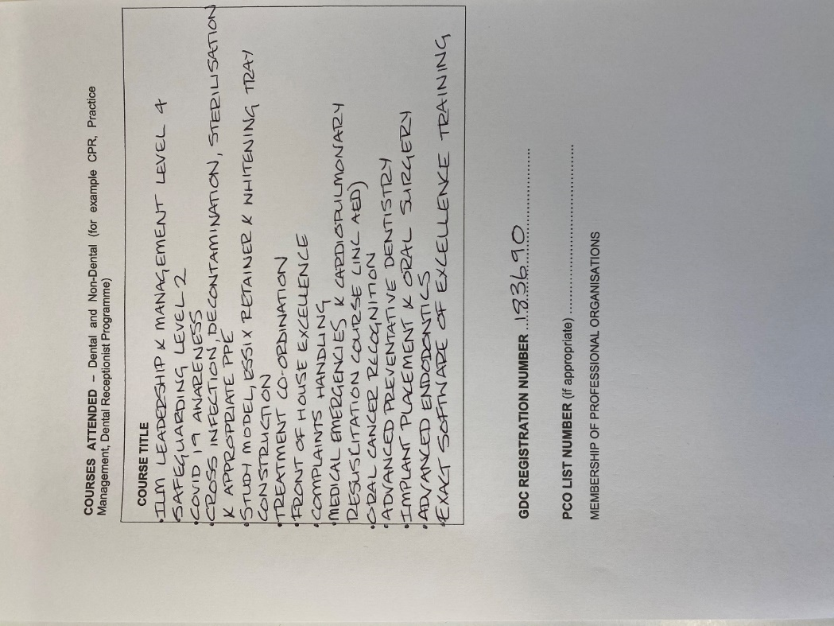

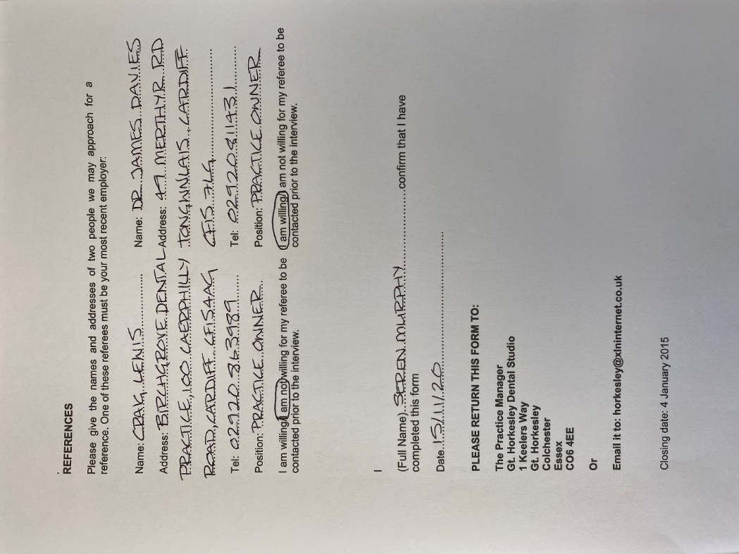
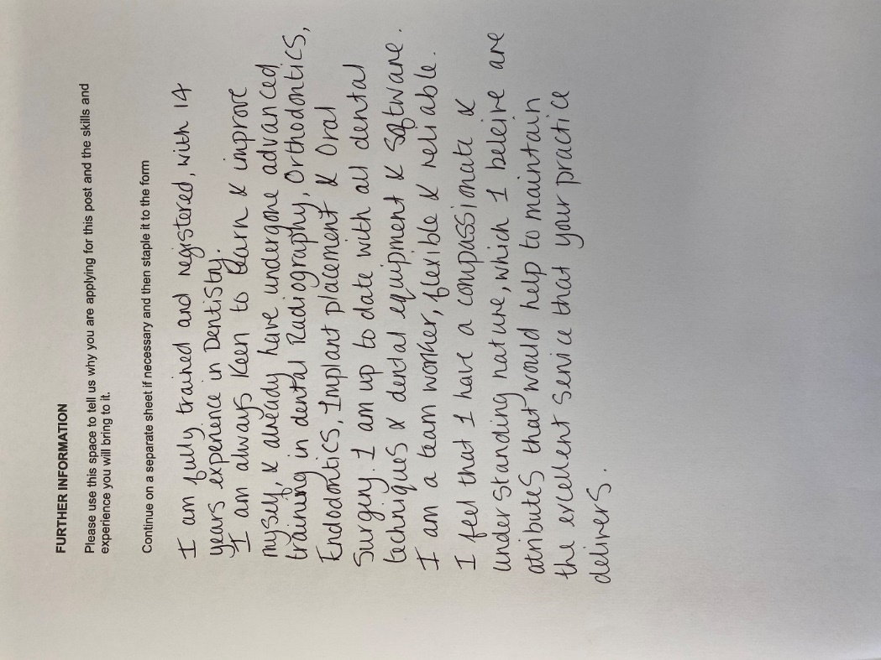

Appendix C
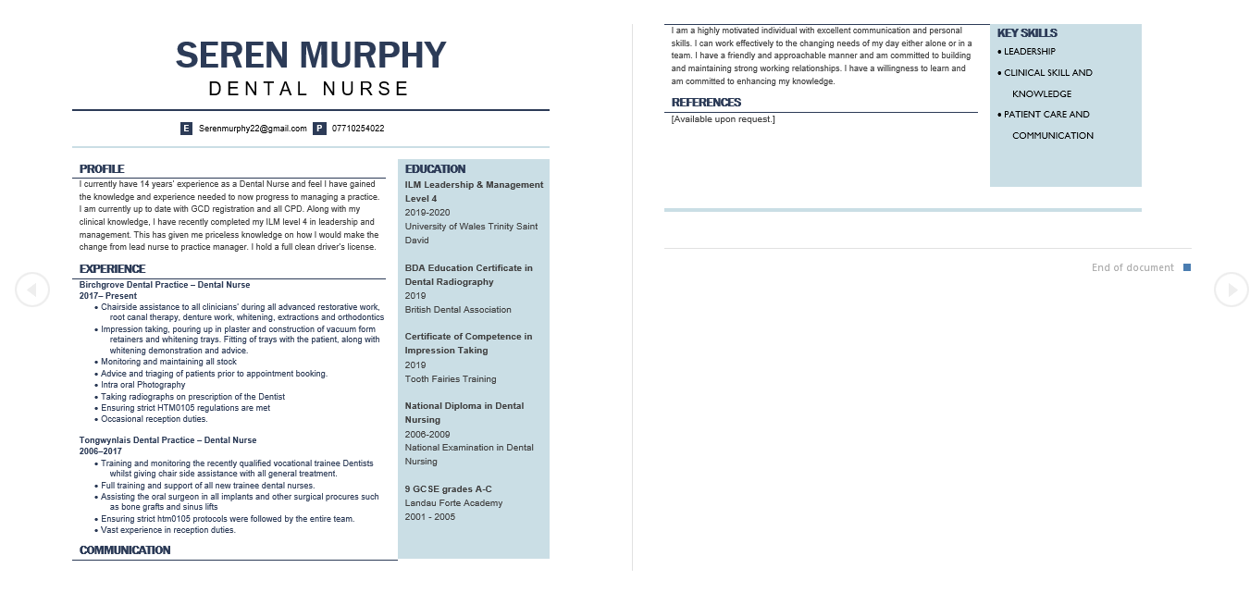

Appendix D



