October 2012
Delegates
Distributed Enterprise Applications
Tim Bashford

Delegates
A delegate provides a type-safe object oriented encapsulating pointer to at least one method or function. This allows for run-time decision making on called functions, and for functions to be invoked through passed parameters (known as callback).

A simple delegate

- Create a new Console application and name it SimpleDelegate
- Ensure the following Using statements are present:
using System;
using System.Collections.Generic;
using System.Linq;
using System.Text;

- Now create the following delegate as the first statements in the workspace:
//Declaration
public delegate void MySimpleDelegate(); //A simple delegate which takes no arguments and returns nothing (void).

- Add two methods:
public static void Function1() //Remember that a function accessed by a delegate must be static
{
Console.WriteLine("Called Function 1.");
}

public static void Function2()
{
Console.WriteLine("Called Function 2.");
}

- Modify the Main function:
MySimpleDelegate myDelegate = new MySimpleDelegate(Function1); //Instantiation

myDelegate(); //Invocation

myDelegate = Function2; //Re-instantiation

myDelegate(); //Second invocation

Console.ReadLine();

- Build and observe the output:
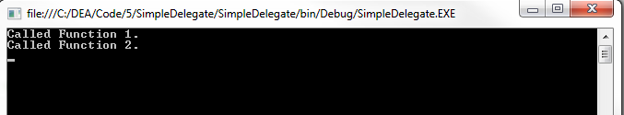

Notice that by re-instantiating the same delegate, two different functions have been called.

A simple delegate with callback
Callback implies the ability to pass a reference to executable code. This may be used to overcome a great deal of scoping and dynamic memory issues.
- Create a new Console application and name it CallbackDelegate
- Ensure the following Using statements are present:
using System;
using System.Collections.Generic;
using System.Linq;
using System.Text;
using System.IO;

- Create a class named Calculator and add a delegate to it which takes a float and returns nothing:
public delegate void WriterSelection(float num);

- Add the following method:
public void AddTwoNumbers(float num1, float num2, WriterSelection myWriter)
{
if (myWriter != null) //Ensure that the delegate references a method
{
float res = num1 + num2;

myWriter(res);
}
}

Note how the WriterSelection delegate is passed to the method as a parameter, the method sums the two numbers then calls the delegate method with the result. The power of this technique is that the AddTwoNumbers method and even the Calculator class have no idea (and do not need to know) the scope or class to which the delegate reference points.
- To the main (Program) class, add the following methods:
public static void NumWriterFile(float num)
{
FileStream fs = new FileStream("Output.txt", FileMode.Append);
StreamWriter sw = new StreamWriter(fs);

sw.WriteLine(num.ToString());

sw.Close();
fs.Close();
}

public static void NumWriterConsole(float num)
{
Console.WriteLine(num.ToString());
}

Note how both of these methods are acceptable matches with the WriterSelection delegate’s prototype, even though they exist in entirely different classes. Regardless of this, if a delegate pointing to either method is passed to Calculator.AddTwoNumbers, the AddTwoNumbers method can invoke it.
To access this functionality, the following code snippets could be used (full listing for obtaining data from the console in Appendix 1)
Calculator calc = new Calculator();

Calculator.WriterSelection myWriter;

myWriter = new Calculator.WriterSelection(NumWriterConsole);

OR
myWriter = new Calculator.WriterSelection(NumWriterFile);

calc.AddTwoNumbers(num1, num2, myWriter);

Note how your selection of myWriter’s reference is entirely irrelevant to the operation of AddTwoNumbers.

Multicast delegates
It may be desirable to call more than one function simultaneously. The + and - operators may be utilised to achieve this.
Write subtract, multiply and divide functions as part of the Calculator class:
public void SubTwoNumbers(float num1, float num2, WriterSelection myWriter)
public void MulTwoNumbers(float num1, float num2, WriterSelection myWriter)
public void DivTwoNumbers(float num1, float num2, WriterSelection myWriter)

Add a namespace scoped delegate for this prototype:
public delegate void MathsOperationDelegate(float num1, float num2, Calculator.WriterSelection myWriter);

Note that a delegate will support a prototype which itself contains a different delegate.
Instantiate this with the Add method:
MathsOperationDelegate mo = new MathsOperationDelegate(calc.AddTwoNumbers);

Use the += operator to add the other methods:
mo += calc.SubTwoNumbers;
mo += calc.MulTwoNumbers;
mo += calc.DivTwoNumbers;

And invoke:
mo(num1, num2, myWriter);

Note the output now displays the result of all four methods in order:
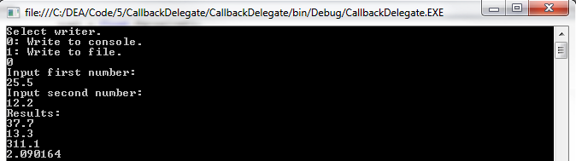
In a single invocation, four methods have been called. Note that this occurred in the order that they were added and was sequential, not simultaneous. The subtract method will not begin until the add method has finished, the multiply method will not begin until the subtract method has finished etc.
A method may be removed from the delegate by using the – operator:

Console.WriteLine("Results:");

MathsOperationDelegate mo = new MathsOperationDelegate(calc.AddTwoNumbers);

mo += calc.SubTwoNumbers;
mo += calc.MulTwoNumbers;
mo += calc.DivTwoNumbers;

mo(num1, num2, myWriter);

Console.WriteLine("Results after removal");

mo -= calc.AddTwoNumbers;
mo -= calc.SubTwoNumbers;

mo(num1, num2, myWriter);

Note that only the methods still referenced (multiply and divide) are called by the second invocation:
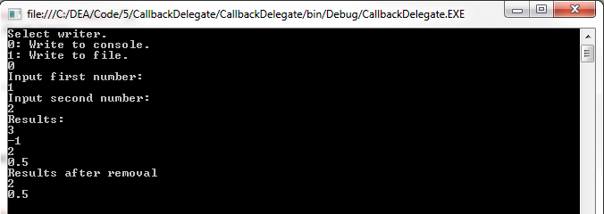

Exercise
- Add to the Calculator class the following functions:
public void SquareNumber(float num, WriterSelection myWriter);
public void CubeNumber(float num, WriterSelection myWriter);
public void SquareRootNumber(float num, WriterSelection myWriter);

- Implement these functions
- Create a second, appropriate delegate named MathsPowersDelegate. Consider that the function prototype
- Either replace entirely or add to the Main function to implement an appropriate test harness to test and demonstrate this code through the delegate.

Exercise
- Create a new Windows form application with the following controls:
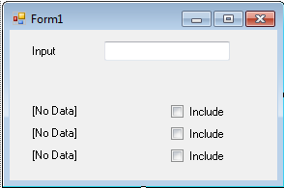
- Using a multicast delegate, implement a system whereby any text input in the text box is duplicated to a label for which the attached check box is checked. When the check box is checked, add the appropriate update method to the multicast delegate and when it is unchecked, remove it.
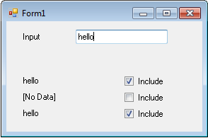
- Remember that an instance of a delegate must always reference a method, so removing every method from a multicast delegate will result in an error. Either limit your program to a minimum of one checked box or implement functionality to allow none through appropriate management of the instance. Hint: if no methods are referenced, you can set the instance of the delegate to null and call new on it again when it is needed.

Appendix 1
This code details how a menu system could be created to obtain a delegate selection and two floating point numbers from the console.
Calculator calc = new Calculator();

Calculator.WriterSelection myWriter;

while(true)
{
Console.WriteLine("Select writer.\n0: Write to console.\n1: Write to file.");
string ret = Console.ReadLine();

try
{
int selection = int.Parse(ret);

if (selection == 0)
{
myWriter = new Calculator.WriterSelection(NumWriterConsole);
break;
}
else if (selection == 1)
{
myWriter = new Calculator.WriterSelection(NumWriterFile);
break;
}
else
Console.WriteLine("Must select 0 or 1.");
}
catch
{
Console.WriteLine("Could not parse value");
}
}

float num1, num2;

while (true)
{
Console.WriteLine("Input first number:");
string ret = Console.ReadLine();

try
{
num1 = float.Parse(ret);
break;
}
catch
{
Console.WriteLine("Could not parse number:");
}
}

while (true)
{
Console.WriteLine("Input second number:");
string ret = Console.ReadLine();

try
{
num2 = float.Parse(ret);
break;
}
catch
{
Console.WriteLine("Could not parse number:");
}
}

calc.AddTwoNumbers(num1, num2, myWriter);

Console.ReadLine();

