

Ordinance, Munitions and Explosives

HNC Level 4

Academic Year 2024 - 2025

Jack Burden

Calorimetry Lab Report

October 2024

This thesis is submitted in partial fulfilment of the requirements for the HNC of OME
(NB. Remove if the degree award is based solely on examination of the thesis)

© UWTSD 2024. All rights reserved. No part of this publication may be reproduced without the written permission of the copyright owner.

Academic integrity declaration
I declare that:
- the thesis submitted has been written by me alone.
- the thesis submitted has not been previously submitted to this university or any other.
- that all content, including primary and/or secondary data, is true to the best of my knowledge.
- that all quotations and references have been duly acknowledged according to the requirements of academic research.
I understand that to knowingly submit work in violation of the above statement will be considered by examiners as academic misconduct.

Abstract
This report explores the Specific Heat of Aluminium, discussing the methods used to get a value as well as the chemical concepts relevant to calorimetry. Calorimetry is then linked to its use in the OME industry.

Table of Contents
Contents
Academic integrity declaration i
Abstract ii
1 Introduction 1
1.1 Aim and Objectives of the Experiment 1
1.2 Theory Relating to Calorimetry 2
2 Results 3
2.1 Observations and Key Findings 4
3 Discussion 6
3.1 Comparing the Results to Chemical Concepts 6
3.2 The Relevance of Calorimetry to OME 7
4 Conclusion 8
5 References 9
6 Appendix 10

Introduction

Aim and Objectives of the Experiment
The aim of the experiment was to determine the Specific Heat Capacity of an Aluminium Cylinder with a mass of 18.5g (grams). In order to establish this, the Heat Capacity of the Calorimeter was calculated.
The Hypothesis discussed prior to the experiment was that the energy required to raise the temperature of the Aluminium would be greater than 0. This conclusion was made as Aluminium does not increase in temperature without assistance from a heat source. If a heat source is supplying enough heat energy to the metal, in theory, the metal will increase its temperature.
The variables for this experiment were identified to be the volume of water and the mass of the metal as controls, the temperature of the water and the temperature of the metal as dependant and time as an independent. These conclusions were made as the control variables could effect the results if they were altered. The temperature of the water dissipated over time. Due to this, time has been identified as the independent variable as it effects other variables.
The equations that have been used to calculate the Heat Capacity of the Calorimeter and the Specific Heat of Aluminium can be seen below:
$$-Q_{hot-water}= Q_{cold-water}+ Q_{calorimeter}$$
$$Q_{calorimeter}= {HC}_{calorimeter}× ∆T_{calorimeter}$$
$$M_{metal}×C_{p metal}×∆T_{metal}= -(M_{water}×C_{p water}×∆T_{water}+ {HC}_{calorimeter}×∆T_{calorimeter})$$

Theory Relating to Calorimetry
The difference between Specific Heat Capacity and Heat Capacity is that Specific Heat relates to the Energy required for the temperature of 1g of a substance to rise by 1°C (Degrees Celsius). Whereas, Heat Capacity is the amount of heat required to raise the temperature of an object by 1°C [1]. The first law of Thermodynamics can also be applied to this experiment. The law states that energy cannot be created or destroyed, it can only be transferred between objects and their surroundings. “The first law of thermodynamics which explains the conservation of energy principle is expressed as follows: “Energy cannot be created out of nothing, only different forms can transform into one another”” [2]. Another law that could be applied to calorimetry is Newton’s law of cooling. “Newton’s law of cooling states that the rate at which an object cools is proportional to the difference in temperature between the object and the object’s surroundings.” [3]. In theory, Newton’s cooling formula could’ve been used to estimate the time at which the temperature of both the metal and the calorimeter are equal.

Results
Below is the results obtained when the Aluminium was placed into the calorimeter. The temperature of the water was measured over time as the hot metal would release its heat exothermically.

Time (s) | T water (°C)
0 | 21.1
10 | 21.3
20 | 21.3
30 | 21.4
40 | 21.6
50 | 21.9
60 | 22.3
70 | 22.5
80 | 22.5
90 | 22.5
100 | 23
110 | 23.1
120 | 23.4
130 | 23.6
140 | 23.7
150 | 23.9
160 | 24.2
170 | 24.3
180 | 24.8
190 | 24.9
200 | 25.1
210 | 25.3
220 | 25.7
230 | 26.1
240 | 26.3
250 | 26.4
260 | 26.4
Table 1

Observations and Key Findings
As shown in Table 1, the heat of the water rises over time after the heated metal is placed into the calorimeter. The results were taken until the temperature stagnated. After 70 seconds, the temperature stagnated at 22.5 °C for 20 seconds. As the temperature had only increased by 1.4 °C at this point, it was assumed that it would continue to increase over time, thus the measurements continued to be taken until a higher stagnation. If the temperature continued to be monitored after 260 seconds, the heat of the water could have increased to a higher temperature however, it was agreed that a temperature increase of 5.3 °C was sufficient enough to calculate the Specific Heat.
2.2 Calculations
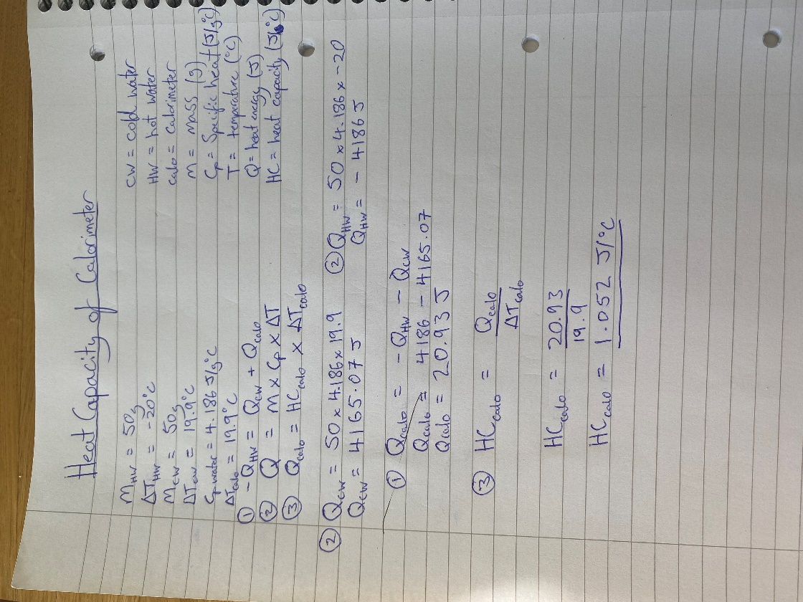
Before the Specific Heat of the Aluminium could be calculated, the Heat Capacity of the Calorimeter had to be determined.

Figure 1

Once the Heat Capacity of the Calorimeter was calculated, the Specific Heat of the Aluminium could be evaluated.
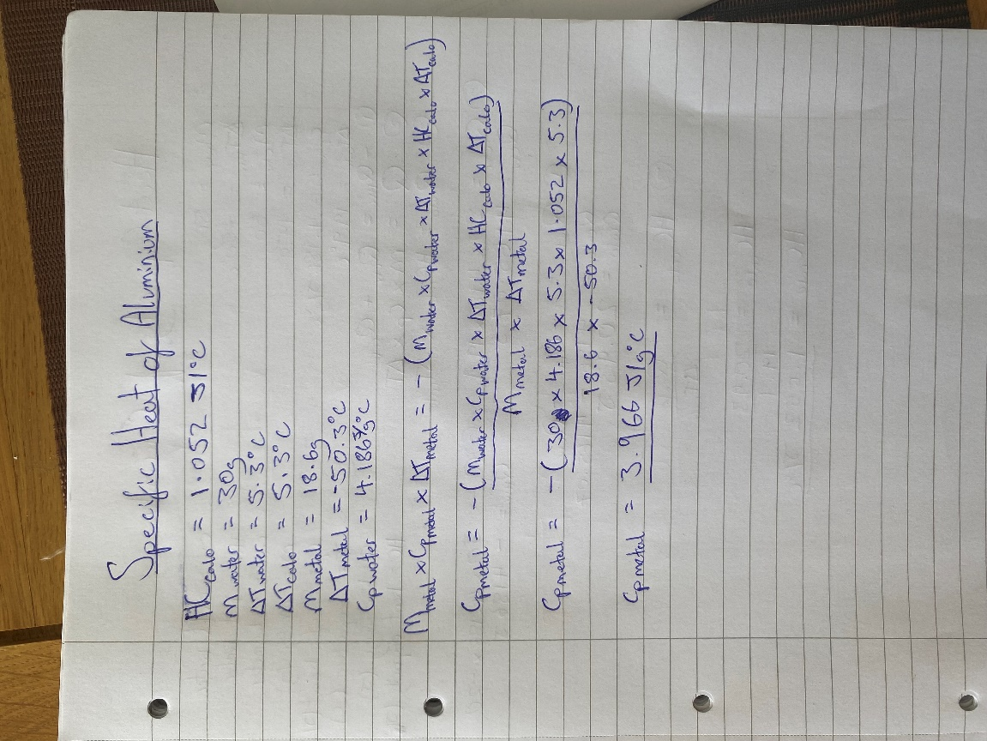
Figure 2

Discussion
After the calculations, it was determined that the Specific heat capacity of Aluminium was 3.966 J/g°C. This value is higher than that of the Specific heat capacity of Aluminium from other sources, they have measured it to be 0.921096 J/g°C [4]. This difference in specific heat could have been due to the heat capacity of the calorimeter being measured incorrectly. As seen in Figure 1, the heat capacity was measured to be 1.052 J/°C. The results taken for this calculation were only done once, increasing the chance of errors. The thermometer used during the measurements for the heat capacity only took the temperature to one decimal place, if the thermometer was more accurate, the results would follow suit. Alternatively, the source of error could’ve been the experiment itself, as they were only completed once to gather the results for both the heat capacity of the calorimeter and the specific heat of Aluminium. These potential sources of errors are the results of limitations. The biggest disadvantage was time. We only had a limited time to carry out the experiment in the lab and due to this, we could only undergo the test once.

Comparing the Results to Chemical Concepts
The first law of Thermodynamics states that the change in internal energy is equal to the difference between the heat added to the system and the work done by the system. This law is relevant to this experiment: the calorimeter is the system. Heat is being added to the system and the work done by the system is the slow release of heat exothermically. Alternatively, it can be applied to this experiment differently. As the metal is heated and then placed inside the calorimeter, the heat from the metal is released and absorbed by its surroundings (the calorimeter).

The Relevance of Calorimetry to OME
Calorimetry is used in the OME sector with the use of Calorimetric bombs. Calorimetric bombs are used to measure the heat exerted exothermically from a combustion. “A certain mass, m, of the substance to be burned is placed in a bomb of volume V, together with a small quantity of water. The bomb is then filled with oxygen at some pressure, p, and at some temperature, t, neither of which is standardized… The amount of this initial oxygen is from 3 to 10 times that which is consumed during the combustion. After the completion of the combustion, the system consists of a gaseous phase… and a liquid phase … these are the conditions for the combustion of substances which contain no elements other than carbon, hydrogen, and oxygen.” [5]. Calorimetric bombs are a useful tool for explosive engineers, however, it carries limitations. One of these is that the equipment cannot be used for explosives that do not undergo combustion, for example Nuclear Warhead. These types of ordinance get their energy from the rapid release of energy from splitting atoms (fission) or forcing atoms to form (fusion).

Conclusion
The results gathered from this experiment dictate that the specific heat of Aluminium is 3.966 J/g°C, whereas, other sources state that the actual specific heat is 0.921096 J/g°C [4]. It is evident that whilst undergoing the experiment something went wrong, whether that was due to the time limitations in the Lab or the degree of accuracy the apparatus, the experiment should be done again to get another value for the specific heat. Future research should be focused on how to successfully and consistently measure the specific heat of a substance in a short amount of time.

References

[1] LibreTexts, “LibreTexts libraries,” NICE CXone Expert, ns ns ns. [Online]. Available: https://chem.libretexts.org/Bookshelves/Introductory_Chemistry/Introductory_Chemistry_(CK-12)/17%3A_Thermochemistry/17.04%3A_Heat_Capacity_and_Specific_Heat#:~:text=%3B%20CK%2D12)-,Summary,substance%20by%201oC. [Accessed 17 10 2024].
[2] I. A. C. B. Sevim BEZEN, “Conceptual Comprehension of Pre-Service Physics Teachers,” Journal of Turkish Science Education, vol. 13, no. 1, pp. 55 - 75, 2016.
[3] “Carolina Knowledge Center,” ns, ns ns ns. [Online]. Available: https://knowledge.carolina.com/discipline/physical-science/physics/newtons-law-of-cooling/#:~:text=Newton's%20law%20of%20cooling%20states%20that%20the%20rate%20of%20heat,the%20object%20and%20the%20surroundings. [Accessed 17 10 2024].
[4] engineersedge, “engineersedge,” Engineers Edge LLC, ns ns 2000. [Online]. Available: https://www.engineersedge.com/materials/specific_heat_capacity_of_metals_13259.htm. [Accessed 17 10 2024].
[5] E. W. Washburn, “Standard States for Bomb Calorimetry,” Bureau of Standards Journel of Research, vol. 10, no. ns, pp. 526 - 558, 1933.

Appendix
Below is a step by step guide on the experiment used for this assignment:

To measure the heat capacity of the calorimeter
- Add 50mL of water to the calorimeter, close the lid. Add the thermometer and stirring rod.
- Measure the temperature of the water in the calorimeter.
- Take 50mL of water in a separate beaker and heat to 80°C. Stop heating and wait till the temperature decreases to 60°C. Record the temperature.
- Add the hot water to the calorimeter and mix thoroughly. Record the maximum equilibrium temperature of the mixture.
- Calculate the heat capacity of the calorimeter.
To measure the specific heat of Aluminium
- Weigh the metal and record the mass.
- Set up a water bath, heat the water until boiling, then carefully put the metal into it. Keep boiling for another 5 minutes. Avoid heating the metal directly.
- Add 30mL of water to the calorimeter, record the temperature.
- Once the metal has reached thermal equilibrium with the boiling water, measure and record the temperature of the hot water and quickly add the metal to the water in the calorimeter using tongs.
- Stir the water and record the temperature every 10 seconds. Continue to record the temperature until it has reached a maximum and then cooled by 2°C.
- Calculate the specific heat of the metal.

