
Balancing the Scales
Exploring the Impact of Work-Life Balance and Family Responsibilities on the Employment and Retention of Female Leaders in Cardiff, Wales
Elena Alexandra Moise (1908804) | 5/3/24 | UWTSD- MA Leadership

Declaration/Statements page

DECLARATION

This work has not previously been accepted in substance for any degree and is not being concurrently submitted as a candidature for any degree.

Signed .......Elena Alexandra Moise......................... (candidate)

Date ....03 May 2024..................

STATEMENT 1

This work is the result of my own investigations, except where otherwise stated.

Other sources are acknowledged by footnotes giving explicit references. A bibliography is appended.

Signed ............... Elena Alexandra Moise............... (candidate)

Date ............ 03 May 2024.

STATEMENT 2

I hereby give consent for my work, if accepted, to be available for photocopying and for inter-library loan and for the title and summary to be made available to outside organisations.

Signed ............. Elena Alexandra Moise......... (candidate)

Date ................ 03 May 2024.

Table of Contents
Abstract 5
Acknowledgements 9
Chapter I 10
1. Introduction 10
1.1 Background and context of the study 10
1.2 Contextual Background 11
1.3 Cardiff, Wales, as the research context 11
1.4 Socio-Cultural Factors 12
1.5 Socio-Economic Factors 12
1.6 Statement of the Research Problem 13
1.7 Key Components of the Research Question 13
1.8 Aims and Objectives of the Research. 13
1.9 Relevance of the research 14
1.10 Overview of the Dissertation Structure 15
Chapter II 16
2. Literature Review 16
2.1 Definition of Work-Life Balance 16
2.2 Work-Life Balance and Gender Equality 17
2.3 Factors Affecting Work-Life Balance 17
2.4 Female Leadership in Cardiff, Wales 18
2.5 Current Status of Female Leaders 18
2.6 Challenges Faced by Female Leaders 19
2.7 Importance of Retaining Female Leaders 19
2.8 Work-Life Balance and Female Leadership 20
2.9 Impact of Work-Life Balance on Female Leadership 21
2.10 Theoretical Frameworks 22
A. Role Theory 22
B. Social Exchange Theory 22
C. Border and Boundary Theory 22
D. Segmentation Theory 23
E. Spillover Theory 23
2.11 Theorists 23
2.12 Research Gap in Wales 24
Chapter III 26
3. Methodology 26
3.1 Introduction 26
3.2 Aim of research 26
3.3 Objectives 26
3.4 Principle of Methodology 26
3.5 Methodological Approach: Primary Research and its Implications 27
3.6 Research Paradigm 27
3.7 Introduction to Saunders’ Research Onion 27
3.8 Saunders’ Research Onion Conceptualisation 28
3.9 Understanding Saunders' Research Onion 28
Philosophy 28
Approach 28
Strategy 28
Choices 28
Time Horizon 29
Techniques 29
3.10 Layer Selection for Methodological Alignment 29
Research Philosophy- Interpretivism 29
Research Approach- Inductive 29
Research Strategy- Action Research 30
Complementary Data Collection Methods for Triangulation 30
Methodological Choice- Mixed Methods 31
Quantitative Research 31
Qualitative Research 31
Time Horizon- Cross-sectional 32
Techniques 32
3.11 Conclusion 33
CHAPTER IV 35
4. Data Analysis 35
4.1 Introduction 35
4.2 Aims and Objectives 35
4.3 Data Preparation 35
4.4 Quantitative Analysis 35
Demographic Profile- Descriptive Statistics 36
Emerging themes from quantitative data 36
Understanding 37
Conclusion 37
4.5 Qualitative Analysis 38
Introduction to the findings 38
Thematic Analysis 38
Narrative Presentation 39
Integration with Literature 40
4.6 Discussion of Implications 41
Chapter V 42
5. Discussion, Conclusions and Recommendations 42
Discussion 42
5.1 Introduction 42
5.2 Analysis and interpretation of qualitative findings 42
Theme 1: Work-Life Balance Strategies and Challenges 42
Theme 2: Organisational Support and Policies 42
Theme 3: Impact on Career Advancement and Retention 43
Theme 4: Personal Coping Mechanisms and Self-Care 43
5.3 Analysis and interpretation of quantitative findings 44
a. Impact on personal life 44
b. Levels of satisfaction 44
c. Inflexible work arrangements 45
d. Lack of awareness of resources 45
e. Lack of support from superiors 45
f. Limited emphasis on personal well-being 45
g. Impact on personal relationships 46
h. Strained personal relationships. 46
I. Underutilisation of flexible work arrangements 46
j. Impact of family responsibilities on career advancement 46
k. Consideration of leaving jobs 47
l. Dissatisfaction with maternity/parental leave policies 47
m. Delayed career progression 47
n. Guilt and conflict between roles 47
o. Perception of Policy Effectiveness 47
Conclusion 49
Recommendations 51
References 52
Appendix 61

Figure 1. Greenhouse and Beutell's Work-life Concept 62
Figure 2. Kossek's Framework 62
Figure 3. Role Theory 63
Figure 4. Social Exchange Theory 63
Figure 5. Border and Boundary Theory 64
Figure 6. Segmentation Theory 64
Figure 7. The distinction between Primary and Secondary Research 65
Figure 8. Saunder’s Research Onion 65
Figure 9. Layer Selection for Methodological Alignment. 66
Figure 10. Mixed-methods research 66
Figure 11. Survey Questions 67
Figure 12. Demographic Characteristics of the Female Leaders' Respondents. 68
Figure 13. Impact on Personal Life 68
Figure 14. Levels of Satisfaction 68
Figure 15. Inflexible Work Arrangements 69
Figure 16. Lack of Awareness of Resources 69
Figure 17. Lack of Support from Superiors 69
Figure 18. Limited Emphasis on Personal Well-being 70
Figure 19. Impact on Personal Relationships 70
Figure 20. Impact of Family Responsibilities on Career Advancement 70
Figure 21. Consideration of Leaving Jobs 71
Figure 22. Dissatisfaction with Maternity/Parental Leave. 71
Figure 23. Delayed Career Progression 71
Figure 24. Guilt and Conflict Between Roles. 72
Figure 25. Perception of Policy Effectiveness 72
Figure 26. In-depth Interview Respondent 1 72
Figure 27. In-depth Interview Respondent 2 74
Figure 28. In-depth interview Respondent 3 76
Figure 29. In-depth Interview Respondent 4 78
Figure 30. Qualitative Emerged Themes 82
Figure 31. Reflection on the research process and limitations 82
Figure 32. Data collection procedures 83

Abstract

This dissertation explores the Impact of work-life balance and family responsibilities on the employment and retention of female leaders in Cardiff, Wales. The research aims to investigate the challenges faced by female leaders in managing work and family commitments, understand the factors influencing their employment decisions and retention rates, and explore potential strategies for supporting female leaders in achieving better work-life balance.
This dissertation aims to critically examine and evaluate the utility of the Research Onion Framework within the context of the impact of work-life balance and family responsibilities on the employment and retention of female leaders. By interrogating its strengths, limitations, and practical implications, this study seeks to contribute to ongoing research methodology discussions and enhance the understanding of the topic.
This research structure follows a logical progression to explore and analyse the subject matter thoroughly:
The introduction chapter provides an overview of the research problem, objectives, and significance, setting the stage for the subsequent chapters.
The literature review delves into existing scholarly literature, theories, and empirical studies relevant to work-life balance, gender diversity, and organisational practices, providing a theoretical framework for the research.
The methodology chapter outlines the research design, data collection methods, and analytical approach, ensuring transparency and rigour in the research process.
The data analysis chapter presents the findings obtained from both qualitative and quantitative data sources, employing appropriate techniques to examine patterns, themes, and trends.
The study employs a mixed-methods approach, incorporating both quantitative surveys and qualitative in-depth interviews to investigate the experiences, challenges, and perceptions of women leaders aged 34 and over in managing their professional and personal lives and the impact of work-life balance and family responsibilities on the employment and retention of female leaders in Cardiff, Wales.
Using a qualitative research approach, in-depth interviews were conducted with female leaders from various industries in Cardiff, Wales. Thematic analysis was employed to analyse the interview data, revealing critical themes related to work-life balance, family responsibilities, career progression, and organisational support. Qualitative analysis of in-depth interviews provided nuanced insights into the lived experiences of female leaders, elucidating themes such as the complexity of work-family dynamics, the importance of organisational support, and the need for policy interventions. Participants expressed frustration with their companies' perceived lack of understanding and support regarding work-life balance concerns, highlighting the significance of fostering a supportive organisational culture. Moreover, the findings underscore the role of flexible work arrangements, family-friendly policies, and leadership training programs in facilitating work-life balance for female leaders.
The comprehensive findings obtained from qualitative and quantitative research methodologies were critical in facilitating the employment and retention of female leaders in Cardiff, Wales. Through a nuanced understanding of the challenges and opportunities encountered by female leaders, companies can tailor their policies and practices to support them better. Insights into work-life balance dynamics, perceptions of organisational culture, and barriers to career advancement provide valuable guidance for implementing targeted initiatives aimed at fostering gender diversity, promoting inclusivity, and supporting work-life integration. By addressing issues such as sexism, discrimination, and lack of support, organisations can create a more supportive and inclusive environment that enhances employment and retention among female leaders in Cardiff. Furthermore, offering flexible working arrangements, childcare support, and opportunities for career advancement not only aids in the recruitment and retention of female talent but also contributes to organisations' overall success and competitiveness in Cardiff, Wales.
Furthermore, the quantitative data analysis revealed significant work-family conflict among participants, with a majority reporting guilt or conflict between their professional and family roles. Dissatisfaction with organisational work-life balance policies, including maternity or parental leave, further highlights the need for supportive practices and interventions. Additionally, a notable proportion of participants indicate having to delay career progression or opt for less demanding roles due to family responsibilities, underscoring the impact on career advancement opportunities and organisational retention.
The discussion chapter critically interprets the findings about the research questions and theoretical frameworks, identifying implications and areas for further research.
The conclusion and recommendations chapter synthesises the key findings, offering insights into practical implications for organisations and suggesting recommendations for policy and practice to enhance the employment and retention of female leaders in Cardiff, Wales.
The implications of the research findings for theory, practice, and policy are discussed, emphasising the need for organisational interventions to address the work-life balance needs of female leaders. Recommendations include revising existing policies, promoting supportive organisational cultures, and implementing gender-equitable practices to foster inclusive and supportive work environments. By integrating insights from both quantitative and qualitative analyses, this study contributes to a deeper understanding of the challenges faced by female leaders in balancing work and family responsibilities. It provides actionable recommendations for promoting gender equity and supporting the retention of female talent in the workforce.
Finally, the key findings from the research have profound implications for the employment and retention of female leaders within organisations. Firstly, the identification of work-life conflict as a prevalent issue highlights the need for organisations to prioritise strategies that promote a better balance between professional responsibilities and personal life for female leaders. This could involve implementing flexible work arrangements, providing access to supportive resources such as childcare facilities, and fostering a culture that values work-life balance.
Secondly, the data revealed that dissatisfaction with organisational policies and limited support from superiors underscores the importance of creating inclusive and supportive work environments. Organisations must address systemic issues such as gender bias and discrimination to ensure that female leaders have equal opportunities for advancement and success. This may involve revising policies related to promotion, pay equity, and family leave to accommodate female leaders' needs better.
Additionally, the findings related to the impact of family responsibilities on career advancement highlight the need for organisations to adopt a more comprehensive approach to talent management. Providing opportunities for career development, mentoring, and leadership training tailored to the unique needs of female leaders can help mitigate the challenges associated with balancing work and family responsibilities. Moreover, initiatives to promote diversity and inclusion within leadership ranks can help address advancement barriers and enhance female leaders' retention.
Overall, the research's key findings underscore the importance of creating supportive work environments that enable female leaders to thrive and succeed. By addressing work-life balance, organisational support, and career advancement opportunities, organisations can enhance female leaders' employment experience and retention, contributing to greater gender diversity and equality in leadership roles.

Acknowledgements

I extend my heartfelt gratitude to the following individuals for their invaluable support and guidance throughout the journey of completing this dissertation:
Marie Pitson, for her unwavering support and guidance as the program coordinator, whose expertise and encouragement have been instrumental in shaping this research endeavour.
Daniella Hellyer, my esteemed supervisor, for her insightful feedback, scholarly guidance, and unwavering support throughout the dissertation process. Her expertise and mentorship have been invaluable in navigating the complexities of this research.
Radu Moise, my husband, whose unwavering love, encouragement, and understanding have sustained me through the challenges of academia. Your endless support and belief in my abilities have been the cornerstone of my success.
Thank you, Raul, my son, for your patience, understanding, and endless encouragement. Your presence has been a source of joy and inspiration, motivating me to strive for excellence in all endeavours.
My family, for their unwavering love, support, and understanding throughout this journey. Your encouragement and belief in my abilities have been a constant source of strength and motivation.
Friends and colleagues, thank you for your encouragement, support, and understanding during the highs and lows of the dissertation process. Your words of encouragement and belief in my abilities have been deeply appreciated.
All participants who took part in the survey, your willingness to share your experiences and insights have been invaluable to the success of this research. Your contributions have enriched the findings and added depth to the study.
Respondents, thank you for participating in the interviews and sharing your valuable insights and experiences. Your willingness to share your perspectives has been integral to the success of this research.
To all those who have contributed in ways large and small, your support and encouragement have been deeply appreciated and have made this dissertation possible. Thank you for being part of this journey.

Chapter I

1. Introduction

1.1 Background and context of the study
It is believed that women with family responsibilities are less dedicated to their careers and are less willing to take on the added pressures and responsibilities that come with higher-level positions such as promotions. When family responsibilities conflict with work, an employee may experience role strain, leading to job dissatisfaction and organisational turnover. This has obvious implications for the field of leadership, which is already facing a shortage and is in high demand for good leaders. However, while this is a common belief, more research needs to be done to investigate whether family responsibilities detract women from leadership positions and the effects of such duties on the employment and retention of female leaders (Padavic et al., 2019)
One of the crucial factors that hinder the progression and retention of female leaders is the work-family interface. While a good balance between work and family life is essential for all employees, it is more so for women aiming to advance to leadership positions. This is due to the nature of leadership, particularly in top and executive-level roles, typically associated with longer work hours, greater responsibility, and taking on a "company first" ethos. Therefore, women with family responsibilities may find such roles unappealing or that the incompatible demands of work and family can harm their well-being and job satisfaction (Halpern and Murphy, 2013).
The number of women entering employment is increasing, and evidence suggests that women are an underutilised source of talent in leadership positions in organisations. The upward career path for women, particularly those seeking leadership positions, has become more complex. Female leaders are undoubtedly critical to the success of any organisation, and it is, therefore, crucial to identify any barriers that hinder progression and address ways to retain female leaders ( Hewlett et al., 2014)
With the rise of work-related stressors, current interest in quality-of-life concerns, the expansion of work-life balance dialogues, and a desire for women to progress into senior leadership positions, clarifying how work and nonwork obligations are managed is an essential component regarding the career and leadership advancement of women (Asirvatham and Humphries-Kil, 2017). For employees, the integration, connection, and support between work and family roles can provide mutual opportunities and means for knowledge transfer, encouragement, growth, and cross-role contributions; however, overlapping role demands and responsibilities can also result in increased perceptions of work-life imbalance and work-family conflict (McMullan et al., 2018).

1.2 Contextual Background
Cardiff, the capital city of Wales, serves as a dynamic hub of economic, cultural, and social activity within the Welsh context. As a critical centre for commerce, industry, and governance, Cardiff is home to various organisations spanning various sectors, including finance, healthcare, education, and technology. The city's strategic location, vibrant urban environment, and robust infrastructure make it a prominent regional centre for business and innovation (Lyons, 2022).
Within this context, the issue of female representation in leadership roles has emerged as a significant area of concern and focus. Despite progress in recent years, women remain underrepresented in senior management and executive positions across many Cardiff industries and organisations, reflecting broader global trends. This underrepresentation underscores persistent barriers and challenges women face in advancing their careers and accessing leadership opportunities (Mattis and Burke, 2013).
At the heart of these challenges lies the complex interplay between work-life balance and family responsibilities, disproportionately affecting women, particularly those in leadership positions. Balancing professional responsibilities with caregiving duties, household obligations, and other familial roles presents unique challenges for female leaders, often resulting in heightened stress, burnout, and difficulty maintaining career momentum (Jones, 2012)
Moreover, societal expectations, organisational cultures, and structural barriers may exacerbate these challenges, perpetuating gender disparities in leadership representation and hindering the retention and advancement of female talent. Traditional notions of leadership and workplace norms may reinforce gender stereotypes and impede women's ability to navigate career progression while fulfilling familial obligations (Smith and Sinkford, 2022).

1.3 Cardiff, Wales, as the research context
Cardiff boasts a diverse and thriving economy, with key sectors including finance, healthcare, education, technology, and creative industries. The city serves as a hub for business and commerce, attracting multinational corporations, startups, and SMEs. Economic growth and investment in Cardiff have led to job creation and opportunities for career advancement, particularly in managerial and leadership roles (Waite, 2015). Moreover, Cardiff's organisational landscape comprises a diverse range of public, private, and third-sector organisations spanning various industries and sectors, which vary in size, structure, and mission, with opportunities for employment and career advancement across different sectors. The presence of multinational corporations, government agencies, and local enterprises offers a unique context for studying organisational dynamics and leadership practices (OECD, 2001)
Cardiff, Wales, offers a dynamic and multifaceted research context for exploring the intersection of work-life balance, family responsibilities, and female leadership. Its diverse economic landscape, cultural vibrancy, educational institutions, organisational diversity, and governance structures provide a rich and complex backdrop for investigating the employment and retention of female leaders within the local context (Yousafzi et al., 2018).

1.4 Socio-Cultural Factors
Socio-cultural factors significantly shape attitudes, perceptions, and practices related to work-life balance and female leadership in Cardiff. Understanding these factors is crucial for addressing gender disparities, promoting diversity, and fostering inclusive workplaces (Blithe, 2015).
Traditional gender norms and expectations may influence perceptions of work and family roles, emphasising women's caregiving responsibilities. Societal expectations regarding women's roles as primary caregivers may intersect with professional aspirations, leading to challenges in balancing career advancement with family commitments (Blair-Loy, 2009).
Cardiff's cultural attitudes towards work and family life impact individuals' decisions regarding work-life balance and career progression. Cultural values emphasising familial obligations and community support networks may shape individuals' prioritisation of family responsibilities alongside professional goals (Lewis et al., 2017)
Organisational culture shapes work-life balance policies and practices within Cardiff's workplaces. Supportive organisational cultures that value flexibility, work-life integration, and gender equality can facilitate female leaders' ability to effectively manage work and family responsibilities (Cardiff et al., 2020).
The availability of family-friendly policies and support resources, such as flexible work arrangements, parental leave, and childcare facilities, can significantly impact female leaders' work-life balance in Cardiff. Access to supportive policies and resources may vary across organisations and sectors, influencing female leaders' decisions regarding career advancement and retention (Warr, 2011).

1.5 Socio-Economic Factors
Socioeconomic factors, such as income levels, educational attainment, and access to affordable childcare, may influence female leaders' ability to balance work and family responsibilities. Socioeconomic disparities within Cardiff's population can impact access to resources and opportunities for career advancement among female leaders from different socio-economic backgrounds. Access to supportive networks, mentorship programs, and community resources can play a crucial role in supporting female leaders' work-life balance efforts. Professional networks, peer support groups, and community organisations may provide valuable resources and social support for female leaders navigating work and family dynamics (Adisa et al., 2021).
By considering these factors, stakeholders in Cardiff can develop targeted interventions and policies to support female leaders in achieving work-life balance and advancing their careers. Creating a culture of inclusivity, gender equality, and support for work-life integration is essential for fostering a more equitable and sustainable professional landscape in Cardiff (Conley and Page, 2014).

1.6 Statement of the Research Problem
In today's complex and rapidly changing work environment, balancing professional responsibilities and personal life has become a critical concern for employees across all levels of organisations. For female leaders, who often juggle multiple roles and responsibilities at work and home, navigating the demands of work-life balance (WLB) and family responsibilities presents unique challenges that can significantly impact their employment opportunities and retention within organisations. Understanding the intricate interplay between work-life balance, family responsibilities, and the career trajectories of female leaders is essential for promoting gender equity, fostering organisational diversity, and enhancing workplace retention efforts (Eagly and Carly, 2007).
The research problem for this dissertation is to investigate the impact of work-life balance and family responsibilities on the employment and retention of female leaders in Cardiff, Wales. Specifically, the study aims to address the following research question: "What impact do work-life balance and family responsibilities have on the employment and retention of female leaders in Cardiff, Wales?"

1.7 Key Components of the Research Question
The research question acknowledges the importance of work-life balance as a critical factor influencing the experiences of female leaders in the workplace. Work-life balance encompasses managing and reconciling work demands with personal life, including family responsibilities, leisure activities, and individual well-being (Lewis and Cooper, 2005).
Furthermore, recognising the significant role that family responsibilities play in shaping the experiences of female leaders, the research question explicitly focuses on family-related duties, such as caregiving responsibilities, household chores, and other familial obligations. Understanding how family responsibilities intersect with work responsibilities is essential for gaining insights into female leaders' challenges and opportunities in balancing their professional and personal lives (Rizzo et al., 2018).
Finally, the research question underscores the importance of assessing the impact of work-life balance and family responsibilities on female leaders' employment decisions and retention rates within organisations. By examining how these factors influence career advancement opportunities, job satisfaction, and turnover intentions, the research aims to provide valuable insights into the retention and advancement of female leaders in the workforce (Weber and Cissna-Heath, 2015).

1.8 Aims and Objectives of the research.
The objectives of this study are multifaceted, aiming to address the complex interplay between work-life balance, family responsibilities, and female leadership in Cardiff, Wales. Firstly, the study seeks to investigate the impact of existing work-life balance practices and policies within Cardiff-based organisations on the career trajectories of female leaders. Understanding how these practices shape the professional journeys of women in leadership positions is critical for identifying areas of improvement and implementing effective strategies to support their advancement (Flechl, 2010).
Secondly, this study aims to identify and examine the challenges faced by female leaders in balancing their professional responsibilities with family obligations within Cardiff's professional landscape. By exploring the difficulties and barriers women encounter in leadership roles, the study sheds light on the factors hindering their ability to achieve optimal work-life balance and career fulfilment (Information Resources Management Association, 2021).
Furthermore, the study seeks to explore the strategies employed by female leaders to navigate work-life balance and family responsibilities within Cardiff-based organisations. By examining the coping mechanisms, negotiation strategies, and support networks women use in leadership roles, the study aims to uncover effective practices and lessons learned that can inform organisational policies and practices (Weber and Cissna-Heath, 2016).
Additionally, this study endeavours to assess the multifaceted impact of work-life balance and family responsibilities on the employment and retention of female leaders in Cardiff, Wales. By conducting a comprehensive analysis, the study aims to elucidate the complex interplay between personal and professional obligations faced by female leaders in Cardiff, Wales. Through a rigorous examination of qualitative and quantitative data, the research seeks to uncover the challenges, opportunities, and dynamics influencing female leaders' employment trajectory and retention rates within organisational contexts. By evaluating the factors contributing to job satisfaction and career advancement, the study provides valuable insights to enhance female leaders' retention in Cardiff, Wales (Yu, 2009).

1.9 Relevance of the research
From a sociological perspective, many previous studies of women's employment have been conducted within a framework of role conflict and multiple role occupancy. It has been argued that traditional social science models assuming that women's primary role is family are inadequate to explain women's work behaviour (Crompton and Harris, 1998). An alternative explanation is that employment decisions are often made from an 'economic rationality' perspective, particularly for a second job or a job taken by a married woman. This research will show that career decisions do not necessarily reflect a preference for paid work over family and may reflect the centrality of family in determinations of job type and duration. This has implications for current and future labour market structures with an increasingly female workforce, job opportunities, and legislation in some sectors, which may need to be designed to accommodate family preferences and avoid excessive job demands (Ballout, 2008).
The significance of this research to the selected groups is threefold. Firstly, for an academic audience in employment and organisation, it will add to the knowledge of an under-researched area. Previous works have suggested that significant employment and career choices are often made around marriage and childbearing, for example, entry to and exit from full-time work or withdrawal from training and development opportunities (Kahn et al., 2014). This supports the logic of exploring career decisions via critical events or transitions. It is posited that extended coverage of employment decisions will complement current psychological literature on work motivation, which tends to neglect the process of choosing jobs or careers (Davidescu et al., 2020).
The topic of "Exploring the Impact of Work-Life Balance and Family Responsibilities on the Employment and Retention of Female Leaders in Cardiff, Wales" stands at the nexus of these pressing issues. This introduction aims to underscore the relevance and significance of this research topic within both societal and organisational contexts.
The relevance of this research topic is evident in the persistent challenges women face in leadership positions, not only in Cardiff but also globally. Despite advancements in gender equality initiatives, women continue to encounter obstacles related to work-life balance and family responsibilities, which hinder their career progression and retention in leadership roles. Understanding the intricacies of these challenges is crucial for addressing systemic barriers and fostering a more equitable landscape for female leaders (Field et al., 2023).
The significance of this research topic extends beyond individual experiences to organisational performance and societal well-being. Work-life balance directly impacts employee satisfaction, productivity, and organisational success. By exploring how work-life balance and family responsibilities influence the employment and retention of female leaders, this research sheds light on critical factors that shape organisational effectiveness and sustainability (Beauregard and Henry, 2009).
The economic implications of gender disparities in leadership roles underscore the importance of this research topic. Closing the gender gap in employment and leadership positions can drive economic growth, enhance productivity, and promote innovation. By examining the impact of work-life balance on female leadership, this research contributes to broader discussions on financial prosperity and social progress (Duflo, 2012)
The research topic is significant for advancing social justice and equity. Societal norms, organisational policies, or cultural expectations should support women's ability to balance work and family responsibilities. By exploring female leaders' challenges in achieving work-life balance, this research aims to challenge existing norms and advocate for more inclusive and supportive environments for women in leadership roles (Madsen, 2024).

1.10 Overview of the dissertation structure
The overview of the dissertation structure for exploring the impact of work-life balance and family responsibilities on the employment and retention of female leaders in Cardiff, Wales, serves as a concise guide outlining the organisation of the research. It provides readers with a brief preview of the main chapters and sections and their respective roles in the study. This overview includes key components: introduction, literature review, methodology, empirical findings, discussion, and conclusion. The overview will help readers navigate the research and anticipate the content covered in each section by presenting a succinct summary of the dissertation's structure (Kornuta and Germaine, 2019).

Chapter II

2. Literature Review

The review of literature on work-life balance signifies different connotations to different people. Its disagreement by individuals from academics, professional groups, and trade unions reflects broad concern about what is happening to the world of work. At one level, the literature on work-life balance and family responsibilities serves to provide an extended understanding of the nature of work and family today, how this has changed since historical times, and under what circumstances changes of benefit can be made so that women and men more easily combine employment with other aspects of their lives (Kalliath and Brough, 2008)
Structural or macroeconomic changes in the economies of many countries entail changes in the form and content of jobs. Still, changes are complex and varied in their impact on people's lives. A second contribution comes from the vast body of research on role strain and accession from numerous disciplines, which considers the work/life interface in terms of the impact of one set of roles on another, usually work on family and employment's implications for health and family functioning (Autor, 2015).

2.1 Definition of Work-Life Balance
The term "work-life" can be taken in terms of employment and non-employment activities, or it can be perceived as the perceptions of how one dedicates one's time and energy to these activities. The definition distinguishes between the two forms of work-life, suggesting that "organisational efforts to assist employees in managing work and non-work demands may result in employees dedicating more time and energy to work or family depending on the preference" (Gragnano et al., 2020).
Kirchmeyer (2000) defines work-life balance (WLB) as the achievement of fulfilling experiences in distinct aspects of life that require various resources, like energy, time, and commitment, which are spread across all domains.
Researchers have suggested that the construct "balance" is important because it emphasises satisfactory fulfilment and an absence of role conflict. Work-life balance is an adequate level of involvement or "fit" between the multiple roles in a person's life, involving properly prioritising work (career and ambition) and lifestyle (health, pleasure, leisure, family) (Shields, 2019).
Individuals can define the balance between work and personal life differently. The proper definition depends very much on the person's values, attitudes, situation, and, importantly, their individual and family needs. For example, the needs of a young single employee will differ from those of the person who is the primary caregiver for an elderly or disabled family member ( Jayasingam et al., 2023).
Seminal works by Greenhaus and Beutell (1985) introduced the concept of work-life balance, emphasising the interplay between work and personal life domains (Figure 1). Their framework highlights the importance of balance for individual well-being and organisational outcomes. At the same time, contemporary research by Kossek et al. (2013) extends this framework to encompass diverse life domains, emphasising the need for organisations to adopt flexible policies that accommodate employees' multifaceted responsibilities (Figure 2).

2.2 Work-Life Balance and Gender Equality
Economic activity in the United States is evenly divided between men and women. According to the U.S. Bureau of Labor Statistics (2021), the workforce comprises 51 per cent women and 49 per cent men. This has not always been the case in the United States, and the period after World War II marked the shift in female employment. During this time, more married women were entering the workforce. Young, single women had always worked before to save money for marriage or to further their education. This began the movement of a more significant female labour force. This movement has further developed over the years into what it is today. With increased numbers of women entering the workforce and taking on vital leadership roles, there have been many changes in the work environment to accommodate this. The ability to balance work and family has become an essential issue in the United States, and it often serves as an obstacle for female leaders (McCarthy, 2016).
Studies by Shockley et al. (2017) and Allen et al. (2013) underscore gender disparities in work-life balance, revealing that women, particularly those in leadership positions, experience more significant conflict between work and family roles compared to men, while Harris and Estevez (2017) research highlights societal expectations and gendered norms as substantial contributors to this disparity, perpetuating inequitable distributions of domestic responsibilities.
A study conducted by Hill et al. in 2001 found a gender difference in the capacity to oversee high-level responsibilities in family life. Most female leaders avoided some types of professional advancement because they were concerned about their ability to manage familial and work commitments. The perception is that work is a deterrent to family life and that family life can be a deterrent to work. In many instances, leaders need help managing both and often choose family over work or work over family. This can be said for both men and women, but it is more relevant to female leaders, who statistically have primary care responsibility for children. In 2010, the Information Resources Management Association found that the work-family conflict was a significant problem for women executives compared to men. This has led to changes in the work environment to better balance work and family life.

2.3 Factors Affecting Work-Life Balance
Factors that can affect work-life balance are multifarious. Broadly, they can be seen as internal or external to the individual. Rosen et al. (1990) reviewed the literature on antecedents to using family-friendly policies. They re-categorized existing theory into a five-factor model and assessed this using a structural equation model. Although their data supported the hypothesis that family-friendly policy usage is a mediating factor between work-family policy and organisational commitment, the household and individual factors that they evaluate against the model reflect our definition of work-life balance and the factors that affect it.
Notable interventions, such as flexible work arrangements and childcare support, have shown promise in mitigating work-life conflicts for female leaders. However, challenges persist in implementing and sustaining these initiatives, as organisational cultures and managerial support play pivotal roles in their effectiveness (Shockley et al., 2017).

2.4 Female Leadership in Cardiff, Wales
The recent assembly government has shown commitment to the cause of female leaders in Wales, particularly within the Cardiff market. The qualitative expansion of public services in devolved areas has allowed more female leaders to excel in previously male-dominated areas. The prospect of free prescriptions has opened doors of opportunity for leading roles in health sectors, and the same can be said for education and an array of other public services. Retaining these female leaders is of paramount importance if Wales and Cardiff are to continue onwards with their development. The benefits of maintaining these female leaders will be highly cohesive to the economy and society of Cardiff, as one of the plentiful issues with today's families is the work-life balance and family responsibilities ( Remke, 2018).
Female leadership is a crucial determinant of a nation's inherent market prospects. A precarious balance exists in the value of female leaders in the UK market today, most significantly in the context of devolved nations (Ibarra et al., 2013). A recent case study of female leaders in broader terms of Wales, done by the Welsh Government in 2016, stated that work-life balance was a vital issue for all these women, and the stressful career route did not coax future leaders to take the path to senior positions. In better facilitation of work-life balance, families and future leaders will benefit from the presence of more female leaders in Cardiff who will feel that senior government jobs are more accessible and less taxing.
The National Assembly for Wales provides cogent endorsement of equal opportunities policies, yet some uncertainty shadows the current status of female leaders in Wales. This is particularly true within Cardiff, a cosmopolitan contemporary town that aspires to have high economic standing within the Welsh and UK markets (Welsh Government, 2020).
A report published by the Equal Opportunities Commission 2005 stated that despite recent progress in equal opportunities for men and women, there were many differences between their employment and experience. A distinct pay gap exists, and more women with power and influence must be represented, particularly in senior management positions and political life (Gov. UK, 2005).

2.5 Current Status of Female Leaders
Research based on a survey of all headteachers in Wales and interviews with a representative sample of 48 respondents revealed that progress was being made in increasing the number of women headteachers as they were proportionally represented when looking at the number of deputy headteachers. However, women headteachers tended to be at the primary level, with far fewer in secondary or special schools. They also tended to be in smaller schools, often in the independent sector. Regarding career progression, it was found that female and male headteachers had distinct patterns in how they achieved headship. Women tended to have less headship experience and to have been a head in fewer schools. They were more likely to have experienced failure in a headship appointment. Although these results could be interpreted as women being appointed head at a younger age, the findings in interviews with women headteachers suggested that these patterns had more to do with women being unable to obtain their desired posts due to a lack of opportunity or support. This was particularly true when comparing the experiences of male and female headteachers under 50, where the current headship generation of women felt that they were facing the most significant barriers in their young ambitions (Owens, 2009).

2.6 Challenges Faced by Female Leaders
Leadership was perceived as a male domain. Although it was agreed that the "mix" of leadership was likely to change in the future, leadership in public services was described as mainly white, middle-aged, and male. Female leaders often had to be 'more male than men' in their behaviour and leadership style. They were likely to suffer a dilemma when enacting leadership – being criticised for being too 'male' and not being 'masculine' enough. This could be seen as both a cause and effect of women being underrepresented in leadership. Often, those who did not conform to the 'token' leadership style were likely to face detractors in their bid for promotion. The 'glass ceiling' was also a critical concern, with women appearing constrained to the lower senior management levels (Sharma and Kaur, 2014).
This has implications for the career progression of female leaders and those aspiring to leadership. A lack of role models has also been deemed an issue, and it was suggested that this may make it difficult for women to imagine themselves in leadership positions. Additionally, it was noted that an over-emphasis on careers for women in leadership could have implications and a recent fielding among those who have opted out of senior management suggested that role theory can still be argued to have relevance in the context of women leaders who are expected to act in a certain way as 'ideal workers' at the expense of their family (Sealy and Singh, 2008)

2.7 Importance of Retaining Female Leaders
Retaining female leaders in Cardiff is essential due to the excessive costs involved with turnover and the difficulties involved in getting into such positions in the first place. Turnover of employees with leadership roles can be costly as replacing them costs around 150% of an employee's annual salary (Lunau et al., 2014). This is due to the time spent on the 'hidden tasks' of recruitment and selection, the fact that successful replacements rely on the cost of the new employees' learning curve, and the potential loss in productivity (Pilbeam and Corbridge, 2010).
A recent study of employees in police forces in the UK revealed that the reasons for women leaving their positions were similar to the work/family conflicts hindering their progression to leadership roles. If there is no support for women with such conflicts, those in leadership roles may step down to a lower level, thus suggesting that support for work-life balance is just as important as female leadership itself (Heaton, 2012).
The underrepresentation of female leaders means that those in such positions are valuable role models. This is essential to inspiring the next generation of potential leaders (Eagly and Carli, 2007) and is crucial to reducing the gender leadership gap. Women have often struggled to gain access to male role models due to occupational segregation, and it seems likely that this may also be the case at the leadership level. A literature review on leadership in the public sector has suggested that mentoring can be an essential tool for women to progress to higher levels and enhance their overall career experience (Healy and Ogle, 2009). Given the proven rapid increase in the number of female leaders in recent years, it can be postulated that if female leaders can be effectively retained, the increased access to them as mentors will create a positive cycle for the progression of women to leadership roles.

2.8 Work-Life Balance and Female Leadership
There is now a large body of evidence to suggest that a conflict between work and family is a significant social problem, and obstacles to combining work and family have a substantial impact on women's careers, the gender gap in pay and promotion, and also on the general underrepresentation of women in positions of leadership. At the most simplistic level, it has been argued that women with family commitments are less able or unwilling to put in the hours and take on the responsibilities required of leadership positions. This has been referred to as the 'ideal worker norm', where the archetype of the ideal worker is entirely devoted to their work role and is always available for work due to not having any conflicting obligations (Bhatia, 2023).
Because women are most commonly the ones with family commitments, they are seen as less suitable for leadership roles. In 2015, LeanIn.Org and McKinsey and Company launched a study that found that women and men experience time famine and work-life conflict. Still, women are more likely to downshift their careers or opt out of senior roles to improve their work-life balance. This has implications not only for the representation of women in leadership but also for their career trajectories and advancement.
Studies by Allen et al. (2015) and Shockley et al. (2017) underscore gender disparities in work-life balance, revealing that women, particularly those in leadership positions, experience more significant conflict between work and family roles compared to men, while Choi and Kim (2019) research highlights societal expectations and gendered norms as substantial contributors to this disparity, perpetuating inequitable distributions of domestic responsibilities.
Nelson and Quick (2013) have suggested several work characteristics commonly associated with leadership roles that can interfere with family life, such as long hours, high work overload, time pressure, and role complexity. This argument suggests that such work characteristics may detract women from taking on leadership or continuing in such roles. Whitlow et al. (2012) have found that women with work roles that interfere heavily with family reported higher work-family conflicts, lower life satisfaction, and higher intentions to quit their jobs.

2.9 Impact of Work-Life Balance on Female Leadership
Research by Byron (2005) and Powell and Mainiero (1999) suggests that work-life balance challenges can influence female leaders' career decisions, with many opting out of high-level positions due to unsustainable demands. Conversely, findings by Thompson (2008) indicate that effective work-life balance initiatives positively impact female leaders' job satisfaction and commitment, contributing to organisational retention.
Measures taken to provide flexible work arrangements and aid female leaders facing a work-family role conflict will inevitably improve work-life balance. Future initiatives can be objectively measured for their impact on female leaders' QWL. Steps taken to improve work-life balance for female leaders have immense potential for addressing the sex difference in QWL and improving the health and well-being of female leaders (Brue, 2018).
Female leaders who have participated in a study to identify work and family life patterns reported strained work and family role experiences due to unmet family demands. This has diminished subjective well-being, high turnover, and reduced female leaders' employment and general health. Any intervening or moderating effects of family-responsive resources on the relationship between work requirements and work and family role experiences and how this relates to health and well-being will need to be an area of future research. This is to gauge the quality-of-life experiences of female leaders and how best to improve them. These results can be compared to male leaders, showing that female leaders have much to gain from helpful family-supportive resources (Begum et al., 2024)
Work-life balance is essential if sex differences in quality of work life (QWL) are to be considered. It is well documented that women experience work and family role conflict more than men. This is particularly more stressful for women in leadership positions. The conducting of a leadership role is very demanding, and the role of a nurturer and caretaker is still predominantly assigned to women in this role and functionary roles. The nature and context of the female leader's dual roles of leader and nurturer create both enhancing and depleting experiences (Easton and van Laar, 2018).
This study aims to systematically review the existing literature and develop an understanding of work-life balance (WLB). Recent leadership research has highlighted women’s struggles with work-family balance, gender bias cultures, and the expectations of women to assume status quo leadership approaches (Ely et al., 2011). Women can better develop their unique leadership identity and successfully address their leadership role obligations when they learn from and experience supportive environments and are offered opportunities to balance their diverse obligations (Brue and Brue, 2018). Organisations which use gender-diverse leadership and work-life balance interventions report a multitude of benefits, including improved performance, organisational branding, and perceptions regarding organisational attractiveness by internal and external stakeholders (Kalysh et al., 2016).
Connecting work-life balance practices with leadership education allows further exploration of how these dynamics help or hinder women’s leadership development. Place and Vardeman-Winter (2018) conclude that “more exploratory research is needed regarding how work-life balance affects leadership, how gender affects such support and how much support influences women’s leadership trajectories.

2.10 Theoretical frameworks
WLB as a concept has been taken up by organisations and human resource departments across the board, and many policies and strategies have been formulated to alleviate the conflict between the domains of work and life. On the theoretical front, various theories have been propounded since the 1990’s. Starting with a generic but intuitive Segmentation theory, many other theories are found in the literature, including the Spillover theory, Role Theory, Social Exchange Theory, and Border and Boundary Theory (Khateeb, 2021).

A. Role Theory
Role theory is a fundamental underpinning for understanding how individuals navigate their work and family roles. It posits that individuals occupy multiple roles - employee, leader, parent, each with associated expectations and demands. This theory highlights the potential conflicts that arise when role expectations from work and family domains clash, particularly for female leaders who often face heightened role strain due to societal gender norms While role theory provides a valuable lens for understanding the challenges faced by female leaders in balancing work and family roles, it tends to oversimplify the complexities of individual experiences. It must fully account for contextual factors influencing role dynamics (Biddle, 2013) (Figure 3).

B. Social Exchange Theory
Social exchange theory posits that individuals engage in relationships and transactions based on the perceived costs and benefits. In the context of work-life balance, employees, including female leaders, weigh the costs (time, energy) and benefits (career advancement, fulfilment) of their work and family commitments. While social exchange theory offers insights into the decision-making processes of female leaders regarding work-life balance, it may overlook the non-economic aspects of their choices, such as personal values, societal expectations, and cultural influences (Emerson, 1987), (Figure 4).

C. Border and Boundary Theory
Boundary theory posits that individuals establish and manage boundaries between different life domains to maintain balance and well-being. Female leaders employ boundary management strategies, such as compartmentalisation, integration, or segmentation, to navigate the permeable boundaries between their work and family roles. Although boundary theory offers valuable insights into how female leaders negotiate work-life balance, it may overlook the structural and systemic barriers that constrain their choices and perpetuate inequities in the workplace (Nail, 2016) (Figure 5).

D. Segmentation Theory
Originally termed by Nippert-Eng (1996) as a ‘segmentation preference,’ the segmentation-integration continuum theory is a model with crucial role integration and key role segmentation as poles. The segmentation model asserts that work and non-work have no influence on each other and are distinct (Guest, 2002). Furthermore, Piotrkowski (1979) asserts that segmentation between work and life occurs when people suppress work-related moods, behaviours, and habits in the life domain and act similarly at work by restraining personal behaviours, emotions, thoughts, or pleasures (Figure 6).

E. Spillover Theory
For most of the work on work-life balance theories that has been done in the last twenty years, a good deal of literature has focused on positive and negative spillover (Zedeck, 1992). Initially proposed by Wilensky (1960), the spillover model is based on the notion that there is an ‘extension’ of experiences from the sphere of work to non-work in a way that the perception of the social experience of the spheres of work and non-work for an individual is effectively boundary-less (Parker, 1971).
Theoretically, spillover has been characterised as Positive Spillover and Negative Spillover. Positive spillover appears in the literature under various names like extension, generalisation, familiarity, identity, isomorphism, continuation, and congruence (Staines, 1980). It refers to positive experiences in one domain that result in fulfilment and attainment in another (Vijayakumar and Janakiram, 2017). The literature's hostile approach, also called contrast, complementarity, opposition, regeneration and heteromorphism, states that the relationship between work and non-work spheres is inverse and antithetical (Staines, 1980).

2.11 Theorists
Several critical theorists have conducted seminal research on work-life balance, family responsibilities, and female leadership, contributing significantly to our understanding of these phenomena. Their groundbreaking research has shaped the discourse on these phenomena. Their work continues to inform academic scholarship, organisational practices, and public policy initiatives to create more supportive and inclusive work environments.
Lotte Bailyn's (1993) work emphasises the importance of organisational policies and practices in facilitating work-life balance. Her research complements the studies by Kossek and Greenhaus, exploring how organisational cultures and structures can either support or hinder employees' ability to integrate work and personal life responsibilities. While Bailyn's work emphasises the need for systemic change within organisations, it may conflict with individual-level interventions proposed by other researchers, such as flexible work arrangements, suggesting potential tensions between structural and individual approaches to addressing work-life balance (Geller, 2015),
Ellen Ernst Kossek's (2010) research focuses on the impact of flexible work arrangements and family-supportive organisational cultures on employees' well-being and performance. Her work intersects with Bailyn's emphasis on organisational change but also complements the theoretical frameworks Greenhaus and Powell developed, highlighting the individual-level factors influencing work-life balance. Conflicts may arise between studies that emphasise the importance of organisational culture and policies and those that underscore individual-level strategies for managing work and family roles.
Jeffrey Greenhaus and Gary Powell's (2006) collaborative work has contributed significantly to developing theoretical frameworks for understanding the interplay between work and family roles. Their research provides a foundation for exploring the individual and organisational factors influencing work-life balance and female leadership. While their frameworks offer valuable insights, conflicts may arise when applying them to diverse populations, as they may not fully capture the intersectional dynamics of gender, race, and socioeconomic status.
Rosalind Barnett's research on workplace policies and practices aligns with Bailyn's emphasis on organisational change but also complements studies by Kossek and Greenhaus by examining the effectiveness of specific interventions, such as flexible work arrangements and parental leave policies. Conflicts may arise when studies highlight contradictory findings regarding the impact of particular policies on employees' work-life balance and career outcomes, underscoring the importance of contextual factors and organisational culture (Barnett, 1999).
Frances J. Milliken, Robin J. Ely, and Shelley M. MacDermid Wadsworth’s research intersects with the themes explored by other theorists but offers additional insights into the intersectional dynamics of gender, diversity, and leadership in organisations. Their work complements studies on work-life balance and family responsibilities by highlighting the unique challenges faced by women, particularly those from underrepresented groups. Conflicts may arise when studies overlook the intersectional experiences of female leaders or fail to account for the broader organisational and societal factors shaping their opportunities and constraints (Milliken et al., 2015).

2.12 Research Gap in Wales
While the literature on work-life balance and female leadership has grown recently, a notable research gap remains in Wales. A comprehensive review of existing scholarly publications reveals a need for more empirical studies explicitly examining the impact of work-life balance and family responsibilities on the employment and retention of female leaders in Wales. Furthermore, the few existing studies that address related topics must be updated, limiting their relevance and applicability to the current socio-economic landscape (Rashmi and Kataria, 2022).
One of the primary indicators of this research gap is the need for more recent publications focused explicitly on work-life balance and female leadership within the Welsh context. A systematic review of academic databases, including journals, conference proceedings, and dissertations, reveals a need for more empirical studies conducted in Wales within the past decade. This suggests a need for more scholarly attention to female leaders' unique challenges and opportunities in balancing their professional and personal responsibilities within the Welsh organisational landscape.
Moreover, the existing research on work-life balance and female leadership in Wales needs to be updated, with many studies dating back to 2000 or earlier. While these studies provide valuable insights into historical trends and patterns, they may need to accurately reflect the current realities and dynamics of the Welsh workforce, which have undoubtedly evolved in response to societal norms, organisational practices, and economic conditions.
Furthermore, the limited scope of existing research in Wales often focuses on broader topics, such as gender equality in the workplace or organisational diversity initiatives, rather than explicitly addressing the intersection of work-life balance, family responsibilities, and female leadership. While these studies offer valuable insights into the broader context of gender dynamics in the Welsh workforce, they may overlook the nuanced experiences and challenges female leaders face in navigating work-life balance issues. Therefore, the lack of empirical research on work-life balance and female leadership in Wales underscores the need for further scholarly inquiry.

Chapter III

3. Methodology

3.1 Introduction
Balancing the demands of career advancement with family responsibilities is a pervasive challenge for many individuals, particularly for female leaders striving to navigate the complexities of modern workplaces. This dissertation seeks to explore the intricate interplay between work-life balance and family responsibilities and their impact on the employment and retention of female leaders. By delving into the lived experiences, perceptions, and coping strategies of female leaders, this research aims to contribute to a deeper understanding of the factors influencing the career trajectories and retention of women in leadership positions.
This introduction outlines the methodology employed to investigate the research questions posed within this study: What is the impact of work-life balance and family responsibilities on the employment and retention of female leaders in Cardiff, Wales?

3.2 Aim of research
This research proposal examines female leaders' work-life balance and family responsibilities issues in Cardiff, Wales, UK. It will supply practical insights for organisations to set up work-life balance strategies and interventions to employ and retain female leaders.

3.3 Objectives
This research will analyse the literature on female leadership, work-life balance, and family obligations. This review will lay the groundwork for the investigation and show knowledge gaps (Chung and Lippe, 2020). The methodology outlined in this dissertation serves as a robust framework for investigating the impact of work-life balance and family responsibilities on the employment and retention of female leaders. By employing a combination of qualitative and quantitative research methods, this study endeavours to identify and understand the work-life balance challenges faced by female leaders, which include the influence of family obligations, societal expectations, and organisational factors (Mushfiqur et al., 2018), to examine how work-life balance affects female leaders' career employment, to study how work-life balance affects the long-term retention of female leaders in organisations (Nair et al., 2021), to identify effective tactics and measures that promote a healthy balance between work and life for female leaders (Chung and Lippe, 2020) and, finally, to supply practical recommendations for organisations to develop a favourable and welcoming setting at work (OECD, 2020).

3.4 Principle of Methodology
The methodology employed in this dissertation is grounded in the principles of rigour, validity, and reliability, aiming to produce credible and meaningful findings. By adopting a systematic and transparent approach to research, this study seeks to offer valuable insights into the challenges female leaders face in achieving work-life balance and the implications for their employment and retention within organisations. Through an interdisciplinary lens, this research aims to contribute to the existing knowledge on gender dynamics in the workplace and inform strategies for promoting gender equality and inclusive leadership practices (Bellamy, 2011).

3.5 Methodological Approach: Primary Research and its Implications
This research is anchored in primary research methodology, driven by the research question: "What impact do work-life balance and family responsibilities have on the employment and retention of female leaders?"
The primary objectives of this study are to investigate the nuanced interactions between work-life balance, family responsibilities, and the employment outcomes of female leaders in Cardiff, Wales, and to identify factors influencing their retention within organisations.
Distinct from secondary research, which involves the synthesis of existing literature and data, primary research entails directly collecting original data from the target population. While primary research offers the advantage of generating firsthand insights tailored to the specific research context, it also presents notable limitations. Despite these limitations, primary research remains essential for addressing the research objectives effectively and generating actionable insights into the impact of work-life balance and family responsibilities on female leadership employment and retention (Gaillet and Eble, 2015).
Primary research may be resource-intensive and time-consuming, mainly when conducting in-depth interviews and surveys with diverse female leaders. Secondly, primary research encounters challenges related to participant recruitment and response rates, limiting the breadth and depth of data collected. Furthermore, the scope and scale of primary research restrict the generalisability of findings beyond the specific context of Cardiff, Wales (Pawar et al., 2023) (Figure 7).

3.6 Research Paradigm
Research methodology is the cornerstone of any academic inquiry, serving as the guiding framework that shapes data collection, analysis, and interpretation. Scholars have developed various methodological paradigms and approaches in pursuing rigorous and credible research, offering unique insights and tools for investigating phenomena. Among these methodologies, Saunders et al. (2012) introduced the concept of the "research onion," which provides a comprehensive and systematic framework for understanding the layers of research design and execution (Figure 8).

3.7 Introduction to Saunders’ Research Onion
The research onion metaphorically captures the multi-layered nature of the research process, illustrating how different methodological choices interact and build upon one another to produce robust findings. The research onion comprises layers representing philosophical assumptions, research strategies, research methods, time horizons, and data collection techniques. Each layer influences and informs the decisions made at subsequent stages of the research journey, shaping the overall quality and validity of the study (Melnikovas, 2018).

3.8 Saunders’ Research Onion Conceptualisation
Saunders et al. (2012) proposed the research onion as a flexible and adaptable tool that can be applied across diverse disciplines and research contexts. By conceptualising research design as a dynamic and iterative process, the research onion empowers researchers to make informed choices at each layer while maintaining coherence and alignment with the overarching research objectives. Moreover, the framework encourages reflexivity and transparency, prompting scholars to critically evaluate their methodological decisions and articulate the rationale behind their chosen approach (Abdelhakim and Badr, 2021).

3.9 Understanding Saunders' Research Onion
Saunders' Research Onion is a conceptual framework developed by Mark Saunders, Philip Lewis, and Adrian Thornhill, primarily presented in their book "Research Methods for Business Students." This model is a systematic approach to understanding the various layers and stages involved in conducting research. Research Onion provides a structured framework for researchers to navigate the complexity of the research process, guiding them from broad philosophical considerations to practical data collection and analysis techniques. It emphasises the importance of aligning research choices with the underlying philosophical assumptions and objectives to ensure rigour and validity in the research outcomes. At its core, the Research Onion consists of six interrelated layers, each representing a different aspect of the research process:

Philosophy
The outermost layer of the onion represents the researcher's philosophical stance or worldview. It includes three main paradigms: positivism, interpretivism, and realism. This layer influences the choice of research methods and the interpretation of findings;

Approach
The second layer involves selecting an appropriate research approach based on the philosophical perspective. It includes deductive (quantitative) and inductive (qualitative) approaches with distinct methodologies and data collection techniques;

Strategy
This layer focuses on the overall strategy or design of the research study. It includes various methods such as experiments, surveys, case studies, ethnography, and action research. The choice of strategy depends on the research objectives, context, and data requirements;

Choices
The fourth layer involves making specific choices about data collection methods, sampling techniques, data analysis procedures, and research instruments. The research strategy guides these decisions and aims to ensure the reliability and validity of the study's findings;

Time Horizon
The fifth layer considers the research's time horizon, distinguishing between cross-sectional and longitudinal studies. Cross-sectional studies gather data at a single point, while longitudinal studies collect data over an extended period to track changes and trends;

Techniques
The innermost layer of the onion focuses on practical techniques and tools for collecting and analysing data. It includes methods such as surveys, interviews, observations, content analysis, statistical analysis, and qualitative coding. These techniques are tailored to the specific research objectives and data sources(Sinha et al., 2018).

3.10 Layer Selection for Methodological Alignment
This dissertation aims to explore the impact of work-life balance and family responsibilities on the employment and retention of female leaders in Cardiff, Wales, with a deliberate choice of the following layers within Saunders' research onion model (Figure 9).

Research Philosophy- Interpretivism
Emphasises understanding social phenomena from the perspective of those involved, acknowledging the subjective nature of reality and the importance of context in shaping individuals' experiences and interpretations. This methodology aligns well with the complexity and nuances of investigating the interplay between professional roles, personal life, and societal expectations that female leaders navigate. Interpretivism allows researchers to delve deeply into the context surrounding the experiences of female leaders. It recognises that diverse factors such as cultural norms, organisational policies, and personal values influence work-life balance and family responsibilities. This approach is suited for this research as it enables a more insightful analysis of how varied factors impact female leaders' employment and retention. The method's structured approach may constrain the flexibility needed for interpretivism's iterative nature. Still, it also needs to provide more direction on practising reflexivity, which is crucial for acknowledging researcher biases in interpretive research (Alharahsheh and Pius, 2020).

Research Approach- Inductive
To effectively unravel the complexities of this topic, the inductive approach within Saunders' onion research method has been deliberately chosen. The inductive approach within Saunders' onion research method offers a comprehensive and flexible framework for exploring the impact of work-life balance and family responsibilities on the employment and retention of female leaders. The approach is particularly suited for exploring complex and multifaceted phenomena, such as female leaders' work-life balance experiences and family responsibilities. This method aligns well with female leaders' diverse and nuanced experiences, allowing for a thorough exploration of their challenges, strategies, and aspirations. Furthermore, it prioritises exploring participant narratives and lived experiences, providing a platform for female leaders to articulate their challenges, successes, and aspirations in their own words. The method's predefined research design may restrict the exploration of emergent themes and patterns during the inductive process. It needs explicit guidance on identifying and interpreting emergent themes within the data, potentially hindering the depth of analysis (Azungah, 2018)

Research Strategy- Action Research
For the research topic on exploring the impact of work-life balance and family responsibilities on the employment and retention of female leaders in Cardiff, Wales, action research has been selected as the primary methodology, supplemented by in-depth interviews and surveys. Action research offers an iterative approach that empowers participants to actively engage in problem-solving and knowledge generation, aligning well with understanding and addressing real-world challenges female leaders face in balancing work and family commitments. In-depth interviews will provide rich qualitative data, allowing for a nuanced exploration of individual experiences, perceptions, and contextual factors shaping work-life balance dynamics. On the other hand, surveys will enable the collection of quantitative data from a larger sample, facilitating statistical analysis and the identification of broader trends and patterns (Brydon-Miller et al., 2003)

Complementary Data Collection Methods for Triangulation
Combining action research, interviews, and surveys made it possible to triangulate findings from multiple data sources, enhancing the validity and reliability of the research findings. Qualitative insights from interviews provide depth and context to the quantitative survey data. At the same time, action research facilitates the translation of research findings into actionable strategies and interventions within organisational settings. This methodological triangulation ensures that the research findings are robust, comprehensive, and reflective of the complexities inherent in exploring the impact of work-life balance and family responsibilities on the employment and retention of female leaders in Cardiff, Wales (Turner et al., 2016).
Two significant limitations in employing action research, in-depth interviews, and surveys for exploring the impact of work-life balance and family responsibilities on female leaders in Cardiff, Wales, include potential sample bias and time constraints. Firstly, sample bias may arise due to self-selection in action research participation, leading to a non-representative sample that must fully reflect the diversity of female leaders' experiences. Similarly, in-depth interviews and surveys may suffer from sample bias if participants do not adequately represent the population of interest. Secondly, conducting action research, in-depth interviews, and surveys requires considerable time commitments from researchers and participants, which may limit the depth of data collection and analysis or result in attrition over time. These limitations underscore the importance of carefully addressing sample selection biases and managing time constraints to ensure the validity and reliability of the research outcomes ( Jack and Raturi, 2006).

Methodological Choice- Mixed Methods
The mixed methods approach within Saunders' onion research method has been purposely chosen, as it offers a robust and flexible framework for exploring the impact of work-life balance and family responsibilities on the employment and retention of female leaders. The method includes both quantitative and qualitative research methods, two distinct approaches to conducting research, each characterised by different methodologies, data types, analysis techniques, and philosophical underpinnings (Clark et al., 2015) (Figure 10).

Quantitative Research
Quantitative research methodology is ideally suited for investigating the impact of work-life balance and family responsibilities on the employment and retention of female leaders in Cardiff, Wales. This approach enables a systematic analysis of numerical data to discern patterns, correlations, and trends within a structured framework. By employing standardised measurement instruments and statistical techniques, quantitative research allows for precise examination of the relationships between variables such as work-life balance practices, leadership roles, and retention rates among female professionals in Cardiff. The quantitative approach facilitates the identification of empirical evidence and statistical associations, offering insights that can inform organisational policies, practices, and interventions to promote gender equality and work-life balance in the workplace (Collier, 1995).

Qualitative Research
Qualitative research methodology emerges as the optimal choice for delving into the impact of work-life balance and family responsibilities on the employment and retention of female leaders in Cardiff, Wales. This approach facilitates a deep exploration of individual experiences, perceptions, and contextual nuances surrounding the intersection of work, family, and leadership roles. Qualitative research allows researchers to capture rich, detailed narratives and understand the complexities of balancing professional responsibilities with personal life obligations among female leaders by employing interviews, focus groups, and participant observation. Moreover, qualitative inquiry enables the examination of socio-cultural factors, organisational dynamics, and local contexts that shape women's experiences in leadership positions within the specific context of Cardiff, Wales. Through qualitative exploration, researchers can uncover nuanced insights that may not be captured through quantitative measures alone, thus providing a comprehensive understanding of the challenges and opportunities faced by female leaders in achieving work-life balance and career advancement in Cardiff (Huberman and Miles, 2002)
The application of mixed methods research to explore the impact of work-life balance and family responsibilities on female leaders in Cardiff, Wales, faces several limitations. Integration challenges arise from the complex synthesis of quantitative and qualitative data, potentially leading to methodological tensions and inconsistencies in findings. Moreover, conducting mixed methods studies requires substantial resources regarding time, funding, and expertise, posing practical constraints, particularly within limited budgets or time limits. Furthermore, while mixed methods aim to enhance validity through data triangulation, aligning quantitative and qualitative findings encounters obstacles due to inherent differences in measurement and scope between the two methods (Köhler et al., 2021).

Time Horizon- Cross-sectional
The choice of a cross-sectional time horizon for the research on the impact of work-life balance and family responsibilities on female leaders in Cardiff, Wales, is informed by several academic considerations. Firstly, a cross-sectional approach allows for the simultaneous collection of data from a diverse sample of female leaders within a specific time limit, providing a snapshot of their experiences and perceptions at a particular time.
This method enables capturing the current state of work-life balance dynamics and employment conditions among female leaders in Cardiff, facilitating timely insights and recommendations for organisational interventions. Additionally, for this research, cross-sectional design offers data collection and analysis efficiency, minimising the logistical complexities and resource demands associated with longitudinal studies. By adopting a cross-sectional time horizon, the research aims to comprehensively understand female leaders' challenges and opportunities in navigating work-life balance in Cardiff, Wales (Saunders et al., 2009).
One of the most significant limitations of employing the cross-sectional method to explore the impact of work-life balance and family responsibilities on female leaders in Cardiff, Wales, is its inability to establish causal relationships or account for temporal changes over time. By collecting data at a single point in time, cross-sectional studies cannot determine the directionality of effects or identify how variables may influence each other longitudinally. This limitation restricts the conclusion of cause-and-effect relationships between work-life balance and employment outcomes among female leaders. Additionally, cross-sectional studies encounter challenges related to sample representativeness and selection bias, as the findings are contingent on the characteristics and experiences of participants at that specific moment, compromising the generalizability of results. These limitations underscore the need for supplementary longitudinal research methods to provide a more comprehensive understanding of the dynamic nature of work-life balance among female leaders in Cardiff, Wales ( Miller and Whicker, 1999).

Techniques
For this research endeavour, which explores the impact of work-life balance and family responsibilities on female leaders in Cardiff, Wales, the choice of techniques from Saunders' Research Onion primarily rests upon surveys and in-depth interviews.
As a quantitative data collection method, surveys offered the advantage of reaching a larger sample size, allowing for statistical analysis, and identifying broader trends and patterns across the population of female leaders. Structured questionnaires were developed so that the surveys could enable the systematic gathering of data on various aspects of work-life balance, employment conditions, and retention factors, facilitating quantitative insights into the prevalence and magnitude of these phenomena (Nardi, 2018)
Conversely, as a qualitative technique, in-depth interviews offered a deeper exploration of individual experiences, perceptions, and contextual nuances surrounding work-life balance dynamics. The respondents engaged in open-ended discussions so that the in-depth interviews captured detailed narratives and explored complex factors influencing the employment and retention of female leaders (Gubrium et al., 2012).
Combining surveys and in-depth interviews provides a holistic understanding of the research topic. It integrates quantitative and qualitative perspectives to uncover multifaceted insights and inform evidence-based strategies for organisational interventions (Tariq, 2013).
Limitations
Despite their utility, surveys and in-depth interviews have several significant limitations in research on the impact of work-life balance and family responsibilities on female leaders in Cardiff, Wales.
Surveys may suffer from response bias, where participants may provide socially desirable responses or omit sensitive information, potentially skewing the data. Additionally, survey questions might need more depth and capture the complexity of female experiences and perspectives regarding work-life balance (Andrade, 2020).
Conversely, while in-depth interviews offer rich qualitative data, they are resource-intensive and time-consuming to conduct and analyse, limiting the feasibility of reaching a large sample size. Moreover, interviews may be prone to interviewer bias, influencing participant responses through unintentional cues or preconceived notions. Furthermore, the subjective interpretation of interview data introduces the risk of researcher bias, potentially affecting the validity and reliability of the findings. These limitations underscore the importance of careful methodological considerations and triangulation with other research techniques to mitigate potential biases and enhance the rigour of the research outcomes (Boyce and Neale, 2006).

3.11 Conclusion
In conclusion, the methodology chapter has delineated a rigorous approach to investigating the impact of work-life balance and family responsibilities on the employment and retention of female leaders in Cardiff, Wales. Grounded in primary research methodology, the study will employ a combination of surveys and in-depth interviews to gather original data directly from the target population. This approach allows for exploring quantitative trends and qualitative insights, ensuring a comprehensive understanding of the multifaceted dynamics at play. While primary research offers numerous strengths, including contextual relevance and control over data collection, it also presents notable limitations, such as resource intensity and potential constraints on generalizability.
Nonetheless, by carefully addressing these limitations and leveraging the strengths of primary research, the study aims to generate valuable insights that can inform evidence-based strategies for promoting gender equality, work-life balance, and retention of female leaders in Cardiff, Wales.
Please see the appendices for more details and a comprehensive understanding of the research process, including its limitations and data collection procedures. Figure 31 and Figure 32. These supplementary materials provide detailed documentation of the study's methodological approach, including any constraints or challenges encountered during data collection and analysis. Additionally, the appendices contain additional information, such as research instruments and interview protocols, which offer insights into the rigour and integrity of the research process.

CHAPTER IV

4. Data Analysis

4.1 Introduction
The data analysis chapter is pivotal in unravelling the intricate dynamics surrounding the impact of work-life balance and family responsibilities on the employment and retention of female leaders in Cardiff, Wales. Grounded in the overarching research question, "What impact do work-life balance and family responsibilities have on the employment and retention of female leaders?" this chapter embarks on a meticulous exploration of quantitative and qualitative data collected to address this inquiry. Guided by the aims and objectives of the research, the data analysis endeavours to unearth nuanced insights, decipher correlations and glean interpretive understandings to illuminate the multifaceted interplay between work-life balance, familial obligations, and the professional trajectories of female leaders in the vibrant landscape of Cardiff, Wales.

4.2 Aims and Objectives
The primary aim of this research is to scrutinise the intricate relationship between work-life balance, family responsibilities, and the employment and retention of female leaders in Cardiff, Wales. The objectives of the research underpin this overarching aim to investigate the extent to which work-life balance practices impact the employment status and retention rates of female leaders in Cardiff, Wales, to explore the influence of familial responsibilities, including caregiving duties and household obligations, on the career trajectories and retention of female leaders in Cardiff, Wales, to identify the factors and challenges hindering the achievement of work-life balance among female leaders in Cardiff, Wales, and their implications for employment and retention, to provide evidence-based recommendations for organisations, policymakers, and stakeholders to enhance gender equality, work-life balance, and retention of female leaders in Cardiff, Wales.

4.3 Data Preparation
To ensure dataset accuracy, data cleaning is critical. This involves identifying and rectifying errors, inconsistencies, and missing values. Outliers are also identified and flagged for further investigation. (Pyle, 1999).
Coding is a crucial step in preparing qualitative data. It involves categorising and labelling text segments to identify patterns, themes, and concepts. This process includes open and axial coding, which helps transform unstructured text into a structured format for analysis and interpretation. (Saldana, 2013).

4.4 Quantitative Analysis
Quantitative data is crucial for addressing the research question and achieving the aims of this study. It helps measure and analyse critical variables of interest in investigating the impact of work-life balance and family responsibilities on the employment and retention of female leaders in Cardiff, Wales. (Blaikie, 2003).
This research uses surveys and statistical analysis to study work-life balance among female leaders. It aims to identify numerical patterns and correlations to inform theory and practice. The study seeks to quantify the relationship between work-life balance factors, employment outcomes, and retention rates among female leaders to develop evidence-based strategies for promoting gender equality and work-life balance in organisations. (Stockemer, 2018) (Figure 11).

Demographic Profile- Descriptive Statistics
The data provided indicates the demographic profile of 120 female survey respondents. Of these respondents, 88% are over 35, suggesting a predominance of older individuals within the sample (Figure 12).
Within this subset of respondents over 35, 83% report working full-time, indicating an essential level of employment engagement among this demographic group. Additionally, 43% of the female respondents work in leadership positions, suggesting a notable representation of women in leadership roles within the sample. Furthermore, these female leaders possess more than two years of experience in their respective positions, indicating a level of tenure and knowledge relevant to the study's objectives.

Emerging themes from quantitative data
Impact on personal life- A considerable proportion, precisely 73% of the subset of respondents over 35, reported missing personal events due to work commitments, which provides significant insight regarding their work-life balance experiences (Figure 13).
Levels of satisfaction- when assessing satisfaction with work-life balance, the data reveals varying levels of discontent among respondents. Notably, 11% reported feeling neither satisfied nor dissatisfied, 20% expressed dissatisfaction, and 31% indicated unhappiness with their current work-life balance (Figure 14).
Inflexible work arrangements- a notable proportion of respondents over 35 need help adjusting their work schedules for personal commitments, with 43% reporting an inability to do so, rating the flexibility of their current roles poorly. Additionally, the data reveals that most respondents aged over 35, precisely 54%, do not have the option to work remotely (Figure 15)
Lack of awareness of resources- 73% indicated that they were unaware of any work-life balance resources provided by their company (Figure 16).
Lack of support from superiors- 63% reported feeling unsupported by their superiors when discussing work-life balance concerns (Figure 17)
Limited emphasis on personal well-being- 55% do not feel encouraged to prioritise personal well-being within their organisations (Figure 18)
Impact on personal relationships- 48% feel that their work schedule does not permit quality time with loved ones (Figure 19), while 38% stated that their relationships are strained due to work-related commitments.
Within the subset of respondents over 35, several significant insights emerge regarding their experiences with managing work-life balance and the impact of family responsibilities on their career trajectories.
Underutilisation of flexible work arrangements—70% indicated that they rarely or never use flexible work arrangements to manage their work-life balance.
Impact of family responsibilities on career advancement- 65% reported feeling that their family responsibilities reduce their opportunities for career advancement (Figure 20)
Considering leaving jobs- 60% considered leaving their jobs due to challenges in balancing work and family responsibilities (Figure 21).
Dissatisfaction with maternity/parental leave policies- 64% expressed dissatisfaction with the maternity or parental leave policies provided by their organisations (Figure 22)
Delayed career progression- 74% reported having to delay promotions or take on less demanding roles due to family responsibilities (Figure 23)
Within the subset of respondents over 35, notable insights emerge regarding the experiences and perceptions of managing professional and family roles and the perceived effectiveness of specific organisational policies in promoting work-life balance.
Guilt and conflict between roles- 54% reported experiencing guilt or conflict between their professional and family roles (Figure 24)
Perception of Policy Effectiveness- 66% expressed the belief that policies such as on-site childcare facilities or family support programs would be effective in promoting work-life balance for female leaders (Figure 25)

Understanding quantitative data
The analysis found themes on managing work-life balance for individuals over 35 with family responsibilities. The survey showed that work-life balance is a significant issue for individuals over 35. The most notable themes were the lack of organisational support, work-family conflict, and the need for supportive policies and programs. These findings emphasise the importance of organisational support structures and policy interventions to promote work-life balance, create a more supportive work environment, and help employ and retain female leaders.

Conclusion
The analysis revealed insights on individuals over 35 managing work-life balance and demonstrating a lack of support and the impact of family responsibilities on career advancement. Organisations should prioritise creating policies and programs that facilitate work-life balance for employees over 35, providing practical support structures, addressing challenges, and promoting interventions such as on-site childcare or family support programs.

4.5 Qualitative Analysis
Qualitative data was essential for exploring the impact of work-life balance and family responsibilities on female leaders' employment and retention in Cardiff. Through in-depth interviews and analysis, this research aims to uncover the dynamics shaping the intersection of work, family, and leadership roles with the employment and retention of female leaders. By delving into participants' narratives, perspectives, and insights, this study aims to understand the challenges and opportunities in balancing work and family responsibilities, capturing the experiences of female leaders through qualitative data.

Introduction to the findings
This study conducted in-depth interviews with four 34–45-year-old female managers from the private and governmental sectors. This age range was designed to represent mid-career female executives with extensive job experience and work-life integration problems. A varied yet appropriate pool of respondents with substantial professional experience was selected via purposive sampling. Sequential pseudonyms like R1, R2, and so on will identify responders while maintaining anonymity (Figure 26, Figure 27, Figure 28, Figure 29).
Based on saturation, the number of interviewees was chosen to reach a point when no new themes or insights arose from additional interviews. Demographic diversity was considered to gather various opinions on the research issue, including educational background, industrial sector, and organisational tenure. To better understand female leaders' work-life balance struggles and how they affect their employment and retention, contextual information like organisational cultures and workplace policies was considered during the interview.

Thematic Analysis
The following findings synthesise key themes and patterns from four in-depth interviews on work-life balance and family obligations on employment and retention. These interviews shed light on female leaders' methods, organisational support, career development concerns, and personal coping mechanisms for balancing work and family. The experiences and perspectives of R1, R2, R3, and R4 illuminate the more significant implications for organisational policies and retention strategies that assist female leaders' professional progress and well-being in varied organisational environments. (Figure 30)
Theme 1: Work-Life Balance Strategies and Challenges
R1: "Balancing work and family responsibilities can be challenging, but I have found that setting boundaries and prioritising tasks helps me manage both effectively."
R2: "Flexibility in work hours and telecommuting options have been instrumental in maintaining work-life balance. However, there are still times when the demands of work and family conflict."
R3: "Striking a balance between work and family has sometimes meant sacrificing career advancement opportunities. This constant trade-off exists between climbing the corporate ladder and prioritising family."
R4: "I appreciate the emphasis my company places on employee well-being. The availability of resources like on-site childcare and wellness programs has made it easier to balance work and family commitments."
Theme 2: Organisational Support and Policies
R1: "My organisation provides supportive policies like flexible scheduling and family leave, which have been essential in navigating work-life balance as a female leader."
R2: "I have seen colleagues leave the organisation due to the inability to maintain work-life balance. Retention of female leaders can be challenging when the organisation does not prioritise supportive policies."
R3: "The availability of resources like on-site childcare and wellness programs has made balancing work and family commitments easier."
R4: "I appreciate my company's emphasis on employee well-being."
Theme 3: Impact on Career Advancement and Retention
R3: " Maintaining a healthy work-life balance has occasionally included passing up chances for professional growth."
Theme 4: Personal Coping Mechanisms and Self-Care
R1: "Taking time for self-care and prioritising my mental health has been crucial."
R2: "Building a strong support network and delegating tasks when necessary has helped me navigate work and family life demands more effectively."

Narrative Presentation
The four in-depth interviews revealed numerous critical themes on work-life balance and family responsibilities on female leader employment and retention.
The fragile work-life balance was the initial subject. According to respondents, boundaries and task prioritisation were needed to balance demanding jobs with family obligations. R1 stressed the necessity of clear work-life boundaries, whereas R2 stressed the need for flexible work hours to meet conflicting demands. These findings underlined the complexity of work-life balance for female leaders and its relevance to the study issue.
Organisational support and policies were another focus of the interview. Workplace policies and resources were crucial to work-life balance, according to respondents. R3 said her company's flexible schedule and family leave helped her balance work and life. R4 liked her company's focus on employee well-being, from on-site daycare to wellness programmes. These anecdotes showed how organisational support mechanisms help female leaders combine work and life. They stressed how office settings affect retention to answer the research question.
Organisational support and policies were another focus of the interview. Workplace policies and resources were crucial to work-life balance, according to respondents. R3 said her company's flexible schedule and family leave helped her balance work and life. R4 liked her company's focus on employee well-being, from on-site daycare to wellness programmes. These anecdotes showed how organisational support mechanisms help female leaders combine work and life. They stressed how office settings affect retention to answer the research question.
As a final topic, the respondents stressed the necessity of resilience in work-life balance, personal coping methods, and self-care. Participants discussed maintaining well-being despite competing pressures, emphasising mindfulness and support networks. R1 stressed mental wellness, whereas R3 stressed delegation and coworker support. These tales illuminated female leaders' coping techniques, highlighting their relevance to the research by revealing individual agency in work-life balancing difficulties.

Integration with Literature
The findings from the interviews with female leaders regarding the impact of work-life balance and family responsibilities align with existing literature and theoretical frameworks in several key areas. Balancing work and family responsibilities resonates with the seminal work-family conflict and enrichment literature (Greenhaus & Beutell, 1985; Greenhaus & Powell, 2006). Consistent with previous research, the interviews revealed the challenges faced by female leaders in reconciling their professional roles with familial obligations, highlighting the need for effective strategies to mitigate conflict and enhance enrichment between work and family domains (Frone, 2003).
Moreover, the emphasis on organisational support and policies in facilitating work-life balance aligns with the Social Exchange Theory (Blau, 1964) and the Organisational Support Theory (Eisenberger et al., 1986). According to these theories, employees respond to supportive corporate conduct with dedication and engagement. The respondents noted that supporting workplace policies and tools can improve employee-employer relations, female leader retention, and job satisfaction.
The findings also differ from previous research on work-life balance and professional growth and retention, suggesting that work-family conflict hinders job success (Kossek & Ozeki, 1998). The interviews uncovered instances where female leaders sacrificed job prospects for family. This gap shows that work-life balance and career results should be considered in light of individual choices, corporate culture, and societal standards.
Two consequences arise from these links between theory and practice. The findings' congruence with current research shows that theoretical frameworks like work-family conflict/enrichment and organisational support theory may explain female leaders' experiences. Divergence highlights the need for theoretical refinement and empirical research to represent female leaders' work-life balancing complexity. To further understand work-life balance and career achievements, future research might examine moderating factors, including gender role expectations and organisational culture.

4.6 Discussion of Implications
The findings complicate the study question, aims, and context. The interviews showed that female leaders struggle to balance work and life, underlining the need for specialised support systems and organisational policies to encourage work-life integration. These findings highlight female executives' challenges in balancing professional progress and family duties and how these interactions affect employment and retention. Finally, according to policy and practice, a supportive corporate culture prioritising work-life balance and providing flexible scheduling, maternity leave, and childcare help is crucial. Interview themes suggest future research on the intersectionality of gender, race, and socioeconomic status in work-life balance experiences and the efficacy of gender equity and female leader interventions.

Chapter V

5. Discussion, Conclusions and Recommendations

Discussion

5.1 Introduction
The discussion chapter of a dissertation serves as a critical component where the research findings are analysed, interpreted, and contextualised within the broader literature and theoretical frameworks. This chapter examines the study's findings' importance, limits, and additions to field knowledge. This section critically assesses quantitative and qualitative themes, patterns, and trends to illuminate the study's research questions, objectives, and goals. The discussion chapter also synthesises the study findings with pertinent theoretical views, empirical investigations, and practical applications, enhancing knowledge of the phenomena. The discussion chapter seeks to improve research theory and practice, academic debate, and future research directions via rigorous analysis and interpretation.

5.2 Analysis and interpretation of qualitative findings
In analysing and interpreting the research findings from qualitative data analysis, several key themes emerged, offering insights into the experiences and perceptions of individuals over 35 in managing work-life balance.

Theme 1: Work-Life Balance Strategies and Challenges
Through qualitative data analysis, work-life conflict shows how female leaders over 35 balance work and family. The qualitative narratives revealed widespread guilt or conflict among respondents, indicating difficulties reconciling job goals with family commitments. The constant balancing act between job and personal life caused participants to experience guilt, stress, and internal struggle. Such discoveries show work-life conflict has far-reaching emotional and psychological effects beyond time management.
This theme shows how professional and personal obligations interact, revealing the difficulties of modern work-life interactions. Participants' narratives show how much juggling competing demands costs, emphasising the need for supporting organisational practices and policies to reduce female leaders' work-life conflict. These findings emphasise the necessity for a supportive workplace that tackles emotional and psychological aspects of work-life conflict. By addressing and minimising the emotional toll of work-life conflict, businesses may build a culture of empathy, understanding, and support, boosting employee well-being and resilience.

Theme 2: Organisational Support and Policies
Qualitative investigation shows how perceptions of organisational rules and practices affect female leaders' work-life balance. Participants' perspectives on organisational policies and practices show how these institutional frameworks shape employees over 35's lives. Participant opinions varied, with some criticising parental leave policies while others stressed the need for supportive efforts like flexible work arrangements and daycare. Furthermore, the theme shows how complex people's views of work-life balance rules and practices are. Participants' dissatisfaction with specific rules emphasises the necessity to connect organisational practises with workers' changing needs and expectations, especially those juggling a family. In contrast, supporting supportive initiatives highlights the possibility of initiative-taking organisational actions to create a work climate that prioritises employee well-being and work-life balance. Finally, the respondent's input urges companies to critically analyse and revise policies to serve their diverse workforce better. Companies may solve policy implementation gaps and improve work-life balance support by encouraging flexibility and adaptation.

Theme 3: Impact on Career Advancement and Retention
Qualitative data analysis shows the complex factors affecting the career development and retention of female respondents over 35 in the context of work-life balance. Participants' narratives reveal a complicated relationship between familial duties and career objectives, highlighting the impact of work-life balance on career progression and retention. Many participants said family commitments hinder their job success, citing work-life balance issues. This investigation highlights the complex conflict between work goals and family duties that over-35s face in achieving professional growth and retention.
This subject illustrates work-life balance challenges and their effects on professional growth and retention. Participants' narratives show that family obligations strongly impact career paths, emphasising businesses' need to acknowledge and solve female leaders' work-life balance issues. The topic also emphasises organisations' need to create supportive policies and practises that meet employees' different requirements, creating a favourable work environment that supports career growth and retention.
The topic also emphasises the need for organisational support mechanisms for career progression and retention of employees over 35. Participants stressed the significance of supportive leadership, flexible work arrangements, and inclusive corporate cultures in balancing work-life and career advancement. Organisational interventions can reduce career development and retention obstacles, improving employee happiness, engagement, and long-term success. Impact on career advancement and retention highlights the complex relationship between work-life balance and professional progress, highlighting the need for businesses to promote the well-being and career development of employees over 35.

Theme 4: Personal Coping Mechanisms and Self-Care
Qualitative data analysis shows how female leaders over 35 manage work-life balance through unique coping mechanisms and self-care. They discussed their coping skills, including ways to balance work and life. These tactics included time management, boundary-setting, social support, and self-care. These narratives show participants' resilience and adaptation in the face of work-life problems by highlighting their initiative-taking agency.
Interpreting this subject shows how human coping methods affect work-life balance and well-being. Participants' stories emphasise the significance of self-care in reducing work-life conflict and improving quality of life. The topic also emphasises the need for empowerment and self-efficacy among professionals over 35 to maintain work-life balance. Self-care and initiative-taking can boost resilience and help people manage work-life balance, improving well-being and happiness.
The topic also emphasises the importance of organisational support for self-care and coping. Participants said supportive work environments, flexible policies, and leadership helped them prioritise self-care and manage work-life balance. This interpretation shows how organisational initiatives might improve employee well-being and work-life balance. Supporting female leaders and promoting staff well-being can help them develop more robust coping strategies and work-life balance. Personal coping strategies and self-care combine individual agency and organisational assistance to promote comprehensive well-being in work-life balance.

5.3 Analysis and interpretation of quantitative findings

a. Impact on personal life
The influence on personal life among respondents over 35 reveals the problems and sacrifices of work-life balance. Work obligations prevented 73% of respondents from attending personal occasions. This shows how professional duties affect personal life and the compromises people over 35 may make to fulfil them. This theme shows how work-life balance affects personal well-being and contentment as people choose between job advancement and meaningful subjective experiences. This subject emphasises organisations' need to develop supportive policies and procedures that respect and accommodate employees' personal lives, promoting a more balanced work-life. Organisations may create a supportive work environment that improves satisfaction, engagement, and quality of life for those over 35 by identifying the influence of work on personal life and emphasising employee well-being.

b. Levels of satisfaction
The theme of satisfaction with work-life balance among respondents over 35 reflects varying degrees of contentment and discontentment within this demographic group. This finding underscores the complex and nuanced nature of individuals' perceptions of work-life balance, which are influenced by many factors, including workload, job flexibility, and personal circumstances. Analysis of this theme reveals the multifaceted challenges individuals over 35 faces in achieving a satisfactory balance between their professional and personal lives, with a sizeable portion expressing discontent with their current situation. Interpretation of this theme underscores the importance of organisations prioritising developing and implementing supportive policies and practices that address employees' diverse needs and preferences, thereby fostering greater satisfaction and well-being in the workplace. By proactively addressing the underlying causes of dissatisfaction with work-life balance, organisations can enhance employee engagement, retention, and overall organisational performance.

c. Inflexible work arrangements
Inflexible work arrangements among responders over 35 highlight the difficulties of balancing work and personal life. These findings show that work arrangements for this population are restrictive, underlining the need for workplace flexibility and autonomy. This subject shows how rigid work arrangements affect the work-life balance and well-being of employees over 35 who struggle to reconcile work and personal duties. This subject stresses the necessity of flexible organisational policies and practises that meet employees' different requirements, creating a more supportive and inclusive workplace. Companies may boost employee happiness, engagement, and well-being over 35 by tackling restrictive work arrangements.

d. Lack of awareness of resources
The demand for resource awareness among responders over 35 shows organisational support for work-life balance. This research highlights a crucial communication and awareness gap in businesses, as employees may not know about work-life balance tools. This topic argues that corporate leadership's lack of understanding or communication may make resources or support programmes less accessible to employees. Organisations should be upfront and take initiative regarding work-life balance tools and assistance. Increased understanding and access to tools can help employees manage work-life balance and increase workplace well-being and satisfaction.

e. Lack of support from superiors
Insufficient support from superiors among respondents over 35 reveals major obstacles in receiving assistance and understanding from organisational leadership on work-life balance concerns. This research highlights a leadership communication and empathy gap in businesses, where employees may need more attention to their work-life balance demands. This topic emphasises that leaders actively listen to and solve employee problems to create a friendly workplace. This topic promotes open communication and a culture of empathy and support in companies. Organisations may boost employee engagement, contentment, well-being, retention, and success by providing excellent support.

f. Limited emphasis on personal well-being
Less attention on personal well-being among responders over 35 indicates a worrying trend in corporate goals and culture towards employee welfare. This argues that organisations should prioritise employee self-care and comprehensive well-being. This topic suggests that business cultures may stress efficiency and performance above employee welfare, neglecting personal well-being efforts. This subject stresses the role of corporate leadership in fostering employee well-being. Encourage work-life balance and prioritise personal well-being to improve employee happiness, engagement, and organisational performance.

g. Impact on personal relationships
The influence on personal connections among respondents over 35 shows a significant worry about work-life balance. This shows how job demands harm personal connections as people attempt to balance work with family and friends. This subject highlights the tremendous effects of work-life balance on personal connections, affecting individuals and their families. This subject stresses the need for companies to promote flexible work arrangements and supporting policies that help employees manage work and life. Companies may improve employee happiness, well-being, and quality of life by addressing work schedules' effects on personal connections.

h. Strained personal relationships.
The subject of strained personal connections among respondents over 35 shows how work affects people's lives. Work expectations negatively impact interpersonal relationships, making it hard for people to maintain healthy and happy relationships with their loved ones. This topic argues that work-related tensions, time limits, and conflicting objectives can damage personal connections, harming individuals and their families. This topic stresses organisations' need to prioritise employee well-being and work-life balance to reduce the negative consequences of work on personal relationships. Organisations may improve employee happiness, engagement, and well-being by promoting a good work-life balance through supporting policies and practises.

I. Underutilisation of flexible work arrangements
The subject of underutilisation of flexible work arrangements among respondents over 35 shows a large gap between their availability and use. This shows a disconnect between corporate regulations and employee conduct, where employees may need greater empowerment or encouragement to embrace flexible work choices. According to this subject, workplace culture, management support, and perceived stigma may impact flexible work options. Organisations must aggressively promote and support flexible work choices for their workers. Organisations may improve employee well-being, contentment, and performance by valuing flexibility and empowering employees to manage their work-life balance.

j. Impact of family responsibilities on career advancement
The influence of family responsibilities on job progress among respondents over 35 shows the difficulties of managing professional and personal goals. This shows how family responsibilities affect career paths as people balance work and life. This topic argues that limited mobility decreased overtime or travel, or a perceived lack of company support for family commitments may hinder professional advancement. This subject stresses organisations' need to establish supportive policies and procedures that accommodate employees' specific family obligations. A more inclusive and flexible workplace culture empowers employees to pursue their career objectives while balancing family obligations and improving employee happiness, engagement, and retention.

k. Consideration of leaving jobs
Work-life balance issues strongly influence professional decisions, as those over 35 considered quitting. Work-life balance difficulties have significant effects on staff retention and organisational stability. This topic argues that unhappiness, burnout, and stress may drive people to quit employment if their professional and personal obligations conflict. This subject emphasises the necessity of companies emphasising work-life balance policies and practices. Work-life balance and well-being measures help reduce employee turnover, boost retention, and create a happier and more sustainable workplace.

l. Dissatisfaction with maternity/parental leave policies
Dissatisfaction with maternity/parental leave policies among respondents over 35 highlights a key issue with organisational support for new parents. This suggests that existing regulations are not satisfying employees' needs and expectations during significant life transitions. This topic argues that restricted length, flexibility, or benefits coverage may cause unhappiness in the maternity/parental leave policy. This subject stresses the need for companies to improve their maternity/parenting leave policies to facilitate work-life balance and parental obligations. Organisations may show they care about employee well-being, gender equality, and a supportive and inclusive culture by promoting comprehensive and flexible leave policies.

m. Delayed career progression
The delayed career development topic among respondents over 35 shows how family obligations affect professional paths. This shows how difficult it is to balance job goals with personal obligations. This topic argues that family responsibilities like caring for or childcare may require individuals to forsake work progression possibilities, impeding their professional success. This subject emphasises companies' need to adopt policies and procedures that help employees with family obligations. By giving flexible work arrangements, career development assistance, and mentoring programmes, businesses may help individuals grow personally and professionally despite parental obligations.

n. Guilt and conflict between roles
The issue of guilt and role conflict among respondents over 35 highlights the emotional and psychological difficulty of balancing work and family. This shows how people struggle to execute their duties in both areas. Conflicting priorities, time limits, and cultural expectations may cause guilt or conflict among people juggling jobs and families. According to this topic, companies should provide a friendly workplace that recognises and values workers' personal and professional lives. Companies may reduce employee guilt and conflict by encouraging understanding, flexibility, and empathy, improving their well-being and job contentment.

o. Perception of Policy Effectiveness
According to respondents over 35, organisational strategies help female leaders combine work and life. Respondents recognised the potential of supportive policies to reduce work-life conflicts and improve employee well-being. This topic shows that people favour organisational activities directly addressing professional-personal balance difficulties. This subject stresses the necessity of companies emphasising work-life balance policies and programmes for female executives. Companies can show their commitment to a friendly and inclusive workplace by investing in on-site childcare and family support programmes, improving employee happiness, retention, and success.

Conclusion

The qualitative and quantitative data synthesis illuminates the complex work-life balance and family obligations of female executives over 35. The qualitative research revealed rich tales of work-life conflict, organisational policies, supportive work environments, and the influence of family obligations on career development and retention. These qualitative insights added depth and context to the quantitative findings, which revealed significant trends like underuse of flexible work arrangements, dissatisfaction with organisational policies, and perceived career advancement barriers—integrating both sets of data allowed for a comprehensive examination of female leaders' professional and personal challenges.
The triangulation of qualitative and quantitative data strengthened the findings' validity and trustworthiness, making conclusions and suggestions more solid. Both data sets showed that corporate culture, leadership support, and policy frameworks shape workers' work-life experiences, suggesting that organisations should emphasise designing and executing supportive activities to meet the different requirements of female leaders.
In synthesising the qualitative data analysis, many major themes reveal the complex dynamics of work-life balance and family obligations for female leaders over 35. Work-life conflict, organisational policies and practices, supportive work environments, career progression and retention, and personal coping techniques highlight these individuals' complex difficulties and experiences. These studies show that corporate culture, leadership support, and policy frameworks shape workers' work-life experiences. They also stress the need to support workplaces that promote holistic well-being and help people balance their personal and professional lives. Addressing these issues may create inclusive and supportive environments that help female leaders succeed and benefit both people and the company.
The quantitative data analysis has illuminated the complex work-life balance problems of female executives over 35. Underuse of flexible work arrangements, unhappiness with organisational policy, and perceived impact on career progression highlights the delicate relationship between professional and personal obligations. According to respondents' perceptions of policy effectiveness, management assistance reduces work-life conflicts. These findings underscore businesses' need to take a comprehensive approach to work-life balance, including supporting policies and practises that meet workers' different requirements. Female leaders may succeed and be satisfied in businesses, prioritising employee well-being and promoting flexibility and support, benefiting both female leaders and the organisation.
Additionally, the findings have extensive implications for organisational practice, policy creation, and future study. Inclusive and supportive workplaces improve employee well-being, contentment, and retention, benefiting employees and the company. This research adds to the work-life balance debate and gives tangible advice for executives striving to establish more egalitarian and supportive workplaces. Research on work-life balance should continue to focus on female leaders' particular experiences and develop methods to promote their success and well-being in the workplace.

Recommendations

Based on qualitative and quantitative data from female executives, numerous recommendations for organisations to manage their work-life balance and career issues emerge:
- Companies should provide flexible and remote working to female executives more regularly. This flexibility will help individuals balance work and family. Companies should offer childcare allowances and on-site daycare to relieve female executives of childcare duties.
- Promoting respect and diversity is essential for a supportive workplace. This involves swiftly resolving sexism and discrimination and taking all reports seriously. Creating a diverse and inclusive workplace empowers and supports female leaders.
- To reduce burnout and accommodate different schedules, companies could adopt night or split shifts. This would provide female executives greater flexibility over their work hours and reduce workload stress.
- For women to balance work and family, companies should provide prolonged maternity leave and split working hours after maternity leave. On-site daycare and sick pay can reduce childcare and family emergency stress.
- Organisations should promote women to higher jobs through mentorship and leadership development. Equal career advancement may build a more inclusive and diverse leadership team.
- These guidelines can help organisations establish a more supportive and inclusive workplace for female leaders to succeed emotionally and professionally. This helps female executives and the company succeed and compete.

References
Abdelhakim, S. A. and Badr, M. R. (2021). Adopted Research Designs by Tourism and Hospitality Postgraduate in the Light of Research Onion. International Journal of Tourism and Hospitality Management. 4(2), pp: 98-124.
Adisa, A.,T. et al. (2021). The Work-family Balance of British Working Women During the COVID-19 Pandemic. Journal of Work-Applied Management. 13(2). Emerald Insight, ISSN: 2205-2062.
Alharahsheh, H. H. and Pius, A. (2020). A Review of Key Paradigms: Positivism vs Interpretivism. Global Academic Journal of Humanities and Social Sciences, 2(3), pp: 39-43. DOI: 10.36348/gajhss.2020.v02i03.001
Allen, D.T. et al. (2013). Work-family Conflict and Flexible Work Arrangements: Deconstructing Flexibility. Personnel Psychology. 66 (2), pp: 345-378. https://doi.org/10.1111/peps.12012.
Allen, T. D., Golden, T. D., and Shockley, K. M. (2015). How Effective is Telecommuting? Assessing the Status of our Scientific Findings. Psychological Science in the Public Interest, 14(2), pp: 1–68. DOI: 10.1177/1529100615593273.
Andrade, C. (2020). The Limitations of Online Surveys. Indian Journal of Psychological Medicine, 42(6), pp: 575–576. https://doi.org/10.1177/0253717620957496
Asirvatham, S., and Humphries-Kil, M. (2017). Feminist Reflections on Life in (im) Balance, Career Praxis, and the PRME. International Journal of Management Education, 15(2B), pp: 126–137. doi:10.1016/j.ijme.2017.03.005.
Autor, H., D. (2015). Why Are There Still So Many Jobs? The History and Future of Workplace Automation. Journal Of Economic Perspectives. 29(3). https://www.jstor.org/stable/43550118.
Azungah, T. (2018). Qualitative Research: Deductive and Inductive Approaches to Data Analysis. Qualitative Research Journal, 18(4), pp: 383–400. https://doi.org/10.1108/QRJ-D-18-00035
Bailyn, L. (1993). Breaking the Mold: Women, Men, and Time in The New Corporate World. New York: Free Press.
Ballout, H.I. (2008). Work‐family conflict and career success: the effects of domain‐specific determinants. Journal of Management Development. 27(5), 437–466. https://doi.org/10.1108/02621710810871781.
Barnett, R. C. (1999). A New Work-Life Model for the Twenty-First Century. The ANNALS of the American Academy of Political and Social Science, 562(1), pp: 143-158. https://doi.org/10.1177/000271629956200110.
Barnett, R. C. and Hyde, J. S. (2001). Women, Men, Work, and Family: An Expansionist Theory. American Psychologist, 56(10), pp: 781-796. DOI:10.1037/0003-066X.56.10.781
Beauregard, T.A. and Henry, L.C. (2009). Making the Link Between Work-life Balance Practices and Organisational Performance. Human Resource Management Review, 19(1), pp. 22. https://doi.org/10.1016/j.hrmr.2008.09.001.
Begum, V. et al. (2024). A Study on Work-family Life Imbalance Among Women Administrators in UAE Higher Education Institutions. 10(6), p: e28286. https://doi.org/10.1016/j.heliyon.2024.e28286.
Bellamy, C. (2011). Principles of Methodology: Research Design in Social Science. United Kingdom: SAGE Publications.
Bhatia, Y. et al. (2023). Work-Life Balance Among Woman Professionals. Italy: Self Publisher.
Biddle, B. J. (2013). Role Theory: Expectations, Identities, and Behaviours. United Kingdom: Elsevier Science.
Blaikie, N. (2003). Analysing Quantitative Data: From Description to Explanation. United Kingdom: SAGE Publications.
Blair-Loy, M. (2009). Competing Devotions: Career and Family Among Women Executives. United Kingdom: Harvard University Press.
Blithe, S. (2015). Gender Equality and Work-Life Balance: Glass Handcuffs and Working Men in the U.S. United States: Taylor and Francis.
Boyce, C., and Neale, P. (2006). Conducting in-depth interviews: A Guide for Designing and Conducting In-depth Interviews for Evaluation Input (Vol. 2). Watertown, MA: Pathfinder International.
Brue, A. (2018). Harmony and Help: Recognizing the Impact of Work-Life Balance for Women Leaders. Journal of Leadership Studies, 12(3), pp: 214–231. DOI: 10.12806/V17/I4/C2.
Brue, K. L., and Brue, S. A., (2018). Leadership Role Identity Construction in Women’s Leadership Development Programs. Journal of Leadership Education, 17(1), pp: 7–27. doi:10.12806/V17/I1/C2.
Brydon-Miller, M., Greenwood, D., and Maguire, P. (2003). Why Action Research? Action Research, 1(1), pp: 9–28. https://doi.org/10.1177/14767503030011002.
Byron, K. (2005). A Meta-analytic Review of Work-family Conflict and its Antecedents. Journal of Vocational Behaviour. 67(2), pp: 169–198.
Cardiff, S., Sanders, K., Webster, J. and Manley, K. (2020). Guiding lights for effective workplace cultures that are also good places to work. International Practice Development Journal, 10(2). DOI:10.19043/ipdj.102.002v2.
Choi, Y. and Kim, S. (2019). Work-life Balance and the Retention of Female Employees: The Mediating role of perceived workplace support. International Journal of Human Resource Management, 30(3), pp: 474–494.
Chung, H., and Lippe, T. (2020). Flexible Working, Work-Life Balance, and Gender Equality: Introduction. Social Indicators Research. 151, pp-365-381. Springer. https://doi.org/10.1007/s11205-018-2025-x.
Collier, D. (1995). Translating Quantitative Methods for Qualitative Researchers: The Case of Selection Bias. American Political Science Review, 89(2), 461–466. doi:10.2307/2082442.
Conley, H. and Page, M. (2014). Gender equality in public services: Chasing the dream. Routledge. United Kingdom: Taylor and Francis.
Crompton, R. and Harris, F. (1998). Explaining Women’s Employment Patterns: Orientations to Work. Revisited. The British Journal of Sociology, 49(1), 118–136. https://doi.org/10.2307/591266.
Davidescu, A., A. et al. (2020). Work Flexibility, Job Satisfaction, and Job Performance among Romanian Employees—Implications for Sustainable Human Resource Management. Sustainability. 12(15), p: 6086. https://doi.org/10.3390/su12156086.
Duflo, E., (2012). Women empowerment and economic development. Journal of Economic Literature. 50(4), 1051–1079. https://www.jstor.org/stable/23644911.
Eagly, A. H. and Carli, L. L. (2007). Through the Labyrinth: The Truth about How Women Become Leaders. United States: Harvard Business School Press.
Easton, S. A., and van Laar, D. (2018). User Manual for the Work-Related Quality of Life (WRQoL) Scale: A Measure of Quality of Working Life. United Kingdom: University of Portsmouth, Quality of Working Life.
Ely, R. J., Ibarra, H., and Kolb, D. M. (2011). Taking Gender into Account: Theory and Design for Women’s Leadership Programs. Academy of Management Learning and Education, 10(3), pp: 474–493. doi:10.5465/amle.2010.0046.
Emerson, R. M. (1987). Social Exchange Theory. India: SAGE Publications.
Ernst Kossek, E., Lewis, S. and Hammer, L. B. (2010). Work-life Initiatives and Organisational Change: Overcoming Mixed Messages to Move From the Margin to the Mainstream. Human Relations, 63(1), pp:3-19. https://doi.org/10.1177/0018726709352385.
Field, E. et al. (2023). Women in the Workplace 2023. Available at: https://www.mckinsey.com/featured-insights/diversity-and-inclusion/women-in-the-workplace. (Accessed: 10 March 2024).
Flechl, V. (2010). Work-Life Balance - A Comparative Study of Women in Senior Management Positions in Austria, Denmark, and Great Britain. Germany: GRIN Verlag.
Fritzsch, B., Rizzo, M., Anderson, S. (2018). The Wiley Handbook on the Aging Mind and Brain. United Kingdom: Wiley.
Gaillet, L. L., Eble, M. F. (2015). Primary Research and Writing: People, Places, and Spaces. United Kingdom: Taylor and Francis.
Geller, W. L. (2015). Lotte Bailyn is Redefining the Rules of Work and Family. Available at: https://www.strategy-business.com/article/00356. (Accessed: 29 February 2024).
Gov.UK (2005). Corporate report: Equal Opportunities Commission- Annual Report 2004 to 2005. Available at: https://www.gov.uk/government/publications/equal-opportunities-commission-annual-report-2004-to-2005. (Accessed: 21 March 2024).
Gragnano, A. et al. (2020). Work-Life Balance: Weighing the Importance of Work-Family and Work–Health Balance. International Journal of Environmental Research and Public Health. 17(3), p: 907. Doi: 10.3390/ijerph17030907.
Greenhaus, J. H., and Beutell, N. J. (1985). Sources of Conflict between Work and Family Roles. The Academy of Management Review. 10(1), p: 76. https://doi.org/10.2307/258214.
Gubrium, F. J. et al. (2012). The SAGE Handbook of Interview Research. The Complexity of the Craft. United Kingdom: SAGE Publications.
Guest, D. E. (2002). Perspectives on the Study of Work-life Balance. Social Science Information, 41(2), pp: 255–279. https://doi.org/10.1177/0539018402041002005.
Halpern, F., D. and Murphy, E., S. (2013). From Work-Family Balance to Work-Family Interaction: Changing the Metaphor. Ukraine: Taylor and Francis.
Harris, E.C. and Estevez, M.L. (2017). The Role of Gender and Motherhood Ideologies in Perpetuating Workplace Inequality. Journal of Research in Gender Studies. 7(2), pp: 67-85. DOI:10.22381/JRGS7220174
Healy, J. and Ogle, A. (2009). Women in leadership: A comparative study of gender leadership styles in Australia and Papua New Guinea. Journal of International Women's Studies, 10(1), pp: 69–84.
Heaton, J. (2012). Reworking Qualitative Data. Sage Publications.
Hewlett, S. A., Forster, D., Sherbin, L., Shiller, P., Sumberg, K. (2014). Off-Ramps and On-Ramps Revisited. United States: Rare Bird Books.
Hill, E. J., Hawkins, A. J., Ferris, M., and Weitzman, M. (2001). Finding an Extra Day a Week: The Positive Influence of Perceived Job Flexibility on Work and Family Life Balance. Family Relations, 50(1), pp: 49–58. https://doi.org/10.1111/j.1741-3729.2001.00049.x.
Huberman, M. and Miles, M. B. (2002). The Qualitative Researcher's Companion. India: SAGE Publications.
Ibarra, H. et al. (2013). Women Rising: The Unseen Barriers. Harvard Business Review. Available at: https://hbr.org/2013/09/women-rising-the-unseen-barriers. (Accessed: 01 March 2024).
Information Resources Management Association (2021). Research Anthology on Challenges for Women in Leadership Roles. United States, IGI Global.
Jayasingam, S., Lee, S.T. and Mohd Zain, K.N (2023). Demystifying the life domain in work-life balance: A Malaysian perspective. Current Psychology. 42, pp: 1–12. https://doi.org/10.1007/s12144-021-01403-5.
Jones, B.D. (2012). Women who opt out: The debate over working mothers and work-family balance. NYU Press.
Kack, P. E. and Raturi, S. A. (2006). Lessons Learned from Methodological Triangulation on Management Research. Management Research News, 29(6). ISSN: 0140-9174
Kahn, R., J. et al. (2014). The Motherhood Penalty at Midlife: Long-Term Effects of Children on Women’s Careers. 76(1): 56–72. Doi: 10.1111/jomf.12086.
Kalliath, T. and Brough, P. (2008). Work-Life Balance: A review of the meaning of the balance construct. Journal of Management & Organization 14(03). DOI:10.5172/jmo.837.14.3.323.
Kalysh, K., Kulik, C. T. and Perera, S. (2016). Help or Hindrance? Work-life Practices and Women in Management. Leadership Quarterly, 27(3), pp: 504-518. doi:10.1016/j.leaqua.2015.12.009.
Khateeb, R., F. (2021). Work-Life Balance- A Review of Theories, Definitions and Policies. Cross-Cultural Management Journal, 23(1). pp: 27–55. https://seaopenresearch.eu/Journals/articles/CMJ2021_I1_3.pdf.
Kirchmeyer, C. (2000). Work-life initiatives: Greed or benevolence regarding workers’ time? In Trends in Organisational Behaviour, Vol. 7: Time in organisational behaviour (pp. 79–93). New York, NY, US: John Wiley & Sons Ltd.
Köhler, T., Smith, A. and Bhakoo, V. (2022). Templates in Qualitative Research Methods: Origins, Limitations, and New Directions. Organisational Research Methods, 25(2), pp: 183-210. https://doi.org/10.1177/10944281211060710.
Kornuta, H. M. and Germaine, R. W. (2019). A Concise Guide to Writing a Thesis or Dissertation: Educational Research and Beyond. United Kingdom: Routledge, Taylor and Francis Group.
Kossek, E. E. (2010). Work-life Initiatives and Organizational Change: Overcoming Mixed Messages to Move from the Margin to the Mainstream. Human Relations, 63(1), pp: 3-19. DOI: 10.1177/0018726709352385. Sage Publications
Kossek, E.E., Valcour, M. and Lirio, P. (2013). Wellbeing in the Workplace: From Stress to Happiness. Wiley-Blackwell
LeanIn.Org and McKinsey and Company (2015). Women in the Workplace. Available at: https://www.mckinsey.com/~/media/mckinsey/featured/women-in-the-workplace-2022.pdf. (Accessed: 11 February 2024).
Lewis, S. and Cooper, C. (2005). Work-Life Integration: Case Studies of Organisational Change. Germany: Wiley.
Lewis, S., Anderson, D., Lyonette, C., Payne, N. and Wood, S. ( 2017). Work-life balance in times of recession, austerity and beyond. Routledge: Taylor and Francis Group.
Lunau, T. et al. (2014). A Balancing Act? Work-life Balance, Health, and Well-being in European Welfare States. The European Journal of Public Health, 24(3), 422-427. https://doi.org/10.1093/eurpub/cku010.
Lyons, M. (2022). Creative accounting? Assessing the economic impact of the creative industries: an input-output approach for the Cardiff City-Region. Cardiff University.
Madsen, R., S. (2024). Handbook of Research on Gender and Leadership: Second Edition. United Kingdom: Edward Elgar Publishing.
Mattis, M., C. and Burke, J. R. (2013). Women on Corporate Boards of Directors: International Challenges and Opportunities. Netherlands: Springer Netherlands.
McCarthy, H. (2016). Social Science and Married Women’s Employment in Post-War Britain. Past and Present. 233(1), pp: 269–305. https://doi.org/10.1093/pastj/gtw035.
McMullan, A. D., Lapierre, L. M., and Li, Y. (2018). A qualitative investigation of work-family supportive coworker behaviours. Journal of Vocational Behaviour, 107, pp: 25–41. doi:10.1016/j.jvb.2018.03.007.
Melnikovas, A. (2018). Towards an Explicit Research Methodology: Adapting Research Onion Model for Futures Studies. Journal of Future Studies, 23(2), pp: 29-44. DOI:10.6531/JFS.201812_23(2).0003.
Miller, J. G. and Whicker, L. M. (1999). Handbook of Research Methods in Public Administration, Second Edition. Hong Kong: Taylor & Francis.
Milliken, F. J., Ely, R. J., and MacDermid Wadsworth, S. M. (2003). Envisioning the Future of Work-Life Research in J. Greenhaus and J. H. S. Powell (Eds.), Handbook of Work-family Integration: Research, Theory, and Best Practices. Academic Press.
Milliken, F. J., Schipani, C. A., Bishara, N. D., & Prado, A. M. (2015). Linking Workplace Practices to Community Engagement: The Case for Encouraging Employee Voice. Academy of Management Perspectives, 29(4), pp: 405–421. https://doi.org/10.5465/amp.2013.0121.
Mushfiqur, R. et al. (2018). The Impacts of Work-Life-Balance (WLB) Challenges on Social Sustainability: The Experience of Nigerian Female Medical Doctors. Employee Relations. Emerald Insight. 40(5), pp: 868–888. https://doi.org/10.1108/ER-06-2017-0131.
Nail, T. (2016). Theory of the Border. United Kingdom: Oxford University Press.
Nair, S., Aston, J. and Kozlovski, E. (2021). The Role of Work-Life Balance in the Retention of Female Employees in the IT Industry: Responses from the South Indian SME Software Sector. International Journal of Applied Business and Management Studies. 6(1), pp: 18-33. ISSN 2548-0448.
Nardi, P.M. (2018). Doing Survey Research: A Guide to Quantitative Methods (4th ed.). Routledge. https://doi.org/10.4324/9781315172231
Nelson, D. L. and Quick, J. C. (2013). Organisational Behaviour: Science, the Real World, and You. Cengage Learning.
Nippert-Eng, C. (1996). Calendars and Keys: The Classification of “Home” and “Work.” Sociological Forum, 11(3), pp: 563–582. https://doi.org/10.1007/BF02408393.
OECD (2001). Public Sector Leadership for the 21st Century. Ukraine: OECD Publishing.
OECD(2020). Policies and Practices to Promote Women in Leadership Roles in the Private Sector. Available at: https://www.oecd.org/corporate/OECD-G20-EMPOWER-Women-Leadership.pdf. (Accessed: 01 January 2024).
Owens, J. (2009). Research into Headship. Welsh Assembly Government. Available at: https://www.gov.wales/sites/default/files/statistics-and-research/2019-07/091111-research-headship-en.pdf. (Accessed: 02 March 2024).
Padavic, I., et al. (2019). Explaining the Persistence of Gender Inequality: The Work–family Narrative as a Social Defence against the 24/7 Work Culture. 65(1). https://doi.org/10.1177/0001839219832310
Parker, S. R. (1971). Future of Work and Leisure. United Kingdom: Praeger Publishers.
Pawar, B. P. et al (2023). Foundation of Research Methodology: A Comprehensive Guide. Red Unicorn Publication.
Pilbeam, S., Corbridge, M. (2010). People Resourcing and Talent Planning: HRM In Practice. United Kingdom: Pearson Education.
Piotrkowski, C. S. (1979). Work and The Family System: A Naturalistic Study of Working-class and Lower-middle-class Families. New York: Free Press.
Place, K. R. and Vardeman-Winter, J. (2018). Where are the Women? An Examination of Research on Women and Leadership in Public Relations. Public Relations Review, 44(1), pp: 165-173. doi:10.1016/j.pubrev.2017.10.005.
Plano Clark, V. L., Ivankova, N. and Ivankova, N. V. (2015). Mixed Methods Research: A Guide to the Field. United States: SAGE Publications.
Powell, G. and Greenhaus, J. (2006). Is the Opposite of Positive Negative? Untangling the Complex Relationship Between Work-family Enrichment and Conflict. Career Development International, 11, pp: 650–659. https://doi.org/10.1108/13620430610713508.
Powell, G. N., and Mainiero, L. A. (1999). Cross-domain Moves Careers in Motion. Organisational Dynamics, 28(3), pp: 45–59.
Powell, G. N., and Greenhaus, J. H. (2006). Is the Opposite of Positive Negative? Untangling the Complex Relationship Between Work‐family Enrichment and Conflict. Career Development International, 11(7), 650-659. ISSN:1362-0436.
Pyle, D. (1999). Data Preparation for Data Mining. United Kingdom: Elsevier Science.
Rashmi, K., & Kataria, A. (2022). Work-life balance: a systematic literature review and bibliometric analysis. International Journal of Sociology and Social Policy, 42(11/12), pp: 1028–1065. ISSN: 0144-333X.
Remke, R. (2018). Perspectives on Women's Higher Education Leadership from Around the World. Switzerland: MDPI AG.
Rosen, L. N. et al. (1990). Prevalence of Seasonal Affective Disorder at Four Latitudes. Psychiatry Research. 31(2), pp: 131–144. https://doi.org/10.1016/0165-1781(90)90116-m.
Saldana, J. (2013). The Coding Manual for Qualitative Researchers. India: SAGE Publications.
Saunders, M., Lewis, P. and Thornhill, A. (2009). Research Methods for Business Students. United Kingdom: Prentice Hall.
Saunders, M., Lewis, P., and Thornhill, A. (2012). Research Methods for Business Students (6th ed.). Pearson Education Limited.
Sealy, R., and Singh, V. (2008). In Leadership perspectives: Knowledge into action. London: Palgrave Macmillan UK.
Sharma, S. and Kaur, R. (2014). Glass Ceiling for Women: A Barrier in Effective Leadership. International Journal on Leadership, 2(2), 35.
Shields, B. (2019). Delayed Gratification: A Double-edged Sword? A Study on the Relationship Between Delayed Gratification, Work-life Conflict and Career Burnout. University of Toronto: Canada.
Shockley, K. M. et al. (2017). Disentangling the Relationship Between Gender and Work-family Conflict: An Integration of Theoretical Perspectives Using Meta-analytic Methods. The Journal of Applied Psychology. 102(12), pp: 1601–1635. https://doi.org/10.1037/apl0000246.
Sinha, T., Clarke, S., and Farquharson, L. (2018, July). Shrek, Saunders and the Onion myth: Using myths, metaphors and storytelling. In ECRM 2018 17th European Conference on Research Methods in Business and Management (p. 366). Academic Conferences and Publishing Limited.
Smith, G., S. and Sinkford, C. J. (2022). Gender equality in the 21st century: Overcoming barriers to women's leadership in global health. Journal of Dental Education. 86( 9), pp: 1144-1173. https://doi.org/10.1002/jdd.13059.
Staines, G. L. (1980). Spillover Versus Compensation: A Review of the Literature on the Relationship Between Work and Nonwork. Human Relations, 33(2), pp: 111–129. https://doi.org/10.1177/001872678003300203.
Stockemer, D. (2018). Quantitative Methods for the Social Sciences: A Practical Introduction with Examples in SPSS and Stata. Germany: Springer International Publishing.
Tariq, S. and Woodman, J. (2013). Using Mixed Methods in Health Research. Journal of the Royal Society of Medicine. 4(6). doi:10.1177/2042533313479197
Thompson, C. A. (2008). The Challenges of Combining Career and Family Roles: Implications for African American Women's Work Experiences. Journal of Family and Economic Issues, 29(2), pp: 197–210.
Turner, S. F., Cardinal, L. B. and Burton, R. M. (2017). Research Design for Mixed Methods: A Triangulation-based Framework and Roadmap. Organisational Research Methods, 20(2), pp: 243–267. https://doi.org/10.1177/1094428115610808.
Vijayakumar, G. and Janakiram, B. (2017). Theories of work-life Balance – A Conceptual Review. International Research Journal of Management and Commerce, 4(9).pp: 184-192.
Waite, D. (2015). City profile: Cardiff and the shift to city-regionalism. Cities, 48, pp. 21–30. Elsevier
Warr, P. (2011). Work, Happiness, and Unhappiness. United Kingdom: Taylor and Francis.
Weber, M. J. and Cissna-Heath, K. (2015). Women in Leadership and Work-family Integration. United Kingdom: Cambridge Scholars Publishing.
Weber, M. J. and Cissna-Heath, K. (2016). Women in Leadership and Work-Family Integration Volume Two: A Woman's Identity. United Kingdom: Cambridge Scholars Publishing.
Welsh Government (2016). Talented Women for a Successful Wales. A Report on the Education; Recruitment, Retention and Promotion of Women in STEM-related Study and Careers. Available at: https://www.gov.wales/docs/det/report/160308-women-in-science-en.pdf. (Accessed: 09 March 2024).
Welsh Government (2020). Advancing Gender Equality in Wales Plan. Available at: https://www.gov.wales/sites/default/files/publications/2020-03/advancing-gender-equality-plan.pdf. (Accessed: 11 March 2024).
Whitlow, A. L., Gilson, L. L. and Galvin, B. M. (2012). How do you get to the top? An examination of antecedents of women's and men's managerial advancement. Journal of Applied Psychology, 97(1), 77–93.
Wilensky, H. L. (1960). Work, Careers and Social Integration. International Social Science Journal, 12(4), pp: 543–560.
Yousafzi, S., Y., Lindgreen, A., Saeed, S. and Henry, C. (2018). Contextual Embeddedness of Women's Entrepreneurship: Going Beyond a Gender-Neutral Approach. Routledge.
Yu, W. (2009). Gendered Trajectories: Women, Work, and Social Change in Japan and Taiwan. United Kingdom: Stanford University Press.
Zedeck, S. and Mosier, K. L. (1990). Work in the Family and Employing Organisation. American Psychologist, 45(2), pp: 240–251. https://doi.org/10.1037/0003-066X.45.2.240.

Appendix
Figure 1. Greenhouse and Beutell's Work-life Concept
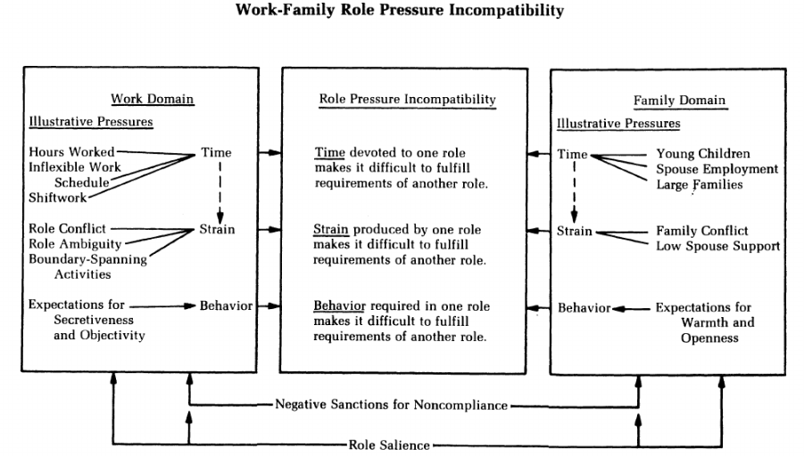
Figure 2. Kossek's Framework
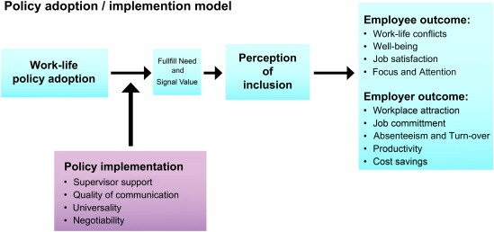

Figure 3. Role Theory
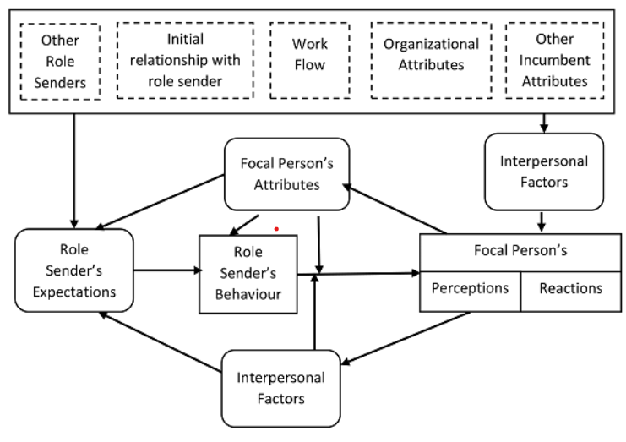
Figure 4. Social Exchange Theory
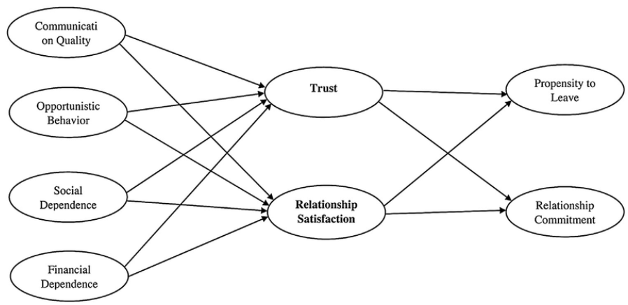

Figure 5. Border and Boundary Theory
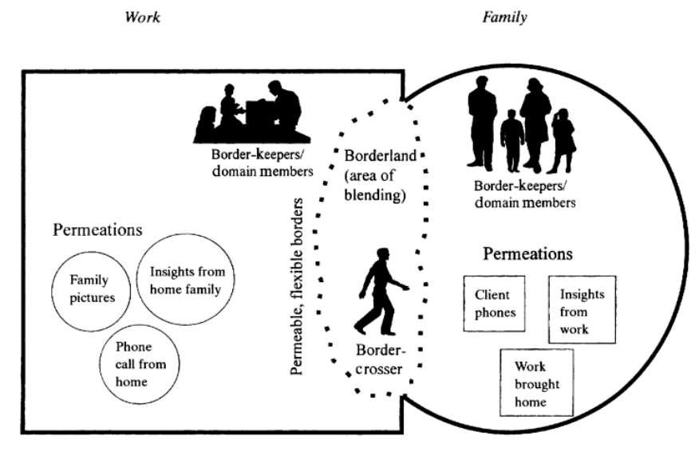
Figure 6. Segmentation Theory
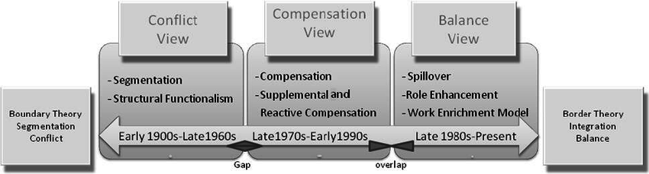

Figure 7. The distinction between Primary and Secondary Research
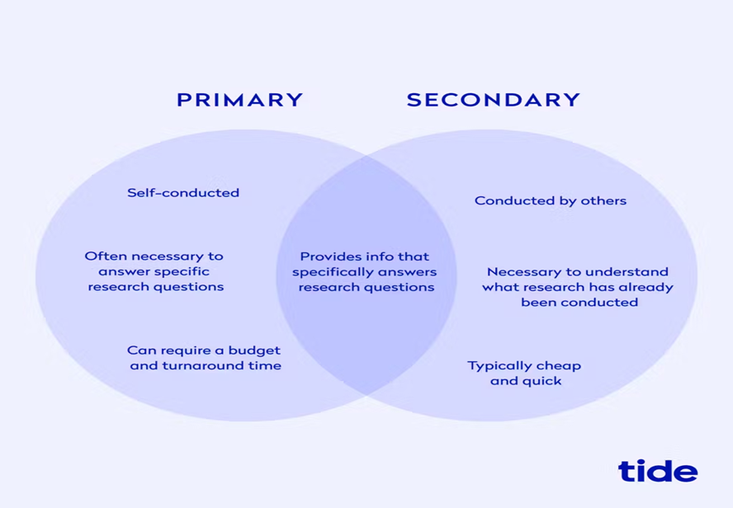

Figure 8.Saunder’s Research Onion
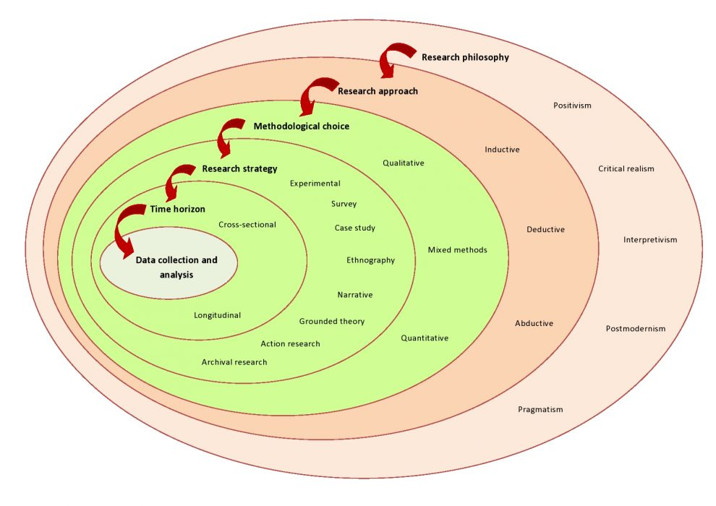

Figure 9. Layer Selection for Methodological Alignment.

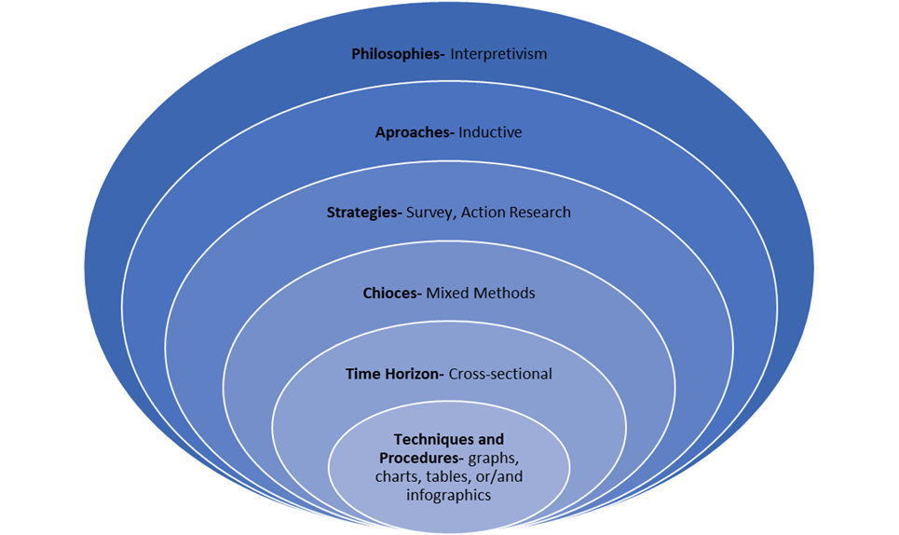
Figure 10. Mixed-methods research
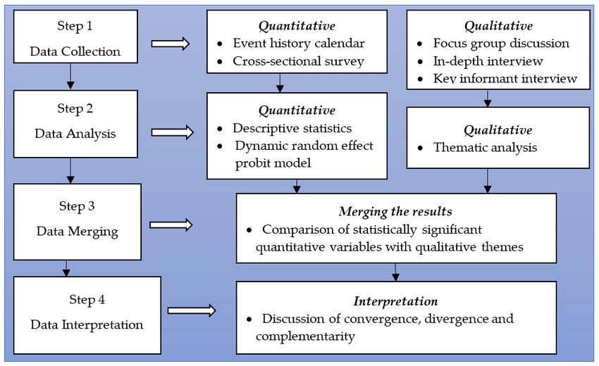

Figure 11. Survey Questions
Figure 12. Demographic Characteristics of the Female Leaders' Respondents.
Characteristic | Number of Respondents | Percentage
Total Female Respondents | 120 | 100%
Aged over 35 years | 105 | 88%
Working Full-Time | 87 | 83%
Working in Leadership Positions | 52 | 43%
With more than two years of experience | 52 | 43%

Figure 13. Impact on Personal Life
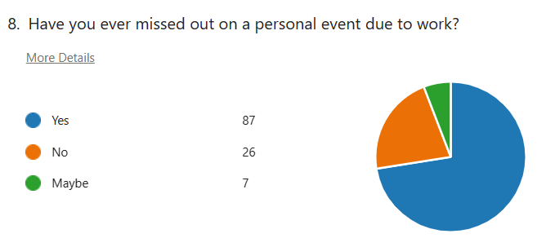
Figure 14. Levels of Satisfaction
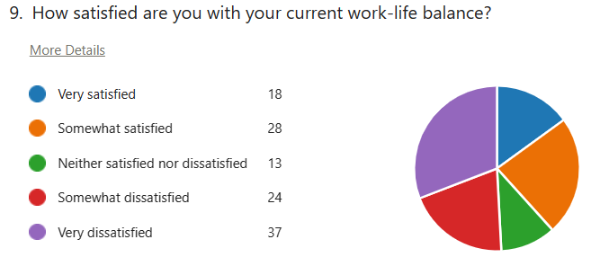

Figure 15. Inflexible Work Arrangements
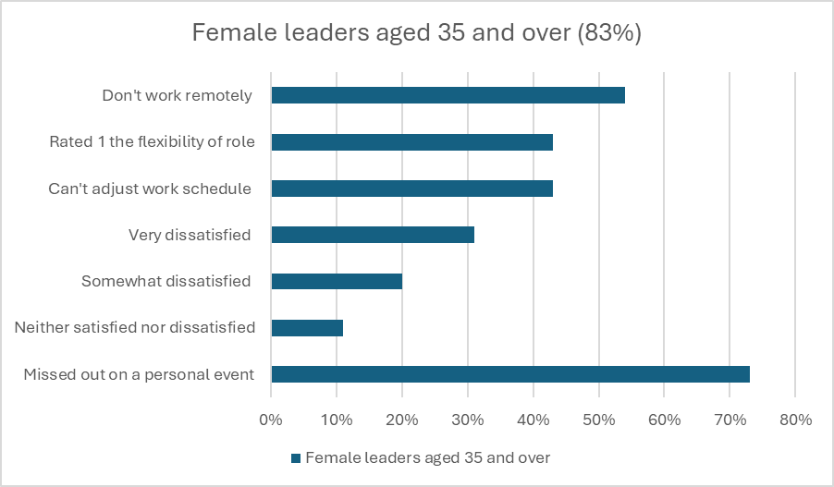
Figure 16. Lack of Awareness of Resources
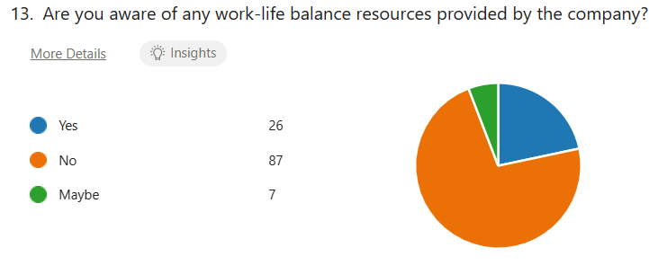
Figure 17. Lack of Support from Superiors
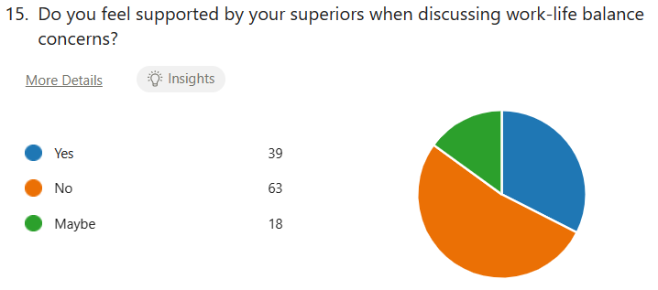

Figure 18. Limited Emphasis on Personal Well-being
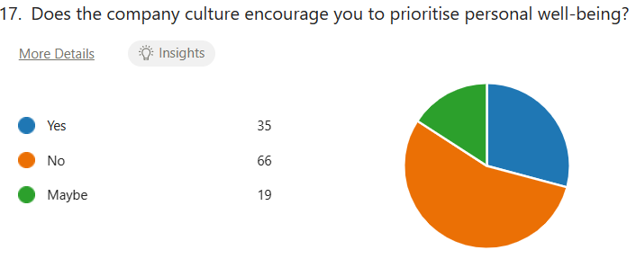
Figure 19. Impact on Personal Relationships
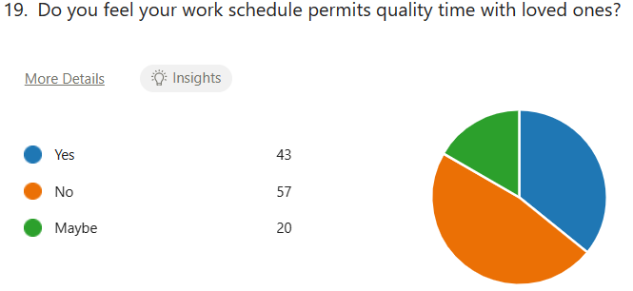
Figure 20. Impact of Family Responsibilities on Career Advancement
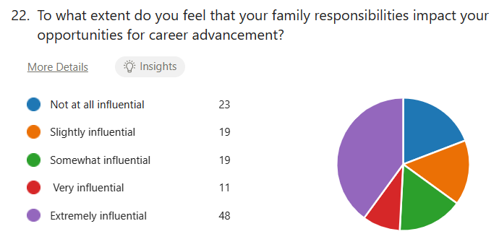
Figure 21. Consideration of Leaving Jobs
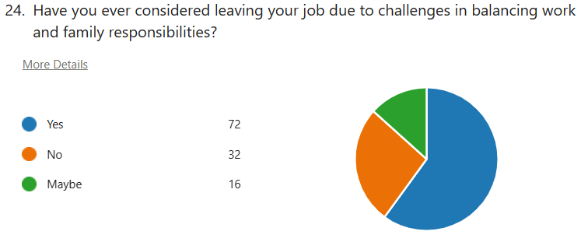
Figure 22. Dissatisfaction with Maternity/Parental Leave.
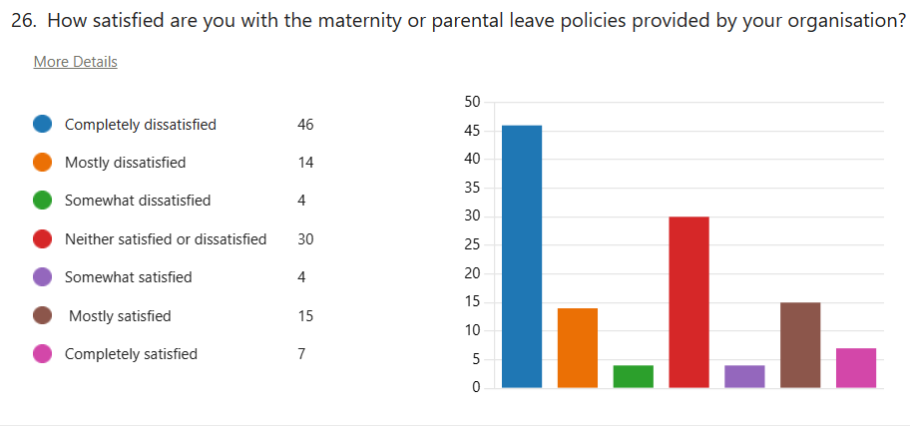
Figure 23. Delayed Career Progression
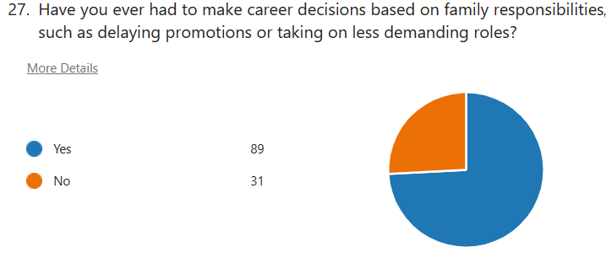

Figure 24. Guilt and Conflict Between Roles.
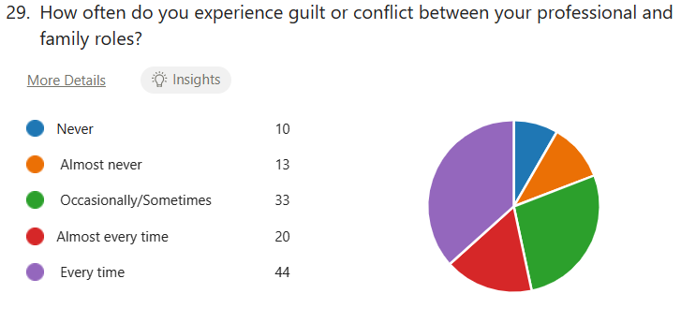
Figure 25. Perception of Policy Effectiveness
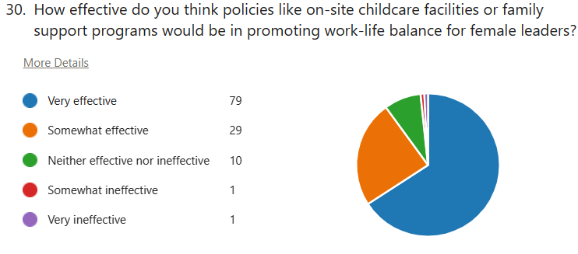
Figure 26. In-depth Interview Respondent 1
Q: Can you share your experiences balancing work-life responsibilities as a female leader, and how have these experiences influenced your career?
A: When I returned to work after having my first children, my employer permitted me to work three days a week, easing the pressure for childcare. This is fortunate, and I will be forever grateful for it. However, on the other side, with my career, I felt I had to work doubly hard to ensure my duties were fulfilled as I was a manager of a team of six at the time—so I worked as hard for three days as if it were five.
Q: In your role as a female leader, what specific challenges do you face in maintaining a satisfactory work-life balance, particularly concerning family responsibilities?
A: Currently, challenges I face include family sickness; even though I have the facility to work from home due to the lockdown, I cannot request the option when a child falls sick. Likewise, my entire weekend is spent preparing for the following working week, cleaning the house, etc. My partner treats his weekend like time off to relax, whereas I rush to get things for the following week. Balancing work and family responsibilities can be challenging, but I have found that setting boundaries and prioritising tasks helps me manage both effectively.
Q: Can you provide examples of situations where your family responsibilities intersected with your professional life, and how did you manage these intersections?
A: By planning, provided I have planned for even, for example, the food shop, it means we are sorted for the rest of the week. Should we have any holidays or events, I must prepare and plan weeks so everything is enjoyable.
Q: How do you establish boundaries between work and family life, and what strategies have you found effective in preventing one from negatively affecting the other?
A: By not talking about work, my partner thinks his job is superior to mine and directs all conversations to the importance of their role.
Q: Have there been instances where your family responsibilities influenced your work environment or interactions with colleagues, and how did you manage any potential challenges or misconceptions?
A: Family responsibilities influenced my work/social interactions only when the children were younger and far more dependent on mum; they are now 13 and 17, so they are becoming more independent, as long as we all communicate about evening or weekend plans every run smoothly
Q: Reflecting on your career, can you share a specific decision where family responsibilities were a driving factor and how that decision contributed to your overall job satisfaction?
A: After being made redundant after 20 years of employment due to company closure. I had to be clear with future employers that I had young children and would require flexible start times due to dropping my children at breakfast club. Had my husband been in the same situation, a delayed start time would not have been up for debate or consideration. I had to know the location, shift times, and how to phrase my request without being detrimental to the interview/consideration for the role. I was fortunate to receive an offer at my current post, and I feel grateful for the precious time it gave me with my children.
Q: How do societal expectations and gender norms regarding family responsibilities impact female leaders in the workplace?
A: Although the social wheels are turning for dad to become the primary parent/carer, I feel as though “mum” will always feel the most pressure to get the children, dinner, food shop, cleaning, birthday preparation, holiday preparations, and family well-being sorted/ready. “Mum” will always feel double the pressure in the family environment and be expected to perform in the career as though we have no family, no distraction.
Q: How have organisational policies and practices supported or hindered your ability to manage family responsibilities while maintaining your leadership position?
A: I felt supported during my career at my previous post and lockdown at my current position. I do not feel as though I have been hindered. At that time, my organisation provided supportive policies like flexible scheduling and family leave, which were essential in navigating work-life balance as a female leader.
Q: In your experience, how do family responsibilities, such as caregiving and parenting, impact the career advancement and overall retention of female leaders within organisations?
A: To be honest, I am happy where I am career-wise. I have no desire to further myself professionally. I want a job where I can come home and not think about it… If this happens, I have not done my job to the best of my ability. Home is home, and work is work.
Q: Have you encountered biases or specific challenges related to family responsibilities during your professional journey, and how have you addressed or overcome these challenges?
A: Not encountered any specific challenges.
Q: How do you prioritise self-care and personal well-being while fulfilling your leadership responsibilities, and what strategies have you found effective in maintaining work-life balance?
A: Regarding self-care and personal well-being, I am always available daily. I work out before work, be it running or through strength training. The downside is a 5.15 a.m. alarm to fit in a 20-minute workout followed by a 20-minute dog walk (weather permitting). I find this beneficial as it takes my mind away from ALL THE “to dos” and wonders for my outlook. Setting boundaries and prioritising tasks helps me manage both effectively.
Q: Can you discuss the importance of mentorship and networking opportunities for female leaders in navigating work-life balance challenges and achieving their career goals?
A: It is suitable for women and mothers to talk. We feel like we must be strong, unemotional female leaders, but at the end of the day, we are just humans trying to manage a family and work-life balance—we all have good and bad days. We can support each other if colleagues recognise and relate to this.
Q: Have you observed or participated in any initiatives or programs within your organisation that have positively impacted the employment and retention of female leaders with family responsibilities?
A: Sorry, no, I have not observed this.
Q: Based on your experiences, what recommendations would you offer to organisations looking to enhance the work-life balance for female leaders and create a more supportive and inclusive environment?
A: Flexible working hours
Q: What are your practical recommendations for your company to help you cope better with your family responsibilities (kids, parents, house chores) so you can successfully balance your work and family?
A: More holidays (20 days is not enough) Flexible start time: 7.30 am is too early The option to work from home: Granted, this is not possible for all the positions here, but if you prove you can do it through lockdown, why not make it an option for those days when a child is sick and needs their mother around? Taking time for self-care and prioritising my mental health has been crucial.
Figure 27. In-depth Interview Respondent 2
Q: Can you share your personal experience navigating the intersection of work-life balance and family responsibilities as a woman in the workforce?
A: Navigating a work-life balance and family responsibilities is particularly challenging. I am not reaching my potential and feel guilty because I work too much.
Q: From your perspective, how does the expectation of work-life balance differ for women compared to men in your industry or workplace?
A: Simply put, men are stereotypically not expected to find a work-life balance. Women are usually expected to spend more hours on family activities, school runs, shopping, cleaning, cooking, attending school functions, etc. At the same time, a man would usually feel suitable for working overtime or during family hours. Flexibility in work hours and telecommuting options have been instrumental in maintaining work-life balance. However, there are still times when the demands of work and family conflict.
Q: Have you encountered any specific challenges related to work-life balance and family responsibilities unique to women in your field?
A: Yes. I had to work overtime at short notice. Although I am not contracted to work extra hours, the expectation is there. My family/home life has become very strained during these times. With the support of my partner, this is possible.
Q: How do societal norms and expectations regarding gender roles impact your ability to balance work and family life?
A: Social norms usually dictate women's societal norms and expectations. Work expects a woman's full attention and potential. The grand expectations from both parties are high pressure for women.
Q: Have you ever felt pressure to choose between advancing your career and fulfilling family obligations? If so, how did you manage that dilemma?
A: In the past, any advancement in my professional career needed to be weighed against family life first. An increase in working hours and a change in responsibilities at work have always impacted my personal life and, most definitely, my children. I had to choose to spend my time with my kids, as my workplace stated clearly that if I cannot accept the new responsibilities, my chances of career progression will be slowed down.
Q: How does your employer support or hinder your efforts to maintain work-life balance as a woman, particularly regarding family responsibilities?
A: Currently, the company I am employed with provides flexible working hours to maintain a work-life balance as a woman, particularly regarding family responsibilities. I can work from home, and I am allowed to reduce or increase the working hours based on my circumstances.
Q: Have you observed differences in how male and female colleagues are treated or perceived regarding their work-life balance and family commitments?
A: In some ways, the pressure on women is higher. In my instance, when the second baby arrived, my partner's life had not changed with absolutely nothing. He had two weeks of rest for parental leave, and everything was back to normal for him. At the same time, for me, it was a different situation: 2 kids, more home responsibilities, doctors’ appointments, house chores, etc., and I do not even know when the nine-month maternity leave will be gone, as now I am in the situation of looking for childcare, being forced to leave my baby with strangers, at nine months, so I do not lose my job, as the financial responsibility is higher, having in consideration the costs of childcare.
Q: In your opinion, what initiatives or policies could organisations implement to better support the work-life balance of female employees with family responsibilities?
A: Companies should adopt more flexible policies around working hours and school holidays. I would like to see the option of reducing full-time hours to part-time during half-terms or when the children are sick, when work has to continue even though the children are on holiday, and to provide facilities for childcare or financial support so that I can afford to put my child in childcare. I have seen colleagues leave the organisation due to the inability to maintain a work-life balance. Retaining female leaders can be challenging when the organisation does not prioritise supportive policies.
Q: How do childcare responsibilities, maternity leave policies, and flexible work arrangements impact women's career trajectory and retention in your field?
A: I am currently on maternity leave and have taken a step back in my career to be at home with my baby. There is no career progression while you are not working.
Q: Have you ever faced discrimination or bias in the workplace related to your family status or responsibilities as a woman? If so, how did you address it?
A: Absolutely. I have been overlooked because I cannot offer the same working hours as my other colleagues, but I am being criticised for expecting fair pay.
Q: How do you navigate discussions about work-life balance during job interviews or performance evaluations as a female employee?
A: Mentioning positive outcomes usually helps in these circumstances. However, I also need to be honest about my priorities, emphasising how achieving a healthy balance between work and personal life enhances my performance and contributes positively to the organisation and how flexible working hours enable me to manage my responsibilities better and contribute effectively.
Q: What role do mentorship and support networks play in helping women achieve work-life balance and navigate career challenges related to family responsibilities?
A: It helps to have a female mentor who has children and empathises with their situation.
Q: How do you maintain your professional network and visibility within your industry while managing family obligations?
A: Maintaining a professional network and visibility within the workplace while managing family obligations can indeed present several challenges, such as:
1. Time constraints- Attending after-work events or industry conferences may conflict with family commitments, making it difficult to engage in networking opportunities.
2. Limited Availability: Some networking events or opportunities may be scheduled during hours that are not conducive to individuals with family responsibilities, such as late evenings or weekends. This can result in missing key networking opportunities within the workplace or industry.
3. Prioritization Dilemma—I feel torn between prioritising family obligations and investing time in building and maintaining professional relationships, which can lead to guilt or frustration.
Q: Have you encountered any misconceptions or stereotypes about working mothers or women with family responsibilities in your career? How have you addressed or challenged them?
A: The primary misconception is that women can multitask and be able to do absolutely everything, which puts lots of intense pressure, resulting in the feeling of being isolated and lonely.
Q: What changes do you hope to see in the workplace culture and policies to create a more equitable and supportive environment for women balancing work and family life?
A: I would love to see more awareness about women's struggles, more consideration, empathy, and support.
Q: What are your practical recommendations for your company to help you cope better with your family responsibilities(kids, parents, house chores) so you can successfully balance your work and family?
A: Provide more flexibility. Raising a family can be unpredictable. Although we try to plan to consider all school holidays, events, illnesses, and closures, they can blindside us, and better understanding is needed.

Figure 28. In-depth interview Respondent 3
Q: Can you share your experiences balancing work-life responsibilities as a female leader, and how have these experiences influenced your career?
A: I am one of the lucky ones working for a supportive company that allows flexible working hours to achieve a work-life balance. It is about communication and commitment to work any time we owe back. It is much easier to accomplish this now that we split our time between the office and working from home.
Q: In your role as a female leader, what specific challenges do you face in maintaining a satisfactory work-life balance, particularly concerning family responsibilities?
A: When I have the school run, I take the time as my lunch hour. This means I need to work through the day to meet my work responsibilities and get back in time to ensure my son meets his needs before I return to my shift. I rarely get 5 minutes to myself on those days, so I leave earlier for peace in the car beforehand. My role has changed this year, so I will have more of a challenge in being available for some school events.
Q: Can you provide examples of situations where your family responsibilities intersected with your professional life, and how did you manage these intersections?
A:
• Child home sick from school
• Covid-19 lockdown
• Leading meetings on a call at work and needing to divert my attention away to stop distractions.
Those examples were managed by setting expectations and explaining the situation at work and home.
Q: How do you establish boundaries between work and family life, and what strategies have you found effective in preventing one from negatively affecting the other?
A: Once my laptop is closed for the night, it does not go back on. This might mean I must clear some tasks, but that gives me more time to chill out and spend quality time together after dinner. When I am working, I am more focused on that.
I use a strategy of dividing my time into blocks. I do not switch off “mum mode” or “work mode;” instead, I allow my mind to understand which one is the current priority and set an approximate time limit for it. This helps me stay on track and continue working on the balance.
Q: Have there been instances where your family responsibilities influenced your work environment or interactions with colleagues, and how did you manage any potential challenges or misconceptions?
A: Yep. Right before lockdown and shortly after. Life events and drastic changes at home gave my colleagues an idea of my stubbornness and resilience. I stayed at work all through it because I needed the stability.
Q: Reflecting on your career, can you share a specific decision where family responsibilities were a driving factor and how that decision contributed to your overall job satisfaction?
A: My most recent decision to develop and achieve a management role was rooted in family responsibilities. I am no longer tied to a schedule; I am responsible for my time and can consider a much more flexible option. Family responsibilities have driven all the steps I have taken. After my maternity leave, I changed my working hours to ensure I could have a day at home.
Q: How do societal expectations and gender norms regarding family responsibilities impact female leaders in the workplace?
A: It impacts less than it used to, but it is still an issue for some.
Q: How have organisational policies and practices supported or hindered your ability to manage family responsibilities while maintaining your leadership position?
A: My employer offers benefits related to childcare and flexible working. I have yet to take advantage of this, but knowing it is there if needed is excellent. However, maintaining a healthy work-life balance has occasionally included passing up chances for professional growth.
Q: In your experience, how do family responsibilities, such as caregiving and parenting, impact the career advancement and overall retention of female leaders within organisations?
A: No, only sometimes. If you work for the correct type of employer, this should be fine.
Q: Have you encountered biases or specific challenges related to family responsibilities during your professional journey, and how have you addressed or overcome these challenges?
A: As a single parent, it has been difficult to explain how much organisation goes into a parenting schedule and how coming into the office on a different day, for example, can have a more significant impact. Again, it is about communication and trust between the employer and employee.
Q: How do you prioritise self-care and personal well-being while fulfilling your leadership responsibilities, and what strategies have you found effective in maintaining work-life balance?
A: It is bittersweet, but I am lucky to have a couple of days in the week when “mum mode” can be dialled back.
Q: Can you discuss the importance of mentorship and networking opportunities for female leaders in navigating work-life balance challenges and achieving their career goals?
A: Building a trusted network around you is essential to develop and achieve your career goals. With it, working mothers would be at the forefront of leadership as they are today. Showing a person setting out on their desired career path that a work-life balance is achievable is one of the most positive things you can do. Building a support network and delegating tasks when necessary has helped me more effectively navigate work and family life demands.
Q: Have you observed or participated in any initiatives or programs within your organisation that have positively impacted the employment and retention of female leaders with family responsibilities?
A: My employer offers emergency childcare, well-being benefits for you and your family and hybrid working.
Q: Based on your experiences, what recommendations would you offer to organisations looking to enhance the work-life balance for female leaders and create a more supportive and inclusive environment?
A: We need more days when you can bring your kid to work! And better support during the holidays regarding annual leave availability.
Q: What are your practical recommendations for your company to help you cope better with your family responsibilities (kids, parents, house chores) so you can successfully balance your work and family?
A: Listen to your leaders, show them how you support them, and give them flexibility without penalising them.

Figure 29. In-depth Interview Respondent 4
Q: Can you share your personal experience navigating the intersection of work-life balance and family responsibilities as a woman in the workforce?
A: As we all know, women have historically conducted most household responsibilities while participating in the workforce. Balancing work and family duties can be stressful and lead to burnout. However, as I have experienced, having supportive employers can powerfully transform workplace structures and policies to support women. Achieving work-life balance requires men to take on shared responsibilities for household duties.
Q: From your perspective, how does the expectation of work-life balance differ for women compared to men in your industry or workplace?
A: In my workplace, there are different expectations for work-life balance for men and women due to societal norms and biases. Women often face additional pressure to balance their professional and family responsibilities, making it challenging to achieve work-life balance. Sometimes, unconscious biases assume women will prioritise caregiving duties over their careers, which can affect their ability to participate in professional opportunities fully. However, there is growing recognition of the importance of gender equality in work-life balance, and efforts are underway to address these disparities.
Q: Have you encountered any specific challenges related to work-life balance and family responsibilities unique to women in your field?
A: Like many others, women in my field often face unique challenges related to work-life balance and family responsibilities. Some challenges include juggling multiple life roles that make it hard to balance career aspirations with traditional caregiving responsibilities at home. This leads to increased stress and difficulty managing both personal and professional responsibilities.
Moreover, they often have limited access to supportive workplace policies such as flexible work arrangements, parental leave, and childcare assistance, which are essential for work-life balance. This lack of support can aggravate the problem, making balancing work and home life even more challenging. Societal expectations of prioritising family over career advancement can lead to feeling guilty, frustrated, and demotivated, making balancing work and home life even more challenging.
Q: How do societal norms and expectations regarding gender roles impact your ability to balance work and family life?
A: Gender roles and expectations can make balancing work and family life hard. As women, we are often seen as the primary caregivers and responsible for household duties, while men are expected to focus on their careers. Societal pressures can also affect career opportunities; women may feel they have to scale back their jobs or take more flexible roles to accommodate family responsibilities, while men may face stigma for prioritising family over work. This can cause stress and burnout and make it hard to balance work and life. To address these issues, the workplace needs to promote gender equality in the workplace and at home and offer support systems such as parental leave, childcare options, and flexible work arrangements. By doing so, we can help everyone achieve work-life balance, regardless of gender.
Q: Have you ever felt pressure to choose between advancing your career and fulfilling family obligations? If so, how did you manage that dilemma?
A: Sometimes, choosing between career advancement and family obligations is complex. Balancing these priorities requires careful consideration of goals and objectives. Here are some strategies that can help manage the dilemma of balancing career and family responsibilities effectively:
1. Prioritisation: It is essential to assess what matters most in the short and long term to prioritise career and family responsibilities accordingly.
2. Communication: Honest communication with employers, colleagues, and family members about expectations, boundaries, and needs can help manage competing demands effectively.
3. Seeking support: Building a dedicated support network of family, friends, mentors, and colleagues can help you balance career and family commitments.
4. Negotiation: Flexible work arrangements like remote work, part-time schedules, or job-sharing can help accommodate family obligations while advancing one's career.
5. Self-care: Prioritising self-care and setting boundaries to avoid burnout is crucial for maintaining overall well-being while managing multiple responsibilities
Q: How does your employer support or hinder your efforts to maintain work-life balance as a woman, particularly regarding family responsibilities?
A: In my workplace, the employer helps the employees maintain a healthy balance between work and personal life by providing certain benefits and accommodations and offering flexible work arrangements, such as remote work, flexible hours, or compressed workweeks, which allow employees to manage family obligations while still fulfilling job responsibilities. Generous parental leave policies enabling mothers and fathers to take time off to care for a new child without sacrificing their careers are also helpful. Fostering a culture that values work-life balance, respects boundaries, and encourages employees to prioritise their well-being can create a supportive environment for all employees, including women with family responsibilities.
Q: Have you observed differences in how male and female colleagues are treated or perceived regarding their work-life balance and family commitments?
A: Women mostly face assumptions or stereotypes that they will prioritise family over work, which can lead to biases in project assignments, promotions, and performance evaluations. Men have an easier time requesting flexible work arrangements or time off for family-related matters due to traditional gender roles, while women face more resistance. Sometimes, women may also experience judgment if they prioritise their careers over family responsibilities or need help to balance both effectively. In contrast, men prioritising family may receive praise or admiration for deviating from traditional gender norms. Balancing work and family responsibilities can have different career implications for men and women, with women facing more significant career setbacks or limitations due to caregiving duties. In some cases, women may have less access to support systems or resources to help manage work-life balance. It is necessary to challenge gender stereotypes, promote equal opportunities for both men and women to balance work and family life, and implement supportive workplace policies and practices accommodating diverse needs and circumstances to address differences.
Q: In your opinion, what initiatives or policies could organisations implement to better support the work-life balance of female employees with family responsibilities?
A: Employers can take steps to support female employees with family responsibilities in maintaining a work-life balance. For example:
1. Offer flexible work arrangements
2. Provide generous parental leave
3. Support with childcare options
4. Provide employee assistance programs
5. Offer training programs and workshops on work-life balance
6. Foster an inclusive culture
7. Establish mentorship and sponsorship programs
8. Create employee resource groups
9. Conduct regular check-ins and feedback
10. Encourage senior leaders to role model healthy work-life balance practices.
Implementing initiatives and policies can help organisations create a supportive and inclusive environment for female employees with family responsibilities, enhancing satisfaction, retention, and productivity.
Q: How do childcare responsibilities, maternity leave policies, and flexible work arrangements impact women's career trajectory and retention in your field?
A: Supportive policies and practices that address childcare responsibilities, maternity leave, and flexible work arrangements are vital in retaining women in the workforce and promoting their career advancement. Organisations prioritising these factors are more likely to attract and keep talented women, leading to a more diverse and inclusive workforce. Moreover, implementing such policies can benefit all employees, irrespective of gender, by promoting work-life balance and enhancing overall job satisfaction and productivity.
Q: Have you ever faced discrimination or bias in the workplace related to your family status or responsibilities as a woman? If so, how did you address it?
A: During my career, I have faced situations where my gender and family status have influenced how I am treated at work. I will share one such experience with you:
My colleagues automatically assumed that, as a woman, I would take on administrative tasks, such as organising team events or managing office supplies. I addressed this issue by openly discussing my professional objectives during team meetings. I emphasised wanting to contribute strategically rather than be confined to stereotypical roles.
Although biases still exist, I have learned to navigate them with resilience. By standing up for myself, seeking allies, and challenging stereotypes, I can continue to make a meaningful contribution to my workplace. Hopefully, these biases will disappear one day, and true equality will be achieved.
Q: What role do mentorship and support networks play in helping women achieve work-life balance and navigate career challenges related to family responsibilities?
A: Mentorship and support networks are crucial for women to achieve a healthy work-life balance while navigating the complexities of family-related career challenges. These networks are powerful resources for women, empowering them to connect with other professionals, build supportive communities, and access valuable mentorship opportunities.
Q: How do you maintain your professional network and visibility within your industry while managing family obligations?
A: By incorporating the following routine, you can maintain a professional network and visibility while managing family commitments:
Focus on building relationships with primary contacts through regular communication in person or virtually if you cannot attend seminars, meetings, etc. Set achievable and realistic goals while considering your work-life balance and family responsibilities. Have a scheduled time for networking, whether attending an event or participating in online discussions; make networking your priority! Find a network that can be reached at nontraditional hours or family-friendly conferences. Have a strategy to reach out to those networking groups that can be useful, align with your professional interest, and help you achieve your targets. Think about quality over quantity when networking. Make yourself connected and visible on the online platform and industry-specific forums. Stay connected with your contacts and engage with others to demonstrate your skills and knowledge. Finally, most importantly, seek support from friends and family in managing your responsibilities so you can dedicate time to networking with other professionals for personal development.
Q: Have you encountered any misconceptions or stereotypes about working mothers or women with family responsibilities in your career? How have you addressed or challenged them?
A: I have faced this challenge because of the misconception that working women are less committed and less productive. I have highlighted this misconception and challenged the team about how their support can bring value to the workplace culture and promote diversity, equity, and work-life balance for all employees.
I then defied that misconception by demonstrating dedication and professionalism towards my work-life balance to prove that women have diverse experiences and can excel in their roles and achieve their goals.
Q: What changes do you hope to see in the workplace culture and policies to create a more equitable and supportive environment for women balancing work and family life?
A: Creating a more equitable and supportive environment for women balancing work and family life requires a comprehensive approach that addresses both workplace culture and policies, and these can be achieved by following these changes:
1. Flexible Work Arrangements
2. Equal Parental Leave
3. Childcare Support
4. Supportive Workplace Culture
5. Training and Education
6. Female Leadership Representative
7. Networking & Support Network
8. Implementing Policies Against Discrimination
By implementing these changes, the workplace can create a supportive environment for women to balance their work and family lives, eventually leading to employee satisfaction and productivity.
Figure 30. Qualitative Emerged Themes
Themes | Work-Life Integration Struggles | Organisational Support and Culture | Career Progression | Importance of Flexibility
Respondent 1 | Juggling, stress, guilt, dissatisfaction | Balancing  Overwhelmed | Stress  Time management  Prioritisation | Strain  Conflict  Burnout
Respondent 2 | Policies  Communication  Collaboration | Trust  Recognition  Inclusivity | Empathy  Transparency  Work-life balance initiatives | Leadership  Training  Mentorship
Respondent 3 | Advancement  Opportunities  Development | Promotion  Growth  Leadership roles | Hurdles  Trade-offs  Family Impact | Career trajectory  Decision-making  Balancing act
Respondent 4 | Remote work  Schedule flexibility  Adaptability  Work-life integration | Flexitime  Job-sharing  Telecommuting  Accommodation | Work arrangements.  Flexibility policies  Time management  Remote options | Flexibility benefits  Customisation  Alternate schedules  Remote arrangements

Figure 31. Reflection on the research process and limitations
While every effort was made to ensure the validity and reliability of the data collected for this study, several limitations should be noted. Firstly, the reliance on self-report measures introduces the potential for response bias, as participants may provide socially desirable responses or inaccurately recall their experiences. To mitigate this limitation, anonymity and confidentiality were assured, and participants were encouraged to respond honestly.
During the data collection phase of this research study, several challenges were encountered that impacted the validity and reliability of the data obtained. These problems warrant careful consideration to accurately interpret the findings and acknowledge potential limitations in the study's conclusions.
One significant challenge pertained to participant recruitment and retention. Despite efforts to engage a diverse pool of participants, including female leaders from various industries and organisational sectors in Cardiff, Wales, recruitment proved challenging due to limited accessibility and availability of potential participants. Consequently, the sample size may have been smaller than anticipated, potentially limiting the representativeness of the findings and the generalizability of the study's conclusions.
Furthermore, issues related to participant response rates and data completeness were encountered during the survey administration phase. Despite reminders and follow-up communications, some participants failed to complete the survey, resulting in missing data and potential biases in the analysis. This threatens the study's internal validity, as incomplete data may compromise the accuracy and reliability of the statistical analyses conducted.
Another challenge involved measuring critical constructs related to work-life balance and family responsibilities. While validated scales and instruments were used to assess these constructs, the applicability and relevance of these measures to the study's specific context in Cardiff, Wales, may have needed to be improved. Cultural and contextual differences in the interpretation of survey items or response patterns could have influenced the validity and reliability of the data obtained.
Additionally, logistical constraints and resource limitations posed challenges to implementing data collection procedures. Time constraints, budgetary considerations, and practical constraints such as access to participants or organisational settings may have impacted the feasibility and scope of data collection efforts. These constraints may have constrained the depth and breadth of data collected, potentially limiting the richness and comprehensiveness of the findings.
Finally, ethical considerations and data protection regulations posed additional challenges during the data collection. Ensuring participant confidentiality, anonymity, and informed consent while adhering to ethical guidelines and legal requirements added complexity to the data collection procedures. Compliance with ethical standards may have necessitated additional safeguards and procedures, potentially impacting the efficiency and timeliness of data collection efforts.
In summary, the problems encountered in data collection procedures highlight the complexities and challenges inherent in conducting empirical research, particularly in studying sensitive topics such as work-life balance and family responsibilities among female leaders. While efforts were made to address these challenges and minimise their impact on the study's outcomes, it is essential to acknowledge these limitations and consider their implications for interpreting and generalising the research findings. Future research endeavours should address these challenges through methodological refinements, careful planning, and initiative-taking strategies to enhance the validity and reliability of data collection procedures.
Figure 32. Data collection procedures
By following a systematic approach to participant recruitment, it was possible to effectively engage female leaders in management positions in Cardiff, Wales, who have at least two years of managerial experience and family responsibilities. This ensures inclusivity, sensitivity, and ethical integrity in the research process while facilitating the collection of valuable insights into the experiences of these individuals with work-life balance.
In-depth interviews were chosen as the data collection method due to their unique capacity to delve deeply into participants' lived experiences, perspectives, and perceptions.
For this research, female leaders aged 35 and over were targeted for in-depth interviews. This age range was chosen to capture the experiences of mid-career female leaders likely to have significant work experience and face work-life integration challenges. Participants were required to have more than five years of professional experience to ensure a depth of insight into the challenges and dynamics of work-life integration among experienced professionals.
The participants were 35 years and above, delineating a demographic of seasoned leadership acumen and substantial career progression. This age criterion ensures professional maturity and experience. It aligns with the research objective of exploring the work-life balance and family responsibilities among female leaders at a stage where such considerations may significantly influence their employment decisions and retention within leadership roles. The interviews were conducted one-on-one between the researcher and each participant. Each interview session lasted 60 to 90 minutes, providing ample time for participants to share their perspectives and experiences.
For the survey, the recruitment process commences with identifying the target population: female leaders in management roles within organisations based in Cardiff, Wales. These individuals are selected based on specific criteria, including their managerial experience of at least two years and the presence of family responsibilities. Organisational directories, professional networks, and industry associations were consulted to compile a list of potential participants meeting these criteria.
Potential participants were contacted through various channels, such as email, professional networking platforms, or direct outreach through organisational contacts. An invitation was extended to these individuals, outlining the purpose and objectives of the study, eligibility criteria, and the voluntary nature of participation. Emphasis is placed on confidentiality, anonymity, and the opportunity for participants to withdraw from the study at any time without penalty.
Eligibility criteria were clearly defined to ensure that recruited participants meet the study's objectives. In addition to holding managerial positions and residing in Cardiff, participants must have at least two years of managerial experience and have family responsibilities, such as caregiving duties, parental obligations, or household responsibilities. This criterion ensures that participants' work-life balance experiences represent the target population.
Recognising the significance of family responsibilities in participants' lives, the recruitment process adopted a sensitive approach to engage potential participants. The language used in recruitment materials acknowledges the challenges of balancing work and family life and assures participants that their experiences will be respected and valued in the study.
Before participation, potential participants were provided with detailed information about the study, including its purpose, procedures, risks and benefits, and data handling practices. Informed consent was obtained from each participant, affirming their voluntary participation and understanding of their rights as research subjects. Participants were assured of the confidentiality and anonymity of their responses, particularly regarding sensitive information about family responsibilities.
The recruitment process adheres to ethical guidelines governing research involving human subjects. Transparency, integrity, and respect for participants' autonomy and privacy are paramount throughout the recruitment process.

