A Report on Effective Teamwork In a Business Setting: Case Study of Next PLC

Effective Teamwork and Communication Module BMSW 4002

Iunsiya Hussain
2024760

Daminabo Pokubo

This report will deliberate all the different attributes of teamwork and how they relate to the case study of Next Plc. Methods such as the Tuckman (1965) and Meredith Belbin’s Team Roles (1969) will be demonstrated in this report to prove that an effective team can be developed by interpretating these models which will encourage a non performing team to become a high performing team.

Table of Content

Title Page ………………………………… Page 1
Executive Summary …………………….. Page 2
Table of Content ………………………… Page 3
Introduction ……………………………… Page 4
Overview of Teamwork ………………… Pages 5-6
Models of Team Development ………… Pages 7-8
Team Roles ………………………………. Page 9
Effective Teamwork ……………………… Page 10
Conclusion …………………………………Page 11

This report will be discussing methods that can be used to ensure Next Plc delivers a successful product launch. In order for Next Plc to ensure a successful product launch takes place, the team that has been organised needs a solution for their rising challenges occurring in their team causing disruption to the goal of the organisation. Methods that will be used to help the team resolve their ongoing problems will be the Tuckman (1965) and Belbin’s Team Roles (1969) in addition Wheelan (1999) will be conversed in this report however will not be used as one of the chosen methods. Literature from the book Team players and Team work written by author Glenn M. Parker will be incorporated into this report as one of many senior members of successful businesses have left high reviews, one describing the book as a ‘essential guide to successful teamwork’.

Looking at the case study, effective team work in Next Plc would be coherent as it would allow the Next Plc team to achieve their goal of a successful clothing product launch across 189 worldwide franchise stores.
To create this effective team, members of the Next Plc team have to go through a sequence of stages to achieve a performing team.
A team is a group of people working together to achieve the same objective. Another definition for a team is a group of two or more people with the same common goal working interdependently to succeed it (Team: Definition, Characteristics, Types and Ingredients of Effective Team).
Parker stated “it was clear that effective teamwork can produce tangible benefits for people and organisations”. A team deciding on a goal and communicating that the only way that goal can be achieved is by working together is an example of effective teamwork. If the team members of Next Plc can prioritise the goal the launch will be successful. Attributes that contribute to an effective team is the team leader allowing the members of the team to feel confident in participating in group discussions, expressing their ideas openly and not domineering. Other contributes to an effective team is having a neutral atmosphere, members of the team not taking criticism negatively but positively to improve their performance to achieve the common goal. Reflecting as a group is another great from of effective team work, being able to track the success of a method that is helping achieve the goal or the barrier that is preventing the goal from being reached.

Source: (Smartsheet Accessed: 23 June 2022)
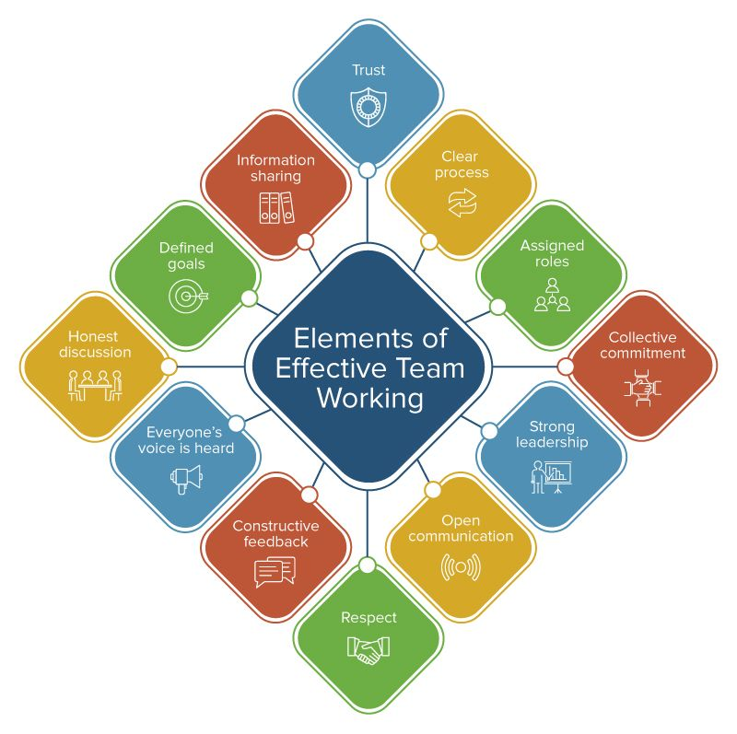

The above diagram breaks down the elements of effective team working. An element of effective teamwork is having a strong leader whom has respectful boundaries with the team members by trusting their ability to get their work completed without doubting or overshadowing them by doing this the team leader allows the members of the team to feel confident in their role and the work they are carrying out. Information sharing is a great factor of effective teamwork this is an important component as this reminds the team members it is great to share information that will help achieve the common goal instead of gatekeeping for their own sense of control, this could potentially break down an effective team.

One method of model development to consider that will help solve Next Plc’s teamwork and communication challenges is the Tuckman’s Model. This model concludes of five stages. Forming, storming, norming, performing and adjourning.
The forming stage can have members of the team feeling anxious and hesitant, members of the team at this stage are forming relationships. They are getting acquainted and understanding team goals that have been set. This stage can only take a few hours as the members of the team are testing the waters between each other and introducing themselves. Members of the team are still looking for direction from the team leader, waiting for them to initiate direction.
The second stage is storming, this stage is crucial for a developing team as for many teams this is where everything ends. Team members are clashing at this point as the feeling of competition between one another rises as members of the team are figuring out their role in the group. Members of the team sharing their individual goals amongst each other is the reason for conflict making this stage challenging for the team.
The third stage of Tuckman is norming, this stage of the model is the period in which the members of the team have their roles established resulting in a strong sense of identity. The members of the team are trusting and helping one another to achieve the goal set. Unlike the forming stage, in this stage members of the team are no longer relying on the team leader for direction and are no longer as dependent on them. Successfully overcoming the storming stage, in the norming stage the team members are working more effectively and respecting each other’s differences and opinions as they would have learnt different triggers for different members of the team during the disagreements in discussions in the previous stage.
The stage where the team is performing their highest level is the performing stage of the model. This is where team members are able to solve problems quickly and effectively also able to make decisions. Every effective team should be at this stage of the model.
The last stage of the Tuckman model is adjourning. This stage is when the team have successfully achieved their common goal and are now going separate ways.

Another model Next Plc could consider for their problem is the Wheelan (1999) which contains of four stages. Dependency and inclusion, counter dependency and fighting, trust and structure also work. This model is similar to the Tuckman method however it only concludes of four stages whereas Tuckman concludes of five.
The dependency and inclusion role consists of members of the team being dependent on the leader and relying on them to make choices. The leader of the team feels a responsibility of the safety of the team members. At this stage the team members are having the feeling of wanting to be accepted so therefor will not express their opinions in fear of the team not agreeing with them.
The second stage, counter dependency and fighting includes of arguing, mainly over the group goal that has been set and not agreeing with the procedures that need to be done to achieve the group goal. Team members may struggle with interpersonal conflict. Interpersonal conflict can be due to different personalities, sharing different values and not agreeing with the attitude of team members towards solving the problem. Even though conflict can be very challenging in a team it is needed to establish trust and boundaries within the team, this allows the members of the team to have confidence in disagreeing with each other.
Trust and structure is the third stage in the Wheelan model. At this point in the model, the leader no longer has to instruct the members of team, they are independently able to work towards the team goal. Team members are able to trust each other and the communication between each other becomes more open and natural. At this stage the main objective is to achieve the set goal, there is no longer the feeling of acquiring power, being the most influential within the team.
The last stage of the Wheelan model is work. This stage is when the team are at their high performing point, they have resolved their conflicts and focus on their task accomplishment.
The group development model that would be most suited in solving Next Plc’s teamwork and communication challenges is the Tuckman model. This model will help the team of Next Plc progress through the stages with understanding towards each other. This is required as the team members are struggling with conflict and communication problems. Tuckman is known to improve team performance and that is what the Next Plc needs to have a successful product launch. Even though the Wheelan model is also useful it’s not as in depth as the Tuckman model and is a much more simplified version of Tuckman. The Wheelan model is also more task orientated. The stages of the Tuckman model are far more divided and detailed ensuring each stage is easy to follow for the leader and team members.

.

The three roles that will help create a sufficient team are the Meredith Belbin’s team roles. Thinking, Action and People. There are nine roles segregated into 3 roles. Belbin developed the idea that a team needs a balance of personalities for them to succeed. Below are the three roles broke down into nine roles.
Thinking
Plant - Creative, imaginative, free-thinking, generates ideas and solves difficult problems.
Monitor Evaluator - Sober, strategic and discerning. Sees all options and judges accurately
Specialist - Single-minded, self-starting and dedicated. They provide specialist knowledge and skills.
Action
Implementer - Practical, reliable, efficient. Turns ideas into actions and organises work that needs to be done.
Shaper - Challenging, dynamic, thrives on pressure. Has the drive and courage to overcome obstacles.
Complete Finisher - Painstaking, conscientious, anxious. Searches out errors. Polishes and perfects.
People
Co - Ordinator - Mature, confident, identifies talent. Clarifies goals.
Resource Investigator - Outgoing, enthusiastic. Explores opportunities and develops contacts.
Team Worker - Co-operative, perceptive and diplomatic. Listens and averts friction.
(The Nine Belbin Team Roles, n.d.)
All these roles diversify a team, diversity is needed as if everyone on the team were similar there would be no success. It’s important to recruit / have all these different roles on the team as each team member has their own individual strength and own personality that can contribute to the teams successfulness. ‘The variation in personality helps to have a great team work’ (Reddy, n.d.).

There are many advantages to team work. Working as a team can increase productivity within the workplace. This will lead to team members feeling more motivated and happier overall. Team work brings people together from different backgrounds, meaning there are many different experiences and ideas this would be effective in helping with solutions in problem solving. Team work aids strong bonds between members of the workplace. This produces understanding of induvial strength and weaknesses and learning team members personalities. Developing strong bonds helps the communication flow within the team as everyone is comfortable with each other.
The barriers to effective team work are members of the team having low self-awareness, meaning members of them are unsure of their strengths, weaknesses and where they aren’t as skilled this leads to no personal growth and development as the member of the team isn’t self-aware and this would not be a good attribute of a team leader. The team members of the Next Plc are working remotely which is another barrier of effective teamwork as it decreases the physical interaction between members of the team which is significant to effective communication. The physical environment can also be a barrier as if the environment is not suitable for e.g., noise, lighting and poor interior of the workplace that prevents interaction within the team. Language is another barrier causing ineffective teamwork, as the product launch is a worldwide one, team members are from all over the world. As they speak different languages, it can be harder to understand each other and communicate ideas.

Teamwork is when the team all share a purpose and put their personal feelings and goals aside to achieve the team goal, in this case a successful product launch. To achieve this goal the team need to communicate better. A solution to this is during team meetings for everyone to have their camera on. Also to extend the time of the meetings to ensure everyone is able to discuss their ideas and for everyone to be heard and understood. The impact this will have will be great as the goal will be much easier to reach. The members of the team will feel confident in themselves and assured. Holding online activities for team members to participate in such as quizzes may encourage quieter members of the team to participate, them doing well being celebrated by the leader to prove to them that they are doing well and that they are heard. This leading to them being more involved in the monthly meetings. In regards to the personality clashes. Members of the team that are struggling with this should be addressed. A meeting held just with the individuals of this problem. In this meeting they will be able to discuss their problems with the leader present. Find a solution that fits them both and reminding them of the team goal. This will have a positive impact as they will reflect on the bigger picture which is for Next Plc to have their successful product launch.

References
Belbin.com. n.d. The Nine Belbin Team Roles. [online] Available at: https://www.belbin.com/about/belbin-team-roles [Accessed 01 July 2022].
iEduNote. n.d. Team: Definition, Characteristics, Types and Ingredients of Effective Team. [online] Available at: https://www.iedunote.com/team#:~:text=A%20team%20is%20made%20up%20of%20two%20or,becoming%20more%20common%20in%20the%20business%20world%20today. [Accessed 16 June 2022].
Louise, E., 2021. *UPDATED* Tuckman's Team and Group Development Model & How to Use it | by Emma-Louise Elsey. [online] The Coaching Tools Company. Available at: https://www.thecoachingtoolscompany.com/get-your-team-performing-beautifully-with-this-powerful-group-development-model/#:~:text=Specifically%2C%20Tuckman%27s%20model%20helps%20managers%2C%20leaders%20and%20team,for%20each%20other.%203%20Ultimately%20improve%20team%20performance.https://www.thecoachingtoolscompany.com/get-your-team-performing-beautifully-with-this-powerful-group-development-model/#:~:text=Specifically%2C%20Tuckman%27s%20model%20helps%20managers%2C%20leaders%20and%20team,for%20each%20other.%203%20Ultimately%20improve%20team%20performance. [Accessed 2 July 2022].
Nibusinessinfo.co.uk. n.d. Advantages of effective teamwork | nibusinessinfo.co.uk. [online] Available at: https://www.nibusinessinfo.co.uk/content/advantages-effective-teamwork#:~:text=%20Advantages%20of%20effective%20teamwork%20in%20the%20workplace,which%20can%20lead%20to%20the%20development...%20More%20 [Accessed 5 July 2022].
OptimistMinds. n.d. What Are 5 Barriers To Effective Teamwork? (+5 Interesting Solutions) | OptimistMinds. [online] Available at: https://optimistminds.com/what-are-5-barriers-to-effective-teamwork/#:~:text=%20What%20are%205%20barriers%20to%20effective%20teamwork%3F,popular%20these%20days.%20Organizations%20are%20also...%20More%20 [Accessed 10 June 2022].
Parker, G., 2008. Team players and team work. [online] Www-vlebooks-com.ezproxy.uwtsd.ac.uk. Available at: https://www-vlebooks-com.ezproxy.uwtsd.ac.uk/Product/Index/4241?page=0 [Accessed 23 June 2022].
Reddy, K., n.d. Why Have Different Personalities in the Workplace? - Wisestep. [online] Wisestep. Available at: https://content.wisestep.com/personalities-in-the-workplace/#:~:text=Team%20work%20is%20very%20important%20to%20bring%20out,comes%20out%20in%20a%20more%20brushed%20up%20way. [Accessed 01 July 2022].
Sasha, P., 2017. Belbin Team Roles: what it means to team effectiveness. [online] HR Katha. Available at: https://www.hrkatha.com/features/learning/belbin-team-roles-what-it-means-to-team-effectiveness/ [Accessed 7 July 2022].
Smartsheet, 2017. [image]. Available at Ultimate Toolkit for Teamworking Success | Smartsheet [Accessed 23 June 2022].
Team Building World. n.d. 10 Team Building Activities for the Storming Stage - Team Building World. [online] Available at: https://teambuildingworld.com/storming-stage-activities/ [Accessed 3 July 2022].

