Graduate Diploma in Professional Learning- SLD/PMLD

Module Title: Diversity of Learning

Module no: M6X02187

Title: Assessment Component 2.

1811104

Eirian Griffiths

Assessment Component 2

This essay focuses on the effectiveness of teaching strategies used for children with ASD. Priorities and considerations will be detailed of how Max’s learning needs are met individually and as part of differentiation of the whole class. In order to ensure activities provided are tailored to meet individual’s learning needs and styles, a range of approaches, choices and teaching styles will be examined (Dean 2016).

NAS (2016, p.1) provide a SPELL framework which responds to the needs of children with ASD. It includes five principles of best practice in autism and sets out ways a practitioner can meet each individual’s needs. The first element of SPELL is Structure. Structure is important for children with ASD as learners know what is going to happen and what is expected. A highly structured environment can also encourage independence and reduce anxiety. Whitaker et al. (2001) support that almost every book or piece of advice concerning children with ASD will mention the need for structure and there is a great deal of evidence that shows structure helps with learning and preventing challenging behaviour. The second element of SPELL focuses on positive approaches and expectations. An emphasis is placed on building on natural strengths, interests and abilities in order to develop self-confidence and self-esteem. The third element of SPELL is empathy; in order to develop communication and reduce anxiety an effort must be made to understand, respect and relate to the experiences of children with ASD. The next element of SPELL is Low – arousal; in order to reduce anxiety and aid concentration, approaches and the environment need to be calm and ordered. There should be as few distractions as possible and noise levels, colour schemes, odours, lighting and clutter all need to be taken into consideration. The last element of SPELL is Links; which recognises the benefits of sharing information, creating open links and communication working alongside the individual, their families and other professionals. Throughout this essay these five principles of SPELL will be demonstrated in practice.

Max uses the Picture Exchange Communication System (PECS) which is an approach that uses pictures to develop communication skills (Pyramid Educational Consultants UK 1998). PECS was developed in the USA in 1985 by Andy Bondy and “is based on B.F. Skinner’s book, Verbal Behavior, and broad spectrum applied behaviour analysis” (Pyramid Educational Consultants 1992-2019, p.1). PECS teaches functional communication through six phases. Max is on stage four: sentence structure; he constructs simple sentences using an “I want” picture followed by a picture of the item being requested (Pyramid Educational Consultants 1992-2019). Max’s use of PECS is identified as his communication goal in his IEP (Appendix 1). Giving Max an additional way to communicate reduces the likelihood that he will get frustrated as a result of not being able to express himself. Other children in the class are at different phases of PECS so it is imperative that differentiation of the phases for each individual is clear to staff. PECS is an example of how empathy, with a focus on developing communication and reducing anxiety included in SPELL is met.

However, there are limitations between the theory of PECS and using it in practice. The first phase of PECS requires one adult as a helper and another adult as the communicative partner (National Professional Development Center on ASD 2016). This can be difficult to staff due to ratio numbers, the needs of the other children and when you have children at different phases. In order to overcome this difficulty, the teacher can arrange with a speech and language therapist or the school’s communication team to support implement the beginning phase. In addition, the day to day use of PECS can be time consuming, especially when you have a number of children using the system. It is important to be organised and have a bank of ready-made symbols to use as they can get easily lost in transition. Also, you may find you need to make ‘on the spot’ symbols quickly if a child has bought in a new item from home. Wicks (2017, p.1) agrees that “it’s challenging to keep up with the adjustments necessary for PECS to be effective”. Gagnon (2019) also points out disadvantages such as it is costly, nonverbal, limiting and modifications are necessary. From discussions in the trust group, it was discovered that other teachers also faced these challenges when implementing PECS in class.

Max uses speech alongside PECS though it is important to note that he already used words prior to PECS and the PECS symbols used support his existing vocabulary. However, this is not the case for all children and as Wicks (2017, p.1) notes “using non-verbal communication makes it hard to attain normal communication abilities”. Schwartz, Garfinkle, and Bauer (1998, p.151) reported that children with no initial spontaneous vocalisations who followed PECS training “showed little or no increase in the number of spontaneous words produced”. In addition, Flippin et al. (2010) carried out a study on PECS and found gains in communication but not in speech. In contrast, Charlop-Christy et al. (2002) carried out a study that showed increases in verbal speech using PECS; though only three children were observed so the outcomes cannot be generalised. Bondy and Frost (1994, p.15) “agree that the long-term goal of communication training is the development of speech”; however, they also point out it “is not appropriate to compare a 2 or 3 year old child who has not developed functional speech with a younger speech-free child who has demonstrated typical patterns of development”. Though it is important to be aware of disadvantages people have faced, in Max’s case, it is important to continue to give him the opportunity to access PECS as it has made a positive difference to developing his vocabulary, as noted in his Person Centred Review (Appendix 2). This demonstrates how positive approaches and expectations included in SPELL are met as PECS supports Max’s natural strengths, interests and abilities.

Lacey et al. (2005, p.386) stress it is imperative for all learners that the physical, social and emotional environments are conducive to learning as demonstrated by Maslow’s hierarchy of needs (Appendix 6). Burleson and Thoron (2017, p. 2) point out it is important to consider how the knowledge of hierarchy of needs can be applied to learning and achievement in the classroom. Although staff can support with physiological needs such as air, food and water, staff cannot ensure physiological needs such as clothing, shelter and adequate sleep are provided due to the fact that these take place outside school. All that can be done by staff is to provide learners with access to programs within school that address these needs. In terms of safety needs it is important to establish a routine as without one learner’s can feel anxious and unsafe. By being made aware of what to expect, learners will feel they have more control within the learning environment. In order to ensure learners feel psychologically and emotionally safe a secure learning environment should be provided in which trust is established and children are encouraged to feel at ease and take risks. Also, in order to meet love and belongingness needs and self-esteem needs it is imperative for staff to ensure that learners know they are valued as individuals. Positive behaviour and self-esteem should be reinforced at every opportunity. Burleson and Thoron (2017, p.3) stress that any efforts that can be made “to contribute to these needs will greatly improve a learner’s ability to learn and achieve”.

When reflecting on strategies for children with ASD it is important to consider not only teaching but also the environment in which learning takes place. Mesibov and Howey (2016, p.122) support this by noting “for those with ASD, a clear, visually organised environment is the first step in making classrooms meaningful and manageable”. Ensuring the environment is clear, predicable and autism friendly is the first step towards children with ASD accessing the curriculum and it supports with overcoming barriers to learning (Mesibov and Howey 2016). An important approach to discuss when examining the physical structure of an environment is TEACCH. The TEACCH program was formed to promote structured learning environments that encourage visual based engagement and communication (Applied Behavior Analysis Programs Guide 2019). TEACCH has four essential components: physical structure; visual schedules; work systems; and task organisation (Research Autism information service 2017). An element of the SPELL approach is structure and TEACCH is a beneficial system for children with autism who require the level of structure included. Jordan and Powell (2007, p.20) note there are examples of situations where the TEACCH structure has been removed and this impacted the child as their stress levels and difficult behaviour reverted back. Schopler and Mesibov (1995, p. 246) advocate that “structured teaching offers learning opportunities not otherwise available”.

Max is in a specialist ASD class that follows the TEACCH approach as all the children in this class respond well to this structure. Max has an individual schedule that uses photographs supported by symbols (Appendix 3). The schedules used in class are differentiated for each pupil, some learners use photos, some use symbols and some use photos alongside symbols. There are also children in different classes that use word schedules; again this depends on each individual and it is important for staff to understand and recognise the differences. Schedules can be presented differently; Max’s visuals on his schedule are presented from top to bottom as he scans vertically. Other children’s visuals are presented from left to right as they are horizontal scanners. NAS (2013, p.2) advice “that vertical presentation of symbols can be more effective because people tend to naturally work downwards, treating information like a list”; though both ways are effective. By differentiating the schedules it ensures that all children are accessing the shared skill of the timetable in a way that is meaningful to them.

Mesibov (2009, p.11) states the many advantages of using structure as part of the TEACCH approach. He notes that TEACCH provides ongoing visual support of sequential information. He recognises that it incorporates routines, which increase familiarity. In addition, TEACCH takes into consideration leaners with ASD who have narrow interests; encouraging them to engage and broaden their interests. He also advocates it focuses on the development of independence. Lastly, he points out that organisation of the environment makes it calm, systematic and predictable. Williams (1996, p. 284) demonstrates that many individuals with ASD find focusing attention in a visually distracting setting difficult by reporting that an ideal education environment would have “no unnecessary decorations or potential distractions”. This is why in the class that Max is in each pupil has an uncluttered ‘empty’ workstation to complete individual, independent tasks. This is an example of the low - arousal element of SPELL. Activity systems created are ordered from left to right and are neat and orderly, predictable, clear and specific and familiar (Mesibov 2009, p.6).

Schopler et al. (1995) note that visually structured teaching has been especially effective for promoting independent learning and work skills as it provides a framework in which vocational, social and living skills are taught. Siua, Linb and Chung (2019) conducted a study that evaluated the TEACCH program’s ability to enhance life skills of adults with ASD. Their study found that TEACCH enhances the learning of functional skills and the results support the effectiveness of the TEACCH approach. In addition, Panerai et al. (2009) conducted a study which found that TEACCH appeared to produce positive outcomes and it showed inclusive value, stating that “TEACCH and ‘‘inclusion’’ are not in contrast, but they seem to strengthen each other if they are used together” (Panerai et al. 2009, p.880).

As with PECS, the TEACCH approach takes time to set up initially to ensure it is used effectively and requires maintenance. From setting up the classroom environment, creating individual schedules and differentiated photos, symbols or words for those schedules, to making name tags and base boards; this can be time consuming and requires a lot of input from all staff. It is important for the teacher to ensure effective staff management when implementing the TEACCH approach. Staff need to ensure that schedules are ready and if children find a visual schedule that sets out a full day overwhelming, staff will need to add photos, symbols or words throughout the day to ensure the schedule is up to date for that pupil. Also, it is important for staff to check workstation tasks are re-set ready for a pupil to use again. When discussing this as part of the trust group it was found that staff in different schools have found the same difficulties with the ongoing maintenance of TEACCH. If staff are not familiar with using TEACCH it can take time to understand why it is important to be well-organised in order for the class to run smoothly. From my own experience, before working in a specialist ASD class as a teacher had not come across TEACCH so can understand why it can be overwhelming to begin with, however, once it was explained you can see why the systems in place are important to ensure an effective learning environment for children with ASD. All the children in Max’s class use a schedule, however, schedules can also be used by just one child in a class, which could be seen as more difficult to use effectively in comparison to adopting a whole class schedule approach. Despite there being some difficulties, these can easily be addressed and as NAS (2017, p.1) support TEACCH responds to the needs of children with ASD “using the best available approaches and methods known so far”.

Not only are staff important when implementing TEACCH, they are a key factor in ensuring an effective learning environment as a whole. Staff aid with the day to day running of the classroom and support meeting each child’s individual needs. Staff play a vital role in Max and the other children’s’ learning experiences. Davies (1997, p.146) writes that it is always essential to have “clear objectives and the ability to work very closely as a team.” As demonstrated in Appendix 4 a rota has been devised so that each member of staff works with each child throughout the day. The member of staff working specifically with Max for each session would support him use his schedule and encourage him to be as independent as possible. Staff also use an agreed script to prompt children to check their schedules, which ensures the message given to children is clear and precise. Staff will prompt children as and when required, though the main aim is to encourage independent learning.

All staff form strong positive relationships with parents or carers and both level three and level one teaching assistants attend parent meetings to ensure everyone is well-informed of the child’s individual needs. The links element of SPELL is demonstrated by creating strong staff-parent connections to ensure each child has an effective learning experience. All staff working with Max and the other children are aware of each individuals needs and targets through the use of this is me booklets, one page profiles, IEP’s, assessment files, individual behaviour programmes (IBP’S) and personal handling plans (PHP’s). All staff in class have input into what is included within these documents. Staff are given the opportunity to read the information within these documents as they are displayed in classes. In addition, with IEP’s rotation activities take place which gives staff the opportunity to work with each pupil on their IEP targets. All staff can make a note of the children’s progress using IEP recording sheets as demonstrated in Appendix 5. Also, to ensure a consistent approach in regards to behaviour class staff have input into what is included in IBP’s (Appendix 7) and PHP’s (Appendix 8). These are updated as and when required as the children’s needs change and are also shared with parents. Overall, as a teacher it is imperative to have good working relationships with other team members.

In conclusion, in order to provide effective teaching strategies for Max and the other learners in class, it is essential to include the four essential components of TEACCH and continue to support communication using PECS. It is also significant to provide staff with clear roles and responsibilities to ensure each individual is given the opportunity to reach their full potential. Most importantly, it is imperative to build a relationship with a child and getting to know each learners strengths and interests is the best way to create effective learning experiences.

References

Applied Behavior Analysis Programs Guide (2019) What is the TEACCH Method? [Online] Available at: https://www.appliedbehavioranalysisprograms.com/faq/what-is-the-teacch-method/ (Accessed: 22nd August 2019).

Bondy, A.S. and Frost, L.A. (1994) The Picture Exchange Communication System. [Online] Available at: file:///C:/Users/griffe2.LEARNING/Downloads/pecsfocuspdf.pdf (Accessed: 21st August 2019).

Burleson, S.E. and Thoron, A.C. (2017) Maslow’s Hierarchy of Needs and Its Relation to Learning and Achievement. [Online] Available at: https://edis.ifas.ufl.edu/pdffiles/WC/WC15900.pdf (Accessed: 21st August 2019).

Charlop-Christy, M.H., Carpenter, M., Le, L., Leblanc, L.A. and Kellet, K. (2002) USING THE PICTURE EXCHANGE COMMUNICATION SYSTEM (PECS) WITH CHILDREN WITH AUTISM: ASSESSMENT OF PECS ACQUISITION, SPEECH, SOCIAL-COMMUNICATIVE BEHAVIOR, AND PROBLEM BEHAVIOR. [Online] Available at: https://www.pecs-unitedkingdom.com/documents/articlePECS.pdf (Accessed: 21st August 2019).

Davies, G. (1997) ‘Communication’, in Powell, S. and Jordan, R. (ed.) Autism and Learning A Guide to Good Practice. London: David Fulton Publishers Ltd.

Dean, J. (2016) Meeting the learning needs of all children Personalised learning in the primary school. London and New York: Routledge.

Flippin, M., Reszka, S. and Watson, L. R. (2010) Effectiveness of the Picture Exchange Communication System (PECS) on Communication and Speech for Children With Autism Spectrum Disorders: A Meta-Analysis. [Online] https://web-a-ebscohost-com.ezproxy.uwtsd.ac.uk/ehost/pdfviewer/pdfviewer?vid=2&sid=187ebfad-3300-4f75-b494-182d1ae6a274%40sdc-v-sessmgr01(Accessed: 21st August 2019).

Gagnon, M. (2019) The Disadvantages of PECS. [Online] Available at: https://classroom.synonym.com/disadvantages-pecs-8036301.html (Accessed: 20th August 2019).

Jordan, R. and Powell, S. (1997) ‘ Translating theory into practice’ in
Powell, S. and Jordan, R. (ed.) Autism and Learning A Guide to Good Practice. London: David Fulton Publishers Ltd.

Lacey, P., Dunn, J., McCall, Y. and Wilson, L. (2005) ‘The learning environment’, in Lacey, P., Ashdown, R., Jones, P., Lawson, H. and Pipe, M. (eds.) The Routledge Companion to Severe, Profound and Multiple Learning Difficulties. London and New York: Routledge.

Mesibov, G. (2009) ‘Structured teaching in the home and community’, in T.E.A.C.C.H training, Autism Independent UK.

Mesibov, G. and Howley, M. (2016) Accessing the Curriculum for Learners with Autism Spectrum Disorders Using the TEACCH programme to help inclusion. 2nd edn. Oxon: Routledge.

National Autistic Society (2016) SPELL. [Online] Available at: https://www.autism.org.uk/about/strategies/spell.aspx (Accessed: 20th August 2019).

National Autistic Society (2017) TEACCH. [Online] Available at: https://www.autism.org.uk/about/strategies/teacch.aspx (Accessed: 22nd August 2019).

National Professional Development Center on ASD (2016) Picture Exchange Communication System (PECS) -Step-by-Step Guide. [Online] Available at: https://afirm.fpg.unc.edu/sites/afirm.fpg.unc.edu/files/imce/resources/PECS%20Step-by-Step.pdf (Accessed: 20th August 2019).

Panerai, S., Zingale, M., Trubia, G., Finocchiaro, M., Zuccarello, R., Ferri, R. and Elia, M. (2009) ‘Special Education Versus Inclusive Education: The Role of the TEACCH Program’, in Journal of Autism and Developmental Disorders, 39 (6), pp. 874–882.

Pyramid Educational Consultants UK (1998) PECS and the Pyramid Approach general information. [Online] Available at: https://www.pecs-unitedkingdom.com/documents/infobrochure-UK-web.pdf (Accessed: 20th August 2019).

Pyramid Educational Consultants (1992-2019) WHAT IS PECS®? [Online] Available at: https://pecs-unitedkingdom.com/pecs/ (Accessed: 20th August 2019).

Research Autism information service (2017) TEACCH and Autism. [Online] Available at: http://www.researchautism.net/interventions/21/teacch-and-autism/keyfeatures (Accessed: 21st August 2019).

Schopler, E., Mesibov, G. and Hearsey, K. (1995) ‘Structured teaching in the TEACCH system’, in Schopler, E., Mesibov, G. (ed.) Learning and Cognition in Autism. New York: Springer Science+Business Media.

Schwartz, I.S., Garfinkle, A.N. and Bauer, J. (1998) The Picture Exchange Communication System: Communicative Outcomes for Young Children with Disabilities. [Online] Available at: https://web-b-ebscohost-com.ezproxy.uwtsd.ac.uk/ehost/pdfviewer/pdfviewer?vid=1&sid =8c9bea67-d802-4ddc-ae49-69345b31afc3%40pdc-v-sessmgr02 (Accessed: 21st August 2019).
Siua, A.M.H., Linb, Z. and Chung, J. (2019) ‘An evaluation of the TEACCH approach for teaching functional skills to adults with autism spectrum disorders and intellectual disabilities’, Research in Developmental Disabilities, 90, pp. 14-21.

The National Autistic Society (2013) Visual support. [Online] Available at: file:///C:/Users/griffe2.LEARNING/Downloads/Visual%20supports%20June%202013%20(1).pdf (Accessed: 22nd August 2019).
Wicks (2017) What Are the Disadvantages of a Picture Exchange Communication System? [Online] Available at: https://bizfluent.com/info-12015513-disadvantages-picture-exchange-communication-system.html (Accessed: 20th August 2019).
Williams, D. (1996) Autism - An Inside-Out Approach. London and Philadelphia: Jessica Kingsley Publishers.

Whitaker, P., Jay, H., Harley, J. and Edwards, D. (2001) Challenging behaviour and autism Making Sense - making progress A guide to preventing and managing challenging behaviour for parents and teachers. London: The National Autistic Society.

Appendices
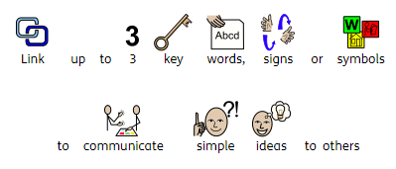
Name: |  |  |  | Teacher: |  |  |  |  | Date issued: May 2019

 |  | 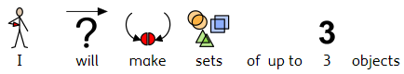  Mathematics |  |  |  | 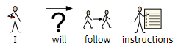  Languages, Literacy and Communication
 |  | 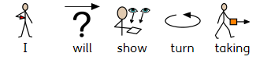
 |  | 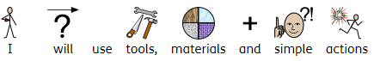

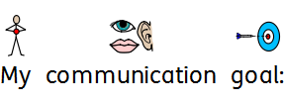

Appendix 1- IEP

*Name changed for anonymity

Learning together in a changing world

Creating Success for All

Keys to Success

Going for Gold!
Anelu am aur!
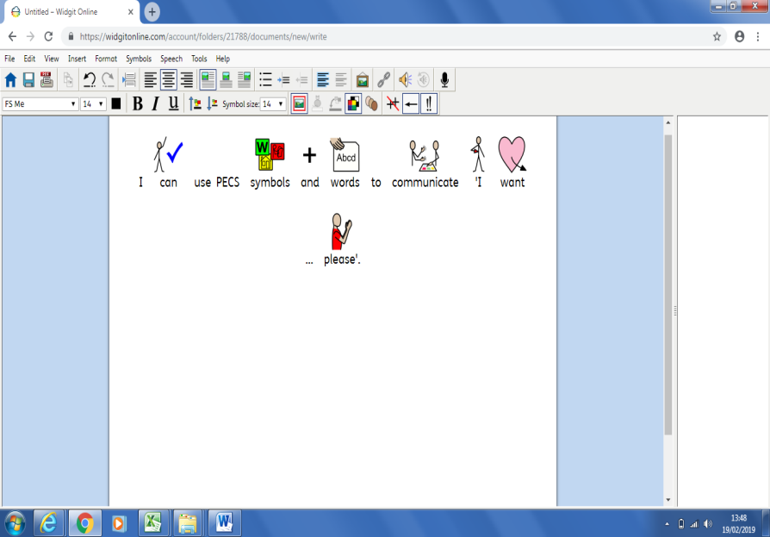

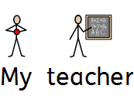
K- ‘Know’…You can do it! –  Ambitious, Capable Learners  (Mathematics, Language, Literacy and Communication: inc Welsh) | Max to show he can follow instructions with 3 key words, signs or symbols given on an individual basis.  (Task to be completed four times a week. 3/4 times correct.) | Listening P6
 | Max to show he can make sets of up to 3 objects.  (Task to be completed three times a week. 2/3 times correct.) | Number  P6
E- ‘Enjoy’ life and be happy!  Healthy, Confident Individuals  (Health and Wellbeing, THRIVE, Multi agency links) | Max to show turn-taking in familiar situations with minimal prompts. (Task to be completed five times a week. 3/5 times correct.) | Attention  P8
Y- ‘Yourself’ …Be ready for life!  Creative, Enterprising, ethical informed citizens  (Digital Competency, Independence, Transition, Work Awareness | Max to use tools, materials and simple actions to produce a piece of work. (Task to be completed twice a week. 2/2 times correct.) | Art and Design  P6
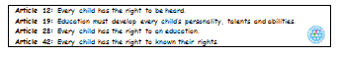

Appendix 2 - School Report for Person Centred Review
*Name changed for anonymity

“Know” …  You can do it!  Ambitious, Capable Learners  (Mathematics, Language, Literacy and Communication: inc. Welsh) | Comments/Assessments  Max follows instructions containing key words, for example, put the bowls on the table ready for snack. Max is able to select objects by function, for example, choosing a toothbrush to brush his teeth. Max combines single words or uses symbols to communicate meaning and engages in simple two-way conversations. Max listens and engages with stories with increasing attention. Max derives some meaning from a book and indicates what it is about. He uses picture cues when sharing a book. He shows interest in the content of a book and demonstrates ‘reading like’ behaviour. Max communicates ideas for scribing with adult support. For example, he will make a choice out of symbols for his News work. Max shows greater control in the use of fine motor skills in a range of activities. He can trace, overwrite or copy shapes and straight line patterns.  Max’s K IEP literacy Target this term focuses on speaking; he will be demonstrating he uses a vocabulary of over 50 words.  PIVATS  - Listening P5b  - Speaking P5c  - Reading P5a  - Writing P5b
Annual Aim: To be able to represent his name using letters or symbols (Writing P6)

“Enjoy” life and be happy!  Health, Confident Individuals  (Health and Wellbeing, THRIVE, Multi agency links) | Comments/Assessments  Max engages in regular physical activity beneficial to his health and well-being. He takes part in PE sessions every week and has access to the specialist facilities on a weekly basis, such as the hydrotherapy pool, splash pool, ball pool and trampoline that enhance his motor development skills.  Max has taken part in activities that cover the breadth of scientific enquiry, life processes and living things, materials and their properties and physical processes. Max can name simple objects, such as ‘egg’. He carries out simple verbal instructions, such as, get your diary. Max remembers events, for example, going to snack cupboard to get raisins.  Max recognises distinct features of objects. Max will repeat actions and modify them, for example, using a skateboard without support, then after losing balance; holding on to the wall to be able to skate.  PIVATS  Scientific enquiry P6b  Life processes and living things P6b  Materials and their properties P6c  Physical processes P6b  Max’s E IEP target this term involves him taking part in Attention Autism sessions designed by Gina Davies, a Specialist Therapist.
Annual Aim: Science- Confirm suggestions about what will happen (P6b)

“Yourself” …  Be ready for life!  Creative, Enterprising, Ethically Informed Citizens.  (Digital Competency, Independence, Transition, Work Awareness | Comments/Assessments  Max uses ICT to select and group objects, letters or images. Max will use ICT devises independently, for example the oculus and IPad. Max can make connections between devices and information on screen. Max can pick out shapes, symbols or characters.  PIVATS:  Finding things out P6c  Developing ideas and making things happen P5c  Exchanging and sharing information P6d  Max interacts with peers for work or play activities with adult support. Max shows initiative to take on a new or untried task. He will select and uses resources independently. Max can transfer his attention to a familiar task/activity. He can take part as a member of a group for a familiar or enjoyable joint activity with 1:1 support. Max understands that tasks/activities have simple routines with boundaries; and he will follow these rules with adult support.  PIVATS  Interacting and working with others P6c  Independent and organisational skills P8b  Attention P7a  Max’s Y IEP target this term focuses on developing his Independent and organisational skills; he be demonstrating he can use resources appropriately within activity.
Annual Aim: Link shapes, symbols and characters to communicate meaning (Developing ideas and making things happen P5c)

1b. Progress
What are the pupil’s strengths? What progress have they made over the last year?

e.g. Relationships with staff / peers. Communication skills – use of alternative communication aids. Perseverance. Arts / Sport / Music etc.
- Max likes familiar routines, a highly structured environment and following a visual schedule
- Using the trampoline
- Confidence in the water
- Using soft play equipment
- Use of IPad in ICT room
- Use of exercise ball outside

What is working?
What strategies are used to support pupil. Link to “What’s important to” and “What’s important for”.
- Max benefits from a small class setting
- Max benefits from a structured approach
- A range of activities for short periods of time
- Access to at least one of specialist rooms on daily basis; ball pool, light room, dark room, hydrotherapy pool, splash pool, ICT room and school library
- Max having time to himself
- Max has a high level of additional adult support which enables flexibility in response to Max’s behaviour and in relation to a bespoke package of activities.

What is not working? How could this be improved?

What isn’t going well? How do you know? What can be changed to make a positive difference? Attention Autism sessions have been introduced.

Provision to meet the pupil’s needs
2a. Please summarise the provision / resources put in place by school to address the pupil’s additional learning needs.
The structured class environment in class offers Max opportunities to work as a whole class, small group, in pairs and individually with an adult. Max also attends sessions including: Hydrotherapy, Rebound, PE, Music.

- Additional comments.

It has been a pleasure to observe the progress that Max has made in class. Max has developed strong relationships with both pupils and staff. Max is happy in school and actively takes part in a wide range of tasks and activities. Max likes going to all the specialist rooms, such as the ball pool, ICT room, light room, dark room, library, Touch Trust, swimming and the splash pool. Max has made progress in all areas of the curriculum and it has been a pleasure watching him develop his skills. Max has made measurable steps of progress in listening, speaking, reading, writing, using and applying, number, shape, space and measure, scientific enquiry, ICT, interacting and working with others, independent and organisational skills and attention in a range of activities.
This term Max has been completing activities linked to our topic of Pirates, Plans and adventures. For example, Max took part in ‘Talk like a pirate day’. In addition, Max has involved himself in Autumn themed activities, such as making hedgehog bread and a hedgehog collage using real leaves. Max has also explored Autumn fruit vegetables, such as apples, pears, pumpkins and potatoes.
Max has taken part in special whole school events, such as the Harvest festival and Children in Need. We have got lots of activities to look forward to as well, such as the zoo lab and Christmas. Max is a valued member of the class and I look forward to continuing to support him develop his self-esteem, confidence, motivation and independence.
Due to Max’s extremely complex needs there have been a series of multi-agency meetings/workshops and discussions. These take place on a regular basis.

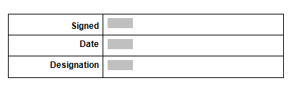

Appendix 3- Schedule
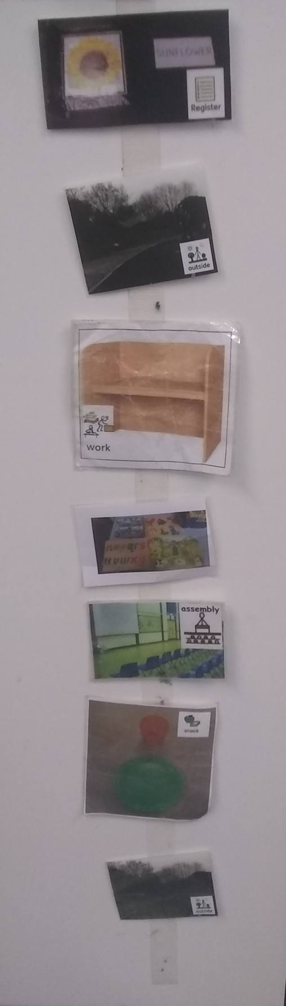

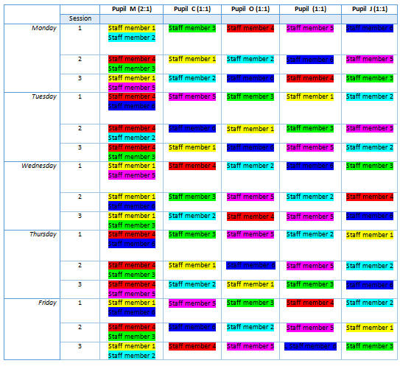
Appendix 4- Staff rota

Appendix 5- IEP recording sheet
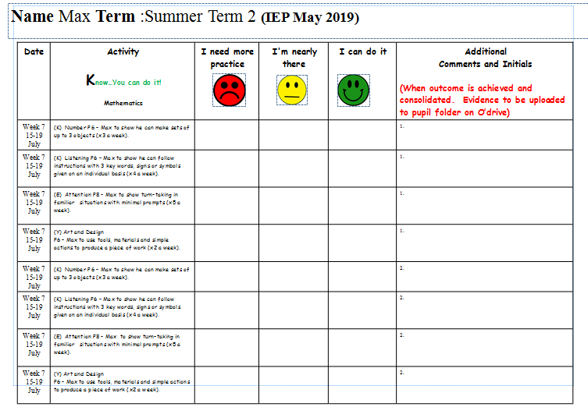
*Name changed for anonymity

Appendix 6 – Maslow’s Hierarchy of needs


Appendix 7- Individual Behaviour programme
*Name changed for anonymity

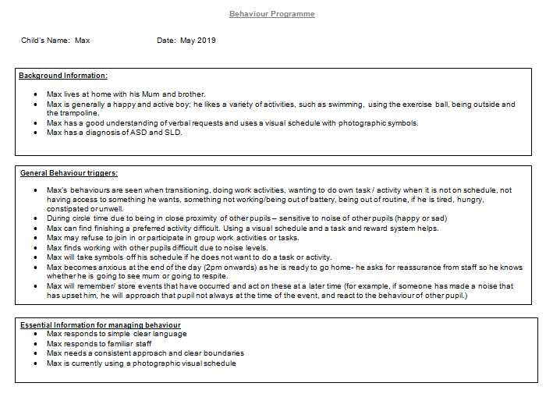

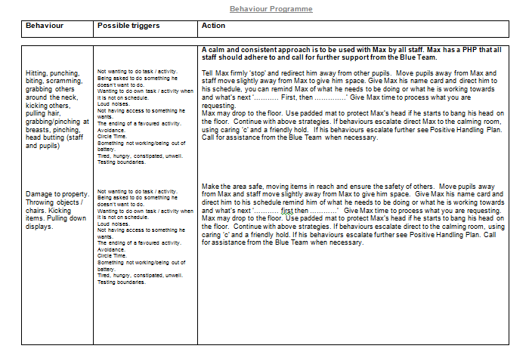
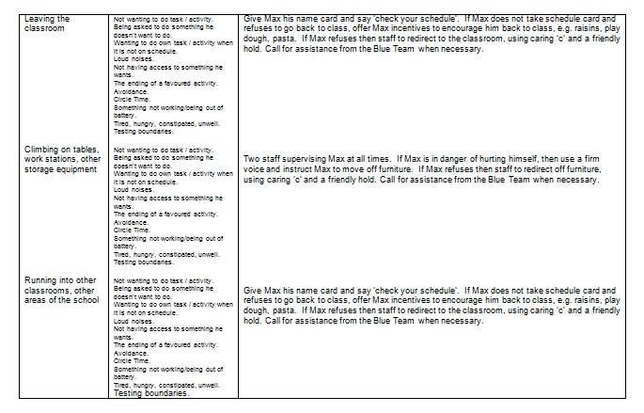
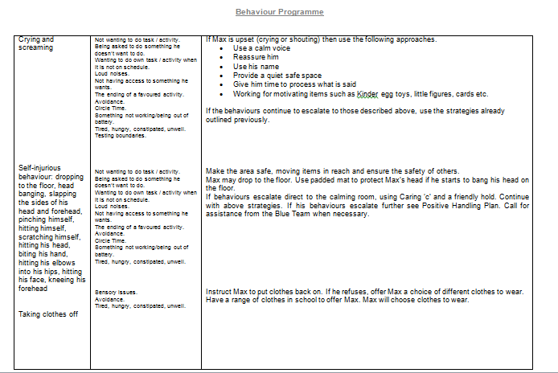

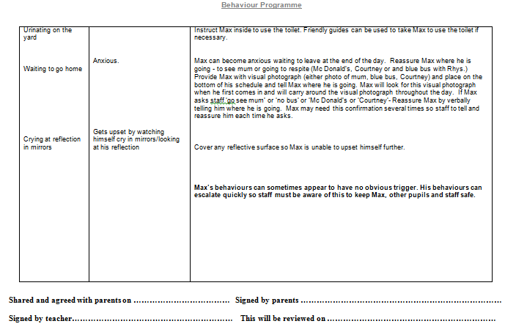

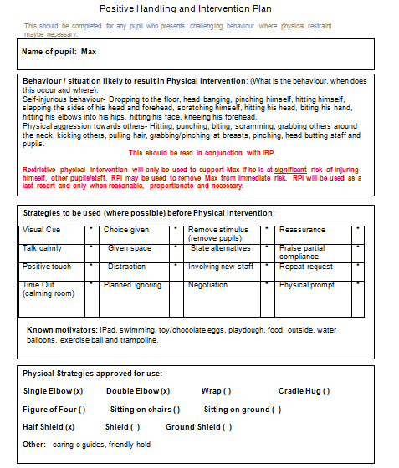
Appendix 8- Positive Handling Plan
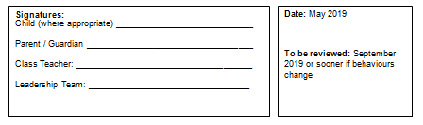
*Name changed for anonymity


