DS 1 Template

My Screenshots/Photos
- Please add 4–6 screenshots or photos of your digital life.
- You can use your phone or laptop.
- For each screenshot, write one or two sentences explaining what it shows.

Screenshot/Photo 1
Im using digital life for writing the my history in the magazine

Im using write the magazine for writing to my life history

Screenshot/Photo 2

im using my microphone to speak to audience about the event and artist to coming in london for consert

Screenshot/Photo 3
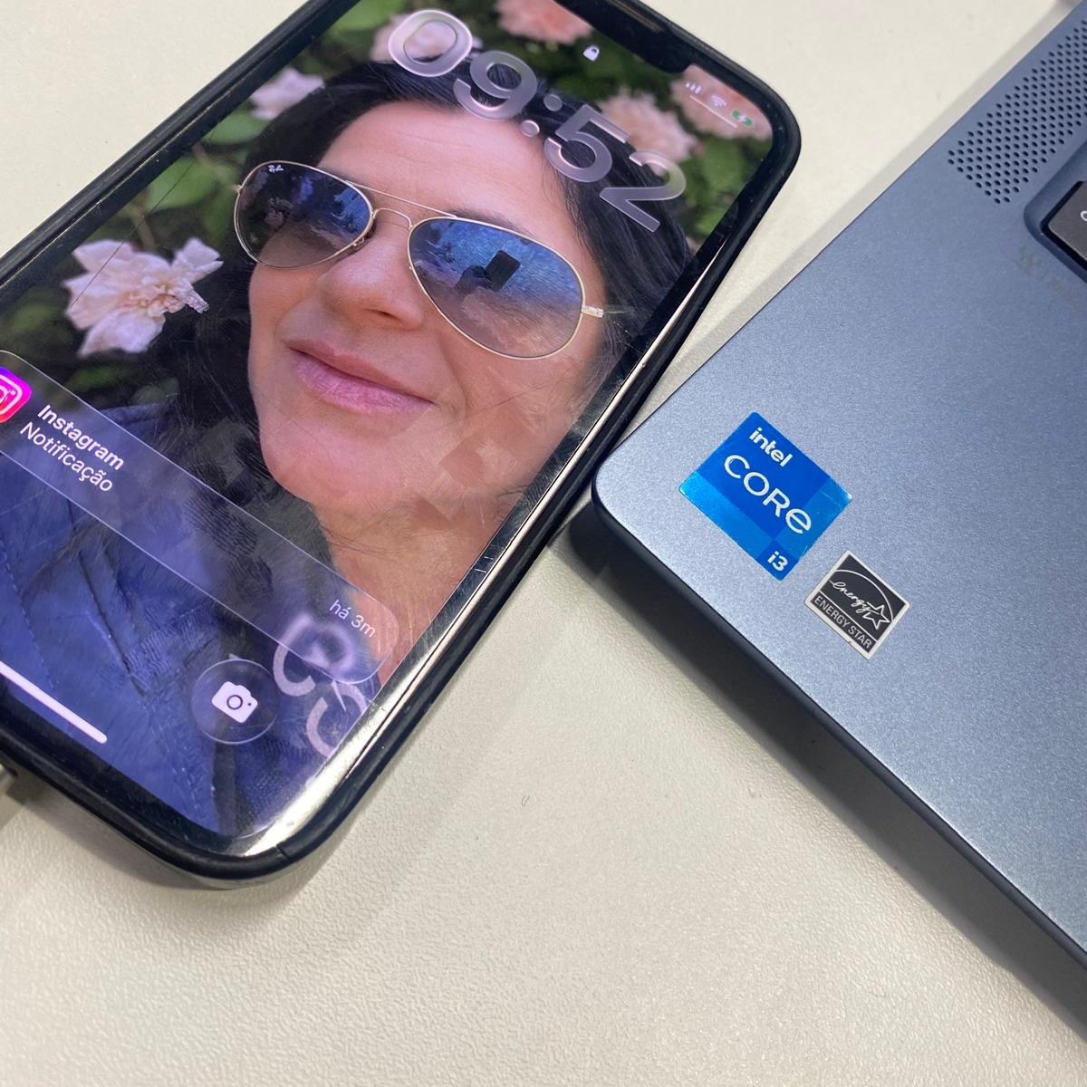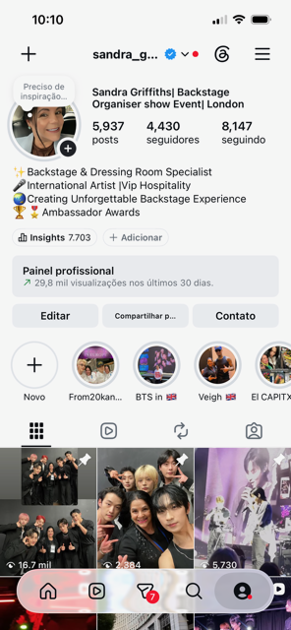
Im using my phone for my communications for family friends and job

Screenshot/Photo 4
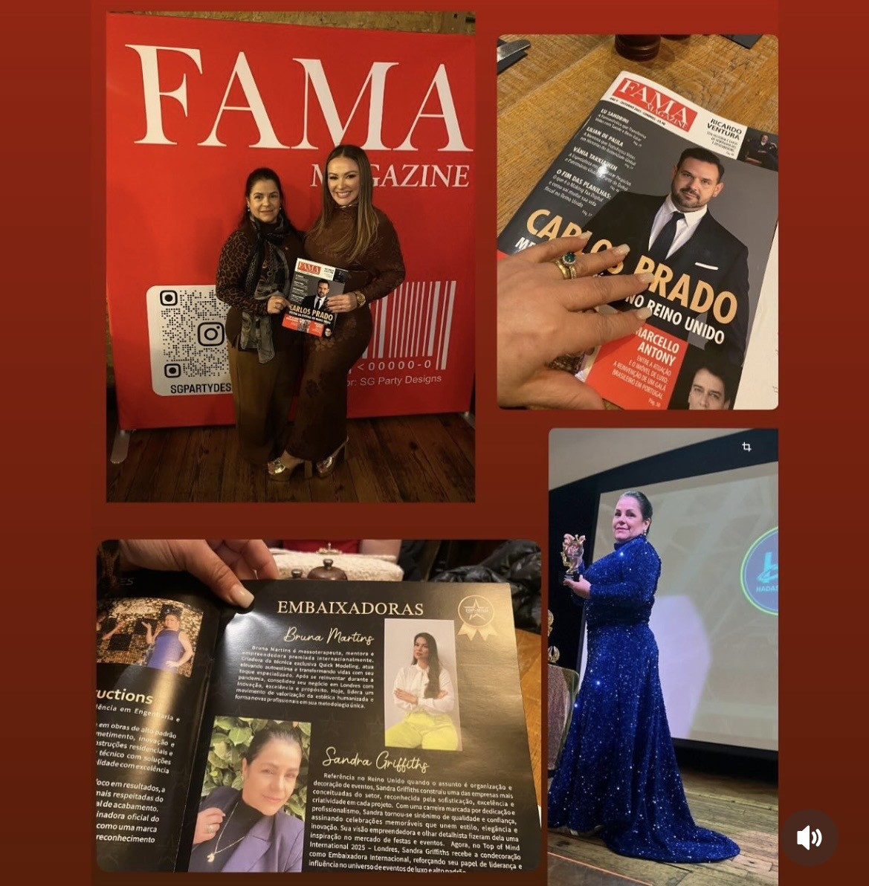
Im using digital life for write my history in the magazine, because im have secund chance for mu life again

My Short Reflection
- Write 5–8 simple sentences about your digital life.
- You can use the sentence starters below if helpful.

Sentence starters
- I use digital tools to …
- I feel confident when I …
- I want to improve …
- I often use these tools: …
- I sometimes feel nervous about …
- I hope this module will help me …
- Digital skills are important for me because …
You can write more if you want.

Submission Checklist
Before you submit, please check:
​​​ ☐ I added 4–6 screenshots
☐ I wrote short sentences for each screenshot
☐ I wrote my short reflection
☐ My work is my own
☐ My file opens correctly
​​☐ My file opens correctly

