Georgia Cox (2510065)

June 2026
Word Count: 5492
Design for Manufacture and
Assembly: Component
Optimisation
Manufacturing Design & Technology (ACMA5002)

Abstract
This report presents the design and optimisation of an injection-moulded TPU mobile phone case for high-volume manufacture. A structured engineering approach integrating Quality Function Deployment (QFD), Failure Modes and Effects Analysis (FMEA), CES material selection, mould flow simulation, and Element Analysis (FEA) was used to evaluate manufacturability, structural performance, and economic feasibility. Optimisation of wall thickness, gate configuration, and geometry refinement improved flow behaviour, thermal uniformity, and defect reduction while maintaining structural integrity under operational loading conditions. Although warpage remained constrained by the thin-walled TPU geometry, the final design achieved an effective compromise between dimensional stability, manufacturability, production efficiency, and cost. Economic analysis confirmed the suitability of injection moulding for large-scale production through low per-unit cost and rapid tooling cost recovery using multi-cavity moulding. Sustainability considerations including recyclability, waste reduction, and material efficiency further supported the final design. Overall, the project demonstrates a robust and commercially viable solution aligned with modern high-volume polymer manufacturing requirements.

Contents
Abstract 1
Table of Figures 4
1. Introduction 5
1.1. Purpose 5
1.2. Scope and Methodology 5
2. Literature Review 6
2.1. Design for Manufacture (DFM) Principles 6
2.2. Application of Injection 6
2.3. Simulation & Analysis Tools 7
2.4. Risk Management: QFD, FMEA and DOE 7
2.5. Material Selection and Sustainability 8
3. Define Customer Requirements 8
3.1. End User Requirements 9
3.2. Manufacturer Requirements 9
3.3. Environmental Requirements 9
3.4. QFD Application 10
3.5. FMEA 11
3.6. PESTLE 12
3.7. SWOT 12
4. Design and Development 13
4.1. 3D CAD Model 13
4.1.1. Geometry 14
4.1.2. Function 14
4.1.3. DFM Considerations 14
4.2. Material Selection 15
4.2.1. Translation 15
4.2.2. Development of Selection Criteria 16
4.2.3. Material Evaluation Using CES Graphs 17
4.2.4. Final Material Selection 22
4.4 Justification of Selection 22
5. Simulation and Validation 23
5.1. Fusion Plastic Simulation 23
5.1.1. Material Flow Analysis 24
5.1.2. Cooling and Shrinkage Analysis 26
5.1.3. Defect Mitigation and Manufacturability 28
5.1.4. Final Design Validation 30
5.2. Mould Calculations 31
5.2.1. Part Volume 31
5.2.2. Total Shot Volume 31
5.2.3. Sprue Diameter 31
5.2.4. Runner Dimensions 32
5.3. Finite Element Analysis (FEA) 32
5.3.1. Key Findings 33
5.3.2. Stress Distribution 33
5.3.3. Displacements 34
5.3.4. Strain Analysis 34
5.3.5. Safety Factor 35
5.3.6. Engineering Insights 35
5.3.7. Dimensional Accuracy 36
6. Cost Calculation Analysis 36
6.1. Manufacturing Process Plan 36
6.2. Cost Analysis 36
7. Sustainability Considerations 38
7.1. Material Recyclability 38
7.2. Process Energy Efficiency 38
7.3. Waste Reduction 38
8. Discussion and Recommendations 39
8.1. Comparison with Requirements 39
8.2. Trade-Offs and Design Decisions 39
8.3. Limitations and Future 39
8.4. Recommendations 40
9. Conclusion 40
References 41

Table of Figures
Figure 1. Booz, Allen, and Hamilton’s New Product Process (Booz-Allen and Hamilton, 1982). 6
Figure 2. Kano Model (University of Cambridge, 2016) 9
Figure 3. QFD 10
Figure 4. FMEA 11
Figure 5. PESTLE 12
Figure 6. SWOT 12
Figure 7. CAD Drawing (Autodesk, 2026). 13
Figure 8. CAD drawings with dimensions (Autodesk, 2026). 13
Figure 9. Material selection methodology (Cebon, 2007) 15
Figure 10. Young’s modulus vs density (ANSYS Granta, 2026). 17
Figure 11. Tensile strength vs Young’s modulus (ANSYS Granta, 2026). 18
Figure 12. Tensile strength vs elongation showing material deformation capability (ANSYS Granta, 2026). 18
Figure 13. Young’s modulus vs price (ANSYS Granta, 2026). 19
Figure 14. Maximum service temperature vs price (ANSYS Granta, 2026). 20
Figure 15. Elongation vs Young’s modulus (ANSYS Granta, 2026). 20
Figure 16. Tensile strength vs elongation (ANSYS Granta, 2026). 21
Figure 17. Comparison of fill confidence (Autodesk, 2026). 25
Figure 18. Comparison of fill time (Autodesk, 2026). 25
Figure 19. Comparison of injection pressure (Autodesk, 2026). 25
Figure 20. Comparison of flow-front temperature (Autodesk, 2026). 26
Figure 21. Comparison of shrinkage (Autodesk, 2026). 27
Figure 22. Comparison of warpage (Autodesk, 2026). 27
Figure 23. Comparison of air traps (Autodesk, 2026). 29
Figure 24. Comparison of weld lines (Autodesk, 2026). 29
Figure 25. Von Mises Stress (Autodesk, 2026). 33
Figure 26. Displacement (Autodesk, 2026). 34
Figure 27. Safety Factor (Autodesk, 2026). 35
Figure 28. Manufacturing Process Plan 36

Introduction

Purpose
This report presents the design and optimisation of an injection moulded mobile phone case for high-volume production while maintaining low unit cost, dimensional accuracy, and surface quality. Injection moulding is widely used for mass production due to its repeatability and efficiency (Czepiel, Bańkosz and Sobczak-Kupiec, 2023); however, thin-walled components such as phone cases are susceptible to defects including warpage, sink marks, weld lines, and air entrapment. These defects can increase material waste, extend cycle time, and reduce both functional and aesthetic performance. Therefore, this report aims to systematically identify, analyse, and mitigate these issues through an integrated design and manufacturing approach, ensuring a robust and economically viable product suitable for large-scale production.

Scope and Methodology
This project follows a structured new product development framework based on the Booz-Allen and Hamilton process, incorporating strategy development, idea generation, evaluation, development, testing, and commercialisation (Fortenberry, 2013). As shown in Figure 1, this approach reduces risk by progressively evaluating decisions before significant investment. The project incorporates CAD-based design, QFD to translate customer requirements, FMEA to identify potential failures, mould flow simulation to evaluate filling behaviour and defect formation, FEA to assess structural performance, and CES for material selection. The final design is validated through simulation and cost analysis, demonstrating improved manufacturability, structural integrity, and suitability for large-scale production.
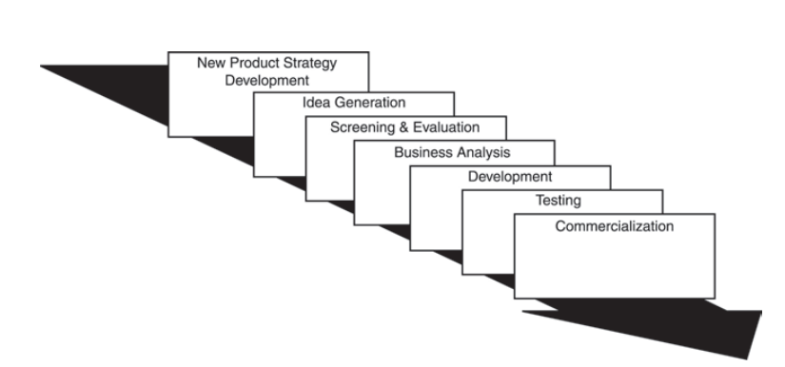
Figure 1. Booz, Allen, and Hamilton’s New Product Process (Booz-Allen and Hamilton, 1982).

Literature Review

Design for Manufacture (DFM) Principles
DFM focuses on optimising product design to simplify production, reduce cost, and improve quality by considering manufacturing constraints at an early stage. This includes minimising part complexity, ensuring uniform wall thickness, and designing for efficient material flow to prevent defects and improve cycle time. Effective DFM implementation can significantly reduce production costs and improve repeatability, particularly in high-volume manufacturing (Six Sigma, 2024).
For injection-moulded components such as phone cases, DFM requires careful consideration of draft angles, radii, and wall thickness distribution to minimise defects such as warpage, sink marks, and residual stresses. Early integration of these principles ensures that design decisions directly support manufacturability and process efficiency.

Application of Injection
Injection moulding remains the dominant manufacturing process for polymer consumer products due to its ability to produce complex geometries with high dimensional accuracy and surface quality at scale (Rosato and Rosato, 2012). However, thin-walled components such as phone cases introduce challenges including non-uniform cooling, material flow instability, and defect formation.

Simulation & Analysis Tools
The use of computer-aided engineering tools has become essential in modern product development, enabling virtual validation of manufacturability and performance prior to tooling. Mould flow simulation allows analysis of filling behaviour, temperature distribution, and defect formation, supporting optimisation of geometry and processing conditions.
FEA provides insight into stress distribution, deformation, and structural integrity under operational loads, supporting material selection and design validation (Ashby, 2017). These tools reduce development time, minimise prototyping costs, and improve product reliability through iterative optimisation.

Risk Management: QFD, FMEA and DOE
QFD and FMEA are critical tools for structured product development, linking customer requirements to engineering design and manufacturing decisions. QFD translates customer needs into measurable technical specifications, ensuring that design priorities align with user expectations and product performance (Hessing, 2013). The combined application of QFD and FMEA has been shown to improve decision-making in manufacturing systems (Reda and Dvivedi, 2021).
FMEA systematically identifies potential failure modes and evaluates risk based on severity, occurrence, and detection, allowing targeted design improvements to reduce failure likelihood (Arnab Chakrabarty, Mannan and Tahir Cagin, 2016). The integration of QFD and FMEA enable a proactive approach to risk reduction, ensuring that critical failure modes are addressed early in the design process.
Design of Experiments (DOE) is a structured approach used to analyse and optimise the relationship between process variables and performance (Defeo, 2017); however, it was not applied in this study as the design focuses on a single-component part rather than complex assembly interactions requiring multi-parameter optimisation.

Material Selection and Sustainability
For polymer products, materials must balance mechanical properties such as flexibility and impact resistance with processing requirements and economic constraints (Ashby, 2017). Market analysis indicates that thermoplastic polyurethane (TPU) and polypropylene (PP) are widely used in the manufacture of protective phone cases due to their favourable combination of mechanical performance and manufacturability (Amazon, 2026). Studies comparing the two materials indicate that TPU provides superior flexibility, elastic recovery, and impact absorption, making it highly suitable for protective consumer products, whereas PP offers advantages in lower cost, dimensional rigidity, and ease of processing during high-volume injection moulding (Lin, Lin and Bao, 2021).
While PP benefits from established recycling infrastructure and lower processing costs, TPU offers improved wear resistance, flexibility, and impact durability, extending product lifespan and contributing to lifecycle sustainability despite the greater complexity associated with TPU recycling. However, repeated reprocessing of TPU can degrade mechanical properties, requiring controlled processing conditions to maintain performance (Lin, Lin and Bao, 2021).

Define Customer Requirements
Customer requirements were identified using a market-oriented approach to ensure that both user expectations and manufacturing constraints are addressed. Understanding customer needs is critical at the early stages of product development, as these requirements directly influence design decisions, material selection, and manufacturing strategy.
The Kano model provides a simple ranking framework that distinguishes between essential and differentiating product attributes. It is an effective tool for visualising product characteristics and supporting discussion and decision-making within the design process (University of Cambridge, 2016).

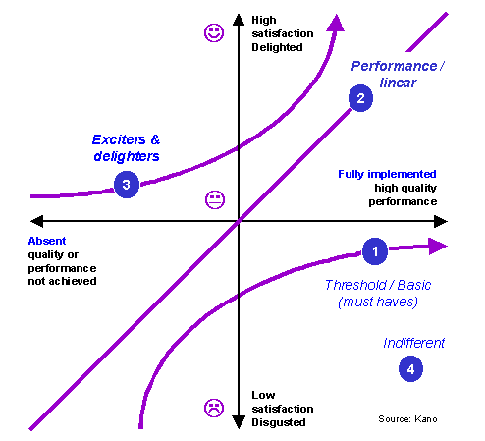
Figure 2. Kano Model (University of Cambridge, 2016)

End User Requirements
- Protection from drops
- Lightweight
- Aesthetic quality
- Durability

Manufacturer Requirements
- Manufacturability for high-volume production
- Design and mould configuration that minimises defects
- Balance between material performance and cost-effectiveness
- Incorporation of sustainable materials and processes
- Short cycle time to maximise production efficiency
- Low scrap rate to reduce waste and cost
- High-dimensional repeatability to ensure consistent quality

Environmental Requirements
- Use of recyclable materials
- Minimisation of production waste
- Energy-efficient manufacturing process

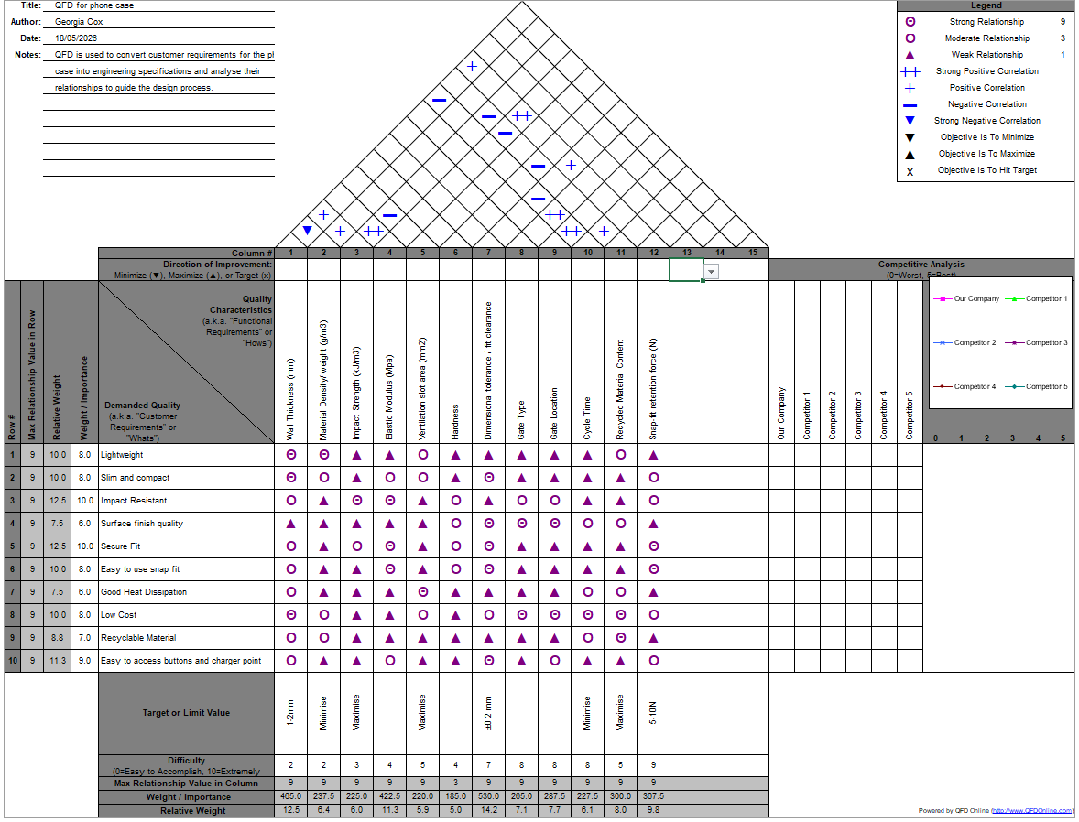
QFD Application
A QFD was utilised to translate customer needs into measurable technical specifications.

Figure 3. QFD

The QFD analysis identifies impact resistance and secure fit as the primary design drivers, confirming that protection and retention are critical customer requirements. Secondary requirements such as lightweight design, low cost, and ease of use emphasise the need to balance performance with user comfort and market competitiveness. Key engineering parameters, including wall thickness, material strength, and dimensional tolerance, were found to have the greatest influence on multiple requirements, while process factors such as gate design and cycle time are critical for manufacturing efficiency. The analysis highlights key trade-offs, particularly between increased wall thickness, improving strength, but increasing weight and cycle time. Overall, the QFD demonstrates that an effective design requires optimisation between mechanical performance, manufacturability, and cost, directly informing key design decisions such as wall thickness, material selection, and geometry.

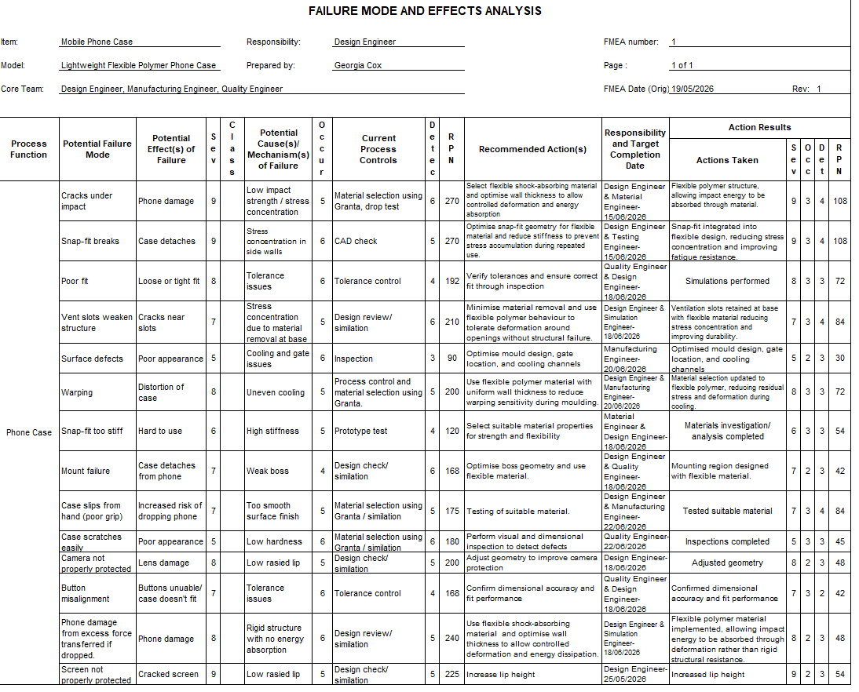
FMEA
Figure 4. FMEA
The FMEA identified key risk areas, with the highest RPN values associated with impact damage, snap-fit failure, and poor dimensional fit, indicating that structural integrity, energy absorption, and tolerance control were critical design concerns. These findings directly highlighted weaknesses in material stiffness, stress concentration at features, and cooling-induced distortion during manufacture.
Following implementation of targeted design changes such as the use of flexible TPU, optimisation of wall thickness and geometry, and improved tolerance control-the occurrence and detection ratings were significantly reduced. This demonstrates that the design modifications directly addressed the root causes of failure, improving durability, manufacturability, and reliability.

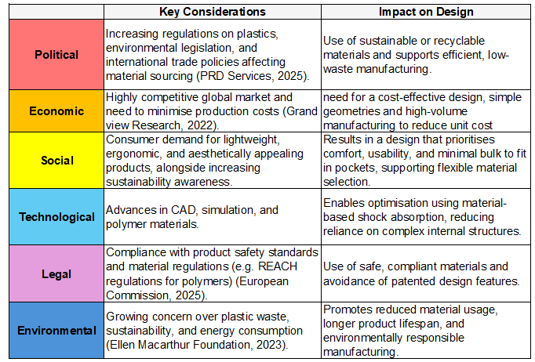
PESTLE
Figure 5. PESTLE

SWOT
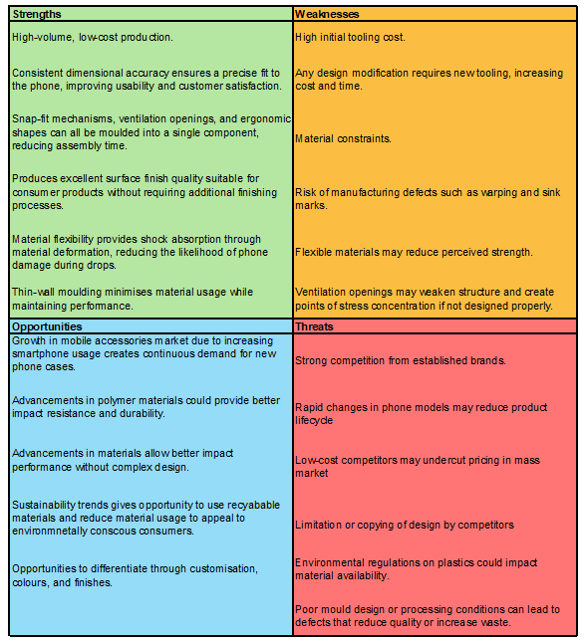
Figure 6. SWOT

Design and Development

3D CAD Model
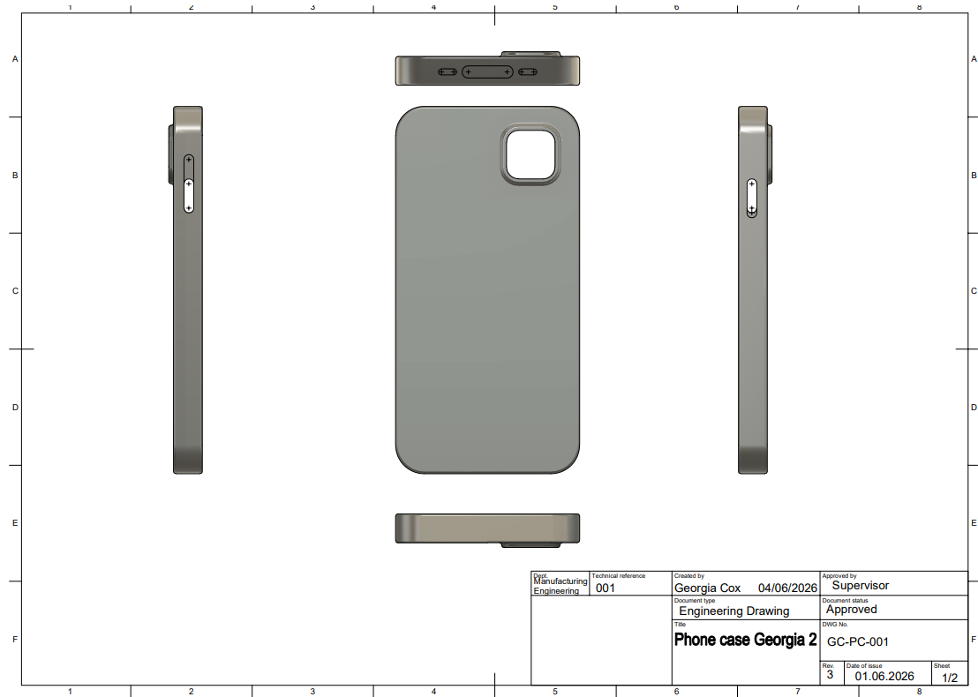
Figure 7. CAD Drawing (Autodesk, 2026).
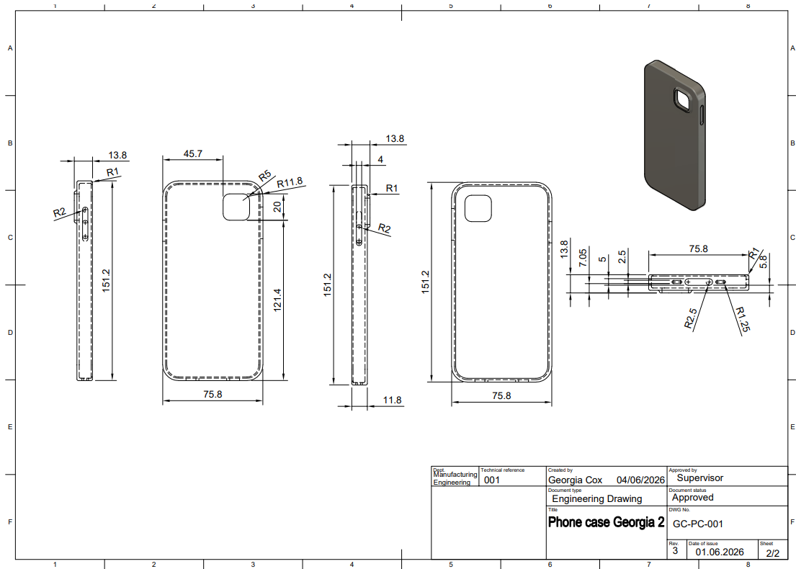
Figure 8. CAD drawings with dimensions (Autodesk, 2026).

Geometry
The geometry of the phone case was optimised to balance structural performance, manufacturability, and user requirements. A uniform wall thickness of 2 mm was implemented to ensure consistent cooling and minimise shrinkage-related defects such as warpage and sink marks. Rounded edges and filleted transitions reduce stress concentrations and improve material flow during moulding while enhancing impact energy distribution during use. Openings for ports, buttons, and camera features are designed to maintain functionality while minimising disruption to structural integrity and flow behaviour.

Function
The design provides effective protection through energy absorption rather than resistance to deformation, aligning with the selection of a flexible TPU material. The case maintains device stability through a secure snap-fit mechanism while allowing controlled deformation during installation and removal. Raised edges around critical regions, such as the screen and camera, improve protective performance. Ergonomic considerations, including grip and edge curvature, further enhance usability and reduce the likelihood of accidental drops.

DFM Considerations
DFM principles were integrated throughout the design process to ensure efficient high-volume production. Uniform wall thickness and simplified geometry reduce the likelihood of defects such as weld lines, air traps, and uneven cooling. Gate placement and flow paths were optimised to ensure consistent filling, while the inclusion of draft angles supports efficient ejection and reduces tooling wear. The design is also compatible with a multi-cavity mould configuration, significantly increasing production efficiency and lowering unit cost. These considerations demonstrate a strong alignment between product design and manufacturing capability.

Material Selection
The design brief was translated into engineering requirements using the methodology outlined by Cebon (2007), which converts functional needs into quantifiable material properties and design parameters.
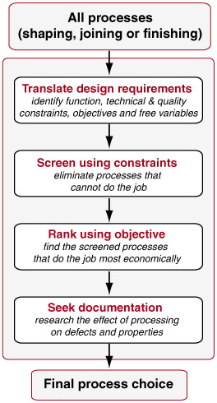
Figure 9. Material selection methodology (Cebon, 2007)

Translation
Function | Protect a smartphone by absorbing impact and resisting abrasion.
Constraints | Impact resistant, rigidity to hold shape and grip phone, thin, lightweight, suitable for injection moulding, resistant to moisture, swear, skin oils and UV. Non-toxic, skin safe and no softening under normal use (0-40c)
Objectives | Minimise cost while maintaining high impact resistance and light weight, and recyclable.

Initial screening using the CES Granta database identified a wide range of candidate materials, including thermoplastics and elastomers, which I had to then filter to meet the specification. At the early stage of the design process, polycarbonate was considered a potential material due to its high strength, durability, and widespread use in impact-resistant products. However, further evaluation was required to determine whether this strength translated into effective protection for the specific application.

Development of Selection Criteria
Material selection limits were developed by integrating findings from FMEA, QFD, SWOT, and PESTLE analyses to ensure the final choice met both functional and external requirements. The FMEA identified critical risks including cracking, insufficient energy absorption, and snap-fit failure, indicating that materials must exhibit low stiffness and high elongation to absorb impact energy. QFD analysis highlighted customer requirements for protection, lightweight design, and comfort, reinforcing the need for flexible materials with good grip. SWOT analysis identified brittle materials as a weakness and emphasised the opportunity to improve performance through energy-absorbing polymers, while PESTLE analysis introduced constraints such as cost efficiency, recyclability, and suitability for high-volume injection moulding.
These combined factors led to the application of limits prioritising moderate strength, low modulus, high elongation, acceptable cost, and sufficient thermal stability for use during charging and sunlight exposure.
Limits:
- Density: ≤1400 kg/m³
- Young’s Modulus: 0.01-1.5 GPa
- Tensile Strength: ≥25 MPa
- Yield Strength: ≥10 MPa
- Elongation: ≥100%
- Maximum Service Temperature: ≥60°C
- Price: ≤ £6/kg
- Additional Requirements: Injection mouldable, recyclable, and good UV resistance

Material Evaluation Using CES Graphs

Young’s Modulus vs Density
The Young’s modulus vs density graph is used to assess the relationship between material stiffness and weight, which is critical for a phone case that must remain lightweight while effectively absorbing impact energy.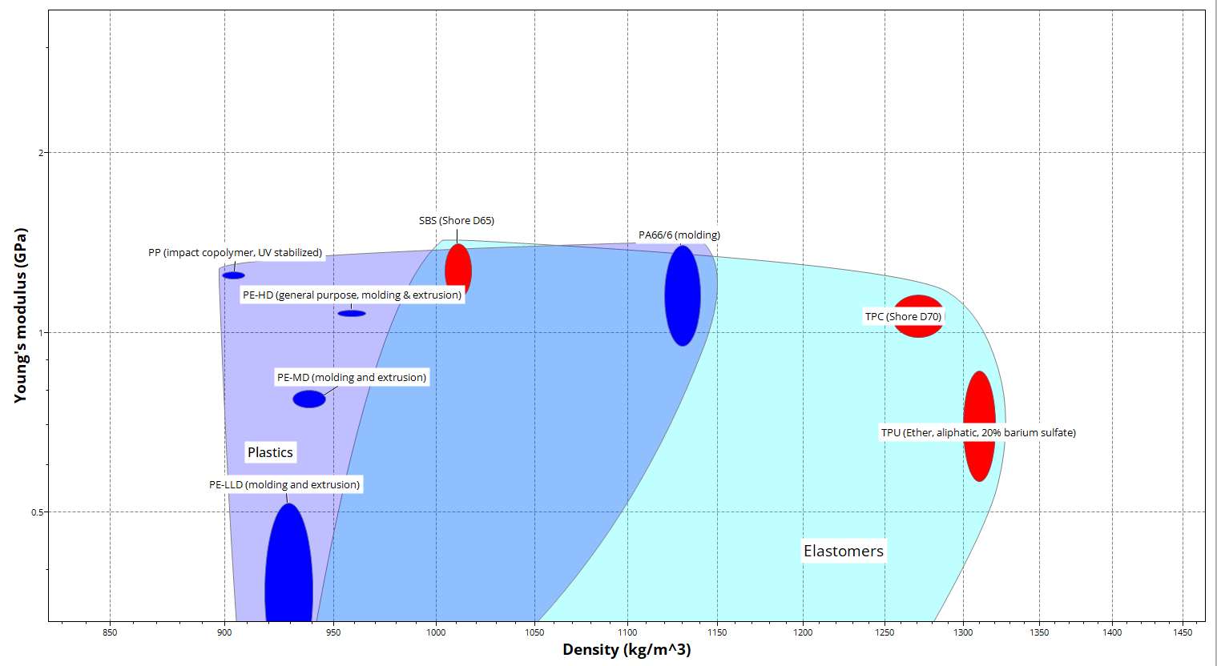
Figure 10. Young’s modulus vs density (ANSYS Granta, 2026).
This demonstrates that TPU is more capable of deforming under impact, whereas rigid plastics are more likely to transfer forces directly to the device.

Tensile Strength vs Young’s Modulus
The tensile strength vs Young’s modulus graph evaluates the balance between material strength and stiffness, which is essential in determining whether a material can withstand loads without failing while still allowing sufficient deformation for impact absorption.

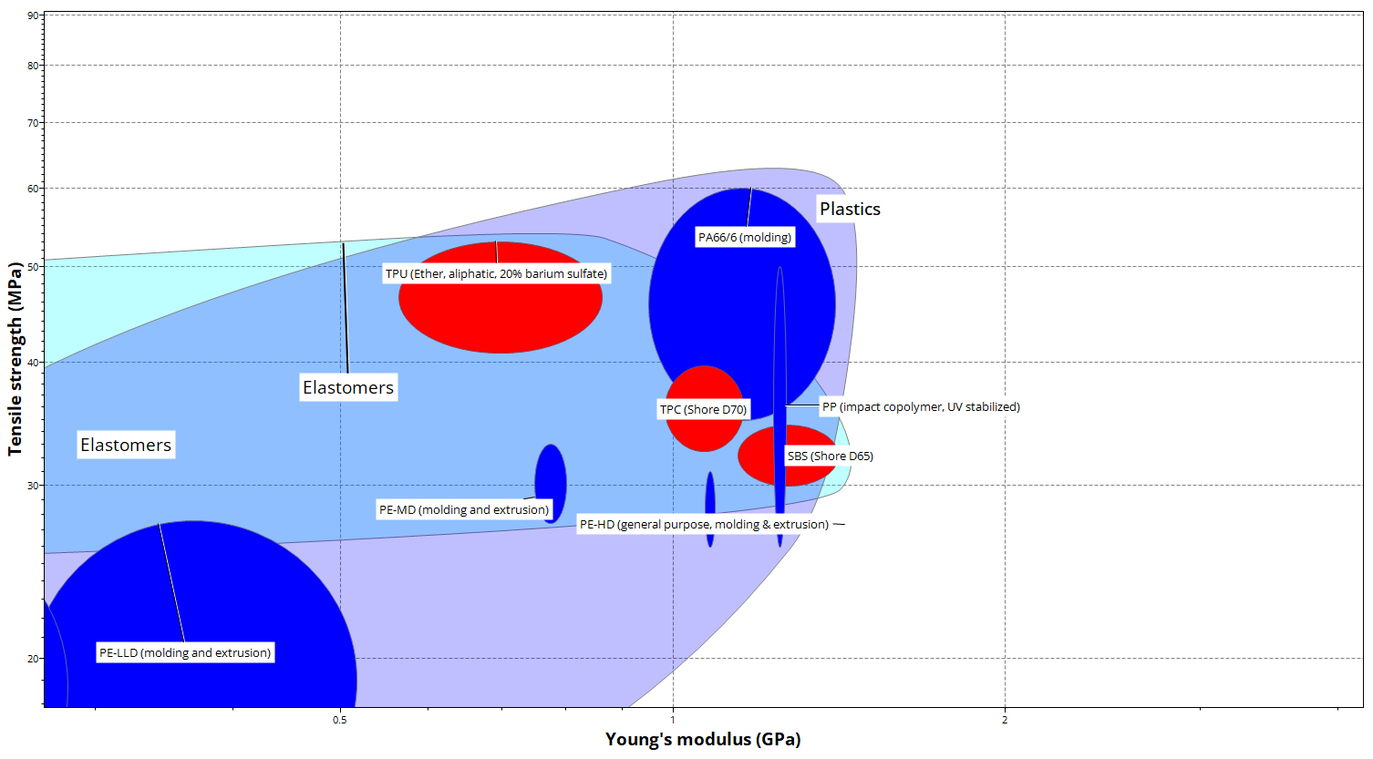

Figure 11. Tensile strength vs Young’s modulus (ANSYS Granta, 2026).
This indicates that TPU provides a better combination of strength and flexibility, reducing the likelihood of brittle failure.

Tensile Strength vs Elongation
The tensile strength vs elongation graph assesses the ability of a material to withstand stress while undergoing deformation, which is directly relevant to the phone case’s ability to absorb energy during drop events without fracturing.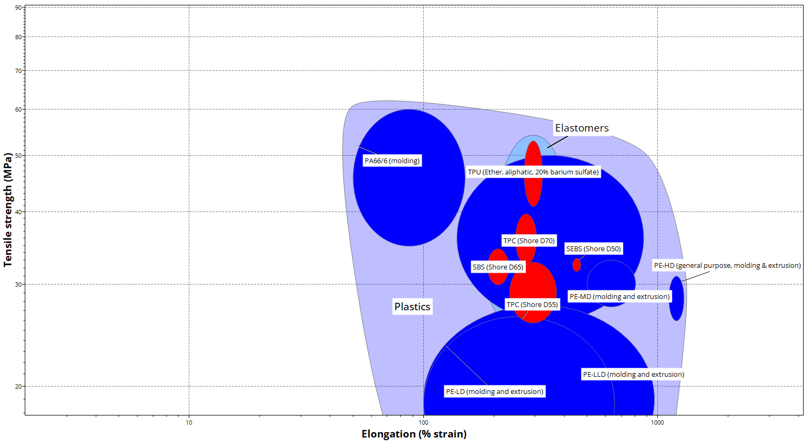
Figure 12. Tensile strength vs elongation showing material deformation capability (ANSYS Granta, 2026).
TPU exhibits significantly higher elongation, allowing it to absorb energy during impact by deforming, whereas materials such as PP and PC exhibit lower elongation and are more prone to cracking.

Young’s Modulus vs Price
The Young’s modulus vs price graph is used to evaluate the cost–performance trade-off, ensuring that materials selected provide the required mechanical behaviour while remaining economically viable for high-volume production.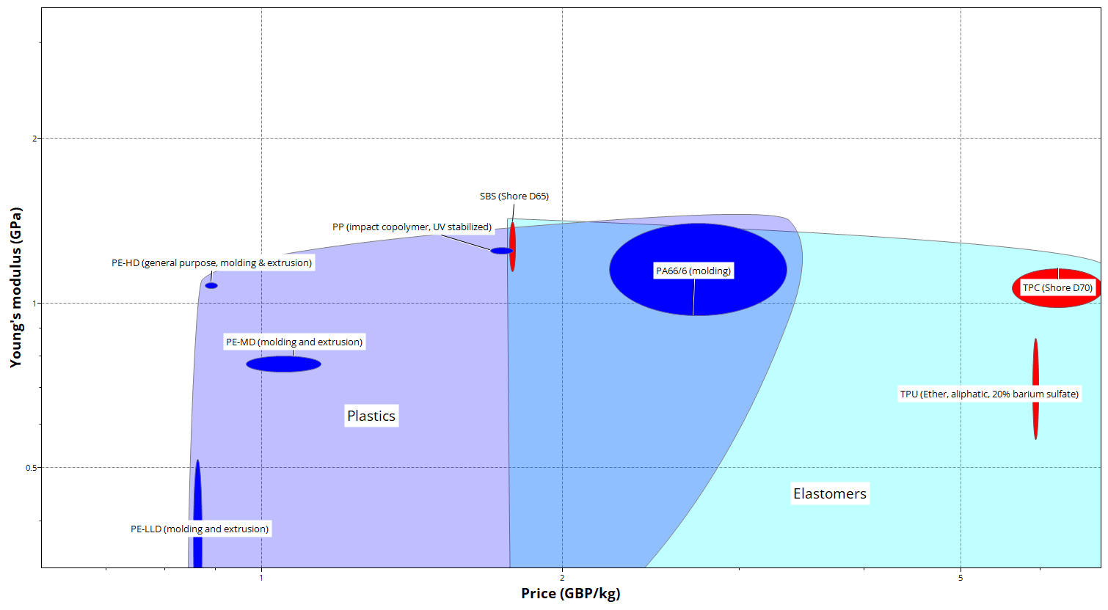
Figure 13. Young’s modulus vs price (ANSYS Granta, 2026).
Although PP provides lower cost, it does so at the expense of increased stiffness. TPU, while more expensive, but still within limit, provides superior mechanical performance aligned with the design requirements.

Maximum Service Temperature vs Price
The maximum service temperature vs price graph assesses whether candidate materials can maintain performance under thermal conditions encountered during use, such as heat generated during charging and exposure to sunlight, while remaining cost-effective.

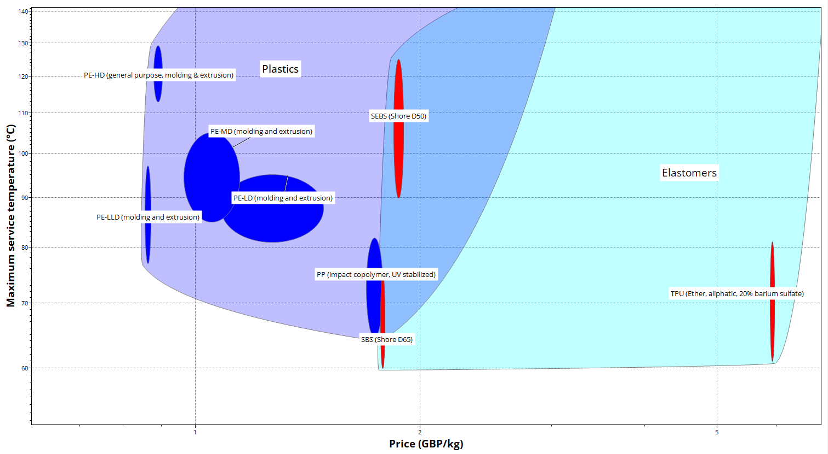

Figure 14. Maximum service temperature vs price (ANSYS Granta, 2026).
This demonstrates that all shortlisted polymers provide sufficient thermal resistance to withstand heat generated during device charging and exposure to sunlight. Therefore, thermal performance does not act as a limiting factor in material selection, allowing greater emphasis to be placed on mechanical behaviour such as flexibility and energy absorption.

Elongation vs Young’s Modulus
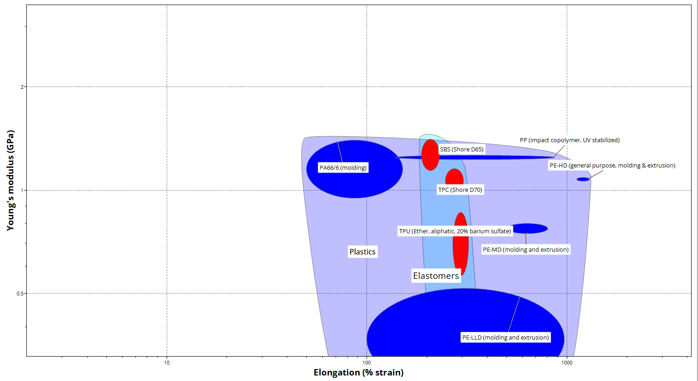
The elongation vs Young’s modulus graph is used to identify materials capable of combining flexibility with deformability, which is essential for a phone case to absorb impact energy and reduce stress transmission to the device.

Figure 15. Elongation vs Young’s modulus (ANSYS Granta, 2026).
TPU lies within the region of low stiffness and high elongation, enabling the material to deform under impact and absorb energy during drop events, thereby reducing the transmission of forces to the device. In contrast, rigid thermoplastics fall outside this region, where limited deformation results in greater stress transfer and increased risk of damage to the phone.

Tensile Strength vs Elongation
The tensile strength vs elongation graph provides a comparison of deformation capacity and structural integrity, allowing evaluation of how well materials can absorb impact energy while maintaining sufficient strength for durability in use.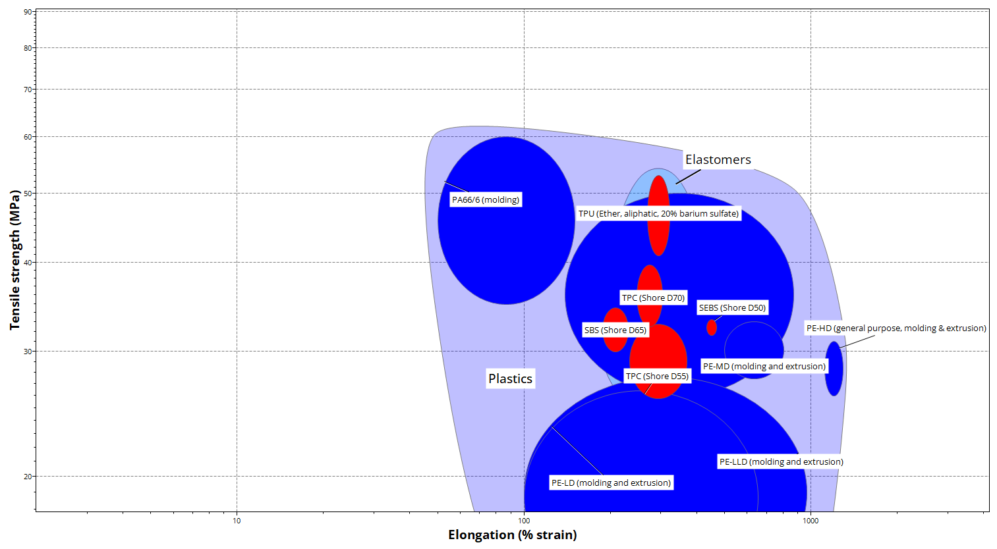
Figure 16. Tensile strength vs elongation (ANSYS Granta, 2026).
Materials such as TPU occupy a region characterised by high elongation and sufficient tensile strength, indicating their ability to deform significantly under load while maintaining structural integrity. In contrast, rigid plastics exhibit lower elongation, limiting their ability to absorb energy. This confirms that TPU is better suited to the application, as it can dissipate impact energy during drop events, reducing the risk of damage to the device.

Final Material Selection
Based on the systematic evaluation of CES material selection charts and integration of FMEA, QFD, SWOT, and PESTLE analyses, the material selection process converged towards thermoplastic elastomers as the most appropriate material class for the application. Unlike conventional rigid thermoplastics, these materials demonstrate the ability to accommodate deformation and dissipate energy under impact loading conditions. From within this class, Thermoplastic Polyurethane (TPU) emerged as the optimal material, as it consistently occupies regions of favourable mechanical behaviour across all relevant property charts.

4.4 Justification of Selection
For a mobile phone case, the primary functional requirement is to minimise damage to the device during impact events, rather than simply resist deformation. TPU provides a superior response to this requirement by exhibiting low stiffness and high elongation, enabling the material to undergo controlled deformation and absorb impact energy during drops. This behaviour reduces peak stress transmission to the phone, directly addressing the failures identified in the FMEA, including cracking and device damage.
TPU maintains sufficient tensile strength to ensure durability under repeated use, handling, and snap-fit assembly, preventing material failure over the product lifecycle. Its inherent surface characteristics also provide increased friction, improving user grip and reducing the likelihood of accidental drops, which aligns with key customer requirements.
From a manufacturing perspective, TPU is fully compatible with injection moulding, allowing efficient production of complex geometries at high volumes while maintaining consistency and quality. Its thermoplastic nature further supports recyclability and compliance with environmental and regulatory considerations, as identified in the PESTLE analysis.

Simulation and Validation

Fusion Plastic Simulation
The simulation and validation stage was conducted to evaluate the manufacturability, structural performance, and defect susceptibility of the injection moulded TPU smartphone case prior to production. Autodesk Fusion 360 simulation tools were used to investigate polymer flow behaviour, filling characteristics, cooling performance, warpage, and structural response under impact loading conditions. Simulation formed a key part of the DFM approach by enabling manufacturing risks and potential defects, including weld lines, air traps, shrinkage, and excessive stress concentrations, to be identified early, reducing the need for physical prototyping and costly tooling rework. By digitally comparing multiple design options, the CAD model became an engineering decision-making tool used to optimise geometry, gate location, wall thickness, and process settings before manufacture. Material properties obtained from Granta were integrated into the simulation workflow to maintain consistency between material selection, CAD development, and performance validation. This iterative simulation-led methodology aligns with modern digital manufacturing practices, where virtual validation is used to reduce development time, minimise tooling modifications, and improve overall product quality.

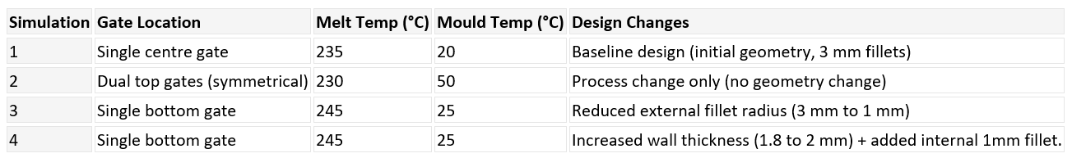

Material Flow Analysis
Material flow analysis was carried out to evaluate cavity filling behaviour, pressure distribution, flow front progression, and thermal behaviour during injection. All simulations achieved complete cavity filling, indicating that the selected process conditions were sufficient to avoid short shots.
Simulation 1 achieved a fill time of 0.21 s and moderate pressure of 12.389 MPa; however, the central gate created long radial flow paths, resulting in uneven material distribution and 23 weld line regions, with local cooling at the edges reducing bonding quality.
Simulation 2 reduced the injection pressure to 9.72 MPa and improved flow distribution, but opposing flow fronts and lower flow-front temperatures increased weld line formation to 25 regions.
Simulation 3 increased pressure to 14.445 MPa due to higher flow resistance, but reduced weld lines to 17 regions through more directional flow and improved thermal continuity.
Simulation 4 resulted in a longer fill time of 0.41 s and increased pressure (15.814 MPa), but further reduced weld lines to 16 regions, indicating improved flow stability and more uniform temperature distribution.
Overall, the results demonstrate that modifying gate configuration and flow direction improved thermal continuity and reduced weld line formation, showing that optimised flow paths directly enhance part quality despite increased pressure requirements..

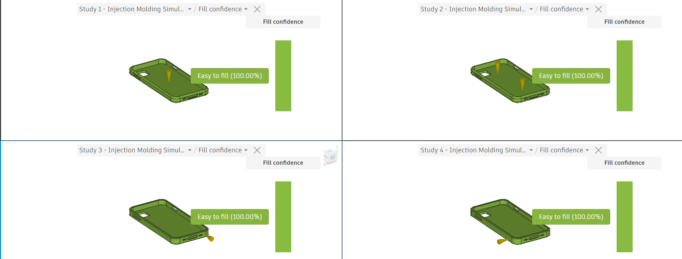
Figure 17. Comparison of fill confidence (Autodesk, 2026).
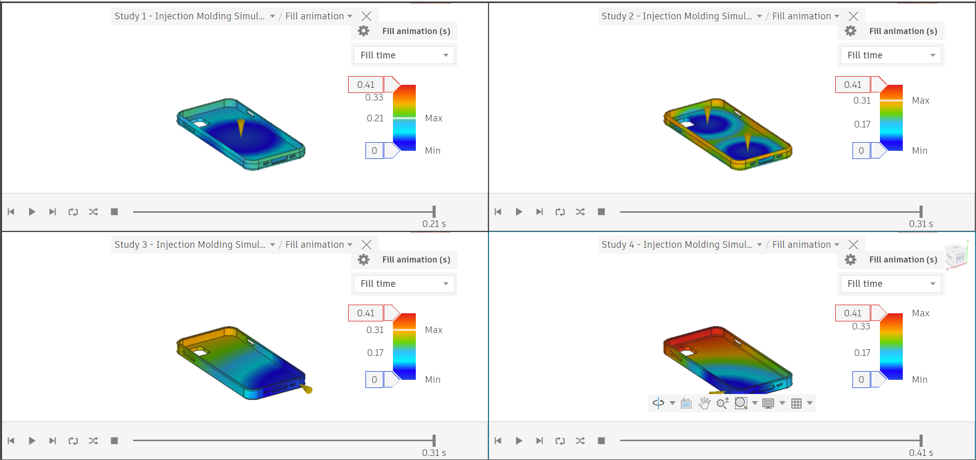
Figure 18. Comparison of fill time (Autodesk, 2026).

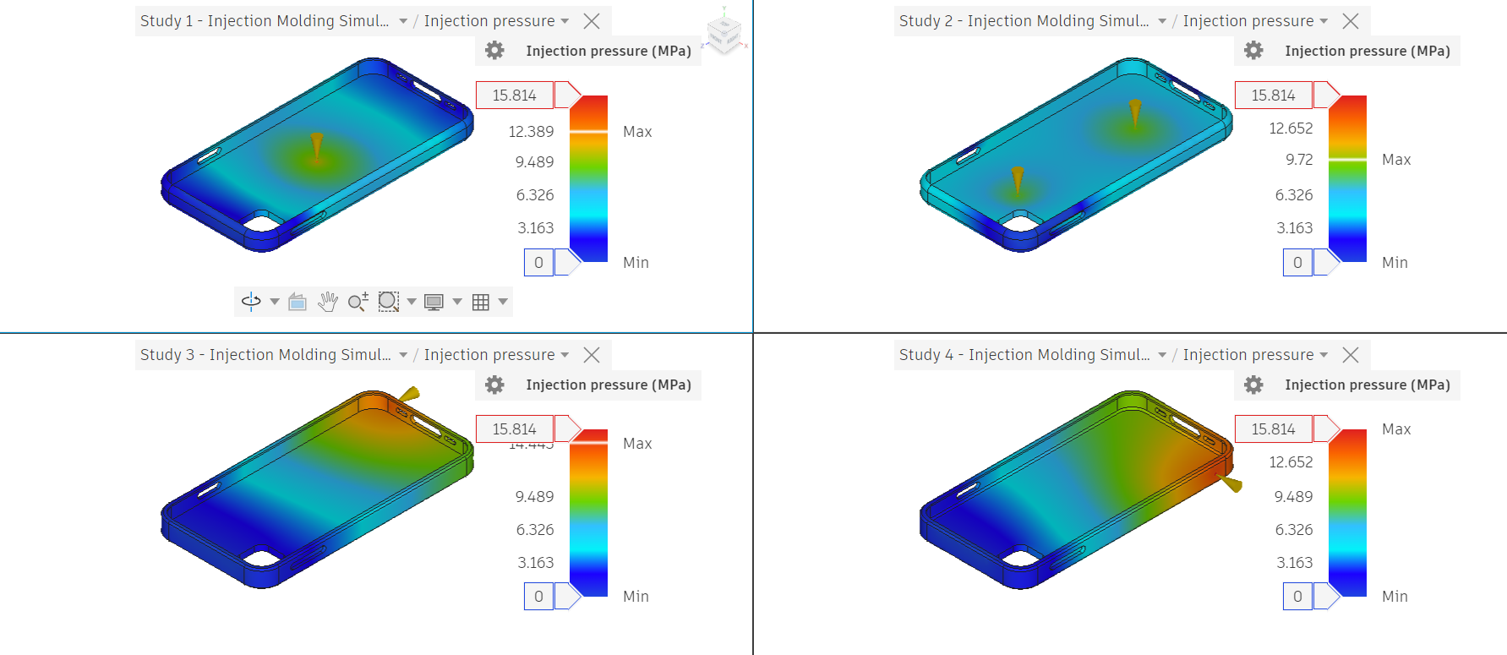
Figure 19. Comparison of injection pressure (Autodesk, 2026).

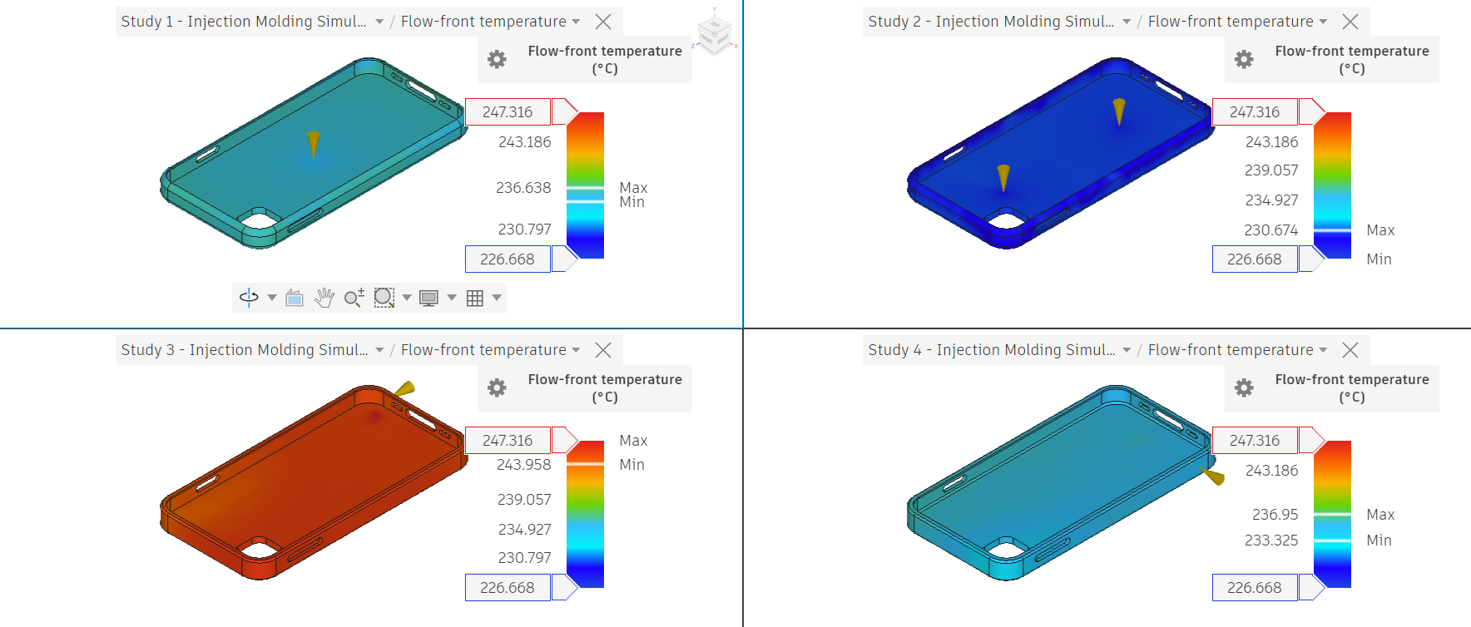
Figure 20. Comparison of flow-front temperature (Autodesk, 2026).

Cooling and Shrinkage Analysis
Cooling analysis was performed to evaluate thermal distribution, shrinkage behaviour, and dimensional stability during solidification. Non-uniform cooling generates residual stresses, contributing to warpage and deformation. A sink mark tolerance of 0.05 mm was applied, reflecting industry expectations for high-quality visible components; all simulations predicted zero sink marks, indicating sufficient packing to compensate for shrinkage.
Simulation 1 exhibited significant thermal gradients due to low mould temperature, resulting in uneven cooling and warpage of 1.579 mm. Simulation 2 improved thermal uniformity but increased warpage to 1.719 mm, indicating that geometric limitations dominated deformation. Simulation 3 enhanced thermal distribution through geometry refinement; however, the initial 3 mm radii caused localised thickness variation, leading to differential shrinkage. Reducing the radii improved wall thickness consistency, enhancing cooling uniformity and reducing residual stress.
Simulation 4 provided the best overall performance, with the lowest out-of-plane deformation due to improved wall thickness distribution and internal fillets, although this increased cooling time and pressure requirements. Volumetric shrinkage remained consistent across all studies, confirming that deformation is primarily influenced by its distribution rather than magnitude.
Overall, the results demonstrate that improving wall-thickness uniformity and adjusting geometric features reduce differential cooling and residual stress, leading to improved dimensional stability and reduced warpage.
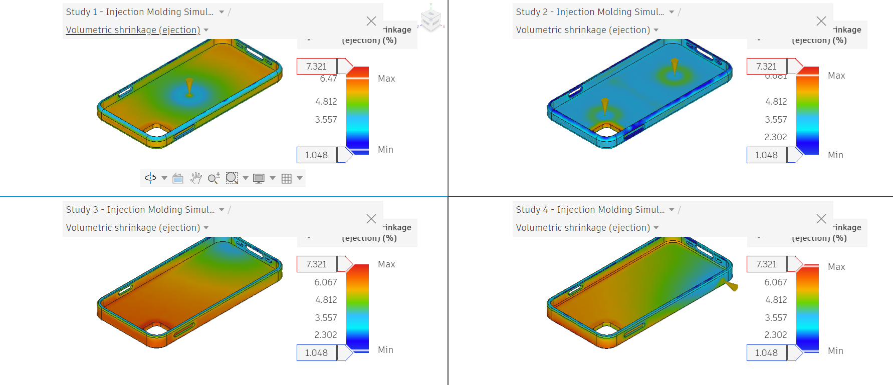
Figure 21. Comparison of shrinkage (Autodesk, 2026).

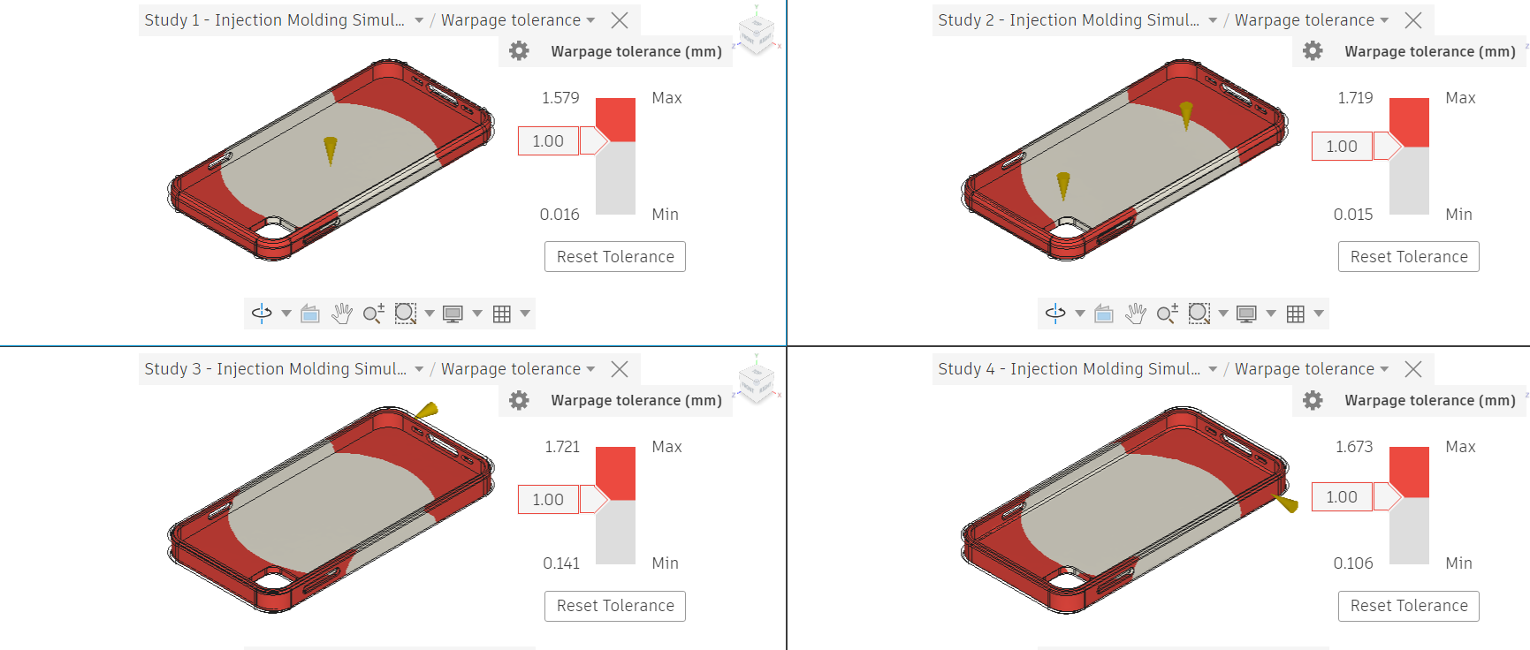
Figure 22. Comparison of warpage (Autodesk, 2026).

Defect Mitigation and Manufacturability
Defect analysis focused on identifying and reducing weld lines, air traps, shrinkage effects, and residual stresses.
Weld lines were consistently observed near the camera opening and slot features due to converging flow fronts. These defects can reduce local strength and surface quality. Through optimisation of gate placement and geometry, weld lines were reduced from 25 regions in Simulation 2 to 16 regions in Simulation 4.
Air traps were primarily predicted at end-of-fill regions, particularly in corner areas and around internal cut-outs where air becomes trapped as the flow front advances. The dual-gated configuration produced a greater number of air traps due to converging flow fronts restricting air escape, whereas the more directional flow in later simulations reduced internal air entrapment. Despite this improvement, localised air traps remain and would require venting features in a production mould to prevent porosity defects.
Design features were implemented to improve manufacturability, including:
- Uniform wall thickness
- Controlled fillet transitions
- Optimised gate positioning
- Inclusion of draft angles for ejection
These results demonstrate that optimising gate placement and flow direction reduced weld lines and air traps, improving structural integrity and manufacturability of the final design.
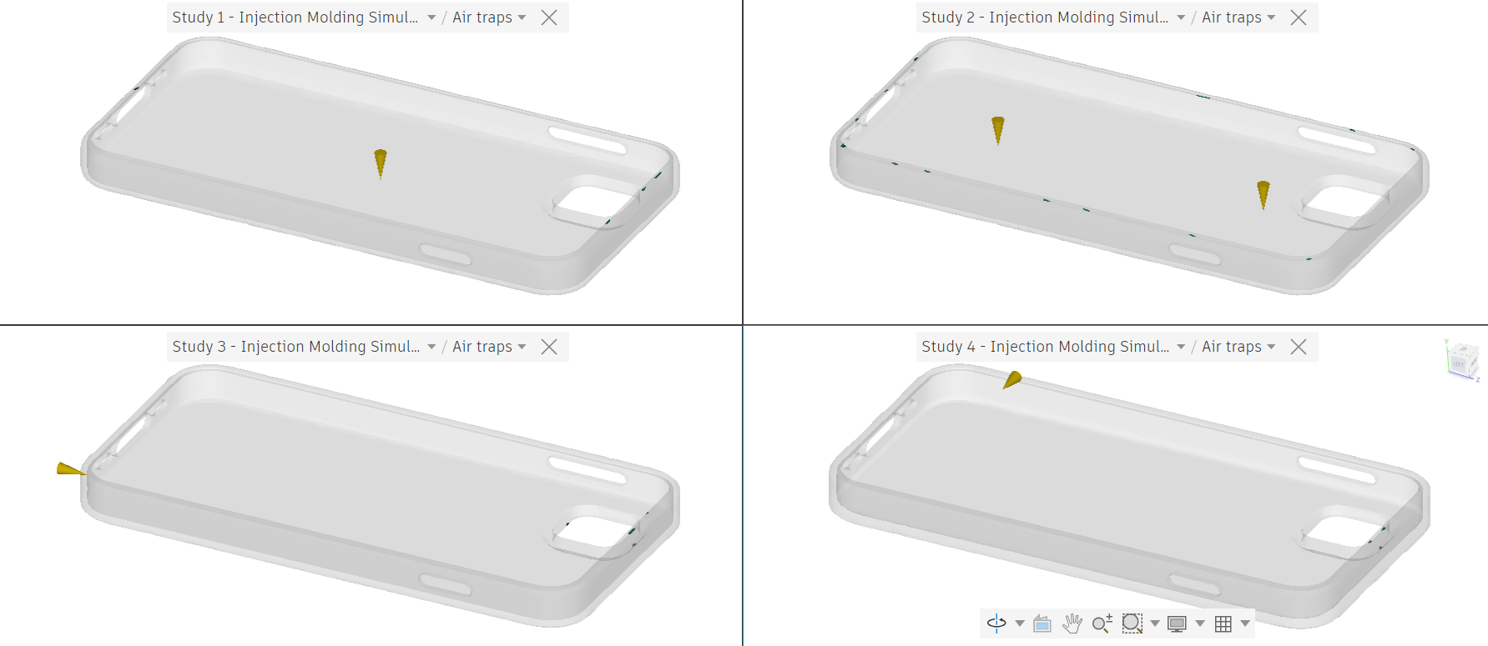
Figure 23. Comparison of air traps (Autodesk, 2026).

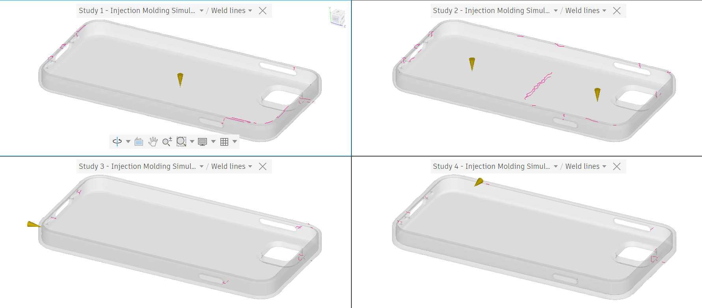
Figure 24. Comparison of weld lines (Autodesk, 2026).

Final Design Validation
A single directional gate in the later studies produced more controlled flow behaviour, maintaining higher melt temperatures and reducing weld line formation, although at the expense of increased injection pressure due to longer flow paths and greater resistance.
Simulation 4 was selected as the final optimised configuration as it provided the best overall balance between manufacturability, flow stability, thermal uniformity, and defect mitigation. Although the final fill time increased, it remained within the acceptable target of 0.5 seconds and is justified by improved wall thickness distribution, which enhanced flow continuity, reduced air entrapment, and produced a more uniform temperature and shrinkage profile throughout the part. This resulted in fewer weld lines and more stable mould filling behaviour.
Despite these improvements, volumetric shrinkage remained consistent across all simulations, indicating that deformation is primarily governed by the inherent material properties of TPU. However, the more uniform distribution of shrinkage in the final design reduced localised deformation and improved dimensional stability.
The maximum warpage remained above the target tolerance of 1 mm, with values in the range of approximately 1.6-1.7 mm. This confirms that warpage is largely controlled by the overall geometry, particularly the thin-walled structure, rather than process conditions alone. Therefore, successive design modifications, including flow path optimisation and geometry refinement, improved thermal consistency and defect reduction, resulting in the most manufacturable final configuration.

Mould Calculations
Although Autodesk Fusion enables detailed simulation of injection moulding behaviour, it does not allow direct specification of feed system geometry such as sprue, runner, and gate dimensions. Consequently, these elements have been calculated for hypothetical implementation to ensure that the final design remains both manufacturable and optimised according to engineering principles.

Part Volume
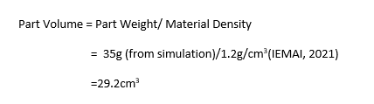

Total Shot Volume
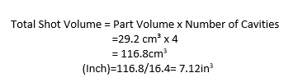

Sprue Diameter
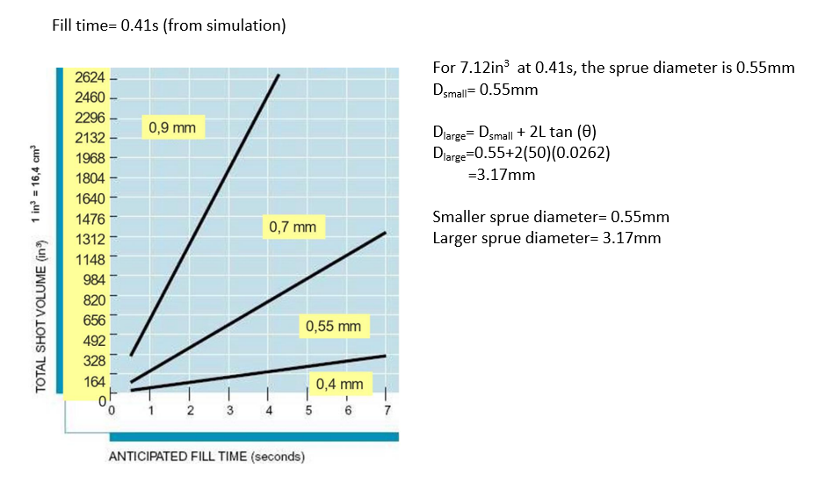

5.2.4. Runner Dimensions
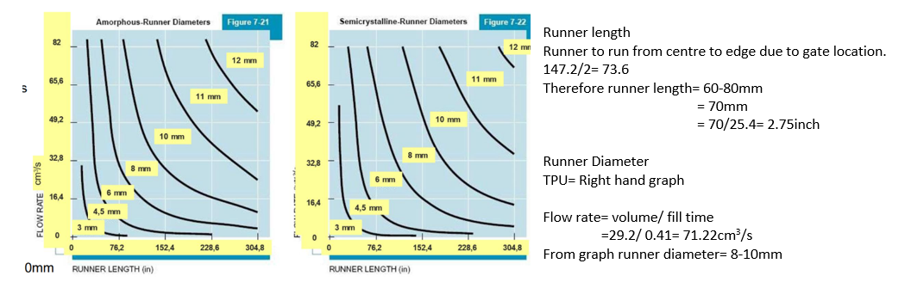A four-cavity mould supports high-volume production by increasing output per cycle while avoiding the excessive flow demand and complexity associated with a higher number of cavities. Increasing cavity number significantly raises the overall material flow requirement, which can lead to higher injection pressures and an increased risk of defects such as weld lines and uneven shrinkage if not properly managed. In this design, the calculated flow conditions required careful selection of sprue and runner dimensions to ensure adequate material delivery without excessive pressure loss. Rather than oversizing the feed system, the design reflects a practical balance between flow capacity and manufacturability. This demonstrates an effective compromise between achieving high production efficiency and maintaining part quality and process stability. Further improvements could focus on enhancing flow distribution and thermal control, including the implementation of a balanced runner layout to promote uniform filling across all cavities.

Finite Element Analysis (FEA)
An FEA was conducted to evaluate the structural performance of the phone case under operational loading conditions representing flexing during installation and removal. An initial simulation was performed using a 10 N load, however this produced unrealistically low deformation. The load was therefore increased to 20 N to better represent typical manual handling forces and to more accurately reflect the flexible behaviour expected from TPU during use. The model was constrained and subjected to loading at the corner, allowing assessment of stress distribution, deformation, and overall structural robustness.

Key Findings
The analysis shows that the component experiences low stress and minimal deformation under the applied load. The maximum von Mises stress is approximately 0.73 MPa, with a maximum displacement of 0.009 mm, indicating that the structure remains well within elastic limits and maintains structural integrity under typical use conditions.

Stress Distribution
Stress is concentrated primarily at the corner where the load is applied, which is consistent with expected flexural behaviour during case installation. The remainder of the structure experiences uniformly low stress with no critical stress concentrations observed. This distribution confirms that the design effectively transfers load without localised structural weakness.
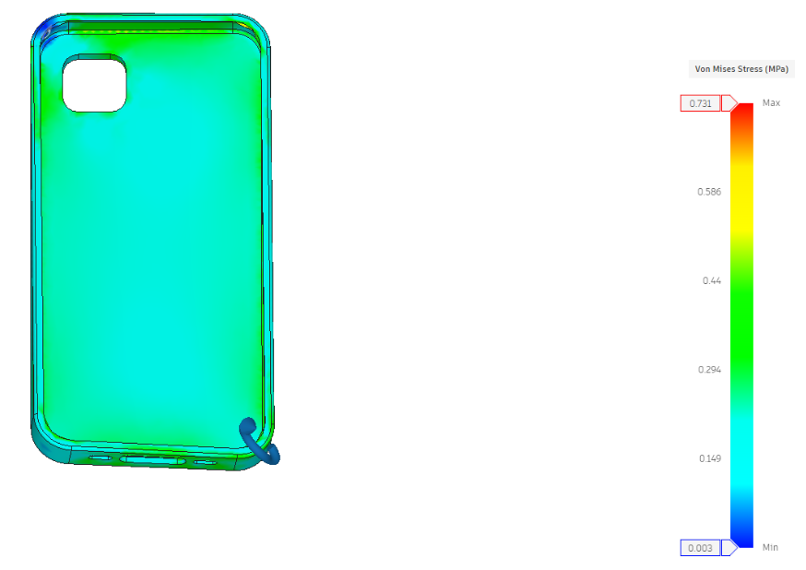
Figure 25. Von Mises Stress (Autodesk, 2026).

Displacements
The maximum displacement of 0.009 mm indicates very limited deformation under loading. While this confirms high structural stiffness and dimensional stability, it also suggests that the model does not fully capture the flexible behaviour expected from a TPU component during real use.
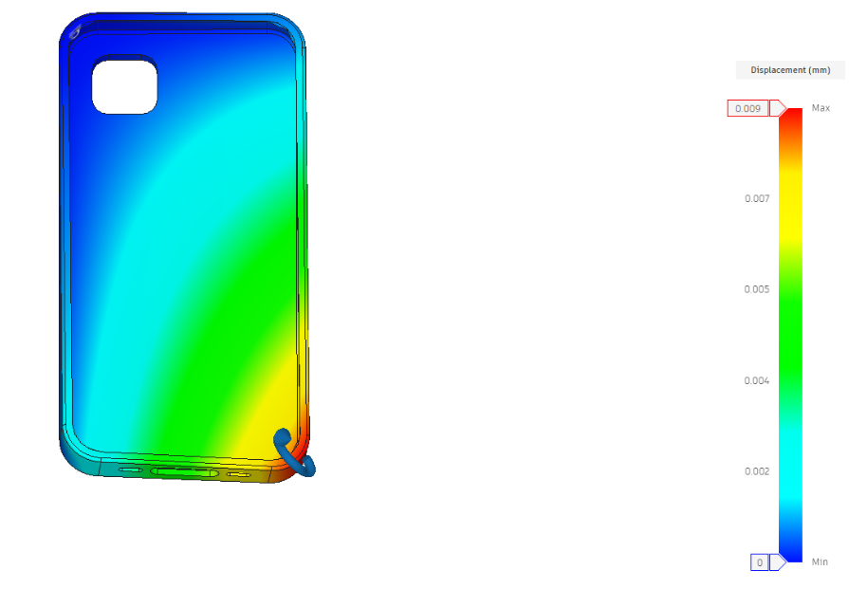
Figure 26. Displacement (Autodesk, 2026).

Strain Analysis
Peak equivalent strain is approximately 5.2 × 10⁻⁶ (0.00052%) which is extremely low compared to the typical elastic strain capability of TPU, which can undergo large elastic deformation without damage. The strain distribution is uniform and negligible across the structure, confirming purely elastic behaviour with no risk of permanent deformation.

Safety Factor
The safety factor is significantly above typical design requirements, with a minimum value of approximately 283, indicating that the component is highly resistant to failure under the applied load. While this confirms a safe design, it also suggests that the component may be over-engineered, with potential for material reduction.
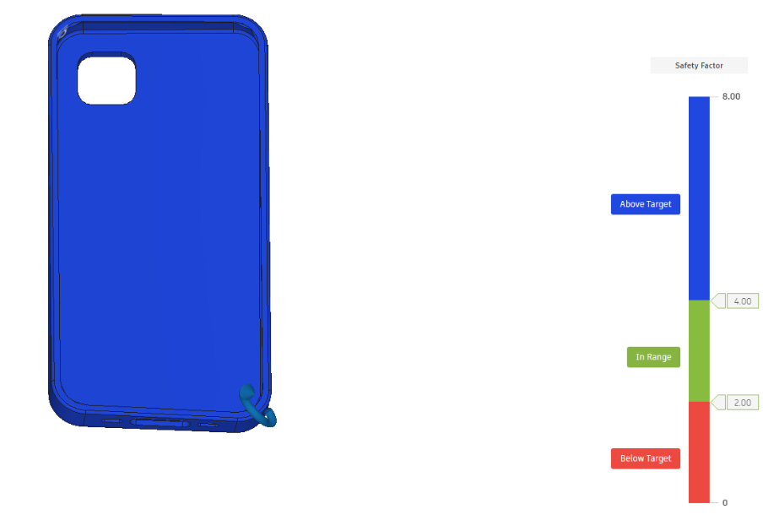
Figure 27. Safety Factor (Autodesk, 2026).

Engineering Insights
The results demonstrate that the design is structurally robust under the applied loading, with low stress, strain, and displacement values indicating negligible risk of failure. The case would maintain its shape and protect the device without permanent deformation under typical use conditions. However, the very low strain and displacement indicate that the model behaves more rigidly than expected for a flexible TPU component. The excessively high safety factor further indicates that the design is over engineered, showing that material in low-stress regions could be reduced, allowing geometry optimisation that maintains performance while improving material efficiency and cost.

Dimensional Accuracy
The minimal displacement observed ensures that dimensional changes under load are negligible, supporting high dimensional accuracy and consistent fit between the phone case and device. This is beneficial for ensuring repeatable performance in high-volume production.

Cost Calculation Analysis

Manufacturing Process Plan
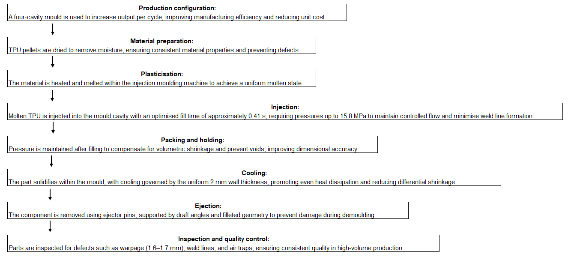

Figure 28. Manufacturing Process Plan

Cost Analysis
Cost analysis was conducted to assess the economic feasibility of the injection moulding process, considering material and manufacturing costs and the break-even production volume. This ensures that the selected design is not only technically viable but also suitable for high-volume production, supported by the optimised manufacturing process shown in Figure 28.

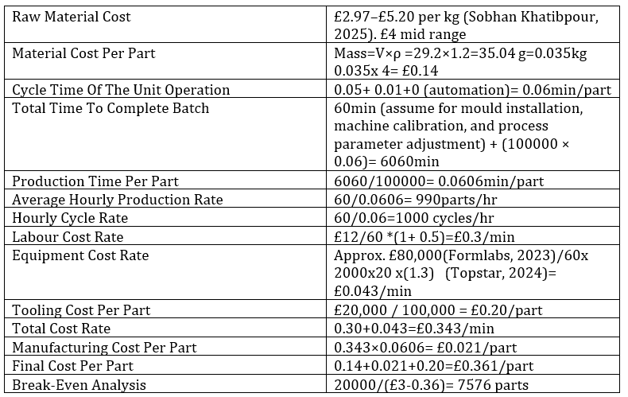

The cost and time analysis demonstrates that injection moulding achieves low unit cost primarily through high production efficiency, with short cycle times enabling rapid output and reducing the manufacturing cost contribution per part. The overall cost is dominated by the initial tooling investment, meaning economic viability is strongly dependent on production volume and break-even recovery. At the selected selling price of £3.00, the break-even volume is significantly reduced, allowing tooling costs to be recovered quickly and resulting in a high contribution margin per part.
The use of a four-cavity mould further enhances this performance by increasing output per cycle, effectively reducing production time per part and improving machine utilisation. This allows fixed and operational costs to be distributed more efficiently across a larger number of units, lowering the effective cost per part and accelerating the break-even point. Consequently, the combined effect of high production rate, controlled cycle time, and multi-cavity tooling results in a cost-effective and scalable manufacturing solution, well suited for high-volume production. This validates the suitability of injection moulding for high-volume production, where high initial tooling costs are offset by low per-unit cost.

Sustainability Considerations

Material Recyclability
TPU supports recyclability through remelting and remoulding, reducing reliance on virgin material and supporting circular economy principles (Lin, Lin and Bao, 2021). Studies investigating mechanical recycling of TPU demonstrated that acceptable mechanical performance can be retained through multiple reprocessing cycles, supporting the feasibility of closed-loop material systems within polymer manufacturing (Nanni et al., 2023). However, repeated recycling gradually reduces mechanical properties, requiring controlled processing conditions to maintain performance. TPU additionally offers high durability and flexibility, extending product lifespan and reducing replacement frequency, while manufacturing waste such as runners and rejected components can be reprocessed and reintegrated into production (Mette, 2024).

Process Energy Efficiency
Energy efficiency was improved through optimisation of geometry and process conditions. Uniform wall thickness and controlled flow behaviour improved cooling efficiency, reducing cycle time and energy consumption per part. High production rates further reduce energy usage on a per-unit basis, making injection moulding increasingly efficient at scale.

Waste Reduction
Injection moulding operates as a near net-shape process, minimising scrap generation and improving material utilisation. The use of recyclable TPU allows excess material and production waste to be reprocessed into new components, while multi-cavity moulding increases output efficiency and reduces waste per unit produced (Mette, 2024).
Sustainability can be further enhanced through the use of recycled TPU, reduced- and recyclable-packaging, carbon offsetting, and closed‑loop material systems. This approach is supported by market research, with companies such as Pela demonstrating how sustainability-driven design can be integrated into both product and business strategy through environmentally conscious manufacturing, global supply chain management, and extended product life initiatives such as repair and reuse (Pela, 2026). Incorporating similar strategies not only improves environmental performance but also enhances competitiveness by appealing to increasingly sustainability-focused consumers.

Discussion and Recommendations

Comparison with Requirements
The final design successfully satisfies the primary customer and manufacturing requirements identified through QFD, particularly impact protection, manufacturability, and dimensional consistency. Simulation results demonstrated stable cavity filling and reduced weld line formation, while optimisation of wall thickness and gate configuration improved thermal uniformity and reduced localised deformation. Although warpage remained above the initial target tolerance, the final configuration achieved the most effective compromise between manufacturability, defect reduction, cooling behaviour, and production efficiency within the constraints imposed by the thin-walled geometry and TPU material behaviour.

Trade-Offs and Design Decisions
Increasing wall thickness improved structural rigidity and flow continuity but increased cooling time, material usage, and cycle cost, requiring a balance between performance and production efficiency. Gate location and flow direction were refined to minimise weld line formation and improve thermal consistency; however, this increased injection pressure due to longer flow paths. Material selection also involved compromise, where TPU provided superior flexibility, impact absorption, and wear resistance compared to rigid polymers such as PP, although with increased processing complexity and material cost.

Limitations and Future
The use of simplified linear material modelling does not fully represent the nonlinear and viscoelastic behaviour of TPU, meaning real-world deformation may be underestimated. Similarly, mould flow simulations are dependent on assumed process conditions and idealised thermal behaviour, which may differ from industrial manufacturing environments. The high safety factor indicates that the component remains over-engineered, presenting opportunities for material reduction and geometry refinement. Future work should therefore focus on nonlinear material modelling, experimental validation through physical testing, and optimisation of cooling channel design to further reduce warpage, cycle time, and material consumption.

Recommendations
Further optimisation could focus on reducing material usage through geometry refinement, particularly in regions with high safety factors. Improvements to mould design, such as conformal cooling, could enhance thermal uniformity and reduce cycle time. Additionally, implementing recycled TPU and closed-loop material systems would further improve sustainability performance.

Conclusion
This project achieved the aim of designing and optimising an injection-moulded TPU phone case suitable for high-volume manufacture while satisfying key customer requirements including impact protection, secure fit, durability, manufacturability, and cost efficiency. The application of DFM principles, simulation-led optimisation, and the integration of QFD and FMEA ensured that customer needs, manufacturing constraints, and potential failure modes informed the design process throughout development.
Mould flow analysis demonstrated that optimisation of wall thickness, gate configuration, and geometry refinement improved flow continuity, thermal uniformity, and defect reduction. Although warpage remained above the initial target tolerance due to the limitations associated with thin-walled TPU components, the final design achieved an effective compromise between dimensional stability, manufacturability, and production efficiency. FEA confirmed structural integrity under operational loading conditions while identifying opportunities for future material reduction.

References
Amazon (2026). Amazon.co.uk. [online] Amazon.co.uk. Available at: https://www.amazon.co.uk/Mobile-Phone-Cases-Covers-Accessories/s?me=A2OAJ7377F756P&rh=n%3A340321031 [Accessed 6 Jun. 2026].
ANSYS Granta (2026). GRANTA EduPack, Formerly CES EduPack: Materials Education Support | Ansys. [online] www.ansys.com. Available at: https://www.ansys.com/products/materials/granta-edupack.
Arnab Chakrabarty, Mannan, S. and Tahir Cagin (2016). Multiscale modeling for process safety applications. Amsterdam: Elsevier/Butterworth-Heinemann.
Ashby, M. (2017). Materials selection in mechanical design. 5th ed. Amsterdam: Butterworth-Heinemann.
Autodesk (2026). Fusion 360 | 3D CAD, CAM, CAE & PCB Cloud-Based Software | Autodesk. [online] www.autodesk.com. Available at: https://www.autodesk.com/products/fusion-360.
Booz-Allen and Hamilton (1982). New products management for the 1980s. New York: Booz, Allen & Hamilton.
Czepiel, M., Bańkosz, M. and Sobczak-Kupiec, A. (2023). Advanced Injection Molding Methods: Review. Materials, [online] 16(17), p.5802. doi:https://doi.org/10.3390/ma16175802.
Defeo, J.A. (2017). Juran’s Quality Handbook The Complete Guide to Performance Excellence, Seventh Edition. New York, N.Y Mcgraw-Hill Education.
Ellen Macarthur Foundation (2023). Plastics and the circular economy. [online] Ellen MacArthur Foundation. Available at: https://www.ellenmacarthurfoundation.org/topics/plastics/overview.
European Commission (2025). REACH Regulation. [online] environment.ec.europa.eu. Available at: https://environment.ec.europa.eu/topics/chemicals/reach-regulation_en.
Formlabs (2023). How to Estimate Injection Molding Cost? [online] Formlabs. Available at: https://formlabs.com/uk/blog/injection-molding-cost/.
Fortenberry, J.L. (2013). Nonprofit marketing. Burlington, Ma: Jones & Bartlett Learning.
Grand view Research (2022). Mobile Accessories Market Size & Share | Global Industry Report, 2025. [online] www.grandviewresearch.com. Available at: https://www.grandviewresearch.com/industry-analysis/mobile-accessories-market.
Hessing, T. (2013). Quality Function Deployment (QFD) and House of Quality (HOQ). [online] Six Sigma Study Guide. Available at: https://sixsigmastudyguide.com/house-of-quality-hoq/.
IEMAI (2021). TPU Technical Data Sheet (TDS). [online] Available at: https://www.iemai3d.com/wp-content/uploads/2021/03/TPU_TDS_EN.pdf.
Lin, T.A., Lin, J.-H. and Bao, L. (2021). A study of reusability assessment and thermal behaviors for thermoplastic composite materials after melting process: Polypropylene/ thermoplastic polyurethane blends. Journal of Cleaner Production, 279, p.123473. doi:https://doi.org/10.1016/j.jclepro.2020.123473.
Mette (2024). Recyclability of TPU material - Create it REAL. [online] Create it REAL. Available at: https://www.createitreal.com/2024/12/06/recyclability-of-tpu-material/.
Nanni, A., Crosetta, L., La Fauci, G., Biagi, F., Parisi, M., Colombo, D. and Colonna, M. (2023). Study of the mechanical properties of thermoplastic polyurethane (TPU) recycled from end-of-life ski-boots and techno-economic analysis (TEA) of the mechanical recycling processes. Sustainable Chemistry and Pharmacy, 33, p.101059. doi:https://doi.org/10.1016/j.scp.2023.101059.
Pela (2026). Our Manufacturing. [online] Pela Case. Available at: https://uk.pelacase.com/pages/our-manufacturing.
PRD Services (2025). The Impact of Legislation on Plastic Recycling in the UK | Packaging Reuse. [online] Packaging Reuse & Disposal Services Ltd. Available at: https://prdservices.co.uk/blog/plastic-recycling/the-impact-of-legislation-on-plastic-recycling-in-the-uk/.
Reda, H. and Dvivedi, A. (2021). Decision-making on the selection of lean tools using fuzzy QFD and FMEA approach in the manufacturing industry. Expert Systems with Applications, p.116416. doi:https://doi.org/10.1016/j.eswa.2021.116416.
Richardson, J. (2019). Solar Photovoltaics - Cradle-to-Grave Analysis and Environmental Cost. [online] The Renewable Energy Hub. Available at: https://www.renewableenergyhub.co.uk/main/solar-panels/solar-panels-carbon-analysis.
Rosato, D.V. and Rosato, M.G. (2012). Injection Molding Handbook. Springer Science & Business Media.
Six Sigma (2024). Design for Manufacturing (DFM): A Guide to Optimizing Product Development. [online] 6sigma. Available at: https://www.6sigma.us/six-sigma-in-focus/design-for-manufacturing-dfm/.
Sobhan Khatibpour (2025). TPE Cost per kg: Latest 2025 Price Updates & Global Market Trends - Farr Polychem. [online] Farr Polychem. Available at: https://farr.ae/tpe-cost-per-kg-latest-2025-price-updates-global-market-trends.
Topstar (2024). How long is the service life of injection molding machines? - TopStar. [online] TopStar. Available at: https://www.topstarmachine.com/how-long-is-the-service-life-of-injection-molding-machines/.
University of Cambridge (2016). Kano model. [online] www.ifm.eng.cam.ac.uk. Available at: https://www.ifm.eng.cam.ac.uk/research/dmg/tools-and-techniques/kano-model/.

