Worksheet Three
James Andrew David Beard
Student University of Wales Trinity St David
Swansea, Wales
1901671@student.uwtsd.ac.uk
- Practical Tasks
- Understanding NTFS and Share Permissions.
- Configuring NTFS Permissions.
The first task the author had to complete in worksheet three was to configure and set up NTFS permissions on the “Client1” device. Setting NTFS on the client device was important as it would allow the author to set certain privileges for each account or account group on the “Client1” machine. This meant that an administrator would have different privileges to the files and or folders than a non-admin account. This is important in a workplace environment as not all employees/ accounts will need the same privileges to the folders and files.
For example, in educational environment a student will need access to view and read files, but the teacher/ lecturer may not wish for the file to be modified, in this case the student user group could be given read-only privileges and be denied privileges to modify the file. The lecturers and teachers however will need complete control of the files/folders in their subject, so they could be given full control privileges.
This task was completed by logging into the “Client1” machine with a domain-admin account’s credentials, navigating to “thisPC”, then navigating to “Windows (C:)” drive. Here the author created a folder that would be used to set and test NTFS permissions, this folder was “Dept_Important_Docs”. Inside this folder the author created a file that would also be used for practise and testing purposes. This file was named “Important_File” by the author.
Next the author navigated to the security tab within the properties of the recently created folder. Here the author tried to edit the permissions for authenticated users but was unsuccessful due to the permissions to this folder being inherited. To resolve this, the author navigated the advanced settings of this folder and clicked to remove all inherited permissions to this folder.
Following this the author returned to the security tab of the folder to edit the permissions to this folder, he then tried to add the account that he was logged in as to the object name filed but it did not recognise the account, after a minute or two of trying and reflection the author realised that his server running as his domain controller was not switched on, after the domain controller was running, he was able to add his account. After this the author set this account to have full control privileges to the folder as it was one of the domain-admin accounts. Proof showing this set up can be seen in Fig. 1.
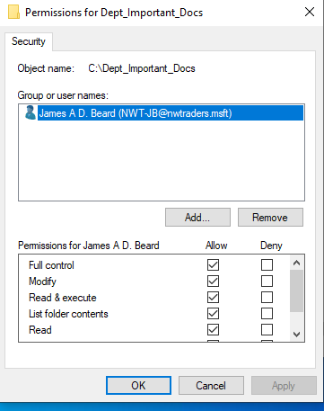
Fig. 1 Permissions For Dept_Important_Docs.

Next the author set up permissions for another user account by completing the same steps discussed before but with two differences. Firstly, the permissions were being set on a different account, this account was part of the “Domain users” group and not part of the “Domain Admin” group so it would likely have less permissions.
Secondly the permissions would be set up on the file within the folder and would be restricted to “Read and Execute” permissions only, meaning the account would not be able to make modifications to the file, proof of this set up can be seen in Fig. 2.
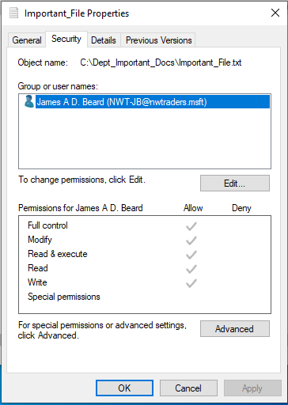
Fig. 2 Important_File_Properties and Permissions.

The author tested that everything was working as expected by adding text to the file while using the “Domain Admin” account and saving it before logging out of the admin account, this step proved successful.
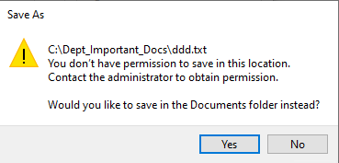
Next the author logged into “Client1” as the “Domain user” account and tried to open the file, this was successful meaning that the author could read the file, next he tried to modify and save the file but as seen in Fig. 3 this was not allowed, showing that the permission were working as expected.
Fig. 3 Message Informing User Does Not Have Correct Permissions.

- Configuring Share Permissions.
The next task the author had to complete was configure and set up share permissions on “Server1”. Setting up share permissions are important as they allow administrators to set permissions up on any files ore folders that have shared access on the network. This differs from NFTS that set permissions locally. This is discussed in more detail by the author in subsection A titled “Explain the main differences between local permissions and file shares” in section two “Observation tasks”.
Share permissions are important in the author’s opinion because often devices are not shared anymore especially in the workplace, where its more and more common to find company’s implementing ‘Bring your own device’ or giving workers their own personal devices to work on. This means workers will often only use their own devices or device that only they have access to instead of using a company owned device.
This will likely mean that the company’s files and folders will need to be shared on the network so that workers can access the resources and permissions to that data must be configured correctly to ensure the CIA security triad (Confidentiality, Integrity and Availability). These permissions as mentioned before will be set by the administrator using share permissions. So, it is important in the author’s opinion that as someone who aims to go into the IT industry that he understands how share permissions work and how to use them.
This task was completed by firstly navigating to sever manger, before clicking on the “File and Storage Services” option. Following this the author navigated through the shares option, then the tasks option and then clicked to add a new share, where the author would create a folder share on the server.
There were several options that the author had to select in “New Share Wizard” to successful set up the new share. The first option that had to be selected came at the “Share Profile” page, here the author chose “SMB Share-Quick” option. On “Share Location” page the author chose the “Select by volume” option. On “ Share name” page the author inputted the share name (“DeptNetShare$”) following this the share wizard automatically set the local path and remote path names. A screenshot of this page can be seen in Fig. 4.
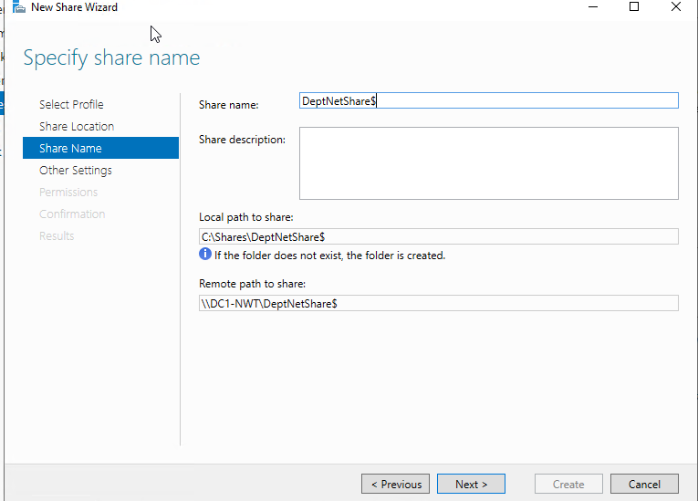
Fig. 4 “DeptNetShare$” Share.

Following this step, the author enabled both “access-based enumeration”, this means that a user will only be able to view the files that they have access to. This could be handy as it could help lower the chances of unauthorised access. The author believes that if a user cannot see a file, they unlikely to know of its existence on network and if they do not know it is there, how they can try and gain unauthorised access. Whereas if a user can see the file or folder, they may become intrigued by the file and try and find a way of accessing it because of curiosity or desire to exploit the resources.
The second option enabled is “Allow caching of share options”, this allows users to see files they have access to if they go offline. This is important as even today there is always a chance that a device can lose connection to a network and the ability to still access some of the information while the issue is sorted out by the networking and IT team is important to ensure productivity.
Following this the author specified the permissions of each user as a group or as an individual. He set the administrators to have full access permissions and set to standard user accounts to “Read and Execute” permissions only. Finally, he checked his selections and clicked the “Create” button to finalise his choices and create the file share on the network. As can be seen in Fig. 5 this share was successfully created.
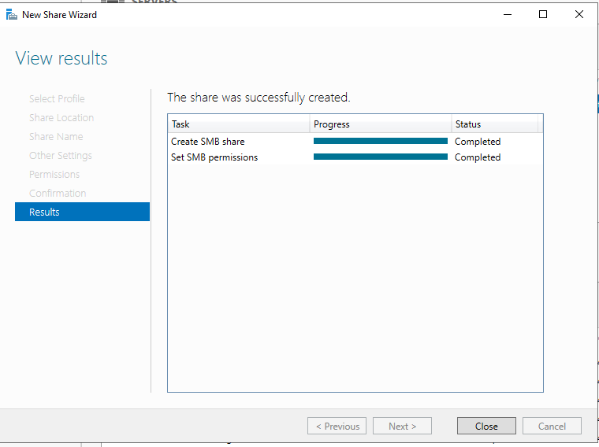
Fig. 5 Share Success Window.

- Accessing File Share Over The Network.
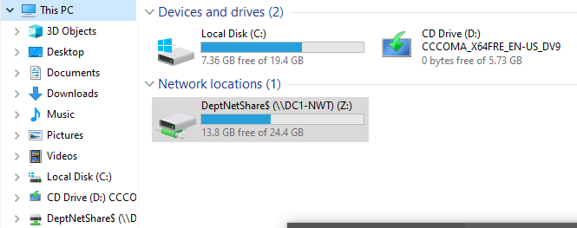
The next task the author had to complete was to ensure that users could access the share. The way that this share will be accessible to the user is by the author creating a mapped drive. A mapped drive gives a continuous connection to the share and appears as another local drive on the device. It also makes it far easier for the users to find the share.
This was useful in the author’s opinion as it would make accessing and adding shared resources on this drive far easier, ensuring productivity if used in a real-world environment.
This task was completed by firstly again navigating to “this PC”, here the author clicked the tab named “Map Network Drive”. Here the author accepted the default drive letter given to him, after this the author inputted the server’s name and full file share name into the text field (\\DC-1-NWT\DeptNetShare$).

- Utilising Group Policy Management Console Group Polices.

- Initial Steps.
The first step the author had to take was to set up and create an Organizational Unit (OU) by right clicking on the “nwtraders.msft” domain and then selecting the option to add a new OU, the name given to this OU was “Non Admin Users”. Following the creation of this OU the author added a new user account to this group, this account would act as a guinea pig for testing the success of the restrictions and policy implementation on the “Client1” machine. Proof of existence can be seen in Fig. 6.
Fig. 6 Proof of File Shares Existence.

- Moderating Access To The Control Panel.
The first group policy that the author began to restrict was access to the control panel and in turn lower the chances of them making unauthorised changes to the system. This is a good idea in workplace or educational environment as the users on the network may not have an extensive knowledge and understanding of the setting that they are changing causing a potential vulnerability risk to the device and network or if lucky just cause the administrator to take time away from other duties to fixes their error lowering the productivity of both whilst rectify the error.
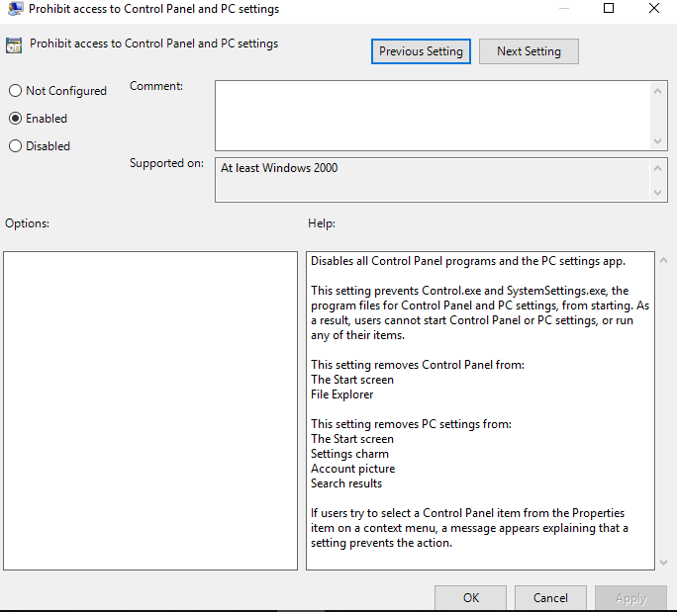
The first step to restricting the user’s access to control panel was to navigate to the Group Policy Management console (GPMC) , from there the author located the OU (“Non Admin Users”) that he recently created, right clicked on it, and selected to option to add a new Group Policy Object (GPO), which he named “NoCtrlPanAccess”. From here the author right clicked on the GPO and chose the edit option. This opened the “Group Policy Object Editor” window, from here the author navigated through the following links to get to the desired window. First the author clicked onto the “User Configuration” option, the next option the author selected was the “Policies” option. The third link the author clicked on was the “Administrative Templates” option, after this the author clicked on the “Control Panel” option. After this the author selected the “Prohibit access to Control Panel and PC settings” option.
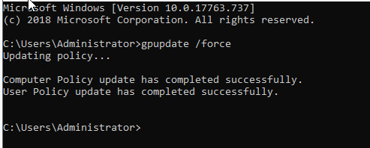
At the “Prohibit access to Control Panel and PC settings” link the author double clicked which opened its properties, at which point the author choose the enable option to enable the policy function that would restrict non admins access to the control panel and other settings on the device. Then clicked apply and then finally clicked ok, a screenshot of this window can be seen in Fig. 7.

Fig. 7 Prohibit Access To Control Panel And PC settings Window.

The final step the author took in this task was to go to the command prompt and the execute the “gpupdate /force” command in the command prompt, this helps ensure that the Active directory checks that the policy is updated, and changes are applied. Fig. 8 shows the author executing the “gpupdate /force” command and command prompt’s response.
Fig. 8 Command Prompt Gpupdate /Force Command and Update Message.

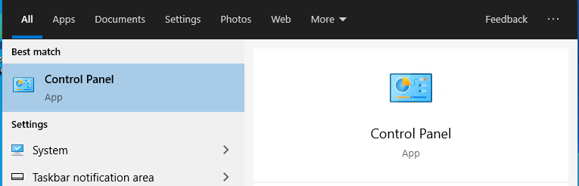
The author then logged into the “Client1” machine as the non-admin account he created earlier. Once logged in the author tried to navigate to the control panel as seen in Fig. 9 but was denied access as can be seen in Fig. 10 showing that the policy had been successfully implemented.
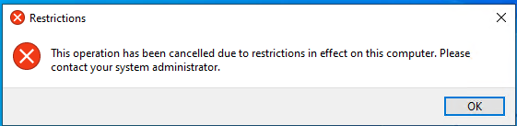
Fig. 9 Control Prompt Screenshot.
Fig. 10 Access To Control Panel Denied Proof.

- Removing Access To The Command Prompt.
The second group policy that the author completed was to remove the Non Admin groups access to use command prompt on the “Client1” machine. This could be an important tool to use in future employment as command prompt is a useful program and tool for IT professionals but at the same time it can be a very dangerous tool if used by an individual for malicious intents. They could use it to bypass other security and access control measures implemented by the administrators or to make changes to the system without express permission to do so. As a standard user will not need to use command prompt as if command prompt is need for troubleshooting an issue it would be done by the systems administrators or staff specified and trusted to have access.
This policy was set up by following steps similar to when the author set up the restrictions to control panel. He followed the same process to create the GPO but with a different name (“NoCmdPrmptAccess”) . At the “Group Policy Editor” window the author navigated through the following tabs/ links in this order to get to the desired location. Firstly, he clicked on the “User Configuration” option, followed by the “Windows settings” option. After this the author chose the “Policies” option and then he selected the “Administrative Templates” option. After this the author selected the “System” option.
From here the author double clicked on “Prevent Access to the Command Prompt” option, from here the author enabled this function, clicked apply and then selected ok, a screenshot of this window can be seen in Fig. 11. Finally, the author executed the “gpupdate /force” command in command prompt to ensure the policy is updated.

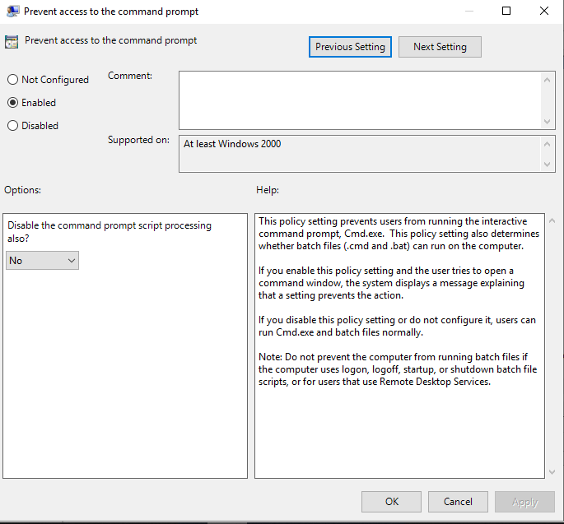
Fig. 11 Prevent Access To The Command Prompt Window.

After this the author logged back into the “Client1” machine as the Non Admin group user. Once logged in the author tried to open Command Prompt and although it opened, it displayed message informing the author that the Command prompt was disabled, proof of this can be seen in Fig. 12. However, the author then tried to run command prompt as administrator and once he input the credential of an administrator, he could access the command prompt backing up the author’s opinion that it was a good restriction to implement as standard users cannot access command prompt, but administrators can.
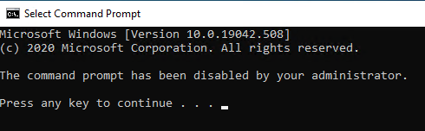
Fig. 12 Proof Command Prompt is Disabled.

- Restricting Access To Removable Media Drives.
The next policy implementation that the author set up was to restrict the use and access to removable storage deivces such as USB sticks. This is a good idea to implement in a workplace as removable storage is a common way that malicious software can be introduced into the network and systems, as well as the possibility of somebody trying to move or add files to the storage device without permission. An infection could happen in a number of ways either by an employee inserting their storage device unaware that it is infected, somebody knowingly adding an infected device to the system or even something along the line of a criminal dropping a USB stick outside the premises, hoping that somebody will find it and wish to see what is stored on the device, unknowing that it has just caused a security breach.
This task again included the author creating GPO in the GPMC, the author named this GPO “NoRemDriveAccess”. After this he clicked the edit option which opened the Group Policy Object Editor. From here the author navigated through the following links and tabs in this order to reach the desired option. The author first selected the “User Configuration” option, after this the author selected the “Expand Policies” option. Following this the author chose the “Administrative Templates” option, followed by the “System” option. Next the author selected the “Removable Storage Access” option.
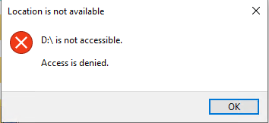
Once the author was at the Removable Storage Access window he clicked on the “All removable storage classes: Deny all accesses”, once enabled this will hopefully prevent any user from accessing and opening any files from a removable storage device . After reaching this point the author enabled this function, applied it, and then clicked the ok button to close the window as can be seen in Fig. 13. Finally, the author went to the command prompt to update the policy. As mentioned above this will hopefully mean that users will no longer be able to open and access files from any removable storage deivces, the next step was to test the functionality of this policy.
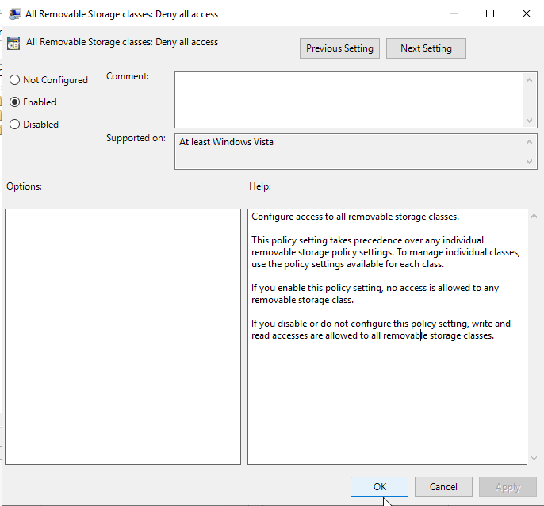
Fig. 13 All Removable Storage Classes: Deny All Accesses Window Pop Up.

Finally, the author logged into the client machine with the Non Admin account. Once here he navigated to “this PC” window here he tried to access a removable storage device, however as shown in Fig. 14 the author was not able to access it and instead received an error message informing him that the location was not available and that “access is denied”. However, when the author tried to access this drive as an administrator, he was granted access. This was the result the author was hoping for as once again the policy had restricted Non-Admin group’s permissions but not the permissions of the Administrators group’s accounts.
Fig. 14 Removable Access Denied.

- Restricting Software Installs.
The fourth policy implemented by the author was to restrict the Non Admin group ability to install software on the client machine. This is useful as it prevents the group from installing potentially malicious software that could harm the system, the downloaded software may not have malicious intent but may have holes that leaves the system vulnerable to attacks or the users could install unnecessary software that takes up unnecessary memory on the system. In reality the only software that should be used by the company is the software that has been approved by senior management and its installation should be handled entirely by the IT and network administrators to ensure the safety of the network.
To complete this, the author again had to create GPO in the GPMC, he did this by repeating the step he had done previously. The author then named this GPO “NounauthSoftInstallS”. After this he clicked the edit option on this GPO which opened the Group Policy Management Editor. From here the author navigated through the following links and tabs in this order to each the desired option. The starting option the author selected was the “Computer Configuration” option, followed by the “Policies” option. Next the author selected the “Administrative Templates” option then the “Windows Component” option. After this the author selected the “Windows Installer” link.
Once at the Windows Installer window the author double clicked the “Prohibit User Install” policy”, at this point the author enabled this function, applied it, and then clicked the ok button to close the window, evidence of this step can be seen in Fig.15. Finally, the author went to the command prompt to update the policy.
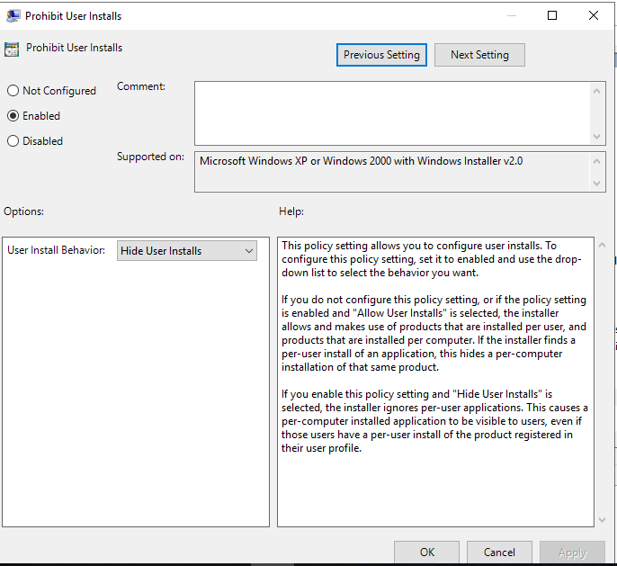
Fig. 15 Prohibit User Install Policy Window.

The author then decided to test the policy to ensure that it was restricting “Non Admin” group’s ability to install software. The author did this by logging into the “Client1” machine with a Non Admin account, he then proceeded to try and install “Google Chrome”. As can be seen in Fig. 16 when the author tried to install the software it requested that the author inputted an admin account’s credentials to proceed with the download. This was a success for the author as it restricted the Non Admin account from installing resources, but the software could still be installed with the right login credentials.
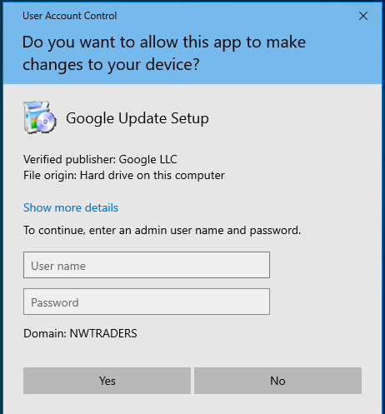
Fig. 16 Install Restriction Pop Up.

- Enforcing Password Policy.
The final policy that the author implemented in this worksheet was to implement a password policy that restricted serval aspect to setting passwords on this domain. This would be useful and important in a real world environment as passwords are an important part of security and ensuring the safety of an organization’s system and resources.
However often people will often leave their account vulnerable to be hacked and in turn risking the organization’s security because they use passwords that are either too short, do not contain a mixture of letters, numbers, and characters, do not update their passwords, or reuse the same passwords.

By implementing this policy, the administrators and senior management can restrict what is considered a satisfactory password by the organization and in turn improve the safety of the user’s account and the organization’s system and resources.

This task was completed in slightly different manner to the other policy. This time the author still navigated to the GPMC, but this time clicked on the “nwtraders.msft” domain to open it up at which point the author right clicked on the “Default Domain Policy” and edited it. This again opened the Group Policy Management Editor. From here the author navigated through the following links and tabs in this order to reach the desired option. First the author selected the “Expand Computer Configuration” link, followed by the “Policies” link. Next the author selected the “Windows Settings” option and then selected the “Security Settings” option. Then the author selected the “Account Policies” option. Finally, the author selected “Click on Password Policy”.

Here the author set the password restrictions that all users on the domain had to adhere to, the restriction set can see in Fig. 17. After this the author ran command prompt as administrator where he updated the policy.

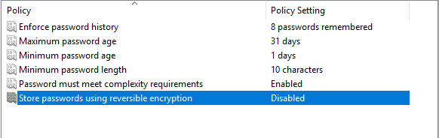
Fig. 17 Password Restriction Settings.

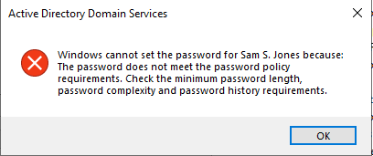
Finally, the author tested this implementation by trying to create a new account with a password that did not comply to the password policy as can be seen in Fig. 18 this caused an error pop up informing the author that this password cannot be used as the author hoped it would, then the author created a password that did comply to the restriction and this time the password was accepted.
Fig. 18 Password Error Pop Up.

- Observation Tasks

- Explain The Main Differences Between Local Permissions And File Shares.

- Overview Of NTFS
New Technology File System (NTFS) is the current file system model used by windows operating system [1], After replacing Microsoft’s old systems FAT and HPFS [1]. NTFS has improved on several aspects from its predecessors’ these improvements include security, extendibility, and performance [1].

- Overview Of NFTS Permissions
An account or users’ access to certain folders and files is determined by NTFS permissions, NTFS permissions are set in the access control list and can assign these permissions to view files and folders to an individual account [1]. However often a company or organization will assign permissions to a group. This is the recommended practice, to assign permissions to access files or folders, as it can save the administrators time from manual setting permission to each account. It is important to remember that the permission restraint set on a file will take precedent over the permission restraints set on a folder [1].
- Overview Of Share Permissions.
Access to folders shared over a network is handled and manged by share permissions, however these permissions are not applied when a user log onto their account locally [2]. “Share permissions apply to all files and folders in the share” [2]. An administrator can also set the number of accounts allowed to access a shared folder with share permissions [2]. NTFS, FAT and FAT32 files systems can all be used with share permissions, there are also three types of share permission that can be applied to a shared file, folder, or object, they are full control, change and read [2].
- Comparison.
There are a number of differences between how NTFS permissions and share permissions operate and are used by the administrators to set permissions for accounts and users. These differences are as followed:
- Permissions set using NTFS permissions apply to accounts and users logged onto the server locally, whereas this is not the case with share permissions [3].
- It is considered too easy to apply and manage share permissions [3], whereas it is considered that NTFS permissions allows the administrator more power over a shared folder and the contents found within the folder [3].
- As mentioned before share permissions allows the administrator to set and restrict the number of accounts and users that can link to the shared folder at one time, this cannot be achieved by NTFS permissions [3].
- An administrator can use share permissions to share folder in FAT and FAT32 file systems as well as NTFS [3].
- An administrator can use NTFS permissions to share folders in NTFS file systems but not FAT32 and FAT file systems [3].
- Finally, when NTFS and share permissions are used together the most restrictive permission set by the administrator always prevails [3]. An example of this is if NTFS permissions allows a file to be modified by a certain group but share permissions only allows that file to be read by the same group, the group will only have permission to read the file and will not be able to make changes to the file [3].

- Describe The Role Of Group Policy Management In The Network Environment, You Can Use Example Policies In Your Answer.

- Overview of Group Policy.
The term group policy comes from the idea that you are combining policy settings [4]. Group Policy is an efficient and simple way for administrators to manage and handle both the preferences and settings of the users and or computers [5]. Group Policy can help administrators handle the settings and preferences of thousands of computers and users as they manage a single computer or user [5]. this is achievable because Group Policy allows administrators change a setting or preference to the appropriate value with the use of one of several management tools. [5] In turn this change is transmitted across the network to the subset of device and users that the administrator has specified [5]. In essence, Group policy is a group of rules that are applied and implemented over several different levels of Active Directory [4]. The devices and users must follow all policy settings that are specified and implemented by the administrators, giving great power and effectiveness over the system [4]. Before the introduction of Group Policy making changes was a far more tedious and lengthy activity, many of the administrative changes that are now done using group policy were before done by entering the Windows registry and making the change on each device individually [5].
- Group Policy Objects.
“GPOs are administrative templates that are configured by system administrators” [6]. As a result, they may have configuration values that defines the applicability of the policy, similar to Registry Editor’s registry keys because of this the settings of GPOs can be set to specific values that can affect both computers and users [6]. There are three configurable values that the administrators can set within the GPO settings, they are:
- Not configured- this is default setting for GPOs [6].
- Disabled: A this setting means that the GPO is disabled and not configured [6].
- Enabled: this means that the GPO is enabled and configured [6].
- Group Policy Management.
The Group Policy Management Console (GPMC) is a system’s administrators favoured tool for helping to manage Group Policy Objects (GPO) [6]. The GPMC is located in the domain controller and enables GPOs to be deployed and enabled across the system as well as acting as the one-stop place for system administrators to make all the necessary changes to the settings on windows server for all the deivces and user accounts on the domain [6]. The two most important aspects and components of the GPM is the GPOs pane and the forest pane [6]. Within the GPO pane is the linked Group policy objects, Group Policy Inheritance, Delegation tabs and the status [6]. The Forest pane on the other hand, shows the administrators the domain’s hierarchical structure [6].
In the Practical section of this report the author discussed several GPO that were implemented by them within the GPMC. He discussed why he believed their implementation could aid a company and the purpose of each policy, majority of which were directly related to the security of the system such as preventing the use of command prompt and restricting install permissions for the Non admin group, to name a few. However, group policies are not only useful for ensuring the safety of the network but can also restrict permissions to more trivial things such as a user’s permissions to personalise their account’s screensaver, background, or icon (see Fig. 19).
This may not be a massive security problem for a company or organization however it could cause ill feelings and offense in the workplace if set to an offensive image, by restricting this the company or organization can avoid such problems. There are hundreds of policies that can be enabled within GPMC, some will help ensure the safety of the system and resources, some will help ensure the productivity and professionalism of the staff and other will did in other aspects. The ability to do all this shows why group management is such a favoured tool by system administrators.
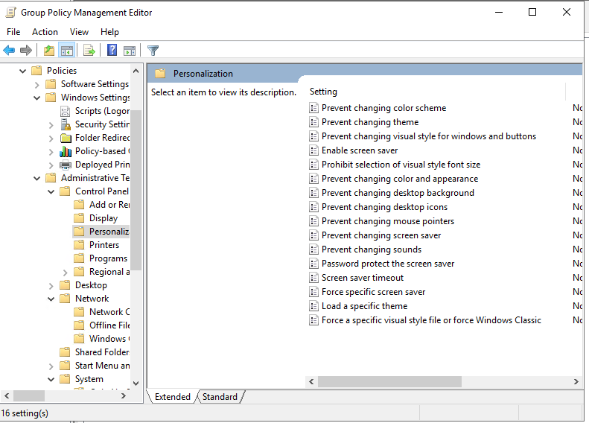
Fig. 19 Personalization Restrictions That Can Be Implemented On GPMC.

- Examples Of Sound Password Principles In Modern Network Environments.
There are many features and ideas out there on how to set a good password, some examples of features and rules that the author believes helps create a strong password are as followed:
- Passwords should be around at least ten characters long [7]and a good practice is for it to between twelve and fourteen characters long [8].
- Passwords should not be used for multiple accounts such as using a work password as a non-work password [9]. This help prevent hackers having access to multiple accounts if one password is compromised.
- The previous point should also be expanded to separate passwords for various work accounts to further increase the security of the account [9].
- Passwords should avoid repetition and personal information, to increase the difficulty of password cracking [8].
- Passwords should not be words spelt backwards [9].
- Passwords should contain a mixture of uppercase and lowercase letters, numbers, and symbols [9].
- However, password should not just be a word with a number or symbol at the beginning or end [9].
- Furthermore, password should be fairly equal on the number of letters, symbols and numbers used and should not be a word with just one or two letters replaced with numbers or symbols. For example, this is not acceptable “B@tM0bile”
- Passwords should not be a pattern of letters, numbers, or symbols such as (Aa11Bb22) [9]
- Passwords should be regularly changed and updated [8], this will help keep the criminals guessing when trying to crack the password.
- Passwords should never be shared with other people or sent via an email, text, letter or stored on device in either file system or anywhere else in clear text form [8].
- Password should never be entered on an open or shared network such as the Wi-Fi at a McDonalds or coffee shop as it could easily be seen and stole [8].
- Passwords should be memorable to the user to avoid the need of writing the password down [8]. However, there are rules that should be followed in regard to setting a memorable password.
  - The user should not use dictionary words as hackers and criminals can uses special computer programs that can filter through all the words in a dictionary to help crack the password [8].
  - This includes all real world language, slang terms, local terms, jargon to further increase the security of the account and password [9]. For example, "Bonjour le monde” is not a secure password just because it a foreign language.
  - The password should not contain any reference to anything personal or sentimental value to the user such birthdates, names, anniversaries, special places and anything that can be discovered about the user on social media or online [8] much of this point is further backed up by the NHS policy document [9]. This is because hackers can gather information on the target and find out details that they will use in their attempts to break into the account.

- References

[1] | C. Schaefer, “Understanding NTFS Permissions,” NTFS Tutorial, 2017.
[2] | dnsstuff, “NTFS vs. Share Permissions,” DNSstuff, 03 04 2020. [Online]. Available: https://www.dnsstuff.com/ntfs-vs-share-permissions#share-permissions. [Accessed 17 02 2021].
[3] | J. Melnick, “Differences Between Share and NTFS Permissions,” Netwrix Blog, 03 03 2020. [Online]. Available: https://blog.netwrix.com/2018/05/03/differences-between-share-and-ntfs-permissions/. [Accessed 17 03 2021].
[4] | J. Moskowitz, “Introduction,” in Group Policy Fundamentals, Security, and the Managed Desktop, Indianapolis, John Wiley & Sons, 2013, pp. 26-27.
[5] | W. R. Stanek, “Administrator’s Pocket Consultant,” Microsoft Press, Vols. X15-44299, pp. 15-16, 2009.
[6] | B. Dauti, “Group Policy in Windows Server 2019,” in Windows Server 2019 Administration Fundamentals: A beginner's guide to managing and administering Windows Server environments, Birmingham, Packt Publishing, 2019, pp. 220,223.
[7] | Securedatarecovery, “The Importance of Strong, Secure Passwords,” Securedatarecovery, 2021. [Online]. Available: https://www.securedatarecovery.com/resources/the-importance-of-strong-secure-passwords#:~:text=A%20strong%20password%20provides%20essential,control%20of%20a%20computing%20device. [Accessed 22 03 2021].
[8] | K. Curran, J. Doherty, A. McCann and G. Turkington, “Good Practice for Strong Passwords,” EDPACS the EDP audit, control and security newsletter, pp. 1-13, 01 November 2011.
[9] | Southern Health NHS Foundation Trust, “IT Password Protection Policy,” Information Security Suite of Policies, 2019.

