

Caspar Thurston-Smith

Analysis of Electromagnetic Wave Propagation

University of Wales Trinity St David
Electromagnetic radiation

Beng
Academic Year: 2024-2025

Supervisor: Stalin Jacob
Associate Supervisor: Jenifer Prince
04 2025

University of Wales Trinity St David
Electromagnetic Radiation

Beng

Academic Year 2024-2025

Caspar Thurston-Smith

Analysis of electromagnetic wave propagation

Supervisor: Stalin Jacob
Associate Supervisor: Jenifer Prince
04 2025

This thesis is submitted in partial fulfilment of the requirements for the degree of Ordnance Munitions and Explosives
(NB. Remove if the degree award is based solely on examination of the thesis)

© UWTSD 2025. All rights reserved. No part of this publication may be reproduced without the written permission of the copyright owner.

Academic integrity declaration
I declare that:
- the thesis submitted has been written by me alone.
- the thesis submitted has not been previously submitted to this university or any other.
- that all content, including primary and/or secondary data, is true to the best of my knowledge.
- that all quotations and references have been duly acknowledged according to the requirements of academic research.
I understand that to knowingly submit work in violation of the above statement will be considered by examiners as academic misconduct.

Abstract
This report asses the difference in dielectric properties of a vacuum filled waveguide v a Teflon waveguide. The report concludes that Teflon waveguide has lower cutoff frequency due to dielectric properties and is able to support lower frequencies. The report also makes use of Ansys software to simulate the radiation pattern of a halfwave dipole antenna. This antenna generated an isotropic radiation pattern and demonstrated the ideal radiation pattern of this antenna.

Contents
Academic integrity declaration i
Abstract 2
Table of Figures 5
Table of Equations 7
Table of Tables 8
1.0 Introduction 9
2.0 Methodology 10
Task 1 10
Task 2 12
3.0 Results 13
Task 1a 13
1a i 13
1 A ii 13
1A iii 15
1A iv 21
1A v 24
Task 1b 25
1b i 25
1b ii 25
1b iii 26
1b iv 33
1b v 37
Task 2 38
i 38
ii 39
iii 39
iv 40
4.0 Discussion 41
Task 1a 41
Task 1a i – ii 41
Task 1a iii 41
Task 1a iv – v 41
Task 1b 42
Task 1B i-ii 42
Task 1biii 42
Task 1b iv-v 42
Comparing a vacuum filled waveguide to a Teflon filled waveguide 44
Task 2 46
Task 2 i 46
Task 2ii -iii 46
Task 2 iv 47
5.0 Conclusions 48
Bibliography 49

Table of Figures
Figure 1 – Perfect E boundary 12
Figure 2 – Mode 1 wave port 14
Figure 3 – Mode 2 wave port 15
Figure 4 – Mode 3 wave port 15
Figure 5 – Electric field strength 16
Figure 6 – Electric field direction and strength of direction 16
Figure 7 – Magnetic field strength 17
Figure 8 – Magnetic field direction and strength indirection 17
Figure 9 – Electric field strength 18
Figure 10 – Electric field direction and strength indirection 18
Figure 11 – Magnetic field strength 19
Figure 12 – Magnetic field direction and strength in direction 19
Figure 13 – Electric field strength 20
Figure 14 – Electric field direction and strength in direction 20
Figure 15 – Magnetic field strength 21
Figure 16 – Magnetic field direction and strength in direction 21
Figure 17 – A graph to show the simulated cutoff frequencies 25
Figure 18 – Port display, mode 1 for a Teflon waveguide. 26
Figure 19 – Port display, mode 2 for a Teflon waveguide 27
Figure 20 – Port display, mode 3 for a Teflon wave guide 27
Figure 21 – Electric field magnitude for mode 1 28
Figure 22 – Electric field vectors for mode 1 28
Figure 23 – Magnetic field magnitude for mode 1 29
Figure 24 – Magnetic field vectors for mode 1 29
Figure 25 – Electric field magnitude for mode 2 30
Figure 26 – Electric field vectors for mode 2 30
Figure 27 – Magnetic field magnitude for mode 2 31
Figure 28 – Magnetic field vectors for mode 2 31
Figure 29 – Electric field magnitude for mode 3 32
Figure 30 - Electric field vectors for mode 3 32
Figure 31 – Magnetic field magnitude for mode 3 33
Figure 32 – Magnetic field vectors for mode 3 33
Figure 33 – A graph showing the simulated cutoff frequency of a waveguide with a Teflon medium 38
Figure 34 – A graph showing the simulated operating frequency of the antenna 40
Figure 35 – The simulated radiation pattern for a halfwave dipole antenna 41

Table of Equations
Equation 1 – how to work out the width (a) and hight (b) of the wave guide. 13
Equation 2 – Cutoff frequency in a rectangular wave guide 25
Equation 3 – An equation showing the permittivity and the permeability of the medium 37
Equation 4 – The equation used to calculate the theoretical cutoff frequencies of a Teflon waveguide 37
Equation 5 – An equation to calculate the length of a halfwave dipole antenna 42
Equation 6 – An equation to calculate the theoretical operating frequency of the antenna 43
Equation 7 – An equation linking Frequency and length of dipole antenna 49

Table of Tables
Table 1 – Data for cutoff frequency calculation of mode 1 22
Table 2 – Data for theoretical cutoff frequency calculation of mode 2 22
Table 3 – Data for theoretical cutoff frequency calculation of mode 3 23
Table 4 – Data for cutoff frequency calculation of mode 1 34
Table 5 – Table showing the data required to calculate the theoretical cutoff frequency of mode 2 Task 1b 35
Table 6 – Table showing the data required to calculate the theoretical cutoff frequency of mode 2 Task 1b 36
Table 7 – Table comparing theoretical and simulated cutoff frequency for Task 1A 41
Table 8 – Table comparing theoretical and simulated cutoff frequency for Task 1A 42
Table 9 – A table showing the cutoff frequencies for Task 1a and 1b 44

1.0 Introduction
The brief gives 2 Tasks both subsections. Task 1a and 1b focus on a rectangular waveguide with two different mediums. Task 2 focusing on a halfwave dipole antenna. Simulations using Ansys Electronic Desktop student software were required for all tasks.
This report covers the simulation designs, including specific elements that may impact the results. It follows with taught and researched knowledge to analyse the simulations results, including theoretical equations to find specific information requested in the brief.
Rectangular waveguides were first theorised by J.J Thomson and proved by Oliver lodge1893-94 [1]. Waveguides support different modes of electromagnetic wave propagation. The two most common modes are transverse electric and transverse magnetic, these modes help to optimise signal transmission while reducing losses [2] [3]. This report will look at the impact of different mediums. In the modern era a trend towards miniaturization has meant that waveguides have got smaller, and advances in materials like low lose di-electric substances have improved wave guide efficiency.
A half wave dipole antenna is usually made of two metal rods, with the feed point in the centre. In 1887 Heinrich Hertz demonstrated the existence of radio waves using a dipole antenna [4]. The radiation pattern produced by a dipole antenna is examined later but in theory should be a broadside pattern. Meaning a strong radiation perpendicular to its length. Modern developments have created more efficient wave guides with lower losses. [5]

2.0 Methodology
For both Tasks Ansys Electronic Desktop student software was used.
Within all calculations the speed of light is rounded up from 299,792,458m/s to 3x10⁸. [6]

Task 1
Task 1 consisted of two parts, requiring software to create a rectangular waveguide, with the medium changed and the results compared. The waveguide walls were made of perfect electric conductor (PEC) using identical dimensions; 50mm length, with height and width based on the student number 2313447, calculated using equation 1. Furthermore, the wavelength was also to be based on the student number (first 3 digits).
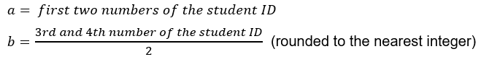
Equation 1 - How to work out the width (a) and hight (b) of the wave guide.
Waveguide Dimensions:
- Length 50mm
- Width 23 mm
- Hight 7 mm
- Wavelength 231mm
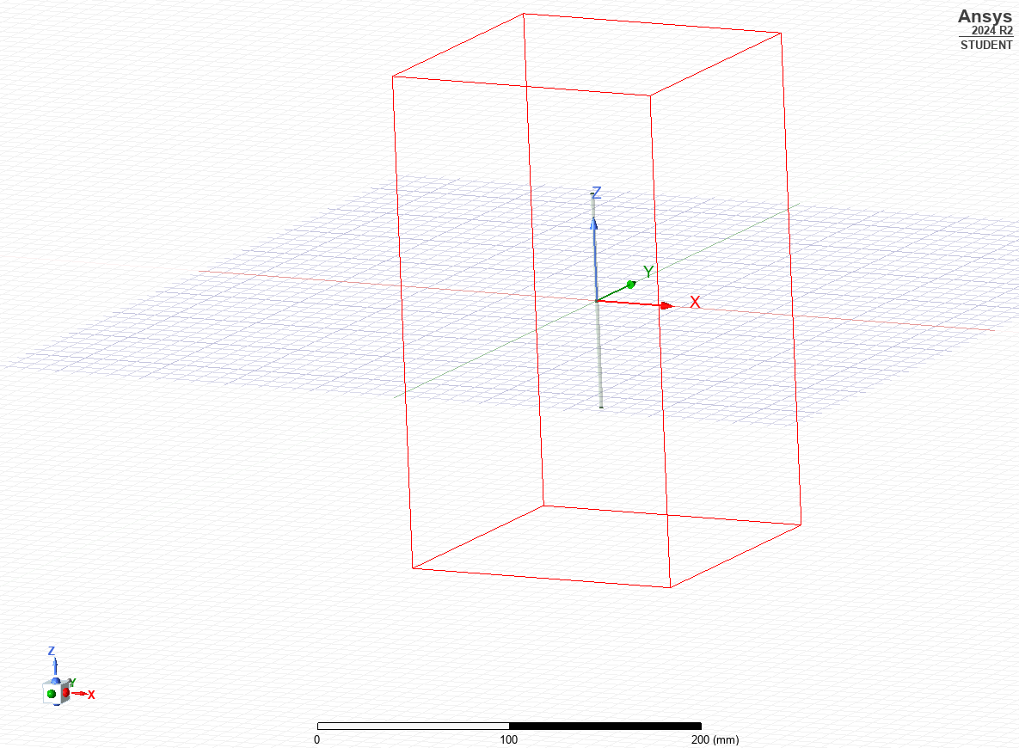

Figure 1 – Perfect E boundary

Once dimensions had been decided, the properties tool assigned the outside of the material (PEC), and the medium. Figure 1 shows perfect E boundary.
Wave ports were added on the shape’s two smallest faces and assigned ‘wave port modal function. 3 modes were selected, and port impedance set at 50 ohms. Then, maximum and minimum frequencies were set, 7Hz and 60Hz, sweep frequency set to, 2-30GHz.
Modifying for Teflon medium requires properties box selection to Teflon and editing relative permeability and relative permittivity to 1 and 1.2 [7] [1]. No further modification is required and once validated can be rerun.

Task 2
Task 2 involved drawing a halfwave dipole antenna (using Ansys software) to identify brief’s output.
Changing the units to millimetres (mm), enables drawing of the modal cylinder with z co-ordinate -half the high of the cylinder and a radius of 1, then assigning the PEC material.
To create a lumped port, a space was created at the centre of cylinder 1. Cylinder 2 was created with a height and radius of 1mm, in the centre of cylinder 1, with the properties of a vacuum and then removed, creating the gap in cylinder 1. To create port, cylinder 2 had the plane changed to YZ, creating a rectangular plane. Finally, an impedance of 50 Ohms at mode 1 was set. An integration line was drawn to complete the port.
The next step is to create an open region by setting the operating frequency to 1GHz and changing boundary settings to PML, creating a rectangular open region.
Finally, a solution setup was created: setting the frequency at 5GHz with 99 maximum number of passes, a start frequency of 1GHz, end frequency of 7.5GHz. Once validated the simulation was ready to run.

3.0 Results

Task 1a

1a i
This task identifies the dominant mode propagating through the wave guide by running the simulation and analysing the wave ports. Figures 2, 3 and 4 show the port field display; evaluating the transverse electric (TE) values shows the shape and size of the wave. The TE value for each mode is: mode 1 TE10, mode 2 TE20 and mode 3 TE30. The dominant mode is the lowest order mode, in this case mode 1.

1 A ii
Below are the port field modes for all three modes, as the display is the same on both ports, only 1 display per mode will be shown in this report.
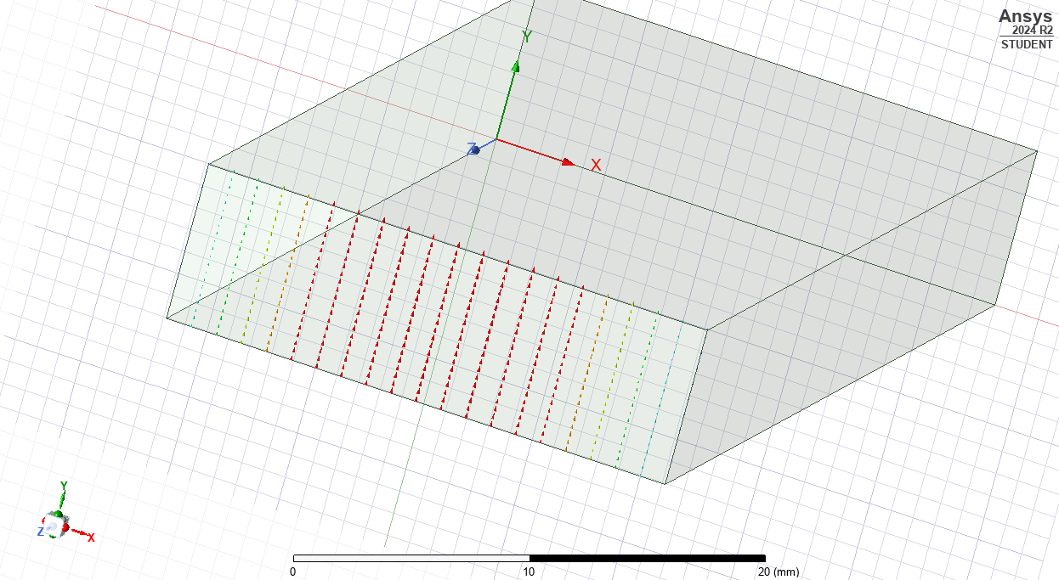
Figure 2 – Mode 1 wave port
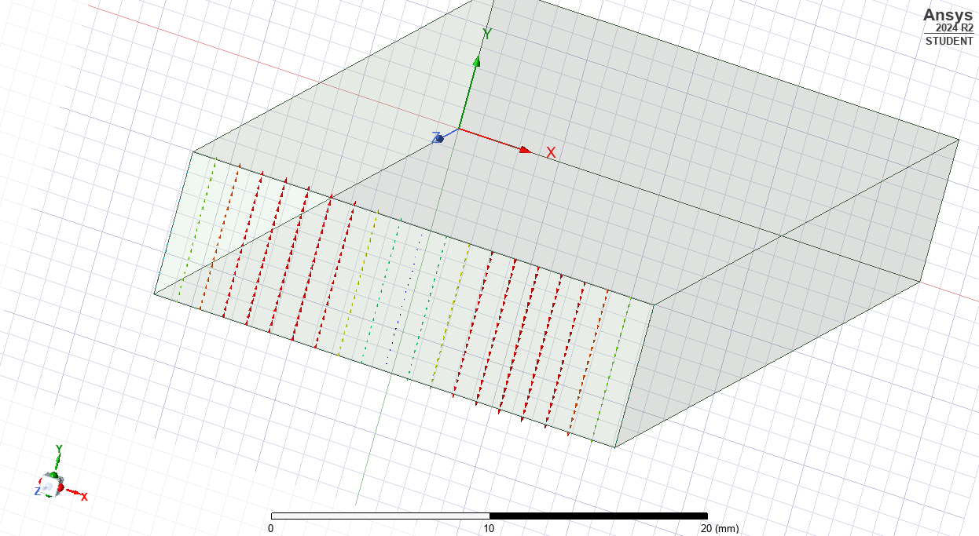
Figure 3 – Mode 2 wave port
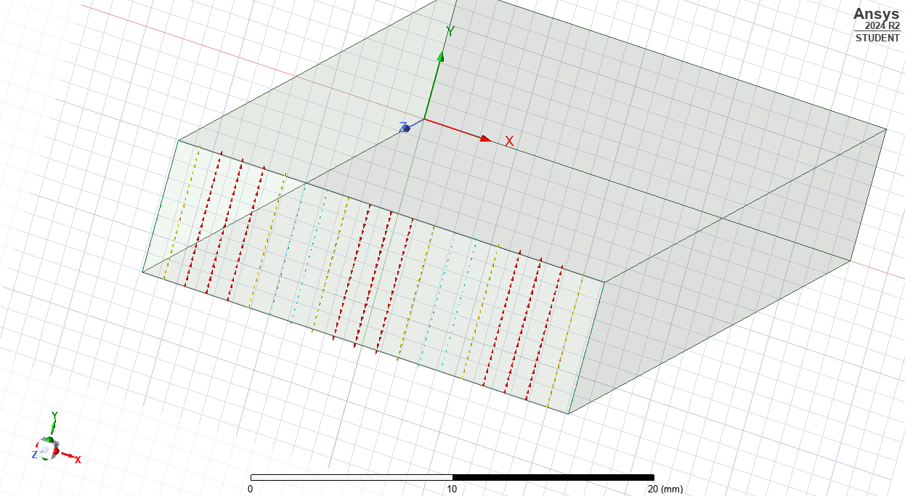
Figure 4 – Mode 3 wave port
The port field displays demonstrate the peaks and troughs of a wave travelling across the wave guide. The TEmn value measures these peaks; the m value represents the number of half wave variations on the azimuthal direction (width), the n value shows the number of half wave variation in the radial mode (height).

1A iii
This simulation delivers the magnitudes and vectors for the magnetic and electric fields; results shown below.

Mode 1
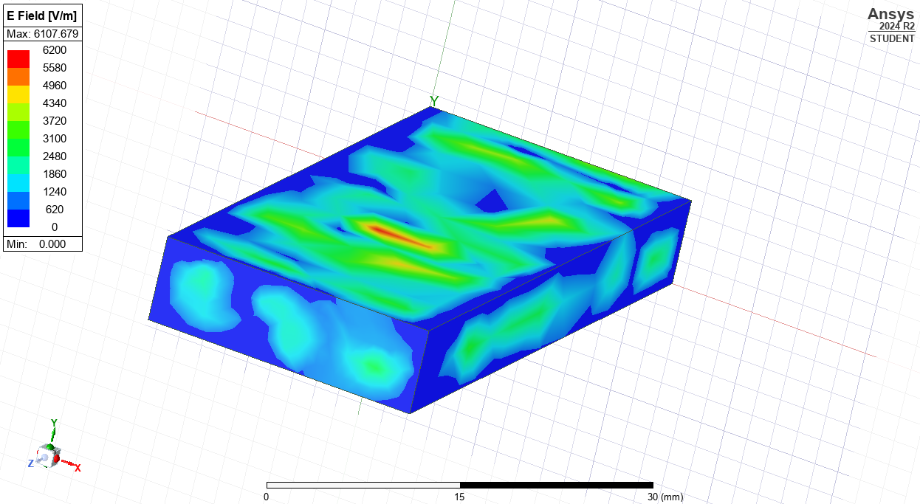
Figure 5 – Electric field strength

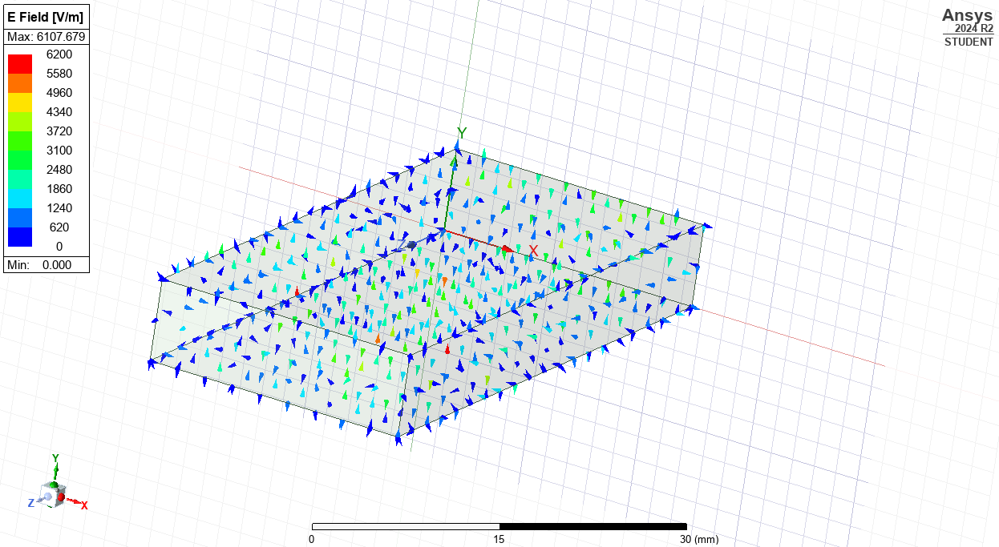
Figure 6 – Electric field direction and strength of direction

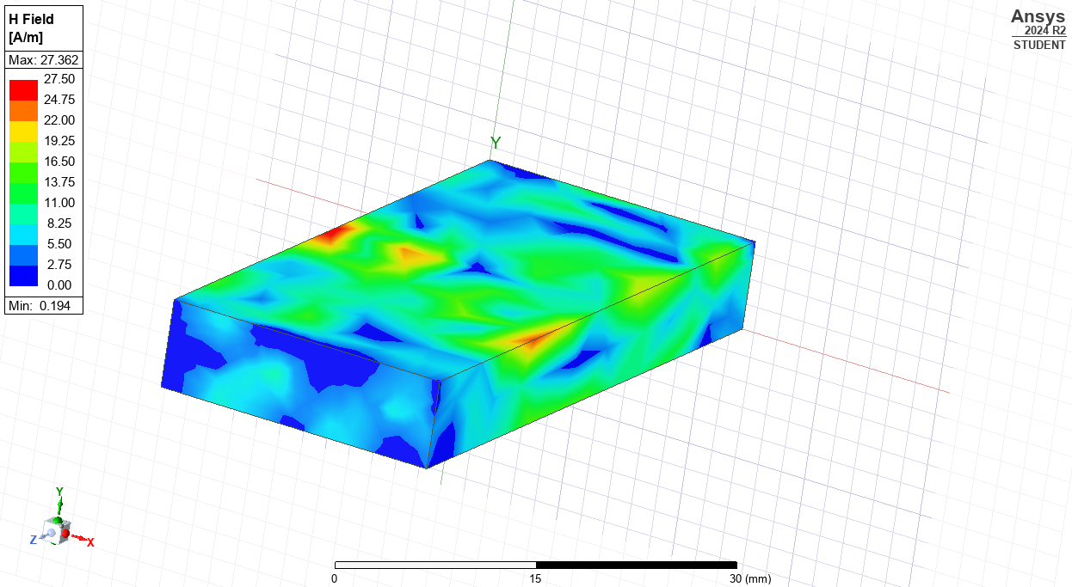
Figure 7 – Magnetic field strength

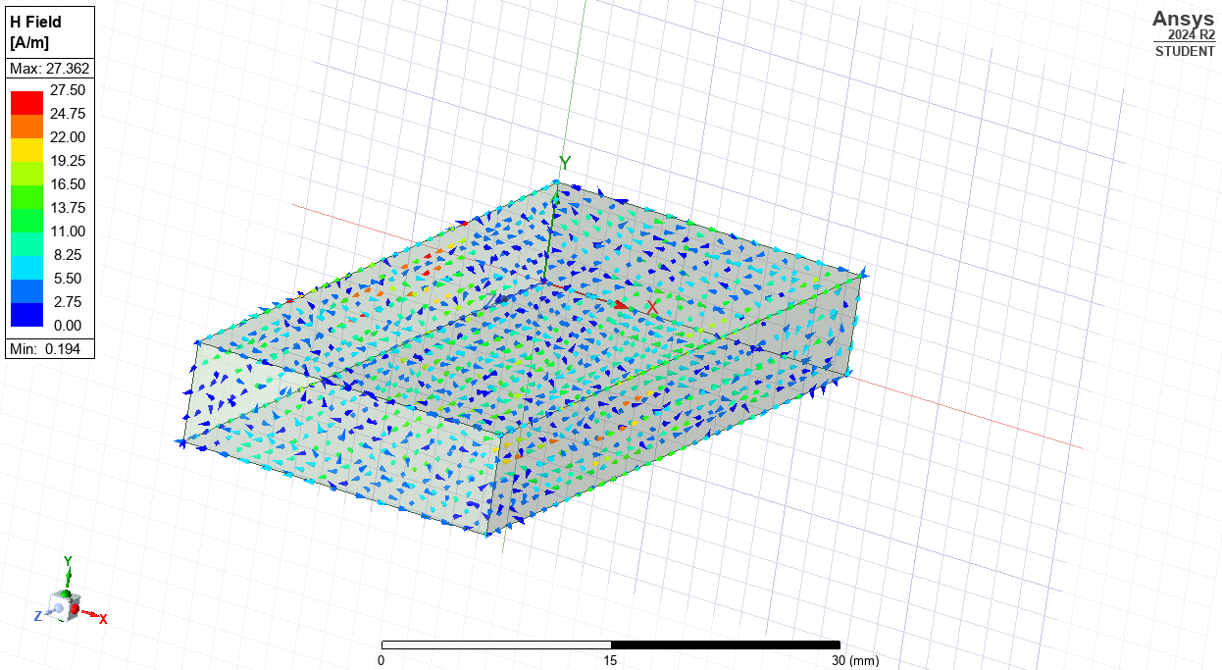
Figure 8 – Magnetic field direction and strength indirection

Mode 2
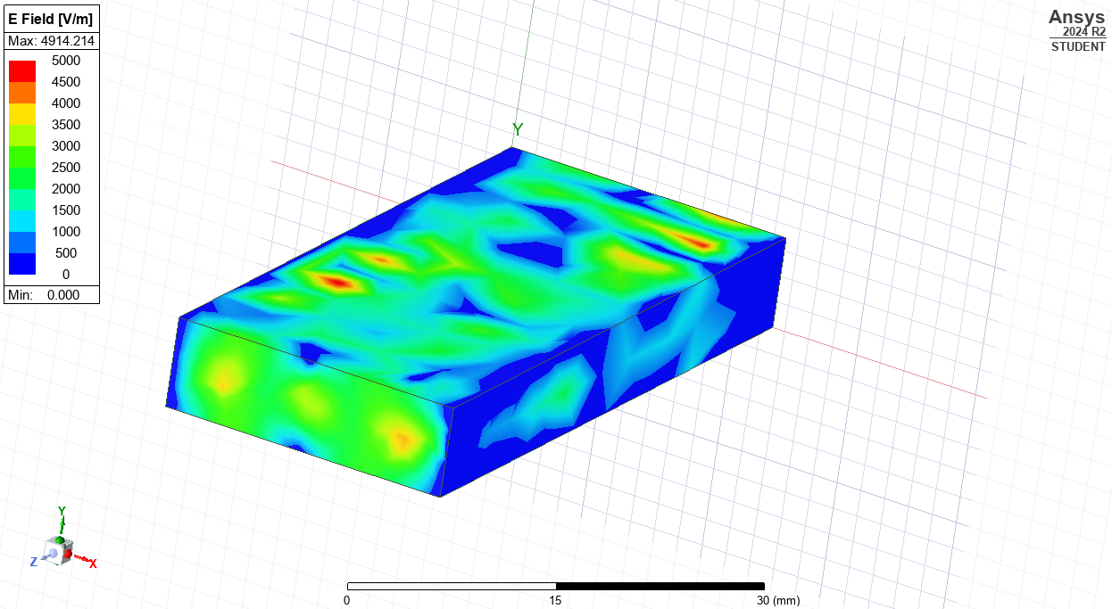
Figure 9 – Electric field strength

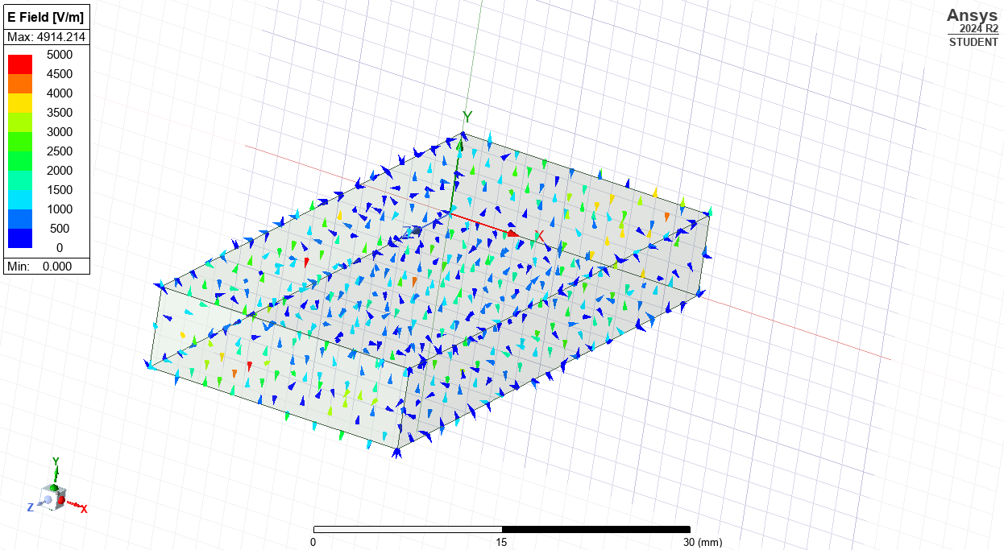
Figure 10 – Electric field direction and strength indirection

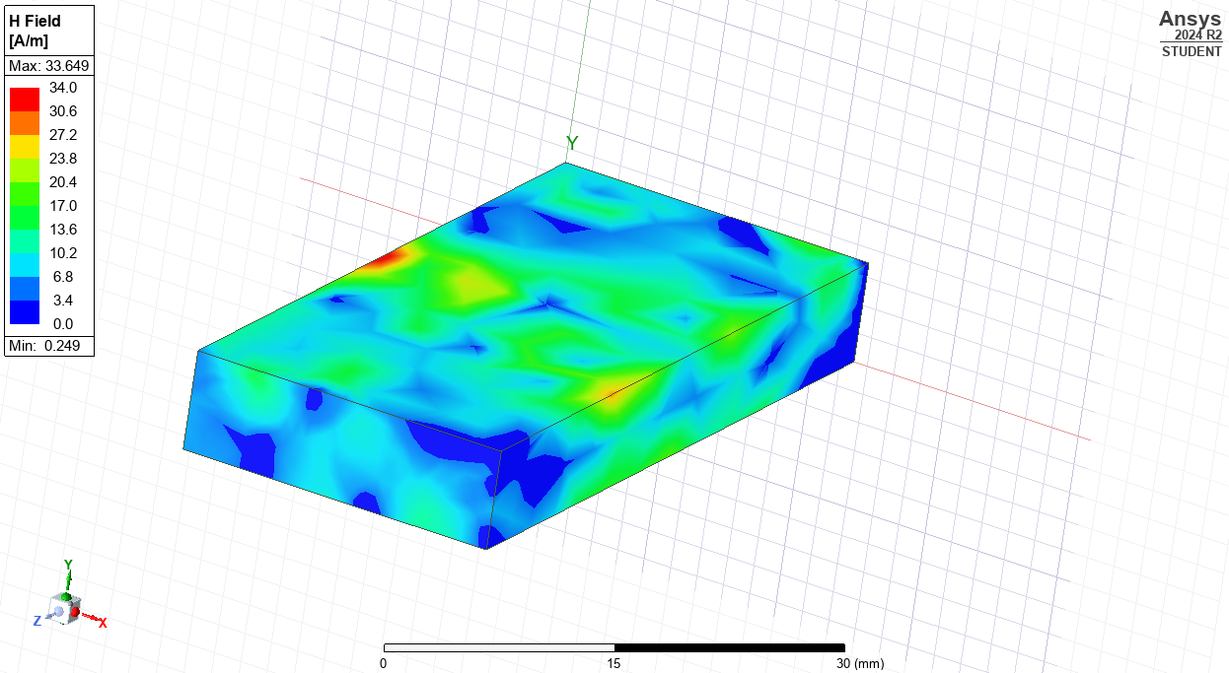
Figure 11 – Magnetic field strength

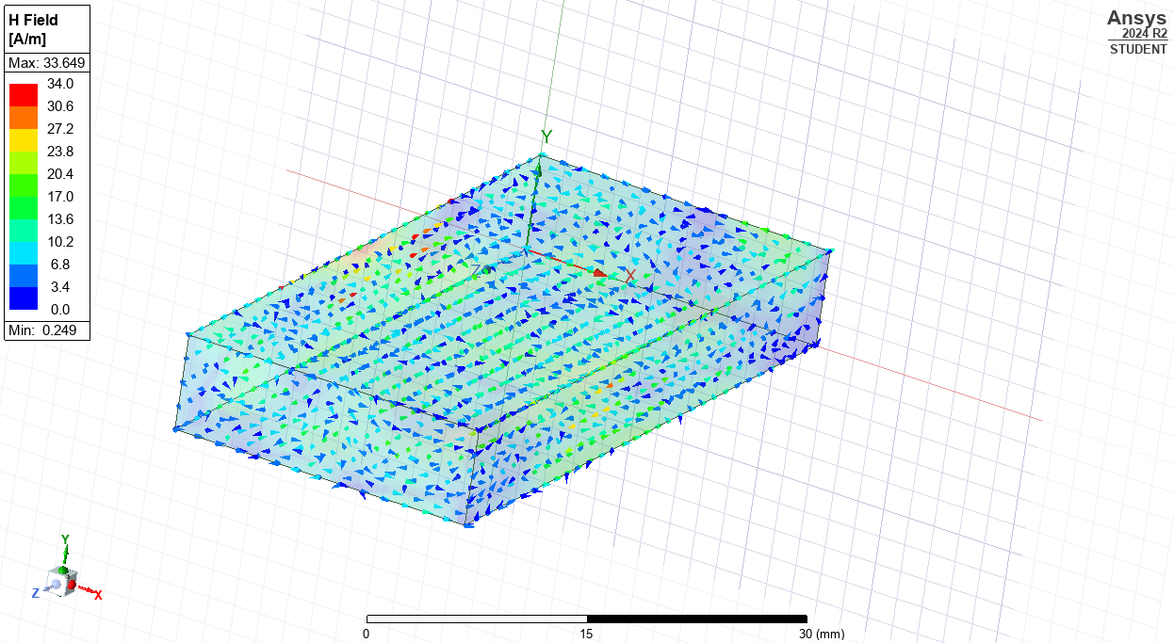
Figure 12 – Magnetic field direction and strength in direction

Mode 3
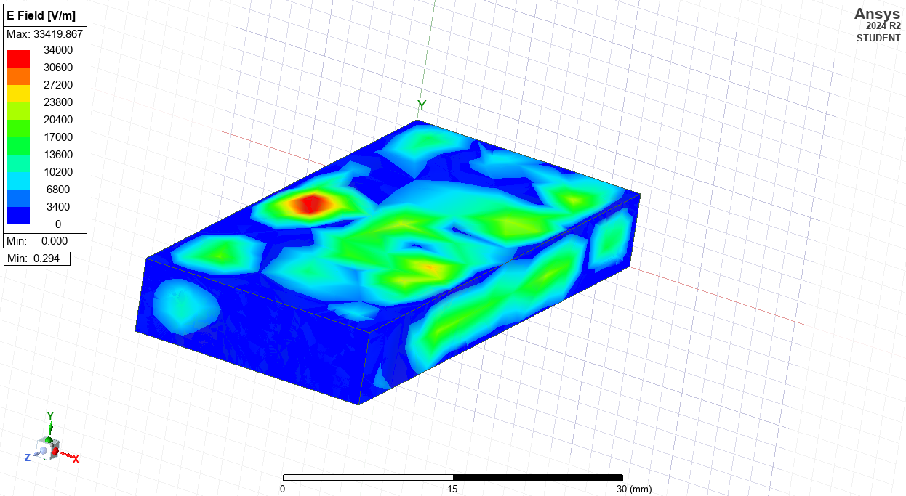
Figure 13 – Electric field strength

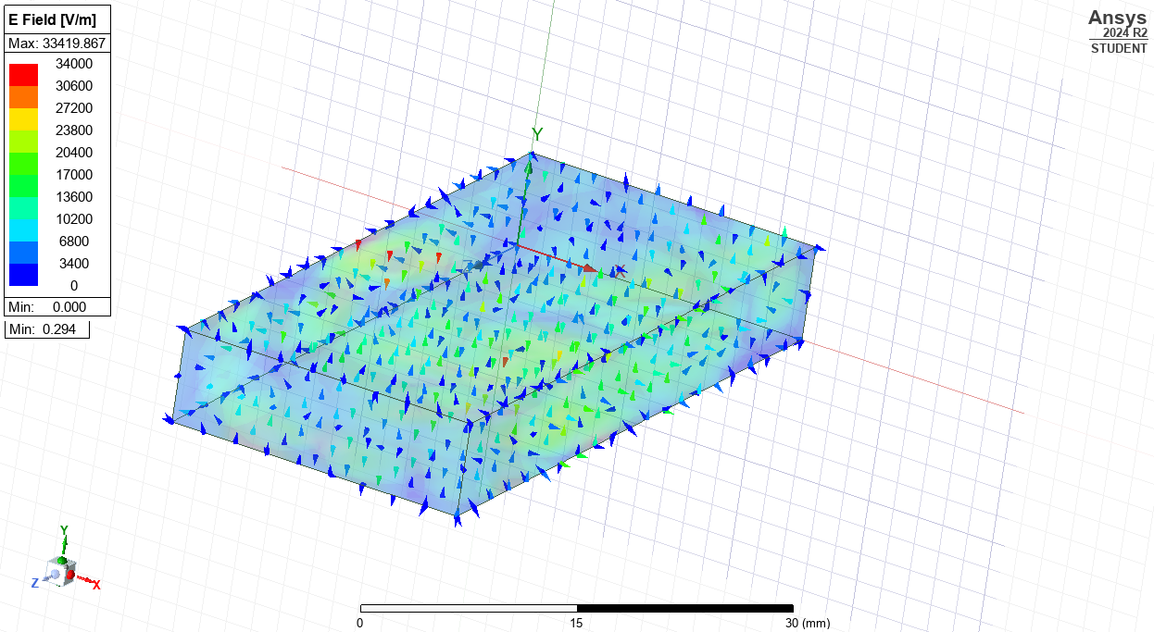
Figure 14 – Electric field direction and strength in direction
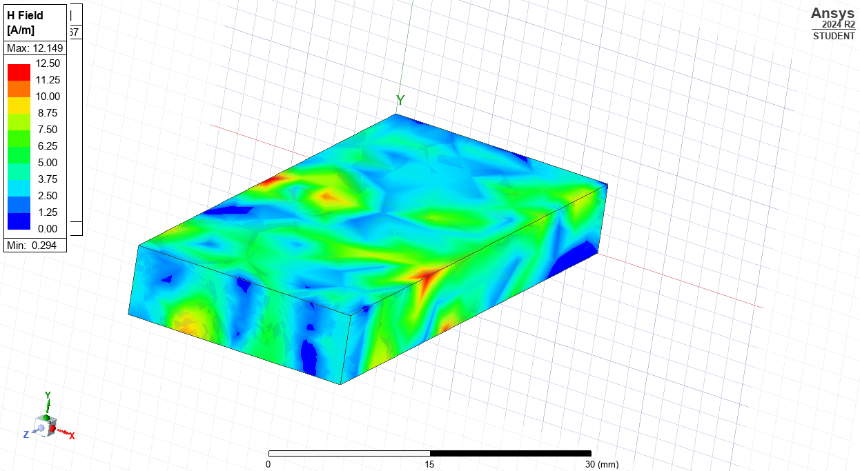
Figure 15 – Magnetic field strength

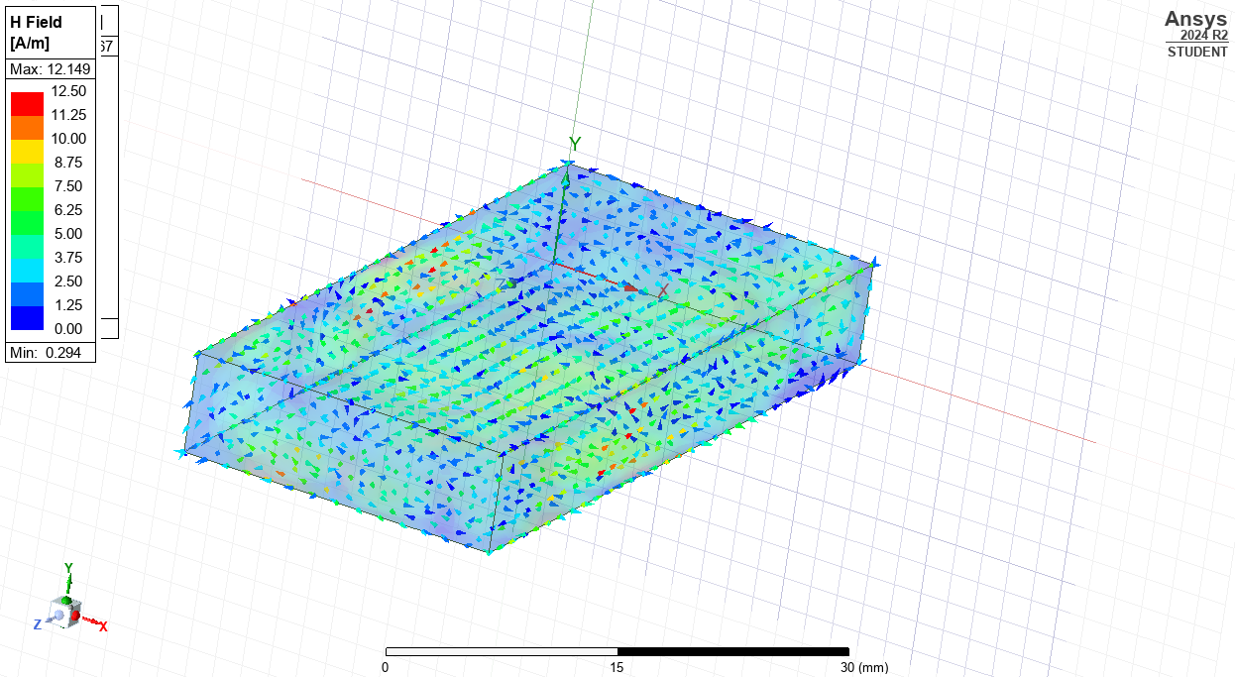
Figure 16 – Magnetic field direction and strength in direction

1A iv
Task iv requires the use of equation 2 and each mode’s TE values. Combining the equation and the simulation information enables the following calculations to be conducted.
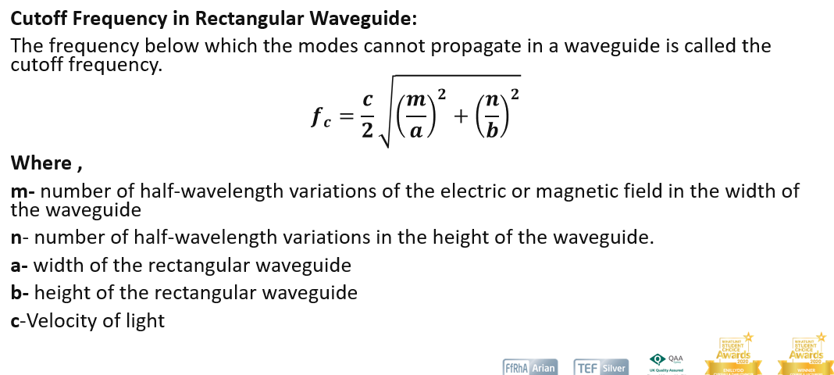
All information must be in SI units, requiring converting a and b into meters. Each table highlights data entered in Equation 2 to calculate the frequencies cut.
Equation 2 - Cutoff frequency in a rectangular wave guide [16]

Mode 1
To calculate the theoretical cutoff frequency for Mode 1, equation 2 and the data below was used.
Table 1 – Data for cutoff frequency calculation of mode 1
Representing letter | Value with units | Value (with SI units)
M | 1 | 1
N | 0 | 0
a | 23mm | 0.023m
b | 7mm | 0.007m
c | 3x10⁸ | 3x10⁸
The theoretical cutoff frequency for mode 1 is, 6.52x10⁹ Hz or 6.52GHz.

Mode 2
Representing letter | Value with units | Value (with SI units)
M | 2 | 2
N | 0 | 0
a | 23mm | 0.023m
b | 7mm | 0.007m
c | 3x10⁸ | 3x10⁸
Table 2 – Data for theoretical cutoff frequency calculation of mode 2
The theoretical cutoff frequency for mode 2 is, 1.304x10¹⁰Hz or 13.04GHz.

Mode 3
Representing letter | Value | Value (with SI units)
M | 3 | 3
N | 0 | 0
a | 23mm | 0.023m
b | 7mm | 0.007m
c | 3x10⁸ | 3x10⁸
Table 3 – Data for theoretical cutoff frequency calculation of mode 3
The theoretical cutoff frequency for mode 3 is, 1.957x10¹⁰Hz or 19.57GHz.

1A v
Post simulation figure 17 was plotted
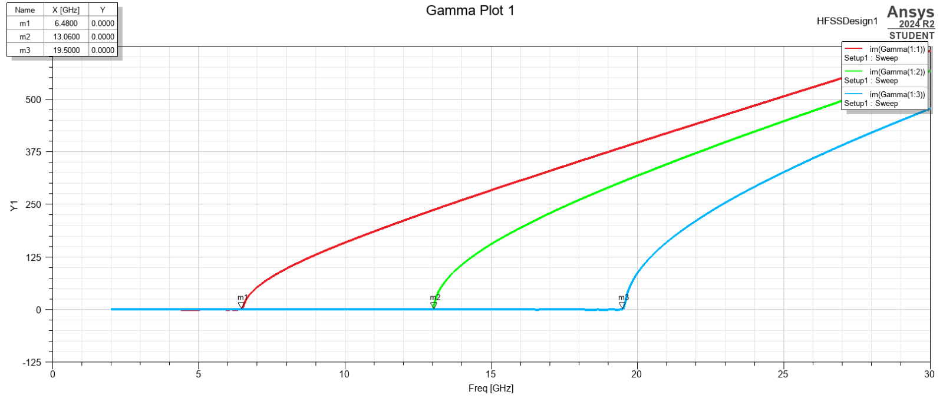
Figure 17 – A graph to show the simulated cutoff frequencies
Figure 17 shows the simulated cutoff frequencies which are mode 1 6.48 GHz, mode 2 13.06 GHz and mode 3 19.50 GHz. demonstrating the dominant mode is mode 1.

Task 1b
The task requires the same information as above using the same method but a different medium.

1b i
Task 1bi identifies the dominant modes propagating through the wave guide. Figures 18, 19 and 20 show the port field display, showing the transverse electric (TE) values.
The TE value reflects the shape of shape and size of the wave. For each mode a TE value has been worked out: mode 1 TE10, Modes 2 TE20 and Mode 3 of TE30. The dominant mode is the lowest order mode, in this case mode 1.

1b ii
Below are the port field modes for all three modes; as the display is the same on both ports, only 1 display per mode is shown in this report.
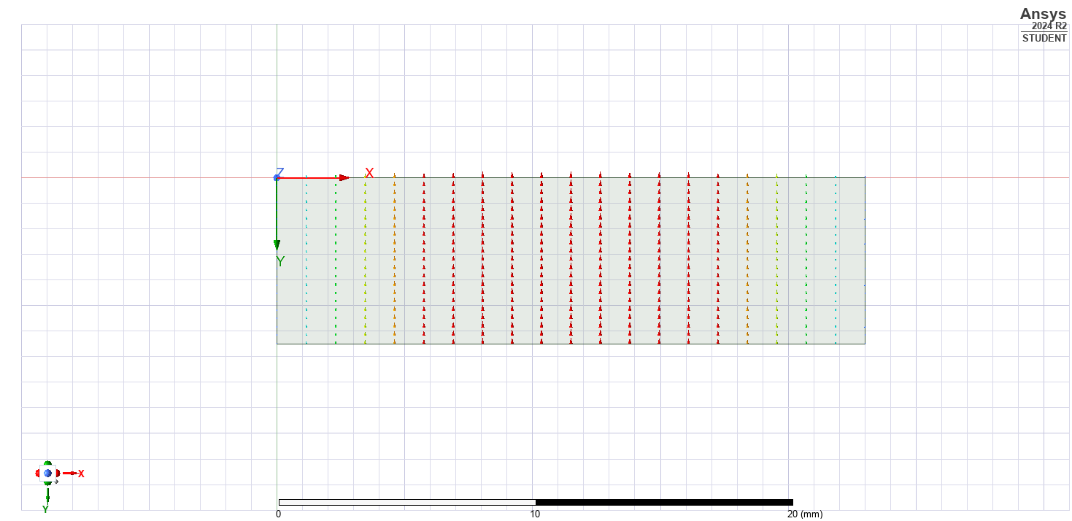
Figure 18 – Port display, mode 1 for a Teflon waveguide.

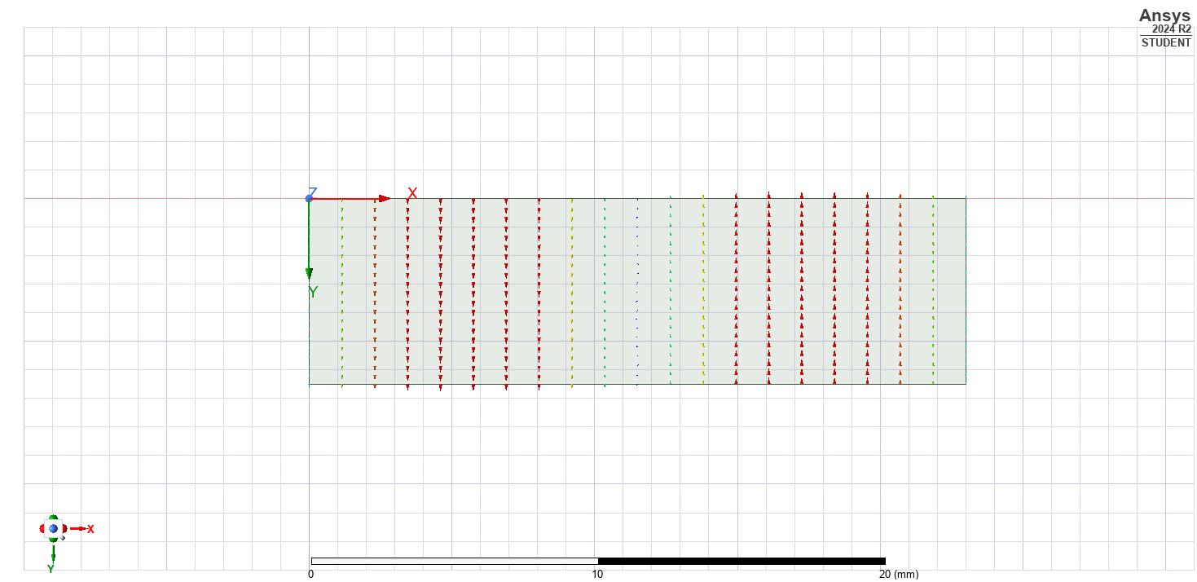
Figure 19 – Port display, mode 2 for a Teflon waveguide
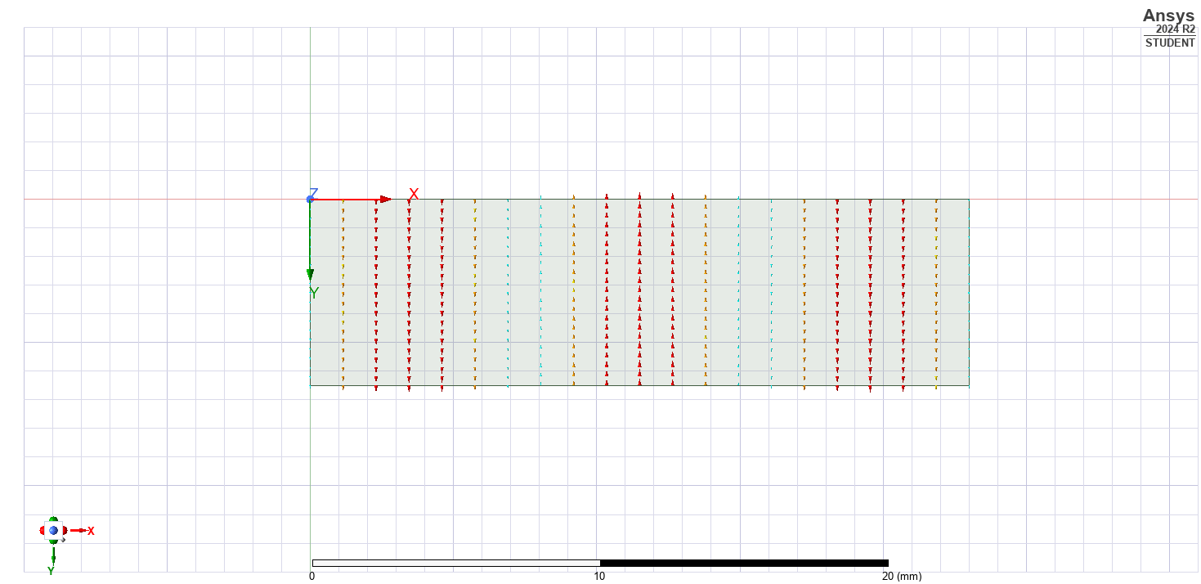
Figure 20 – Port display, mode 3 for a Teflon wave guide

1b iii
This simulation delivers the magnitudes and vectors for the magnetic and electric fields; results shown below.
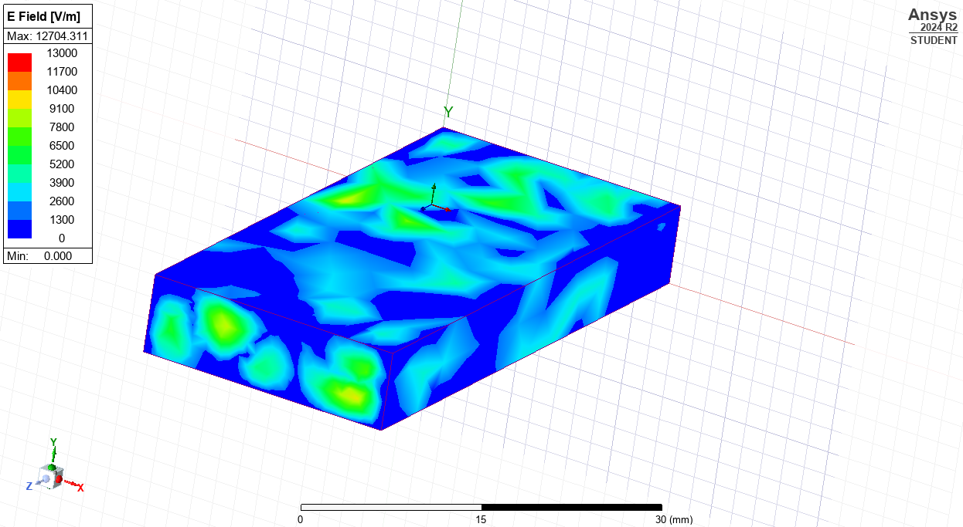
Figure 21 – Electric field magnitude for mode 1

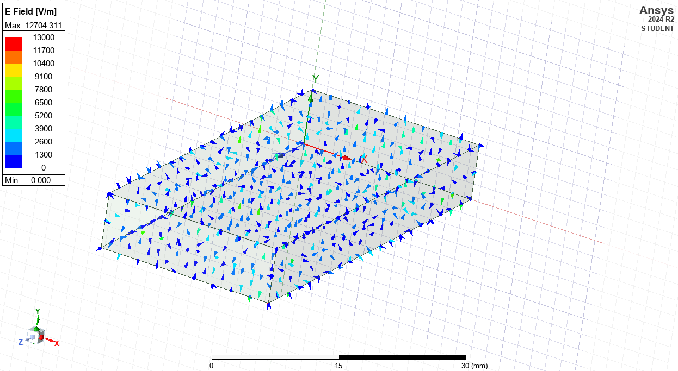
Figure 22 – Electric field vectors for mode 1

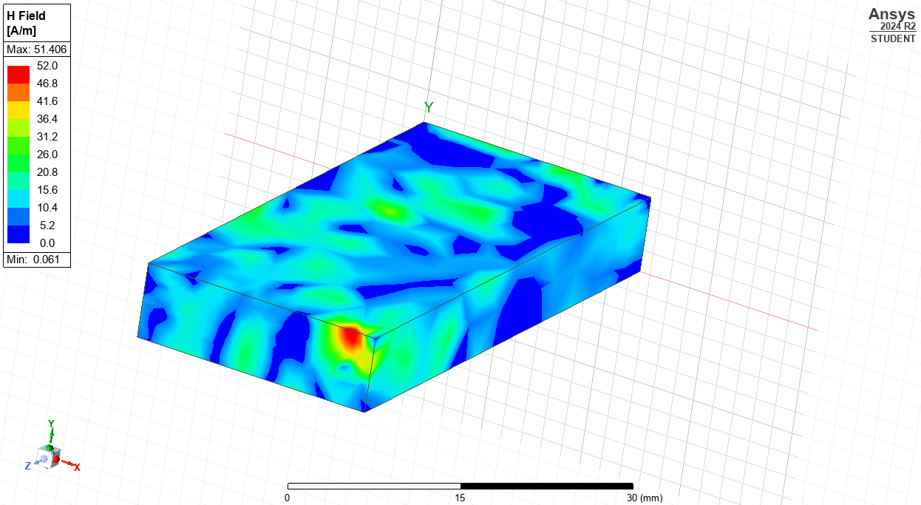
Figure 23 – Magnetic field magnitude for mode 1

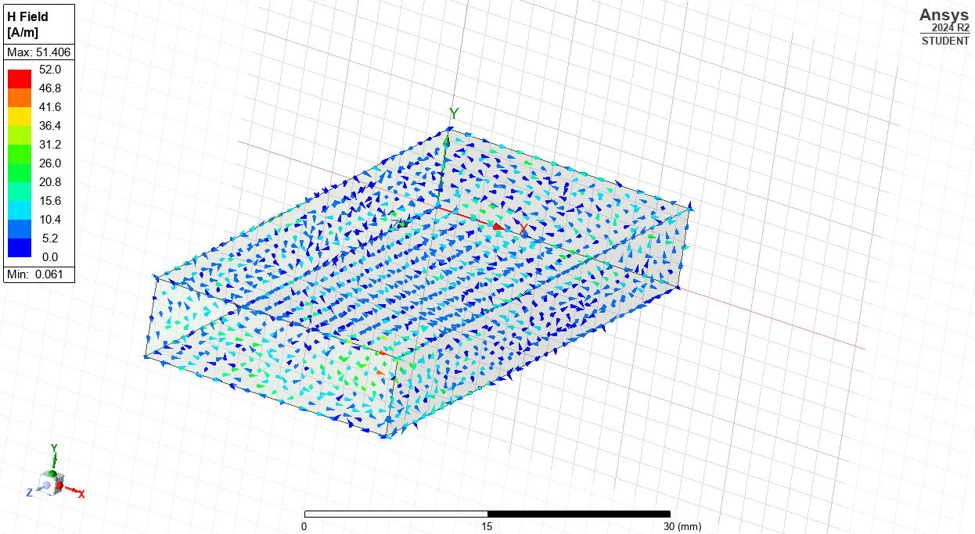
Figure 24 – Magnetic field vectors for mode 1

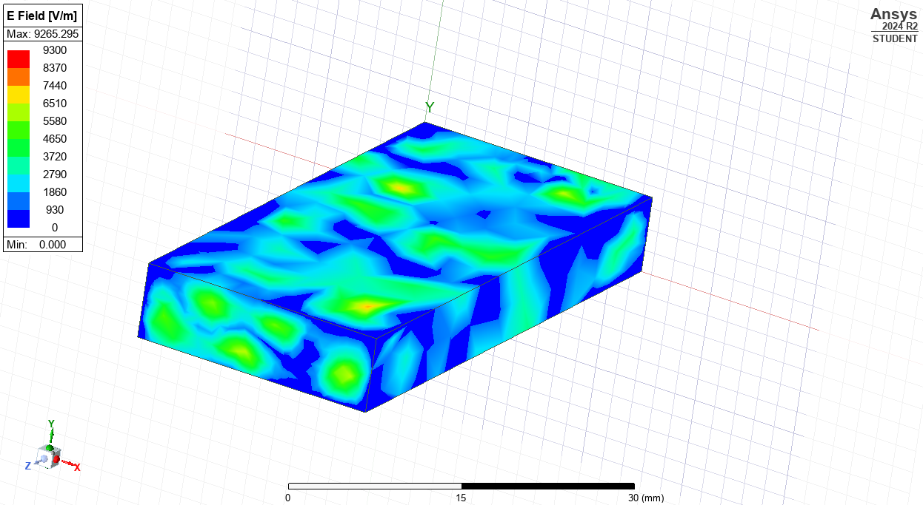
Figure 25 – Electric field magnitude for mode 2

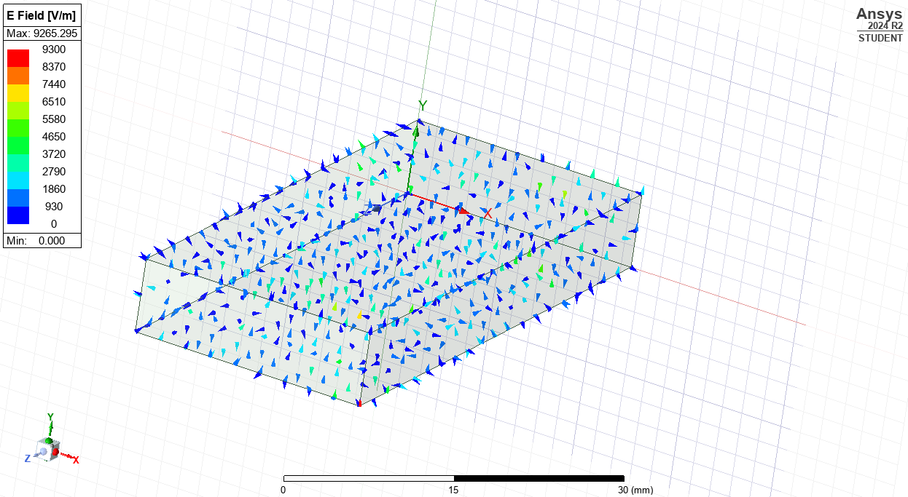
Figure 26 – Electric field vectors for mode 2

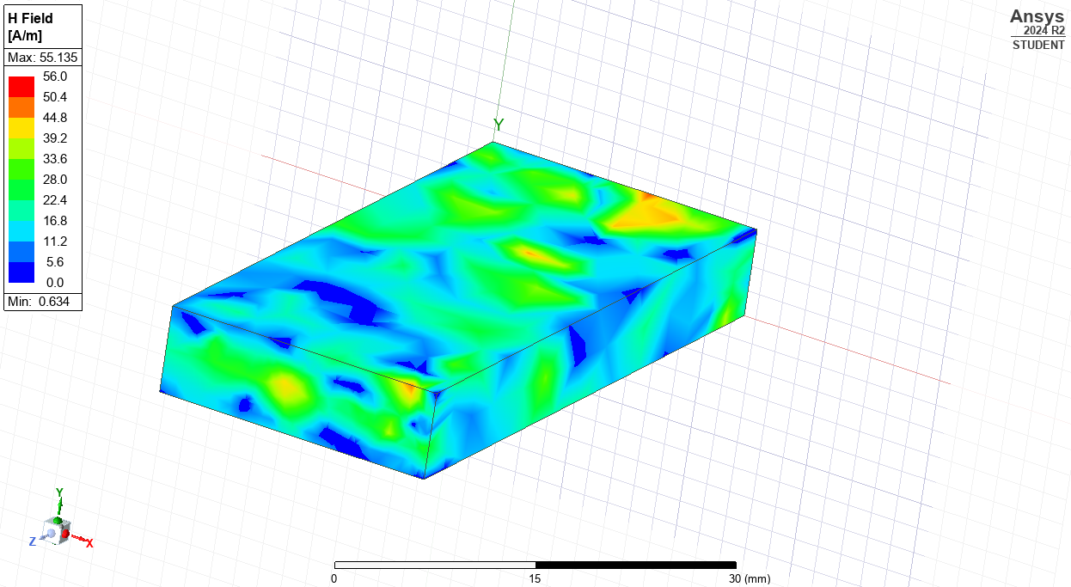
Figure 27 – Magnetic field magnitude for mode 2

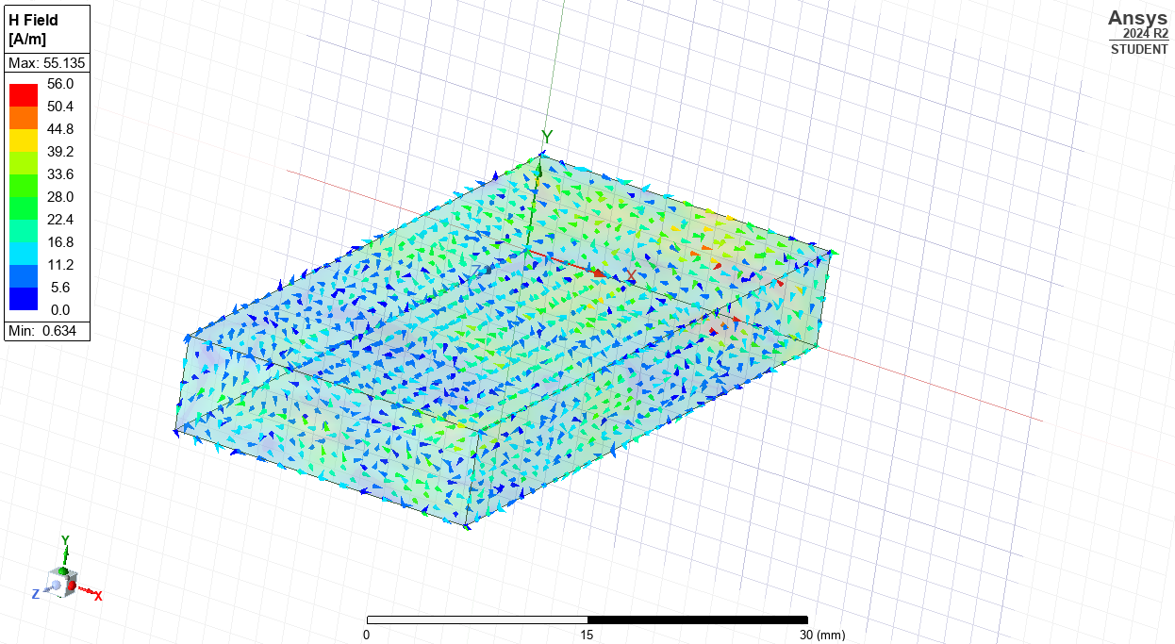
Figure 28 – Magnetic field vectors for mode 2

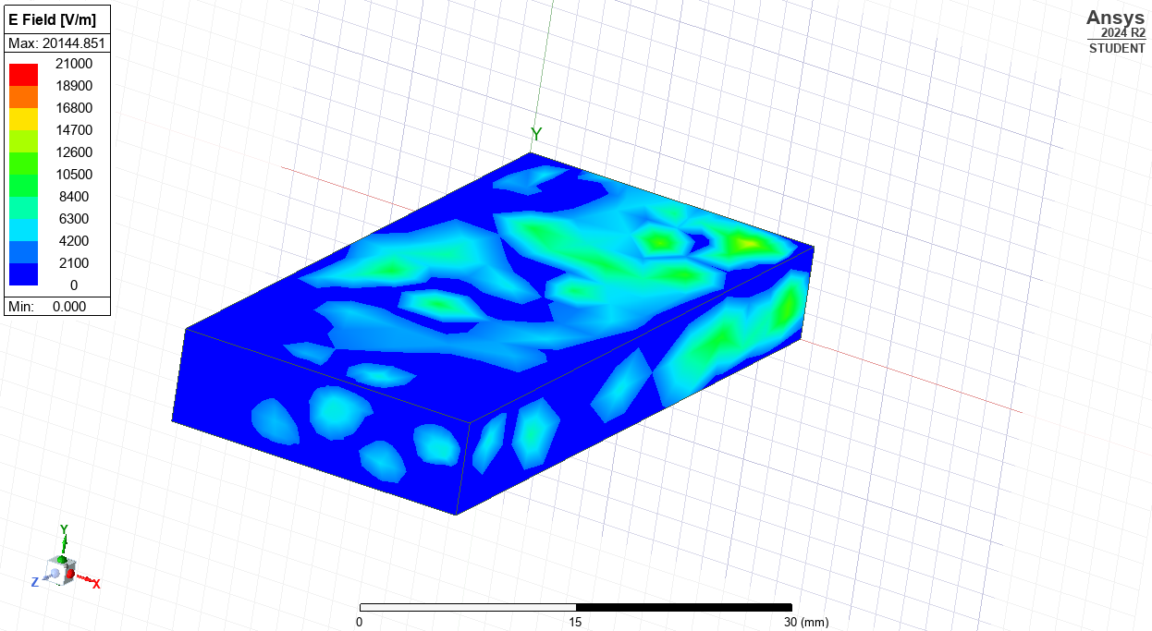
Figure 29 – Electric field magnitude for mode 3

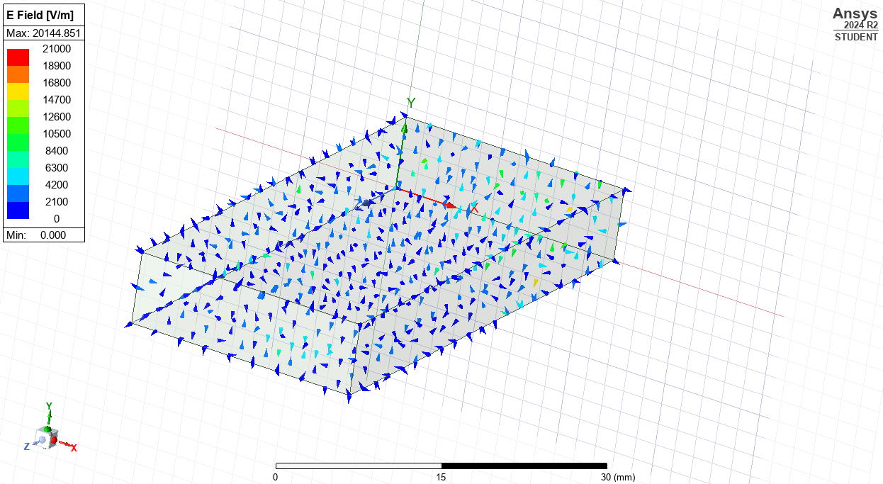
Figure 30 - Electric field vectors for mode 3
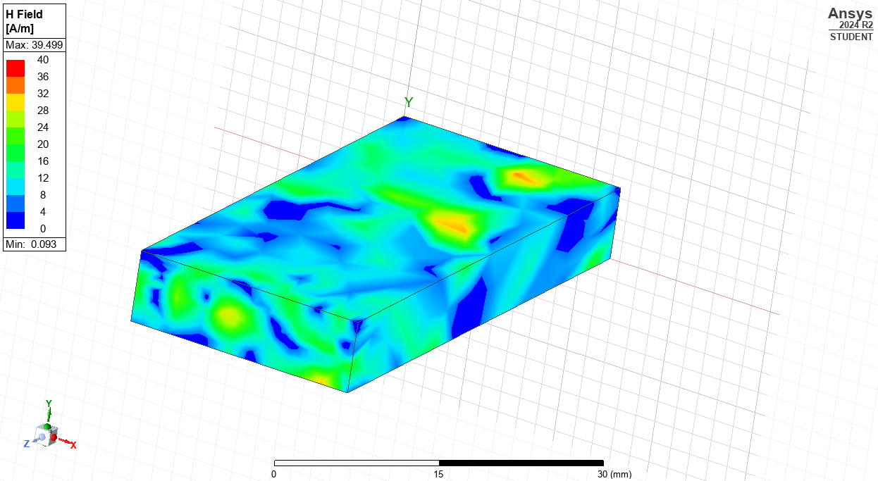
Figure 31 – Magnetic field magnitude for mode 3
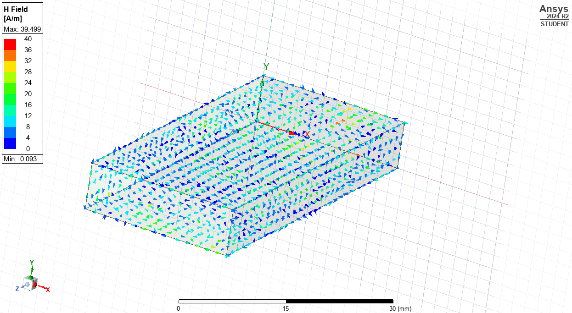
Figure 32 – Magnetic field vectors for mode 3

1b iv
In contrast to 1a iv, the Teflon medium, requires a new equation.
All information must be in SI units, requiring converting a and b into meters. Each table shows Equation 4 data enabling the frequencies cut calculations.
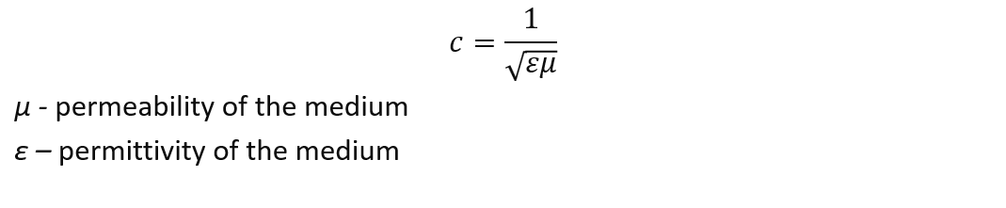
Equation 3 – An equation showing the permittivity and the permeability of the medium
Combining Equation 2 and Equation 3 the following equation is created.
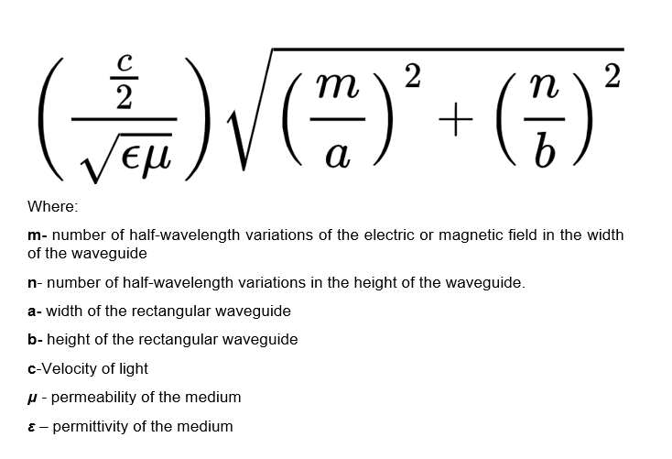
Equation 4 – the equation used to calculate the theoretical cutoff frequencies for a Teflon waveguide [8]

Mode 1
To calculate the theoretical cutoff frequency for Mode 1, the data below and equation 4 was used.
Table 4 – Data for cutoff frequency calculation of mode 1
Representing letter | Value | Value (with SI units)
ε | 2.1 | 2.1
μ | 1 | 1
M | 1 | 1
N | 0 | 0
a | 23mm | 0.023m
b | 7mm | 0.007m
c | 3x10⁸ | 3x10⁸
The calculated theoretical cutoff frequency for mode 1 was, 4.500427561 x 10⁹Hz or 4.5GHz

Mode 2
To calculate the theoretical cutoff frequency for Mode 2, the data below and equation 4 was used.

Table 5 – Table showing the data required to calculate the theoretical cutoff frequency of mode 2 Task 1b
Representing letter | Value | Value (with SI units)
ε | 2.1 | 2.1
μ | 1 | 1
M | 2 | 2
N | 0 | 0
a | 23mm | 0.023m
b | 7mm | 0.007m
c | 3x10⁸ | 3x10⁸
The calculated theoretical cutoff frequency for mode 2 is, 9.000855122 x10⁹ Hz or 9 GHz

Mode 3
To calculate the theoretical cutoff frequency for Mode 3, the data below and equation 4 was used.

Table 6 – Table showing the data required to calculate the theoretical cutoff frequency of mode 2 Task 1b
Representing letter | Value | Value (with SI units)
ε | 2.1 | 2.1
μ | 1 | 1
M | 3 | 3
N | 0 | 0
a | 23mm | 0.023m
b | 7mm | 0.007m
c | 3x10⁸ | 3x10⁸
The calculated theoretical cutoff frequency for mode mode 3 is, 1.350128268x10¹⁰Hz or 13.5GHz.

1b v
Post simulation figure 33 was plotted.
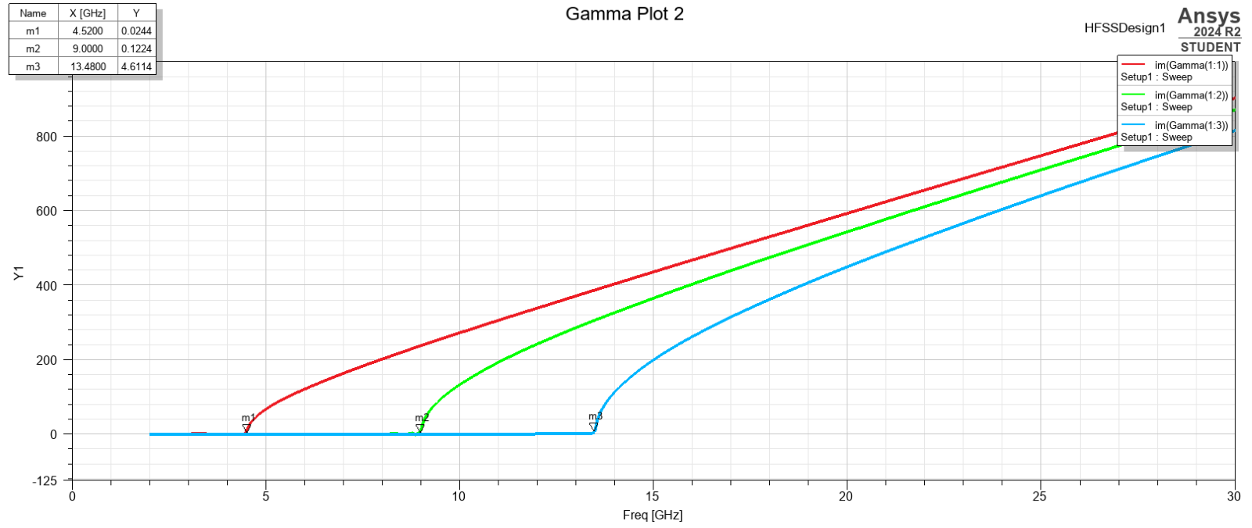
Figure 33 – A graph showing the simulated cutoff frequency of a waveguide with a Teflon medium
Figure 33 shows the simulated cutoff frequencies, mode 1 4.52GHz, mode 2 9.00GHz and mode 3 13.48Ghz, demonstrating the dominant mode is mode 1.

Task 2
This Task requires designing a halfwave dipole antenna, then extrapolating an information set from simulation output, identified in subsets i-iv.

i
To calculate the length of the halfwave dipole equation 5 was used.
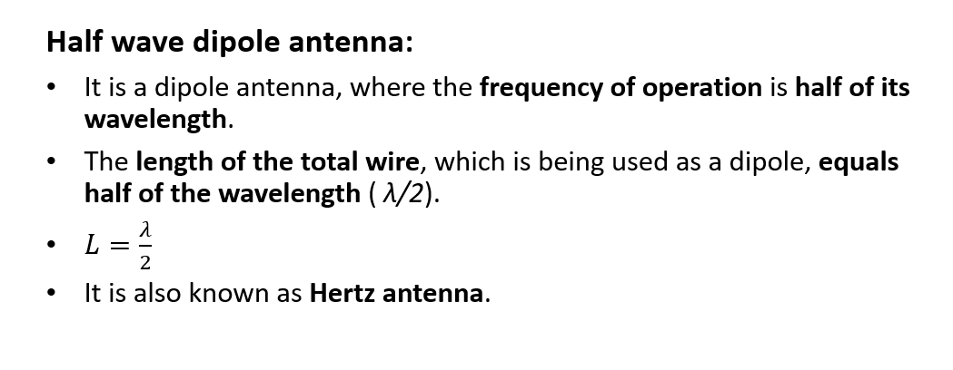
Equation 5 – An equation to calculate the length of a halfwave dipole antenna [9]
Using the wavelength of 231mm, the following calculation is done:
0.231meters /2 = 0.1155m
L = 0.1155m

ii
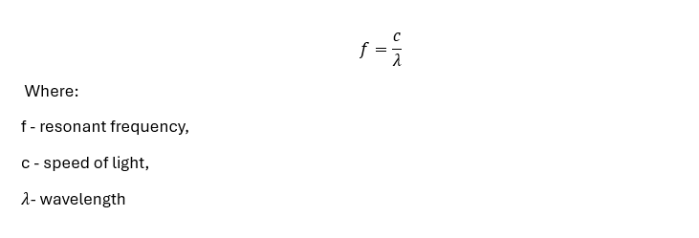
Equation 6 – An equation to calculate the theoretical operating frequency of the antenna [9]

The theoretical operating frequency is calculated using equation 6 - shown below (data in SI units):
f = 3x10⁸/0.231 = 1298701299Hz or 1.299GHz

iii
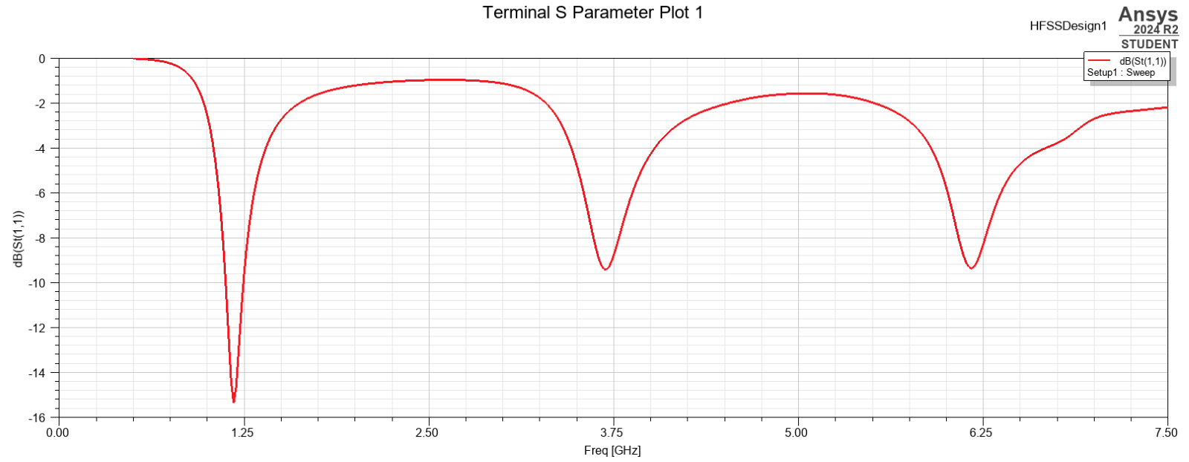
Figure 34 – A graph showing the simulated operating frequency of the antenna

Figure 34 shows the simulated operating frequency of 1.2GHz.

iv
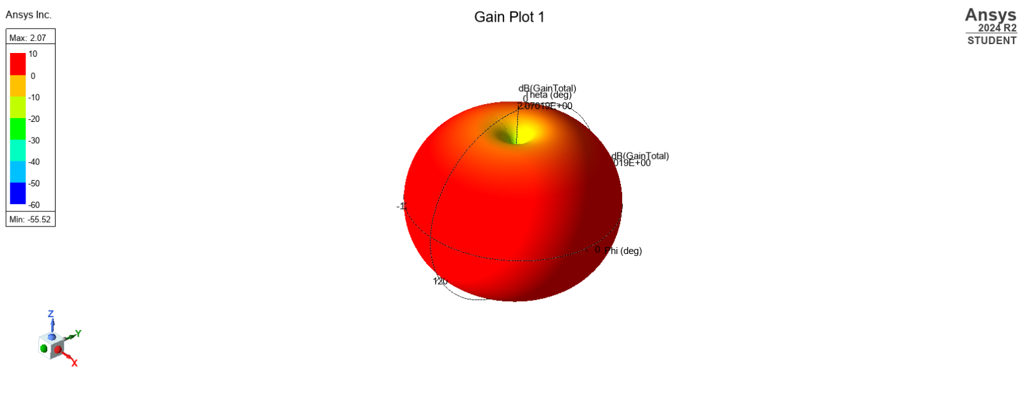
Figure 35 – The simulated radiation pattern for a halfwave dipole antenna

4.0 Discussion

Task 1a

Task 1a i – ii
Figures 2, 3 and 4 show the port faces for the waveguide with a vacuum medium. The dominant is mode1. The TE_{mn} values increase through the modes.

Task 1a iii
Figures 5 - 16 show the electric (E) fields and magnetic (H) field magnitudes and vectors for mode 1 – 3. The figures showing the magnitude of the E field illustrate the distribution and intensity of the electric field within the waveguide, influenced by the waveguide's permittivity and the specific propagation modes. Permittivity being properties that describes how a material responds to an electric field. Analysing these modes, there’s significantly greater magnitude of magnetic field than electric field on the outside of the waveguide. Regarding vectors, the arrow shows the direction, and the colour represents the magnitude. The figures depicting vectors show all fields in an outwards direction from the waveguide, each vector diagram has a similar set of directions. The large variation in direction of the vectors suggests there are complex interactions within the waveguide.

Task 1a iv – v
The results section details the cutoff frequencies found using equation 2 and the simulation. The close results correlation, see Table 7, suggests an accurate simulation, assuring further simulation data trustworthy.
Table 7 – Table comparing theoretical and simulated cutoff frequency for Task 1A
Mode | Theoretical cutoff frequency | Simulated cutoff frequency | Difference
1 | 6.52GHz | 6.48GHz | 0.04GHz
2 | 13.04GHz | 13.06GHz | 0.02GHz
3 | 19.57GHz | 19.50GHz | 0.07GHz

Task 1b

Task 1B i-ii
The TE_{mn} value’s indices characterise the number of half-wavelength variation along the structure’s two principal directions. This means each value represents the number of half-wavelengths in either of the two directions, vertically (n) and across the width (m).
With this information the number of half wavelength variations increase width ways through the modes in both Task 1a and b. The dominant mode is mode 1.

Task 1biii
As in Task 1a iii the H and E fields represent the magnitude and vectors of a magnetic and electric field the wave guide. In comparing the two fields the H field has a significantly higher magnitude. This is especially obvious when comparing figure 25 and figure 27. Although large variations within the direction of the vectors, the figures showing magnetic field vectors appear more uniform suggesting a more uniform pattern compared to the electric field vectors’ complex interactions.

Task 1b iv-v
The results section details the cutoff frequencies found using equation 4 and the simulation. The close results correlation, see Table 8, suggests an accurate simulation, assuring further simulation data trustworthy.
Table 8 – Table comparing theoretical and simulated cutoff frequency for Task 1A
Mode | Theoretical cutoff frequency | Simulated cutoff frequency | Difference
1 | 4.50GHz | 4.52GHz | 0.02GHz
2 | 9.00GHz | 9.00GHz | 0.00GHz
3 | 13.50GHz | 13.48GHz | 0.02GHz

Comparing a vacuum filled waveguide to a Teflon filled waveguide
Table 9 – A table showing the cutoff frequencies for Task 1a and 1b
 | Vacuum wave guide |  | Teflon wave guide
Mode | Calculated | Simulated | Calculated | Simulated
1 | 6.52GHz | 6.48GHz | 4.50GHz | 4.52GHz
2 | 13.04GHz | 13.06GHz | 9.00GHz | 9.00GHz
3 | 19.57GHz | 19.50GHz | 13.50GHz | 13.48GHz

As table 9 shows, the Teflon filled waveguide has a significantly lower cutoff frequency compared to the vacuum filled waveguide. With each mode increase, the difference in cutoff frequency increases N+2. This pattern can be extrapolated to find the cutoff frequency of either waveguide.
The cutoff frequencies differences are due to the relative permittivity (di electric constant) of a vacuum compared to Teflon. A vacuum has a relative permittivity of 1 but Teflon’s value is 2.1, impacting the speed the electromagnetic waves propagate though it, waves propagating slower through Teflon. Using the same frequency the wavelength of a wave is shorter due to the slower speed. The cutoff frequency for a waveguide’s mode is limited by the dimension of the waveguide and the wavelength of the wave, a shorter wavelength means the waveguide can support a lower cutoff frequency demonstrating why Teflon medium can support a lower cutoff frequency.
The magnitude and vectors of electric and magnetic fields can also be compared. It’s important to note a vacuum has permeability(µ_r) and permittivity (ε_r) of 1, whereas Teflon has permeability of 1.000058 and permittivity value 2.1 [7]. When comparing (ε_r) fields, although the colouration does not look dramatically different, the key shows the maximum amperes/meter value achieved by the waveguide with a vacuum was 27.5A/m compared to the 56A/m in figure 27. The difference is due to the larger permeability value which supports more powerful magnetic field intensity.
Teflon’s higher permittivity value allows it to store more electrical energy when influenced by an electric field. However, the results presented in this report show a mix of data, between mode 1 and 2 the Teflon E field has a higher maximum value, however in mode 3 (Figure 13 v Figure 29) the Teflon has a lower value and seems to contradict the theory. The differing data suggests that there was an error in this simulation, human or digital, and this caused the differing data.
These specific dielectric properties allow Teflon to be used in components such as low loss transmission lines. [10] In a vacuum the field distribution is only affected by the geometry of the shape and source. However, in a Teflon medium the dielectric properties can generate additional boundary conditions can concentrate the source leading to changes in field direction and might be what is causing a disruption to expected patterns.

Task 2

Task 2 i
Using equation 5 the halfwave dipole antenna calculated length was 0.1155m. The length is important as if incorrect, it won’t transmit the desired frequency efficiently leading to poor transmission and difficulty in reading data transmitted at this frequency. Using the equation 7 and taking the result of Task 2 ii we define value 0.1155 as the antenna’s ideal optimum length. Using equation 7 the results of equation 5 can be validated thereby proving equation 5’s accuracy.
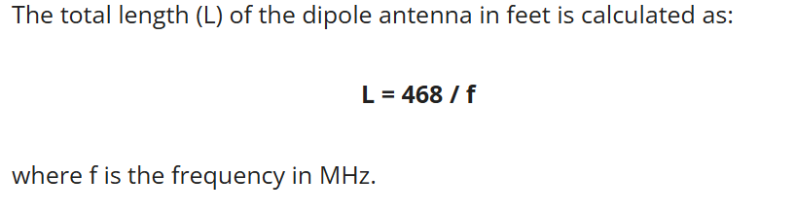
Equation 7 – An equation linking Frequency and length of dipole antenna [8]

Below are the calculations done to verify the results of Task 2 i
492/1298.7013Mhz = 0.3788ft
0.3788ft = 0.1155m

Task 2ii -iii
The operating frequency of an antenna is the frequency at which it operates most effectively.
Using equation 6 the theoretical operating frequency was calculated to be 1.299GHz. Figure 34 shows a simulated operating frequency of about 1.2GHz. The close relationship between theoretical and simulated theoretical operating frequency suggests there’s either similarity in the method of simulating and calculating or each option used different methods to come to similar answers. Assuming both methods are different, this result proves the accuracy of both methods.

Task 2 iv
Figure 35 shows the simulated radiation pattern of the antenna, resembling a sphere and is an isotropic radiation pattern which is ideal and can only exist in theory, this antenna would likely give off an omnidirectional radiation.
Examining figure 35. most of the sphere’s outside is bright red and according to the key, means it has a gain of between 0-10dB. The higher the gain the more effectively the antenna can transmit signals in that direction. On the top of the sphere the colours fade to yellow/green suggesting any transmission from the top of the antenna will be more difficult to receive. It’s only by doing a simulation of the radiation pattern that this can be drawn.

5.0 Conclusions
Task 1 initial conclusion is the equations used to calculate cutoff frequencies were accurate, enabling future data calculation. Secondly, a Teflon medium results in lower cutoff frequencies than using a vacuum. When comparing these mediums, it became clear the Teflon dielectric properties reduce the wave’s phase velocity allowing it to handle lower cutoff frequencies.
Task 2’s conclusion shows an antenna ideal length of 0.1155m with operating frequency of 1.2GHz; its isotropic radiation pattern enables signal transmission in all directions making it suitable for signal tower use.
Ultimately this report demonstrates the difference between a vacuum filled and a Teflon filled waveguide, analysing the difference using theoretical and simulated results, whilst also analysing the length, operating frequency and radiation pattern of an halfwave dipole antenna.

Bibliography

[1] | N. W. Mchlachlan, Theory and Application of Mathieu Functions, 1964.
[2] | R. Farhan, “Cornell courses,” 2006. [Online]. Available: https://courses.cit.cornell.edu/ece303/Lectures/lecture27.pdf. [Accessed 20 04 2025].
[3] | S. Michael, “6.4 Rectangular waveguides,” North Carolina state university , [Online]. Available: https://eng.libretexts.org/Bookshelves/Electrical_Engineering/Electronics/Microwave_and_RF_Design_II_-_Transmission_Lines_%28Steer%29/06%3A_Waveguides/6.04%3A_Rectangular_Waveguide. [Accessed 16 04 2025].
[4] | Constantine A. Balanis, Modern Antenna Handbook, John Wiley & Sons, 2011.
[5] | W. T. Longfellow, “The End-Fed Half-Wave (EFHW) Dipole Wire Antenna,” 2023.
[6] | A. Helmenstine, “What is the speed of light,” Science notes , 11 April 2012. [Online]. Available: https://sciencenotes.org/what-is-the-speed-of-light/. [Accessed 20 04 2025].
[7] | M. M. f. R. J. Z. Handoko Efran, “Permeability and Permittivity Measurements of Teflon in Millimeter Wave,” Journal of Physics Conference Series, 2019.
[8] | 3ROAM, “Half Wave Dipole Antenna Length Calculator,” 20 04 2025. [Online]. Available: https://3roam.com/half-wave-dipole-antenna-length-calculator/.
[9] | S. Jacob, “Lecture 10 - Antennas,” 2025.
[10] | B. B. Willam, “Low Loss Flexible Dielectric Waveguide,” 1983.
[11] | Creatives AT, “TE & TM modes,” 15 09 2017. [Online]. Available: https://www.engineeringdone.com/te-tm-modes/te-tm-modes/.
[12] | “Understanding Waveguide Mode: A Guide to Signal Propagation,” [Online]. Available: https://www.daenotes.com/electronics/microwave-radar/waveguide-modes-of-signal-propagation.
[13] | A. Laundrie, “Higher-Order Waveguide Modes,” 12 02 2025. [Online]. Available: https://www.everythingrf.com/community/higher-order-waveguide-modes.
[14] | K. Garrison, “Waveguides, Modes, and Cutoff Frequencies,” in Geek Speek .
[15] | M. f, “Transmission Lines and Waveguides,” in Microwave Measurement and Beam Instrumentation Course, 2018.
[16] | S. Jacob, “Lecture 5 - Waveguide cut off frequency,” 2025.

