
Faculty of Architecture and Construction
Site Investigation Report
Lecturer: Allan Nantel

KingzTon Construction Firm

A SITE INVESTIGATION OF THE AREA LOCATED BETWEEN THE COUNTRY HALL AND THE MARRIOT HOTEL ON SWANSEA FORESHORE

BY KELENE FREDERICK
JUNIOR CONSTRUCTION PROFESSIONAL

Submission Date: 6th Jan 2022
Body work count: 2449

TABLE OF CONTENTS
FIGURE LIST ………………………………………………………………………………..3
EXECUTIVE SUMMARY …………,……………………………………………………….4
- INTRODUCTION ……………………………………………………………………5

  - Purpose …………………………………………………………………………...5

  - Background ……………………………………………………………………....5

  - History…………………………………………………………………………….8

- GEOLOGICAL BACKGROUND……………………….. …………………….…...13
  - Ground Subsidence Risks……...…………………………………………………17

- ENVIRONMENTAL BACKGROUND ……………………………………..………20
  - Potential Contamination………………………………………………………….20
  - Pollution History………………………………………………………………….21
  - The Hydrogeology in Swansea……………………………………………...……23

- ARCHEOLOGICAL BACKGROUND & CONCEPTUAL GROUND MODEL…...24

- SITE SUMMARY ………………………………………..……………………….....25
  - Location…………………………………………………………………………..25
  - Geology…………………………………………………………………………..27
  - Recommendations……………………………………………………………..…27

- BIBLIOGRAPHY……………………………………………………………………30

FIGURE LIST

Figure | Pg. No
Fig.1 Map showing aerial view of the site area | 6
Fig.2. Map showing access to the site area | 7
Fig.3. Image showing the seafront railway in the 1950s in Swansea | 8
Fig.4. Map showing both engine shed and timber yard in the 1890s within the site area | 9
Fig.5.Map showing engine shed, canister works, and wagon works in the 1940s within the site area | 11
Fig.6. Map showing the removal of the timber yard wagon works and canister works in the site sire area. | 12
Fig.7,8&9. Images showing borehole data | 14
Fig.10 & 11. Map showing the geology of the proposed site area | 18
Fig.12 & 13. Map showing the geology of the proposed site area | 19
Fig.14. Map showing the hospital for contagious diseases in the 1890s near the site area | 21
Fig.15. Graphing showing the number of deaths as a result of air pollution in Wales | 22
Fig.16. An image showing the Sea express oil spill in 1996 | 23
Fig.17 A map showing the gas works found around the area of the proposed site | 25
Fig.18.Map showing mean high water and mean low water in the proposed area | 26
Fig.19 & 20 Drawing showing a sketch of a driven pile foundation | 29

EXECUTIVE SUMMARY
The Marriot Hotels, City and County of Swansea has decided to create a new restaurant and ice-cream parlour with residence for the manager on the Swansea Foreshore. The site’s placement is found between both Country Hall and the Marriot Hotel, the structure therefore, would share both parts of the car park. It is located south of Wales along the Coast Path.
A preliminary study in order to conduct a thorough site investigation was conducted to identify potential risk and hazard that may be on site. Historical maps, images, borehole test, geology and the hydrology of the site was examined to identify all possible elements of pollution and contamination of the soil found on site. The history reveals that the area housed services such as a hospital, school, engine shed, wagon works and gas works. Transportation via train was also accessible within this area. With this information we can make assumptions that these structures would have contributed to the contamination and pollution of the area. Engine sheds and trains produce heavy metal waste, oil, carbon dioxide gas and lead that may remain within the soil.
A coastline is subjected to strong wave action especially during a storm surge or hurricanes. This results in coastal flooding and considerable damage to the infrastructure located along the coast. In addition, the site and its surrounding areas are relatively flat with a large river to the east, this also increases the risk of flooding. Swansea’s coast has been categorized as an area with poor air quality as a result of the nearby port called Talbot. This pollution of the air resulted in the death of numerous persons. The beach found in front of the site has also experienced land pollution due to persons disposing plastic waste inappropriately. At peak tourism times this risk of pollution will increase significantly and reduce the beauty of the area. This area also experienced the tragic oil spill event when the Sea express was damaged and leaked substantial amounts of oil into the ocean. This oil travelled along the coast reaping havoc as it moved.
The borehole test done on the site previously shows that the soil composition consists of, sand, sandy clay, clay, gravel, clay boulder and grey mudstone. The over lying till is artificial and contains layers of ash, brick shale, sand and clay. These soil conditions are known to shift, shrink and swell with different variables. This makes it difficult to conduct construction works without risks of uneven settlement and cracks along the structure of the building. These factors were taken into consideration to derive a suitable foundation type to support the structure. Deep foundation types are normally used in this case, therefore, the foundation recommended for this site would be driven piles.

- INTRODUCTION

  - Purpose
- To conduct an introductory study for an investigation of the site located between the Marriot Hotel and the County Hall on the Swansea Foreshore.

  - Background

- Location: The site is located at SSW of Wales, along the Swansea Foreshore between the Marriot Hotel and the County hall. Found at Lat 51º36’ 49.2408 N, -3º 56’ 47.2632 E.

- Present site use: The area is currently used as an accessway to the beach, additionally, both upper boundary edges run through the parking lots of the Marriot Hotel and the Swansea City and County Council.

- Proposed site use: Swansea City and County Council have decided to agree with Marriott Hotels to build a new restaurant and ice cream parlour with a manager's residence on Swansea's waterfront in the location mentioned. The structure would share sections of the parking parks of both current neighboring buildings, will also have a gross internal area of roughly 300 square meters at ground floor level. The structure will include a restaurant, a café bar, an ice cream parlour, a kitchen, food stores, and other amenities. A manager's apartment and staff welfare amenities are planned for the second floor.

MAP SHOWING AREAL VIEW OF THE PROPOSED SITE AREA
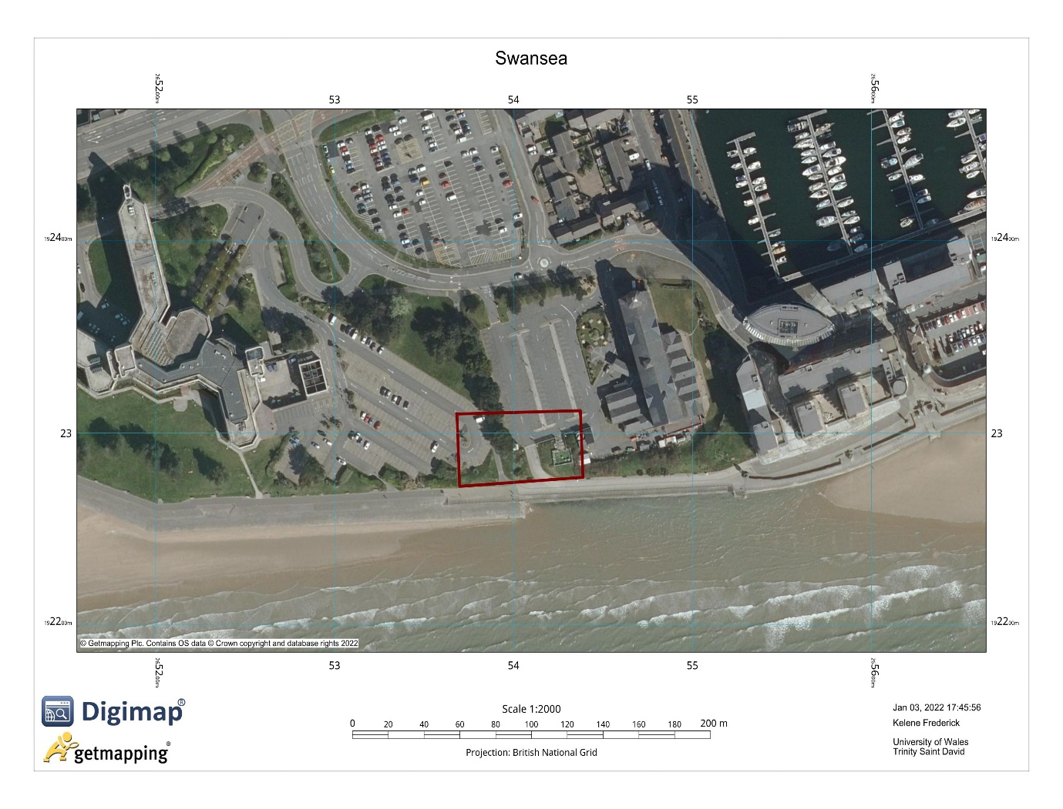
Figure 1. Digimap (2022). Swansea.

- Site Access: The site can be easily accessed, at the north of the area is the main road called Oystermouth which ranches off to Dunvant Pl leading access to both parking lots and the proposed site.

MAP SHOWING ACCESS TO THE PROPOSED SITE AREA
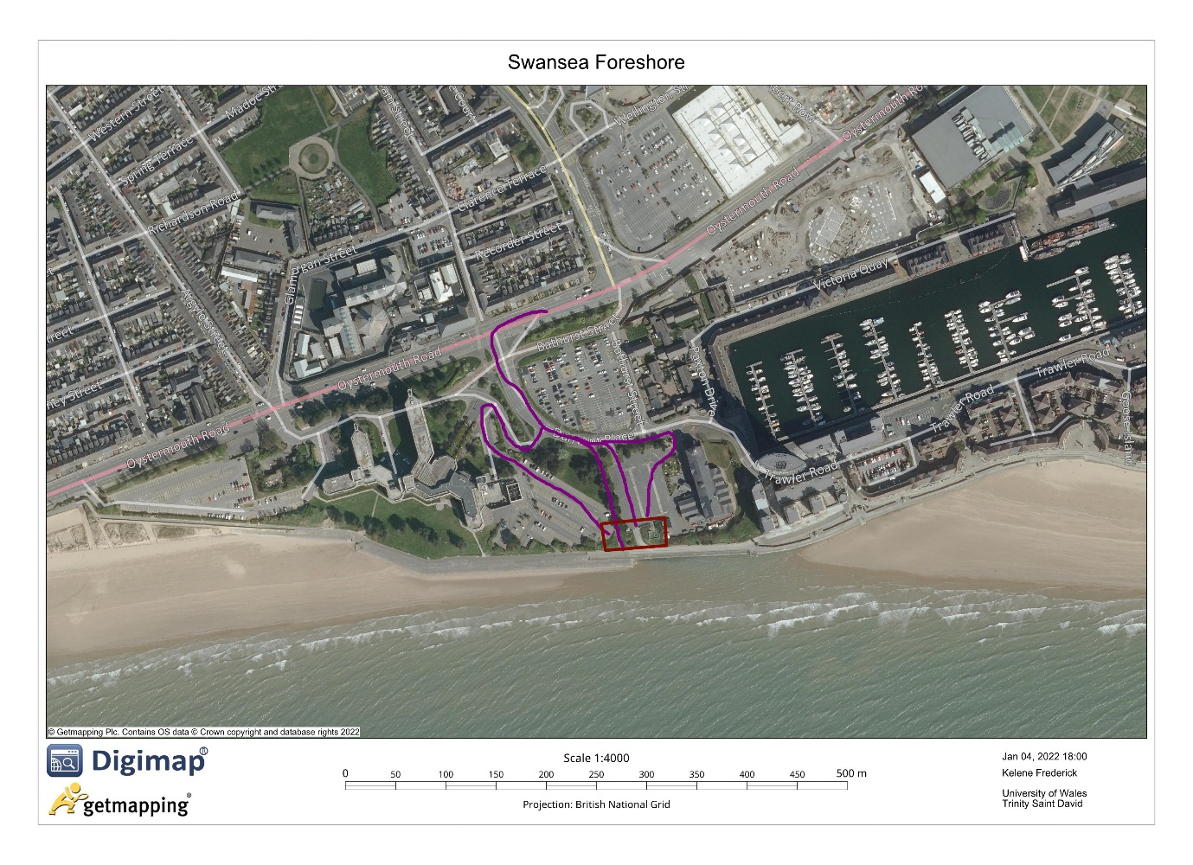
Figure 2. Digimap (2022).

  - History
This site contained a timber yard in the 1890s, a canister works in the 1910s, a wagon works in the 1940s and in the 1960s the wagon works was demolished. Next to the site there was a hospital for contagious diseases in the 1870s, which was then replaced by an engine shed in the 1890s this shed remained in the area until the 1960s when it was demolished. In addition, the foreshore area was lined with a railway which was removed in the 1960s. The maps below show the timeline and changes in the proposed area.

IMAGE SHOWING THE SEAFRONT RAILWAY IN THE 1950S IN SWANSEA SEAFRONT
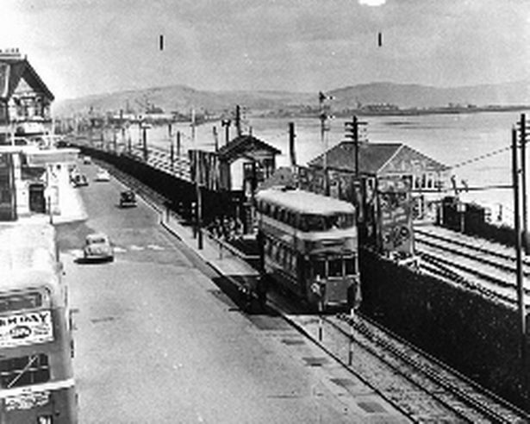
Figure 3. Turner, R. (2009).

MAP SHOWING BOTH ENGINE SHED AND TIMBER YARD FOUND IN THE 1890S WITHIN THE SITE AREA
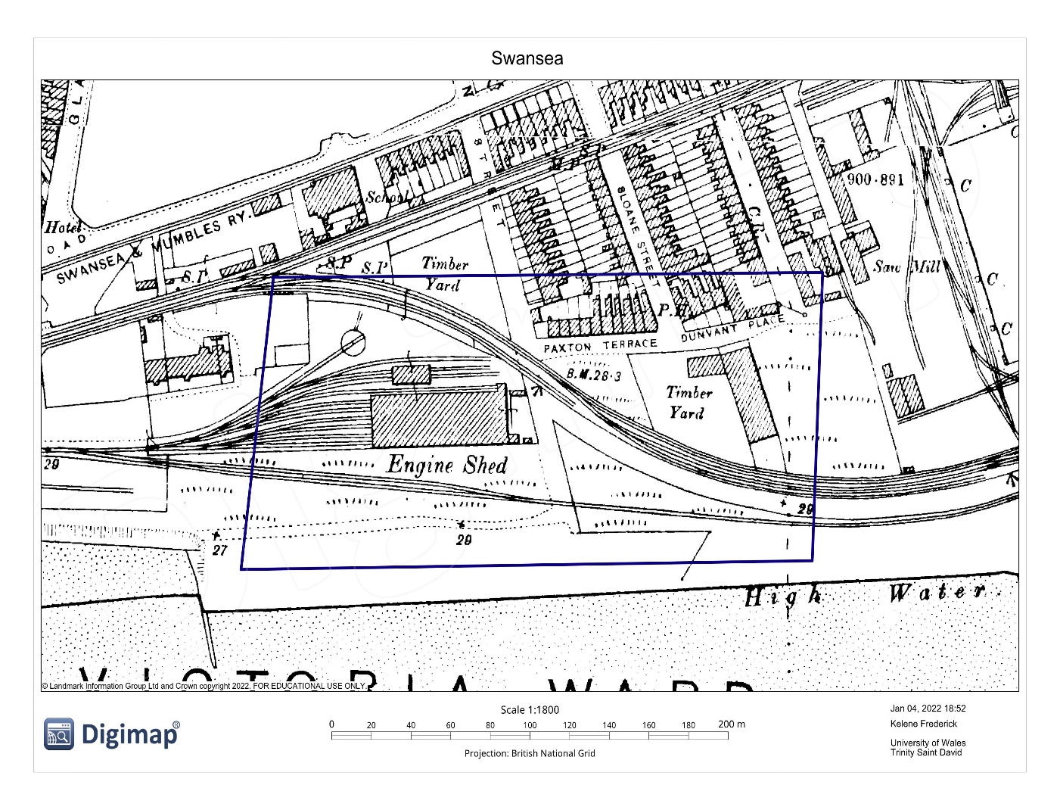
Figure 4. Digimap (1890). Swansea.

MAP SHOWING BOTH ENGINE SHED AND CANISTER WORKS IN THE 1910S WITHIN THE SITE AREA
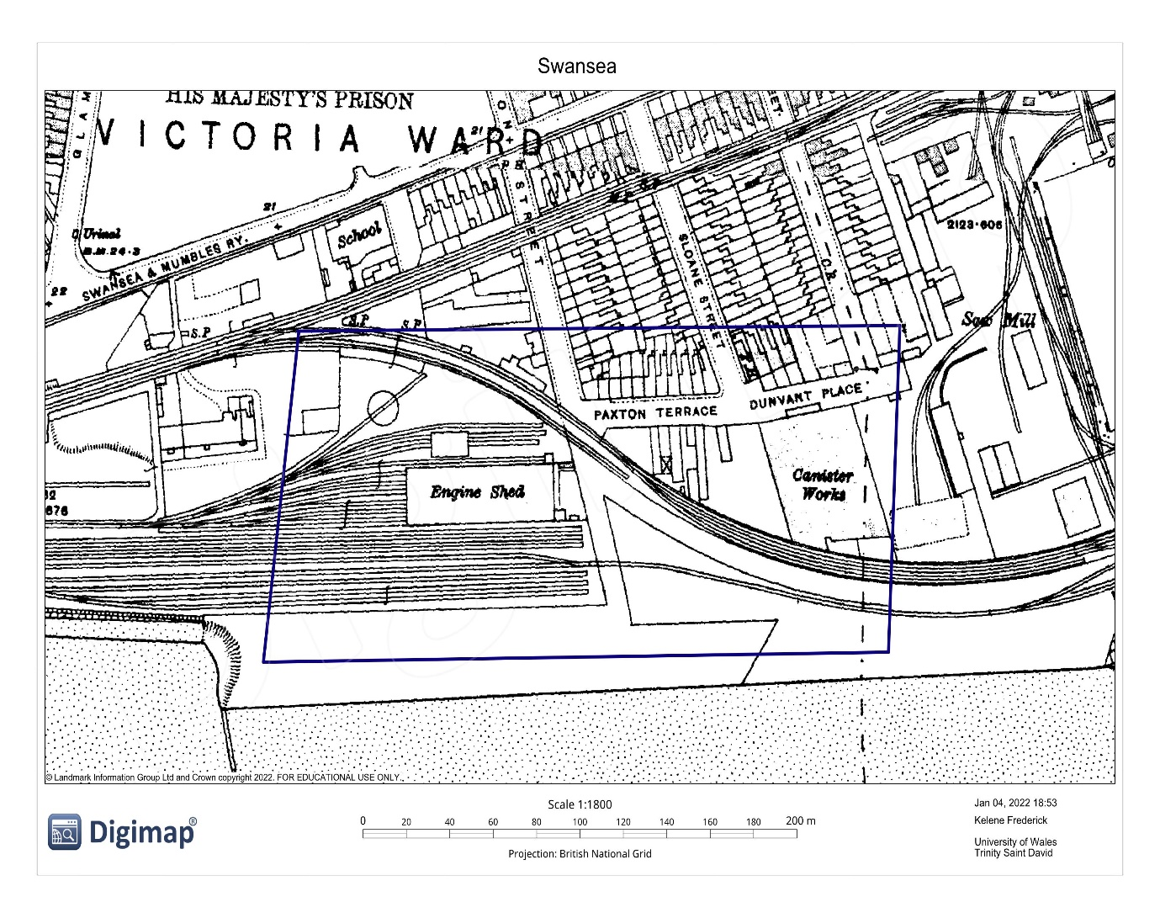
Figure 5. Digimap (1910). Swansea

MAP SHOWING ENGINE SHED, CANISTER WORKS & WAGON WORKS FOUND IN THE 1940S WITHIN THE SITE AREA
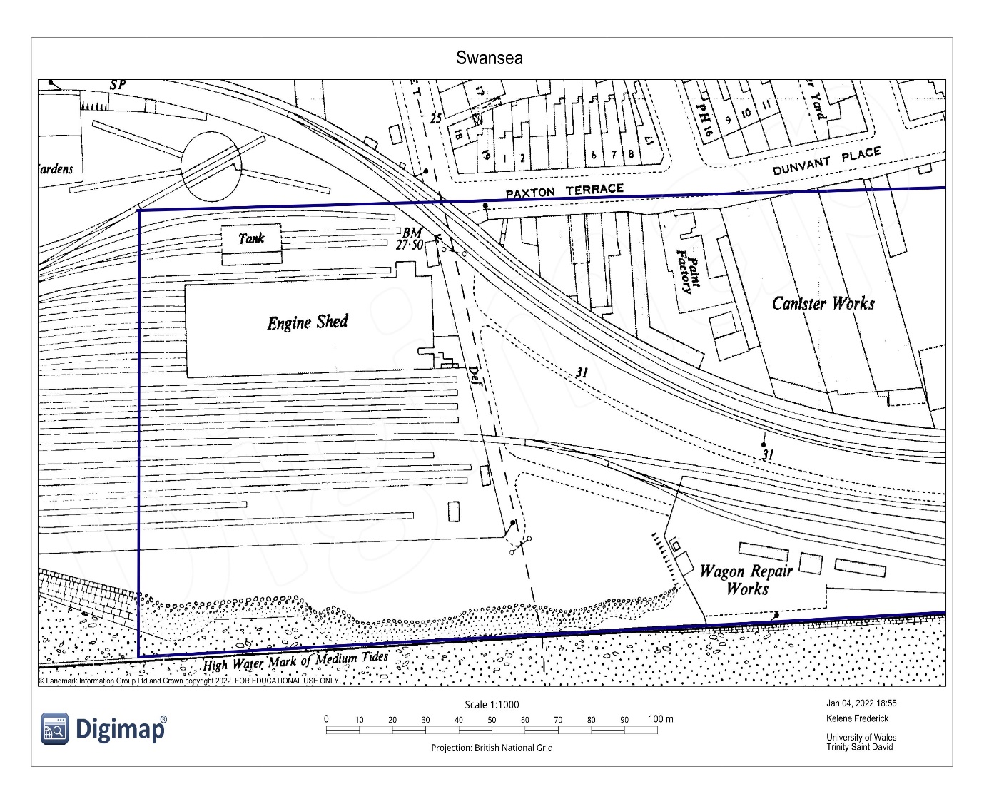
Figure 6. Digimap (1940). Swansea.

MAP SHOWING REMOVAL OF THE TIMBER YARD, WAGON WORKS & CANISTER WORKS IN THE 1960S AT SITE AREA
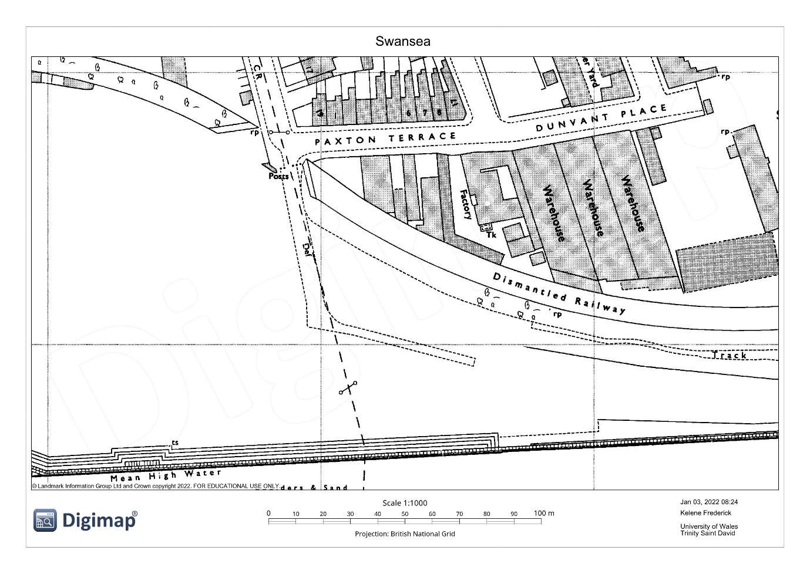
Figure 6. Digimap (1960). Swansea.

- GEOLOGICAL BACKGROUND
The evaluation of the borehole log found on the site shows that the overlying till is manmade. It consists of ash, loose fine grey medium-sized sand, traces of soft sandy clay, red-brown clay with brick shale and dense bricks up to depths of 3.50 meters. Beneath the manmade layer, the soil’s stratification includes layers of very dense brown sandy gravel, sandy clay, dense sand with gravel, and stiff grey, brown gravelly boulder clay up to depths of 18 meters. The bedrock found beneath these layers is grey mudstone found at depths of 18.50 meters, the borehole log continued up to 22 meters.
The map below shows evidence of the area containing artificial ground, a bedrock of mudstone and superficial beach deposits of brown sand, silt, and clay. Mudstone was deposited in the Triassic era between 200 and 250 million years ago, it underlies much of central and southern England and serves as the foundation for many metropolitan centres and their infrastructure according to (British Geological Survey, 2020).
Found along the coast are littoral rock environments that include bedrock, boulders, and cobbles found in the intertidal zone, the area of the shoreline between high and low tide and the splash zone stated by the (Joint Nation Conservation Committee, 2021). Physical factors influence rocky coast ecosystems, including wave exposure, salinity, temperature, and the diurnal emersion and immersion of the beach according to the (Joint Nation Conservation Committee, 2021).

IMAGES SHOWING BOREHOLE DATA
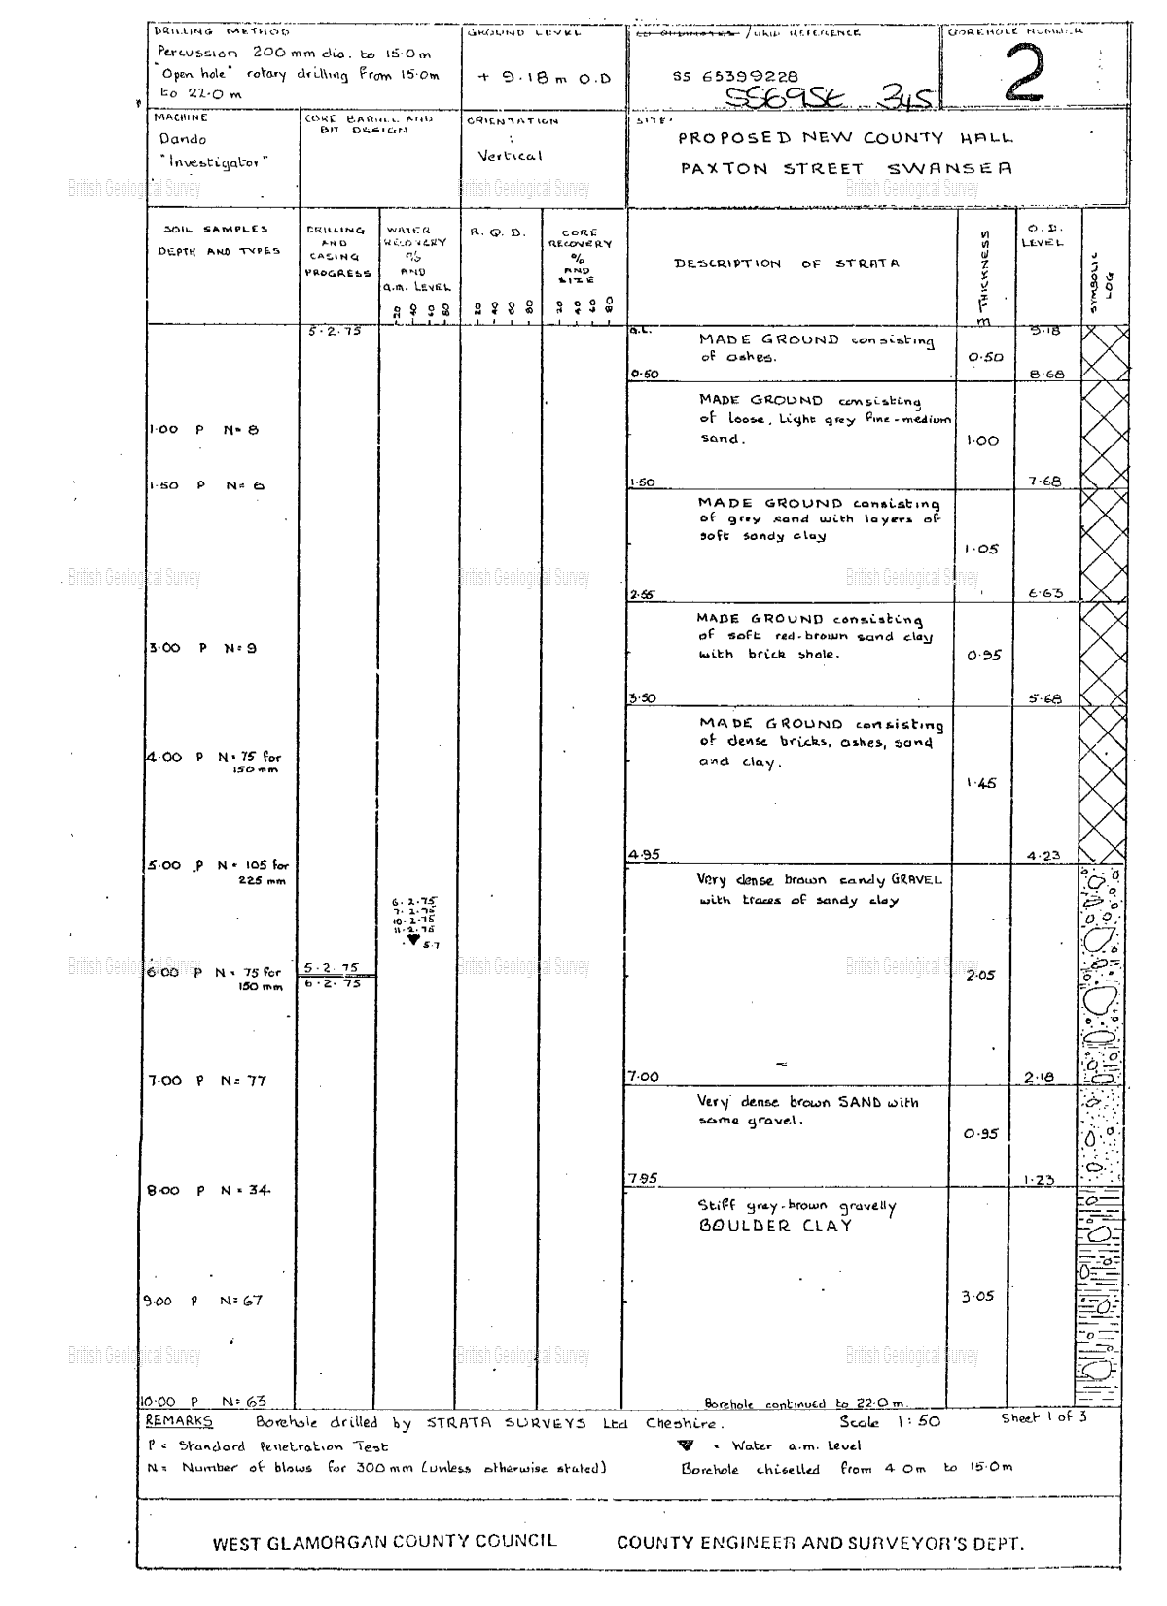
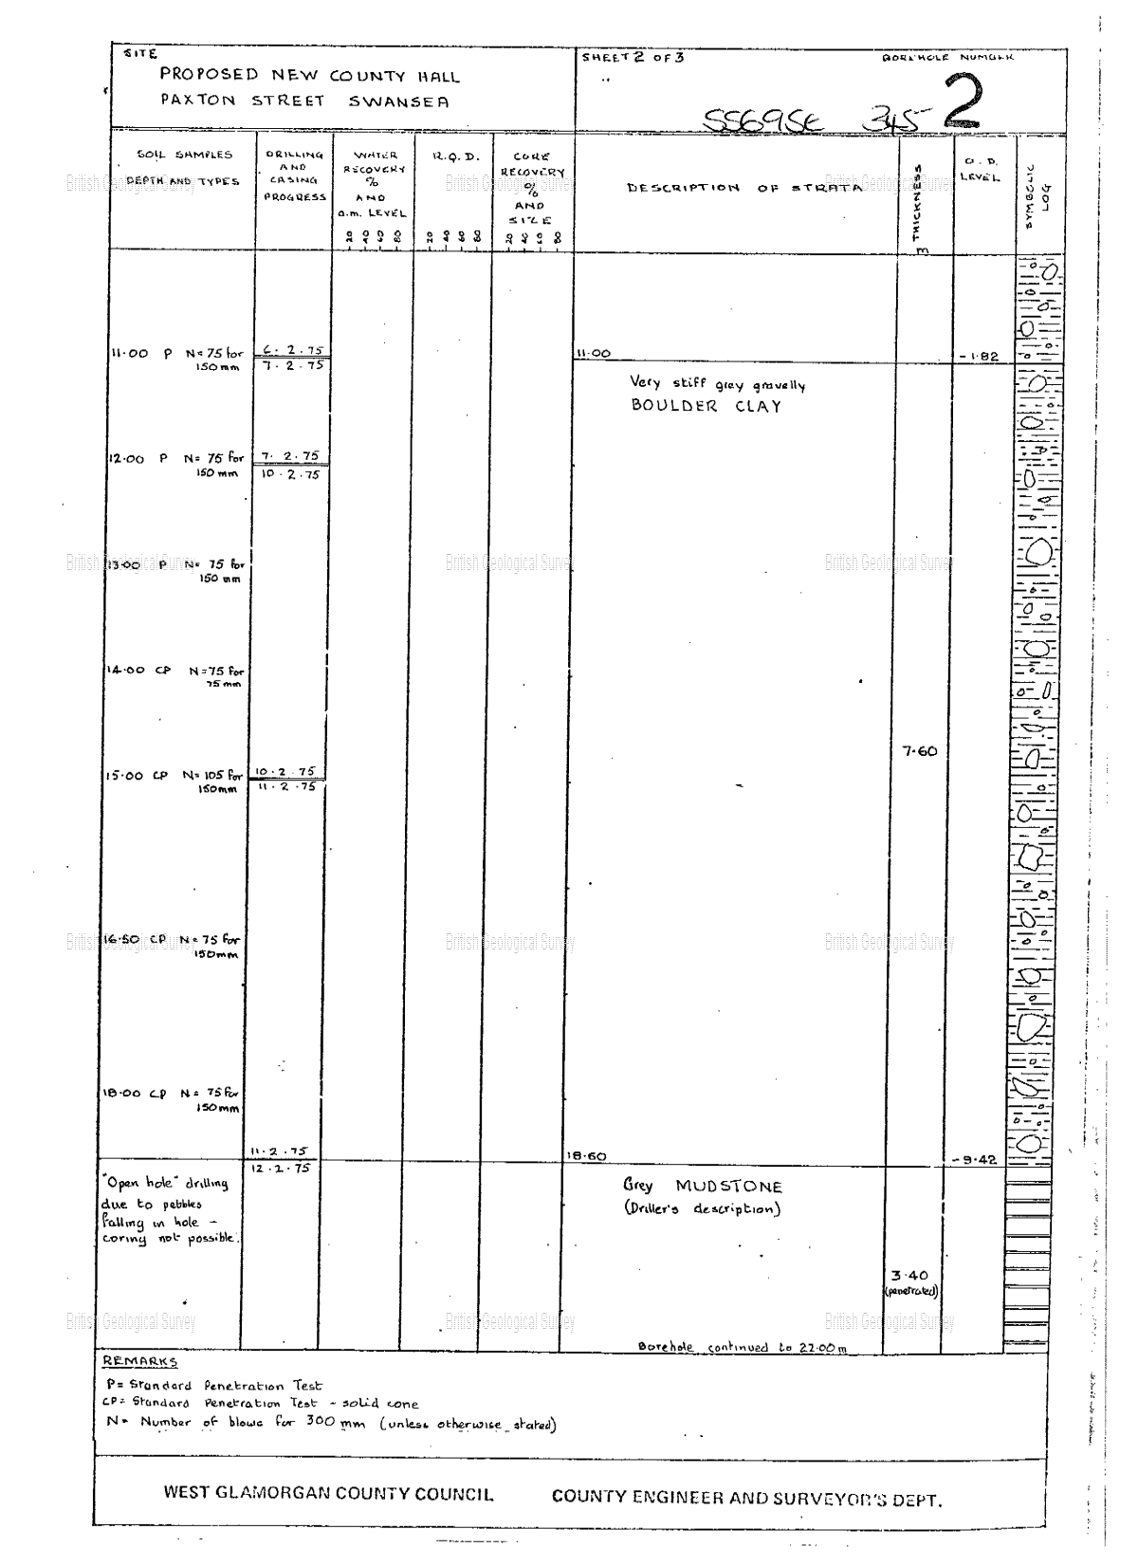

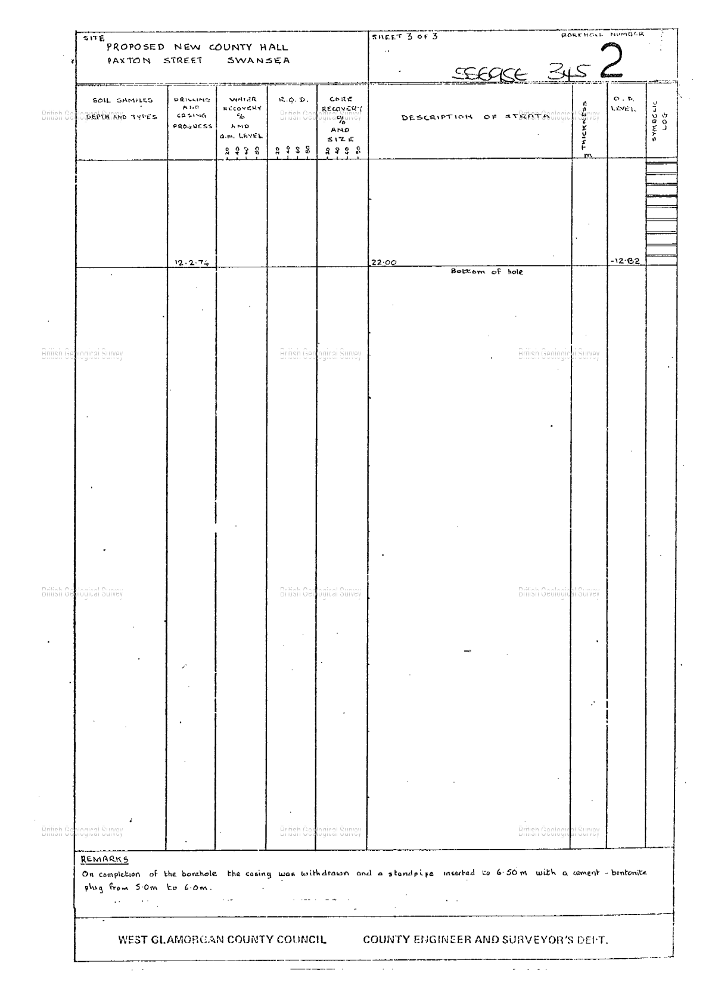
Figures 7,8&9. British Geological Survey (1835).

  - Ground Subsidence Risks
Ground subsidence usually occurs when the earth sinks due to a lack of support underneath and is sometimes accompanied by load exerted onto the surface. It may be caused by natural events or human activities such as the building of infrastructure. This typically occurs in silt and clay soil types. According to Geobear (2021) subsidence is more common in cohesive soils, such as clay and silt, since they compress, and swell based on moisture content. This indicates that the weather has a huge influence on their composition. Clay soil is widespread in England and Wales. The soil is also mainly comprised of sand, which is non-cohesive and non-plastic, therefore, having no strength unless confined. Based on the borehole log it will be safe to say that the ground subsidence risk is high. Therefore, this occurrence increases the probability of infrastructure settling and developing cracks.

MAP SHOWING THE GEOLOGY OF THE SITE AREA
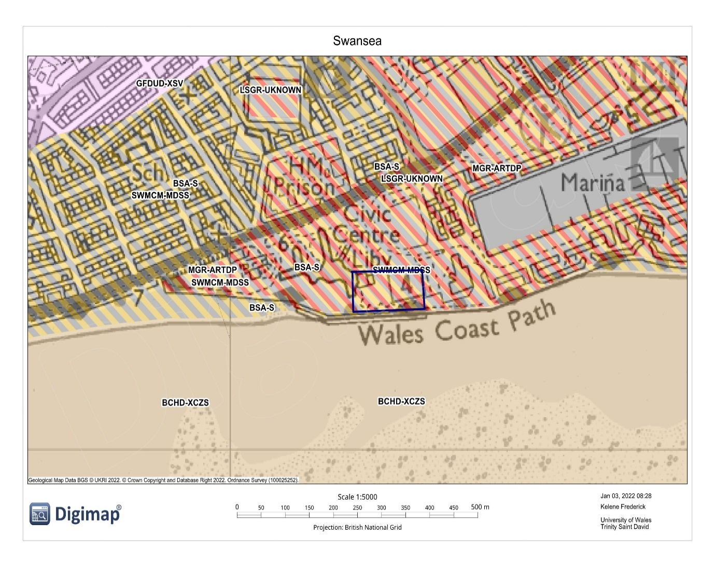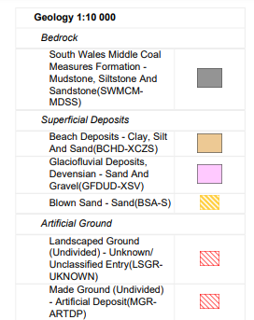
Figures 10&11. Digimap (2022). Swansea
MAP SHOWING THE GEOLOGY OF THE SITE AREA
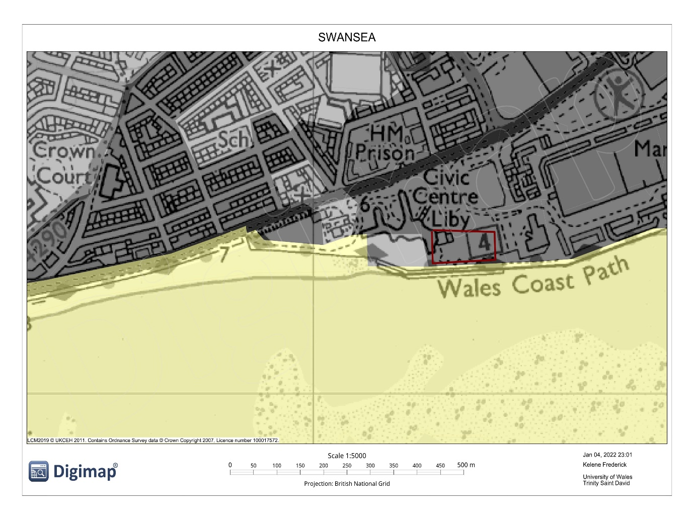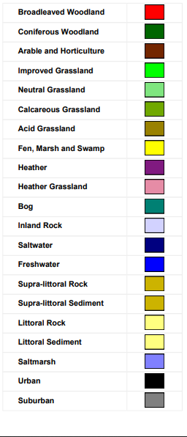
Figures 12&13. Digimap (2022).

- ENVIRONMENTAL BACKGROUND
  - Potential Contamination
According to Rails-to-Trails Conservancy (2019) railway sites are known to produce several chemicals that are harmful to the environment. Some of these include coal, sider and ash which contains traces of lead and arsenic. They further explained that sometimes spills of oil, gasoline, and herbicides may occur, additionally, metals and traces of asbestos can be found in these areas. Other serious concerns, such as lead and arsenic, may be discovered during soil surveys, as they are made from coal ash and cinder, these hazardous compounds can be found in copious amounts stated by (Rails-to-Trails Conservancy, 2019).
Historical maps showed that in the 1890s a hospital for contagious diseases was found near the proposed site location. At this time Great Britain would have been affected by the third Bubonic Plague spreading from central Asia to the rest of the world. It can be assumed that this hospital held infected persons with this disease along with other contagious diseases. Markman (2018), explains that amoebae, which are widespread soil and other aquatic microorganisms that consume bacteria, may have a role to play in protecting this hazardous disease between epidemics. He continues to say that this association may provide a haven for plague bacteria to multiply and wait for the conditions to be correct for another outbreak.

MAP SHOWING THE HOSPITAL FOR CONTAGIOUS DISEASES FOUND IN THE 1890S NEAR THE SITE AREA
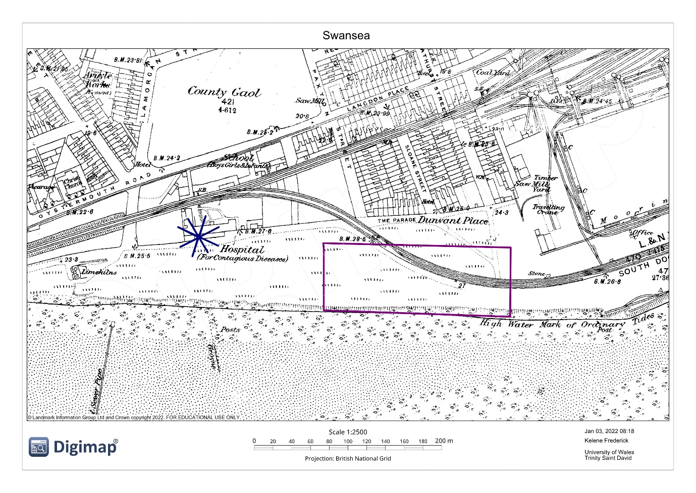
Figure 14. Digimap (1890). Swansea.

  - Pollution History
The site is found the Wales Coast Path which was polluted by waste materials such as plastic bottles. BBC News (2018), states that environmental Minister Hannah Blythyn commented saying that the plastic waste along the coast had a devastating impact on the marine environment. As a result, measures were put into place to reduce this pollution and to improve the health of the marine environment. The idea was that persons within the area would be informed of businesses offering free water or refills to reduce the need for plastic bottles. The air quality around this proposed area is also evidently poor as Neath Port Talbot has some of the highest records of air pollution in the United Kingdom. BBC News (2020) states that air pollution has been connected to 158 fatalities in Swansea and Neath Port Talbot.

GRAPH SHOWING THE NUMBER OF DEATHS AS A RESULT OF AIR POLLUTION IN WALES
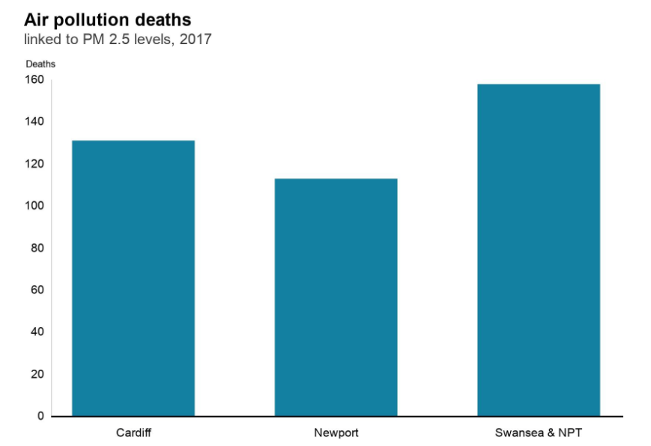
Figure 15. BBC News (2020).
It would have been twenty-six years ago now that the Sea express oil tanker crashed into some rocks causing a devastating oil spill along the Swansea coastline in 1996. Misstear (2016), explained that the ship's cargo of 72,000 tonnes of crude North Sea oil began to seep into the sea on Thursday, February 15, 1996, it was one of the biggest environmental disasters ever, damaging one of Wales’s most beautiful coasts. He continued to say that the leak originated near the mouth of the Cleddau Estuary in Pembrokeshire, but it quickly expanded, polluting 120 kilometres of Welsh shoreline.

AN IMAGE SHOWING THE SEA EXPRESS OIL SPILL IN 1996
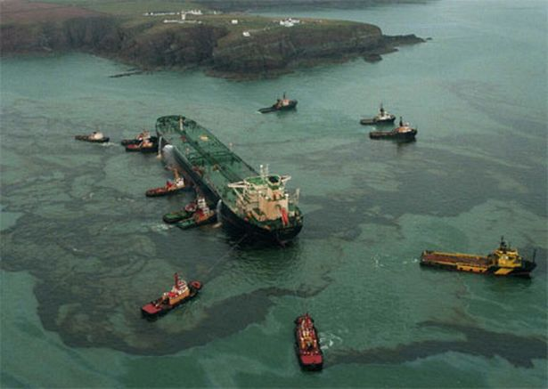
Figure 16. Misstear, R. (2016).

  - The Hydrogeology in Swansea
The overall topography of the proposed site is relatively flat, located near river Tawe and it is found right in front of the ocean. Normally at the beach, the water table is usually at a similar level as the ocean, which is just under the sand's surface. These are all indicators that the groundwater table would be high in this area. In addition, of being close to the sea the threat of storm surges is increased, this hazard can cause infrastructural damage and flooding. WalesOnline (2004), explains that Swansea city has the number 1 highest average rainfall in Britain with 1360mm annual rainfall. As a result of rainfall being so often, the risk of flooding becomes higher.
Around this site, some trees provide shade and shrubs that are growing naturally within the habitat. With the commencement of works these living organisms would be affected by the construction and may have to be removed off-site. As the beach is located right below the site other organisms such as marine habitats, fishes, crabs, seagulls, and other creatures living within the sand may be affected by the runoff material caused by the works. When the rain comes sediments from site works would travel to the ocean causing sedimentation which then leads to the smothering of corals, increasing the process of eutrophication, and dampening the aesthetic qualities of the beach.

- ARCHEOLOGICAL BACKGROUND AND CONCEPTUAL GROUND MODEL
The latest collection represents only a small portion of the artefacts unearthed on the Bay, which has diverse and sensitive archaeology according to (The Bay Magazine, 2017). They continued by saying the area contains bronze age trackways and ancient woodlands, Roman brooches, pottery, shipwrecks, and World War II explosives. This knowledge provides us with the mindset that there most likely would be buried artefacts found below the proposed site area. With that being said caution must be taken to ensure the preservation and protection of these items.
Within the historical data maps, there were industrial sites such as gas works, engine sheds and other services such as schools and hospitals. These infrastructure types would need water, gas, and sewer pipelines to transport the respective liquid, gas or waste. Pipes usually run underground to avoid any external disruptions, precaution must be taken when conducting tests and excavation works.

A MAP SHOWING THE GAS WORKS FOUND AROUND THE AREA OF THE PROPOSED SITE
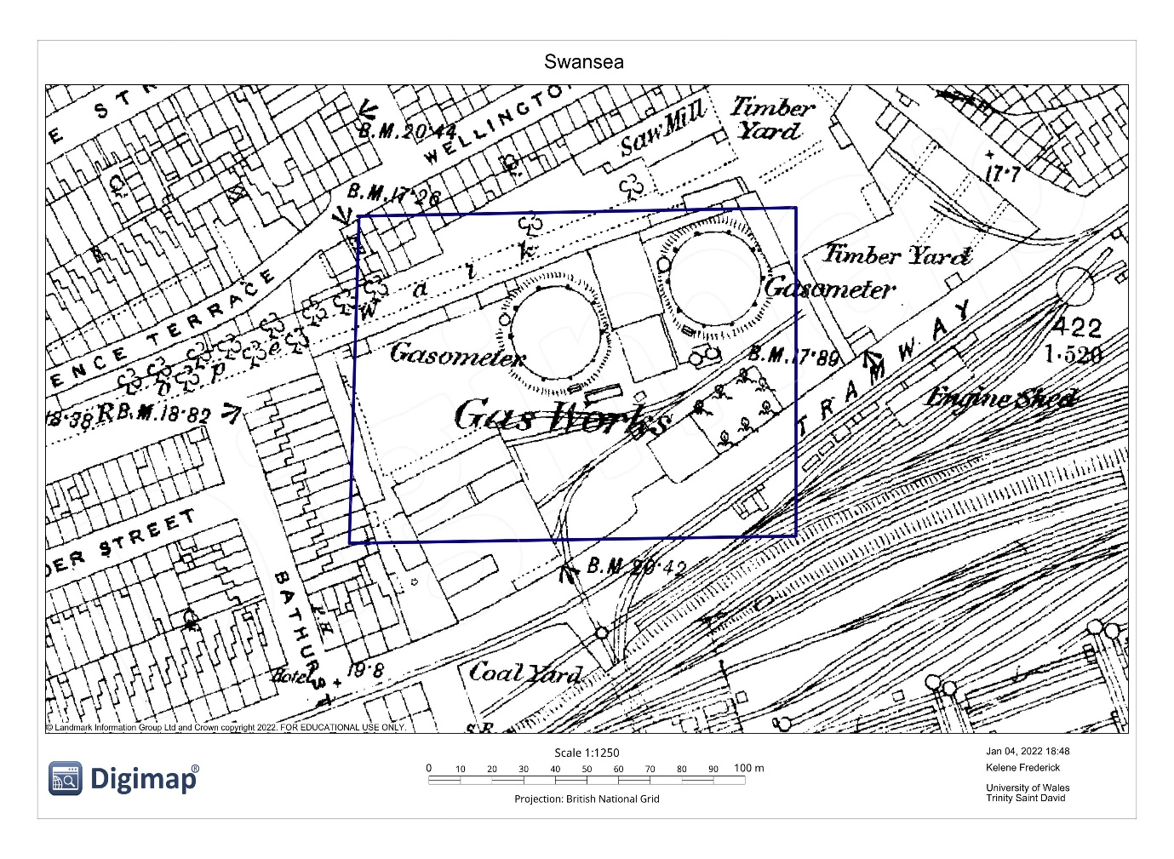
Figure 17. Digimap (1890). Swansea.

- SITE SUMMARY
  - Location
The site’s location found directly opposite to the ocean makes it prone to coastal flood and damages in the event of a storm surge. The high tide levels also signify that the water can reach up to the Wales Coast Path found directly in front of the site. This places the site at risk to be battered by harsh wave action in the event of a storm. The site is flat with a river channel found in the vicinity. In the event of the Tawe river being in spate areas found adjacent would be affected by its floodwaters.

MAP SHOWING MEAN HIGH WATER AND MEAN LOW WATER IN THE PROPOSED AREA
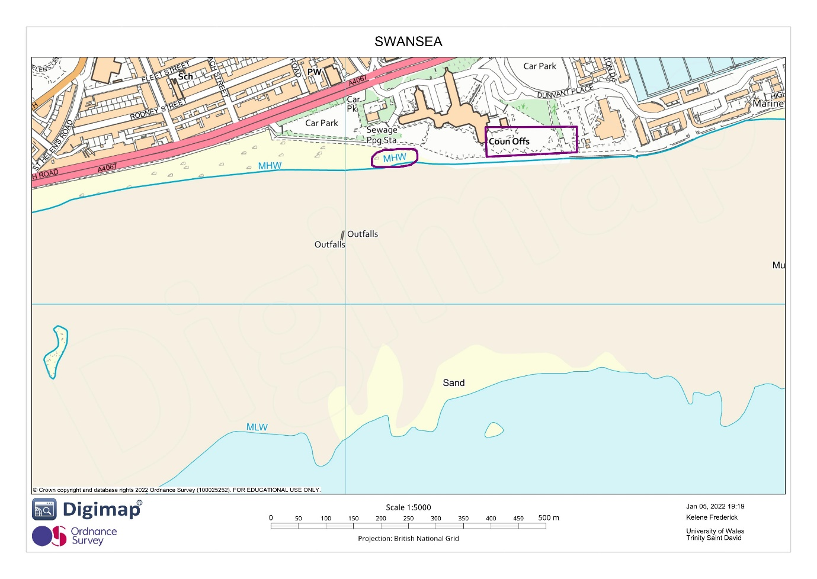
Figure 18. Digimap (2022). Swansea
The site is located between a hotel and an archival library and has a road civilians may use to access the Wales Coast Path and the beach. The commencement of work in this area will lead to increased noise pollution, remove the coast’s aesthetic properties obstruct access to the beach for locals and tourists. Once excavation begins the top layer of the soil will be carried away as surface runoff when it rains. The contamination of a public water body and recreational site results in locals and tourists being unable to use or access the beach.
The history of the site proves that there was a railway, a hospital for contagious diseases, an engine shed, wagon works, and gas works found in the area. These industries may have caused contaminations to the soils. With the risk of possible gases, human waste, oil, and deadly pathogens remaining in the soil, proper testing must be conducted to rule out these harmful variables. The site is located near Port Talbot, this dock has been contributing to the areas air pollution for years, causing deaths and respiratory ailments. The land is subjected to pollution via persons who may carelessly dispose of their waste products. This site could also house special archeologic artefacts beneath the soil, therefore precautionary measures and careful handling must be conducted once site works begin.
  - Geology
The main soil types found are sandy soils and clay with mixed layers of gravel, boulder clay and soft sandy clay. The overlying till is manmade ground that contains ash, dense bricks, sand and clay. The bedrock was identified as grey mudstone which is common in the area. These soil types have proven difficult to construct due to their characteristics. Sandy soils are known to have excellent drainage while clay retains water. This mixture of both cohesive and non-cohesive increases the risk of ground subsidence in this area. Sinking, swelling or sliding movements within the soil would cause uneven settling and cracks throughout the infrastructure. Previous borehole logs did not describe all elements and characteristics of the soil for example soil permeability was not calculated. Therefore, a thorough evaluation of the soil must be conducted to further understand and rule out the mentioned risks.

  - Recommendations
- Before conducting any site works the site should undergo a ground probing radar scan to locate any pipes (utilities) found below, utilities are usually found 2 meters below the surface. Use BSI PAS 128 as a guide to conduct this investigation. Under the HSE (2021), all works such as the erection of scaffolding and rotary was boring must be done 10 meters away from overhead poles, see HSE AIS No 8. For further guidance.
- Conduct tests for harmful gases found within the area. Borehole drilling can result in the release of any harmful gases that was trapped beneath the soil. Conduct this investigation using BS 10175-2011 for guidance. While conducting this investigation a test for air quality within the area should be carried to indicate the levels of pollution.
- Conduct laboratory tests on the soil for harmful diseases or pathogens that may be hidden within its contents. Once safe begin the rotary wash boring to update and compare the previous borehole log. This test would indicate a suitable foundation type for the structure. Once samples have been collected laboratory tests should be conducted. Chudley et al., (2020, p.99), states that soil identification and classification tests based on moisture content include liquid limit, plastic limit, particle size distribution, bulk density and permeability tests. Further guidance can be found in BS1377 and for more information on soil moisture content refer to BS EN ISO 17892-1.
- Once the clearance is given to commence site works, any activity that may produce loud noises such as drilling or excavating should be done after usual work hours. This ensures that persons staying at the hotel or the library near the site would not be disturbed. To avoid any accidents or traffic congestion, contact the local police department to assist with traffic management and transportation. To mitigate the causes of land pollution, site clean-ups should be regularly done. Place safety signs around the site so that civilians are aware of the current works. For further guidelines follow the Health and Safety Executive regulations.
- Based on the current borehole log and location of the site I must recommend a driven pile foundation type. Suitable for the soil type present, rather than removing the soil, displacement would make it more compacted around and below the pile. The piles should be approximately 22 m in length and about 650mm wide. For a sturdy foundation, nine piles should be placed, three on each side and three found within the middle.

DRAWINGS SHOWING A SKETCH OF A DRIVEN PILE FOUNDATION
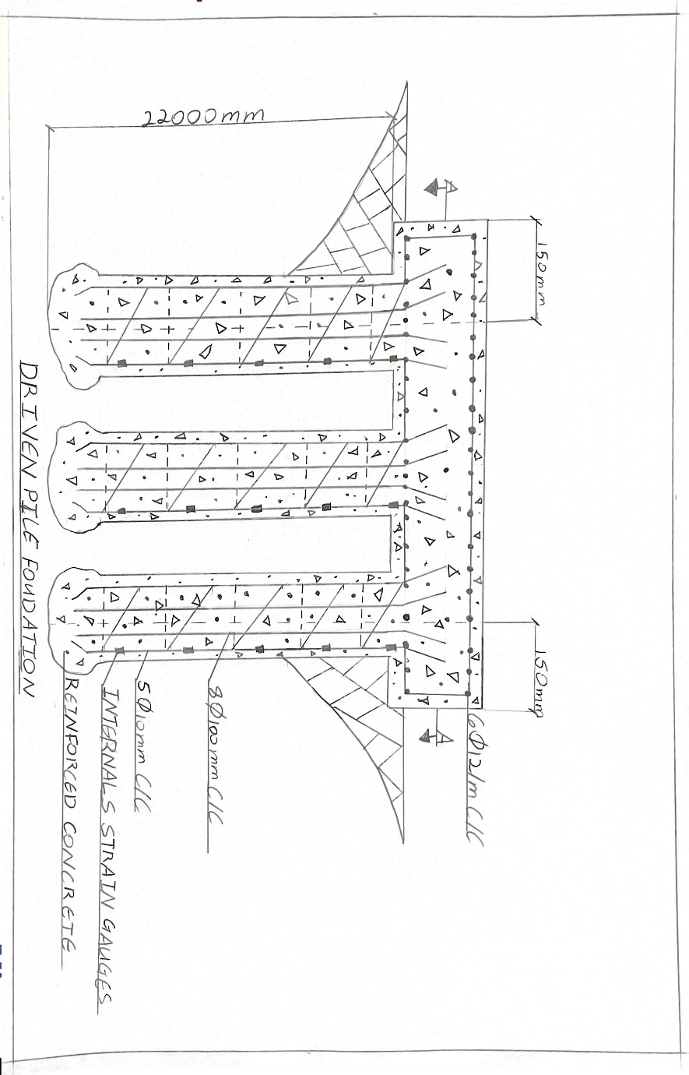
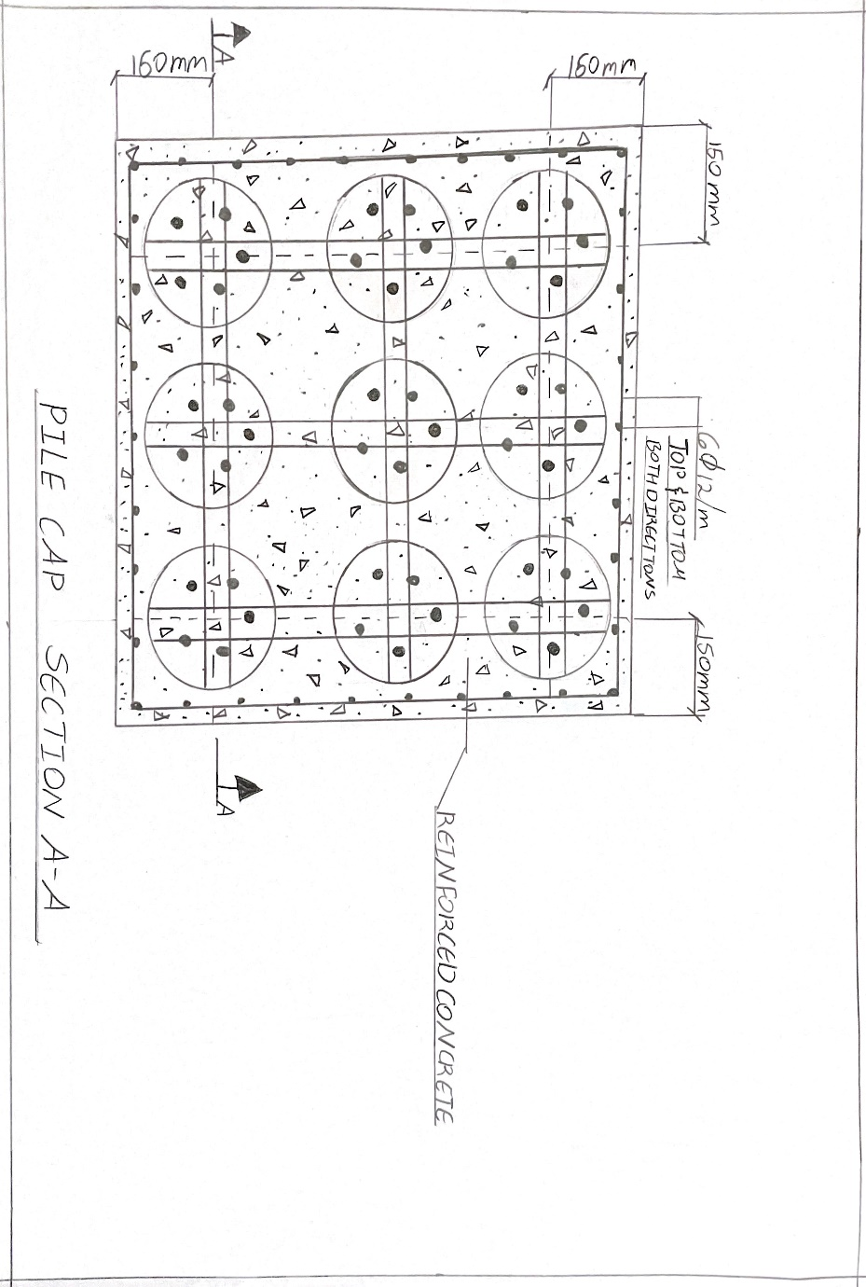
Figures 19 & 20. Frederick, K. (2022).
- BIBLIOGRAPHY

- Barclay, W. and Schofield, D. (2020). Swansea. Geological Survey of England and Wales. Available at: https://webapps.bgs.ac.uk/data/maps/maps.cfc?method=viewRecord&mapId=9862 [Accessed 20 Dec. 2021].
- BBC News (2018). Plastic pollution to be tackled by coast path water refills. BBC News. 5 Jun. Available at: https://www.bbc.com/news/uk-wales-politics-44358974 [Accessed 21 Dec. 2021].
- BBC News (2020). Air pollution: Call for stricter rules in Wales. BBC News. 27 Jan. Available at: https://www.bbc.com/news/uk-wales-51262400 [Accessed 4 Jan. 2022].
- British Geological Survey (1835). Geology of Britain viewer (classic). Bore hole Scans. Available at: http://mapapps.bgs.ac.uk/geologyofbritain/home.html [Accessed 20 Dec. 2021].
- British Geological Survey (2020). Engineering Geology of British Rocks and Soil. British Geological Survey, Keyworth, Nottingham: British Geological Survey, p.2. Available at: https://www.bgs.ac.uk/geology-projects/engineering-geology-maps/engineering-geological-studies-of-bedrock-formations/mercia-mudstone-group/ [Accessed 4 Jan. 2022].
- Chudley, R., Greeno, R. and Kavoc, K. (2020). CHUDLEY AND GREENO’S BUILDING CONSTRUCTION HANDBOOK. 12th ed. 2 Park Square, Milton Park, Abingdon, Oxon, OX14 4RN: Routledge, p.99. Available at: https://b-ok.lat/ [Accessed 4 Jan. 2022].
- Digimap (1870). Swansea. Historic Roam. Available at: https://digimap.edina.ac.uk/roam/map/historic [Accessed 4 Jan. 2022].
- Digimap (1870). Wales Coast Path. Historic Roam. Available at: https://digimap.edina.ac.uk/roam/map/historic [Accessed 3 Jan. 2022].
- Digimap (1910). Swansea. Historic Roam. Available at: https://digimap.edina.ac.uk/roam/map/historic [Accessed 4 Jan. 2022].
- Digimap (1940). Swansea. Historic Roam. Available at: https://digimap.edina.ac.uk/roam/map/historic [Accessed 4 Jan. 2022].
- Digimap (1960). Swansea. Historic Roam. Available at: https://digimap.edina.ac.uk/roam/map/historic [Accessed 4 Jan. 2022].
- Digimap (2022). Swansea. Available at: https://digimap.edina.ac.uk/roam/map/aerial [Accessed 3 Jan. 2022].
- Digimap (2022). Swansea. Geology Roam. Available at: https://digimap.edina.ac.uk/roam/map/geology [Accessed 3 Jan. 2022].
- Digimap (2022). Swansea. Enviromental Roam. Available at: https://digimap.edina.ac.uk/roam/map/historic [Accessed 3 Jan. 2022].
- Digimap (2022). Swansea. Roam. Available at: https://digimap.edina.ac.uk/roam/map/os [Accessed 3 Jan. 2022].
- Frederick, K. (2022). Driven Pile Foundations.
- Geobear (2021). Causes of Subsidence, What are the most common? | Geobear. UK. Available at: https://www.geobear.co.uk/common-causes-subsidence/ [Accessed 20 Dec. 2021].
- Google Earth (2020). Swansea. Available at: https://earth.google.com/web/@51.61393532,-3.9448119,6.65075594a,1310.24675052d,35y,353.7673331h,0t,0r [Accessed 20 Dec. 2021].
- Google Maps (2021). Google Maps. Google Maps. Available at: https://www.google.com/maps/@51.6135799 [Accessed 20 Dec. 2021].
- HSE (2021). Working safely near overhead electricity power lines. www.hse.gov.uk. Available at: https://www.hse.gov.uk/pubns/ais8.htm [Accessed 4 Jan. 2022].
- Joint Nation Conservation Committee (2021). Littoral rock (and other hard substrata) - JNCC Marine Habitat Classification. mhc.jncc.gov.uk. Available at: https://mhc.jncc.gov.uk/biotopes/jnccmncr00000003 [Accessed 20 Dec. 2021].
- Markman, D. (2018). Plague bacteria may be hiding in common soil or water microbes, waiting to emerge. The Conversation. Available at: https://theconversation.com/plague-bacteria-may-be-hiding-in-common-soil-or-water-microbes-waiting-to-emerge-90610 [Accessed 4 Jan. 2022].
- Misstear, R. (2016). 20 years after the oil spill, whatever happened to the Sea Empress? WalesOnline. Available at: https://www.walesonline.co.uk/news/wales-news/20-years-after-devastating-oil-10880420 [Accessed 21 Dec. 2021].
- Rails-to-Trails Conservancy (2019). Environmental Contaminants | Rails-to-Trails Conservancy. Rails-to-Trails Conservancy. Available at: https://www.railstotrails.org/build-trails/trail-building-toolbox/acquisition/environmental-contaminants/ [Accessed 20 Dec. 2021].
- The Bay Magazine (2017). The Lost Treasures of Swansea Bay. The Bay Magazine Swansea. Available at: https://www.theswanseabay.co.uk/2017/06/29/lost-treasures-swansea-bay/ [Accessed 21 Dec. 2021].
- Turner, R. (2009). “People are always asking about the Mumbles train, and it would be a huge attraction now.” WalesOnline. Available at: https://www.walesonline.co.uk/news/wales-news/people-always-asking-mumbles-train-2067647 [Accessed 4 Jan. 2022].
- WalesOnline (2004). Soggiest city in Britain pays high price for rain. WalesOnline. Available at: https://www.walesonline.co.uk/news/wales-news/soggiest-city-britain-pays-high-2440570 [Accessed 4 Jan. 2022].

