

Master of Business Administration

Dissertation (LCMB7035)

Research Proposal- marketing

Student Name-Manjeet Sharma

Student ID-2422944

Lecturer Name-Amir Homayounfard

Submission Date- 7 November 2025

Table of Contents
1. Title of the study 3
2. Research background 3
3. Problem statement and question 5
3.1. Research question 5
4. Aim and objectives 6
4.1. Aim 6
4.2. Objectives 6
5. Preliminary literature review 6
6. Proposed methodology 8
6.1. Research philosophy 8
6.2. Research design 8
6.3. Research approach 9
6.4. Research strategy 9
6.5. Data collection 9
6.6. Data analysis 10
7. Expected contributions 10
8. Ethical considerations 11
9. Research timeline 11
References 12
Appendices 14
Appendix 1: Influencer marketing market 14

1. Title of the study
“Social media influencers’ marketing strategy and its impact on consumer behaviour & purchase decision in the fashion industry in London, UK”.

2. Research background
Marketing plays a crucial role in the global fashion industry in influencing consumers’ purchasing behaviour over the years to ensure a sustainable competitive edge. Traditional marketing methods, such as hiring celebrities or fashion icons as brand ambassadors and placing TV and newspaper advertisements, have become somewhat outdated these days. However, social media marketing through online advertisements and blogs is prevalent now to reach a wider audience cost-effectively (Sundaram, Sharma and Shakya, 2020). Recently, the trend of influencer marketing has surpassed all other social media streams to convincingly engage fashion enthusiasts over digital platforms. Fashion brands have started to collaborate with credible and well-known social media influencers to promote their products through their content to influence customer purchasing intention (Ibáñez-Sánchez et al. 2022). Fashion brands need to collaborate with the appropriate influencer to engage maximum audiences, relying on the influencer's credibility and content quality. Conversely, social media influencers are also required to understand a particular product, the targeted audience, and campaign management. Therefore, many influencer marketing organisations have flourished over the last five years. Sprout Social, AspireIQ, SocialEdge, Mavrck, and Neoreach are some of the market leaders in the social media influencer marketing industry (Fortune Business Insights, 2025). According to a recent report, the size of social media influencers’ market is estimated to reach 23.59 billion USD in 2025 and is expected to increase to 70.86 billion USD by 2032 with a CAGR of 17% [Refer to Figure 2.1].
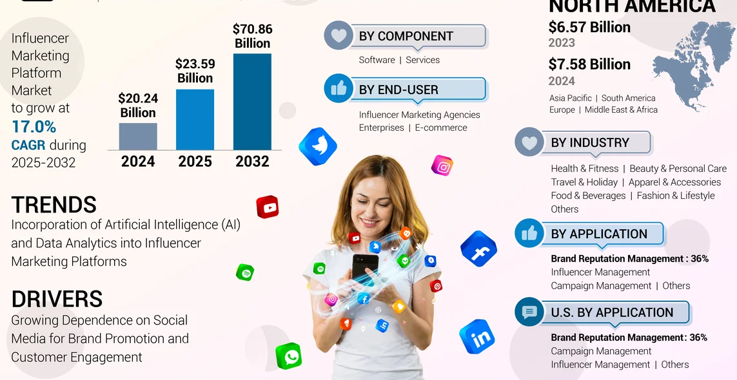
Figure 2.1: Global market size of Influencer marketing
(Source: Fortune Business Insights, 2025)
According to another source, the market size of the influencer marketing sector in 2025 is 31.07 billion USD and projected to grow with a 31.42% annual CAGR [Refer to Appendix 1]. The fashion industry of the United Kingdom has exponentially increased investments in creator-ad collaborations. The amount was 791 million GBP in 2023, more than three times that of 2019 (Influencer, 2024). Fashion influencers are delivering significant engagement across all social media platforms through brand promotion content and interactions. The average engagement rate of fashion creators across all platforms is approximately 1.53%, whereas TikTok (2.26%) and Instagram (1.59%) are the top two social channels that are used by influencers for social media marketing [Refer to Figure 2.2]. Nowadays, fashion brands are prioritising influencer marketing due to its effectiveness in enhancing customer engagement and influencing purchasing intention. Nearly 29.54% of fashion enthusiasts follow their favourite creators or celebrities to discover fashion items (Influencer, 2024). Additionally, repeated influencer recommendations enhance the potential for purchase by 68.25% in the fashion sector in the UK. Hence, this research will analyse the growing trend of influencer marketing to explore effective approaches used by creators to promote fashion brand and their impacts on customer buying behaviour.
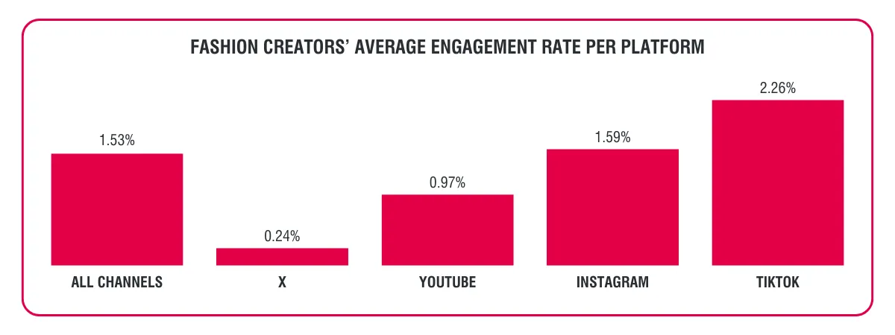
Figure 2.2: Engagement rate on social media platforms
(Source: Influencer, 2024)

3. Problem statement and question
Influencer marketing has revolutionised marketing and brand promotions, especially in the global fashion sector (Ibáñez-Sánchez et al. 2022). However, there is limited empirical evidence on how different influencer marketing strategies impact customer behaviour and buying decisions. The key problem is the lack of specific research to examine multiple accidents, like the number of followers, trust, authenticity, credibility, content type, and quality, and their individual effectiveness on influencing consumer attitude. Besides this, the utilisation of influencer marketing specifically in the fashion industry of London, UK, still remains unexplored. On the other hand, limited knowledge is available regarding particular challenges faced by fashion brands, including both contemporary brands and luxury brands, in incorporating influencer marketing cost-effectively. Furthermore, a research problem has been found in measuring the actual contribution of social influencer marketing on brand loyalty, engagement and online sales for both short and long periods. This research will address each of the recognised problems stated to articulate a meaningful research question.

3.1. Research question
What are the key marketing strategies used by social media influencers, and how do these strategies shape customer attitude and purchasing intention in the UK fashion industry based on influencer attributes such as trust, authenticity, credibility and content quality?

4. Aim and objectives

4.1. Aim
To examine how social media influencers’ marketing strategies influence consumer behaviour and purchase decisions in the fashion industry in London, UK.

4.2. Objectives
- To identify the key marketing strategies used by social media influencers in promoting fashion brands in London.
- To assess the impact of influencer credibility, content quality, and engagement on consumer trust and purchase decisions.
- To identify how social media influencer marketing shapes consumer attitudes and decision-making processes within the fashion industry in London.

5. Preliminary literature review
Existing literature sources support that influencer marketing through social media has become a highly productive marketing tool to influence customer engagement. Nurfadila and Riyanto (2020) have performed a primary quantitative research to evaluate the impact of influencer marketing, especially on the fashion industry. It has been identified that 71% of marketers who responded agreed that influencer marketing is better than other available options in terms of enhancing traffic and customer quality. Besides this, 89% of the respondents said this marketing method yields a high return on investment (ROI). Moreover, it has been identified that Instagram is the most influential social media platform on which creators post reels or short video content in order to maximise revenue earned by fashion retailers.
A primary survey was performed to gather data on 610 respondents and analysed data based on the “partial least squares model” to examine the role of fashion influencers in influencing consumer purchasing behaviour (Chetioui, Benlafqih and Lebdaoui, 2020). The article had concluded that fashion influencers influence the brand engagement and purchasing intention of customers positively. Moreover, a summary of certain attributes has been provided, which define the success of influencer marketing. These include perceived expertise, credibility, trust, congruency and behavioural control, which have a direct influence on consumer buying behaviour. On the other hand, a qualitative study has been reviewed to understand the role of influencer marketing on purchasing decision-making (Carneiro, Sousa and Remondes, 2022). This research included qualitative semi-structured interviews to examine the effectiveness of influencer marketing in the contemporary age. It has been found that influencers like bloggers, YouTubers and Instagrammers are playing a key role in promoting products or brands. However, the findings are not context-specific; rather, they generally establish a direct relationship between influencer marketing and consumer buying decisions. Similarly, George et al. (2025) have suggested specific influencer-related antecedents such as trust, credibility and attractiveness of influencers that shape the impact on consumer engagement. In addition, review authenticity and quality of information have been marked as content-related antecedents that build perceived influence on followers’ purchasing decisions.
The competition in the fashion industry has been increasing day by day due to continuously changing fashion trends and intensive competitive strategies (Thilina, 2021). In this regard, influencer marketing has appeared as a new-edge marketing strategy by utilising the idealised influence of social media creators in promoting fashion brands. This article also establishes a direct relationship between fashion influencers and the buying intention of consumers. However, the credibility of influencers and the quality of information shared in the content have been specified as two key mediators that determine how effectively influencers can inspire audiences to purchase the mentioned fashion articles. Hence, the authenticity and credibility of reviews provided by an influencer directly shape customer behaviour. As per the studies of Schunk and DiBenedetto (2020), social cognitive theory works as the theoretical pillar of social media creators’ influence on followers' purchasing behaviour. This theory suggests that the social learning of individuals develops by observing social contexts. Therefore, people often follow others to ensure observational learning and self-efficacy.
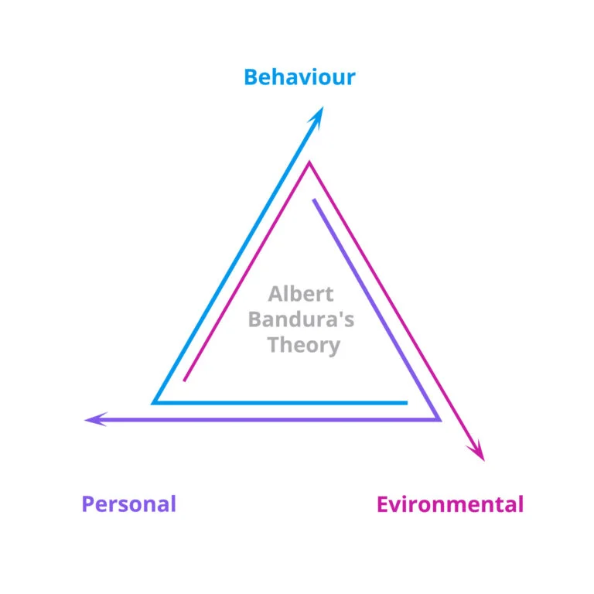
Figure 5.1: Social cognitive theory
(Source: Schunk and DiBenedetto, 2020)

6. Proposed methodology

6.1. Research philosophy
The research will incorporate the interpretivism philosophy to understand different perspectives on influencer marketing and their impact on fashion branding. As opined by Junjie and Yingxin (2022), interpretivism philosophy is developed based on the idea that reality is socially constructed and can be varied. Hence, information needs to be subjectively interpreted to consider individual opinions and experiences to explore a specific topic. It is suitable to develop new ideas regarding the unexplored areas.

6.2. Research design
Research design guides researchers on how to research a topic suitably based on adequate knowledge. This study is looking to explore the impact of influencer marketing on fashion branding in the UK, rather than measuring the effectiveness of a previously explored strategy numerically. Henceforth, exploratory design will be used here to address the formulated research question. It is effective in investigating problem statements and gaining deeper insights based on limited existing information.

6.3. Research approach
Mostly, deductive and inductive approaches are used in business research due to their distinctive nature and effectiveness. The deductive research approach is suitable to test existing theory hypothetically and quantitatively. Conversely, the inductive approach is commonly used to explore uncovered areas and develop new theories based on existing knowledge (Kumar and Ujire, 2024). This study will employ the inductive approach to identify the actual impact of influencer marketing in the UK fashion industry.

6.4. Research strategy
A qualitative research strategy will be followed as it incorporates the inductive approach. At first, qualitative data will be collected from existing sources addressing each research objective. Later, the information will be critically analysed to recognise certain patterns to generate new insights to find answers to the research questions.

6.5. Data collection
It is essential to select the most suitable method to collect adequate relevant data, relying on the research needs, expected outcomes and available resources to optimise research outcomes. According to Johnson and Sylvia (2023), the secondary data collection method is convincing for developing deeper insights based on the existing knowledge. In addition, it is less time-consuming and resource-intensive as knowledge can be easily gathered from open-access sources. In this research, the secondary method will be followed to collect relevant data from relevant articles, journals (Google Scholar and Scopus), case studies, and industry reports on influencer marketing in the UK.
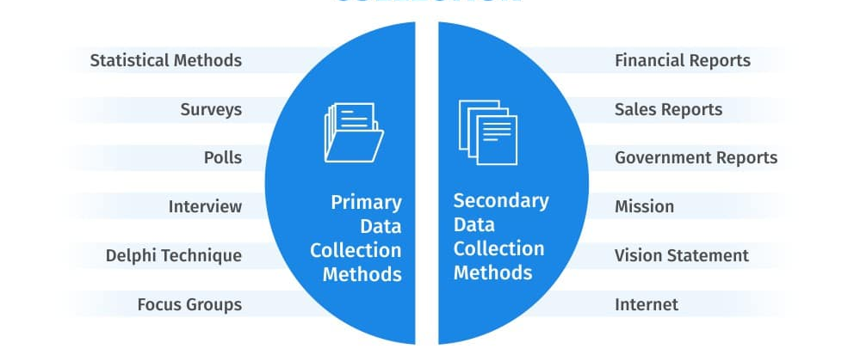
Figure 6.5: Data collection method
(Source: Johnson and Sylvia, 2023)

6.6. Data analysis
As the research employs a qualitative strategy, a thematic analysis will be used to interpret the collected data. Specific themes will be formed depending on the research objectives to explore the intended areas. Later, the collected data will be systematically organised and subjectively interpreted to answer the research question.

7. Expected contributions
The research will provide insights into recent influencer marketing strategies commonly used in the UK fashion sector. It will help analyse the individual effectiveness of each strategy in engaging fashion enthusiasts and identify the most effective strategies. Besides this, the study will elaborate on how variables like specific social media platforms, number of followers, content type, campaign quality, trust, authenticity and credibility of creators determine the efficiency of influencer marketing. Moreover, the research will provide a context-specific knowledge on how contemporary influencer marketing shapes purchasing decision-making in the fashion industry of the United Kingdom. Finally, data-driven recommendations will be added to suggest improvement strategies to the UK fashion organisations to maximise brand engagement and sales in the long term.

8. Ethical considerations
The secondary research method also requires consent from concerned authorities to gather information from existing sources. Hence, authentic data will be collected only from published and openly accessible articles or industry reports. Personal biases sometimes impact the authenticity and reliability of research outcomes (Nii Laryeafio and Ogbewe, 2023). In this context, conscious biases will be eliminated by strictly adhering to the actual findings of secondary sources rather than any kind of misinterpretation. Along with this, actual sources will be properly cited and referenced within the text to maintain authenticity. It will minimise the possibility of copyright strikes and plagiarism and make the research more reliable.

9. Research timeline
Figure 9.1: Timeline
(Self-created)

References
Carneiro, T., Sousa, B.B. and Remondes, J., 2022. The role of digital influencers in the purchase decision process: a study applied to the fashion consumer. Revista Gestão em Análise, 11(3), pp.57-69. https://doi.org/10.12662/2359-618xregea.v11i3.p57-69.2022
Chetioui, Y., Benlafqih, H. and Lebdaoui, H., 2020. How fashion influencers contribute to consumers' purchase intention. Journal of Fashion Marketing and Management: An International Journal, 24(3), pp.361-380. https://doi.org/10.1108/JFMM-08-2019-0157
Fortune Business Insights., 2025. Influencer Marketing Platform Market Size, Share & Industry Analysis, Component. [Online]. Available at: https://www.fortunebusinessinsights.com/influencer-marketing-platform-market-108880 (Accessed 03 November 2025).
George, A., Shibu, M., Joseph, E. T. and Sunny, P., 2025. Impact of social media influencer marketing on customer purchase intention in the fashion industry: A systematic literature review. Frontiers in Communication, 10, p.1676901. https://doi.org/10.3389/fcomm.2025.1676901
Ibáñez-Sánchez, S., Flavián, M., Casaló, L.V. and Belanche, D., 2022. Influencers and brands successful collaborations: A mutual reinforcement to promote products and services on social media. Journal of Marketing Communications, 28(5), pp.469-486. https://doi.org/10.1080/13527266.2021.1929410
Influencer., 2024. The State Of Influencer Marketing In The Fashion Industry. [Online]. Available at: https://www.influencer.com/knowledge-hub/the-state-of-influencer-marketing-in-the-fashion-industry (Accessed 03 November 2025).
Johnson, E. and Sylvia, M.L., 2023. Secondary data collection. Clinical Analytics and Data Management for the DNP,, pp.41-69.
Junjie, M. and Yingxin, M., 2022. The Discussions of Positivism and Interpretivism. Online Submission, 4(1), pp.10-14. https://eric.ed.gov/?id=ED619359
Kumar, S. and Ujire, D.K., 2024. Inductive and deductive approaches to qualitative research. International Journal of Multidisciplinary Educational Research, 13(1), pp.58-63. http://ijmer.in.doi./2024/13.1.69
Mordor Intelligence., 2025. Influencer marketing market size & share analysis - growth trends & forecasts (2025 – 2030). [Online]. Available at: https://www.mordorintelligence.com/industry-reports/influencer-marketing-market#:~:text=Influencer%20Marketing%20Market%20Analysis%20by,a%2038%25%20CAGR%20to%202030. (Accessed 03 November 2025).
Nii Laryeafio, M. and Ogbewe, O.C., 2023. Ethical consideration dilemma: systematic review of ethics in qualitative data collection through interviews. Journal of Ethics in Entrepreneurship and Technology, 3(2), pp.94-110. https://doi.org/10.1108/JEET-09-2022-0014
Nurfadila, S. and Riyanto, S., 2020. The impact of influencers in consumer decision-making: The fashion industry. Interdisciplinary journal on law, social sciences and humanities, 1(2), pp.1-13. https://doi.org/10.19184/ijl.v1i1.19146
Schunk, D.H. and DiBenedetto, M.K., 2020. Motivation and social cognitive theory. Contemporary educational psychology, 60, p.101832. https://doi.org/10.1016/j.cedpsych.2019.101832
Sundaram, R., Sharma, D.R. and Shakya, D.A., 2020. Power of digital marketing in building brands: A review of social media advertisement. International Journal of Management, 11(4). Pp.244-254. https://papers.ssrn.com/Sol3/Papers.Cfm?Abstract_Id=3600866
Thilina, D.K., 2021. Conceptual review of social influencer marketing on purchase intention; Dynamics in fashion retail industry. Sri Lanka Journal of Marketing, 7, pp.25-52. https://doi.org/10.4038/sljmuok.v7i0.48

Appendices

Appendix 1: Influencer marketing market
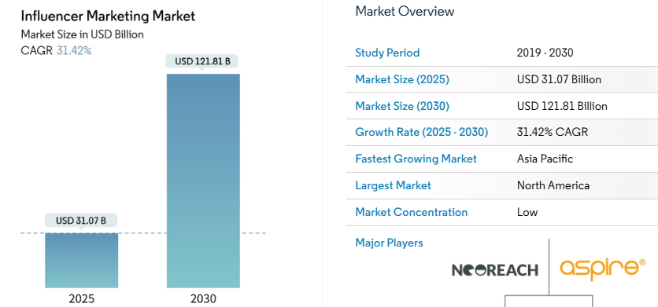
(Source: Mordor Intelligence, 2025)

