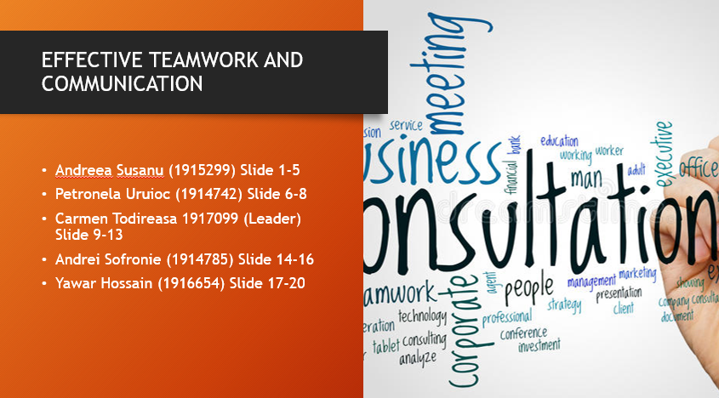

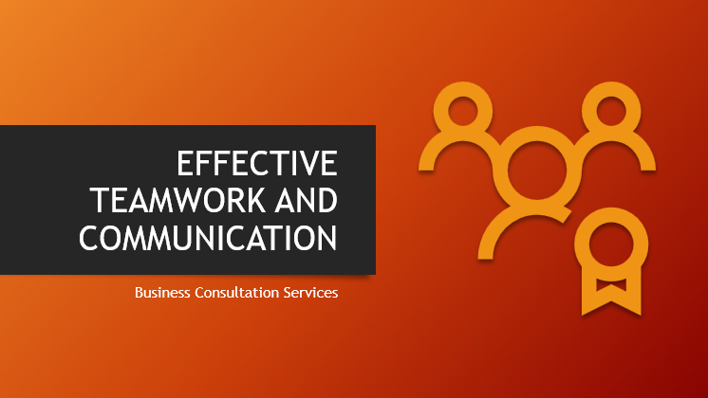

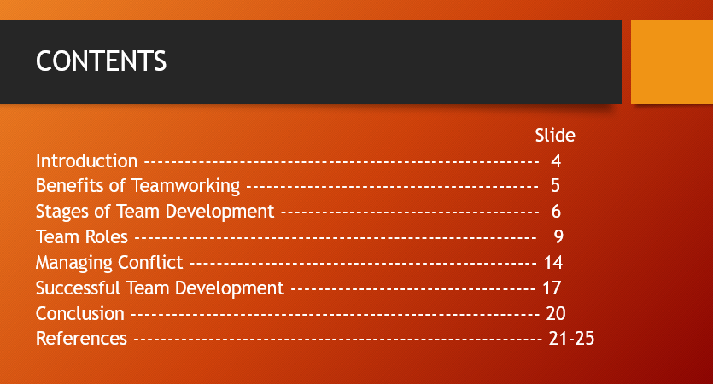

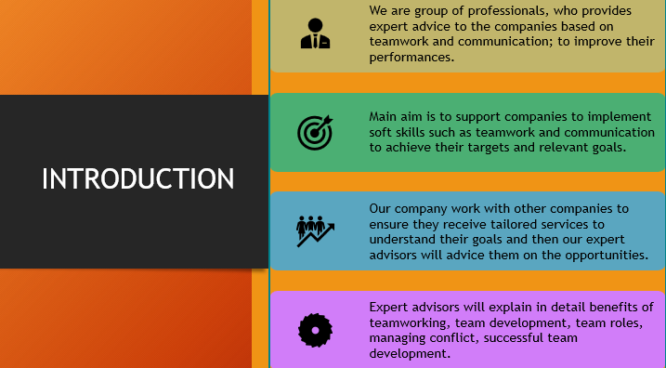
There are several advantages that could be attain by individual or organisation by enhancing team working practices. The major benefits of team working are mention below in detail.
Team working will lead to foster creativity of performing task and activities. It will help individual to gain knowledge from other team member as well as enhance learning. Team members can learn creative and new approaches form each other or developer personal skills and capability.

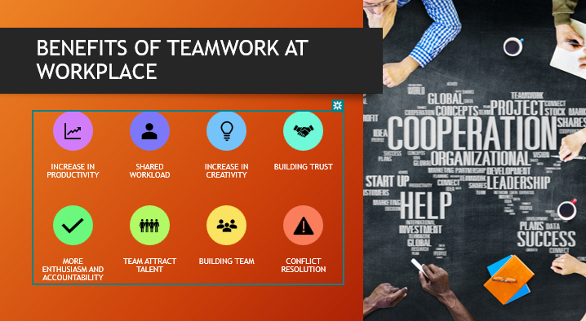

Working together will help in blending complementary strengths of individual. Team working practices will let individual build on talents and other team member helps in determining the major strengths of each other.
Team working is beneficial for creating a pool of ideas as all team members are free to share their idea in order to resolve the issues as well as considering different perspectives. Through this practices team member can easily develop effective problem-solving skills.
It is beneficial for building trust as naturally when employees are working with other, they will rely on each other. Team working will increase the trust of individual and this will lead to help in making working relationships stronger.
Team working will help in making work more fun as well as stress free. In this team member share workload and it will lead to reduce pressure from individual. Team working in inspiring and motivating for each other and help in enhancing the overall performance or productivity of individual. (Innovation, 2020)

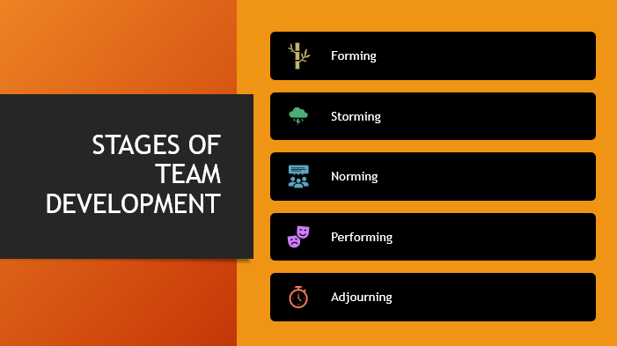

Team management is defined as one of the best factors that helps in conducting the business activities effectively. In the present scenario, there is discussion about benefits of team working and stages of team development. This provides information about the managing of conflicts and fights among team members. There is need to manage presence of successful team development in order to accomplish the organisational goals in specified time.

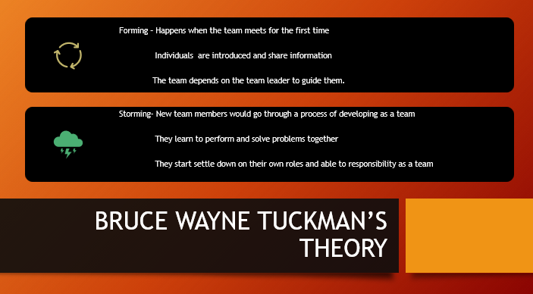

It is very important for me to manage team building (Marasi, 2019). It helped me to manage conflicts and fights among my team members and make them to achieve assigned targets. According to the team development analysis, there are following stages of team listed below -
Forming - As the manager of project, it was duty of mine to divide the team members into groups and make them to work in proper manner. These teams will include people who are having various skills and abilities.
Storming - When teams are developed, it is concluded that there are fights and conflicts among the team members (Mazzarol, and Reboud, 2020). It is responsibility of manager to control these by increasing bond and relation among team members.

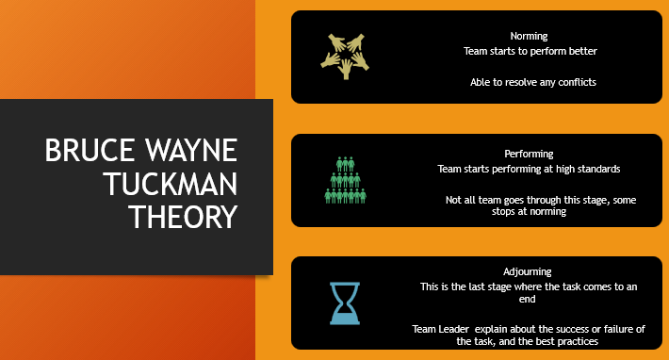

Norming - This includes the need for managing good control over all the activities assigned to different groups.
Performing – In this stage, tasks and activities are delegated. The main objective is to improve the way of conducting business activities (Soni, 2020).
Adjourning - This means proper time must be invested in order to improve the employee relation.

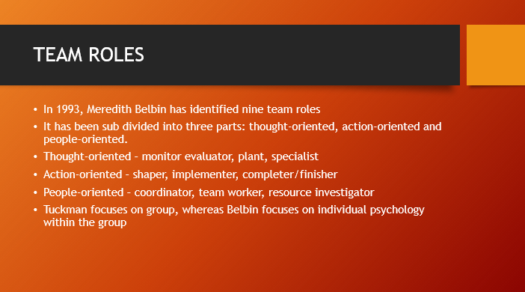

In 1993, Meredith Belbin has identified nine team roles while studying and testing in Henley Management College, it is a productive way to evaluate the relevant team’s strengths and weaknesses. It allows the team to understand in which way they could improve performance goals. There has been a wide usage of this tool, which has a greater simplicity for the success of the management team for using the team roles.
It has been sub divided into three parts: thought-oriented, action-oriented and people-oriented.
Thought-oriented – monitor evaluator, plant, specialist
Action-oriented – shaper, implementer, completer/finisher
People-oriented – coordinator, team worker, resource investigator
Tuckman focuses on group, whereas Belbin focuses on individual psychology within the group. Belbin also explains that if an individual takes on certain job role, they tend stick to the same role in different groups. (Team roles at work (Book, 1993) [WorldCat.org], 2020)

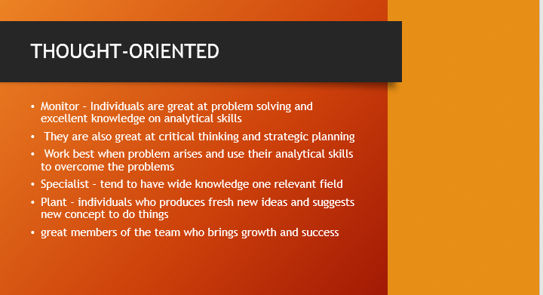

Monitor – Individuals are great at problem solving and excellent knowledge on analytical skills. They are also great at critical thinking and strategic planning. Work best when problem arises and use their analytical skills to overcome the problems. Due to the extensive knowledge and decision-making skills, they normally hold management position. (Example: Senior Manager or Chairman).
Specialist – Unlike the monitor, the specialist tends to have wide knowledge one relevant field. They are not much of a team player, as they could only help in certain job. Specialist tend to help the monitor with their expertise advise. (Example: Financial Advisor).
Plant - Plant are individuals who produces fresh new ideas and suggests new concept to do things. They would prefer working alone to produce creative and innovative ideas. Plants are great members of the team who brings growth and success. (Example: Advertisement Agency).
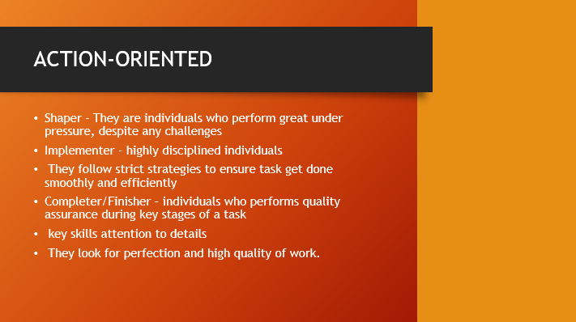

Shaper - They are individuals who perform great under pressure, despite any challenges. Shapers who can motivate themselves and others, they are goal oriented who thrives for the best. (Example: Leaders and Managers).
Implementer – Implementers are highly disciplined individuals who would dis-regard own interest and focus on importance of the team or organisation. They follow strict strategies to ensure task get done smoothly and efficiently. (Example: Senior Office Workers).
Completer/Finisher – Completer or finisher are individuals who performs quality assurance during key stages of a task. They have one of the key skills attentions to detail, which enables them to scrutinise any finished task and look for any error. They look for perfection and high quality of work. (Example: Quality Control Team).

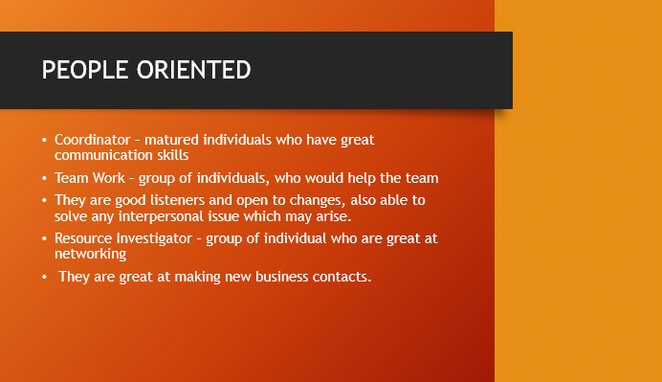

Coordinator – Coordinators are matured individuals who have great communication skills. They are normally hold management positions but are different to shapers. Their management style is more directive and would prefer a democratic approach which includes open communication. They help the team to accomplish their objectives by delegating tasks. (Example: Managers).
Teamwork – Team workers are group of individuals, who would help the team whenever they needed help. They are good listeners and open to changes, also able to solve any interpersonal issue which may arise. (Example: Factory Worker, Retail Team member).
Resource Investigator – They are group of individuals who are great at networking. Resource Investigator are positive, enthusiastic and outgoing, who would like to look for new opportunities and investigate new ideas. Not necessarily they would come with new ideas, but they are great picking up from other individuals. They are great at making new business contacts. (Example: Business Development Team).

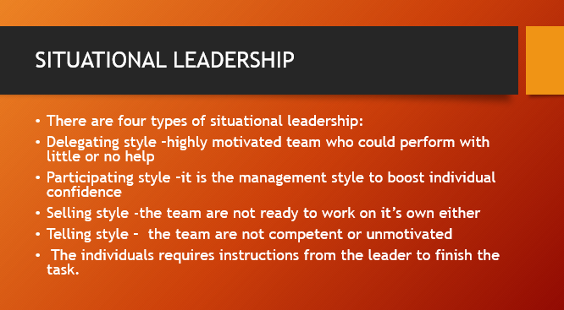

Paul Hersey and Ken Blanchard theory explains that all leadership style is variable, and no single style is better than the other. It depends on variety of circumstances and how quickly the leaders can adapt to the changes. Maturity should be considered for the right candidate who would be leading the team.
There are four types of situational leadership:
Delegating style – It requires a matured team, who can follow what the manager delegates. They are highly motivated team who could perform with little or no help, leader must communicate goals to the team.
Participating style – The team sometimes get overwhelmed with the workload; it is the management style which requires manager to speak with the individual to boost confidence.
Selling style - At this level, the team are not ready to work on its own either lack of skills or knowledge. The leaders should be able to sell ideas and convince them to get the work done.
Telling style – At this level, the team are not competent or unmotivated. The team requires good support and monitoring entire work process to ensure they are successful. The individuals require instructions from the leader to finish the task. (Hersey and Blanchard Situational Leadership Model EXPLAINED | B2U, 2020)

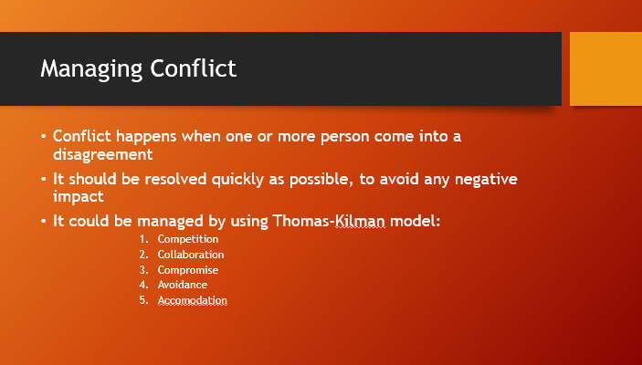

Conflict management represents the process of limitation of negative aspects of a conflict, while increasing the positive aspects of the conflict. Mainly the aim of managing conflict is that of enhancing effectiveness or performance inside groups.
Managing conflict represents a norming that ensures that the team can get achievements and surpass incoming conflicts that may appear inside a defined team.
The most important is to settle conflicts, addressing the issues, applying a win-win scenario. A good conflict management, helps on reduce of the loss of productivity, allowing teams to expand on different scenes, and if needed to change roles to ease the achievement of certain goals and deadlines. (UCSD Standards for Effective Supervision, 2020)

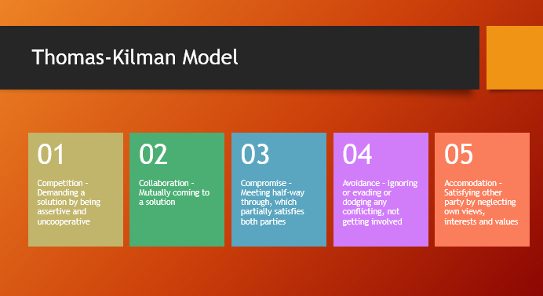

More than often, the role of managing conflicts inside a team, according with Belbin and Tuckman theories are going to coordinators. One of the main theories was formulated by Blake and Moulton (1970), later confirmed by Thomas (1976) and splits the conflict in two categories: one that focuses on own concerns and second that focuses of others concerns.
The models separated the conflict resolution on five separate categories.
Avoidance, in this scenario, the parties are ignoring the conflict, ideally the issue is small, and it will disappear, but under certain condition escalades, being considerate a win-lose scenario. Competing is another win-lose situation, mainly because the approach is assertive, and works only as an emergency solution. In this scenario the approach is known by all parties and is necessary to find a quick fix.
Compromising as an approach is considered a lose-lose solution. The reason behind this conclusion is that no parties is winning the argument, mainly working only on short term. This scenario allowing the solution to work only in the case of both parties having a common goal and requires a moderate level of cooperation.
Accommodating is yet another lose-lose situation , that can be used as a wining solution only if one of the members come with a better solution for the issue, the main issue with this approach is that is expensive, and may actually affect the final aim of the project, and may cost the relation with one party.
Collaborating is a win approach; in this case all the participants are collaborating to achieve the goal of the team. This case demanding high degrade of trust between the participants.
(model, 2020)

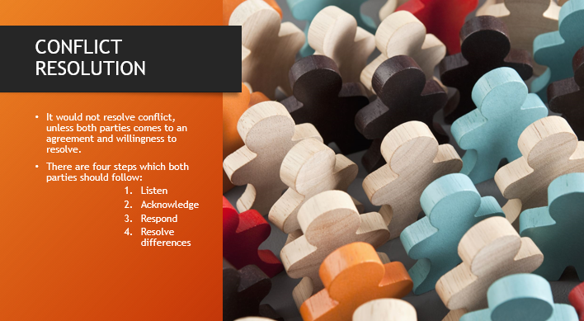

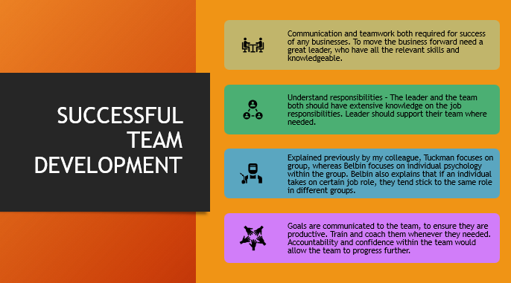

Communication and teamwork play a critical role in successful team development; therefore, the team should have comprehensive familiarity on the job. Managers should offer full support and understanding to the team when is needed, offering full attention, great effective communication, patience and listening actively. Tuckman theory concentrate on groups however, Belbin theory focuses on individual behaviour and attitude within the group.
Teamwork can become erratic if communication is lost. If team members are sharing identical vulnerabilities, the whole group may tend to lose connection with each other, in the other hand if strengths are sharing between the team, competitiveness for the best efficiency could take place. Therefore, the goal is to ensure they are working well together for constructive progress in future. (7 Tips on How to Build Effective Teams, 2020)

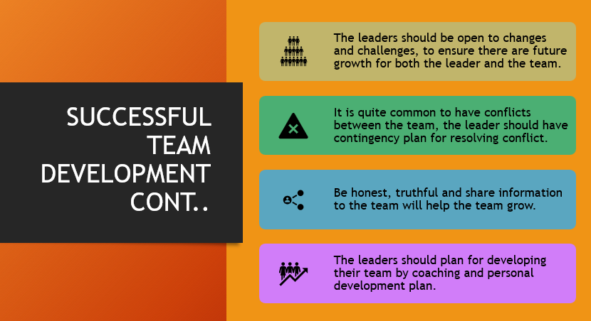

To establish an efficient and impressive team, the leaders should efficiently master the leadership skills, furthermore the team will be able to handle daily responsibilities while the leader is not present. The leaders should establish connection with the team by inspiring trust, confidence, support and honesty. As a great leader, connecting with each team member will help to discover individuals’ capabilities and accomplishments; therefore, everyone capability is well known will be easier to distribute the right task.
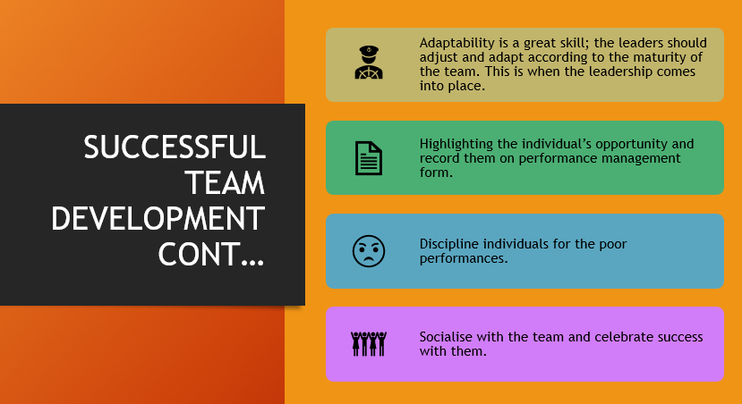
Flexibility is a great skill that every team member should follow; therefore, the team leaders should accustom with the maturity of the team. Highlighting the members performance in the management diary with great and poor performances will help leaders to keep track of any changes in the group. Disciplining the team members for under performances when the task has not been carried out to the proper standard or performance manage individuals giving them the opportunity to improve. Leaders should celebrate success with the team by congratulating them and giving them rewards, when great outcome emerges. (Indeed.com 2020)

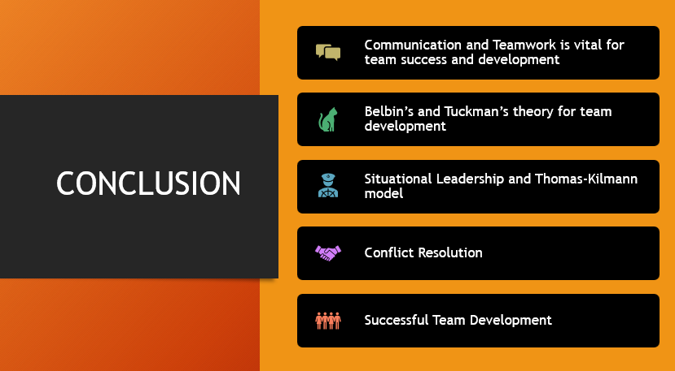
Communication and teamwork are vital skills for team success and development. Tuckman and Belbin theories are productive and supportive to follow in achievement of a great team. Most of the time, conflicts can happen between team members due to different ideas and visions, however an effective leader should be able to bring the team back in the right path. Thomas-Kilmann provides an exceptional theory on how the conflict should be managed. A remarkable leader will have the opportunity to put together an excellent team follow with outstanding achievements.





