Student Name: Abdul Malik. Student ID: 1805518
Module: Effective Team – working & Communication. Module Code: BMSK4002
Assignment Title: A presentation on team - working
Submission Deadline: 28/02/2019
Speakers Note: The Characteristic of Effective Team
“A group of people who work together towards a shared and meaningful outcome in ways that combine their individual skills and abilities and for which they are all responsible” (Baguley P 2003 Teams and Team – Working, p12) is a typical definition of a Team. People have formed work groups and teams in order accomplish goals and tasks since the beginning of human history. Together as a team people can accomplish what one person alone can not do. Business and organizations private or public are much more likely to perform better and achieve more when their people or employees work effectively as a team. There are tasks that can or should be done by one person without input from others, but gigantic projects and complex nature of work for example building an airplane or a bridge, developing a strategic plan require people to work in teams.
Effective teamwork is what makes an organization succeed. The characteristics that are found in an effective team are that team members work toward to a common goal, they have defined roles and clear direction. Team members communicate freely and honestly with one another they encourage differences of opinion, supports risk taking and change. Moreover, they have faith and trust on each other and accept mutual responsibility.
(https://medium.com/@mikeschoultz/10-team-characteristics-for-effective-teamwork-e0429b362ddd)
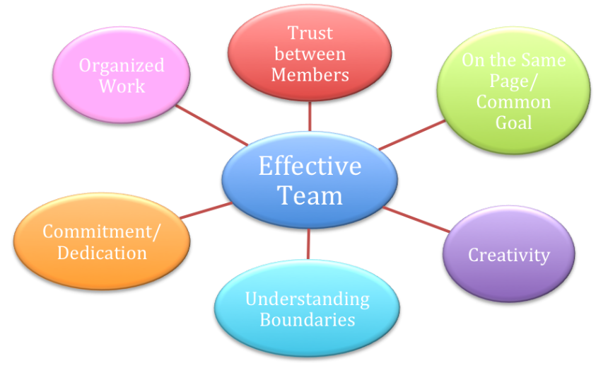
According to Dr Belbin and his teams research an effective team will have nine clusters of behaviour called ‘Team Roles’ when these roles are implemented a team can become high performing.
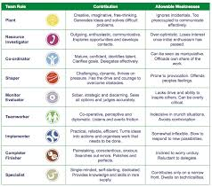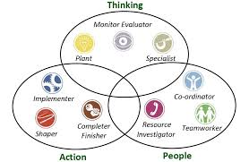
( www.belbin.com )

However, not all teams are high performing there are many teams that have difficulty functioning effectively and as a result are less productive. Characteristics that coerces a team towards ineffectiveness are many. When team members lack commitment to achieving the common goal has no emotional attachment or clear directions to the goal extinguishes the drive of the team. Lack of openness and trust, lack of camaraderie between team members also abates the motivation of the team.
There is also another thing to recognise is that a real effective team doesn’t just happen it needs to be created, it requires continues development, maintenance and sustenance (Baguley P 2003). Research has found that team develops over a period of time. According to psychologist Dr Bruce Tuckman you can’t expect a new team to perform well when it first comes together. Forming a team takes time. Team develops across time very much like people do. People experience childhood, adolescence, adulthood and old age. Childhood is associated with dependency, adolescence is normally comprised with some periods of conflict and adults spends a significant amount of time working. Older adults typically begin reducing their focus on work (Wheelan S A 1999). Bruce Tuckman’s research has found that teams also experience periods of dependency, conflict, trust and structuring, work and disengagement (www.mindtools.com/pages/article/newLDR_86.htm).
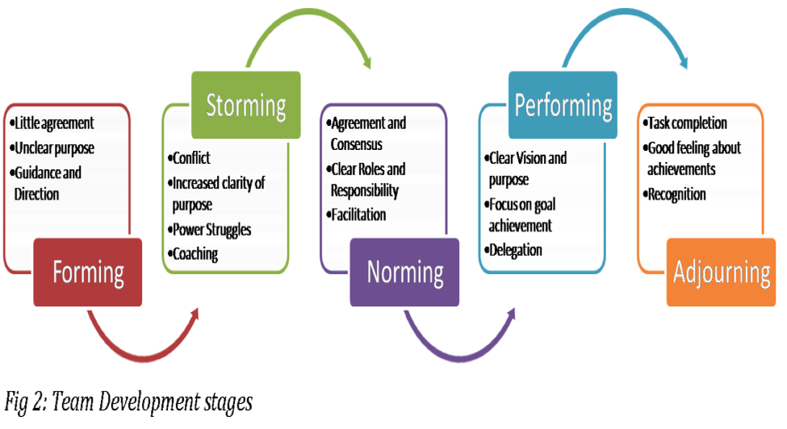
(http://www.mspguide.org/tool/tuckman-forming-norming-storming-performing)
The graph above explains Bruce Tuckman’s theory that teams takes time to form. Member in a group often go through perceivable stages as they change from being a collection of strangers to a united group with common goals.

References
Baguley P 2003 teach yourself. Teams and Team – Working, p12
Belbin M R 2002, Butterworth Heinemann. Management Teams Why they succeed or fail, p62 Gibbs G 1998, Oxford Brooks University. Learning in Teams, p4
Wheelan S A 1999, Sage Publication. Creating Effective Team, p23

www.belbin.com visited 27/02/19
www.mindtools.com/pages/article/newLDR_86.htm visited 28/02/2019
http://www.mspguide.org/tool/tuckman-forming-norming-storming-performing) visited 28/02/2019
(https://medium.com/@mikeschoultz/10-team-characteristics-for-effective-teamwork-e0429b362ddd)

