  Component One: Student Journal (learning log) 750 words +/- 10%  Contribution to Overall Module Assessment: 25% | Student No: | 2245369 – Aniko Takacsne Feher
 | Module Title: | Hotel Placement – Operating Hotel Facilites
 | Module Code: | BMIH4006
 | Lecturer: | Natalie Brailsford
Lead-in

Embarking on the reflective journey of my housekeeping placement at Hotel Ibis Stratford London, I employ Gibbs' Reflective Cycle (Ezezika & Johnston, 2022) to meticulously analyze the intricacies of my experiences. By delving into the tasks performed, their impact on guest service, and the evolution of my skills, this reflective evaluation endeavours to provide an exhaustive exploration of my personal and vocational growth during this transformative placement.

Body

Tasks and Contribution to Guest Service

Assigned the crucial responsibility of upholding the highest standards of cleanliness and attention to detail, my role in the housekeeping department significantly influenced the overall guest service experience. Performing tasks such as cleaning, changing bed linen, and engaging in basic room service activities demanded not only precision but an unwavering commitment to meeting elevated expectations (Bhuian, 2021). The meticulous folding and organization of clean laundry heightened my attention to detail, leading to a positive impact on both personal characteristics and professional development. The initial pressure to adhere to high-level requirements served as a catalyst for continuous improvement, resulting in heightened precision and motivation.

Academic Research Integration

Expanding the lens beyond the specific skills identified, it is imperative to acknowledge the comprehensive skill set demanded by the hotel industry. This encompasses technical competence, effective communication skills (Samy et al., 2023), problem-solving prowess, time management, teamwork (Magalhaes et al., 2022), adaptability, customer focus, ethics, and professionalism (David et al., 2015). The mastery of key-card systems, communication tools, and housekeeping technology underscored the need for continuous learning and adaptation to new tools, solidifying the connection between academic research and practical application (Afifi et al., 2020).

Communication and Teamwork Development

Analysis of the development of communication and teamwork during my internship using the Gibbs model shows my transformation. Coordinating guests' requests initially presented challenges, yet through deliberate efforts to communicate positively with both guests and colleagues, I not only cultivated effective communication skills but also enhanced my abilities as a team player (Shen et al., 2020). The success in responding to guests' requests not only bolstered my confidence but also had a positive ripple effect on the overall work ethic and productivity within the team (Sharma and Singh, 2020).

Overall Reflection and Future Commitments

This immersive experience underscored the pivotal role of communication and teamwork in the successful operation of the housekeeping department. As I navigate forward, I am resolute in my commitment to seek further training opportunities, maintain open lines of communication, and foster a collaborative team environment to augment overall efficiency and guest satisfaction (Afifi et al., 2020).

Action Plan for Continuous Growth

To ensure sustained growth in my hospitality career, I have meticulously crafted a comprehensive action plan:

Leadership and Communication Training: Engaging in personalized or online courses that meticulously focus on leadership and communication skills, with a commitment to applying them daily in the housekeeping department to enhance team coordination and effectiveness.

Team Meetings: Regularly attending team meetings to not only improve open communication but also enhance teamwork coordination, fostering idea development to solve problems efficiently. This proactive approach aims to contribute to a positive team dynamic and efficient problem-solving.

Technical Skills Development: A commitment to continuously developing technical skills related to housekeeping, ensuring thorough familiarization with tools and mastery of their operation. Regular training sessions will be actively sought to stay updated on emerging tools and equipment.

Cross-Departmental Communication: Elevating communication with colleagues in other departments to contribute significantly to the hotel's overall efficiency and effectiveness in serving customer needs (Boudreau et al., 2022). Establishing strong relationships across departments aligns seamlessly with the organizational goal of fostering collaborative synergy.

Conclusion

In conclusion, this reflective evaluation has offered profound insights into my personal and vocational development during the housekeeping placement. The focus on precision, attention to detail, and the development of communication and teamwork skills emerges as pivotal components of success in the dynamic hospitality industry. The meticulously outlined action plan underscores my unwavering commitment to continuous growth and improvement, emphasizing my integral role in contributing to the overall success of Hotel Ibis Stratford London. This reflective journey not only enriched my skill set but also instilled a profound sense of responsibility towards maintaining the highest standards and positively contributing to the collaborative and customer-focused ethos of the hotel.

Component Two: Health and Safety Guide
Contribution to Overall Module Assessment: 25%

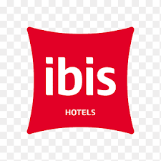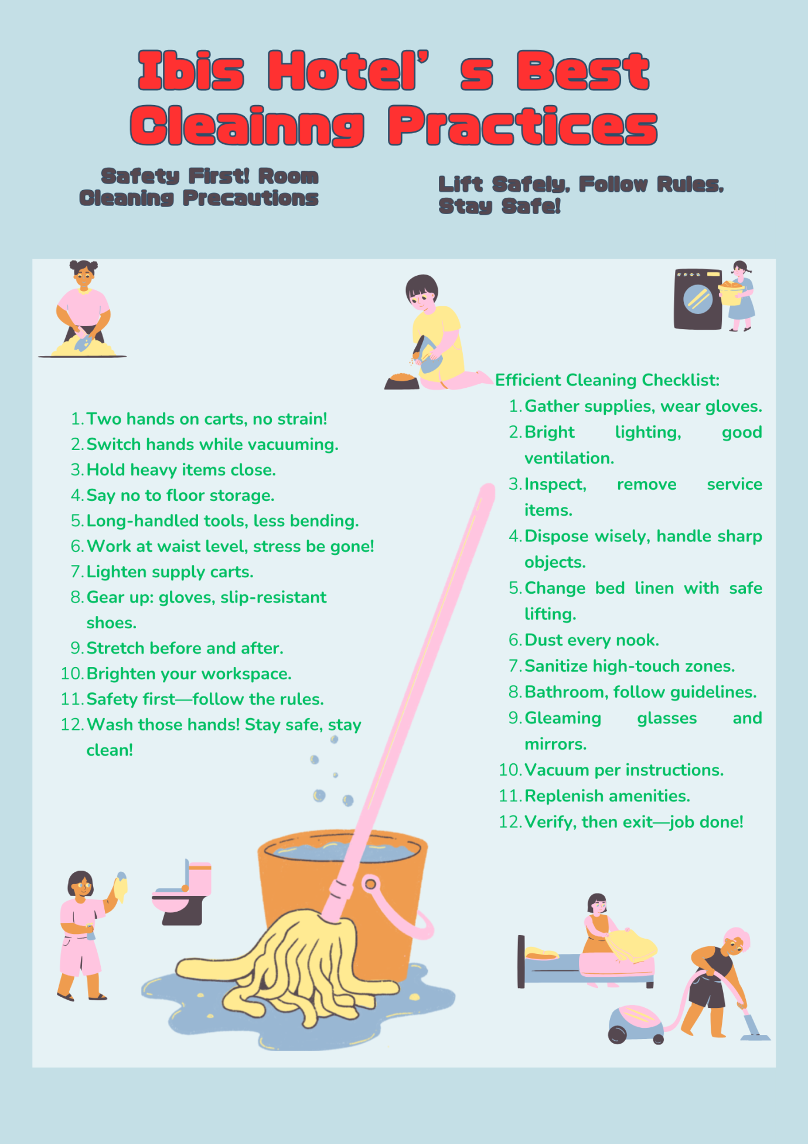
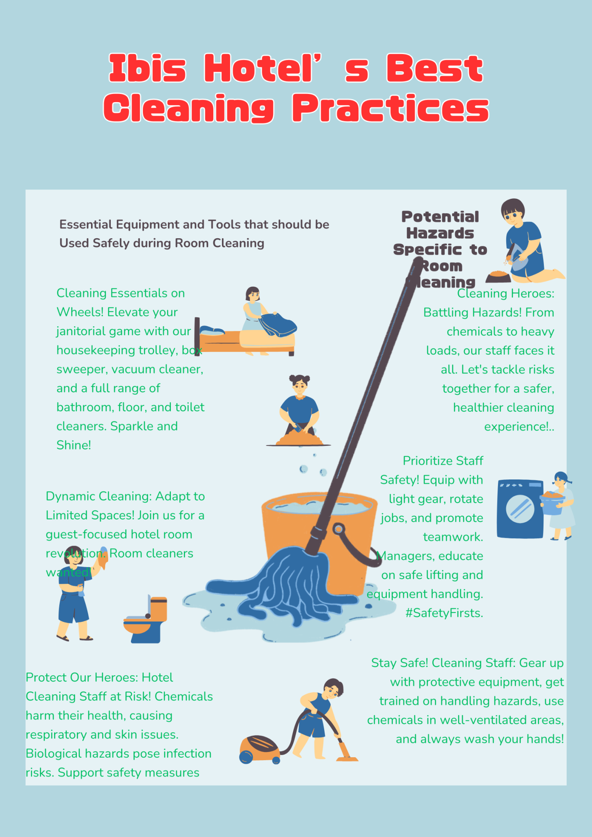

Reference List
Component One:
- Afifi, M.A., Kalra, D. and Ghazal, D.M. (2020). Integration of Collaboration Systems in Hospitality Management as a Comprehensive Solution. International Journal of Advanced Science and Technology Vol. 29. No. 8. pp. 3155-3173
- Bhuian, D. (2021). The Impact of Service Quality on Customer Satisfaction in Hotel Business Development. Karlstad Business School.
- Boudreau, A., Rose, H. and Landine, J. (2022). Soft Skills in Ontario’s Post-Pandemic Hospitality and Food Services Sector. A Report for The Hospitality Workers Training Centre
- David, S., Baum, T., Robinson, R.N.S., Lockstone-Binney, L. (2015). What about the workers? Roles and skills for employees in hotels of the future. Journal of Vacation MarketingVol. 22. No.3.
- Ezezika, O. and Johnston, N. (2022). Development and Implementation of a Reflective Writing Assignment for Undergraduate Students in a Large Public Health Biology Course. Pedagogy in Health Promotion. Vol. 9. Issue 2.
- Magalhaes, C., Araujo, A. and Andrés-Marques, M.I. (2021). How Do Hospitality Workers Perceive Their Work Skills before and after the Lockdown Imposed by the COVID-19 Pandemic? Social Sciences. Vol. 11. No. 12.
- Samy, M., Moussa, M. and Salama, M.A. (2023). Exploratory Study of Soft Skills in Tourism and Hospitality Sector: Perspectives of Hotels and Travel Agencies Managers. Journal of the Faculty of Tourism and Hotels-University of Sadat City. Vol. 7. Issue 1.
- Sharma, S. and Singh, V. (2020). Soft Skills in Tourism-A Case Study of Tourism Management Graduates.International Journal of Research and Analytical Reviews, Vol. 7. No.1. pp. 430-437
- Shen, L., Qian, J. and Chen, S.C. (2020). Effective Communication Strategies of Sustainable Hospitality: A Qualitative Exploration. Sustainability. Vol. 12. No. 17.

Component Two:
Divincenzo, K. (2020). Injury-Free Hotel Housekeeping. https://www.work-fit.com/blog/injury-free-hotel-housekeeping.
https://canva.com

