

School of Sport, Health & Outdoor Education

Assessment Feedback Sheet

Student Name: Michaela da Cunha
Module: Facilitating Learning through Experience
Module Code: SHOE7002

Assignment Title: Project Report

Design, deliver and reflect upon an experiential project or activity to facilitate learning within a specific outdoor education context. The facilitated activity must address an identifiable element of sustainability. The report should include the following:
- An abstract
- An introduction and rationale for the project (500 words)
- A literature review: critical analysis of theoretical perspectives underpinning your project / activity/ (2,000 words);
- An outline of the context of the activity and recognition of ethical concerns- “a simplified methodology” (500 words);
- A critical discussion and evaluation of the overall project in relation to the reviewed literature that leads to an appropriate conclusion (1,500 words);
- An annotated session plan (in appendix)
(4,500 words)
Submission Date:
3rd January 2020
Personal Evaluation – to support your academic progress please complete the section below BEFORE submitting your work.
What do you consider to be the best aspects of this work? | To be able to put robust theoretical research (in particular, Dewey) behind my chosen style of facilitation. This gave me confidence when delivering the session.
Which aspects do you consider could have been improved in this piece of work? | Despite broad and extensive reading, I do not make enough notes as I am reading. The recent introduction to Zotera (and similar) has turned this around for me, however, I need just a little more practice. This will be a strong focus for my next assignment.
What have you found most satisfying whilst undertaking this submission? | Understanding Dewey at a deeper level. I feel I respect and connect with his work as never before. I would like to dig much deeper.

ASSESSMENT CRITERIA | Learning  Outcomes
ASSESSMENT CRITERIA | Learning  Outcomes | Unsatisfactory  0 – 49% | Good  50 – 59% | Very Good  60 – 69% | Excellent  70% + | %
Evidence of critical discussion of relevant theoretical perspectives underpinning facilitation and experiential learning. | 1,2 |  |  |  | ✔ | 40%
Critical analysis of the practical applications of facilitation and experiential learning in your project / activity. | 2,3 |  |  |  |  | 30%
Evaluation of the project that is both reflective and critical | 3 |  |  |  |  | 20%
Construction of a coherent argument that leads to an appropriate conclusion | 1,2,3 |  |  |  |  | 10%

Tutor comments

First Tutor’s Comments:

Second Tutor’s Comments:
Tutor 1: G. Harvey | Tutor 2:
1st Mark: % | 2nd Mark: % | Agreed Mark: %

An Outdoor Experiential Learning and Orienteering-based Programme to Facilitate the Procurement of Grit in Adolescents.

Abstract
The aim of this study is to measure the value of an experiential learning programme for the procurement of grit in adolescents. Grit is described by Angela Duckworth as "perseverance and passion for long-term goals" (Duckworth et al., 2007) and is a common trait to those who successfully achieve valued goals (p.1087). Mental well-being, part of the United Nation's Sustainable Development Goal 3 (United Nations, 2019) is a "state of well-being in which every individual realises his or her own potential, can cope with the normal stresses of life, can work productively and fruitfully, and is able to make a contribution to his or her community." (Organization, W.H., 2004, p.12). Grit and well-being are associated with academic and professional success (Khan et al., 2007, p.123). Orienteering-based activities were delivered in this study through Dewey's progressive theory of experiential learning. Three participants took part in a single session that included challenges of various levels, to procure grit. The results revealed a decrease of perseverance being consistent in all participants, with the overall levels of perseverance remaining higher than levels of passion. The procurement of grit using orienteering-based exercises is inconclusive, however, the robust evidence for grit as an indicator of success, and success for well-being (Khan et al., 2007), suggests further research would be useful.

Introduction
Angela Duckworth spearheaded 'Grit' and developed the 'Grit scale' test in 2004 as a reliable indicator of success since when it has been the subject of growing academic interest across the world. Despite falling down, gritty people get up again and keep going. When others become disinterested or tired and give up, gritty people will continue working with enthusiasm to reach their end goal even if it takes a long time (Duckworth, 2007).
Common traits studied by Duckworth and Quin consistently associated professional and academic success with happiness and grit (Khan and Khan, 2017). I argue that grit, if procured through effective learning experiences, results in students being more likely to be successful and enjoy mental well-being. The growing number of mental disorders faced by individuals in 2020 continues to impact social, economic and human rights issues across the world. Mental well-being is a "state of well-being in which every individual realises his or her own potential, can cope with the normal
stresses of life, can work productively and fruitfully, and is able to make a contribution to his or her community." (Organization, W.H., 2004, p.12). Between 1995 and 2014 there was a six-fold increase in the number of children with a reported long-term mental health condition and a recent study by the Health Foundation found that 49% of children moving into adulthood did not receive the emotional support they needed when growing up (Hargreaves, 2018). The maintenance of social networks and social activities is important to well-being and the qualities of orienteering experiences referred to later, contribute toward these basic needs. As well as social relationships, Diener (2000) finds that lasting happiness could also result from renewable physical pleasure, working for one's goals and flow activities (Singh and Duggal, 2008, p.44).
There are several reasons why outdoor experiential opportunities are not open to some demographic groups, in particular those from low socio-economic backgrounds. The benefits of grit to their success in professional and academic terms may be hindered and this may possibly result in the negative impact on their well-being. Further inequalities exist within the constructivist paradigm of Dewey's progressive theories that underpin this study.
Teachers and role models, are not always able, comfortable or experienced enough to facilitate outdoor experiential or 'discovery' learning, denying some pupils the opportunity to develop grit in the outdoor environment and reducing their ability to learn in new or different ways. In the age of precarity (Kirk, 2018), schools may not be able to fund educational trips.
Change from the norm can be a challenge for teachers, parents and adolescents in any scenario, and I have surmised, in acknowledgement of the age of digitalisation and social-media influence, that innovative ways to motivate adolescents into new environments for learning will be needed for this study. Whilst radical change may appear to be the only answer for some (Jones, C., 2019, p.4), Educational Theorist, John Dewey, reminds us that "operating blindly and in confusion, on departure from the old forms of education, will not solve problems" (Dewey, 1983, p.25). This project was designed to be a reflective response to issues faced by adolescents today and to procure grit through specifically designed orienteering-based activities to inform future facilitation. The study was not robust to be valid and recorded levels of perseverance being more significant than levels of passion on the grit scale.
Two areas of study have been outlined to provide an understanding of how theories can inform future development of this study: Grit and effective learning opportunities.
Critical analysis and theoretical perspectives underpinning study
The paradigm of constructivism has been identified to provide an understanding of the theories that underpin my research and the context within which they lie. These are Duckworth's Grit theory as a predictor of success, alongside Dewey theories of Experiential Learning as predictors of well-being. I chose constructivism because the students are constructing their own understanding and knowledge through experience and reflection. Constructivism emerged from Piaget and Dewey and their developed theories of childhood development and educational learning that became known as progressive learning.
Dewey's Theory of Experiential Learning for Effective Learning Experiences.
Grit on its own is not a predictor of happiness. Grit is a predictor of success and academic and professional success is a predictor of well-being. Therefore, opportunities to achieve academic success is a concern of this study, specifically for teenagers. Whilst grit requires conditions and tools to achieve success, if the tools are not available in the first place, areas of inequality are highlighted and potential solutions sought, so that grit procurement can be accessed by all. Although highlighted as a problem, opportunities and inequalities are the focus for further study, whereas this study is concerned with maximising the effective learning environment through the design of a specific programme, 'orienteering-based activities', within the Dewey's framework of experiential learning and Duckworth's framework for the procurement of grit.

Pragmatist Dewey and his theory of experiential learning, claimed students needed to interact with their environment if they are to learn, with meaningful, systematic and valued reflective practice. Dewey (1933, p.118) defined reflective thought as "Active, persistent, and careful consideration of any belief or supposed form of knowledge in the light of the grounds that support it and the further conclusions to which it tends".

Educational theorist Kolb was influenced by Dewey, and whilst searching for effective experiential learning experiences to maximise academia for success and well-being, Ord and Leather (2011), argue that "in order to fully comprehend an outdoor experience, it must be understood as a form of lived experience" (p.13). Ord and Leather argue that whilst cyclical models, such as the Kolb cycle, simplify complexity, they also simplify reality. The authors call for a return to Dewey's original ideas that, as Greenway agrees, provide an experience that stimulates future thinking:

"Dewey provides a broader vision of "educative experience" than many of his followers do. Dewey's interest was in the kinds of experiences that arouse, that are intense, that strengthen, that stimulate, and that live on in future experiences that have similar properties." (Ord and Leather, p.13).

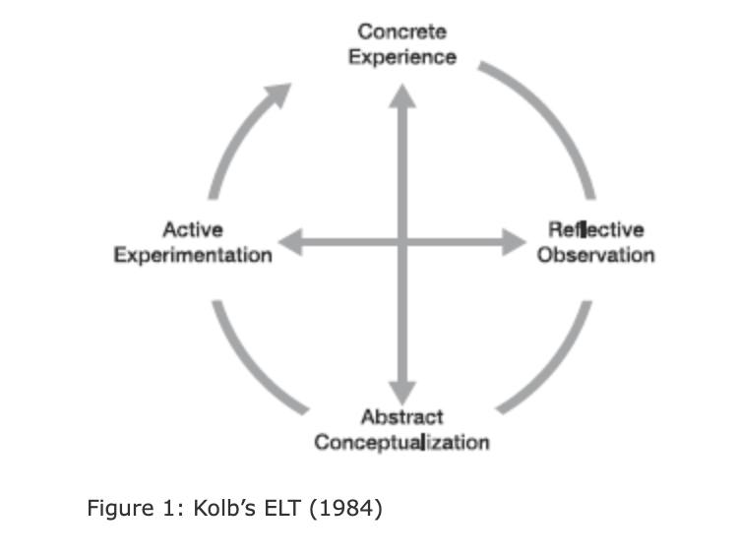
In this study I am interested in understanding, applying and reflecting on five points of Deweys's theory that have been 'lost' to less complex models that have evolved. The model below shows Kolb's simplified experiential learning cycle that, although popular, has received much critique.

Critics voice that the learning styles: Pay insufficient attention to the process of reflection (Bould et al, 1983); are too extravagant (Jarvis, 1987; Tennant, 1997); lack consideration for cultural variances (Anderson, 1988). In their critique of Kolb, Ord and Leather (2011) suggest below why it is necessary for the original theoretical conceptualisation by John Dewey to be revisited:

- The Experience of Experiential Learning.
The words 'doing' and 'activity' hide the more subtle and deeper aspects of the underlying experience. The use of such words masks what outdoor experiences mean beyond the physical. "Understanding an experience in the outdoors is best done by appreciating the subtle and often significant difference in why they are undertaken, and what they mean to those undertaking them" (Ord and Leather, 2011, p.19).

2. Reflection as critical thinking.
The need for reflection is agreed by Kolb and Dewey. "No experience having a meaning is possible without having some element of thought." (Dewey, 1916/2007, p.107).
Schon (1987) agrees "reflection-in-action" is more desirable than "reflection-on-action".
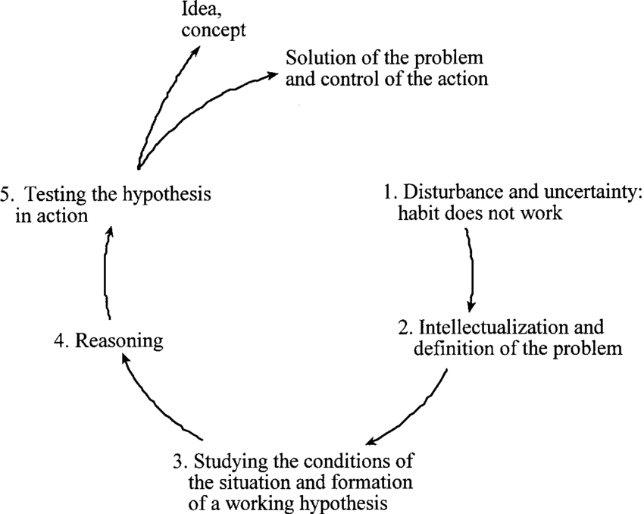

Figure 2: Dewey's model of reflective thought and action (Miettinen, 2000).

3. The Meaning of Nature.
The importance of "meaning".
"It is not experience when a child sticks his finger into the flame; it is experience when the movement is connected with the pain which he undergoes in consequence. Henceforth, the sticking of the winter into the flames means a burn" (p.104).
Experience is linked to meaning and meaning is a consequence of 'trying' and 'undergoing'.

4. Thoughts and actions to arouse curiosity.
Rejection of Dualism and separation of thought and action in learning, Dewey disagrees with
Kolb that for every experience there is a consequence. Dewey writes "Mere activity does not
constitute experience" (Dewey, 1916/2007, p.104).

5. Past, present and future experiences.
"In directing the activities of the young, society determines its own future in determining that of the young. Since the young at a given time will at some later date compose the society of that period, the latter's nature will largely turn upon the direction children's activities were given at an earlier period" (Dewey, 1916/2007, p.36).
Dewey emphasises the importance of the past in informing the future.

These five points have been acknowledged within the 'Orienteering-based Activity Programme' in this study, to assess their validity in creating a more effective learning environment for the teenagers, essential for grit procurement. Problematic areas forecast relate to the accessibility of suitable outdoor environments, weather, motivation, connection with experiential-styled learning and willingness or ability to immerse themselves in a facilitation, whereby my part is not to lead, but to facilitate opportunities as a co-learner. I envisage this to be a challenge, with teenagers used to common methods of teaching such as recitation and memorisation and with my own instilled traits as a facilitator.

The Orienteering-based activities, mentioned later, have been designed to minimise the aforementioned issues and problematic areas relative to inequality, accessibility, opportunity, facilitation, motivation and reflection. Fundamentally, the programme has been designed to measure the procurement of grit as an outcome.

Characteristics of Grit theory and procurement within orienteering-based activities.
"Duckworth herself is the first to say that the essence of grit remains elusive. It has hundreds of correlates, with the nuances and anomalies, and your level depends on the expression of their interaction at any given point." (Perlis, M., 2013).

Perlis discusses the five grit characteristics defined by Duckworth:
Courage: The management of fear is a a predictor of success and thus courage is director indicator of grit levels. Orienteering exercises demand progressive levels of courage that can, by choice, ultimately lead to running through a forest with a map and torch, in the dark. For most, this demands courage, however, to reach this level, there are several steps to aspire to beforehand. However, for this specific project, the role models encouraged each other to show courage as they attempted two specific moves they selected: The shoulder role (a safety landing) and the kong (requiring elements of grit, if to be achieved).
Conscientiousness: One of the big five character traits, this is achievement oriented vs. dependable: According to Duckworth this characteristic is most closely associated with grit. However, conscientiousness is not associated with easy-going peoples and therefore, I question if an easy-going person can procure grit? Although the sample size is too small to ascertain this in the study, it is, in my opinion worthy of further research. Can, for example, orienteering exercises procure grit in individuals who lack both motivation and have existing low levels of grit?
Long-term goals and endurance: Follow through: Duckworth writes: "....achievement is the product of talent and effort, the latter a function of the intensity, direction, and duration of one's exertions towards a long-term goal". It is a repeated fact that it takes 10,000 hours of practice to reach elite standards. The idea of holding an orienteering-based event in six months time is an aspirational goal.
Resilience: Optimism, confidence and creativity. "Everything will be alright in the end, and if it is not alright, it is not the end." I would argue that a person who is not conscientious may be resilient and therefore, capable of being gritty.
Excellence vs. perfection: Gritty people strive for excellence rather than perfection. To procure grit in the first instance, a carrot is used to persuade participants to become involved, in the case of this project, in a social, competitive and non-competitive event that will take place in six months time. To reach the end goal, observations of how the adolescents respond to the short-term goals, will be made.
Since Duckworth's Grit (TED Talk, 2013) the popularity of Grit has swept across the world in academic circles. The reason for this is that Duckworth managed to produce robust research for grit in a variety of settings (Duckworth, 2016). The conclusions were unanimously in favour of grit for success. The grit test, however, is divided into two parts, firstly with regard to passion and secondly, for perseverance. This is important in because whilst the goal of 'success' maybe a procurement of grit, it may not lead to well-being. Duckworth responded to this question on her webpage:
"I can’t tell you whether happiness or achievement is more important. That’s a question of values, not science. I can say that when you measure both, you find they tend to go together more than they split apart. In other words, while we can all think of someone we know who is happy but not successful, or successful but unhappy, these are exceptions. The grit paragons I’ve interviewed over the years are on the whole quite happy and successful. While I would not call them “carefree” or “laid back,” I would say that they are tremendously satisfied with their lives—even if that includes never being satisfied with their level of skill or achievement. I myself think, daily, about what I could do better. And yet I’m happy." (Duckworth, 2020).
Duckworth is aware that happiness is not a foregone conclusion for people with grit, but that it is a probability, confirmed by the research of Khan and Khan (2017) who conclude that 'professionals who have a high level of grit they also had high levels of happiness, thus grit does affect happiness in a person in a positive manner' (p.130).
Happiness is an affect derived from a combination of non-cognitive emotions and feelings. Short-term emotions, with cognitive thought or reflection lead to feelings, which together result in 'affect' or 'mood' (Grande. T, 2018). Just as Dewey calls for greater attention to be paid to the broader meaning of experience, Professor of Education, David Kirk, more recently argued for those working in physical education to address the need for pedagogies of affect in the age of precocity, or uncertainty (2018). Kirk suggests that learning about feelings, emotions and attitudes should receive greater priority in our present, uncertain, cultural climate. Living in uncertainty is not conducive to well-being and grit may be considered not simply as a means to success and happiness, but also, a fundamental affect for teenagers seeking sustainable lifestyles in future times of uncertainty.

Emotional intelligence is described as the ability to identify and manage one's own emotions, as well as the emotions of others. Sam Alibrando PhD (2017), argues that Grit sits within two of the categories of emotional intelligence described by psychologist Daniel Goleman: Self-awareness; and self-management. Although robust research does not support this idea, I am aware of the merits of grit procurement, if it can be identified as a trait of emotional intelligence, in area of growing interest for mental well-being and that could be practically applied to the outdoor learning environment. This is a potential area for future study.

Theories underpinning facilitation
The orienteering-based activities have been adapted so they are underpinned, inspired and theorised by Dewey's theory of experiential learning for well-being and the procurement of grit for success from learning. Particular attention has been given to the five areas below, highlighted by Ord and Leather as areas of necessary complexity within Dewey's theory that have been 'lost' in Kolb's cyclical model, but are required so that "the full experience of outdoor education can be maximised and the full meaning of that experience explored" (Ord and Leather, 2011 p.13).

These five original theoretical facilitation styles were applied in practice (Appendix D). Dewey's theories are non-linear and this idea is applied during facilitation, with every child being different. Whilst experience and time with children who are learning allows an educator to adopt multiple styles of facilitation within one session to meet varying needs, the collaborative approach of a co-learner underpinned this study, incorporating a number of theories:

1. The interlinked five areas of neglect within Dewey's theory of experiential learning.
- The Experience of Experiential Learning.
- Reflection as critical thinking.
- The Meaning of Nature.
- Thoughts and actions to arouse curiosity.
- Past, present and future experiences.

2. Goal-setting and 21st technology opportunities to motivate habits and perseverance.
- Dewey advocates for the interdependence of cognitive and emotional development, along with, and empowered by, habit.
- Duckworth advocates for the perseverance and passion in achieving long-term goals.

3. Phenomenon-based Learning
- Facilitation of a holistic approach when learning from orienteering-based activities rather than a subject approach, as is practiced in theme-based learning (Appendix D).

4. Howard Gardeners theory of multiple-intelligences (2020), shown in diagram 1.
- Facilitation of 21st Century 'choices', so the varying learning styles of the teenagers can be met, and experiences maximised.
- New skills sets required to complete a project will be highlighted in the individual 'Progression Sheets' (Appendix D).
- To maximise learning opportunities in minimum time-frames, experts in specific fields will be
- invited to help teenagers develop these skills over six week rotating block sessions (Appendix D). Beyond these introductory sessions, the teenagers are encouraged to seek out new information for themselves.

Diagram 1: Frames of Mind: The Theory of Multiple Intelligences by Howard Gardener (2020).

Programme of Orienteering-Based Activities to Procure Grit in Teenagers
An framework of Dewey's model of facilitation was adapted to guide the facilitator and teenagers in this study and beyond (Appendix D).
1. Pre-session briefing
- Grit Test: The participants in this study, three teenage boys (13-15), filled in the grit test (Appendix C) at the beginning of the activity and again at the end of the session.
- Purpose: The purpose of their roles as volunteers was made clear: To acquire the skills, knowledge and experience to run a local orienteering event for family and friends. To acquire orienteering skills that enabled them to be knowledgeable role-models and guides for non-orienteers attending the event. 'Progression' sheets distributed to individuals (Appendix D).
- Motivation: An inspirational video on orienteering and Free-running would be shown at the beginning of the session to inspire the students and help visual learner understand basic concept of activity (Dynamic Vision).
- Informed: The concepts of phenomenal-based learning and multiple-intelligences were explained. Collaboration between themselves, in solving problems of three types, was encouraged. I explained my position as a co-learner.
- Autonomy: The teenagers were given complete autonomy over the session as reflected in their lesson plan (Appendix D), so that I could observe how long they would persevere with tasks that felt too difficult.

2. Main session
The activities were based on six progressive levels which could be returned to at any point according to individual preference.
- Organisation of inspirational video of orienteering and free-running through forest setting.
- The setting up of an obstacle course inspired by Georges Hebert (2009), that emulated the forest floor, included an easily achievable (shoulder roll) and more challenging (kong) practice. Personal experiences whilst playing on the equipment.
- The setting up of a navigational challenge that involved a reasonably complicated grid-work
of cone-placement using a guide-sheet. The subsequent role-modelling and activities, challenged the participants to a possible five levels of navigation.
- The distribution of an 'event organisation' check sheet following a break from the physical and navigational challenges. I was particularly interested to find out how the participants handled this part of the challenge, with the role involving administrative tasks, such as organising insurance and permissions.
- Final showing of video, prior to filling out the grit scale test once again. The purpose of
this was influence their positive psychology with an inspirational video rather than a tough challenge before completing the test for a second time.
- Dewey's Five Stage Model of reflection (Figure 2, p.7) was used on a superficial scale for this project, firstly, to introduce the concept to the group (Appendix D), secondly, to practice parts of the reflection that 'fitted', and finally, because if we stopped to reflect, the idea of measuring 'perseverance' became restricted. Dewey believed that for reflection to happen, the action needed to be halted so the group could collectively:
- Identify a problem
- Observe and refine to create a greater understanding
- Develop an understanding of the problem and what maybe required to overcome it.
- Subject the solution to scrutiny.
- Put the solution into practice.

Reflection took place during a fifteen minute informal time during and following the time spent clearing up the equipment together.

Critical discussion and evaluation of study.
This project was approved by the UWTSD ethics committee. Following a meeting with the head of the school, an agreed amendment was made to the Grit Scale questionnaire and it was renamed 'About me'. The term 'free-will' was used in place of the word 'grit'. A copy of the consent form to parents can be found at the end of this report (Appendix A) and ethics form (Appendix B). The idea that orienteering-based exercises could procure grit was hypothesised, with three adolescents taking part in this study. This number of adolescents was insufficient to effectively validate the results.
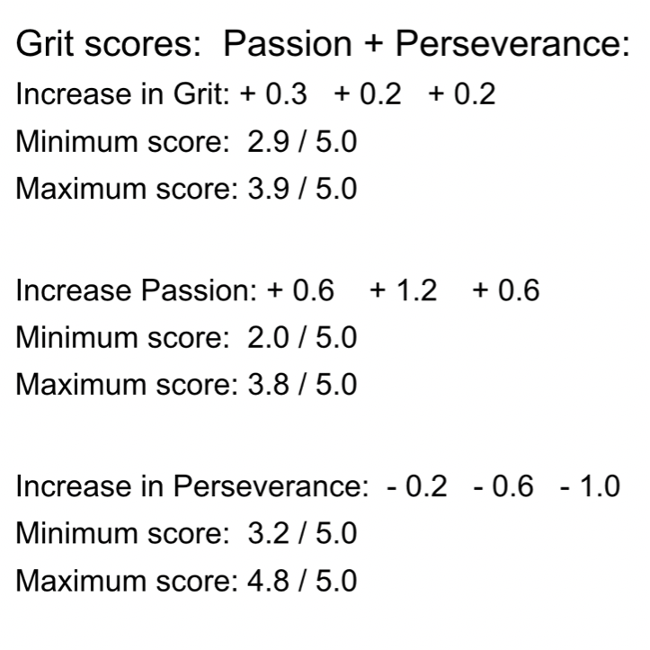
Table 2: Results of Grit Test.
The decrease of grit perseverance was consistent in all participants. However, overall levels of grit perseverance remained higher than levels of grit passion. Further study will be required to understand how effective the orienteering exercises are for procuring grit. Furthermore, the length of study was possibly inadequate, although verbal feedback indicated that the participants were keen to continue organising the event after the study.
From the facilitators point of view, and as a co-learner, I was able to reflect during, immediately after and prior to the next session taking place, one week later. "Reflection is an active, persistent and careful consideration of any belief or supposed form of knowledge in the light of the grounds that support it, and further conclusions to which it leads" (Dewey, 1933, p.118).
On reflection, the use of orienteering-based activities allowed for two theories with certain nuances, to work in synchronisation to procure grit. I was able to observe the reactions and expressions of the participants during various elements of facilitation, in particular relative to levels of motivation and perseverance.
During the pre-session briefing the purpose of the roles of the participants was explained. This was a discussion beyond the questions of ethics, and related to the phenomenon - the idea of an event with multiple themes being created by themselves and with co-learning styled input from myself.
"There is, I think, no point in the philosophy of progressive education which is sounder than its emphasis upon the importance of the participation of the learner in the formation of the purposes which direct his activities in the learning process." (Dewey, 1938/2015).
As a co-learner, passing on the formation of ideas to the 'learner' was difficult, with a certain expectancy of the 'norm', and for information to be dealt out rather than sought. This may relate to a lack of conscientiousness, a forerunner in the field of gritty people, highlights the need for grit procurement in the first place to access grit traits in the long-term.
The motivational video was used for this purpose and was successful in promoting enthusiasm for the orienteering activities, as well as discussion on 'film-making' possibilities. One of the teenagers asked to watch it a second time at the end of the session.
During the main session the students became involved in the various activities at varying degrees of intensity and interest. For example, the navigation exercises motivated the mathematician in the group (cognitive development), whereas the obstacle course enthused the footballer in the group (physical or psychomotor development). When invited to role model what they had learnt to a younger audience, they teenagers were hesitant to engage in eye-to-eye contact but were able to demonstrate their skills and share their knowledge with enthusiasm.
Setting out the navigation activity was perhaps the most problematic challenge to solve for the teenagers, and although the mathematician lead the group, there was also some collaboration and interest from the other two participants.
The areas of the activities that related to the five areas of neglect within Dewey's theory and that reached out to the deeper and more subtle meanings of experience were more problematic for myself, the facilitator. They related to the activities surrounding event organisation which they had not previously experienced and which called for 'problem-solving curiosity', 'resilience' and 'reflective thinking' to find answers on how to progress. This underpins Ord's and Leather's call for the re-instatement of Dewey's original theory of experiential learning and the need for deeper reflection.
Orienteering provides opportunities for reflection, before, during and after an activity. Navigation, reflection on route-choice and the story of the journey provided significant opportunities for mindful reflection and progressive learning. The use of orienteering-based activities to procure grit in this study has been useful for myself, as a facilitator, in understanding how the deeper and more subtle meanings of experience can be reached. The present exercise has also been useful in helping me reflect on my own facilitation, so I can mindfully progress with how I facilitate learning opportunities in the future.

Conclusion
Teenagers today are the decision-makers of tomorrow. In the age of precarity, Kirk calls for pedagogies of affect so that todays children are more able to cope with the uncertainties of tomorrow. Grit, if procured through effective outdoor experiential learning experiences, is likely to help young people be more successful and enjoy mental well-being. Outdoor experiential opportunities do not reach all demographic groups and so for those lacking in associated grit, they maybe hindered, possibly resulting in negative impact on their well-being. New ways of facilitating learning maybe a challenge for teachers, parents and adolescents in any scenario, and I surmised, in acknowledgement of the age of digitalisation and social-media influence, that innovative ways to motivate adolescents into new environments would be needed for this study.
The theories of grit and experiential learning were used to steer this study, underpinned by a paradigm of constructivism. Grit was used as a predictor of academic and professional success and effective learning opportunities as a predictor of happiness in response to the academic success reached through grit. This non-robust study showed that levels overall levels of passion rose during the study, whilst levels of perseverance fell. Further study is warranted in light of the robust research that associates grit with academic success and happiness.

4,716 words

REFERENCES

Alibrando,S. (2017) Grit or Emotional Intelligence: The Winner Is? Available at: http://power-heart-mindfulness.com/grit-or-emotional-intelligence-the-winner-is/ (Accessed: 14 January, 2020).

Dewey, J. (1916), (2007 edition) Democracy and Education. Teddington: echo Library.

Dewey, J. (1933) How We Think, New York: D. C. Heath.

Dewey, J. (1938), (2015 edition) Experience and Education. New York, N.Y.: Touchstone.
Duckworth, A. (2013) Grit: The power of passion and perseverance [video]. Available at: https://www.youtube.com/watch?v=H14bBuluwB8 (Accessed 4th February, 2020).
Duckworth, A.L., Peterson, C., Matthews, M.D., Kelly, D.R., (2007) Grit: Perseverance and passion for long-term goals. Journal of Personality and Social Psychology, 92, pp.1087–1101. DOI:10.1037/0022-3514.92.6.1087

Duckworth, A.L. (2020) Isn't it more important to the happy than successful? Available at: https://angeladuckworth.com/qa/ (Accessed: 4 February, 2020).

Dynamic Vision, (2012) Forest Jump (A Short Freerunning/Orienteering Film)[video]. Available at: https:// www.youtube.com/watch?v=c-_3rH0oOh8 (Accessed: 4 February, 2020).
Gardner, H., n.d. (2020) The Official Authoritative Site of Multiple Intelligences. [WWW Document]. MI OASIS. URL https://www.multipleintelligencesoasis.org/the-components-of-mi (Accessed 4th February, 2020).
Grande, T. (2018) What are Emotions, Feelings, Affect and Mood [video]. Available at: https://www.youtube.com/watch?v=55_-YsfSPK0 (Accessed: 4 February, 2020).
Hargreaves, D. (2018) Minds matter: Time to take action on children and young people's mental health. Available at: https://www.nuffieldtrust.org.uk/news-item/minds-matter-time-to- take-action-on-children-and-young-people-s-mental-health (Accessed: 14 January, 2020)
Hebert, G., (2009). Practical Guide of Physical Education 1912. Available at: http://stuff.maxolson.com/Practical-Guide-of-Physical-Education-1912.pdf (Accessed 14 January, 2020).
Jones, C., (2019). Fit for Future Education in Wales. Available at: https://futuregenerations.wales/resources_posts/education-fit-for-the-future-in-wales-report/ (Accessed 4 February, 2020).
Khan, B. Khan, A., (2017). Grit, happiness and life satisfaction among professionals: a correlational study. Institute of Science and Technology, Karachi, Pakistan 2Kings County Hospital Center, New York, USA. Journal of Psychological Cognitiion 2, 123–132.
Kirk, D., 2018. 'Precarity and physical education', Revista de ALESDE, vol 9, no.1, pp. 15–28. https://doi.org/10.5380/jlasss.v9i1.60800
Kolb, D., (1984) Experiential Learning, Experience as the Source of Learning and Development, englewood Cliffs, NJ: Prentice Hall.
Miettinen, R., (2000). The concept of experiential learning and John Dewey’s theory of reflective thought and action. International Journal of Lifelong Education 19, 54–72. DOI.org/10.1080/026013700293458

Ord, J., Leather, M., (2011) The Substance Beneath the Labels of Experiential Learning: The Importance of John Dewey for Outdoor Educators. Australian Journal of Outdoor Education 15, 13–23.N.d.

Organization, W.H., (2004) Promoting Mental Health. World Health Organisation, Geneva.

Perlis, M., (2013) 5 Characteristics Of Grit -- How Many Do You Have? Forbes
Psychology Today (2020) Psychology Today. Available at: https://www.psychologytoday.com/gb/basics/emotional-intelligence (Accessed 4th February, 2020).
Singh, K., Duggal, S., (2008) Positive and Negative Affect, and Grit as predictors of Happiness and Life Satisfaction. JIAAP, Special Issue 34, 40–45.
United Nations (2019) Sustainable Development Goals. Available at: https://sustainabledevelopment.un.org/sdg3 (Accessed 4 February, 2020).

APPENDICES

AppendixA: Parental Consent Form...................................................21
Appendix B: Ethics Form...................................................................26
Appendix C: Grit Test ........................................................................27
Appendix D: Lesson Plan ..................................................................28

APPENDIX A

Michaela da Cunha UWTSD
Research Project : SHOE7002
ParcoursO 'O' Club: Measuring 'Free-will'. Training & Research Project November - December 2019
[Informed Consent Form for __________________
Training Group: Females aged 7 to 12 Participants Female & Males 13+ Volunteers
Name of Principle Investigator: Michaela da Cunha
UWTSD
'Measuring Grit Procurement in children aged 12+'

This Informed Consent Form has two parts:
• Information Sheet - to share information about the study with you.
- Certificate of Consent - for signatures if you agree that your child may participate. You will be given a copy of the full Informed Consent Form

Part I: Information Sheet
Introduction
I am Michaela (Kyla) and I presently study the pedagogy of outdoor education at the University of Wales, Trinidad St. David. I am doing some research to help children become more driven by their 'Free-will'. In the research I'll be asking the children to answer a simple questionnaire that has been ethically modified to ensure they do not feel judged. A copy of the questionnaire will be attached and we ask that we can have your permission, and that of your child, to answer the questions. Both of you have to agree independently, before I can begin. If there is anything you do not understand, please ask me, now, during or after the research is complete.

Purpose
The purpose of the study is to measure levels of 'grit', referred to as 'free-will', in participants before and after Orienteering-based activities. During the training, methods to encourage self-empowered 'free-will' will be used.
During the study each participant will receive attention to assess their preferred methods of communication to maximise 'free-will'. Likewise, the influence of rapid societal change and screen-use on children will be addressed and the robustness of Lovelock's 'Theory of Gaia' relative to the recovery-elastic resilience discussed by Fleming (2010). These authors, amongst others, will be visited to address the perceived barriers and barriers to 'Free Will'.
This study is relevant to understanding the significance of genuine out-of-school linked activities to levels of 'free-will' in children, when participating in extra-curricular activities in school. This in turn, implicates the long-term well-being of children measured by the United Nations Sustainable Development Goal 3.

Type of Research Intervention
Briefly state the intervention. This will be expanded upon in the procedures section. A questionnaire will be used in the first and last session of the study to quantify changes in the levels of 'free-will' amongst participants. Some changes to the questionnaire may compromise its validity, however, for this age group the questions have been ethically considered.
Selection of Participants Although initially intended to open this research to both boys and girls between the ages of seven and eleven, I decided to focus this study on teenagers who are also participating in volunteer work for their Duke of Edinburgh Award.

Voluntary Participation
You do not have to agree that your daughter answers the questionnaire. You can say no and any training will continue without inclusion in the research project. Please ask as many questions as you like.

Procedure
The questionnaire will be taken at the beginning of the session on the 4th November. It will then be repeated at the end of the session on the 11th November. On the 11th November, prior to the questionnaire being filled in, the children will also be given information about the event being held on the 8th December, 2019 at Kings Wood, Monmouth. At this point the children will feel confident that they have learnt the skills needed to attend such an event, when fully explained using a video clip to help them build up a visual picture of what to expect.
The volunteer teenagers will be building up their own skills in parallel to organise an event in 2020. They will also be role-modelling, a procedure we use to help children improve on their own skills through self-will.
If your child does not wish to answer some of the questions in eluded in the questionnaire, they may skip them and move on to the next question. The information recorded is confidential and no one else will have access to the questionnaire, which will be destroyed after the experiment.

Benefits
There maybe immediate and direct benefits to your child through this research, but either way, your child's participation is like to help us find out more about how we can improve participation in physical activity and outdoor education.

Confidentiality
We will not be discussing or sharing any information about your child outside of the research team. The information we collect from this research project will be kept confidential. Information about your child will be put away and only myself will be able to see it. The data may collectively be viewed, without identification of individuals, to the UWTSD, my tutor and my fellow students.
We cannot guarantee complete confidentiality of information that your child shares with us in a group discussion or with friends outside the research group, however, we will ask children not to share information outside the group.

Sharing of Research Findings
At the end of the study, we will share be sharing what we have learnt with the participants and with the community. We will do this by meeting first with the participants and then with the larger community. Nothing that your child will tell us in the questionnaire will be shared outside the research team and nothing will be attributed to her by name. A written report will also be given to the participants which they can share with their families. We will also be presenting our results to other university students on the MA Outdoor Education course. A further report will be available to the tutor of this course.

Right to refuse or withdraw
At any time, your child can withdraw from or ask to be excluded from the research project which will not in any way impact their ability to participate in any of the training sessions.

Who to Contact
This research project has been approved by the UWTSD (Prof. Graham Harvey), whom you can contact directly on: 01267 225122 Email: gharvey@uwtsd.ac.uk

PART II: Certificate of Consent Certificate of Consent

I have read the foregoing information, or it has been read to me. I have had the opportunity to ask questions about it
and any questions that I have asked have been answered to my satisfaction. I consent
voluntarily for my child to participate as a participant in this study.
Print Name of Parent or Guardian ___________________________________
Signature of Parent of Guardian_____________________________________
Date ___________________________ Day/month/year___________________
Statement by the researcher/person taking consent
I confirm that the parent was given an opportunity to ask questions about the study, and all the questions asked by him/her have been answered correctly and to the best of my ability. I confirm that the individual has not been coerced into giving consent, and the consent has been given freely and voluntarily.

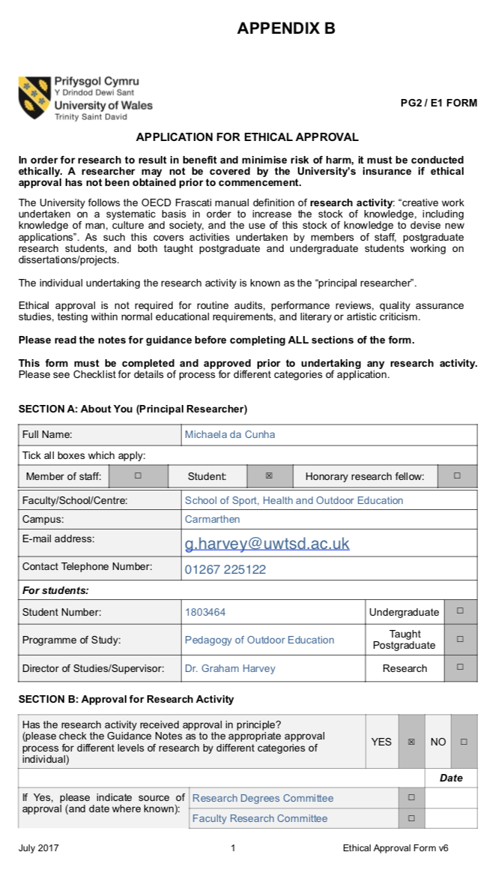

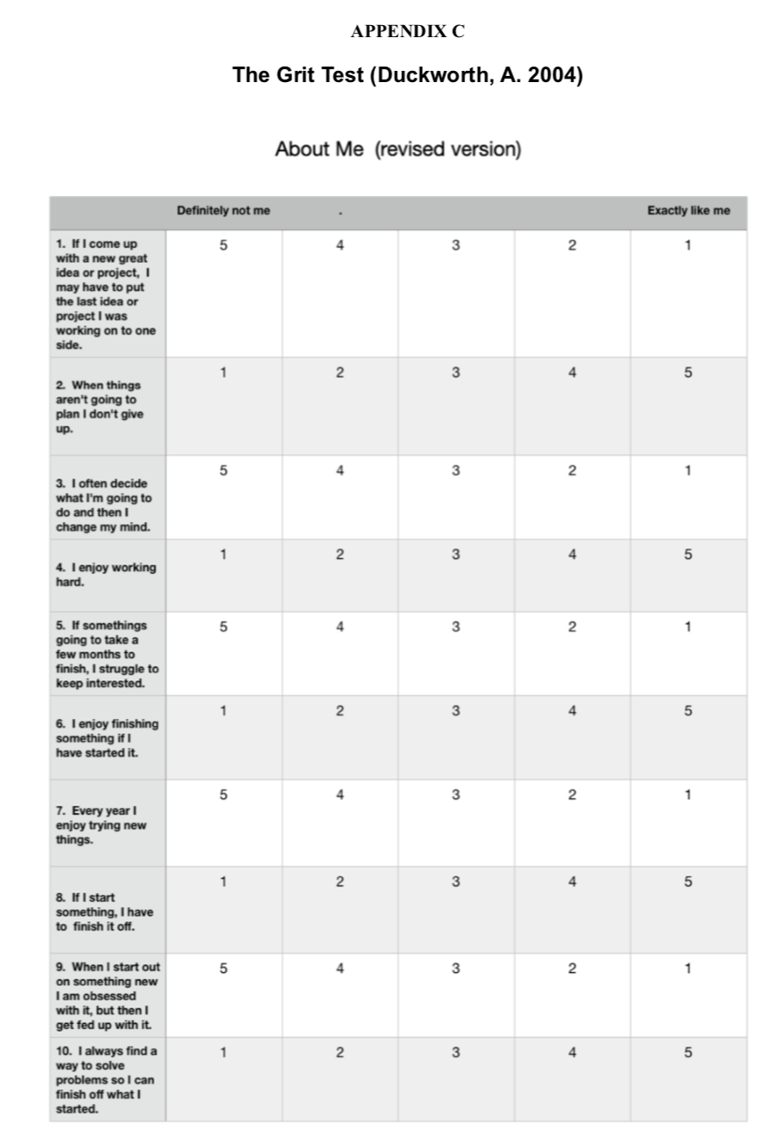

APPENDIX D

Lesson Plans & Progressions for Teenagers and Grit Procurement
Plans used beyond the study programme.

FACILITATOR: Collaborative and Co-learning Progressions based on Deweys Reflective Cycle.

 | Pre-session Planning | Pre-session briefing | Main session | Post session
Identify a problem | Based on my knowledge & skills. | Co-learning facilitation | Co-learning facilitation | Co-learning facilitation
Define the problem | Grit procurement | Unfamiliar style of facilitation | Unfamiliar style of facilitation | Motivation & post-school day fatigue. Familiarisation much improved. Practice required.
Examine the conditions and form ideas | Research & development | Re-affirm idea with group | Expected role of 'learner' played out. Distance myself form project | School grounds - maybe not as inspiring as local woodland would be
Scrutinise the ideas | Establish flow | Consider other approaches to introduce co-learning | Varying responses to understanding of and confidence to be autonomous | Access to woodland. Permissions. All easily surmountable.
Put ideas into action | At pre-session briefing | Pro-active in asking learners for ideas | Opportunity to build up habit and routine | Training at Aconbury Park Woods.
Solutions & new ideas | Reflect on actions to progress | Reflect on actions to progress | Reflect on actions to progress | Significant change in levels of motivation. Address co-learning ideas in new environment.

BLOCK DATE | BLOCK | SHORT AND LONG-TERM GOALS | NOT YET | CONFIDENT
 |  | Develop my reason to support a phenomenon.
 |  | Connect with peer group interested in phenomenon and clarify short, medium or long-term goals.
 |  | Understand overall skills required to achieve goals.
 |  | Reflect on my own skills & weaknesses to understand how I can confidently contribute within group.
 |  | Reflect on the new skills & knowledge I would like to develop for personal growth and understanding.
LEARNER: PROGRESSION TEMPLATE: Phenomenon-based Learning.

LEARNER PROGRESSION SHEET: Orienteering Event Organisation.
BLOCK DATE | BLOCK | SHORT AND LONG-TERM GOALS | NOT YET | CONFIDENT
 |  | Develop my own reasons for being part of a community Orienteering event (the phenomenon).
 |  | Understand who else wants to be involved and what needs to be done. Set short, medium and/or long-term goals.
 |  | Understand skills required to achieve goals.
 |  | Reflect on my strengths and weaknesses.
 |  | Reflect on the skills I would like to develop.

Dewey's thoughts on the interaction between experience, reflection, contemplation and experimentation do not sit well within contemporary society where simplistic order, as expressed in Kolb's experiential learning cycle, is maybe perceived to be more easily managed by teachers, parents, leaders and facilitators. In reality, a routine or habitual walk in the mountains is not complex for a group, once procedures that can be replicated, have been established. Dewey would argue that the reflections from the walk will impact decision-making in the future. This means the past experiences of the teenagers in this study, may impact their grit procurement potential in the present, affecting their personal success and happiness in the future.

REFLECTIVE PRACTICE: Individual & group collaboration. Based on Deweys Reflective Cycle.
'GROUP THINK TANK'  (The place to go to tackle those bigger obstacles) | DEWEYS 5-STAGES OF REFLECTION IN PRACTICE | NOT YET | COMPLETED
Have you a problem on your mind that you want to solve? | 1
Can you make sense of what is going on? | 2
Can you work out the cause of it? | 3
Can you come up with creative ideas to solve the problem? | 3
Can you discuss your idea/s to the group and why they work? | 4
Give it a go and see what happens. | 5
Does your new idea work?
What next? |  | Go to 1 or 2 or 3 or 4 | Record it and decide how to progress next.

BLOCK SESSIONS: Knowledge and skills-building opportunities: Developing opportunities for multiple-intelligences (Gardner, 2020).
BLOCKS  (6 WEEKS) | 1 | 2 | 3 | 4 | 5 | 6
FILM-MAKING | 
LEGALS HEALTH & SAFETY
SOCIAL MEDIA & MARKETING
MAP MAKING & CREATIVE ART
NAVIGATION
CONSERVATION

The teenagers choose which topics will be covered in each six week block. Outside professionals are invited to share their knowledge and skills with them to help the young people find their specific areas of interest that they may continue to develop afterwards.

