MANAGEMENT AND ORGANISATIONAL BEHAVIOUR
Name of the Student: Ana Maria Ndreka
Lecturer Name: Dale Clarke
Student ID: 2118393
Executive Summary
This report was focused on the Hilton Hotel Group. This chain of hotels has been one of the very famous or well-known in the US. It tends to manage a wide range of hotels and resorts under them. This hotel was founded by someone named Conrad Hilton in the early 1900s. The headquarters of the Hilton Hotel Group is in Tyson, Virginia, United States of America. It has hotels and resorts in about 118 countries all over the world. There are about 983,465 rooms in these hotels. Hilton Hotel Group has 18 brands across various segments of the market.
Contents
Introduction 4
Organisational Structure 5
Organisational Culture 5
Organisational Theories 5
Organisational Goals 6
Change initiatives and its impact 7
Strategic Direction 8
Business Performance 9
Conclusion 9
References 11

Introduction
The Hilton Hotel group is one of the most popular hotel chains in America. It is one of the most well-known hotels to ever exist in Europe. It works as a global brand with its worldwide resorts and hotels along with others like Conrad Hotels and Resorts. They have tourists from all over the world coming to their hotels to stay while on their visit or tour of the respective country. They have quality customer service that helps satisfy their customers depending on their interests, tastes, and preferences. They cater to all the needs of the customers and make sure that they are entirely satisfied. There are diverse options that Hilton Group provides to their customers. The Hilton group is a chain of hotels that are luxury renowned and provide excellent service. They consist of unique styles and maintain the commitment of the brand as well. This report will focus on the Hilton Hotel Group along with the structure of the company, the culture that it follows, and the goals set. Recent initiatives of change will be discussed, their impact and how they were managed. Lastly, the company's strategic direction and performance of the business.
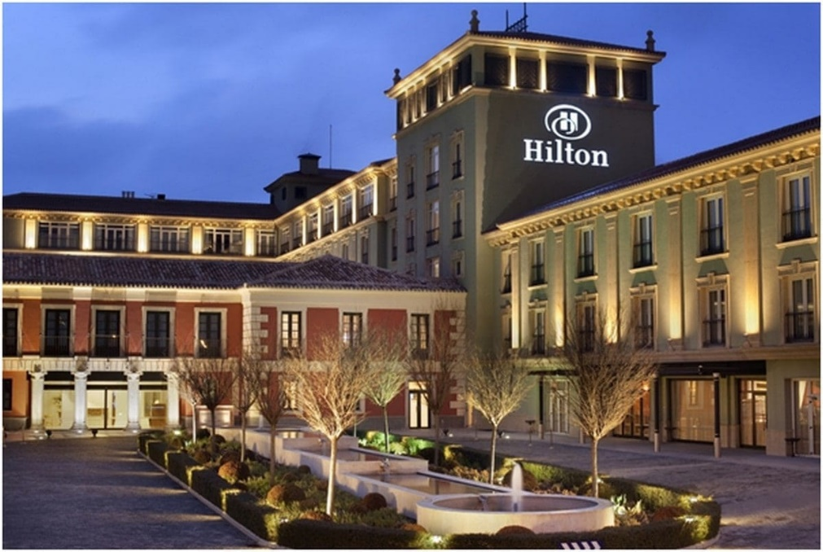
Figure 1: Hilton Hotels
(Source: Hilton, 2023)

Organisational Structure
The structure of the organisation of Hilton Hotel Group is quite large as one might assume but it also follows the same structure as the others do. The whole company has been divided into departments (Cedillos et al., 2020). First stands the general department where all the operations are taking place, and the general manager tends to look over their tasks. Then comes the front office which takes care of the services that guests may ask for or resolves any questions that the customers may have. It deals with the rooms, check-ins and outs and other things as well. The department of housekeeping manages all the maintenance of the rooms, these are the people that work very hard throughout the day. Food and beverages are the department that provides the tourists with all the food and beverages that they want. Then the marketing and sales department handles the promotion of the company as well as the tickets of the company. The finance department tends to manage the financial accounts of the company along with the budget and other funds (George and Wooden, 2023). Lastly, the human resource management department that deals with the employees working under the management. It deals with training, educating and empowering the employees to do their best.
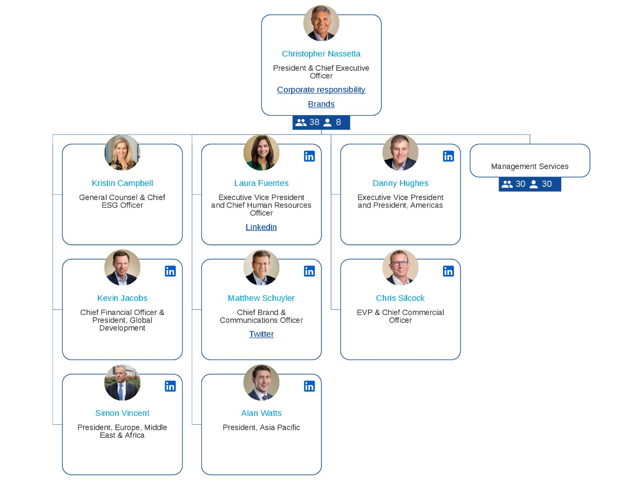
Figure 2: Organisational structure
(Source: Hilton, 2023)

Organisational Culture
The main culture that the Hilton Hotel Group exudes is the culture of commitment to excellence, customer-oriented services, and innovation at its highest. They tend to keep their core values a priority. They value teamwork as one of the most important things, leadership follows second and then integrity. This company is focused on the development and growth of the employees as they are to make sure that the standard of the company has been maintained with exceptional service. They prove to be one of the most diverse companies to ever exist in the US. They have created an environment for their employees that is safe and has made their security and health a primary focus (Clemente-Almendros et al., 2019). They tend to respect the values and ethics of each background and encourage them to give opinions and thoughts regarding each situation. They dedicate their work to gain sustainability and responsibility towards their duties towards their environment. They have created experiences that are unique and will be something to remember in the future. They have set high expectations for potential customers with the quality they provide their existing customers. They keep outdoing themselves and are higher than other companies.

Organisational Theories
Just like any other theories, Hilton Hotel Group also incorporates theories like Human relations theory, Contingency theory, and others as well. Hilton tends to implement the classical theory that suggests that there is a clear structure of hierarchy present within the company. It shows the clear responsibilities and roles of the people in the company so that no one is confused with the processes and operations. The next theory that Hilton Hotel Group has implemented is the human relations theory which has recognised the great importance of the motivation and satisfaction of the employees in the company. This theory has been applied for the enhancement of relationships in the company and the productivity of the employees as well (Fatoki, 2019). The contingency theory has been implemented by the Hilton hotel group as it tends to suggest that there needs to be an adaptation to the management style and structure as well depending upon the factors that lie externally. These conditions may be differences in culture and conditions of the market. Lastly, the systems theory suggests that hotels, especially Hilton, use systems to make operations happen. The overall performance of the company has been optimised to ensure that everything works systematically.

Organisational Goals
The basic goal that they would like to achieve is one in which they want to provide their customers with exceptional services. They want to have a strong presence in the market and ensure that there is growth in sustainability. They want to focus on achieving great customer satisfaction to build customer loyalty with amazing reviews so that others visit them as well. They want to expand their business more than what they already have (Hilton, 2023). Taking in partnerships has a strategy and new developments in the property. Taking advantage of and making use of the advancements made in technology to make or innovate answers to questions helps customers have better experiences. They have invested a lot in the development and training of the employees so that they can do better and perform better. They have been implementing sustainable practices to help reduce any harm coming upon the environment in any way. This will also help them to gain the kind of social responsibility that they want. The goals are like any other goals that organisations have as well. Along with all this, they want their financial reports to be consistent.

Change initiatives and its impact
The initiatives of the Hilton hotel group depend on certain aspects of the company. Hilton hotel group tends to focus on areas like management, technology, and sustainability. It is like an enhancement for the customer experience. To enhance these experiences, companies must implement a reservation system that is advanced or adopt eco-friendly practices (Lam et al., 2021). Giving their customers the best experiences, they have ever had is their focus.
Impact: There is a great impact of the changes that are to be taking place. Upgrades in technology help to streamline the operations to improve the services provided to the customers and to increase the efficiency of the company. There will also be initiatives of sustainability taken which will not only reduce or decrease the impact of the environment. It also has set into alignment with the customer interests and preferences that are always changing and evolving with time (Santana et al., 2020). These preferences are always changing, especially with the time. The trends and patterns are always changing so the company must keep up with them. All data that is collected helps them to make changes if need be. Once the changes are made, they also must be managed.
Management: With the initiatives taken for change, there is also change management that is to be effective. To do this, a proper communication plan must be created, as well as to have proper engagement with the employees. This tends to occur through programs of training that educate employees on change and its importance. This makes sure that the management will be able to adapt to any changes that have been made with the help of the new technologies to go through the procedures and processes in a smoother way (Lăzăroiu et al., 2020). There were strategies of communication to be created to inform the employees and the customers regarding the changes that are to be made. The expectations that the customers have are to be managed to make sure that there is a positive transition or not. There needs to be mechanisms to provide feedback to the company from the customers so that they know what needs to be improved or if changes are to be made. This also must be monitored continuously so that the impacts are assessed. Adjustments are to be made and must be aligned with the changes that are to be made.

Strategic Direction
More traditionally, the Hilton Hotel Group has focused on expansion in an international way, innovation in the most technological way and sustainability within the company as well. There has been a way to adapt to the various trends and patterns of the industry according to the preferences and interests of the customers and the people that they cater to. They aim to embrace all kinds of technology and digital means that will help them enhance their operations and grow accordingly. They have also aimed to implement eco-friendly approaches or practices that mostly appeal to travellers who have been visiting for a purpose. They are trying their best to get deep within the global markets and expand their horizons. They are trying to capture diverse customers who come from all sorts of backgrounds. Due to COVID-19 and other natural disasters, they have started to focus more on the protocols and procedures they take to ensure that the travellers are taken care of and are also kept safe (Gomes et al., 2021). Hilton has a very unique identity which is comparatively different from the other companies. This is the reason why people prefer Hilton over the others as well.

Business Performance
Hilton Hotel Group's business performance has had an integration of solutions that are innovative and advanced technologies. This helps them to work together to get an increased working business but of lesser costs, as costs are to be decreased. Here, quality will not be compromised even though the costs are reduced considerably (Peccei and Van De Voorde, 2019). The services tend to provide some sort of access to the tools that are the latest and advanced with forward-thinking strategies. There are more than 600 sales professionals in the sectors all around the world and operators that can be sure that the property has gotten plenty of benefits. The sales team has been engaged with creating a platform that is providing a selling that is differentiated for their brand portfolios. They are more focused on being recognised as one of the best hotels globally known. Business Performance Management is a very significant aspect of the industry. There are strategic goals created by the company by the objectives and indicators of key performance that are quite meaningful to the Hilton hotel group. The main value of the Hilton hotel group tends to follow a corporate identity of culture. According to the reports of September 2023, the sales and revenue were about 2.6B which was more than 12% than the previous year.

Conclusion
To conclude, this has been a report which was focused on the Hilton Hotel Group, along with the structure of the organisation, culture of the organisation and goals of the organisation. There was also a discussion on the change initiatives that Hilton has made over the years along with its impact and how it was managed. Lastly, the strategic decision of the organisation was analysed as well as the current performance of the business. Organisations tend to operate with the help of different structures that also consist of various merits and demerits. Changes are very regular, and if changes are made in an environment there must be changes made in companies in that environment as well. Different cultures belonging to this company have had completely different reactions to the changes that they were about to make but they also understood why the changes had to be made. The change also must be promoted and for that, the employees within the organisation must understand it.

References
Cedillos, C., Maellaro, R. and Wysong, S., (2020). To sell or not to sell: the impact of managers' sales experience on organisational financial performance. International Journal of Revenue Management, 11(4), pp.316-330.
Fatoki, O., (2019). Hotel employees’ pro-environmental behaviour: Effect of leadership behaviour, institutional support, and workplace spirituality. Sustainability, 11(15), p.4135.
George, B. and Wooden, O., (2023). Managing the strategic transformation of higher education through artificial intelligence. Administrative Sciences, 13(9), p.196.
Gomes, D.R., Lourenço, P. and Ribeiro, N., (2021). When Covid-19 is the invader and internal communication is the hero: Understanding the influence of internal communication on individual performance and evaluating the mediating role of perceived support. Administrative Sciences, 11(4), p.136.
Hilton, (2023). Hilton Brands Global Hospitality Company. Hilton Brands | Global Hospitality Company (Accessed: 13/11/2023).
Lam, L., Nguyen, P., Le, N. and Tran, K., (2021). The relation among organizational culture, knowledge management, and innovation capability: Its implication for open innovation. Journal of Open Innovation: Technology, Market, and Complexity, 7(1), p.66.
Lăzăroiu, G., Ionescu, L., Andronie, M. and Dijmărescu, I., (2020). Sustainability management and performance in the urban corporate economy: a systematic literature review. Sustainability, 12(18), p.7705.
Peccei, R. and Van De Voorde, K., (2019). Human resource management–well‐being–performance research revisited: Past, present, and future. Human resource management journal, 29(4), pp.539-563.
Santana, M., Morales-Sánchez, R. and Pasamar, S., (2020). Mapping the link between corporate social responsibility (CSR) and human resource management (HRM): how is this relationship measured? Sustainability, 12(4), p.1678.
Seguí-Amortegui, L., Clemente-Almendros, J.A., Medina, R. and Grueso Gala, M., (2019). Sustainability and competitiveness in the tourism industry and tourist destinations: A bibliometric study. Sustainability, 11(22), p.6351.

