Classroom management is not just about rules or maintaining order; it is about creating an environment where children feel safe, secure, and ready to learn. Many pupils struggle to recognise and regulate their emotions, which can lead to frustration, anxiety, or challenging behaviour in the classroom. The Calm Corner, also known as the Emotion Regulation Toolkit, provides a dedicated and structured space where children can calm down, reflect on their feelings, and practise strategies to manage emotions positively. By providing pupils with a safe space to self-regulate, the Calm Corner supports emotional growth and prevents situations from escalating into conflict or disruption.
The resource draws upon key psychological theories, including Maslow’s Hierarchy of Needs, Vygotsky’s Socio-Cultural Theory, and Skinner’s Operant Conditioning, linking theory directly to practice. It helps children meet their basic and emotional needs, learn through guided support, and receive positive reinforcement for managing their emotions effectively. Tools such as emotion charts, breathing exercises, reflection sheets, mindfulness videos, and digital apps accommodate a variety of learning styles and individual needs, ensuring every child has access to strategies that work best for them.
Importantly, the Calm Corner also benefits teachers, helping to reduce classroom disruptions and providing a proactive, supportive approach to behaviour management. It fosters a calm, inclusive, and respectful classroom climate where emotional competence, empathy, and positive relationships can flourish. By aligning with whole-school wellbeing strategies, such as the Welsh Government’s Whole School Approach to Emotional and Mental Well-being (2021), the Calm Corner contributes to both individual development and the wider school culture, ensuring that all pupils feel valued, understood, and equipped to achieve their full potential.
Good classroom management helps children feel calm, safe, and ready to learn. Some pupils find it hard to manage their emotions, which can cause frustration or upset in class. A Calm Corner, also called an Emotion Regulation Toolkit, is a quiet space in the classroom where pupils can go to calm down and manage their feelings.
Unlike traditional reactive strategies that address behaviour after it happens, the Calm Corner is proactive, helping pupils prevent escalation and build self-regulation skills.
This resource helps children understand their emotions and learn how to manage them positively. It also supports teachers by reducing disruptions and creating a peaceful, inclusive classroom where everyone feels respected and supported.
Rather than focusing on rules and punishment, this approach builds emotional competence and promotes inclusion and well-being.

Resource Description
The Calm Corner is a quiet space in the classroom where children can go when they feel upset, angry, or worried. It helps them calm down and get ready to learn again.
The Calm Corner includes:
- Feelings posters or charts – to help children name how they feel.

- Emotion cards – pictures and words like happy, sad, angry, worried, or excited. See in Appendix A
- Breathing cards – simple steps such as “smell the flower, blow the candle” to help them relax.
- Calm-down tools – stress balls, fidget toys, glitter jars, or soft toys.
- Reflection sheets – to draw or write about their feelings and what they can do next time.
- Mindfulness videos – short, calming videos from apps or YouTube.
- Timer – for short 5-minute calm breaks.
- Rules poster – showing how to use the Calm Corner safely and sensibly.
Offering a variety of tools accommodates different learning styles, contrasting with one-size-fits-all behaviour management strategies.
Any child in the class can use the Calm Corner when they need a short break to calm down. It can be used alone, in a small group, or by the whole class as part of a wellbeing activity.
Its flexibility and autonomy differ from fixed interventions, allowing children to self-regulate in multiple contexts.
Helping children manage their emotions is very important for a calm and positive classroom. When pupils understand their feelings and know ways to calm down, they behave better and can focus on learning.
The Calm Corner helps in several ways:
- Supports good behaviour – pupils learn strategies to calm themselves instead of acting out.
- Inclusive for all learners – especially helpful for children with Autism, ADHD, or social and emotional difficulties.
- Helps teachers – fewer disruptions mean teachers can focus on teaching and respond calmly to behaviour.
- Promotes whole-school wellbeing – fits with the Welsh Government’s Whole School Approach to Emotional and Mental Well-being (2021).
Unlike general classroom strategies that may overlook emotional development, the Calm Corner actively promotes inclusion, emotional competence, and alignment with wellbeing guidance.

Welsh Government Whole School Approach to Well-being (2021) This guidance helps schools create a positive emotional and social environment. It focuses on three values: belonging, efficacy, and voice. Schools, PRUs, and partners like the NHS work together to support pupils, review well-being provision, and ensure fair and consistent approaches for all children (Gov.Wales, 2021).
Using the Calm Corner helps pupils feel in control of their emotions, develop emotional skills, and contribute to a respectful and caring classroom.

Maslow’s Needs & the Calm Corner. Maslow: Children must have basic and emotional needs met to learn and grow.
Calm Corner Supports Each Need:
- Physiological: Rest, water, comfort (cushions, quiet space)
- Safety: Predictable, secure space to manage emotions
- Love & Belonging: Connect with peers, feel included
- Esteem: Reflect, self-regulate, celebrate achievements
- Self-Actualisation: Creative activities, self-expression, curiosity
The benefits are that it supports emotional regulation and independence, prepares children to learn and boosts confidence, creativity, and well-being.
Stocking the Calm Corner with tools for comfort, reflection, and creativity to meet children’s needs (Brodie, 2025).
It supports all levels of Maslow’s hierarchy, contrasting with interventions that focus solely on behaviour or academics, ensuring holistic development.
The Calm Corner links to Vygotsky’s Socio-Cultural Theory (1978).
Vygotsky stated that children learn best with help from adults or peers before doing things on their own. This is called scaffolding.
In the Calm Corner, adults help children understand and manage their emotions. Over time, children learn to calm themselves without support. This helps them build emotional independence and self-control. Learning and development occur through social interaction and guided participation (Daniels, et al., 2007).
Emphasises social learning, contrasting with purely independent strategies. Guided support helps children develop emotional self-regulation.
The Calm Corner supports positive reinforcement, a key idea in Skinner’s Operant Conditioning theory (1953). When children use calming strategies or manage their emotions effectively, praising or rewarding this behaviour helps them repeat it in the future.
By acknowledging calm, self-managed behaviour — for example, saying “Well done for using the Calm Corner to calm down” — educators strengthen positive responses to stress and frustration. Rewarding calm, self-managed behaviour reinforces positive responses to stress and frustration.
This approach helps children learn that managing emotions brings positive outcomes, building long-term emotional regulation and resilience (Banyard & Grayson, 2008).

Reinforcement promotes long-term resilience and self-regulation, contrasting with punitive behaviour management.
Instructions for Use
Set-up:
- Choose a quiet corner or small area with comfortable seating (e.g., beanbag, rug, small desk, plants) (System, 2025).
- Display visual resources such as emotion charts and calming strategies. This interactive visual tool helps children develop emotional awareness and learn calming strategies that support self-regulation, resilience, and overall well-being (Box, 2025).
- Store calming tools neatly in labelled boxes or baskets, so it is easy to find when in need (Tales, 2025).
How to Use:
- Explain to the class that the Calm Corner is a safe, positive space where they can go to relax and manage their emotions — not a place for punishment (Star, 2025).
- Model how to use it: show pupils how to choose an emotion card, for example, you could ask the child, “Can you show me which face matches how you feel right now?” Use a calm-down tool and fill in a reflection sheet (Baja, 2025).
- Allow pupils to visit the Calm Corner when they recognise they need a break (or when guided by a teacher). Whereas adults can find a noisy, busy classroom overwhelming at times and may need a few minutes of quiet time away to recharge (Careers, 2018).
- Set a timer (3–5 minutes) to ensure the child has time to regulate but still returns to learning (Careers, 2018).
- Once calm, the pupil completes a reflection card or short discussion with the teacher (e.g., “How do you feel now?”) (School, 2025 ).
- Celebrate progress – praise children when they use the Calm Corner effectively and return ready to learn.
ICT Use:
- Use interactive whiteboard visuals for breathing exercises or short mindfulness clips.
- Pupils can access digital resources like the Calm Kids App, which has audio stories that help children relax, manage anxiety, fall asleep peacefully, and improve focus (Kids, 2023). Headspace for Schools, or GoNoodle videos, to support regulation.
- Teachers can record usage patterns digitally (e.g., frequency of visits) to identify triggers or improvements over time.
Structured, theory-based, and technology-enhanced, unlike unstructured or non-digital calming approaches.

The Calm Corner and Emotion Regulation Toolkit help children learn to manage their emotions before problems start.
- Promotes self-regulation: Children learn to calm themselves instead of acting out.
- Reduces conflict: Fewer disruptions mean less need for punishments.
- Builds positive relationships: Encourages trust, empathy, and respect between pupils and teachers.
- Supports children with additional needs: Provides structure and predictability, helping them feel safe and secure.
- Helps teachers: Acts as a practical tool for managing behaviour while supporting learning and wellbeing.
By combining psychological theory, hands-on resources, and digital tools, the Calm Corner links emotional well-being to effective behaviour management and inclusive classrooms.
It links emotional well-being directly to learning and inclusion, contrasting with reactive or purely academic classroom strategies. It fosters a positive cycle of calm, self-regulation, and mutual respect.
The Calm Corner combines psychological theory, hands-on resources, and digital tools to support emotional regulation, resilience, and inclusive classroom practice. It is proactive, flexible, and evidence-informed, promoting calm, engagement, and lifelong emotional skills.
The Calm Corner is a practical, evidence-based resource that goes beyond being just a quiet space—it actively supports emotional regulation, resilience, and inclusive classroom practice. By providing children with a structured area to pause, reflect, and apply coping strategies, it enables them to manage emotions before they escalate, promoting self-regulation and positive behaviour. Unlike reactive behaviour strategies that focus on punishment after incidents, the Calm Corner encourages proactive skill-building, fostering long-term emotional competence and resilience.
By integrating principles from Maslow, Vygotsky, and Skinner, the Calm Corner ensures children’s needs are met at multiple levels: physical comfort, emotional security, social connection, self-esteem, and opportunities for creative self-expression. Guided support and positive reinforcement help children develop independence, understand their emotions, and experience the benefits of calm and regulated behaviour. Its flexibility allows pupils to use the space independently, in small groups, or as part of class activities, making it inclusive for children with additional needs, such as Autism, ADHD, or social and emotional difficulties.
For teachers, the Calm Corner reduces disruptions, enhances classroom management, and strengthens relationships through trust, empathy, and mutual respect. By embedding this resource into everyday classroom practice, schools can create an environment where emotional wellbeing is prioritised alongside academic learning, promoting engagement, inclusion, and holistic development. Ultimately, the Calm Corner equips children with lifelong emotional skills, supports teachers in their practice, and demonstrates how a calm,

proactive, and evidence-informed approach to wellbeing can transform classroom dynamics for the better.

Appendix A
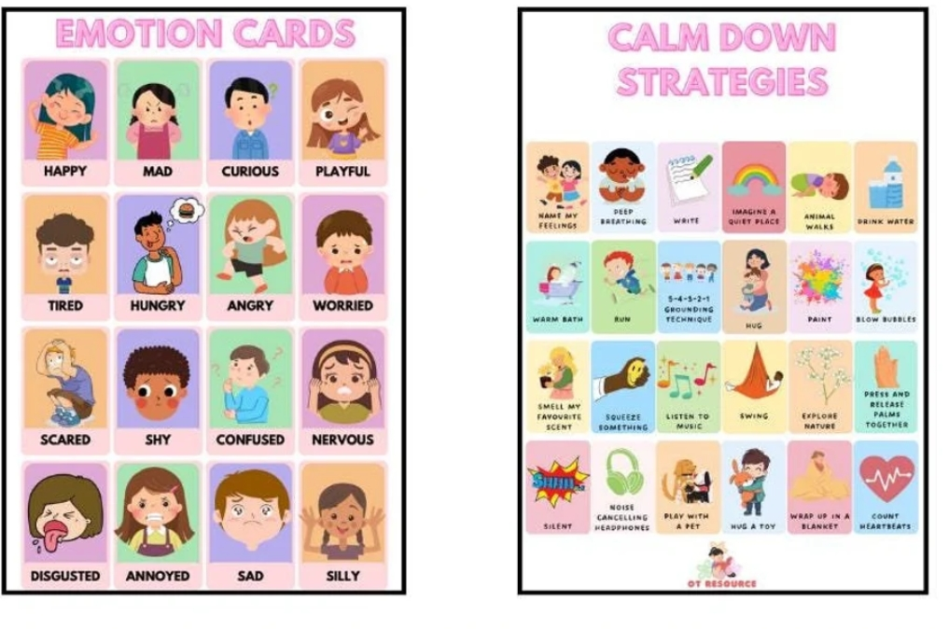
(Etsy.com, n.d.)

References
Baja, T., (2025) Emotion Cards.
Available at: https://www.scribd.com/document/492239399/Emotion-Cards
(Accessed: 1 November 2025).
Banyard, P. & Grayson, A., (2008) Introducing Psychological Research. 3 ed. London: Palgrave Macmillan.
Box, F. H., (2025) Tips to Relax – Feelings and Coping Tools Poster for Children’s Emotional Regulation.
Available at: https://feelingshelpbox.com/tips-to-relax-feelings-and-coping-tools-poster-for-childrens-emotional-regulation/
(Accessed: 31 October 2025).
Brodie, K., (2025) Maslow’s Hierarchy of Needs for Children.
Available at: https://www.earlyyears.tv/maslows-hierarchy-of-needs-children/
(Accessed: 31 October 2025).
Careers, E. Y., (2018) Why all settings should have a calm down corner.
Available at: https://www.earlyyearscareers.com/eyc/enabling-environment/settings-calm-corner/
(Accessed: 2 November 2025).
Daniels, H., Cole, M. & Wertsch, J. V., (2007) The Cambridge Companion to Vygotsky. New York: Cambridge University Press.
Etsy.com, (no date) Emotional regulation toolbox.
Available at: https://i.etsystatic.com/54610502/r/il/91f33d/6307545761/il_1080xN.6307545761_ta6n.jpg
(Accessed: 30 October 2025).
Gov.Wales, (2021) Framework on embedding a whole-school approach to emotional and mental wellbeing.
Available at: https://www.gov.wales/sites/default/files/publications/2021-03/framework-on-embedding-a-whole-school-approach-to-emotional-and-mental-well-being.pdf
(Accessed: 31 October 2025).
Kids, C., (2023) Unlocking the Magic of Mindfulness, Yoga, and Storytelling for Kids.
Available at: https://www.calm-kids.com/
(Accessed: 2 November 2025).
School, J. T. P., (2025) Behaviour.
Available at: https://www.josephturnerprimary.co.uk/behaviour/#:~:text=When%20the%20child%20is%20calm%20or%20ready%20to,are%20recorded%20using%20the%20behaviour%20tool%20on%20SPTO.
(Accessed: 2 November 2025).
Star, L. Y., (2025) Six Dos and Don’ts of Successful Calm Down Corners.
Available at: https://littleyellowstarteaches.com/2023/08/18/six-dos-and-donts-of-successful-calm-down-corners/
(Accessed: 1 November 2025).
System, S., (2025) Stress Less: Create a School Calm Room Students Want to Visit.
Available at: https://smithsystem.com/smithfiles/stress-less-create-a-school-calm-room-students-want-to-visit/
(Accessed: 31 October 2025).
Tales, V. S., (2025) How to Prepare a Calming Box for your Kids or Students.
Available at: https://veryspecialtales.com/calming-box/#:~:text=Therearemanysituationsathomeandschoolwhenyourkidsorstudentswillbenefitfromusingself-soothingboxes:
(Accessed: 1 November 2025).

