University of Wales Trinity Saint David

OME level 6 degree apprenticeship



Modelling of a shaped charge jet within Dassault ABAQUS CAE
Advanced Physics (ACDB5015)

Max Fisher

2113637

April 2023

Lecturer: Kelvin Donne

Contents
Table of Figures 3
1.0 Introduction 4
1.1 Aims and Objectives 4
2.0 Background Information 4
2.1 ABAQUS 4
2.2 Shaped Charges 5
3.0 Reference Shaped Charge 7
4.0 2D Modelling 10
4.1 Fully unconstrained 2d model 12
4.2 Partially constrained 2d model 14
4.3 Fully constrained 2d model 16
5.0 3D Modelling 19
5.1 Fully unconstrained 3d model 20
5.2 Partially constrained 3d model 23
5.3 Fully constrained 3d model 25
5.4 Test ‘full 3d’ model 27
6.0 Summary 29
7.0 References 30
References 30

Table of Figures
Figure 1 Sectioned view of Faustpatrone 30 (top) and Panzerfaust 60 (bottom) warheads 5
Figure 2 Charge Depth of penetration by standoff 6
Figure 3 Jet formation by varying conical liners 7
Figure 4 Structural and Dimensional diagrams of the shaped charge warhead 8
Figure 5 LS DYNA modelling results 9
Figure 6 2D Mesh Generated 10
Figure 7 test 1 unconfined step 4 12
Figure 8 test 1 unconfined jet only step 10 13
Figure 9 test1 unconstrained jet tip velocities 14
Figure 10 test 2 sides confined step 4 15
Figure 11 test 2 sides confined jet only step 10 16
Figure 12 test 2 sides constrained jet tip velocities 16
Figure 13 test 3 fully confined step 4 17
Figure 14 test3 fully confined jet only step 10 18
Figure 15 test 3 fully constrained jet tip velocities 18
Figure 16 3d mesh 20
Figure 17 test 1 3d fully unconfined step 1 (error) 21
Figure 18 test 1 3d fully unconfined jet step 1 (error) 22
Figure 19 test 1 3d fully unconfined jet velocities 22
Figure 20 test 2 3d partially confined step 1 (error) 23
Figure 21 test 2 3d partially confined jet only step 1 (error) 24
Figure 22 test 2 3d partially confined jet velocities 24
Figure 23 test3 3d fully confined step 1 (error) 25
Figure 24 test3 3d fully confined jet step 1 (error) 26
Figure 25 test3 3d fully confined jet velocities 26
Figure 26 full 3d test 27
Figure 27 full 3d jet 28
Figure 28 full 3d jet velocities 28

Introduction
This report will discuss the use of ABAQUS CAE to modelling the formation of a shaped charge jet through the use of a case study. It will also highlight the different techniques for explicit modelling, as well as the places where error and variance from physical results can be caused.

Aims and Objectives
The reports will highlight two approaches to modelling: 2d and 3d, comparing and contrasting the effects of mesh generation and boundary conditions between the two simulation methods. The use of adaptive meshing (Arbitrary Lagrangian-Eulerian/ ALE) will also be discussed in regard to 3d simulations and its effects on the simulation.

2.0 Background Information

2.1 ABAQUS
ABAQUS CAE is a Dassault systems software package which utilises finite element analysis, to simulate a wide range of conditions and events. ABAQUS was first released in 1978 [1], and has received a multiday of version updates, the latest being released in November 2022 [2]. ABAQUS allows the user to use both Eulerian an Lagrangian calculation methods, with a hybridised simulation also being possible. Eulerian uses a description of a flow field, with a mesh being generated within a defined inflexible mesh [3], particles ‘flow’ during a simulation however, the mesh remains constant. In Lagrangian simulations the ‘flow’ of particles is represented by the mesh deformation [3]. This is beneficial for cases where velocity of measured as there is defined points when a velocity graph can be achieved. However, this runs into an issue in high-deformation simulations, as the mesh can be overly stretched. Adaptive meshing (ALE) can be used to reduce this, by splitting single elements into two when excessive distortion is detected, this will be further explained later in this report. A hybridised approaches combine these and is often considered ideal as it uses many of the best features especially for high deformation simulations [4]. This however is relatively complex and required a greater understanding of the software package than the author of this report currently has.

2.2 Shaped Charges
Shaped charges are explosive devices that utilise the Munroe (also known as Neumann) effect. The Munroe effect describes the focussing effect of a hollow void on the surface of an explosive charge and can be used in a variety of application, ranging from armour penetration in weaponry to cutting charges in demolitions. The first use of the shaped charge effect is disputed, however Franz von Baader (1765-1841) a German mining engineer proposed the idea as a way to save on blasting powder in 1792. The first true example of the shaped charge was not till 1883 and the Munroe effect was not name such until 1888, when Charles Munroe described the presence of lettering on a steel plate after the firing of a stamped charge; ‘USN’ was left imprinted on the surface of the steel plate; Munroe had observed that when a cavity was formed in a block of explosive, opposite the point of initiation, the penetration or depth of cavity was increased [5]. Shaped Charges did not come into come into common use till the second world war, when devices like the Panzerfaust and Bazooka saw widespread use, in the case of the Panzerfaust [6] across all variants, over 8 million were made. These were much advanced on the simple cavity design and contained metallic liners of different cone angles as seen in Figure 1.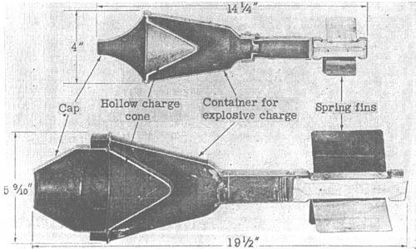
Figure 1 Sectioned view of Faustpatrone 30 (top) and Panzerfaust 60 (bottom) warheads
Today, shaped charges are in use in a variety of weapon systems such as anti-tank guided missiles, torpedoes, rifle grenades, bomblets and many more. Many tend to use copper alloys or reactive materials to increase their penetrative or behind armour effects. They are also used in civilian contexts for items such as cutting charges used in demolitions as the effect can be used in a shape where focussing occurs, not just in rounded munitions.

Shaped charges nominally show a greater penetration with ‘stand-off’, this is because the liner takes time to form the jet (although this is in the μS region). The exact distance varies charge to charge and depends on the quality of manufacture of the liner as at longer stand-offs the jet begins to ‘particulate’. This is where the material is over stressed and the jet breaks into smaller pieces instead of one solid line. Figure 2 [7] demonstrates this relationship, where penetration increases until a point, at which point a ‘real’ charge will see its penetration degrade significantly. When working with shaped charges the marking ‘CD’ describes Charge Diameter or the width from edge to edge of the charge liner.
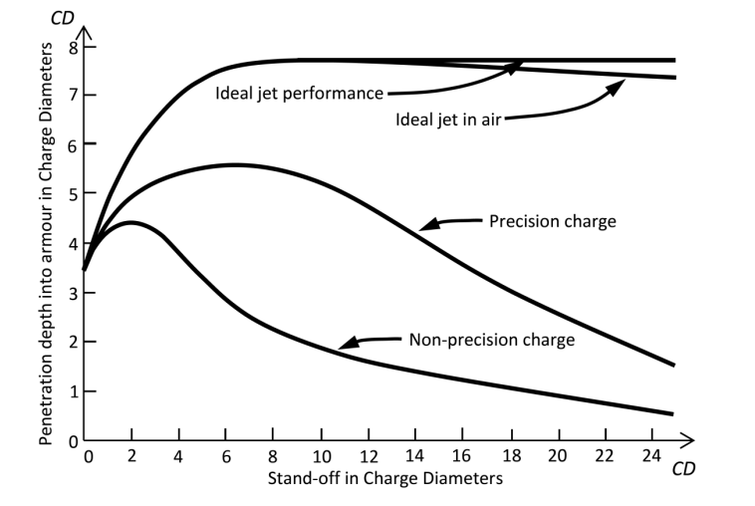
Figure 2 Charge Depth of penetration by standoff
Liner geometry is also extremely important as to the performance of a shaped charge jet. By varying the cone angle and design, the properties of the jet can also be varied e.g. a conical shaped charge with a cone angle of 60⁰ will have a very narrow jet with high velocity and slow slug speed, while a narrower angle will have a small tip-slug velocity gradient [8]. This is further demonstrated by Figure 3 [9]. Other geometries such as the trumpet liner also demonstrate differing properties, Walters and Zukas describe the trumpet liner as having a high tip velocity while not possessing the inverse velocity gradient of slug and tip as conical liners do. [10]This is potentially beneficial for producing high penetration performance.
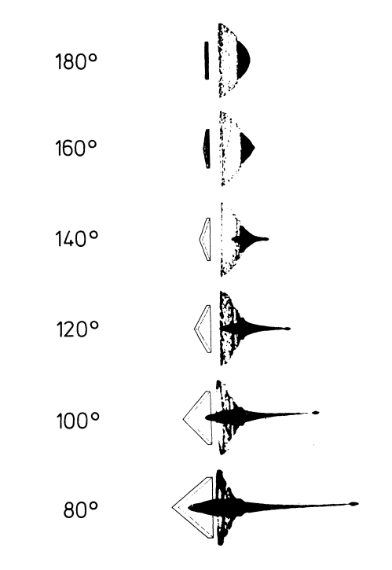

Figure 3 Jet formation by varying conical liners

3.0 Reference Shaped Charge
The Charge examined was a trumpet style liner which had previously been simulated and tested in a paper by Yanna Du, Guanglin He, Yukuan Liu and Zhaoxuan Guo. This paper ‘Study on Penetration Performance of Rear Shaped Charge Warhead’ described the theoretical penetration of the warhead of a guided munition, taking into account the presence of the guidance electronics and items in the path of the jet formation. In order to do this, they first had to understand the raw formation and penetration characteristics of the charge. They conducted both simulations and trials to identify this. Figure 4 [11] shows the warhead design, this was also used by the author as the basis for the modelling done later both in the 2d and 3d environments.
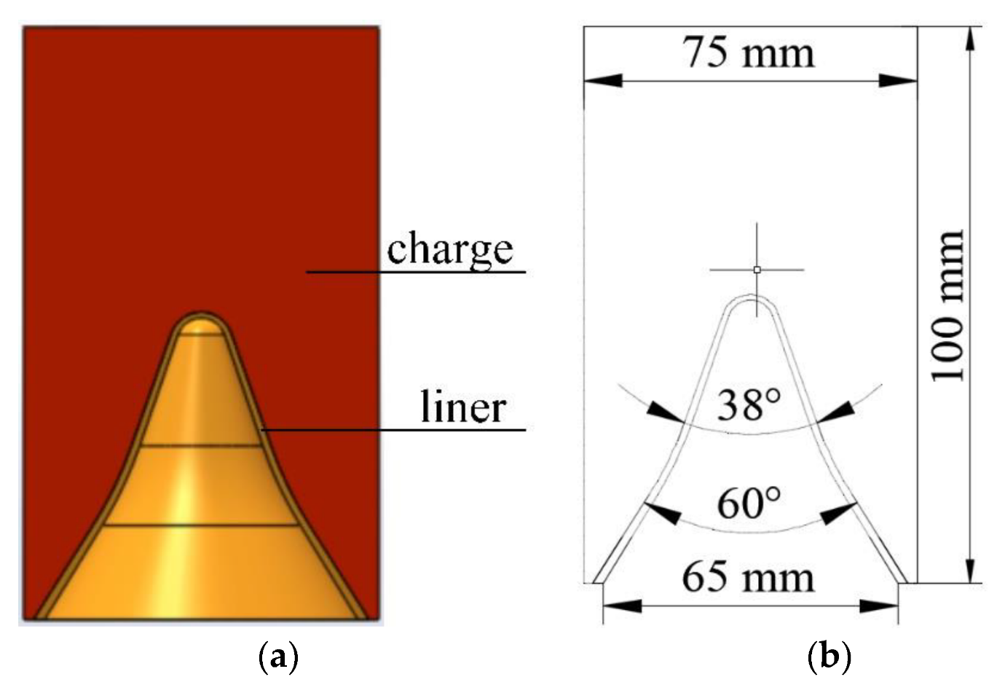
Figure 4 Structural and Dimensional diagrams of the shaped charge warhead
To complete their simulations, a different software package was used; LS DYNA this is a software package developed by Ansys and also utilises explicit and implicit finite element analysis to complete the simulation. While not all of the parameters used to complete the simulations are available, it is clear that a hybridised Lagrangian/Eulerian approach was used, allowing the report to simulate the impact of the jet into a steel target. Figure 5 shows their results, demonstrating the depth of penetration at different times and standoffs. Note the formation of the jet (red) and the appearance of a ‘collar’ at the base of the slug, this likely the base of the liner, being pulled into the jet as the jet decouples from the explosive. The jet becomes extremely stretched and thin, at this stage particulation does not occur.
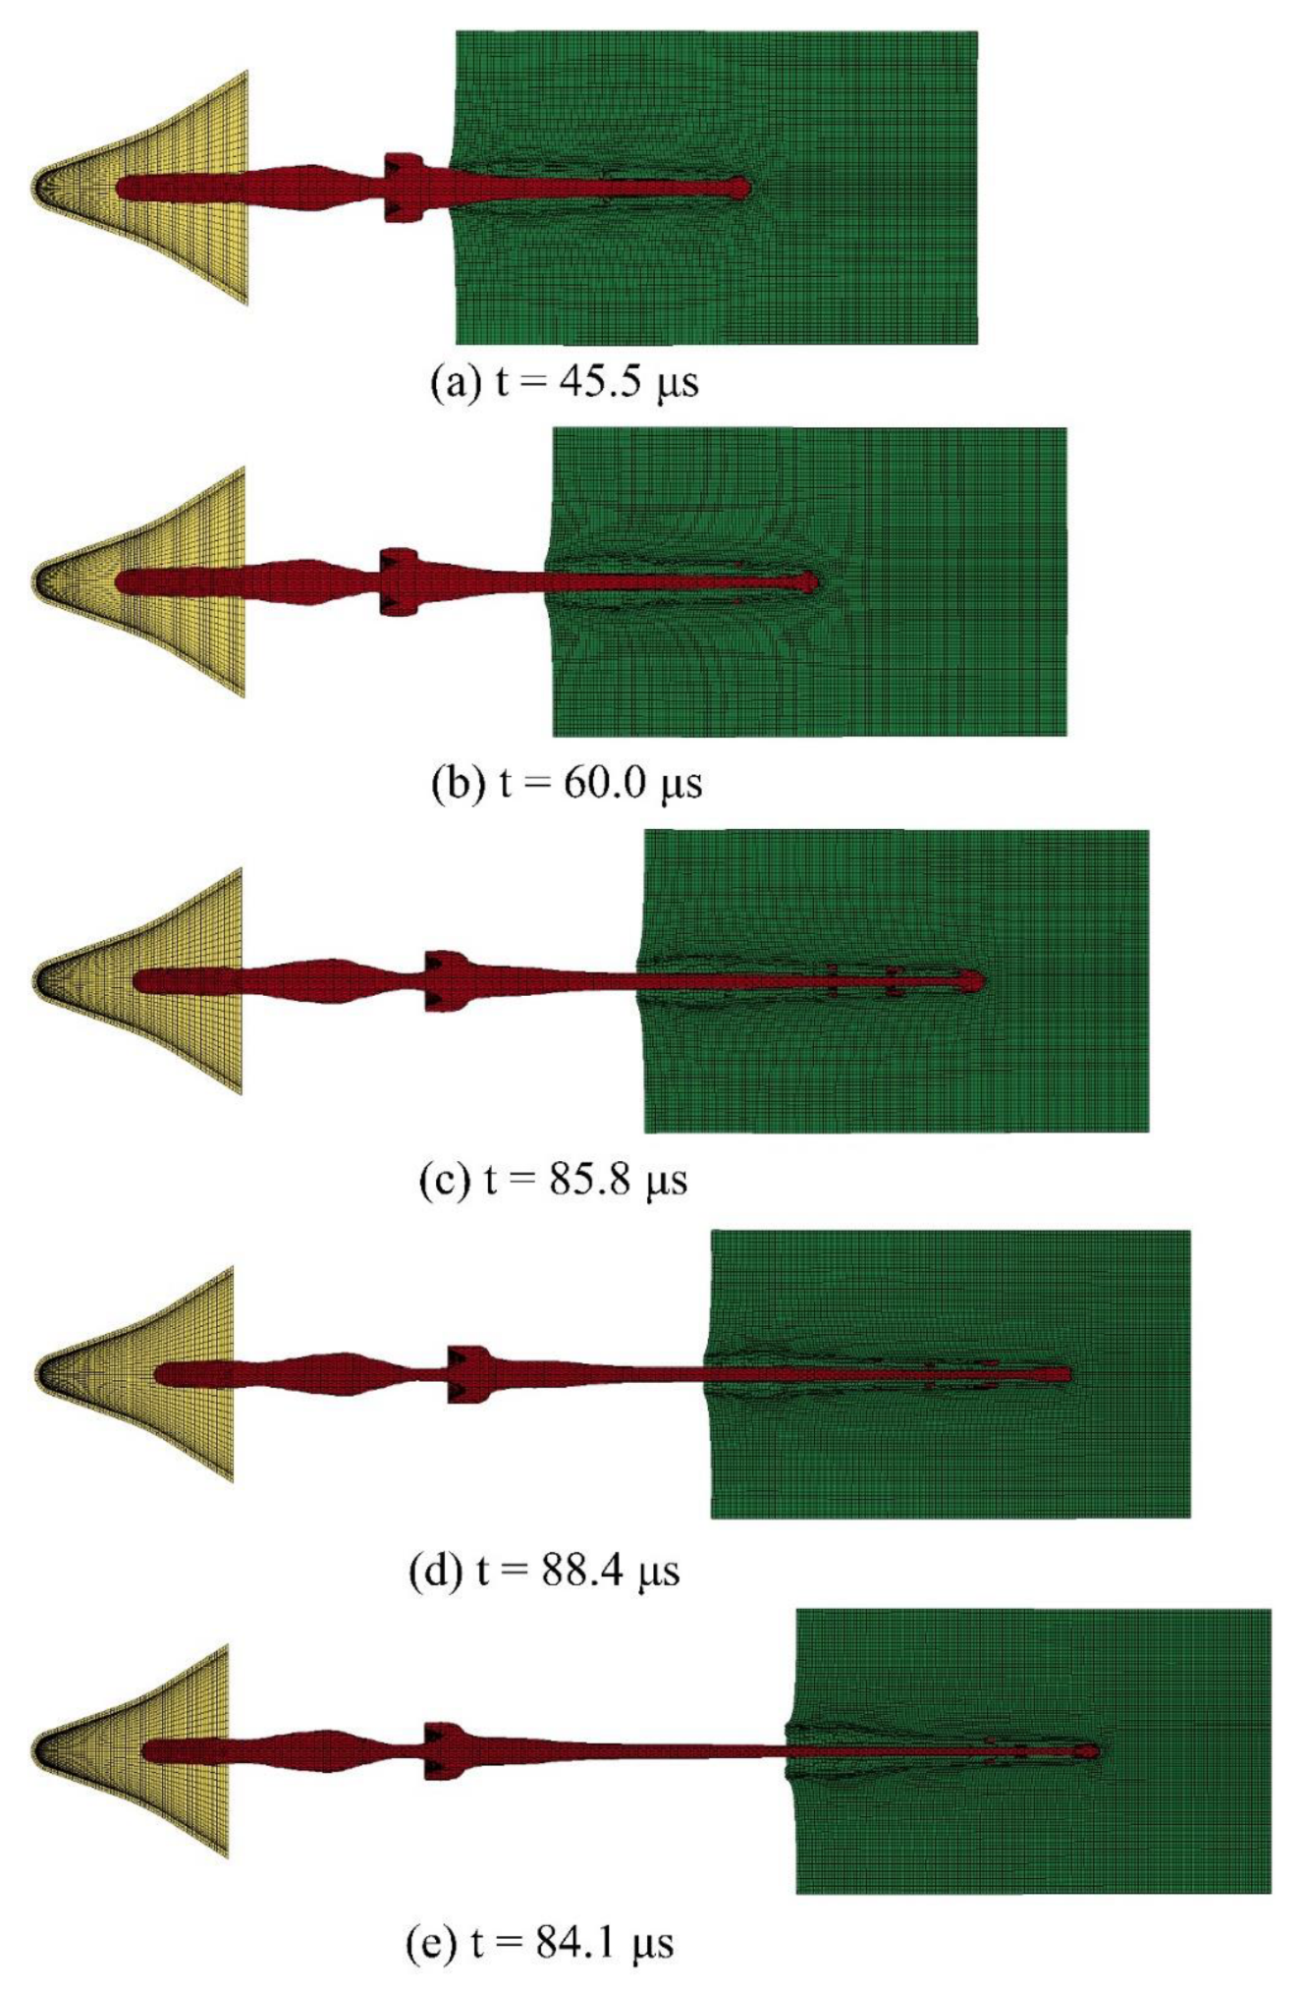
Figure 5 LS DYNA modelling results

4.0 2D Modelling
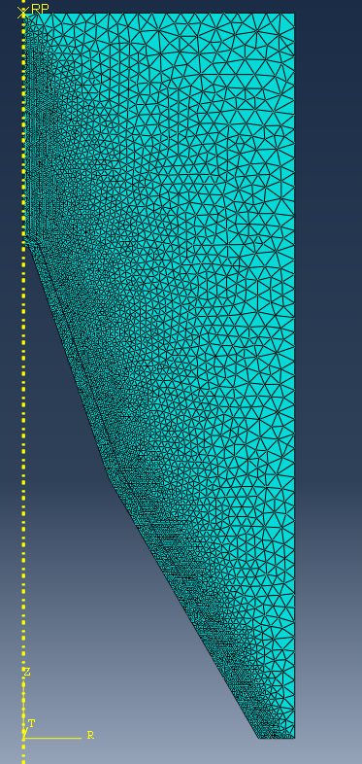
The modelling performed by the author was done using ABAQUS software package previously discussed. To Begin, the liner and explosive shown in Section 3, was drawn within ABAQUS’ own environment. As this was a 2d simulation to begin with, only a 2d sketch was drawn. An initial mesh was generated with the following properties:
Figure 6 2D Mesh Generated
Explosive Fill:
Contact face - 0.005
Side and top - 0.002
Liner:
All faces – 0.005
A ‘tri’ mesh was used throughout.

Figure 6 shows this within the environment. Note that the mesh is much finer in the vicinity of the liner and the yellow dotted line. This is an ‘axisymmetric model’ this in effect allows the user to simulate a cylindrical effect without having to do the full 3d simulation, it is a fixed plane which the model cannot violate. Also note the lack of a case, this is a deliberate decision as the reference charge also did not appear to have one. The effects of this will be discussed later in this section.
After the mesh was generated, material properties were assigned. A copper liner would be used similar to the reference report; however, the exact material properties were unavailable. As such the following properties were used:
Johnson-Cook Damage:
Fracture Energy: 1300000000
d1: 0.54 d2: 4.89 d3: 3.03 d4: 0.014 d5: 1.12 [12]
Melting temperature: 1790 Transition temperature: 293 Reference Strain Rate: 1
EOS:
Type (Us-Up)
c0: 3933 s: 1.489 Gamm0: 2.02 [13]
Density: 8770
Shear modulus: 44000000000

Unlike the reference report with uses 8701 explosive (95%RDX 5% TNT) as a fill, it was decided to use a baseline of TNT. This had the following properties [14]:
EOS (JWL):
Detonation wave speed: 6930 A: 373800000000 B:37470000000
Omega: 0.35 R1: 4.15 R2: 0.9 Detonation Energy Dens 3680000
Pre-deton Bulk modulus :0
Density: 1630
It was at this stage that the detonation point was set, in this case:
X: 0 Y: 0.095 Z: 0 Detonation Delay time: 0
The materials were then assigned using the materials manager, to their respective parts.

In order for the software to recognize the collisions between the fill and the liner, an interaction was created between the faces. This was set to a ‘general contact’ where all nodes interact will all others if they collide. This is the simplest but most resource intensive of all the interaction options.
Next a ‘step’ was created, this instructs the software how long to run the simulation for. His was set to 1E -4 Seconds.
The final item required for the simulation to run was to generate a ‘Job’ in the job manager, when this was created the first simulation could begin.

4.1 Fully unconstrained 2d model
The first simulation was fully unconstrained, as such there was no casing or boundaries aside from the axisymmetric plane. Unfortunately, this simulation did not come to a conclusion due to extreme deformation of some elements near the end of the run. However, jet velocities were able to be obtained and the jet could be seen to form. In order to better understand what was happening within the simulation, it was revolved 180⁰. It is important to stress at this point that the simulation still remains in 2d it is simply the results being revolved around the axisymmetric plane. 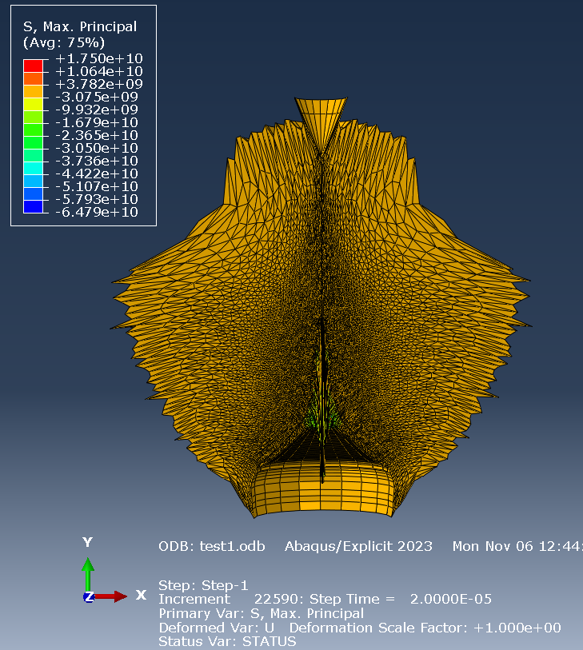
Figure 7 test 1 unconfined step 4
Figure 7 Shows the fill expanding and the formation of the jet tip. The liner cone is approximately half inverted at this stage, with the upper narrower cone angle section being fully inverted. At this stage note the ‘shadow’ formed by the liner as the fill moves past it. There is a strange ‘cone’ like artifact at the top of the fill, at present this is unexplained and could be due to mesh errors. Figure 8 shows only the jet and at a later stage (5E-5s). The jet has significantly lengthened, and the collar noted in the reference paper appears to have formed. Near the tip of the jet ‘necking’ can be seen. This is where the mesh is being stretched beyond its normal range and can cause instability in the program. If this progresses it can cause simulations to fail.
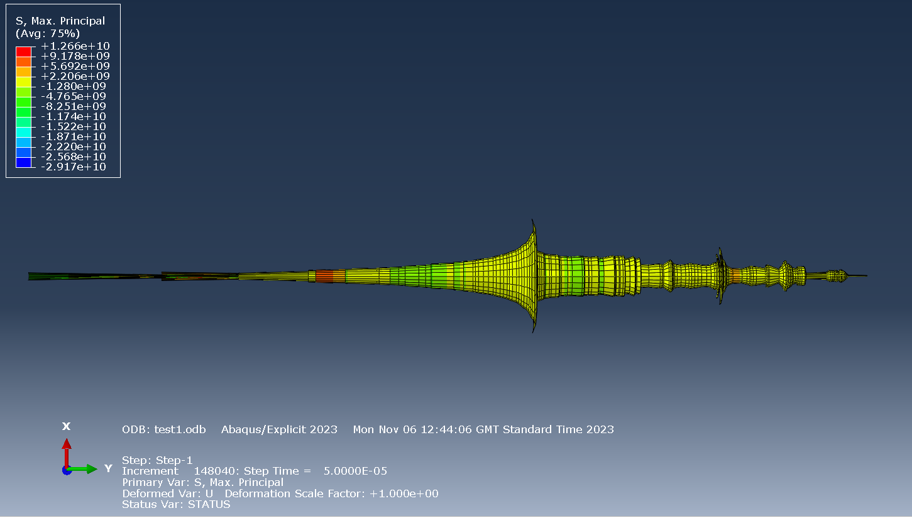
Figure 8 test 1 unconfined jet only step 10
In order to calculate the jet velocity a range of nodes in and around the tip area were selected and plotted. Figure 9 shows that the jet velocity is approximately 6kms⁻¹ with a maximum seen at just below 7kms⁻¹. This is near to but below the wave velocity of TNT which is 6.930kms⁻¹.
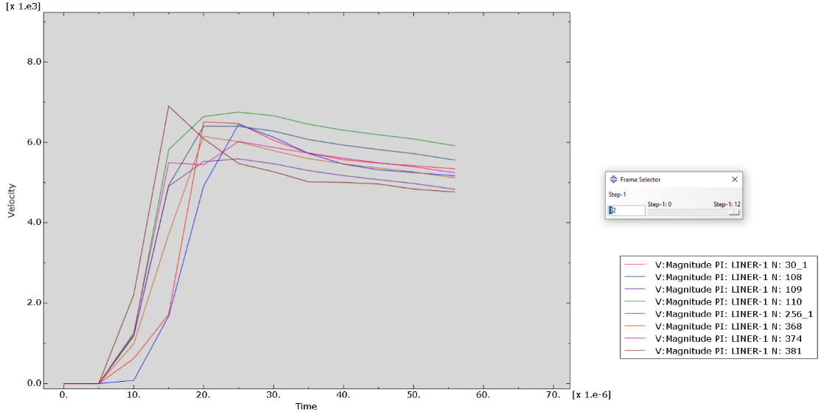
Figure 9 test1 unconstrained jet tip velocities

4.2 Partially constrained 2d model
The second simulation was aimed at simulating a perfect case boundary and was an attempt to increase the jet velocity. By introducing this edge boundary all expansion of gases would be directed up or down into the liner. This again was simulated in 2 dimensions however was revolved around the axisymmetric plan by 1800 to better visualise the charge and liner. Figure 10 shows the effectiveness of the boundary, unlike in test 1 where the expanding fill appeared to ‘ball’ out the fill is purely directed above and below. The ‘shadow’ be the liner appears deeper and cone shaped artifact the top of the shell no longer appears. There is a definite ring of nodes appearing at the boundary, moving ahead of the rest of the expansion. This is likely due to the inability of the fill to expand outwards, and in the context of this simulation it suggests that the boundary conditions may be having the desired effect.
Figure 11 shows only the jet, at the same moment in time as Figure 8, it seems to be much more developed, the jet tip being significantly longs and the slug appears to have merged with the jet. A thin, collar can also be seen, however as it is only one node thick at this stage it is unclear if it is a modelling anomaly or a real entity as it would be extremely thin in reality. This appears several times towards the end of the slug, but to much less degrees.
Figure 12 demonstrates as speculated from the advanced formation, that the jet time is travelling much faster than in test 1. The majority of nodes are travelling at around 8kms⁻¹ significantly faster than the 6kms⁻¹ of test 1. The fastest moving nodes are travelling at approximately 10.5kms⁻¹,1.5 times the velocity of the detonation wave. This is likely due to the restricted nature of the flow of expanding fill. All explosive that previously went sideways dissipating its energy by expansion is instead forced up or into the liner; likely causing the increase in velocity.
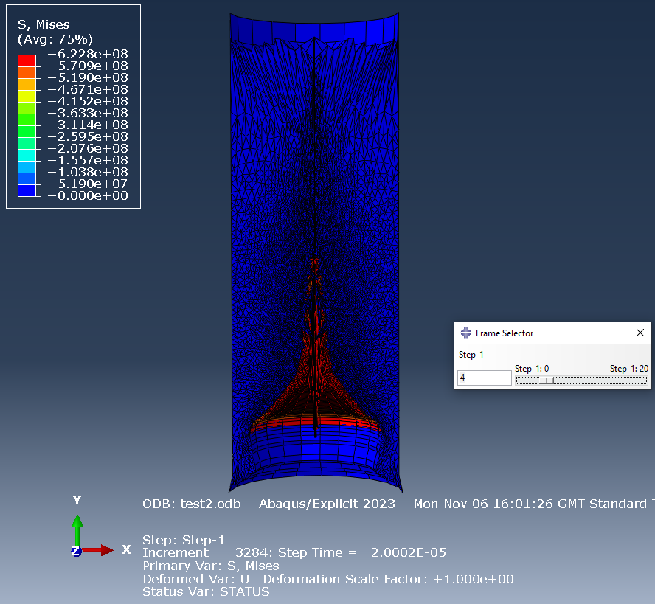
Figure 10 test 2 sides confined step 4
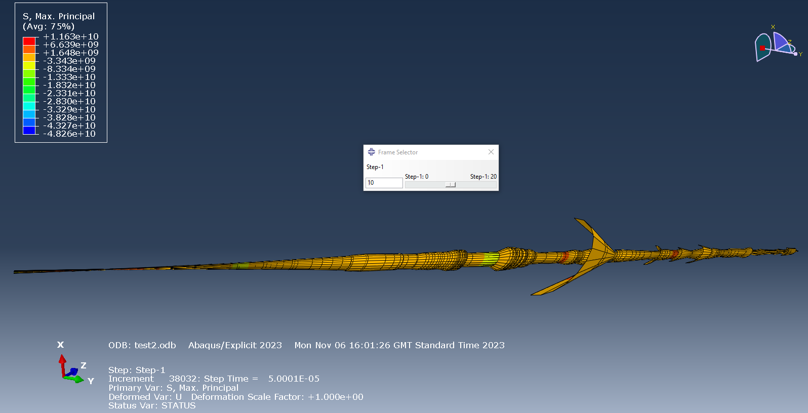
Figure 11 test 2 sides confined jet only step 10
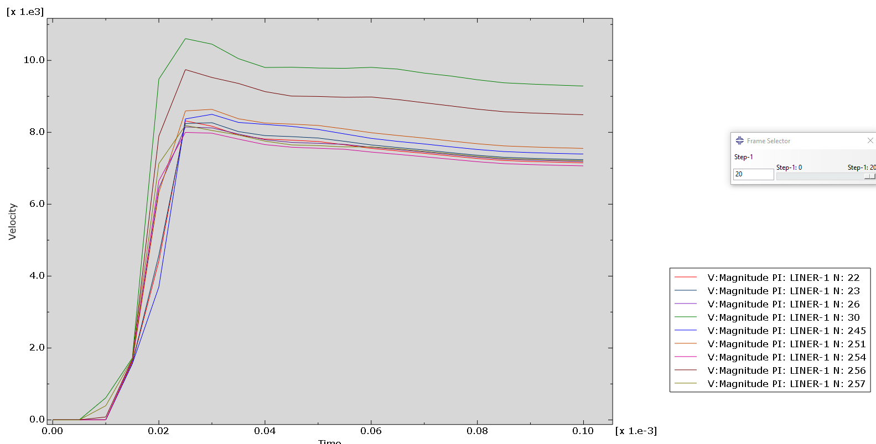
Figure 12 test 2 sides constrained jet tip velocities

4.3 Fully constrained 2d model
The final 2d model simulated was a fully constrained one. This simulation considered the same setups as before; however, it now consists of the ‘perfect’ case. Both the sides and top of the case are inflexible so all energy, in theory, will be forced down into the liner. This should mean that the velocity obtained should be the maximum theoretical value for this mass of TNT. As before it the simulation was completed in 2d before being revolved around the axisymmetric plane. Figure 13 shows the simulation at 2E-5S and clearly demonstrates the effectiveness of the boundary condition. All expansion is occurring ‘down’ into and around the liner once again casting a major ‘shadow’ around the line when the fill expands past it. Even at the extremes of the expansion there is still significant compression of the fill, suggesting that it will continue to rapidly expand.
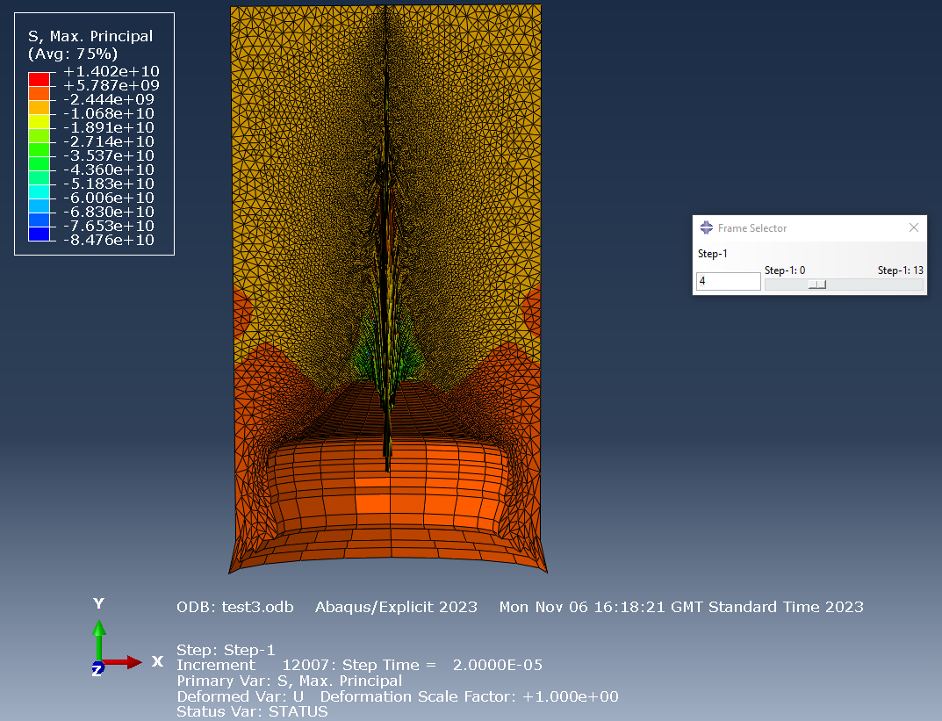
Figure 13 test 3 fully confined step 4
Figure 14 again shows the jet in isolation, the jet has stretched significantly, but once again shows sign of necking, which in combination with the ‘collaring’ occurring at the back of the jet and slug led to the model crashing 3 steps later. The collars appear once again to only be one node thick, once again raising the possibility of them being modelling errors. Aside from this the underlying jet appears to have formed well.
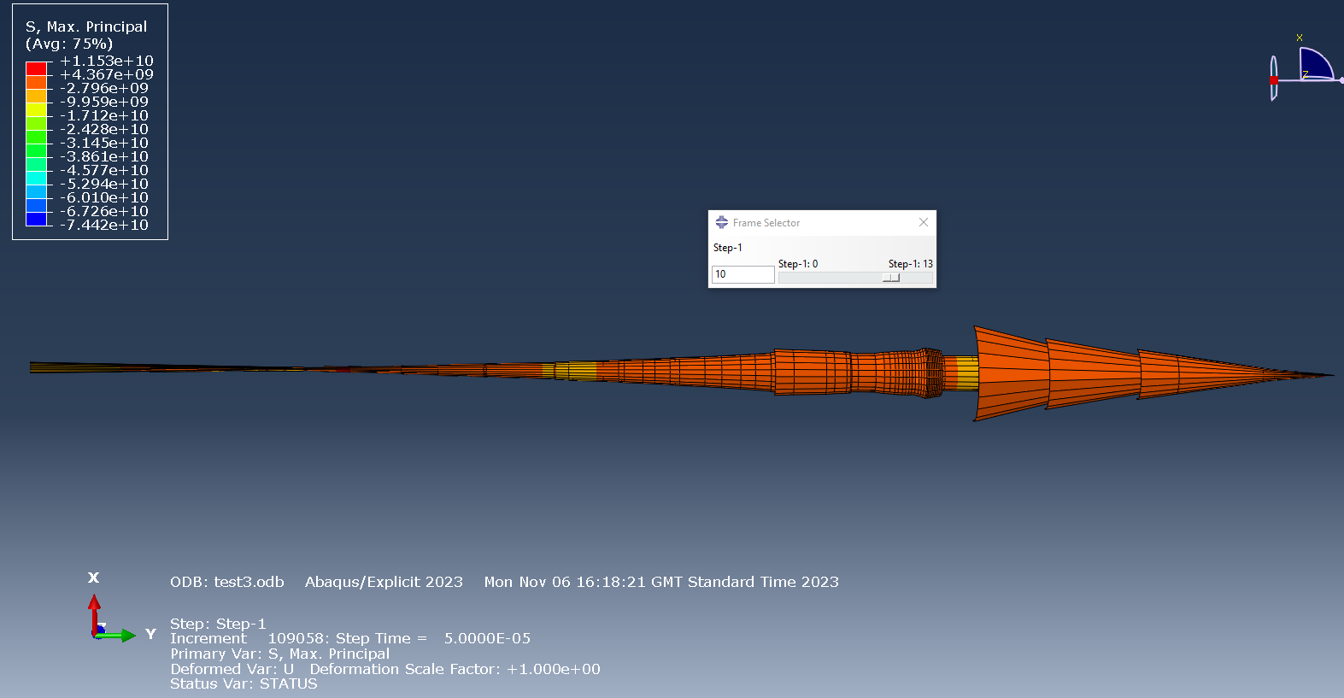
Figure 14 test3 fully confined jet only step 10
Unexpectedly, Figure 15 shows a very similar velocity graph to Figure 12. The velocity has increased by less 0.5kms⁻¹ (~8.25kms⁻¹). The maximum velocity at approximately 10.5kms⁻¹ is similar to test 2. This was not expected, as it was theorised that directing the energy that was released ‘up’ down, a significant increase in velocity would be seen. At present it is unclear to the author where this energy is otherwise dissipated and is potentially an area for future research.
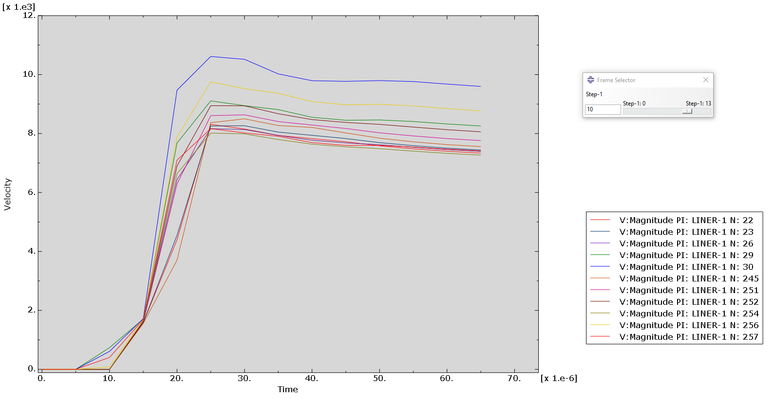
Figure 15 test 3 fully constrained jet tip velocities

5.0 3D Modelling
The 3-dimensional modelling was also done within the ABAQUS package, the setup and design for this was much the same for the 2d however different in two key areas. Firstly, instead of an axisymmetric plane being applied the drawing was initially revolved 360⁰ before the meshing took place. The author initially attempted to use the same mesh sizing for this but immediately ran into the issue of node counts. When object is in 3 dimensions there is several orders of magnitude more nodes required to simulate the same object. This became clear when simply meshing the object took a similar time to run the 2d simulations. It was also here that the limitations of the teaching version of ABAQUS came into effect. The version of Abaqus used allows up to 250,000 nodes. Whilst this is ample for most 2d applications in 3d this can pose a real issue for the user, especially when coupled with hardware issues. This issue was only resolvable by making the mesh significantly coarser. The mesh was set to 0.002 at the tip of the liner and 0.004 everywhere else (a graduation was used in the contact areas). This coupled with only revolving the model through 180⁰ brought the simulation below the node count. Figure 16 shows this new mesh, including the graduation near the apex of the liner clearly doing this is intended to aid the formation of the jet while limiting the time required to run the simulation. A general contact use used once again, with the same steps being applied to begin with. Initial test runs were unsuccessful, with fatal errors immediately appearing when the simulation was started. One method for dealing with this was to use ALE adaptive meshing. The adaptive meshing causes the simulation to pause after each step and re-evaluate the mesh. If an element is significantly deformed, then it is split into two new elements. This intends to prevent crashing and allow the simulation to progress. It is common practice to increase the remeshing sweeps before the ALE frequency as it is less computationally intense, however while varying this feature it seemed to be most effective when the frequency was increased. It was initially tried with the following settings:
ALE frequency: 2,000 Remesh sweep: 2
This was an improvement, and the simulation did run, but still crashed before a meaningful jet was generated. The frequency and sweeps were increased through various runs which allowed the simulations to run further and further. This however came at a cost of processing time. Due to computer access limitations, the author was unable to complete a full interrogation of this feature, however it was clear that in improvement was seen when using it. Below are the settings used:
ALE frequency: 200000 Remesh sweep: 5
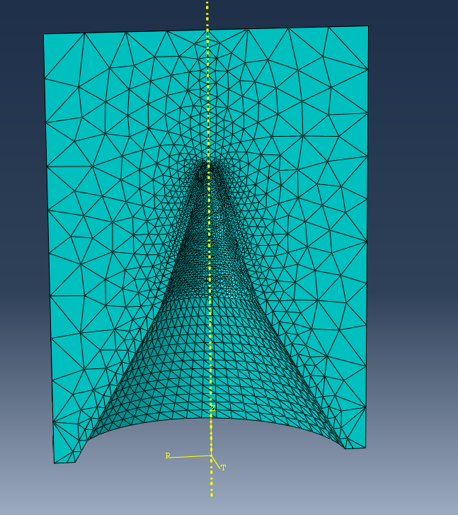
Figure 16 3d mesh

5.1 Fully unconstrained 3d model
Similar to the 2d models, the first test of the 3d was fully unconfined. Despite the efforts of the ALE meshing this still failed early in the simulation (4.25E-5s). This is likely due to the relatively coarse mesh used and is evident from the ‘spikes’ seen in Figure 17 and Figure 18. There are several violations of the plane of symmetry, and the mesh does not appear to deform evenly. This uneven expansion could cause off axis formation of the jet as the load is not applied evenly to the liner, further increasing the computational load, and causing errors. Figure 19 shows the jet velocities, these are quite varied with a peak of just over 6.5kms⁻¹. At around 30μs the majority of nodes velocities stabilize, at around 3kms⁻¹, much lower than that of the 2d, around half in fact. This value has a low confidence, due to the errors encountered, however it suggests that there are significant differences between the two approaches.

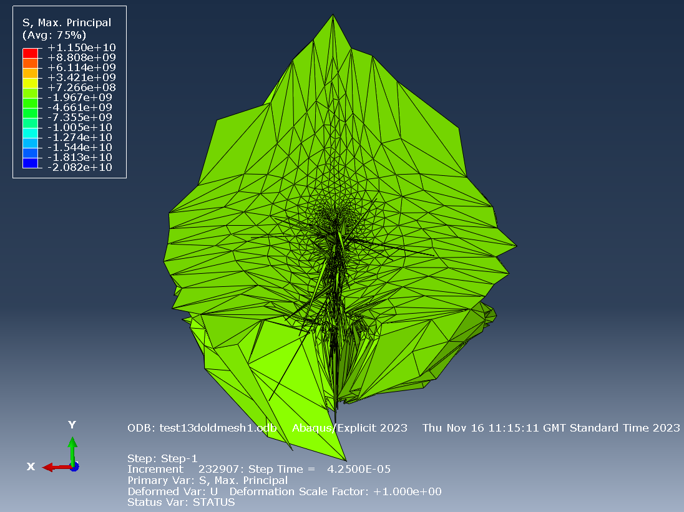
Figure 17 test 1 3d fully unconfined step 1 (error)
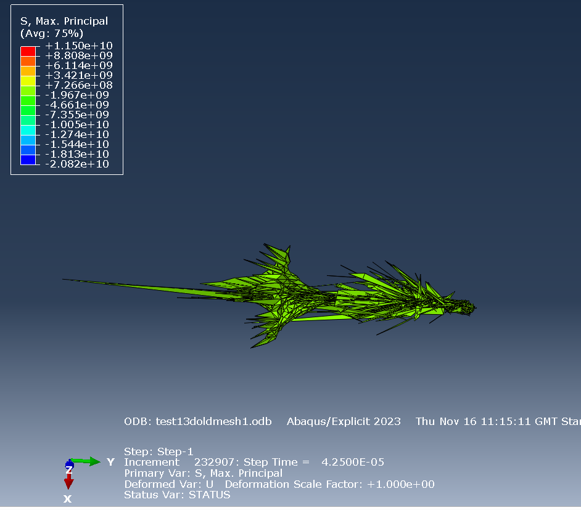
Figure 18 test 1 3d fully unconfined jet step 1 (error)
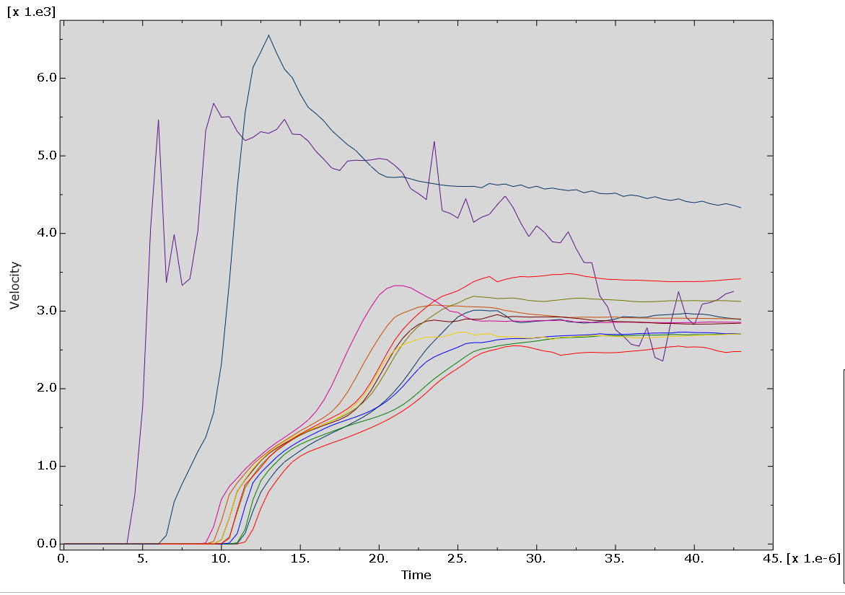
Figure 19 test 1 3d fully unconfined jet velocities

5.2 Partially constrained 3d model
In this test, the model was further constrained, this time adding a boundary condition around the perimeter of the fill. By limiting the movement of the nodes, it was again theorized that more of the energy generated by the detonation would be focused into the liner material, as it could not be dissipated radially. This appeared to work to an extent as demonstrated by where the velocities are spread around 5kms⁻¹, much faster than that of test 1 (3d) and closer to those seen in test 1 (2d), although significantly reduced when compared to test 2 (2d). Unfortunately, once again this simulation was unable to be run to its full completion due to element errors. Figure 20 and Figure 21 show numerous ‘spikes’ where elements are overstretched; this overstretching appears to cause the software to fail the simulation and is unlike real shaped charge formation. Figure 21 shows what appears to be a single node forming the tip of the jet, while this is desired, due to the fact it is only one node at the point the simulation ends, it is impossible to make a firm conclusion on the accuracy of the tip velocity.
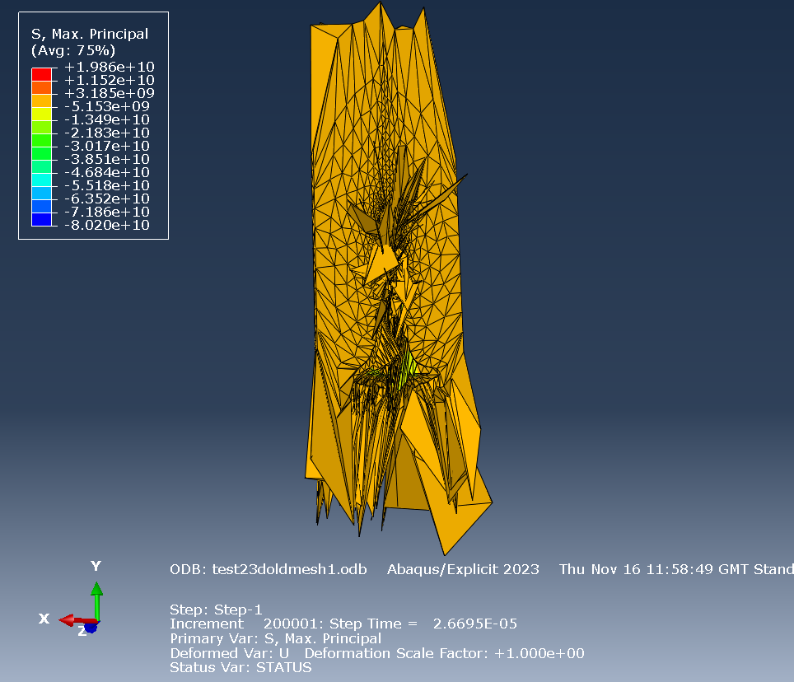

Figure 20 test 2 3d partially confined step 1 (error)
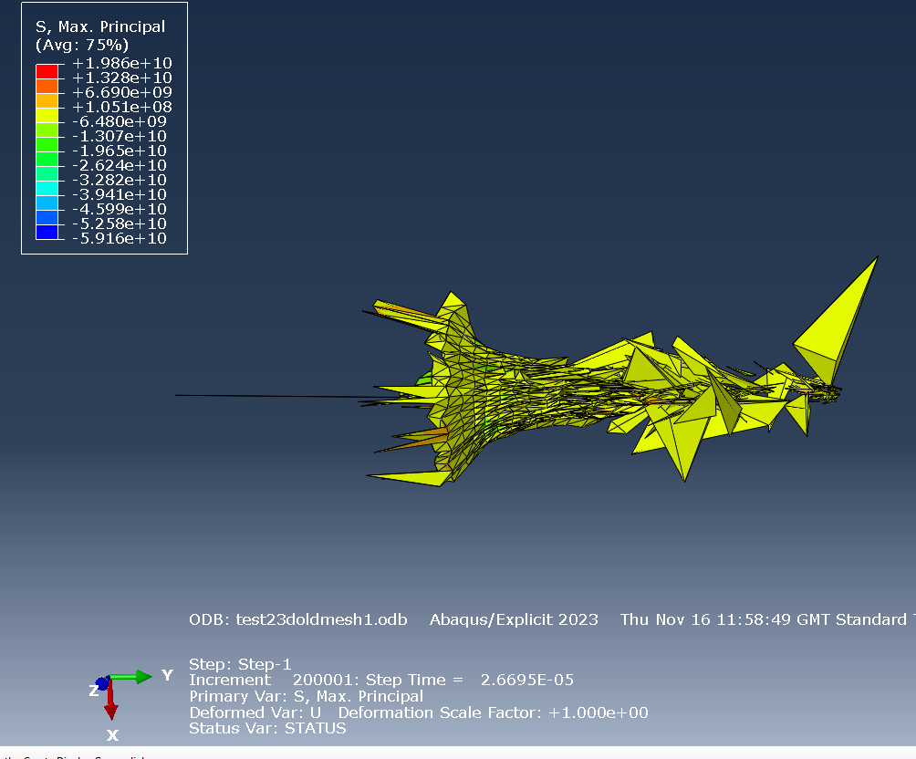
Figure 21 test 2 3d partially confined jet only step 1 (error)
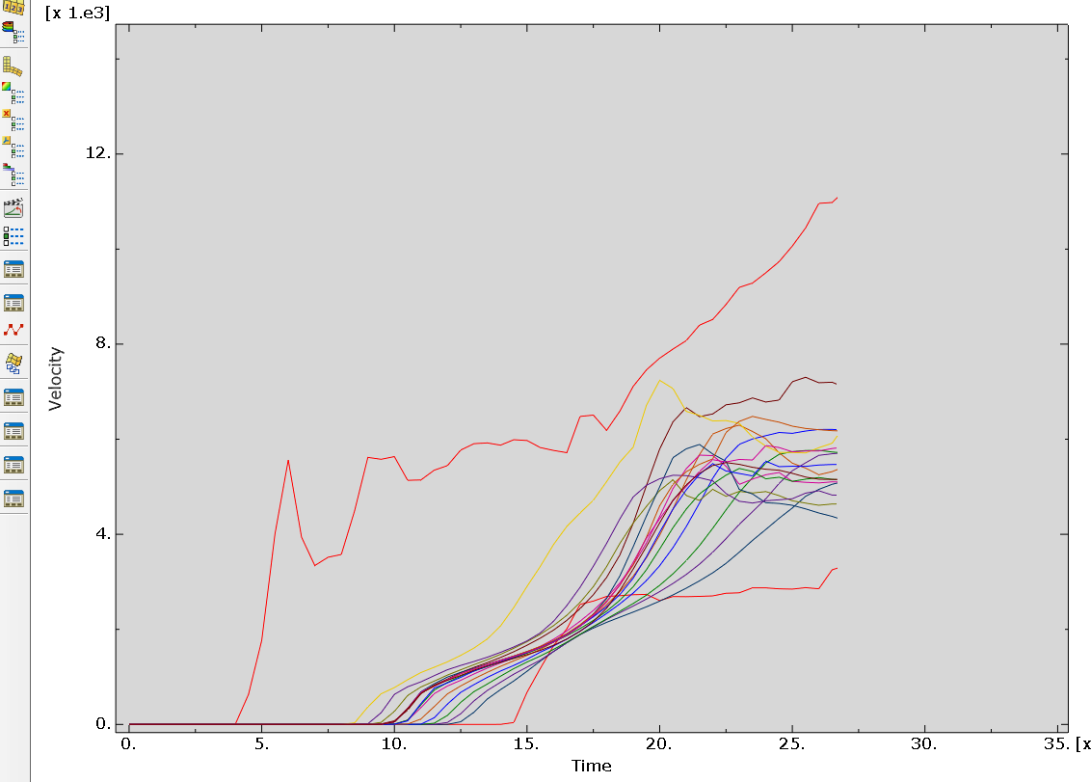
Figure 22 test 2 3d partially confined jet velocities

5.3 Fully constrained 3d model
In this case all exterior faces of the fill were given a boundary condition creating the ‘perfect case,’ forcing the fill and the liner to only move ‘down.’ This is shown clearly in Figure 23 where the full outer shape of the fill remains unmoving while the base projects down. Again, it is noticed there is significant stretching of nodes despite the ALE remeshing. This is especially clear at the apex of the cone where violation of the boundary conditions is seen. At present it is speculated that this is a numerical issue caused by the solver, but there is no conclusive evidence as to its root cause. While the simulation does error early in the jet formation, velocity can still be obtained, Figure 25 shows that the velocity is similar to that of test 2 (3d) between 4 and 6 kms⁻¹, an increase if present is rather minimal which was unexpected. 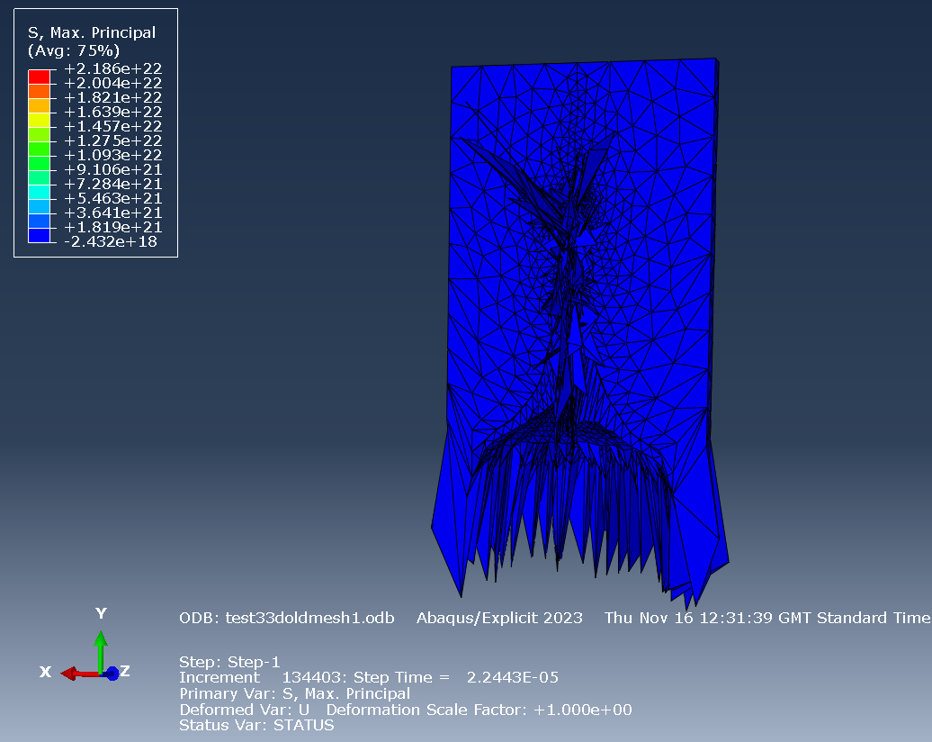
Figure 23 test3 3d fully confined step 1 (error)
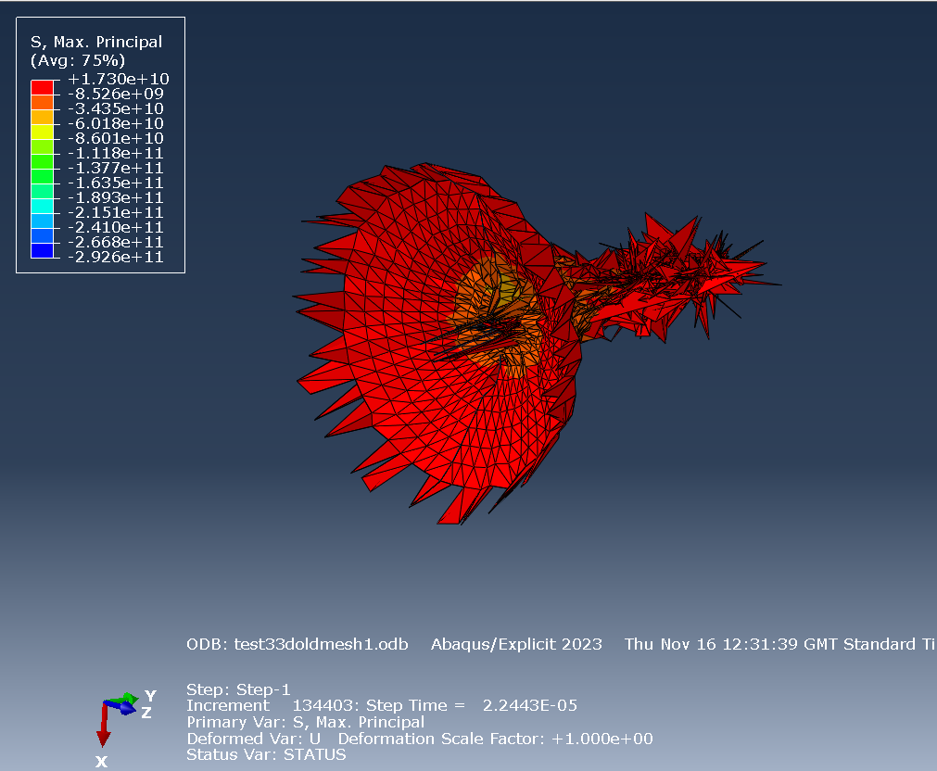
Figure 24 test3 3d fully confined jet step 1 (error)

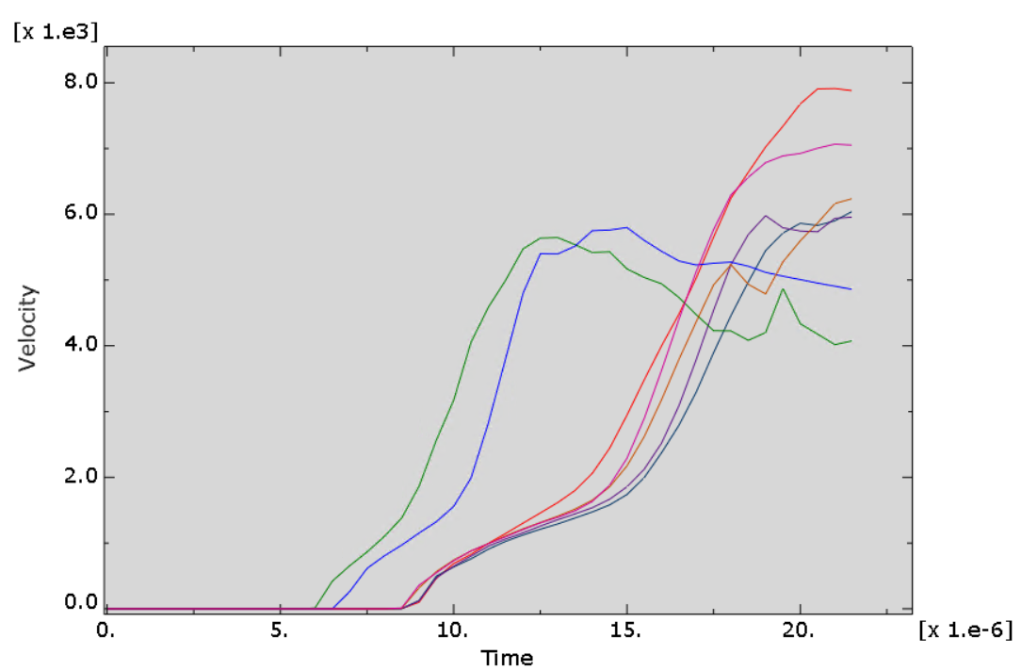
Figure 25 test3 3d fully confined jet velocities

5.4 Test ‘full 3d’ model
A final test simulation was done as a reference for the 3d tests. This simulation was similar to test 1, the fully unconstrained test case, however the model was revolved a full 3600. All other parameters were kept the same including remeshing. It was noted that this significantly increased the simulation time, and as such was impractical to run all test cases with this environment. The simulation also sufferance from the random spiking of over stretched nodes, this caused issues within the simulation which led to errors. In the centre of Figure 26 a single spike can be seen, when investigated and as shown by Figure 27 this spike was actually an artifact of the fill, and something that would not occur in reality. The velocity seen in Figure 28 is higher than that of the partial 3d simulations, and closer to that of the 2d tests. It is possible that the true velocities would be within this region, however, to determine with any degree is confidence the errors would have to be rectified. 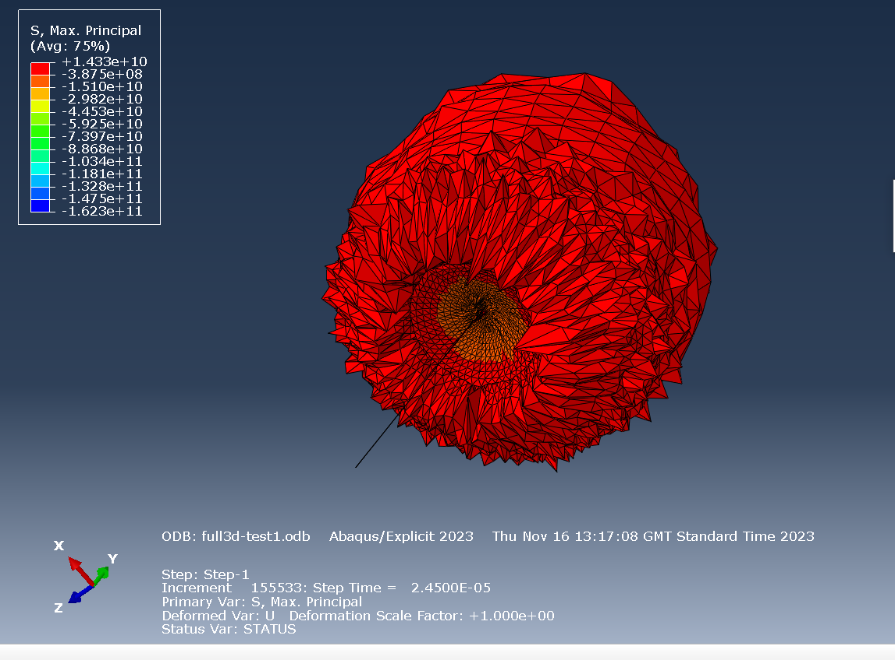
Figure 26 full 3d test
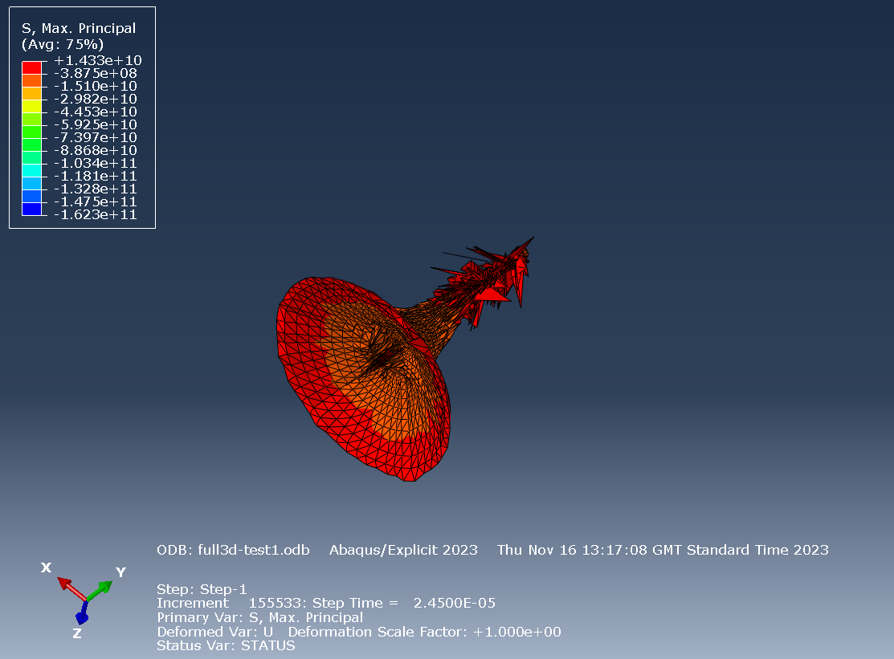
Figure 27 full 3d jet
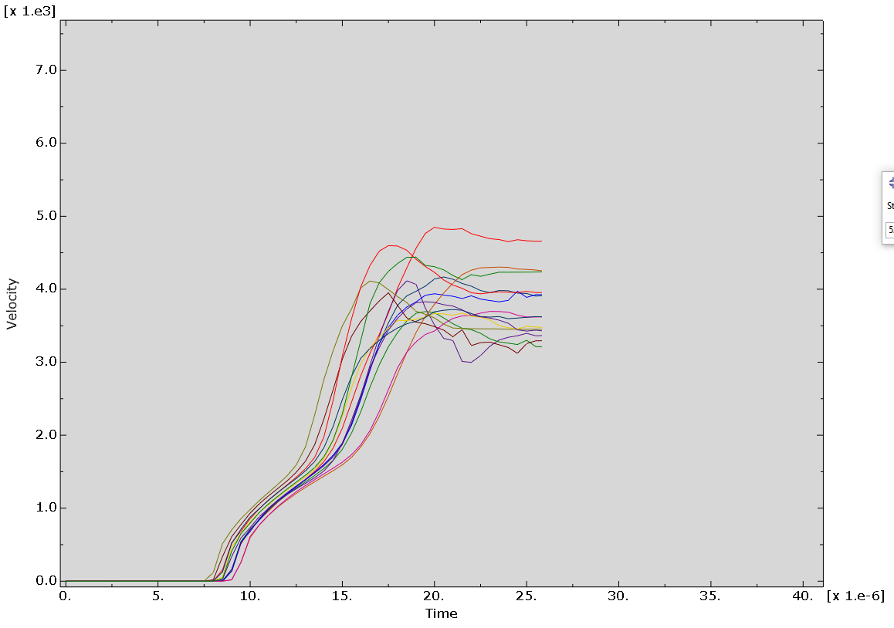
Figure 28 full 3d jet velocities

6.0 Summary
ABAQUS software can be utilised to great effect when simulating shaped charges, while there are many different ways of achieving this, this report does not claim to be the most effective or accurate way of doing this, it shows cases some of the features within. From the authors experience of using the software, the ALE adaptive meshing does help with some errors, further work using this would be likely be advantageous for future simulations. There appears to be significant differences in results between the 2d and 3d runs, especially with respect to jet velocities, within this the 2d appear to give much faster results than the 3d (180⁰) while one true 3d test (360⁰) lays in between this, to prove this further true 3d tests must be completed. The ‘spikes’ or excessive deformations may also be reduced by a hybrid Eulerian-Lagrangian approach, this could be of use especially during the initial formation of the jet and the inversion of the cone, where the liner material radically deforms, it is known from literature that Eulerian analysis is good at dealing with this [15] so a combination of both models would likely have the best results.

When comparing the different tests and the resultant velocities the results are somewhat unexpected. When comparing the fully unconfined and partially confined tests, a major increase of velocity was expected, this can be seen occurring in both the 2d and 3d models. However, it was again expected that significant increase would be seen when fully confining the fill (compared to partially confined). This was not the case, at a best minor increase of velocity was seen. Further investigation of why this occurred is recommended for future work, especially if maximum velocity for a given mass and type of explosive is desired.

7.0 References

References

[1] | “ABAQUS,” [Online]. Available: https://en.wikipedia.org/wiki/Abaqus. [Accessed 17 12 2023].
[2] | DASSAULT SYSTEMS , “Whats new in ABAQUS 2023,” DASSAULT SYSTEMS, [Online]. Available: https://www.3ds.com/products-services/simulia/products/abaqus/latest-release/. [Accessed 17 12 2023].
[3] | “Lagrangian and Eulerian specification of the flow field,” [Online]. Available: https://en.wikipedia.org/wiki/Lagrangian_and_Eulerian_specification_of_the_flow_field. [Accessed 17 12 23].
[4] | A. Y. Jamil, “Coupled Eulerian Lagrange (CEL) Analysis with ABAQUS,” [Online]. Available: https://simplifiedfem.wordpress.com/about/coupled-eulerian-lagrange-cel-analysis-with-abaqus/. [Accessed 17 12 2023].
[5] | W. Zukas, “Funamentals of shaped charge,” in 2.2 The Munroe effect, Maryland, Wiley-Interscience, 1989, p. 12.
[6] | J. S. Gordon Rottman, “Panzerfaust and Panzershrek,” Bloomsbury Publishing, 2014, p. 28.
[7] | W. Zukas, “Funamentals of Shaped Charges,” Maryland, Wiley interscience, 1989, p. 180.
[8] | J. Milinazzo, “Engergy transfer of a shaped charge,” Sandia National Laboratories, 2016, p. 3.
[9] | W. Z. /. H. Schrobenhausen, “Funamentals of shaped charges,” Maryland, Wiley Interscience, 1989, p. 343.
[10] | Z. Walters, “Funamentals of Shaped charges,” in Non-conical liners, Maryland, Wiley interscience, 1989, p. 311.
[11] | Y. Du, G. He, Y. Liu, Z. Guo and Z. Qiao, “Study on the Penetration Performance of Rewar Shaped Charge Warhead,” Beijing Insitute of Technology, Beijing, 2021.
[12] | D. C. e. al, “omparison Analysis Between Simulation and Experiment of Cutting Force and Cutting Stress as Well as Chip Morphology During the Macro and Nano Cutting of Single Crystal Copper,” Beijing, 2021.
[13] | K. Donne, “L5- Advanced Physics of OME,” [Online]. Available: https://moodle.uwtsd.ac.uk/course/view.php?id=9094. [Accessed 18 12 2023].
[14] | R. Tiwari, “Dynamic analysis of ungerground tunnels subjected to internal blast loading,” Indian insitute of technology, Delhi.
[15] | Virginia tehc, “Eulerian Analysis ABAQUS Guides,” [Online]. Available: https://docs.software.vt.edu/abaqusv2022/English/SIMACAEANLRefMap/simaanl-c-euleriananalysis.htm. [Accessed 3 1 2024].

