Problem solving and decision making

Contents
Introduction 1
Picking up a key study 2
PESTLE and SWOT analysis of Marks & Spencer 3
The challenges derived from the study 5
Further details of the identified problem 6
Tools and Models analyze the problem 7
Solutions 9
Conclusion 11
References 12

Introduction

Aravopoulou et al., (2018) refers that, now this is the age of so much competition in terms of quality, productivity, marketing, human resources or IT management by in business sectors. Every firm or business organizations try to maintain a model or unique type of operational management model so that their internal business objectives can be achieved in a great extent indeed. In terms of managing any sorts of business organizations or business form within any particular external or internal business organization, organizations may often face some sorts of basic problems. Solving the organizational emerged problems determines whether the organization will sustain successfully or not in the running business market. In this case, organizations have to formulate unique type of strategies so that they can overcome their existing organizational problems and can go for their already set goal or objectives. In this case, appropriate business decisions should be taken so that organizational problems can be solved effectively. Regarding this, decision making is basically about choosing the best alternative from various sorts of options and applying the chosen decisions to the matter of organizational operational management so that the emerged problems can be solved very easily and effectively (Sousa et al., 2014). Decisions should be made very strategically so that organizational problems can be addressed properly and the best suitable solutions can be chosen in order to achieve the organizational target. In this study, we are going to study about various strategically s of issues those can be arisen within any sort of organization. In this case, how the problem solving initiatives will be, we will look for in our study. We are also going to study, look into the organizational perspective of a particular organization by making SWOT and PESTLE analysis. We will see how particular problem is being faced by the organizational authority of the organization, what are the challenges exist there, what sort of models or tools and how they can be used to solve the problems and the solutions can be founded out and how they can be implemented in line with having satisfactory organizational output or organizational goal accomplishment.

Picking up a key study
Like any other business organization, In order to accomplish this study, out chosen organization is Marks & Spencer. This company is the one of the dominants multinational retailer in UK headquartered in Westminster, London. This organization was founded in 1884 by Michael Marks and Thomas Spencer in Leeds. This organization basically produces and sells various sorts garments products, home products, gift & hampers, beverage etc. It is a big multinational organization with its numerous outlets around the world. The number of total employees is around 84939 within its total 979 stores around the world. The annual revenue of the organization in 2017 is £10.622 billion. In addition to, the net income of the company is £115.7 million.
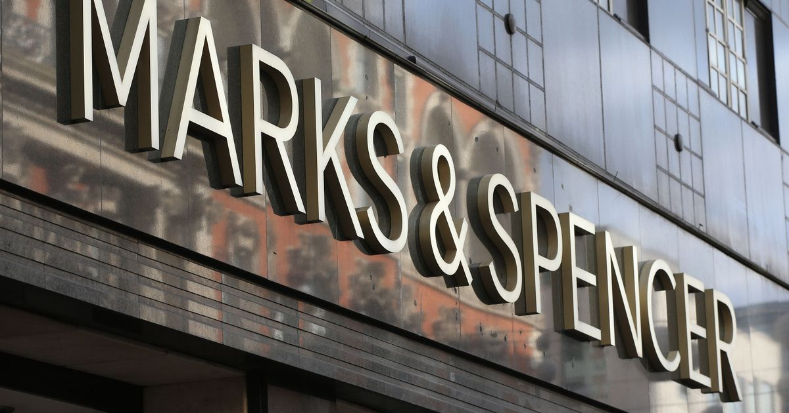
A study published in Statista shows that, Marks and Spencer is becoming leading retailer organization in UK market highly. With its unique types of operational management strategies and internal business processes, this organization is being enabled to make good in financial perspective. In the year of 2018, the global revenue for Marks & Spencer is 10.7bn GBP, the country in which the organization generates the highest revenue is UK. In addition to, the revenue achieved from the franchised businesses is 360.6m GBP and annual online sales in 2016 is 791.5m GBP (Facts, 2018). Moreover, this organization is doing well in other sector or production or service delivery. In Clothing and home ware share, Marks & Spencer do have 39% share, in food revenue this organization has achieved 5.87bn GBP. The study also shows that, in the sector of retail and fashion industry, there is satisfactory rating point from the customers. In addition to, the total Facebook followers of this organization is about 2251027 and huge number of customers indeed. This organization is really doing well in the matter of fashion and food industry (Marksandspencer.com, 2018).
In Marks & Spencer, I have been working for five years as human resource officer and I have experienced lots of things in the form of leading this organization. I am trying to develop an attractive career through giving my best effort.

PESTLE and SWOT analysis of Marks & Spencer
In the previous discussions, we have already told about that, we are working on the topic of problem solving and decision in the light of the organizational setting of Marks & Spencer organization. As I have been working to this organization for a long time as human resource officer, I have been gone through experiencing how the both internal and external environment is going on. In below, we are going to discuss about both external and internal environment assessment by making PESTLE and SWOT analysis.
- PESTLE analysis: PESTLE analysis is about analyzing the external environmental factors those are influence any particular organization in many ways. The things are discussed in details in line with the organizational setting of Marks & Spencer.
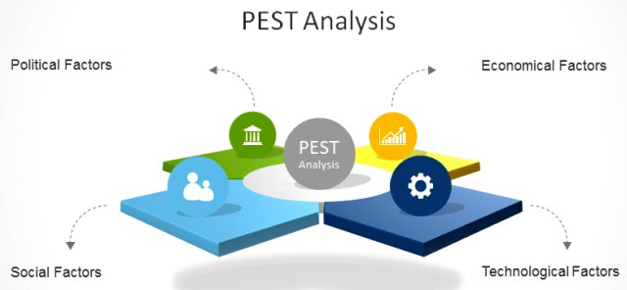
- Political factors: It is known to all that UK is a quite politically stable and it have wonderful business environment. There is no any sort of political violence greatly. So, Marks & Spencer is now being enabled to conduct better business performance. But due to having some sort of silly problems like unemployment problem, some political parties make procession and opposition this sometimes hampers business operation.
- Economic factors: UK economic market is more or less fine. But there exists now 2.4% inflation. This amount of inflation sometimes varies in terms of some sorts of business environment. In this case, Marks & Spencer sometimes feel difficulty if raw materials price goes up (Tradingeconomics.com, 2018).
- Social factors: UK people now often prefer using good quality products. In this case, they go to Marks & Spencer in order to buy their expected products. But sometimes, Marks & Spencer cannot provide the demand products. So, the organization have to go through loss.
- Legal factors: Heavy taxation system is now pressuring many business organizations in great extent. In this case, Marks & Spencer have to follow the environment policy very strictly and have to pay so much taxes in every year.
- Technological factors: The technological advancement in UK is flourishing the business activities between the organizational authorities and the customers. In this case, Marks & Spencer sometimes cope up with the running technological demands. Due to not having IT skilled people, the organization cannot comply with the technological needs.

All these are about the external environmental information of Marks & Spencer which has been found out through conducting PESTLE analysis in a large extent indeed.
- SWOT analysis: SWOT analysis is basically about conducting internal business environmental analysis through which the particular business organizational details can be known. Now we are going to show the SWOT analysis of Marks & Spencer in below.
SWOT analysis
Strengths.  - Good communication channel with the customers where organizational authorities can communicate with the customers and can serve them well by knowing their demands and wants.  - Flat organizational structure of Marks & Spencer ensures minimizing the procedures problems. Employees can work on their own will bring output in their own way.  - Marks & Spencer has a great brand value within business world. They can use this sort of thing for having new customer acquisition.  - The organization can easily retain its customers and customers become loyal to this company.  - High turnover is often ensured by Marks & Spencer for their unique business quality. | Weaknesses:  - Unsatisfactory employee relations is often seen in the organizational workplace of Marks & Spencer. In this case, line managers are often seen not to maintain good interactive action with the staffs.  - Lack of job rotation is not also visible matters in Marks & Spencer. In this organization, employees are not often given new assignment so they often feel bored by doing same jobs.
Opportunity:  - High demand for having the product of Marks & Spencer is creating new opportunity for increasing organizational net sales and revenue.  - New outlets opening in new market is making broadening the opportunity of making possibility of making reach to more customers.  - Organizational satisfactory business policy for good operational management. This is going to make hazard free organizational management. | Threats:  - One of the threats for the organization is that, employees sometimes are seen to be engaged in clashes and they are not accustomed to doing team working. This can hamper the productivity of Marks & Spencer.  - Employee turnover is increasing and job satisfaction is now being increased highly. In this the organization can have shortage of employees.
These are the findings after making SWOT and PESTLE analysis of Marks & Spencer Company.

The challenges derived from the study
In the form of conducting both SWOT and PESTLE assessment of Marks & Spencer, we have gone through some sorts of problems and challenges in the form of weaknesses and threats. From these sort of things we have come to know a specific challenge which can pose a major threat for Marks & Spencer is that is not solved properly. In the form of conducting the analyses we have known about a serious problem that is dissatisfaction of the employees for having various sorts of conflicts and improper human resource management. The employees are now being engaged in various sorts of anarchy and they are often seen to violate organizational rules and regulations. As I have been working in Marks & Spencer for five years, so I have been observing this sort of problems within the human resources those are not doing satisfactory activities which can hamper performance management culture within Marks & Spencer and the organization can go through serious economic losses (Marksandspencer.com, 2018). In this case, the organizational management should be aware and I should have given proper authority so that I can fix the problem.

Further details of the identified problem

In the previous discussion, we have already discussed about a specific problem within Marks & Spencer which can be serious problem for generating expected outcome from the company. In this case, the selected problem is dissatisfactory behavior from employees who are often being engaged in various sorts of clashes and anarchy. This problem is not a very new problem in Marks & Spencer. It is already discussed that, there about 979 stores around the world and the total number of employees working in various outlets of Marks & Spencer is about 84939. In this case, almost of the outlets are engaged with many employees from different sort of background. For example, in London outlet, there are many employees from many countries who are giving service. In this case, the native employees cannot bear the other country’s employees. They are often seen scolding or abusing the foreigner employees. In addition to, some employees are seen to make racism and engaged in quarrelling with the ethnic backgrounder employees. In this case, they are now often tended to be engaged in various sorts of conflicts or violence. For doing so, company’s team working and employees’ performances are getting low day by day and the company has to go through so much loss as productivity is getting low and sales is not increased (Marksandspencer.com, 2018). In addition to, there is no required accountability mechanism and legal provisions so that employees or any authority can be accountable for their unwanted behavior. The human resource management is now giving expected output to the organizational authority. The controlling apparatus is getting weakened. In this case, productivity is getting low day by day. In this case, the human resource management as well as the organizational authority should be aware so that they can fix these sorts of problems in a great extent indeed.

Tools and Models analyze the problem
Workplace or organizational problems are some sorts of difficulties which can be emerged either from internal or external environment of a particular organization. In this study, we have already showed a problem which has taken place from the internal organizational perspective which is the employees’ engagement in various sorts of conflicts and they are not concerned about their team working and how to increase their efficiency. By using Force Field, we are going to analyze the overall mattes in below.
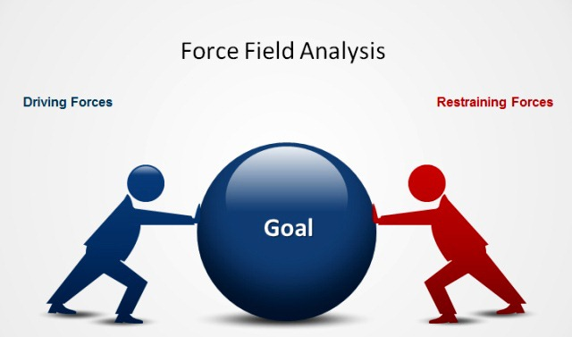
- Force Field analysis: In order to make proper change management, Sociologist Kurt Lewin developed this model in 1951. The current performance for any sort of organization is the result or affiliation of two forces and its equilibrium. The two forces are driving forces and resistance forces. This two forces actually determine how a particular organization will be run within a certain business context. Organizations can be run very well and effectively when these sorts of forces will reach its equilibrium greatly. The driving forces are basically the reasonable, logical, conscious, positive and economic. These sorts of forces should be welcomed by the organizational authority but that is not so much easy. The resistance forces which are mostly negative, illogical, unconscious or emotional. In this case, these sorts of things may set barriers in welcoming the driving forces (Moresteam.com, 2018).
Following these things, just only increasing the driving forces for a particular change may not be regarded as enough to make the change in particular. In this case, the organizational authority of any sort organization should also think about the resistance factors. Authorities should make balance between the both driving and resistance forces. This things can be make relate with our current human resource management problems within Marks & Spencer Company.
As in our organization, there is being seen a serious damage in employee relationship because of their internal conflict and violence for their bad cultural practice. The organizational authority can analyze this matter using this Force Field model. Firstly, we have to find out the driving forces for solving these problems and then the possible resistance problems which may create barrier in the way of driving forces. Now, we are going to illustrate both driving forces and resistance forces in below related with the organizational perspectives of Marks & Spencer.
- Driving forces: In minimizing and fixing with the current human resource problems and minimizing their conflicts, some sorts of driving forces can be worked. For example, in solving the problem, possibility of bringing harmony between workers, increasing organizational efficiency, maintaining good employee relations, high productivity, possibility of maintaining good culture (Gatt et al., 2015). This sorts of possibilities can be worked as motivation factor which can drive to bring a positive change by mitigating the problems.
- Resistance forces: In case of solving the arisen problems within the employees, some sorts of problems can be emerged as resistance forces. In this case, disagree of not complying with by the native employees, possibility of leaving the dissatisfied groups, possibility of increasing more clashes, possibility of further mismanagement etc. these sorts of matters may not welcome the driving forces properly to be implemented within the organizational setting of Marks & Spencer. In this case, these sorts of factors should be considered highly (Leonard, 2007).
In order to solve these sorts of problems, the organization and we have to be more strategic so that there can be brought balance between these forces. If we only consider about the driving forces, then resistance forces will not be considered. In this case, resistance forces may be occurred highly and the problems will be remained unsolved. So, the organizational authority should try to make a balance between these two sorts of forces so that the existing organizational problem can be solved easily. The dominated groups from the employees should be given recovery treatment and should be given shelter. On the other hand, the dominators should be given some sorts of guidelines or punishment so that they do not do the things further but it should not so much pressurizing. By making balance between these forces in such a way, the arisen can be solved.
- Fishbone analysis: Fishbone analysis is basically called as cause and effect relationship presentation for any particular organizational problem. In below, we are going to show various sorts of causes of our identified problem and the effects of the problem
Cause-01 Cause-02 Cause-03
Lots of employees’ Weak accountability uncontrolled mechanism
Effects
Low organizational performance

Caue-04 Cause-05 Cause-06
Low employee relations Lack of job rotation Lack of supervision

Figure: Fishbone analysis
In the figure, some sorts of causes of the employee clash problem have been identified. In the diagram, it is seen that, some sorts of specific causes are making happen of the identified problems. These sorts of causes are making serous bad effects as a result net productivity is being decreased and organizational performances are getting low day by day. In order to overcome this problems, the identified causes should be solved properly.

Solutions
In the previous tasks of discussion, we have already shown about how a specific problem is happening within the organizational setting of Marks & Spencer. Our already found problem is the unrest problem within the human resource management system and the bad workplace culture. In this case, some sorts of solutions can be suggested considering the organizational context of Marks & Spencer. The solutions are illustrated in below.
Solutions for dealing with the problem:
- Identification of the problem: Before addressing or taking strategy for solving any sort of organizational problem, the nature of the problem should be recognized and identified properly so that actual scenario can be enlightened in the eye of the managerial authority of the relevant organization like Marks & Spencer . In this, our problem statement has been done earlier. The problem is about the existing bad working culture, and the low employee relationship within the workers in a great extent indeed.
- Brainstorming: In order to solve any sort of problem, brainstorming should be conducted properly so that problems can be brought under consideration by making logical thinking. In this case, thinker have to find out the best possible options and then should seek the best option so that decision making can be best suited for solving the problem in a great extent indeed (Zaraté, 2008). In this case, the organizational authority can bring change or make restructuring about the workplace culture.
- Choosing the best strategy: In case of making decision for solving the arisen problems, organizational authority of Marks & Spencer should think about the best strategy by which the organizational needs can be met up properly. In this case, various sorts of ways can be suggested but I think the best strategy can be that, employees should be make proper grooming and an organizational policy should be formulated in which the details about the possible punishment for the relevant crimes. By doing, problems can be solved properly. This can be the best strategy for solving the problem.
- Implementation of the strategy/ solution: The identified solution in the previous point, can should be implemented properly within Marks & Spencer in order make proper solution. In this stage, the identified solution should be implemented through taking some sorts of strategies. In this case, all sorts of employees from every section of the organization should be brought under a common ground in which they can be communicated the taken strategy. They should be involved in the change management. In addition to, the organizational authority should take policy about giving punishment for making any sorts of conflicts. In this case, various sorts of rules can be taken. The level of punishment can be from financial fine to suspension of guilty for showing their agitating behavior or activities (Warner, 2010).
Alternative solutions:
Besides on the above mentioned solutions techniques or strategies, some sorts of solutions can be suggested broadly. These sorts of strategies or ways are very much strategic and realistic. The alternative solutions are given in below in a large extent.
- Team working: As now-a-days in Marks & Spencer, there is seen huge collapse of employee relationship between the employees, so the organizational authority should work on how to increase the team working and the employee relations can be rebuilt in a great extent.
- Job rotation: Sometimes, employees are engaged with various sorts of misunderstanding or anarchy by working with each other for a long period of time. In this case, the organizational authority of Marks & Spencer can make job rotation so that employees can have new taste of doing new work and they can comply with the new companions easily.
- Recognition: Marks & Spencer should take initiatives for motivating good employees for their good friendly culture within the organization. The employees should be assessed with some sorts of KPIs in which their behavior assessment can be a big part (Forgang, 2004). In which, people with the best familiar and poplar faces, should be recognized so that others can be motivated greatly.
- Entertainment: The organizational authority of Marks & Spencer can arrange a range of entertainment system like annual excursion, sports of others. By doing so, employees from all sorts of sectors of the organization will have the opportunity to come closer and maintaining a good interpersonal interrelationship. In this case, their social bondage will certain be enriched. By this, way the level of conflicts will be tended to be minimized greatly and the problem will be automatically solved in a great extent indeed.
By taking these sorts of ways or strategies, the organizational authority of Marks & Spencer can go for a long way for having their expected solutions. By doing so, organizational human resource related problems will be abolished and a good working culture can be established by which organizational performance can be increased in a great extent indeed.

Conclusion
Every firm or business organizations try to maintain a model or unique type of operational management model so that their internal business objectives can be achieved in a great extent indeed. In terms of managing any sorts of business organizations or business form within any particular external or internal business organization, organizations may often face some sorts of basic problems. Solving the organizational emerged problems determines whether the organization will sustain successfully or not in the running business market. In this case, organizations have to formulate unique type of strategies so that they can overcome their existing organizational problems and can go for their already set goal or objectives. In this case, appropriate business decisions should be taken so that organizational problems can be solved effectively. Regarding this, decision making is basically about choosing the best alternative from various sorts of options and applying the chosen decisions to the matter of organizational operational management so that the emerged problems can be solved very easily and effectively (Sousa et al., 2014). In this study, we have tried to our best to identify the very internally closed problem and we have also suggested the possible best solutions for the problem. Actually, in order to meet up the recovery and to have an expected organizational output, Marks & Spencer should work on it. In addition to, about a specific identified problems, its impacts, organizational environmental assessment, possible solutions of the problem have been tried to illustrate in the organizational setting of Marks & Spencer.

References
Aravopoulou, E., Branine, M., Stone, M., Mitsakis, F. and Paul, G. (2018). Strategic decision-making process (SDMP) in times of crisis: Evidence from Greek banks. Journal of Business & Retail Management Research, 12(04).
Creative problem solving. (2007). Puchong, Selangor: Winsure Resources.
Facts, M. (2018). Topic: Marks and Spencer. [Online] www.statista.com. Available at: https://www.statista.com/topics/3707/marks-and-spencer/ [Accessed 7 Aug. 2018].
Forgang, W. (2004). Strategy-specific decision making. Armonk, NY: M.E. Sharpe.
Gatt, R., Mizzi, L., Azzopardi, K. and Grima, J. (2015). A force-field based analysis of the deformation mechanism in α-cristobalite. physica status solidi (b), 252(7), pp.1479-1485.
Leonard, B. (2007). Multidimensional decision making. [Bradford, England]: Emerald.
Marksandspencer.com. (2018). Welcome to Marks & Spencer. [Online] Available at: https://www.marksandspencer.com/ [Accessed 7 Aug. 2018].
Moresteam.com. (2018). Fishbone Diagram Tutorial. [Online] Available at: https://www.moresteam.com/toolbox/fishbone-diagram.cfm [Accessed 6 Aug. 2018].
Sousa, F., Monteiro, I., Walton, A. and Pissarra, J. (2014). Adapting Creative Problem Solving to an Organizational Context: A Study of its Effectiveness with a Student Population. Creativity and Innovation Management, 23(2), pp.111-120.
Tradingeconomics.com. (2018). United Kingdom Inflation Rate | 1989-2018 | Data | Chart | Calendar. [Online] Available at: https://tradingeconomics.com/united-kingdom/inflation-cpi [Accessed 6 Aug. 2018].
Warner, A. (2010). Strategic analysis and choice. [New York, N.Y.] (222 East 46th Street, New York, NY 10017): Business Expert Press.
Zaraté, P. (2008). Collaborative decision making. Amsterdam: IOS Press.

