Student name: Klaudia Csoka
Student number: 2407757
Module code and title:BMHP5014 Changemakers: Creativity and Value Creation
Assignment title: Component 2: Written Assignment (Report)


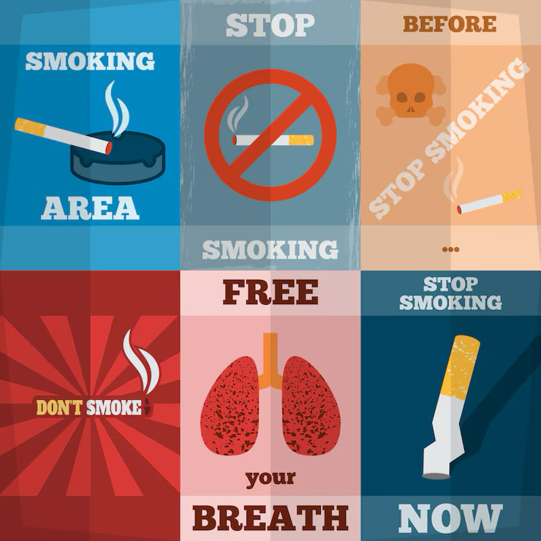
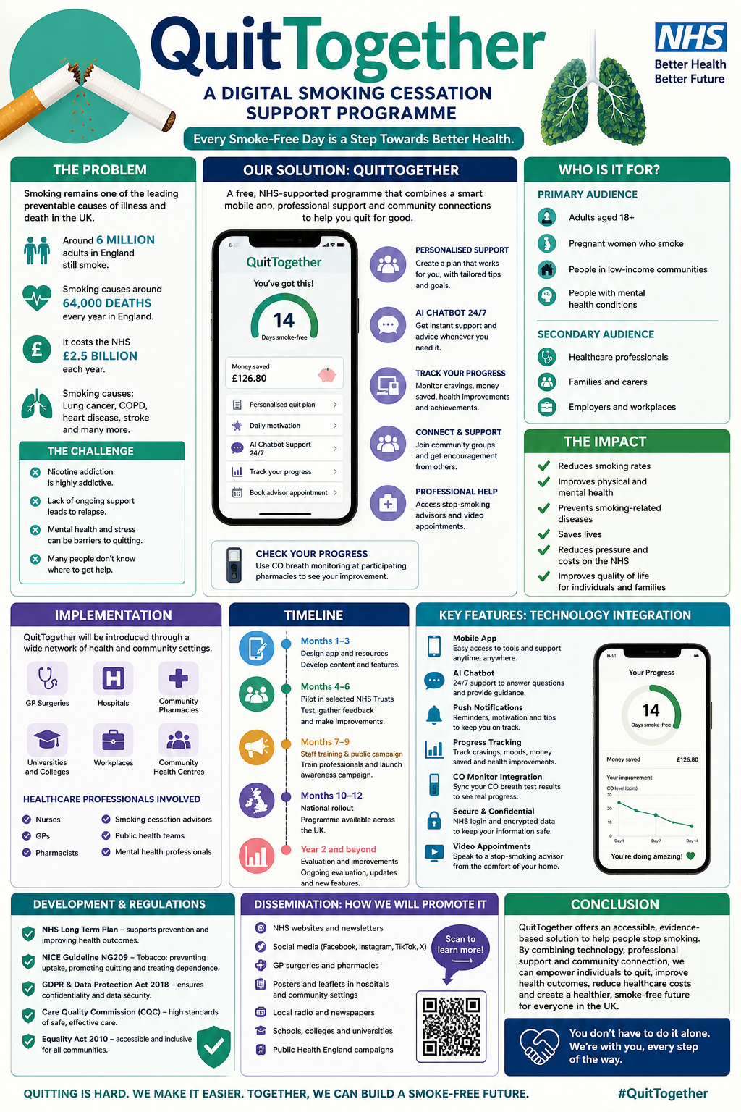
Pitch: QuitTogether – An Innovative Digital and Community-Based Smoking Cessation Programme
Smoking remains one of the leading preventable causes of illness and premature death in the United Kingdom. Despite decades of public health campaigns and the availability of NHS Stop Smoking Services, around six million adults in England continue to smoke, contributing to diseases such as lung cancer, chronic obstructive pulmonary disease (COPD), heart disease and stroke (NICE, 2023). Smoking also places considerable pressure on NHS resources through avoidable hospital admissions and long-term treatment costs. Many smokers attempt to quit several times before they succeed, often because they lack continuous support, motivation or access to personalised interventions. For these reasons, innovative approaches are needed to improve smoking cessation outcomes.
QuitTogether is an innovative programme that combines digital technology with community-based support to help people stop smoking. It consists of a free NHS-supported mobile application integrated with local healthcare services, including GP surgeries, pharmacies and NHS Stop Smoking Services. The programme provides users with personalised quit plans, progress tracking, motivational support, peer communities and access to healthcare professionals. Artificial intelligence (AI) is used to tailor advice according to each individual’s smoking habits, previous quit attempts and personal goals, making support more relevant and engaging.
The primary target audience for QuitTogether includes adults aged 18 years and over who currently smoke. However, the programme is also designed to support groups that experience higher smoking rates, including people living in deprived communities, pregnant women who smoke and young adults who are beginning to develop nicotine dependence. Smoking is closely linked to health inequalities, with prevalence remaining significantly higher in disadvantaged populations. By providing free, easily accessible support through digital technology and local healthcare services, QuitTogether aims to reduce these inequalities and improve health outcomes for vulnerable groups.
One of the key strengths of QuitTogether is its personalised approach. Research shows that behavioural support combined with evidence-based stop-smoking treatments significantly increases the likelihood of successfully quitting (NICE, 2023). Through AI technology, the application creates tailored quit plans based on the user’s smoking history, preferred quitting method and progress over time. Daily motivational messages, educational resources and reminders encourage users to remain committed throughout their quit journey. The app also allows users to monitor improvements in health, money saved and smoke-free milestones, reinforcing positive behaviour and increasing motivation.
Community support is another essential component of the programme. Many smokers struggle with isolation during quit attempts and benefit from encouragement from others who have experienced similar challenges. QuitTogether includes moderated online peer support groups alongside local face-to-face sessions delivered through GP practices, community centres and pharmacies. Healthcare professionals, including nurses, pharmacists and smoking cessation advisers, provide evidence-based guidance and monitor participants’ progress where appropriate. This combination of digital and personal support creates a more comprehensive service than relying on technology alone.
Technology plays a central role in enhancing the effectiveness of QuitTogether. AI-powered coaching enables the app to adapt advice according to users’ behaviour, while secure cloud-based systems allow progress to be monitored safely. Users can also choose to connect wearable devices or carbon monoxide monitors to track improvements in their health after stopping smoking. Automated reminders encourage attendance at appointments and completion of milestones, helping to reduce dropout rates. Importantly, all personal information is stored securely and handled in accordance with the UK General Data Protection Regulation (UK GDPR) and the Data Protection Act 2018, ensuring confidentiality and protecting users’ privacy.
The successful implementation of QuitTogether depends on collaboration between healthcare professionals, public health organisations and local communities. The programme would initially be piloted within selected NHS Trusts before being evaluated and expanded nationally. GPs, practice nurses, pharmacists and NHS Stop Smoking advisers would introduce eligible patients to the service during routine appointments. Public health teams would oversee implementation and evaluate outcomes using measurable indicators such as quit rates at four weeks, three months and one year. Feedback from participants would also be collected to improve future versions of the programme.
The innovation aligns closely with current UK health policies and legislation. The NHS Long Term Plan highlights the importance of preventing illness and providing greater support for people who wish to stop smoking. Similarly, NICE Guideline NG209 recommends combining behavioural support with pharmacological interventions to maximise smoking cessation success. QuitTogether directly supports these recommendations by offering behavioural support while encouraging appropriate use of nicotine replacement therapy and prescribed stop-smoking medications under professional supervision. Furthermore, the programme supports the UK Government’s ambition to create a smoke-free generation by reducing smoking prevalence and preventing smoking-related disease.
Promotion and public engagement are essential to the programme’s success. QuitTogether would be promoted through NHS websites, GP surgeries, pharmacies, hospitals, universities and workplaces. Social media campaigns on platforms such as Instagram, Facebook and TikTok would increase awareness among younger adults, while local community events would encourage participation from harder-to-reach populations. Healthcare professionals would play an important role in recommending the programme to suitable patients, helping to increase trust and uptake. Partnerships with charities and public health organisations would further strengthen dissemination and encourage widespread adoption.
Although implementing QuitTogether requires initial investment in technology development, staff training and marketing, the long-term benefits are likely to outweigh these costs. Reducing smoking prevalence decreases demand for expensive treatments associated with smoking-related diseases, ultimately generating substantial savings for the NHS. In addition to financial benefits, the programme has the potential to improve quality of life, increase productivity and reduce health inequalities across the UK. Evaluation through user satisfaction surveys, healthcare data and quit rates would enable continuous improvement and ensure that the programme remains effective and responsive to users’ needs.
In conclusion, QuitTogether offers an innovative, evidence-based solution to one of the UK’s most significant public health challenges. By combining AI-powered digital support with community-based healthcare services, the programme provides personalised, accessible and continuous assistance for individuals who want to stop smoking. It supports national health priorities, complies with UK legislation and promotes healthier communities while reducing pressure on NHS services. Investing in QuitTogether would contribute towards a smoke-free future, improve health outcomes and empower thousands of people to successfully overcome nicotine addiction.

Reference list:
Action on Smoking and Health (ASH) (2024) Smoking statistics. Available at: https://ash.org.uk (Accessed: 12 July 2026).
Department of Health and Social Care (2023) Stopping the start: our new plan to create a smoke-free generation. London: Department of Health and Social Care.
National Institute for Health and Care Excellence (NICE) (2021) Tobacco: preventing uptake, promoting quitting and treating dependence (NG209). Updated 4 February 2025. Available at: https://www.nice.org.uk/guidance/ng209 (Accessed: 12 July 2026).
NHS England (2019) The NHS Long Term Plan. Available at: https://www.longtermplan.nhs.uk (Accessed: 12 July 2026).
UK Government (2018) Data Protection Act 2018. Available at: https://www.legislation.gov.uk (Accessed: 12 July 2026).
UK Government (2021) UK General Data Protection Regulation (UK GDPR). Available at: https://www.legislation.gov.uk (Accessed: 12 July 2026).

