Marketing Management 1
Module LCMB7001

Eleonora Mariana Filip
1806173
Lecturer:Tushara Balenndran

INNOVATIVE MARKETING STRATEGIES FOR THE BUSINESS PROCESS OF CHANEL

Table of Contents
Introduction 3
Background Information 3
PESTLE Analysis of Chanel Company 4
Porter’s 5 Factor 5
SWOT Analysis 7
Segmentation, targeting, and the positioning 9
Marketing Mix 11
Conclusion and Recommendations 13
References 15

Introduction
Chanel is a France-based company; the segmentation of this company is the house of luxury fashion. Nowadays the house of luxury fashion is growing frequently in the market and the performance of the industry is getting so much profit. And Chanel is among them and one of the oldest companies that are holding their position in the market and growing their profit frequently from the market through their business on fashion products. Chanel is also considered as a company that is held privately, the reason behind this is that, unlike some other famous fashion brands, the Chanel Company is not owned by a publicly-traded company that is agglomerate publicly. And because of this reason, the Chanel Company doesn't have any obligation for sharing the earnings which they earn in their financial time circle. As per all of this information, Chanel is considered an independent and private company. The products of the Chanel Company are quicker listed on their website the fashion product, fine jewelry products, watches, beauty products as well as fragrances are also available. As for developing the innovative strategies for the marketing of the business of Chanel Company, this report has been structured. With the help of this report, the current situation of the business will be known and the points where the business of Chanel Company needs to be improved will also be known. For gathering all of the information of the company first of all the background of Chanel Company will be explained, then the Macro Environment of the company or the factor of PESTLE of this company will have a description, following these things the 5 factors of Porter will be described, after that there will be a SWOT analysis which will describe the strengths, weakness, opportunity and the threats of the company, then the marketing mix will be explained, after that the recommendation will be suggested for the innovative strategies of the company.

Background Information
The Chanel Company was founded by Coco Chanel in the year of 1910, the company had been founded in the city of Paris, France. The company basically focuses on the clothes for the women which are ready to wear and also it produces the luxury items goods as well as accessories for the women. The headquarters of the company is based in London, United State. It has also a partner organization which is known as 'Chanel Limited'. Currently, the owner of the company is Alain Wertheimer and Gerard Wertheimer, and the CEO of the company is Alain Wertheimer from 2016 and 2022 Leena Nair is also being a CEO of the company (Pereira, 2021). At the very early date of the company, Coco Chanel was firstly producing the perfume, and after that she launched her dress which is known as the little black dress which is also considered very comfortable for women. Coco Chanel was also a designer. She was famous for timeless design, for her suits which was also her trademark, and most importantly she was extremely famous for her "little black dress".

PESTLE Analysis of Chanel Company
P: The Chanel Company’s global reputation makes it more sensitive to impact upon the political surroundings of multiple nations. In a contemporary discourse, diversifying potential impacts seems to be the secret to success in some kind of a vibrant international market place. A state's political landscape is made up of many different factors. A steady and amicable workplace environment with consistent revenue growth developments is provided by significant political stabilization. Even if there is political turmoil, meanwhile, it deters investment as well as affects shareholders' belief in macroeconomics and, as a result, organizational effectiveness (Peng, 2021). Chanel is presently available in a number of nations, each with its own set of political problems. Growing tensions, as well as instability in the international political climate, can have an impact on the development of the gold sector as well as restrict Chanel's expansion potential.
E: Chanel must comprehend capital expenditure incurred like as currency swaps rate, employment rates, unemployment, and access financial, among others, since these influence the government's actual financial climate (Grilec et al. 2020). Chanel can forecast the overall growth of organization and industry with a thorough awareness of the market situation. A country's industrial growth has a significant impact on organizational effectiveness. Emerging markets provide Chanel with several prospects for expansion. Similarly, it is critical to comprehend the development and product stage. Joining mature businesses might be more difficult owing to consumer adoption than define the business in the development stage. Furthermore, Chanel's performance measurement.
S: Corporate culture is heavily influenced by societal standards, attitudes, and movements. Using comprehensive PESTEL analysis, Chanel could build clever advertising communications as well as meet company objectives by analyzing population trends, power dynamics, consumers' purchase habits, and common opinions (Guseva, 2021). Chanel's sales department may utilize information gleaned from sociological and also environmental analyses to target certain groups of customers and boost the attraction of provided items to prospective purchasers.
T: The fourth PESTEL analysis component includes 'technology.' The fast growth and dissemination of technology throughout the world has raised the relevance of comprehending technical aspects even during operational judgment procedures. A thorough examination of the technology environment may assist Chanel in capturing emerging innovations in order to gain specific business benefits, including such as improving productivity, accelerating the creative process, as well as improving business.
E: Growing land pollution, along with technology innovation, has driven businesses to use novel recycling and reusing strategies. Composting has practically become an economic necessity in several nations. Furthermore, Chanel places a great priority on implementing appropriate waste management procedures in organizational units situated in or around metro regions.
L: The sixth PESTEL analysis aspect L is considered as "Legal." Chanel could not enter a new industry unless the regulatory climate, as well as regulatory environment of the growing customer market, are well researched (Guseva, 2021). To prevent significant legal difficulty, a rigorous study of legal implications is essential. Knowledge throughout this respect could result in unfavorable outcomes for Chanel, including a loss of comparative advantage as a consequence of infringement on intellectual property laws as well as a tarnished company's reputation as a consequence of violations of consumer/employee/environmental legal requirements.

Porter’s 5 Factor
The business process chanell is associated with offering a wide rage of beauty products to customers where effective implementation of the model of Porters' five forces can assist in making effective analysis of the microenvironment. In addition, the essential strategic objective of Chanel business is to generate greater value for the potential audience and to enhance business in the global environment. In this dimension, this model shows five crucial factors including - existing competitors, new entrants in the market, bargaining power of the buyers, bargaining power of the suppliers, and the threat of substitutes. Add to that, in the context of existing competitors, this business process is involved with several competitors such as "Coty, L’oreal, Ultra beauty, Glossier, Revon and others” (Leite, 2019). Therefore based on the implementation of the model porter's, it can be identified as growing marketing competitiveness in the US as well as the global environment so that it can be made a strong positioning strategy.
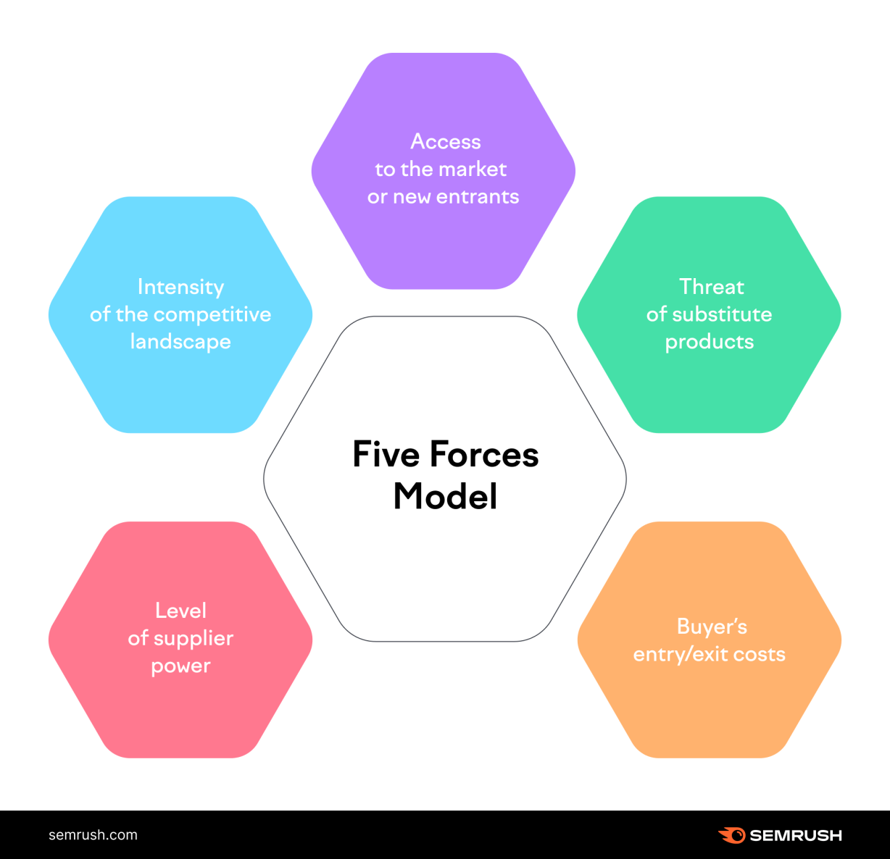
Figure 1: Five force Porter’s Model
(Source:https://static.semrush.com/blog/uploads/media/63/42/634256ac748c65132e8e9b05974f574e/1-EN-6-market-analysis-steps-6.png )
Apart from that, the bargaining power of the potential buyers is another essential factor that can impact strategic business goals of Chanel. The availability of several competitors in the market is associated with the force of buyers' power of bargaining therefore, an effective measurement of this bargaining power is required for generating effective sales revenues as well as profitability. Furthermore, this model also represents that, the substitution threat is also a major force that can impact on the acquisition as well as retention of customers. Add to that, there are some available close competitors of the Chanel, associated with “Estee lauder, L’oreal and coty" where availability of several alternatives or options of customers, can harm the retention rate of the customers (Alonso, 2021). Retaining a good segment of customers is one of the major objectives of this company where a fast operation process of any new entrants can impact the market development and other expansion objectives. According to this model porter's, increasing the power of supplier bargaining is also a major aspect that can impact the operational efficiency of the business. In addition, in the case of the availability of ineffective supply sources, it can affect cost management along with the pricing strategy of this business.
The main strategic objective of its business process of Chanel is to expand its operation in the international market along with the domestic market. Based on the market report of 2019, it can be identified that the market size of the cosmetic industry has reached around 380 billion USD and it is the projection that this size would reach to around 465 billion USD by the year 2027. In this large and growing industry size, a proper implementation of porter's model can assist in evaluating different forces of the micro-business environment that can impact on the efficiency of business initiatives (Fernandes, 2019). In the context of expanding the business, this business is highly considered on increasing the product line and offering customers a wide range of services where its crucial product lines are related to fragrance, jewelry, makeup, skincare, watches, ear wears, and others. Gaining an effective value in return is largely dependent on the strong position of product and services where a greater efficiency in positioning and making differentiation is largely dependent on the evaluation of micro forces of the business environment. Therefore, it can be said that an effective application of this model can help this business in generating higher value for customers and to gain an effective retention rate by meeting customer satisfaction.

SWOT Analysis
Analysis of swot is represented by the brand with the help of "strength, weakness, opportunity, thread". The internal factor of the sword analysis is age strength and weakness and the external factor of the swot analysis is age opportunity and state.
Strength
The strength of the channel company is international, with companies having nearly 300 + boutiques. International channel brand has been published for many years. The channel company also provides comfortable clothing to the customer with affordable design globally (Tran, 2020). The channel organization also provides many products around the globe like perfume, side bags, watches, skincare, etc. The organization also collects classical and timeless designs which are very popular with consumers.
Weakness
Chanel's market dominance growth was constrained due to strong competition from these other luxury brands. Despite very good brand brilliance, switching the brand is very high.
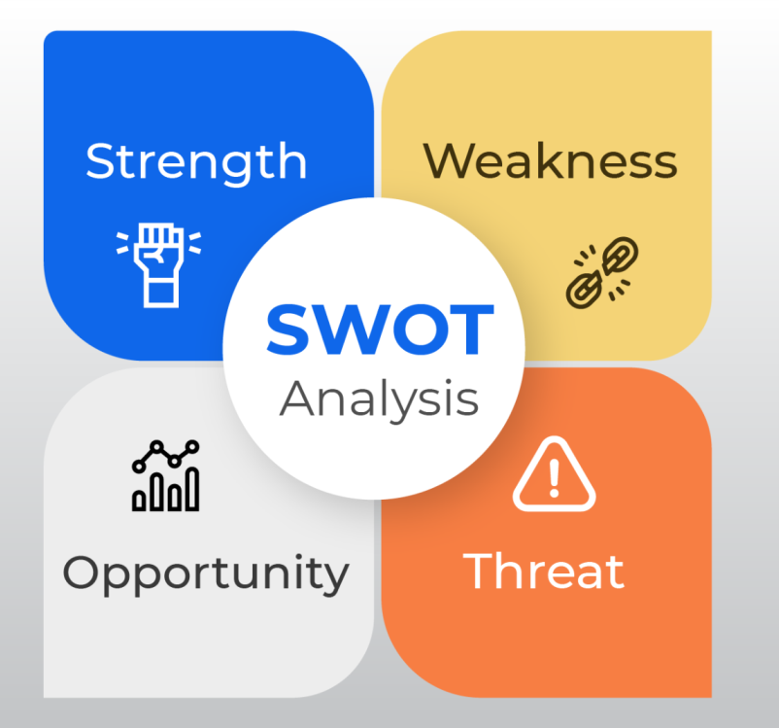
Figure 2: SWOT Analysis
(Source:https://www.socialpilot.co/wp-content/uploads/2021/07/Featured%20image@3x.p)
Opportunity
Nowadays the channel company's best opportunity is the online sales as well as e-marketing obtained and much significance has been tapped by the channel organization. Emerging markets, as well as international expansions including acquisitions (Zhou, 2019). Takeovers plus its innovative products Collaborations with well-known hotel chains plus fashion firms to help the company grow.
Threat
Chanel's customer base may be reduced by competing companies that sell similar apparel and shoes. Production is driven by market slowness and slump. Counterfeiting as well as high prices also are obvious threats. Other less expensive and lower-end brands are attempting to imitate its classic styles while selling at far lower prices.

Segmentation, targeting, and the positioning
After evaluating the external environment micro and macro analysis and making internal analysis, proper implementation of the marketing model of STP - " segmenting, targeting and positioning" can assist in acquiring a large number of the potential audience.

Segmenting  Demographic segmentation:  Segmenting the market based on income, occupation, gender  Geographic segmentation  Segmenting the market based on the population and higher number of the potential audience  Psychographic segmentation  Considering segmenting the market based on customer's thinking, culture, interests  Behavioral Segmentation  Considering market segmentation based on brand awareness, brand equity, brand loyalty | Targeting  Targeting customers based on the age group of 18-45  Targeting customers based on the income of different customer group  Considering generating effective personalized communication based on customer's interests, thinking, and behavior | Positioning  Strategies  Implementing strategy of cost leadership:  Considering keeping the price lower than rival businesses  The strategy of Product differentiation:  Considering offering quality products and features  Applying positing types:  Focusing on “competitor versus positioning”-  Proving product better than any available top competitor  User Positioning  Positioning of products and services based on audience type
Table 1: STP Model
(Source: Self-Created on MS-Word)
Effective implementation of the marketing model STP can assist in dividing the entire market based on the demographic, psychographic, behavioral as well as geographic aspect (Deerod, 2018). In the context of the business of Chanel, these four essential segmentation approaches can assist in making a strong content marketing strategy for establishing strongly targeted personalization. Add to that, considering the age group of 18-45 effectively it can generate effective sales revenue by offering its wide range of products (including -fragrance, jewelry, makeup, skincare, watches, ear wears, and others) (Bruijl, 2018). In evaluating micro factors, it has been identified above that Chanel is associated with several existing competitors such as “Coty, L’oreal, Ultra beauty, Glossier, Revon, and others". In this dimension, a focused strategy of cost leadership and a focused strategy of product differentiation can assist in price-sensitive as well as quality-sensitive audiences.
Furthermore, the current marketing process is highly associated with the strategies of digital marketing where an effective content generation based on different users can help enhance the customer engagement so that it can generate an effective lead. For instance, female audiences can be effectively targeted based on their interests, behavior, and income by making strong content.Based on the essential objectives of Chanel, it can be identified that the generation of effective brand awareness and the creation of strong brand equity are crucial aspects.
Brand equity model of Keller
According to the “brand equity model of Keller", the creation of strong brand equity and brand value dependent on the creation of strong value for customers and providing a great customer experience. In this dimension, a proper application of identified two positioning strategies and types can assist in building a strong brand value and equity. According to the market report of 2019, it can be observed that the market size of the cosmetic industry has reached around 380 billion USD and it is the projection that this size would reach to around 465 billion USD by the year 2027 (Kabeyi, 2018). . In generating a greater brand image in the competitive market, evaluation of the process of customer buying decision making is also a major task where based on differentiation strategy as well as influence marketing strategy, it is required to include this buying process of customers. In this aspect, a proper application of the STP model with considering the model of Keller for genes brand equity can assist Chanel in gaining a positive outcome from marketing efforts.
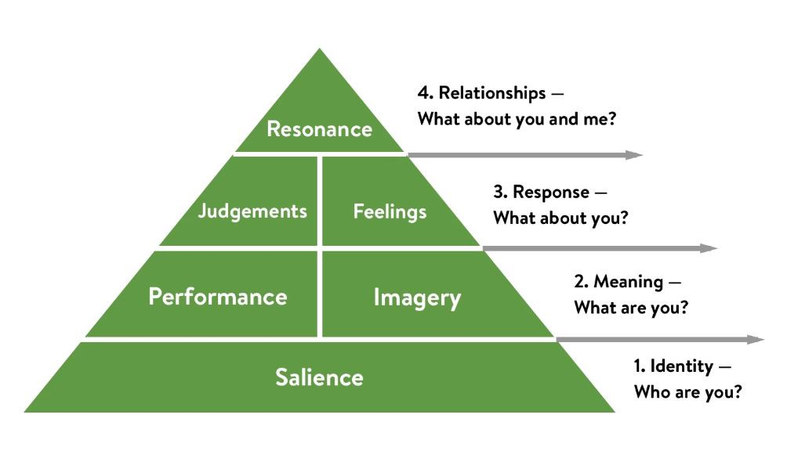
Figure 3: Brand Equity Model of Keller
(Source: https://miro.medium.com/max/1004/1*hE-Yu63UKg31nRwXXo8r-A.jpeg)

Marketing Mix
The marketing mix is called a 4PS marketing mix. Effective achieving this net requires more hard work to find out what consumers required and identify where the consumer is going for shopping. After that urgently required to identify how to manufacture the goods at a worth which is presenting the value of it. After that take, it is entirely assembled at the analytical time. But if the Chanel company gets the wrong elements then it might spell disaster. It might be left to the promotion of the product of Chanel's organization (Anastasiu et al. 2020). The Chanel organization marketing mix along with the 4ps marketing are the great tools that may help it to keep away from this type of mistake. From this above discussion, it has gotten little idea about the marketing mix or perhaps the 4ps analysis. The 4ps marketing is one type of module to improve the ingredients of the marketing mix of the Chanel organization. It is the method in which it will extract a novel product or els service to the USA market. The full form of the 4 ps is "product, price, promotion, along with the place". So its benefit is linked up to particular consumer demand.
As per the marketing mix or else 4s of the Chanel organization, it is discussed below:
Product
Chanel is a french based company and the segment of the company house of luxury fashion. Mainly this Chanel company product is focused on women, there is also a line of fragrances plus the cologne for men. The many types of marketing mix products are bags, skincare, perfume, sunglasses, etc (Zhang et al. 2020). Chanel's goods were well throughout the world along with their use by elevated clients including such as Hollywood actors plus others. Provided Chanel's global image, customer satisfaction is very crucial to the corporation, since even the tiniest error might severely harm the elevated luxury brand presence. As a consequence, the cleanliness element for such goods has been much more a cleanliness component.
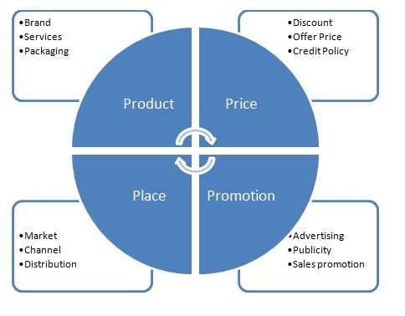
Figure 4: 4Ps of the Marketing Mix
(Source: https://neilpatel.com/wp-content/uploads/2020/06/4-ps-of-marketing-visualization.png)
Place
The place is the most important 4ps marketing mix to develop a Chanel organization business. For the high-class segment and the Chanel, the store is located in the area of high-end posh location. In the high-class segment and the Chanel, the store is located in the area of high-end posh location (Goyal, 2020). Chanel organization Store has been located in the airport also because in the Chanel airport are traveled the many potential consumers. The Chanel Store is also situated in the lobby of a 5-star luxury hotel to reply to its consumer base.
Price
Price is the most important thing for the Chanel organization in developing marketing strategies. Well, provide the product in brant oriented with high quality of the product. The channel company has been selling the products only to target customers or cash-reach customers. That is the reason the cost of the channel product is very high.
Promotion
Promotion is the most important thing to advertise the product of the channel. Channel is a very big international company (Sukma et al. 2019). The organization is promoting products the help of strategies of social media marketing including Facebook, Instagram, advertisement etc. It is also promoting the products of television, many kinds of newspapers, etc.
Integrated marketing communication
Integrated marketing communication is associated with applying all different kinds of promotional strategies including sales promotion, personal selling, direct marketing, social media marketing and others
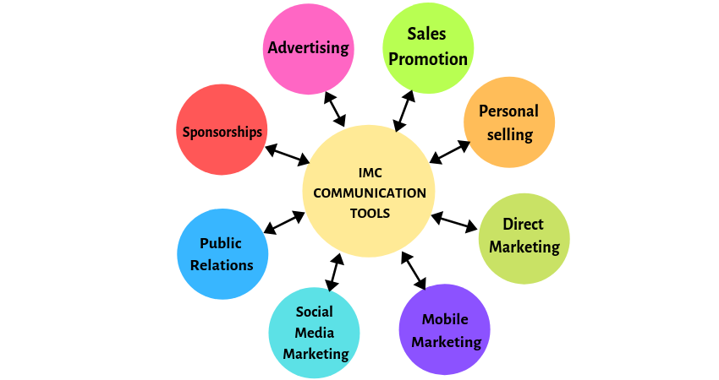
Figure 5: Integrated Marketing Communication process
(Source: https://www.hitechnectar.com/wp-content/uploads/2019/06/IMC-COMMUNICATION-TOOLS-7.png)

Conclusion and Recommendations

Conclusion
Environmental scanning has been the current trends tracking plus organization's occurrences internal plus external environment which can bear to its achievement, presently including in the upcoming. The solutions are very helpful in shaping the aim and its strategies.Environmental analysis is commonly used in the business sector. It is one type of strategic tool which helps to find out the external and internal environment of the business. That environment analysis may impact the Chanel organization. The internal environment is directly indicated the strength and weaknesses and the external environment indicates the opportunity and thread of the Chanel organization. It is considering its trends and its high-level factor-like interest rate plus how it may change Chanel's company business. Doj environmental analysis review may help Chanel company evaluate the attractiveness of the market class create an excellent strategy for future. Finally, it can be said that effective marketing strategies are needed to be made after evaluation of environment to gain optimum outcome.

Recommendations
Excellent for first-time customers for whom marketers lack user information profiles, offering consumers recommendations depending on product sales as well as trends over their first experience. Product qualities (such as design plus pattern), visitor source, gadget, system software, weather reports, location, the regularity through which various goods are bought together, as well as other factors can all influence suggestions. The much more advanced technique combines product plus user information to reveal appropriate suggestions for every user on a case-by-case basis. Displaying "Top Products," or objects categorized as "most purchased" and "best," seems to be a frequent suggestion approach. Its weight vector among all actions, like as buys, and asserts, including product searches, is used to rate items. When a data stream is synchronized, the dignity needed is initial over contemporary ones as well as adjusted scores. It is also recommended that the online platform increases sales. If the channel company has been provided a little low cost of product in future it is best for the product sales. It is also suggested that it will have to improve the quantity of the store which will help to improve the Selling quantity. It also provides many online selling quantities and also has to focus on the advertisement of the company. That helps to reach the customer very easily. When a tip is well-linked with such a customer, it can produce a positive customer experience, boosting the likelihood of a website with visitors building a bond. Marketers could do that at volume with simplicity now that they have access to a rich amount of user-related product information. Advertisers must, though, find the correct balance, guaranteeing that they have this same correct data again for the right strategy – like purchase history for buying suggestions – and so that companies don't cross any lines that could jeopardize their connections with customers.

References
Pereira, A.M.M.O., 2021. Pedagogical case of marketing strategies during the Covid-19 pandemic: The extraordinary case of Chanel (Doctoral dissertation).
Grilec, A., Vukusic, D. and Dujic, D., 2020. Communication Strategies of Luxury Brands during Covid-19 Crisis. Economic and Social Development: Book of Proceedings, pp.281-290.
Guseva, I., 2021. Storytelling as a marketing tool: Case Study Chanel. Tan, A., 2021. The Art of Marketing Luxury (Doctoral dissertation, Sotheby's Institute of Art-New York).
Miglani, S. and GCG, L., Viral Marketing-Impact on Customer’s Choices of Beauty Products. Le Xuan, T., 2019. Digital marketing strategies of luxury fashion brands in China: The Gucci brand.
Leite, B.R.B.F., 2019. Beatriz Bettencourt Womenswear marketing plan: a fashion brand case study (Doctoral dissertation).
Alonso, M.D., 2021. Plan de marketing: lanzamiento Habi Cosmeceuticals: una línea de cosméticos basada en el bienestar.
Fernandes, C.C.M.S., 2019. Kering: a path towards sustainable luxury (Doctoral dissertation).
Tran, H., 2020. Entering the Vietnamese textile and apparel consumer market: Case: Marimekko.
Chesula, O.W. and Kiriinya, S.N., 2018. Competitiveness In The Telecommunication Sector In Kenya Using Porters Five Forces Model. International Journal of Research in Finance and Marketing, 8(7), pp.2231-5985.
Bruijl, G.H.T., 2018. The relevance of Porter's five forces in today's innovative and changing business environment. Available at SSRN 3192207.
Kabeyi, M.J.B., 2018. Michael porter’s five competitive forces and generetic strategies, market segmentation strategy and case study of competition in global smartphone manufacturing industry. IJAR, 4(10), pp.39-45.
Anastasiu, L., Gavriş, O. and Maier, D., 2020. Is human capital ready for change? A strategic approach adapting Porter’s five forces to human resources. Sustainability, 12(6), p.2300.
Zhang, C., Leng, M. and Zhou, L., 2020. Developing strategies of social enterprises explained using Porter's five forces analysis model: Taking mental challenged car wash as an example. International Journal of Organizational Innovation (Online), 12(3), pp.50-64.
Goyal, A., 2020. A Critical Analysis of Porter’s 5 Forces Model of Competitive Advantage. Goyal, A.(2021). A Critical Analysis of Porter’s, 5.
Sukma, D., Lubis, P.H. and Utami, S., 2019. Analysis of Marketing Strategy of Minyeuk Pret Using STP, Ansoff Matrix, and Marketing Mix.
Deerod, K., 2018. Developing port marketing strategies: a case study for Bangkok Port, Thailand.
YOLOAN, M., Timbuleng, J.A. and Korompis, M.J.A., 2020. THE MARKETING STRATEGY OF OPPO AND XIAOMI SMARTPHONE DURING COVID-19 PANDEMIC (Case Study March-July 2020) (Doctoral dissertation, UNIVERSITAS KATOLIK DE LA SALLE).
Zhou, Z., 2019, December. Analysis of Marketing Strategies for Related Products in China’s Financial Market from the Internet Perspective--Taking Ant Credit Pay as an Example. In Proceedings of the 2nd International Symposium on Social Science and Management Innovation (SSMI 2019).
Peng, Y., 2021, December. Marketing Strategies and New Focus for Luxury Companies under COVID-19 Pandemic. In 2021 3rd International Conference on Economic Management and Cultural Industry (ICEMCI 2021) (pp. 949-952). Atlantis Press.

