Marketing plan written for

Premier Inn

Student Name
SIMONA MILITARU
__________________________________________________

Student ID number:
2214268

Marketing Essentials BMIH4005

Lecturer

CHRISTOPHER WILKIN

- Introduction
The aim of this paper is to determine any visible increase in profitability for this brand in the UK and other countries.
This study discusses key aspects of a marketing plan under development.
Hotel chains operate in a variety of locations, including airports, city centre, and suburbs. The brand was founded in 1987 by Whitebread as Travel Inn. In 2004 Whitebread acquired Premier Lodge and merged it with Travel Inn to form the name Premier Travel Inn, shortened to Premier Inn in 2007. The brand has hotels around the world, including the UK, UAE, Ireland, Qatar and Germany (Premier Inn 2022).
One of the main reasons for choosing this brand is because of the extensive experience in the industry. This helps us evaluate marketing strategies over the years and present more comprehensive results.
- Situation Analysis

Company: SWOT analysis

Strength
Premier Inn maintains the identity of a strong brand name with a large geographic reach and customer base. Additionally, Premier Inn's focus on product and service innovation helps hotels maintain a strong market position and enhance customer satisfaction through a range of options. A key strength of is that the Premier Inn brand is very popular with children, offering a variety of family-friendly options, bike-friendly, electric charging, Wi-Fi, and free parking and more then that having plenty of rates for every budget: flex, semi-flex, advance, standard and non-flex.

Weakness
The low revenues and the increase in the unemployment rate at the beginning of 2020 have made Premier Inn customers more reluctant, therefore although the quality of our services has been maintained, there has been a decline in the number of rooms occupied especially during the lock-down period.
After the pandemic, Premier Inn faces a shortage of technical and financial resources, limiting its ability to do business internationally.
It is important that the sector remains optimistic and embraces the challenges posed by the pandemic. A focus on resilience and responsible and sustainable tourism will help the sector recover quickly (Bas and Sivaprasad 2022).

Opportunities
Premier Inn can achieve internet penetration, allowing businesses to seize opportunities by developing interactive digital platforms to market their business and attract top-tier customers.

Threats
Premier Inn is dealing with competition from domestic and foreign competitors with rapidly changing customer tastes and show business trends. Various competitors are increasing the risk of duplicating the organizational model. Also, a shortage of qualified and qualified employees jeopardizes the stable development of profits (Dachhyar, 2020).

Customers
Are segmented by fields of activity for those interested in the service, by income classes, offering various packages for each client's budget, as well as for large families

Competitors

Our main competitors are those who operate on this market for the same purpose as us, proposing to present the highest standards to the client. Some of our main competitors are: Holiday Inn, Best Western, Marriot (hotels and resorts), Raffles, Ibis and others.

Collaborators
- technology partners (e.g. Atriis, Hotelhub, Vibe and Conferma)
- GDS platforms (Amadeus, Galileo and Apollo)
.

Climate: PESTEL (Macro analysis)

P | E | S | T | E | L
Political | Economic | Social | Technological | Environmental | Legal
The UK government has imposed various regulations and restrictions on tourism, severely impacting the hospitality industry during Covid-19 | The UK hotel industry is growing steadily after lock-down.  National inflation rates show that more customers are likely to spend money on luxury goods and services that benefit the hotel industry as a whole (Statista, 2022).  The UK's economic growth has picked up over the past five years, benefiting the hotel industry. | Safety and health awareness are among the top concerns of people today (Wildman and Wildman, 2021), forcing the hospitality industry to adopt new strategies and operational tactics. | The 21st century is cutting-edge and requires extensive use of technology and innovative practices in business. | Climate change is considered a major environmental threat to the hospitality industry. Each country has different environmental standards that can affect an organization's bottom line (Perera, 2017). | In addition, hotels must comply with many other regulations and rules of data protection law. For example, in the UK you must comply with the Health and Safety at Work Act 1974 and the Gas Safety Act 1998 (Leighton, 2021).

- Objectives
Increasing the number of customers sing one of our KPI (key performance indicator) we expect that as this marketing plan to increase our profit by 30%. The implementation of the plan will take place in the next 6 months, and the results are expected to appear at the end of the year 2023.

- Strategy
Bowman's Strategy Clock ranks Premier Inn at Differentiation Level 4, prioritizing providing the highest level of customer satisfaction. We are confident that we can provide the highest quality service.
Premier Inn has grown into a brand that enjoys both loyalty and brand recognition, with an impressive track record of meeting the most demanding needs of its guests. Increased value may therefore determine the best brands to achieve the high price and value this strategy requires
We differentiate our activities by geographic criteria through professional training, promotional packages, and strategies for our employees. Promotions are conducted primarily in an online environment with the cooperation of partners.

- Marketing Mix
Product - For Premier Inn hotels, the main product is the type of service the brand offers. These services, both tangible and intangible, together form the product offered by the brand. In the case of Premier Inn, the brand offered different rooms and different services for different types of customers. For example, the family room has a king size bed. In addition, other services include restaurants, bars, and a gym.
Price - Room rates at Premier INN are highly dependent on demand and season. This means that discounted prices are planned even for rooms booked early (Jaeger and Pahiyiannakis 2020).
Place - The Premier Inn brand operates hotels in the United Kingdom and internationally. Customers have the option to book rooms through the brand's website and mobile applications, or they can use third-party his providers such as travel agencies.
Promotion - Premier Inn has invested heavily in advertising and effective use of various platforms. Some of the most important platforms are social media, television, and magazines. With this, brands also plan to invest to expand and strengthen their digital reach (Jefferson 2021). The development of this website is one of the primary tools used to provide customers with policies related to room reservations and availability (Lim and Seo 2021).

- Action
Premier Inn aims to host a series of thematic events every year, after which it will succeed in having new customers. Offering discounts at the biggest events will be done through a series of very inexpensive marketing channels. Among these we can list a series of marketing channels such as:
- Email marketing - We may send emails to encourage people to join our business, send email newsletters to announce sales, or ask you for recommendations.
- Cold email - This channel allows you to email potential customers without prior knowledge. You can easily find someone's email address and send an email. Freelancers, marketing agencies, and consultants can benefit from this type of marketing channel.
- Website
- Content marketing
- Paid social media advertisements

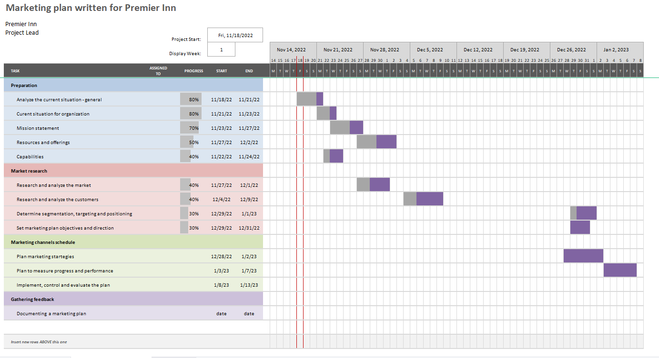

- Control
Our main product is to offer discounts to our customers at big events, especially for new customers. Using this strategy, we can differentiate the percentage of potential new customers. You can also track performance growth through key performance indicators.
It should be clear and concise to communicate the maximum value your customers or customers will get from doing business with our brand and the emotional reasons for doing business with us.

- Conclusion
Given our plans, we expect our marketing strategies to work at their best, especially during this time when micro- and macro-economic volatility has led to significant budget cuts. However, Christmas and New Year’s is usually time spent with family and everyone wants unforgettable experiences and memories, so we feel that the schedule we are considering is a strength for us. When you offer your customers discounts, you get a tendency to move up quickly towards an established goal.
- References

Atasoy, B., Türkay, O. and Şengül, S., 2022. Strategic responses of chain hotels to COVID-19 from a situational crisis communication theory perspective. Journal of Hospitality and Tourism Insights.
Bas, T. and Sivaprasad, S., 2020. The impact of the COVID-19 pandemic crisis on the travel and tourism sector: UK evidence. SSRN Electronic Journal, pp.1-19.
Dachyar, A.Z.N.S.M. and Sahir, A., 2020. Hotel revival strategy planning with SWOT-Fuzzy AHP-TOPSIS: A case study of 4-star hotel.
Harwood, S.A. and El-Manstrly, D., 2011. ‘From the spatial to the digital domain’: a need for hotelier reconfiguration? Transition, 1(8).
Ngwa, G.N., occupancy performance and strategic response within the hotel industry in UK.
Nurpeissova, A. and Islam, D.M.Z., 2021. Analysis of key steps to overcome the crisis in tourism during a pandemic: the experience of Kazakhstan and the United Kingdom. Central Asian Economic Review, (2), pp.64-80.
Octafilia, Y. and Amin, A.M., 2022, March. MARKETING STRATEGIES TOWARD DIRECT AND INDIRECT PURCHASING AT THE PREMIERE HOTEL PEKANBARU. In International Conference of Business and Social Sciences (pp. 461-473).
Papadopoulos, O., Lopez‐Andreu, M. and Jamalian, M., 2021. Violation and lack of awareness of employment rights in the United Kingdom's hotel industry: Isolation, fragmentation and barriers to labour enforcement. Industrial Relations Journal, 52(4), pp.315-330.
Pearson, C., 2020. Mock Tudor. Architectural Theory Review, 24(2), pp.211-213.
POPȘA, R.E., HOTEL INDUSTRY-TRENDS AND PERSPECTIVE IN THE CONTEXT OF COVID-19 PANDEMIC.
Sharpe, D., 2022. The Lived Experience of Hotel Isolation: Evaluation of the Newham Council Hotel Isolation Pilot: Learning from a Rapid Evaluation 2021–2022.
Spanaki, M.Z., Papatheodorou, A. and Pappas, N., 2021. Tourism in the post COVID-19 era: evidence from hotels in the North East of England. Worldwide Hospitality and Tourism Themes, 13(3), pp.357-368.
Statista, 2022. United Kingdom: Inflation rate from 1987 to 2027. [Online] Available at https://www.statista.com/statistics/270384/inflation-rate-in-the-united-kingdom/ [Accessed on 22nd November 2022].
Williams, C.C., 2021. Impacts of the coronavirus pandemic on Europe's tourism industry: Addressing tourism enterprises and workers in the undeclared economy. International Journal of Tourism Research, 23(1), pp.79-88.
Yang, Y., Mao, Z. and Wen, Z., 2022. Pandemic severity, policy stringency, and tourism performance: A global analysis. Journal of Travel Research, 61(8), pp.1928-1946.



