
Skills for the Workplace
Module Assignment Submission
Student Name: | Sarah Richardson
Student Number: | 1911315
Module No: | BMSK4003
Module Title: | Digital Skills and Research Methods

Statement of Confirmation of Authenticity
By the act of making this submission, the student declares that this is the work of the student named above. The work has not, in whole or in part, been knowingly presented elsewhere for assessment, or where assessment has been built on a previous assessment, this has been identified. Where materials have been used from other sources it has been properly acknowledged. If this statement is untrue, the student acknowledges that an assessment offence has been committed.
Attention is drawn to the plagiarism and unfair practice policies of both the University and of ILM.
Permission for ILM to use this script
ILM uses learners’ submissions – on an anonymous basis – for assessment standardisation. By submitting, both the centre and the learner agree that ILM may use this script on condition that identifying information is removed. However, if you are unwilling to allow ILM use this script, please refuse by ticking the box: □

Table of Contents
What has been the impact of 21st Century Technologies on the modern workplace? 4
Introduction 4
Part 1 4
An in-depth look at the technologies used in own workplace 6
Part 2 8
An exploration of the use of social media in the workplace generally 8
An in-depth look at the use of social media in own workplace 11
The use of social media to enhance networking and career prospects 12
LinkedIn Profile 14
Conclusion 15
References 16
Appendix A 17
Appendix B 18
Appendix c 19
Appendix D 20
Appendix E 21
Appendix F 22
Appendix G 23

What has been the impact of 21st Century Technologies on the modern workplace?

Introduction

In this assignment I will be looking in depth at the impact of 21st century technologies within the workplace. I will look at the types of technology used and the impact they have in the modern workplace both positive and negative impacts. I will explore the technology used within my own work place and analyze the impact these technologies have had. I will explore social media and how there are positive impacts and negative impacts to using social media platforms.

Part 1

Technological advancement has entirely reshaped our work place. How we communicate has changed, workflow, communication channels, productivity, flexibility, have all advanced due to technology. M. Lynne Markus and Daniel Robey(May, 1988), pp.583-598 encourages a more in depth look at how information technology has impacted on organizational change and the impacts on organisations and other interested parties.
Email, social media, web chat, video conferencing, smart phones and chat apps are all different ways in which now communicate, we no longer have to be in person to be able to communicate effectively. The speed in which we communicate has changed, we can now send emails within seconds, respond to the public live through web chat. We have face to face meetings with people without even being in the same room and we can now do this through video conferencing using apps such as skype. All of this potentially speeding up our workflow enabling us to be more productive and being able to carry out much more work in less time. Technology has helped the workplace to be more cost effective. Markus, M. and Robey, D. (1988) explores significant trends that show that technology that has indeed had an impact on the speed of production and has in some areas significantly reduced costs. From the simple changes like going paperless to the larger cost effectiveness such as using computers to carry out tasks instead of employing more staff. In order for me to be able to analyse and evaluate a 21st century technology I have decided to pick two technologies and look at the positive and negative impacts this they have had in the modern workplace. In order for me to check the reliability of these resources I will evaluate these by looking at Currency, Relevance, Authority, Accuracy and Purpose. This will give me the confidence that the sources I am using are trustworthy.
Email is one of the most widely used communication tools used within the workplace.In 2017, the most popular internet activity was sending or receiving emails (82% of adults), up 3 percentage points from 79% in 2016 (office for national statistics). Email is free to use it does not cost to send or receive emails so you could suggest that they are cost effective for the workplace. It is a fast and effective way to communicate, you can send and receive an email within seconds and send 1 email to multiple people saving a considerable amount of time. Email is accessible from anywhere worldwide, through a computer, tablet, phone and even smart watches as long as you have the internet. Email is cost effective as it is paperless and beneficial to our planet. Email enables us to have instant access to information and files. Email helps us to store and keep a paper trail of communication that enables us to refer to. Storage of files etc within email can be beneficial to the workplace as it frees up space within the office and can be a quick and effective way to access files within seconds, whereas previously you would spend considerable time looking through paper files of which there are thousands.
Although there are several positive aspects in using email it does also have its disadvantages. Information overload due to the amount of emails we receive on a daily basis, this runs the risk of some emails being dismissed or possibly unread. Email does not have the personal touch such as verbal communication or written communication. Some email messages can contain viruses causing system failure and breach of General Data Protection Regulation . Email requires timely responses therefore urgent emails are responded with priority leaving other emails unresponded or left for a much longer period of time. Emails can be misunderstood and cause possible conflict between colleagues, business or the public. Emails can be seen as disruptive due to the time taken to read an action each email taking you away from other tasks. Email can also have an effect on work life balance as we are able to access email at any time of the day this resulting in responding to emails outside of working hours. Munjal, S. (2017) states that “Work life balance is defined as an individual's ability to meet their work commitments as well as other non-work and family commitments. Not everyone is that well adjustable to the balance of work and personal life and therefore either fail in areas of work or don’t commit to their family this impacting on their wellbeing. Email could have the potential to impact on the reduction of workers within the workplace due to the speed of emails fewer staff are required. Time was previously spent on face to face communication requiring employers to have more staff to carry out meetings with several clients are no longer needed, as 1 person can send several emails communicating with several people within seconds.
Wifi is a revolutionary technology that has enabled us to be mobile and not attached to ethernet cables and be able to use our devices such as mobiles, tables and computers in multiple locations.
The wireless use of the internet allows us to be able to use the internet on our devices in different locations that are convenient to ourselves. Being wireless can help us be more productive as we can carry out work not just in our work environment but also in places such as cafe’s, home and other public places giving us more time and freedom. However with freedom comes danger for example staff taking advantage of mobile working, not being in the places they say they are creating risks impacting on lone working procedures. Higher risks of breaching of General Data Protection Regulation due to not being confined in a safe secure place such as an office which is a confidential environment. Wireless networks can serve a suddenly-increased number of staff with the existing equipment, however if we were still all using ethernet cables we would require more of it and more space and equipment therefore it can be cost effective. Sickness in the workplace can be reduced as we can work from home when we are feeling under the weather rather than taking a sick day. The Chartered Institution of Personnel and Development (CIPD) survey, which reported the reduction in absenteeism after the introduction of flexible working practices. They also reported that staff morale has increased as they are able to carry out work in a place that is convenient to them.
However it does also have its disadvantages wifi for example the range of wifi is not always great for example you might be able to get wifi in one room in your workplace however not in another. Speed can sometimes be a problem unless you pay a considerable amount for your internet provider speeds on the internet through WIFI can be slow and very frustrating. Frequency transmission can also be lost from time to time so you can lose wifi at any time, if you are carrying out a work task this could cost you time, effort and cause frustration. It can also be costly to the employer if they require a high speed internet and in different locations of the building possibly having to pay for wifi extenders and other added devices needed.

An in-depth look at the technologies used in own workplace

I work in a charitable organisation that provides housing law to advice the general public. And how this is carried out is communicating to the public using most of the 21st century technologies such as web chat, email and social media. Advice is provided through these different technologies in order to help prevent homelessness and how they are being used is proving very effective. Shelter Cymru Live was launched in 2014 prior to this the services still carried out the same goal which was to prevent homelessness however how this was done was through telephone conversations, face to face appointments and court duty. Even though the email was being used at that time it was not used as a prevention method it was used to communicate with other organisations and not directly to the client. The switch to using 21st Century technology has helped to re-shape and build how the organisation now communicates with the public and is proving to be very effective“You never change things by fighting the existing reality. To change something, build a new model that makes the existing model obsolete.”― Buckminster Fuller. However the impact on the services that Shelter provides through modern technology can be both positive and negative. (Appendix A) is a graph that gives figures on areas of improvement since using these technologies, the information was provided to myself by my manager who runs the project. As you can see the graph shows a considerable rise in client communication, from 2008 to 2014 the total client contact reached 5400 people however from 2014 until Dec 2019 total client contact was 17,450 more than double the amount. Due to email and smart phones clients are able send in eviction notices, court documentation and consent forms this has resulted in a massive rise in saved evictions. Conference calls since the past 2 years have been allowed within the county courts freeing up staff having to attend court face to face saving money on mileage expenses and giving the staff more time to deal with more cases. A rise in young people using the service has risen from 755 young people in a 6 year period to 6929 young people demonstrating that being able to use things such as social media, smart phones and web chat is an easy and accessible way to communicate, especially for young people who have grown up with these technologies. John Dewey (1859–1952) believed that human beings learn through “Hands on approach” and this is demonstrated through the youths of today. Their educational experiences are completely different from what mine would have been for example a book would be where I got my information and learning from and in order to use them you open the page and read. However, today's books have been replaced with online libraries to be able to access these I would have to know first how to navigate the computer and secondly being able to understand how to search for a particular book I was looking for. Modern technology is not learning through reading instructions but through using a “hands on approach” and interacting in their environment which today is technology. I can relate and understand to the hands on approach learning as I learnt from my last assignment I am a kinesthetic learner.
The systems that are used within Shelter are Snap Enage and DMA. They enable us to effectively communicate with our clients through web chat and email. DMA is our computer systems network where all the information we store is held, with the organisation having their own storage resources helps to keep files more secure and protected.
But do the positive impacts of technology used in my work place outweigh the negative impacts. The use of technology within my workplace has in some departments resulted in fewer staff, as 1 staff member can now communicate with more than 20 clients a day through email, web chat, and social media where previously more staff were required to have to carry out face to face appointments. (Brynjolfsson and McAfee 2014; Frey and Osborne 2013) & A. Kahler. (1935) Discuss in depth evidence of technology displacement, you could argue that the use of technology within my workplace has created technology induced unemployment as there has since been redundancies within my organisation. In many cases this displacement is the result of increased productivity which is responsible for reduction in labor demand and wages in some sectors Acemoglu, D. and Restrepo, P. (2017)
But where there has been job losses due to technology there has also been job opportunities such as a new department within my organisation called the comms team where they deal with responding purely to social media issues and press release relating to social media. However arguably this can bring negative impacts as it brings exposure to negative public feedback which in effect can have a massive impact on the organisations reputation. Having explored this further with my organisation they disclosed the way they deal with crisis communication is through a theory system called Situational Crisis Communication Theory, SCCT Coombs, W. (2007). They use this theory to help rebuild their reputation by using the stages in which SCCT demonstrates ( Appendix B). With the development of technology my organisation has the added stress of finding new adaptable ways to deal with these unexpected challenges like using the SCCT theory.

Part 2

An exploration of the use of social media in the workplace generally

Many workplaces use social media as a platform for a variety of things,some use it as a selling point and way to generate more custom and others use it as a communication point or a way to gather data which they can then generate into profit. Having researched the most used UK social media platforms YouGov provided the following information.
- 56% Facebook.
- 42% Instagram.
- 40% Twitter.
- 37% Google+
- 34% Pinterest.
- 28% Linkedin.
- 26% Snapchat.
These results are a broad reflection on social media used in both business and personal. So in order to make this reflective on social media in the workplace (Appendix C,D,E & F) shows the results of a survey that I compiled in order to gather information more specific to social media within the workplace. The survey was posted on a social media website to be able to target a wider audience who work in a variety of different work environments. In this survey I have gathered general information on Age and income and more specific information public knowledge of social media used within the workplace. 54 people participated in completing the survey. The results give an overview of social media used within those 54 individual workplaces. As you can see from the results there is a clear age bracket of 25 to 60 of those who completed the survey, only 2 over the age of 60 completed the survey and 4 ages between 16 to 24. This gives an idea of the age range of people I have within my own social media. There is a very high percentage on a low income and 11 on the higher income again showing household income of those on my own facebook. The results on social media used within the workplace however are interesting in that they give a clear indication that the majority of those 54 people who did complete the survey do in fact use social media within the workplace, the most popular social media is Facebook and secondly Twitter. The survey shows that the participants of the survey are aware of what social media is used for and the results in this survey show that advertising is used the most and service feedback secondly. 22 people agreed that social media benefits the company and 8 people did not agree. 21 participants agreed that social media had a positive impact and only 6 who did not agree. Looking at the results from this survey it would suggest that firstly social media is clearly being used within the workplace, more people than most feel that is beneficial and they are aware of what the social media is being used for.
Social media in the workplace if used in a productive way could be a powerful marketing tool Dimitriu, R. and Guesalaga, R. (2017) Explores how social media marketing activities influence brand equity creation and consumers' behavior towards a brand. This type or marketing helps to address gaps that have not been included in previous social media marketing, so in layman's terms what customer audiences have been missed due to the wording or branding of a previous product. So by gathering information we are collating data and by doing this business can look at ways to improve certain services or a better way to reach certain target audiences. This data could then be used to help businesses improve their economic growth Kaplan, A. and Haenlein, M. (2010) explores how businesses use social media as a tool to gather data and turn this into economic growth, they demonstrate clearly that the data collected from social media can be productive and indeed help a business to grow.
Zeleny and Ackoff, (1989) have been credited with originating the DIKW pyramid Data, Information, Knowledge, and Wisdom.

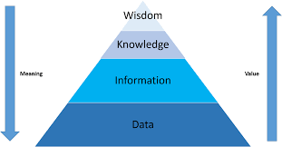

DIKW as one of several ways to define, illustrate and explain the various forms of data, information etc. in a business. It helps to provide answers to “who”, “what”, “where”, and “when” questions. So for example a business using social media for market research can collate data, turn the data to information and then use this information to understand and see possible gaps that are in their sales approaches, this knowledge can help to give direction on how to make these improvements to better reach their target audiences with the potential to increase their profit/customer relations/age range/quality of service. The wisdom is looking at what is best and what is the right thing to do that will enable a positive impact to your business. “knowledge is like the recipe that lets you make bread out of the information-ingredients of flour and yeast (with data as the atoms of the ingredients)” Milan Zeleny. The way that the pyramid is demonstrated is very similar to Maslow, A. (1943) hierarchy of needs. They both have what’s called a foundation point where the basic needs are required to help climb the pyramid. The DIKW looks more at the external foundations related to within the workplace, like data and information, whereas Maslow looks at our internal needs such as basic human needs as a starting point. They also both demonstrate that we must aspire to move up the pyramid to achieve and have more clarification, satisfaction and fulfillment.

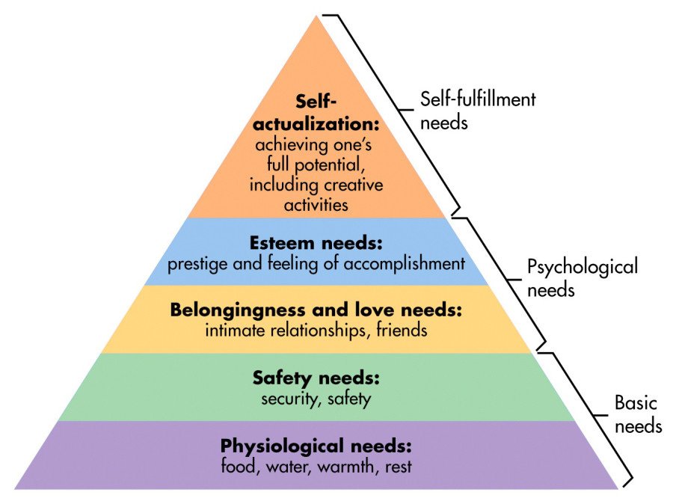

An in-depth look at the use of social media in own workplace

In my own workplace we use social media such as facebook and twitter and they are used in a variety of ways. Facebook is used as a point of communication for the general public to be able to get in touch and seek advice on their housing issues. It is also used to advertise and promote the services through advice videos and client feedback. We also use facebook to gather data on who is accessing the services looking at their age ranges, locations and housing issues. With this information they are able to identify themes (Appendix G) shows these themes relating to locations, age range and housing related issues. Between 2018 to 2019 the Newport area was the most reported area for communication issues and Cardiff county council second. Rejected homeless applications was the highest reported housing related issues and illegal evictions second. The age ranges varied of people accessing the service varied, 16 to 24 years old accessing the service was high however 25 to 35 was not far behind. With this information my workplace was able to challenge, enhance and make changes to the services that they provide. Within the Newport and Cardiff area’s they provided more funding to allocate two additional case workers to be able to tackle communication issues with both Newport and Cardiff council. Housing related issues were tackled by providing more provisions such as more face to face advisors within the local council offices. And other provisions such as advertising in more public spaces in order to reach the older age range.
A lot of businesses use social media to build their enterprises and essentiality make a profit by using such things as marketing. 73% of marketers believe that social media marketing has been “ somewhat effective” or “Very effective” for their business. Buffer, (2019). However the organisation that I work for is a charitable organisation who are a non profit organisation therefore do not use social media to make a profit. The purpose of social media within my own work place is to better communicate with the public.
Strangely, although social media is used within our organisation, we are not however allowed to use our personal facebook account within the workplace. This message has a negative impact on the staff as it is presenting the message that tells employees that you do not trust them to monitor their own time and productivity.

The use of social media to enhance networking and career prospects

Before the 21st century we would search for a job by looking at local job adverts in the paper, calling to the job centre or looking in shop windows. Today there are various ways in which you can search for a job. Social job searching involves us using social media sites such as facebook, twitter and linkedin to search for jobs. Social media can be used not only for the job seekers but also the employer. Using social media sites are proving to be an effective way of enhancing your career opportunities. In 2016 a survey was carried out that shows 84%, the majority of companies are social recruiting [SHRM]. The most popular social media platform Linkedin, 91% of employers use LinkedIn and give it a 3.8 effectiveness rating on a 5-point scale [NACE]. And 55% of job seekers find social and professional networks to be the most useful resource during a job search [CareerArc]. Social media platforms such as linkedin helps to give you an online presence where you can demonstrate to employers your skills and experience. Social media has changed the ways in how employers recruit “The Internet has drastically changed the face of recruitment. Employers must now actively market themselves by instituting a well-implemented e-recruitment program to find better quality candidates and improve hiring decisions, all in less time and at a lower cost.” (Smith and Rupp 2004). In the past you would complete a job application and wait to be requested for in interview and the only information that a recruiter would have would be the completed application. Although there are positives to using social media to job search and to recruit, it does also have negative impacts on both the employee and the employer. Companies that recruit through social media leave themselves open to charges of discrimination and the employee being discrimnated against. (Broughton et al 2011) The use of social media in the recruitment process, highlight these issues and explains that recruiters have access to information such as, sexual orientation, age, gender, ethnicity, religion, marital status and political views. And can be accused of using this information to not recruit potential candidates. As the potential candidate you are also exposing yourself being discriminated against because of your personal characteristics are available to the public.
There are other risks to consider when using social media as an online presence, Identity theft can leave you exposed to potential financial loss, damage to reputation, for example if your facebook account was used in a derogatory way. Afterwork behaviour can cause potential harm to your career, for example posting pictures on social media whilst under the influence, Posting information about your employers can lead to disciplinary action. Rachel Burns, Former care home manager (reported on BBC NEWS) recently lost her job after posting a photo of her and work colleagues singing on stage at her Christmas party. Rachel had done four things wrong. She'd posted the photo on Facebook, she'd identified a Park Hall resident in the photo - a man with Down's syndrome, she had also posted a video of the music night, and she was Facebook friends with a relative of one of the residents. These were all breaches of Surrey County Council policy. Two days later, Rachel was suspended from her job. This is just one example of how social media can have an impact and how exposed we are. So although social media can have positive impacts on our career development it can also have a detrimental effect. Knowing how to use privacy settings and being aware of what others can see on your social media will help to protect you from social media negative exposure.

LinkedIn Profile

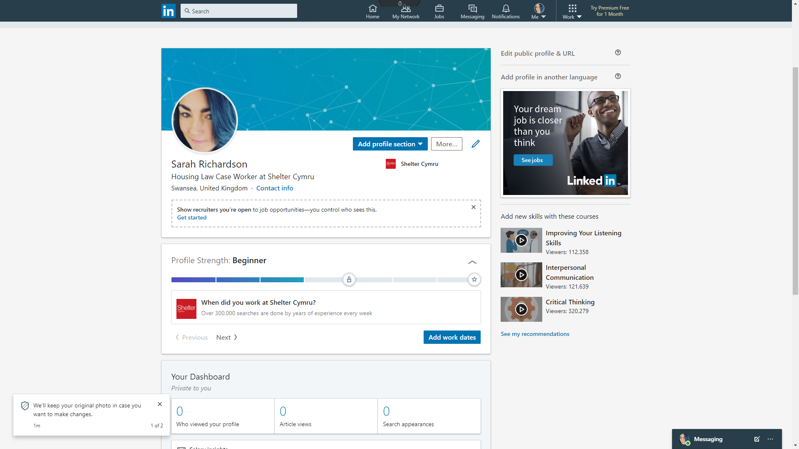

Conclusion

To conclude, having carried out research into 21st technology it is evident that there has indeed been an impact to the workplace since these modern technologies have been implemented. The power of social media can be productive but also destructive and having the knowledge and wisdom of how they are used and how to use them correctly can indeed enhance our opportunities and careers.

References

Markus, M. and Robey, D. (1988). Information Technology and Organizational Change: Causal Structure in Theory and Research. Management Science, 34(5), pp.583-598.
Markus, M. and Robey, D. (1988). Information Technology and Organizational Change: Causal Structure in Theory and Research. Management Science, 34(5), pp.583-598.
Ons.gov.uk. (2020). Home - Office for National Statistics. [online] Available at: https://www.ons.gov.uk/ [Accessed 24 Jan. 2020].
Munjal, S. (2017). Work-Life-Integration Through Flexible Work Arrangements: A Holistic Approach to Work Life Balance. SSRN Electronic Journal.
CIPD. (2020). CIPD The Professional Body for Human Resources and People Development. [online] Available at: https://www.cipd.co.uk/ [Accessed 24 Jan. 2020].
Fuller, B. (1952). Buckminster Fuller. Perspecta, 1, p.28.
ANDERSON, A. (1960). MILESTONES OF EDUCATIONAL PROGRESS: HORACE MANN, 1796?1859; JOHN DEWEY, 1859?1952. Educational Theory, 10(1), pp.1-8.
BRYNJOLFSSON, E., MCAFEE, A. and MANYIKA, J. (2014). Will Your Job Disappear?. New Perspectives Quarterly, 31(2), pp.74-77.
Acemoglu, D. and Restrepo, P. (2017). Robots and Jobs: Evidence from US Labor Markets. SSRN Electronic Journal.
Coombs, W. (2007). Protecting Organization Reputations During a Crisis: The Development and Application of Situational Crisis Communication Theory. Corporate Reputation Review, 10(3), pp.163-176.
Today.yougov.com. (2020). YouGov | What the world thinks. [online] Available at: https://today.yougov.com/ [Accessed 24 Jan. 2020].
Dimitriu, R. and Guesalaga, R. (2017). Consumers’ Social Media Brand Behaviors: Uncovering Underlying Motivators and Deriving Meaningful Consumer Segments. Psychology & Marketing, 34(5), pp.580-592.
Kaplan, A. and Haenlein, M. (2010). Users of the world, unite! The challenges and opportunities of Social Media. Business Horizons, 53(1), pp.59-68.
Zeleny, M. (1989). Preface to ‘Management & Philosophy’. Human Systems Management, 8(4), pp.251-251.
Maslow, A. (1943). A theory of human motivation. Psychological Review, 50(4), pp.370-396.
“State of Social 2019.” Buffer, buffer.com/state-of-social-2019.
“The Voice of All Things Work.” SHRM, 30 Oct. 2019, www.shrm.org/.
“NACE International - The Worldwide Corrosion Authority.” NACE, www.nace.org/.
“Building A New Standard InModern Hiring & Outplacement.” CareerArc, www.careerarc.com/.
U, Eddy. “The Hiring of Rejects.” Modern China, vol. 30, no. 1, 2004, pp. 46–80., doi:10.1177/0097700403259117.
Meyer, Michele. “The Impact of Social Media on Non-Monosexuals’ Responses to Discrimination: A Co-Cultural Approach.” Social Media + Society, vol. 5, no. 1, 2019, p. 205630511982612., doi:10.1177/2056305119826120.

Appendix A



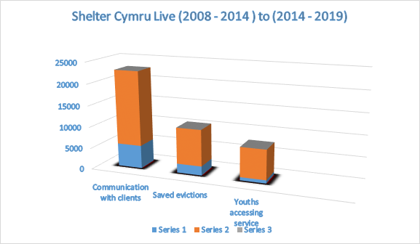

Appendix B

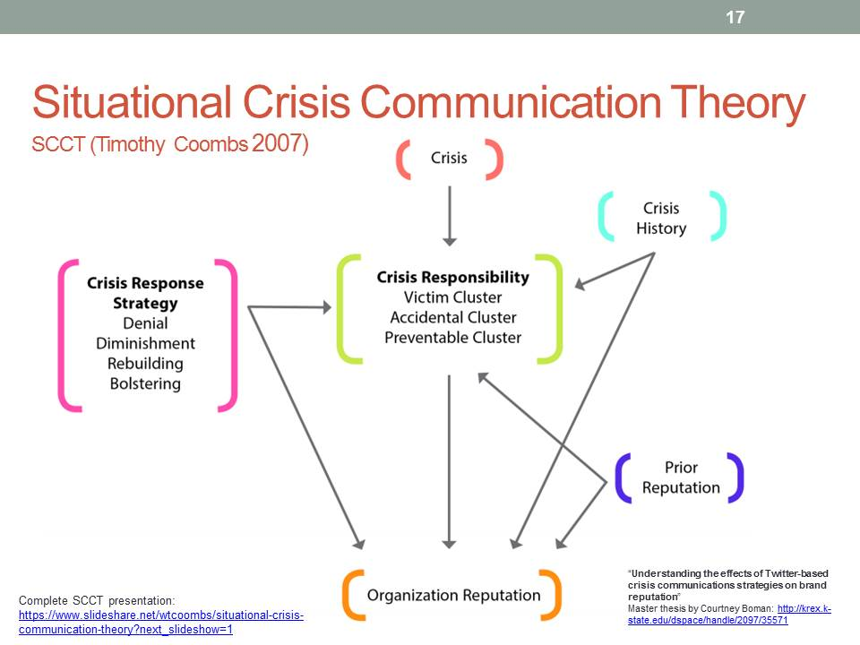

Appendix c

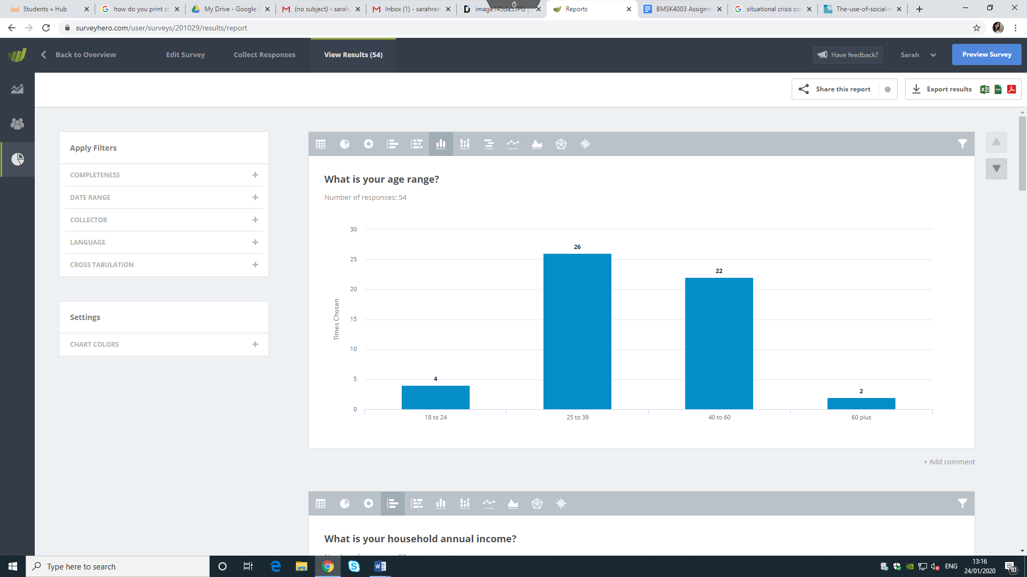

Appendix D

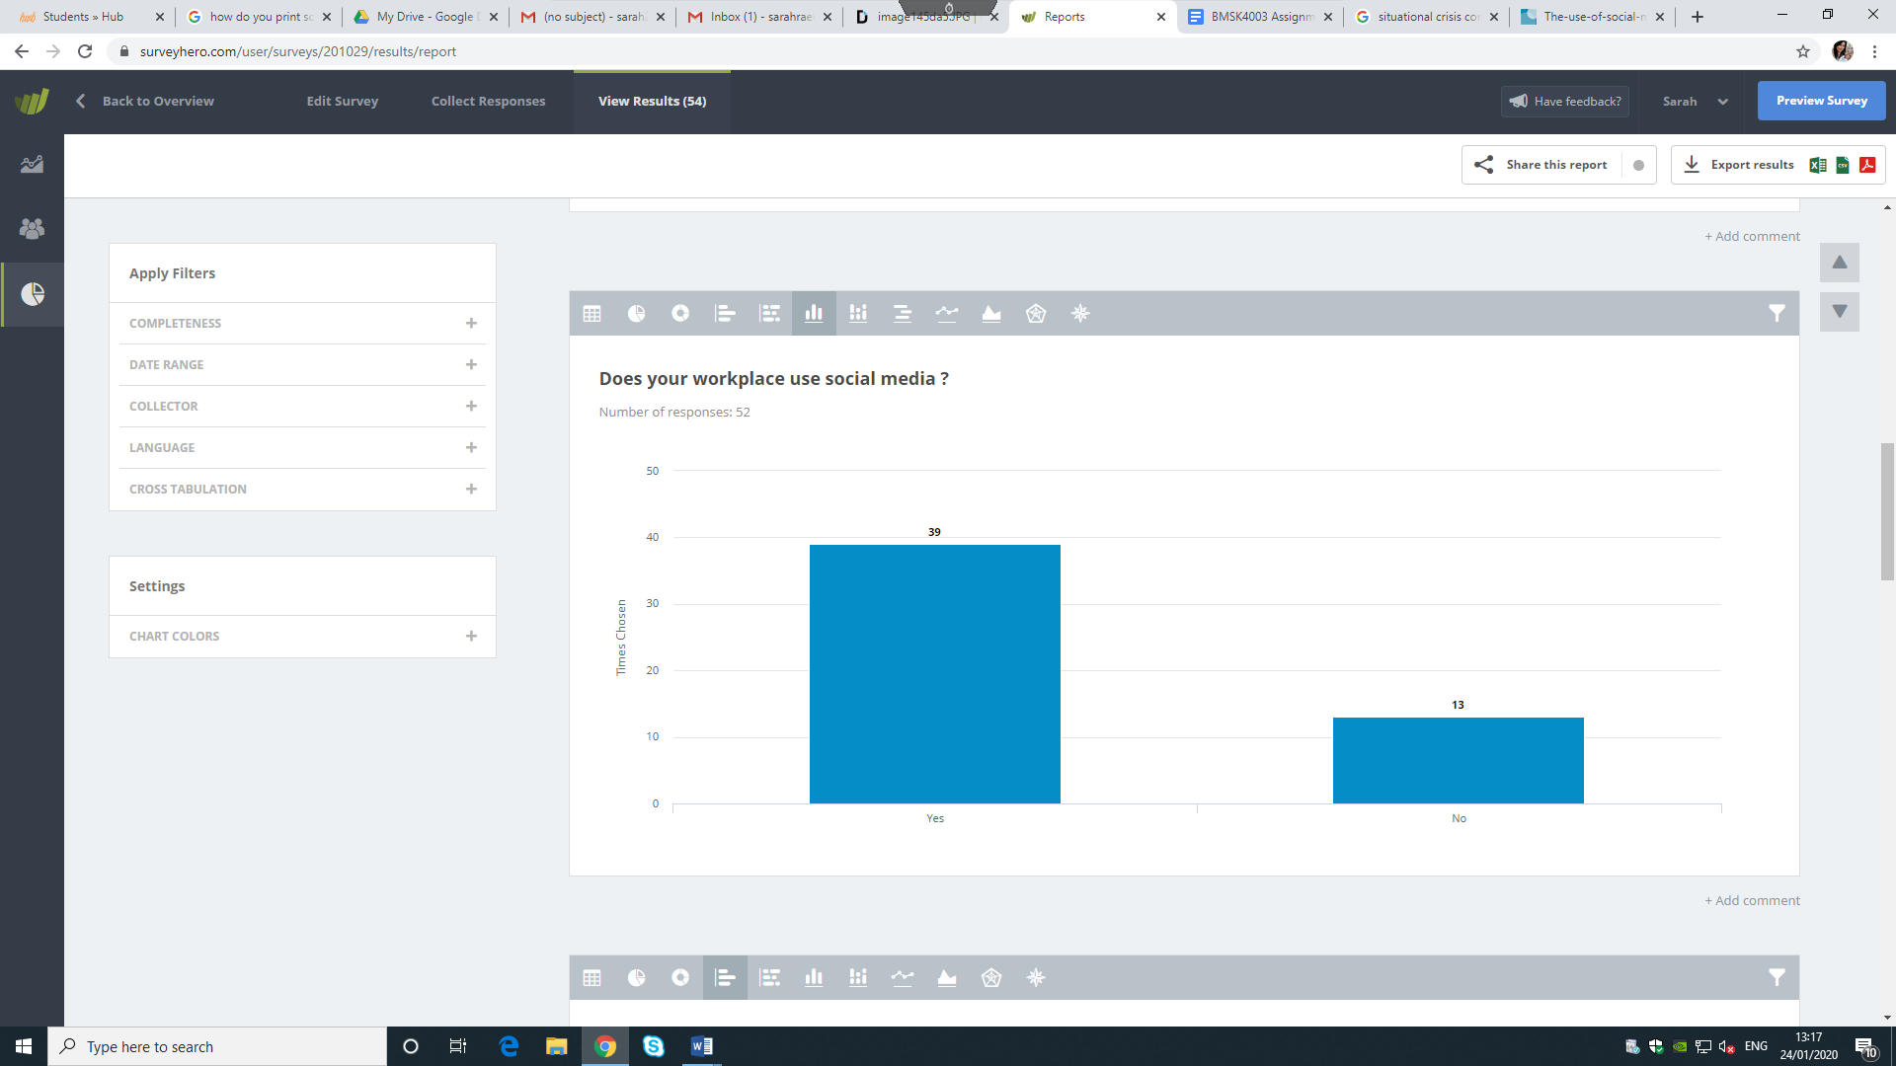
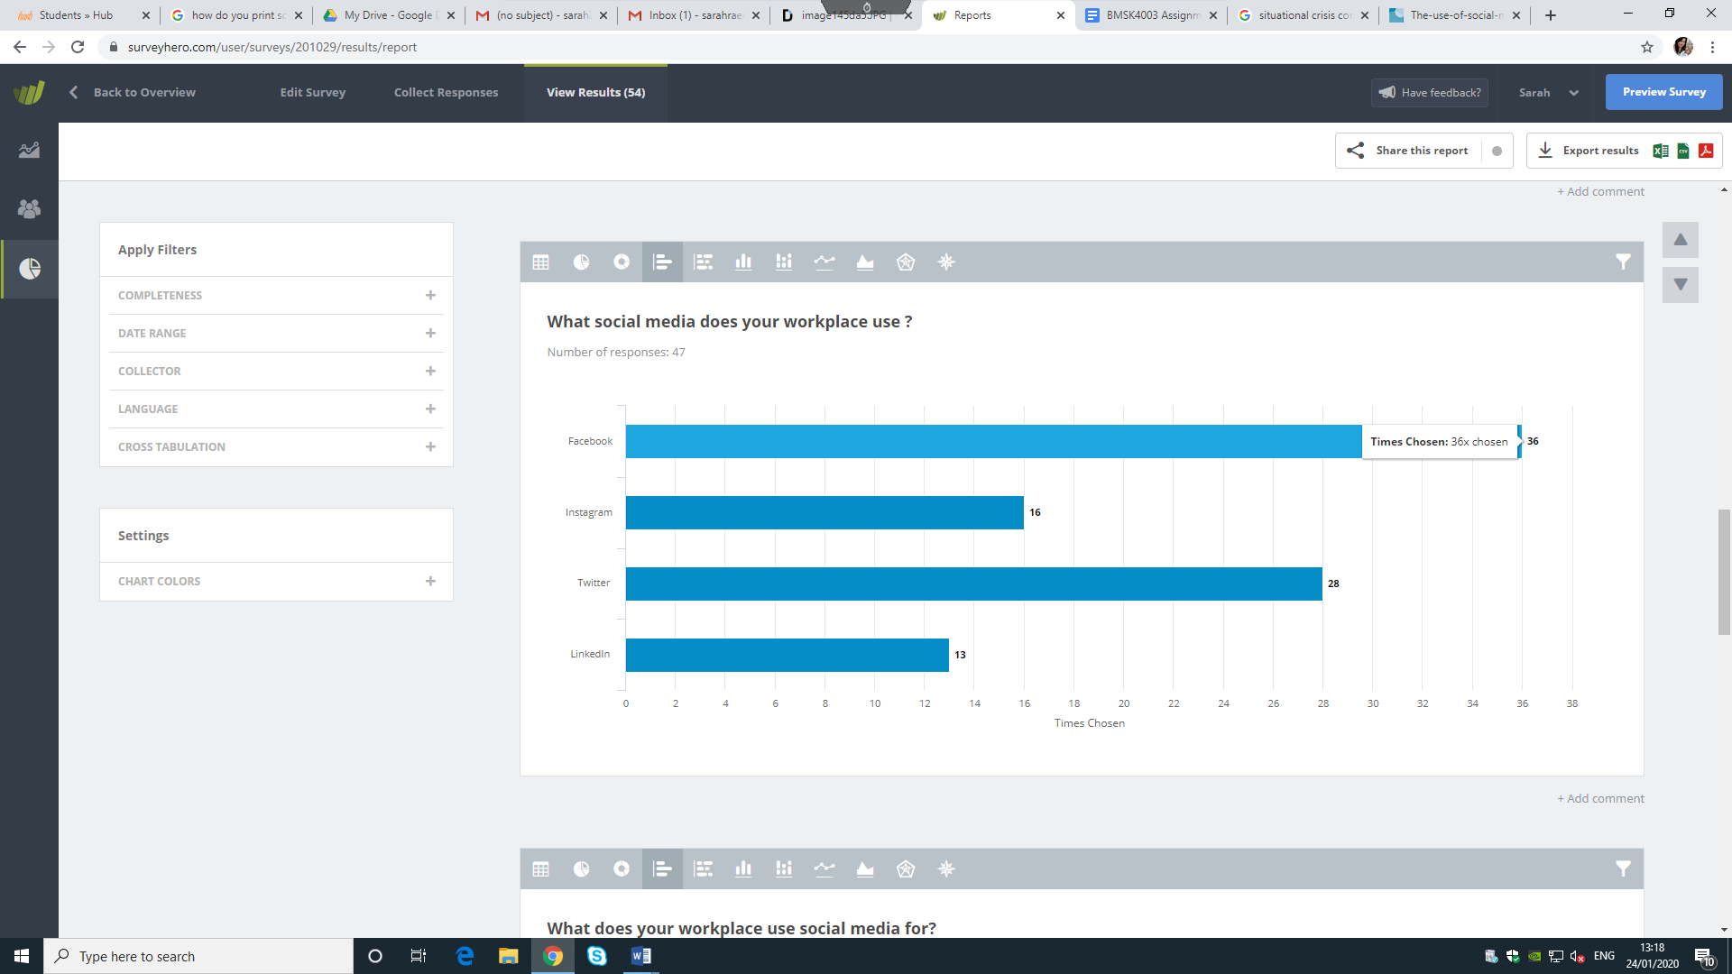

Appendix E
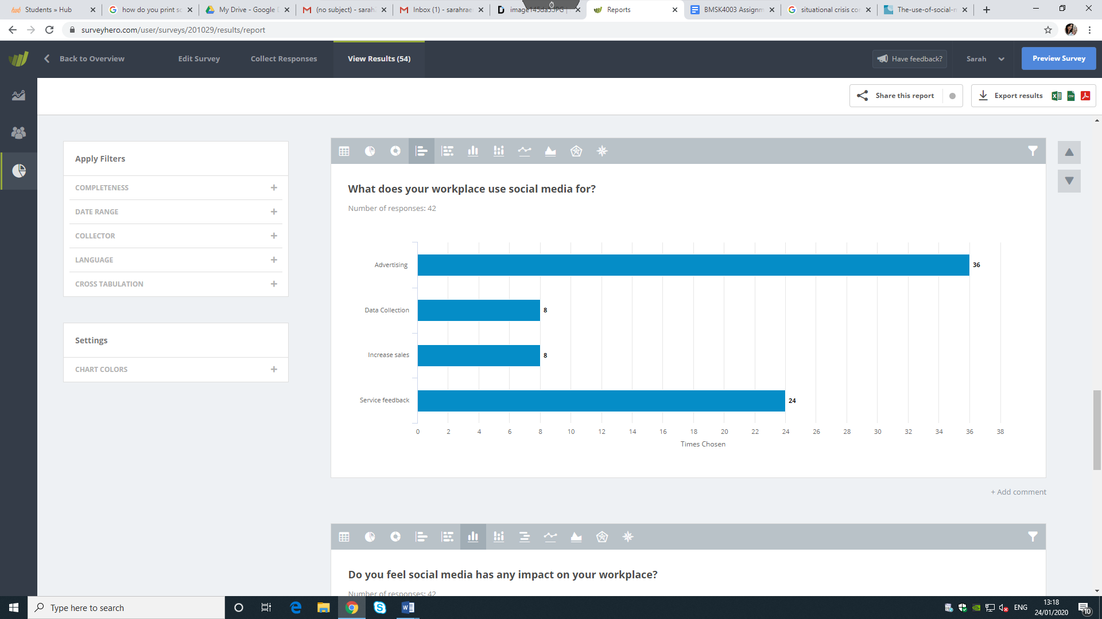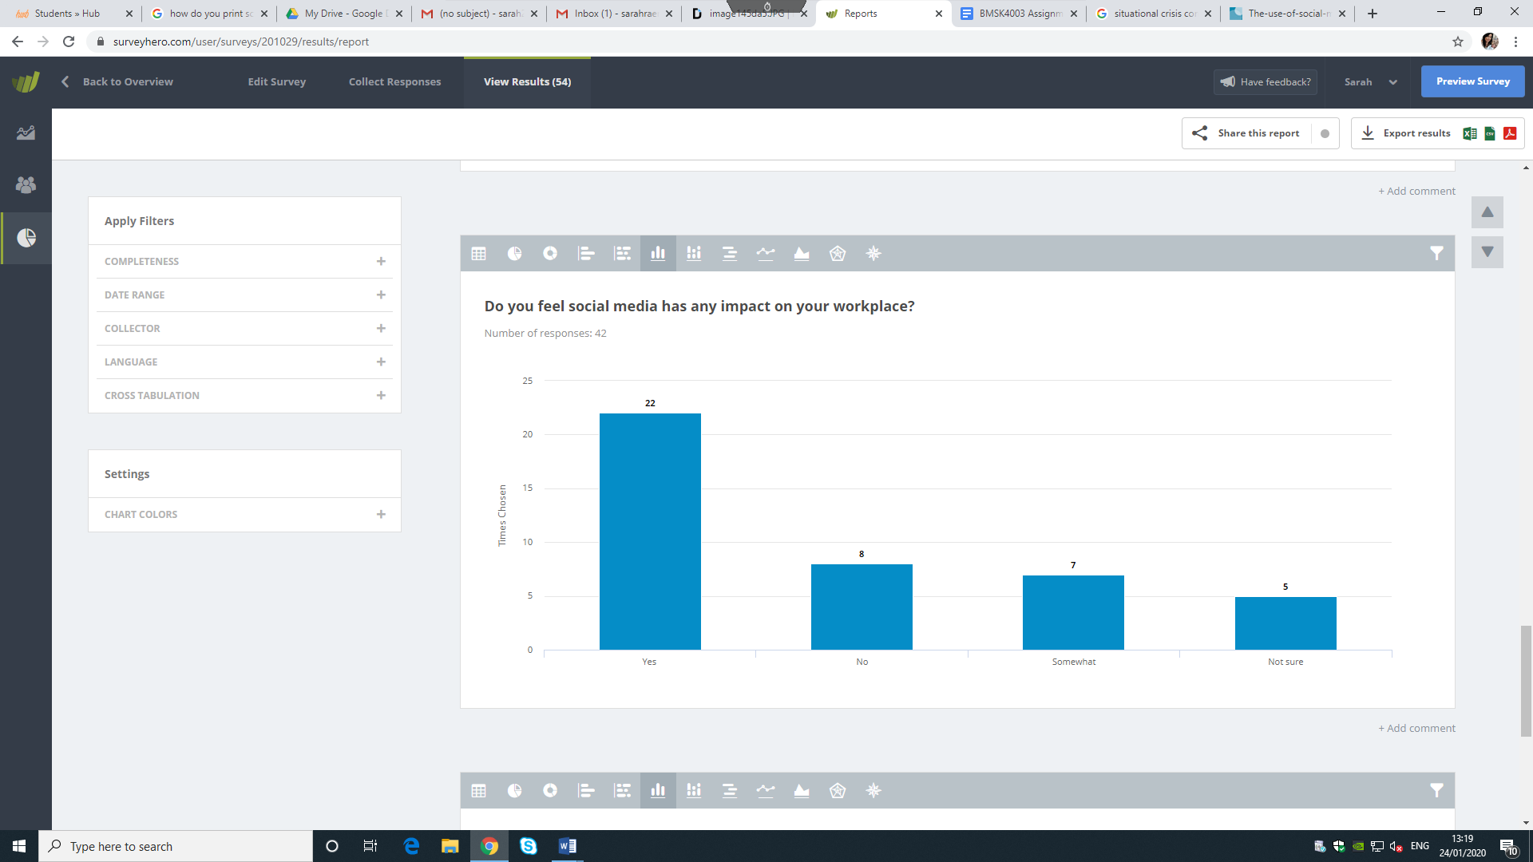

Appendix F
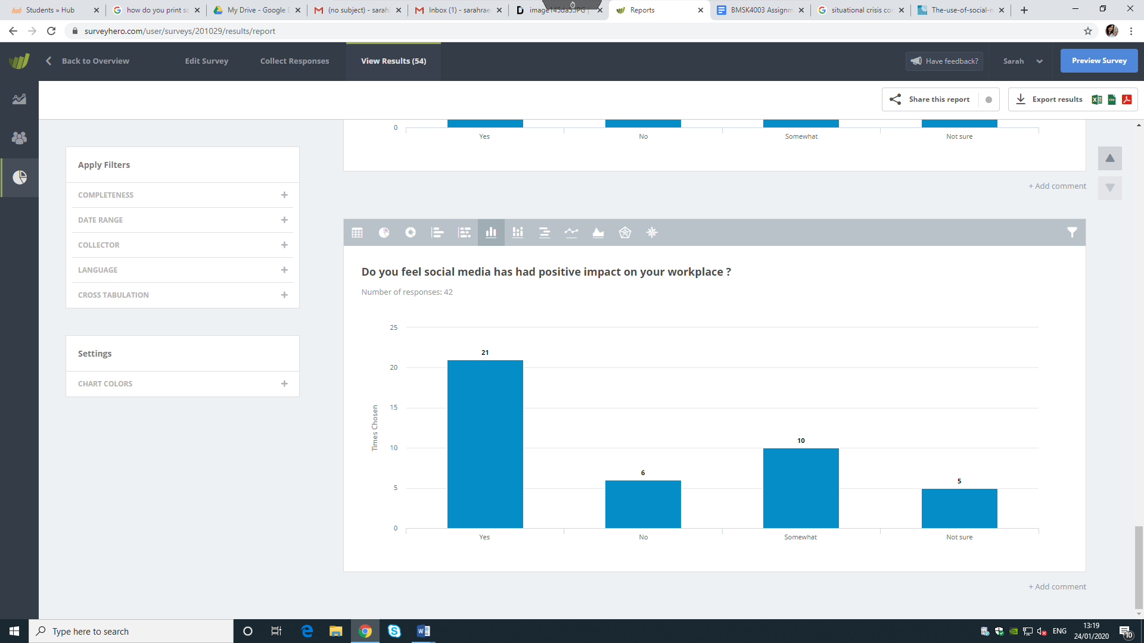

Appendix G



