Personal Portfolio Development
Justin Brighton, 2306759

University of Wales Trinity Saint David
BA Animation & VFXBA Computer Games Design

Contents
Employment Database 2
Showreel Link 4
Business Card 5
Bibliography 6

Employment Database
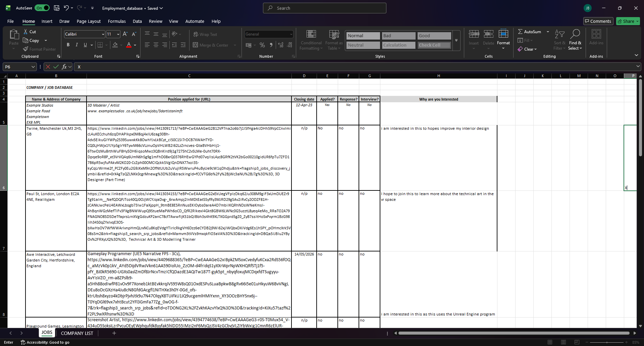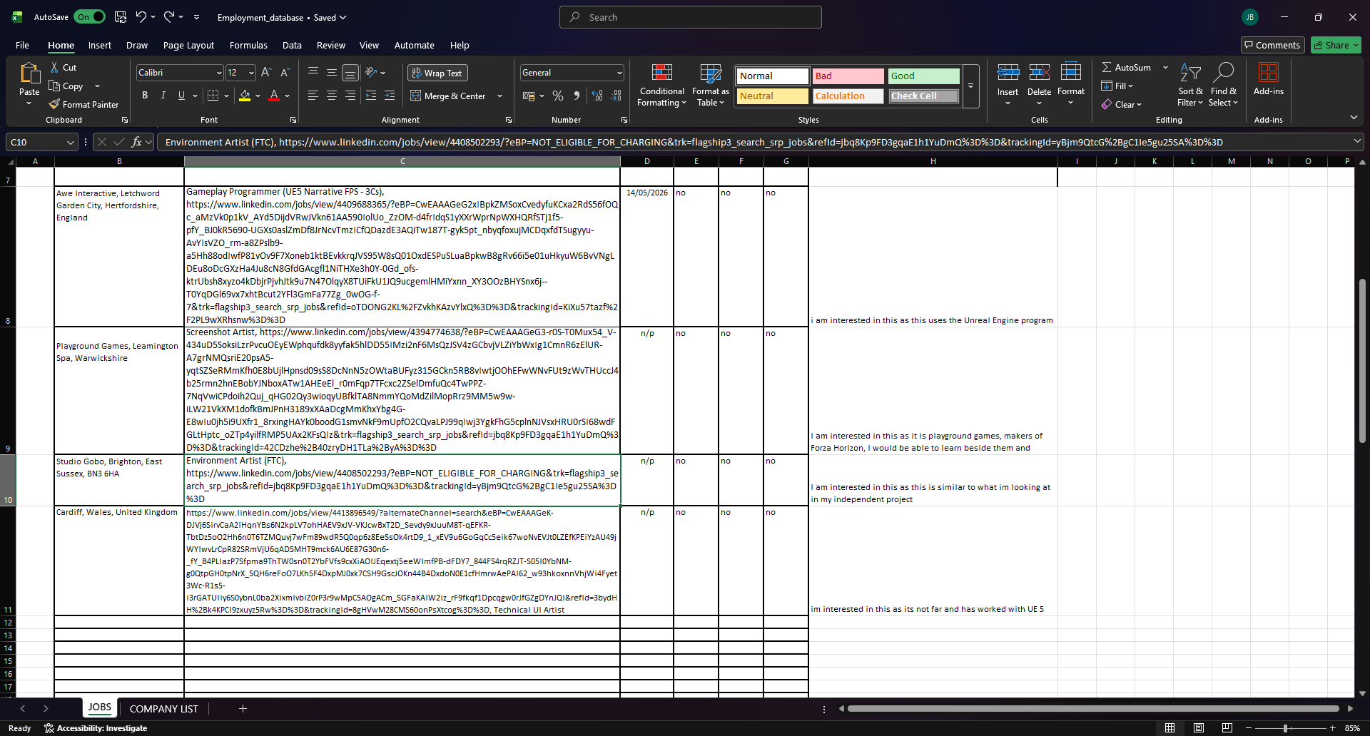
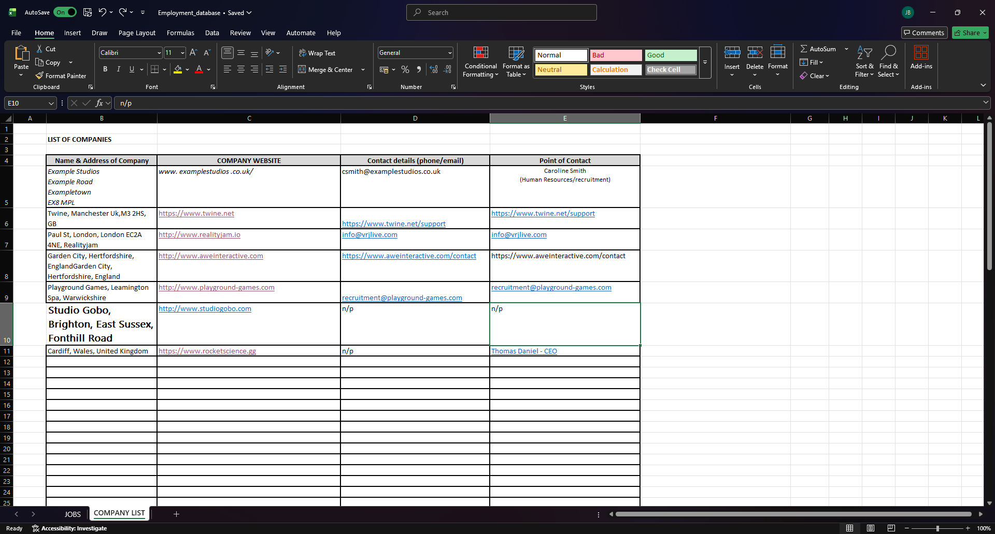

Showreel Link
https://youtu.be/2-n4OxL8r-g

Business Card



Bibliography
Jobs found on: https://www.linkedin.com

Music used: https://www.bensound.com/royalty-free-music?filters[]=Calm&category=Mood&type=free&sort=relevance

