

MODULE CODE : ECPT6007

ASSESSMENT COMPONENT : 1 – The Teaching Toolkit 2

STUDENT NAME: Louise Ridley

STUDENT NUMBER: 1908502

I acknowledge the use of Grammarly (https://www.grammarly.com/) on 22 May 2025 to check my work using the prompt(s):
1. Please check the following text for readability, grammar and syntax.
I confirm that I have not presented any AI generated text as my own work. I confirm that I have copies of my drafts, notes, and other resources I used before, and after the use of AI tools which I may be asked to provide in evidence.

Name: Louise Ridley
Student No: 1908502
Assignment No: ECPT6007
Word count: 1400
Draft

Reflective Report on Peer Review and Curriculum Development

Introduction

This reflective report explores the process of designing my curriculum module “The Art of the Pitch: Selling a World Through Visuals” for third-year BA illustration students and critically evaluates peer feedback received as part of a blind review process. The development of my curriculum aimed to bridge the gap between the pre-production phase and full development within the entertainment industries, such as animation, gaming, and film, while also emphasising the critical role of illustrators in shaping early-stage visual storytelling, character development, and world-building. Additionally, the module addresses the increasing demand for illustrators to be proficient in industry-standard software (Carey, 2025), such as Adobe Photoshop and InDesign, to effectively communicate visual ideas in a professional context. Designing this curriculum was an academic exercise and a personally fulfilling one. It allowed me to create the kind of learning experience I would have valued during my own undergraduate studies. As a student, I felt a disconnect between the skills we were taught and the professional expectations of the creative industries. This module represents the type of course I believe would have better prepared me for those demands, offering a clear pathway from imaginative development to industry-ready outcomes. I particularly enjoyed the challenge of blending creative freedom with professional structure, ensuring students feel supported and creatively empowered. This experience gave me valuable insights into pedagogical design, inclusive teaching, and aligning curriculum with learner aspirations and real-world demands (Carey, 2025).

Professional Learning Through Curriculum Design

One of my most significant learning moments was recognising the importance of providing a strong rationale for the module. From my own experiences and informal student feedback, it became clear that traditional illustration programmes often overlook the need to equip students for roles within the entertainment industries despite the growing interest in these fields in recent years (Creative Industries Federation, 2018). This module looked to respond to that gap by offering a progressive and practice-led structure that would enable students to develop a complete pitch bible and character portfolio suitable for creative careers in areas such as film, animation, and gaming. The peer reviewers affirmed this need, consistently noting that the module had a strong justification and was clearly aligned with the goals of its intended audience.
In designing the module's structure, I adopted a constructivist approach, I worked by scaffolding the learning experience carefully (Chand, 2024), beginning in Week 1 with an introduction to the module and guided idea generation for a visual pitch. This is followed in Weeks 2 and 3 by focusing on character design, starting with silhouette exploration, rough sketches, and visual development, then progressing to refinement and finalisation. In Week 4, introductory workshops introduce students to Adobe Photoshop to support transitioning from traditional to digital media. Subsequent weeks expand into worldbuilding, environment design, narrative development, and storyboarding, gradually equipping students with the skills needed to assemble a professional pitch bible and present it effectively. Learning was structured to support progression using principles of Bloom's Taxonomy (Ruhl, 2025), which was also recognised by one peer reviewer who commented on the effective sequencing of skills and concepts across the module.
A key design choice was the inclusion of both traditional and digital media. I was mindful not to emphasise digital tools too early, as some students might have stronger foundations in hand-drawn work. Therefore, the early week's module centres on traditional sketching, pencil character studies, and sketchbook visual research. Digital tools are introduced later, once the foundational creative thinking is established. One peer suggested that more attention could be paid to traditional methods, which prompted me to review the module, but I believe this is clearly embedded throughout the programme. Traditional sketching and idea development are introduced in the early weeks and supported by digital workshops later on. This balance is clearly outlined in the scheme of work and reinforced in the assessment strategy, where sketchbook development and digital outputs are both recognised as essential. The hybrid approach is, therefore, already visible in both the learning structure and the expected outcomes.
Another important aspect of my professional learning was incorporating inclusion and accessibility into the module design. I aimed to reflect diverse visual cultures in the examples used and to build on opportunities for students to express their identities through character creation. Feedback highlighted this as one of the module's strengths, and I was pleased that this commitment to inclusivity was recognised. I also embedded various assessment types and built-in one-to-one tutorials to support individual learner needs and goals. These one-to-one sessions were designed to serve as spaces for both artistic critique and guidance. One peer-recommended adding tutorials of this nature, which led me to realise that while these were already included throughout the module, I had not clearly articulated their purpose. In future iterations, one-to-ones are intended for feedback on work-in-progress and to help students align their creative work with their professional ambitions and goals and assist students' needs. This reflects the values promoted in the FE professional standards (Professional Standards for Further Education Teachers and Work-Based Learning Practitioners in Wales, 2017).
Several reviewers commented on the importance of benchmarking and linking the module more clearly to professional standards. In reflecting on this feedback, I considered what benchmarking means in the context of Art and design in Further Education, which includes illustration within its scope (QAA, 2019).
The QAA states that learning in Art and Design supports the development of:
- The capacity to be creative
- An aesthetic sensibility
- Intellectual enquiry
- Skills in team working
- An appreciation of diversity
- An appreciation of quality and detail
- The ability to conduct research in a variety of modes
- The quality of critically reflecting on one’s own learning and development
- The ability to factor ethical considerations into creative practice
- The capacity to work independently, encouraging resilience and self-determination
- The ability to communicate in a range of formats
(QAA, 2019)

In developing my module, I embedded these aligned benchmarks through clear progression, real-world industry relevance, and inclusion of formative assessment strategies. The focus on employability, digital skills development, and student-centred learning supports the FE emphasis on preparing learners for creative roles or further study. While I did not reference QAA benchmarks directly, my module's structure and aims reflect many of the principles outlined in those statements, such as visual communication, independent enquiry, and integration of professional practices. However, the benchmark lens applied throughout was intentionally rooted in FE practice, which aligns with the qualifications and learner pathways my curriculum supports.

Conclusion

Engaging in the design and review of my curriculum module has been a valuable and professionally enriching process. It has deepened my understanding of creating an inclusive, industry-aligned, and pedagogically sound curriculum in Further Education. Designing this module allowed me to bring together my creative knowledge, professional experience, and an awareness of current sector needs. It also helped me reflect on what I have found useful in my own undergraduate studies, blending both traditional and digital approaches and ensuring students are not only supported in their development but also challenged in meaningful ways.
The peer feedback I received was constructive and highlighted areas that helped me refine the clarity and structure of my module. Suggestions around making tutorial support more explicit, rebalancing feedback opportunities, and clarifying workshop intentions all contributed to a more accessible and transparent scheme of work. One valuable insight was the reminder to be careful with language in learning outcomes, for example, ensuring terms like "confidence" are framed in observable, assessable ways. In future iterations, I will adapt the language of such outcomes to ensure they focus on demonstrable behaviours.
Similarly, while my assessment design was generally well-received, I recognise the importance of making workshop time more exploratory and less burdened by assessed expectations. Maintaining space for experimentation, without the pressure of output, is essential in a creative learning environment. I will also encourage students to link their reading and research more explicitly to their project goals and career ambitions, particularly through one-to-one tutorials and self-directed development tasks.
This process has affirmed my ability to design a curriculum that prepares learners for real-world creative industries while also remaining flexible and inclusive. It has made me more confident in my practice and more committed to continual reflection, collaboration, and student-centred planning. Most importantly, it has reminded me that curriculum design is not a one-off task but an evolving process that grows through feedback, experience, and engagement with learners and peers.

Reference’s

Carey, Heather. “Skills Mismatches in the UK’s Creative Industries - Creative Industries Policy and Evidence Centre.” Creative Industries Policy and Evidence Centre, Green Doe Ltd, 12 Feb. 2025, pec.ac.uk/state_of_the_nation/skills-mismatches-in-the-uks-creative-industries/. Accessed 19 May. 2025.
CAST. “The Universal Design for Learning Guidelines.” 2024. Accessed 20 May. 2025.
Chand, Satish Prakash. “Constructivism in Education: Exploring the Contributions of Piaget, Vygotsky, and Bruner.” International Journal of Science and Research (IJSR), vol. 12, no. 7, 5 July 2023, pp. 274–278, Accessed 20 May. 2025. www.researchgate.net/publication/378071316_Constructivism_in_Education_Exploring_the_Contributions_of_Piaget_Vygotsky_and_Bruner, https://doi.org/10.21275/sr23630021800. Accessed 19 May. 2025.
Creative UK, Growing the UKs Creative Industries. Creative UK, 2018, www.creativeindustriesfederation.com/sites/default/files/2018-12/Creative%20Industries%20Federation%20-%20Growing%20the%20UK’s%20Creative%20Industries.pdf. Accessed 20 May. 2025.
Professional Standards for Further Education Teachers and Work-Based Learning Practitioners in Wales. 2017. Accessed 19 May. 2025.
QAA MEMBERSHIP Subject Benchmark Statement Art and Design.The Quality Assurance Agency for Higher Education, Dec. 2019. Accessed 20 May. 2025.
Ruhl, Charlotte, and Saul McLeod. “Bloom’s Taxonomy of Learning.” Simply Psychology, Simply Psychology, 11 Mar. 2025, www.simplypsychology.org/blooms-taxonomy.html. Accessed 19 May 2025.

Appendices
Received peer reviews

Peer review 1
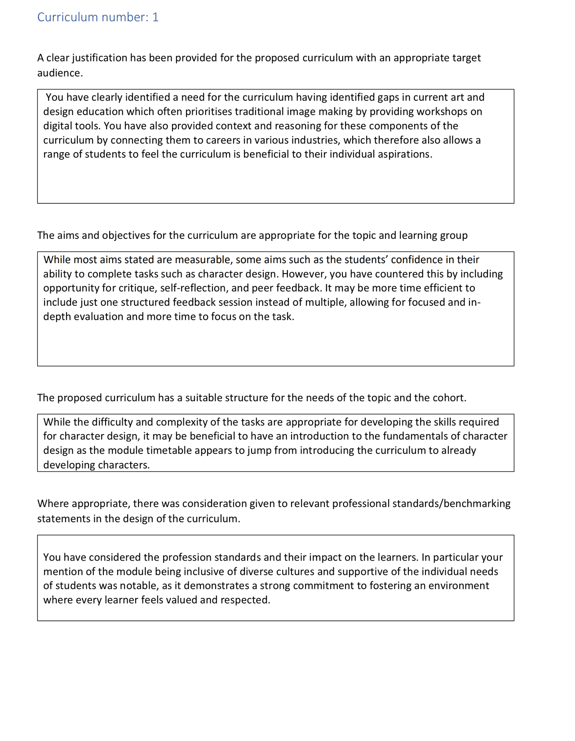

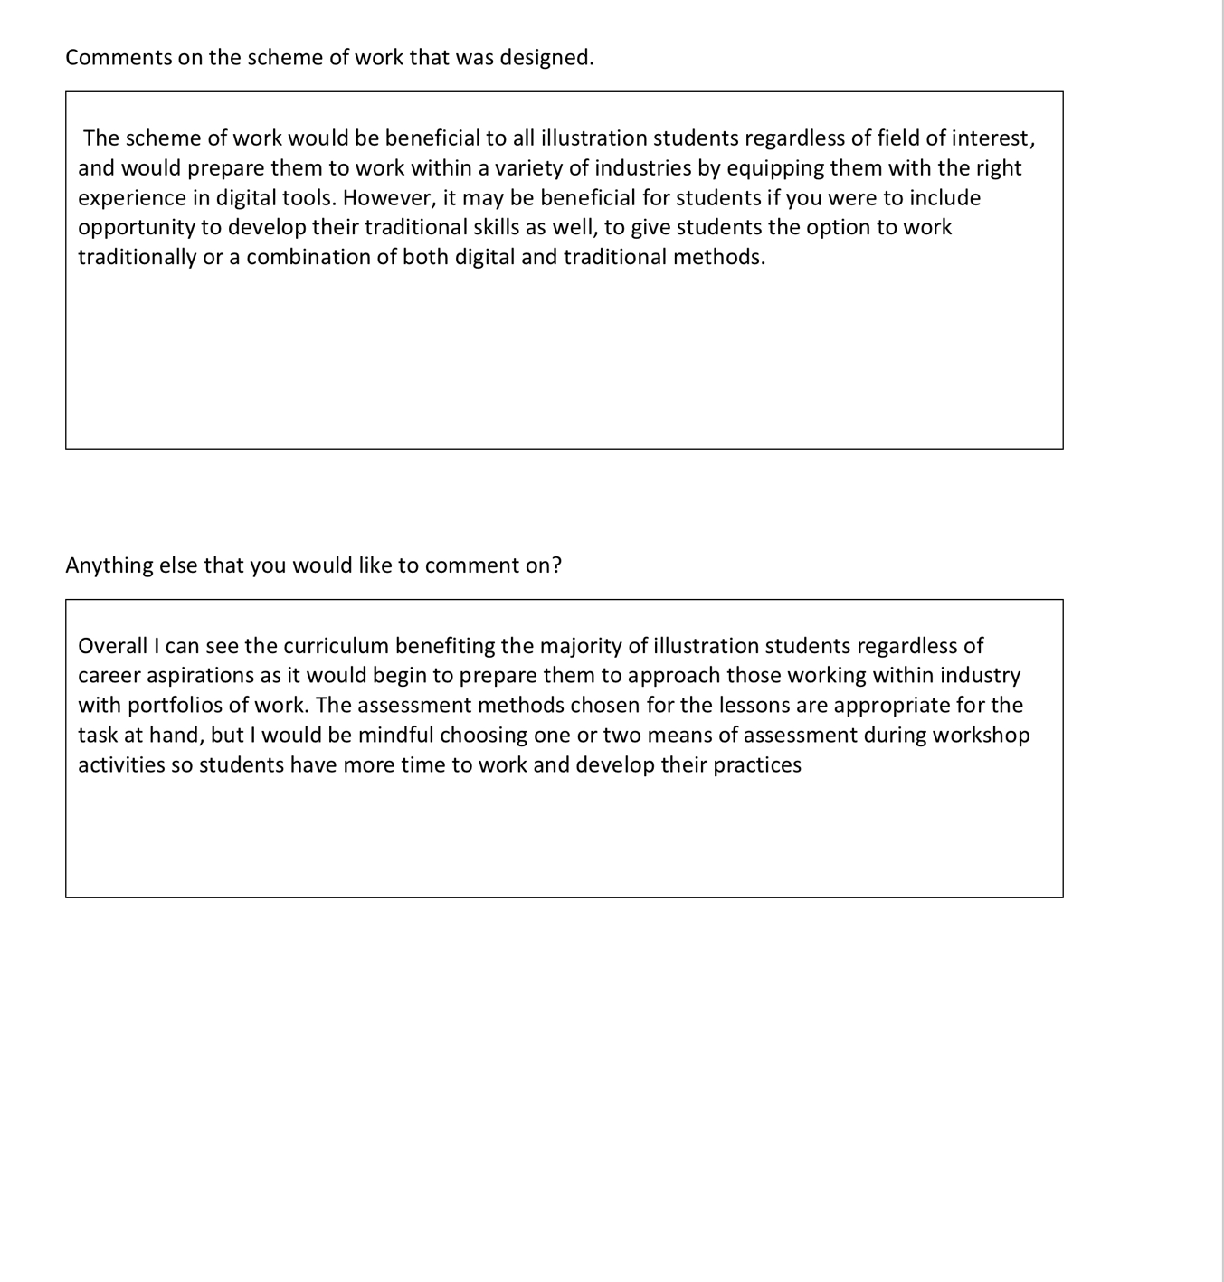

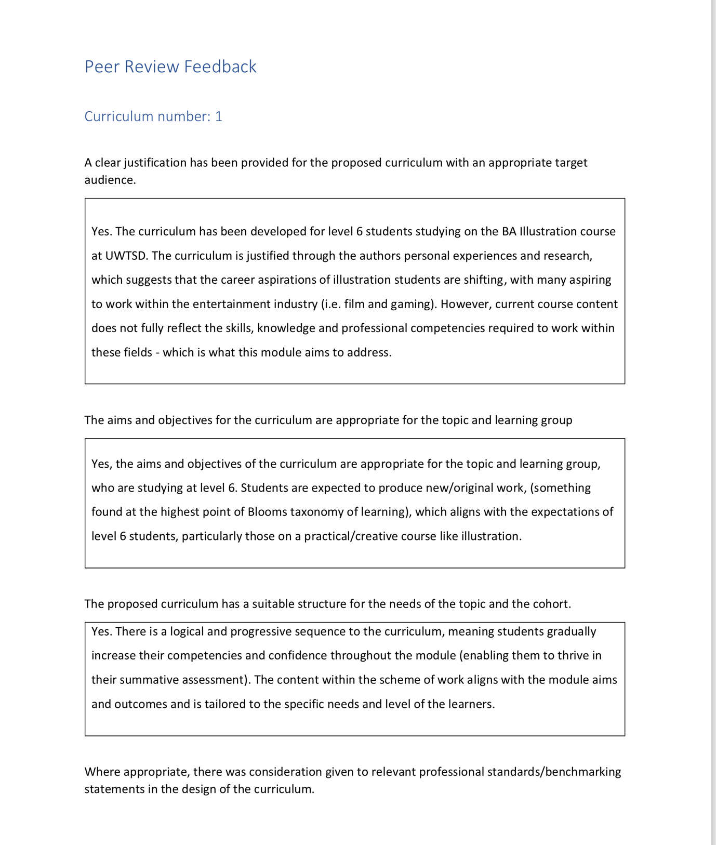
Peer review 2

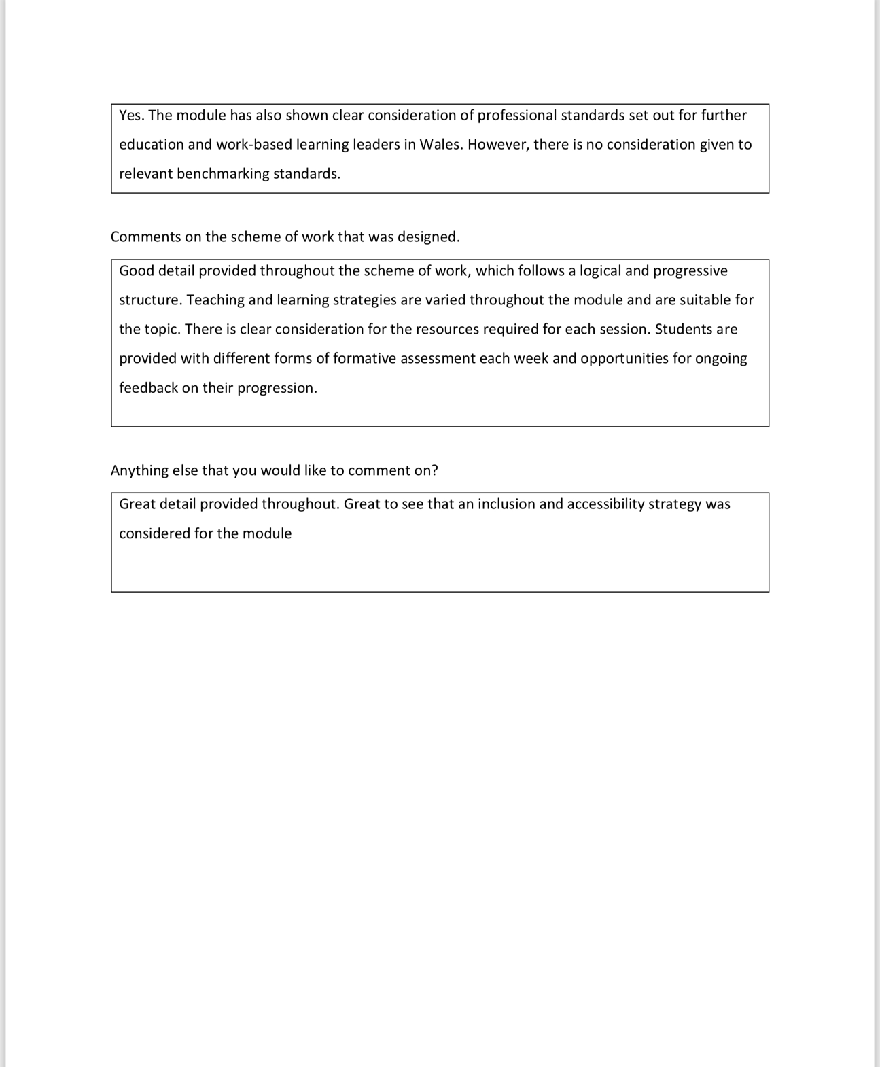
Peer review 3
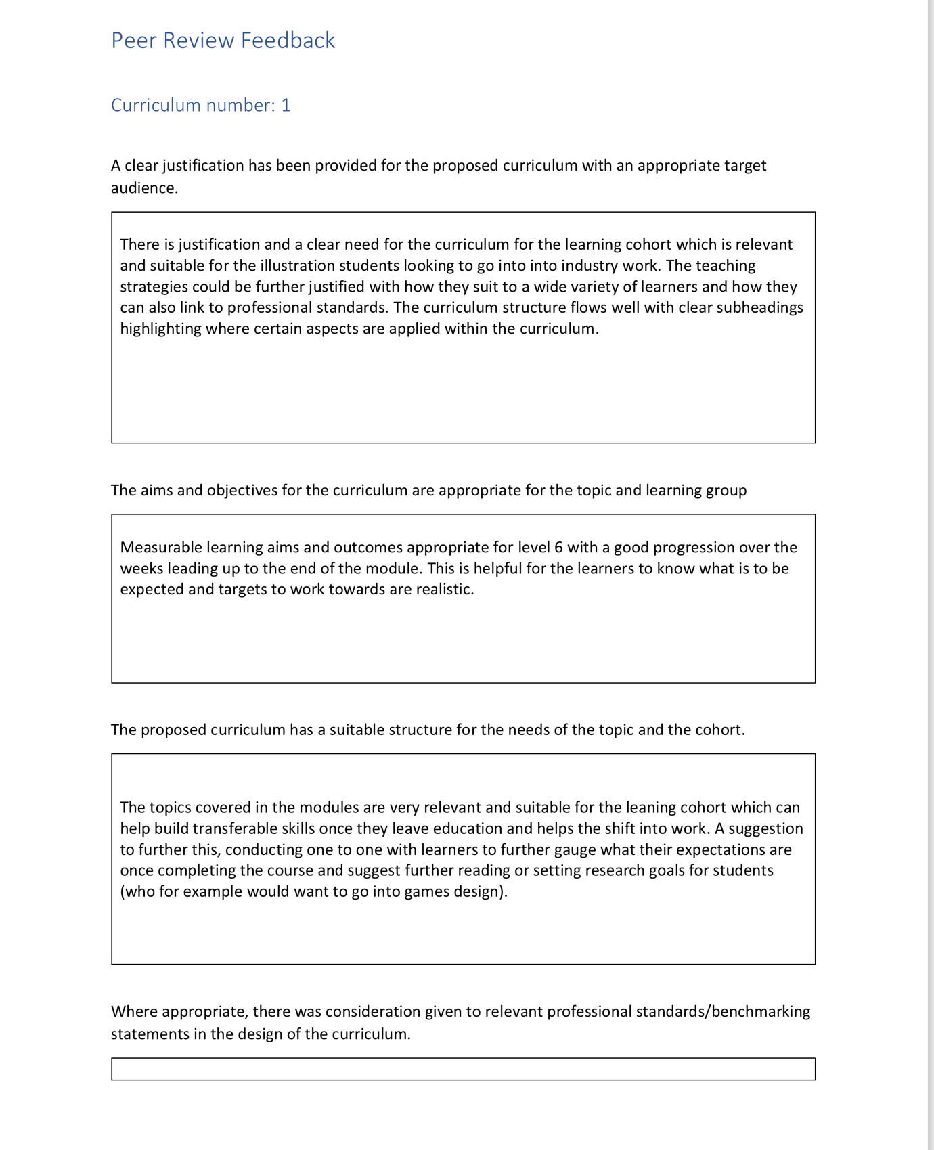

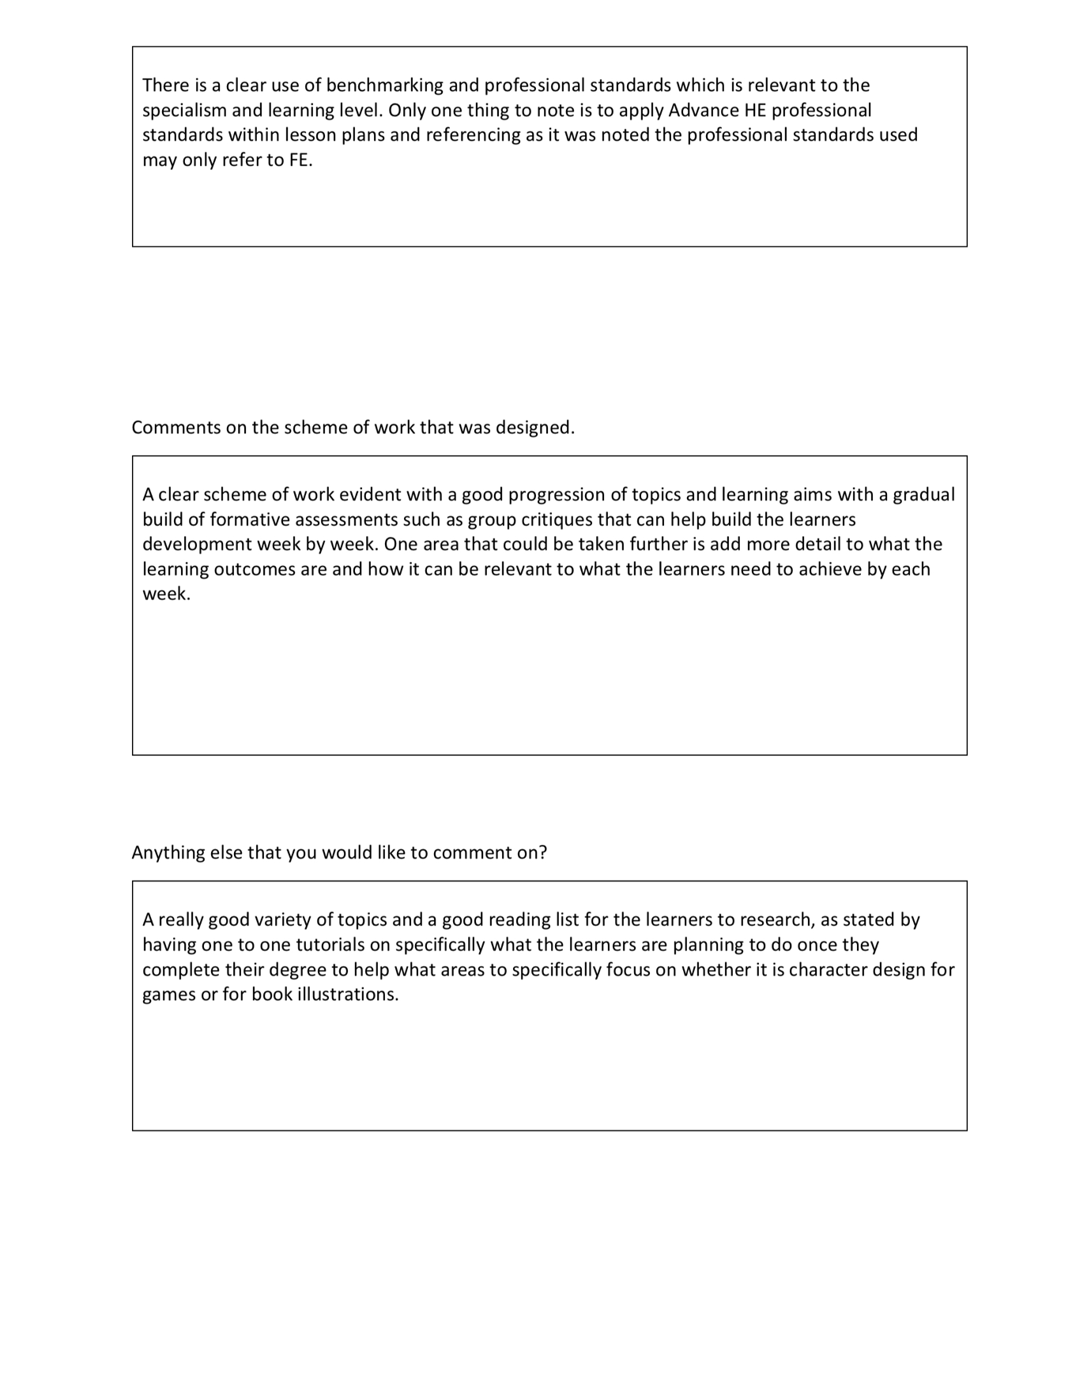
peer reviews presented

Peer review #7
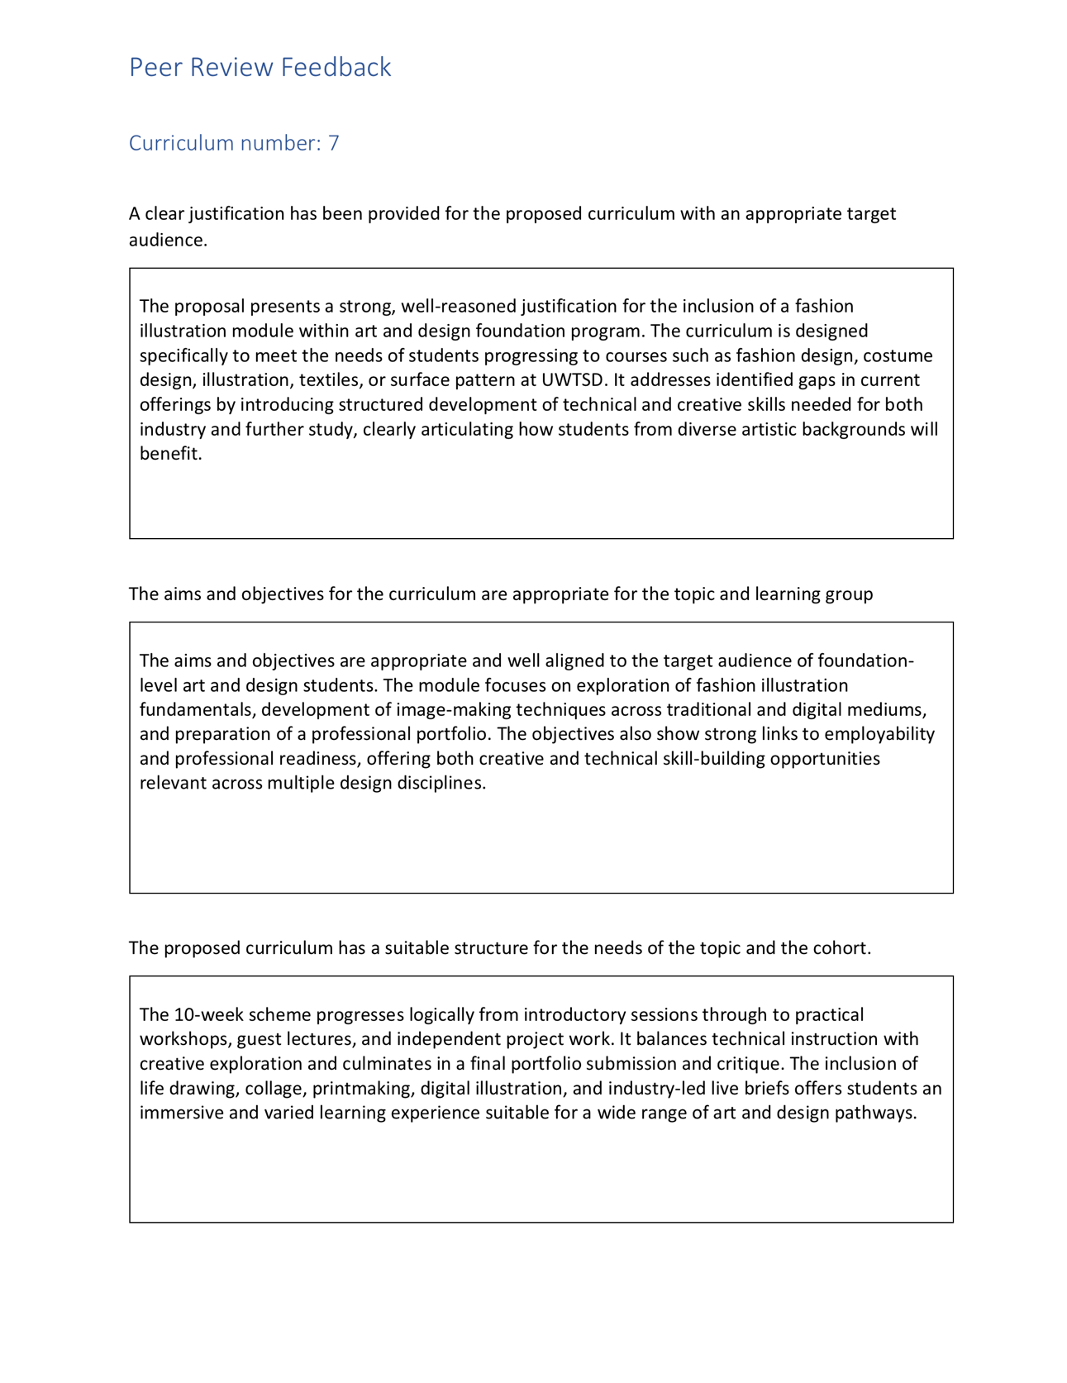

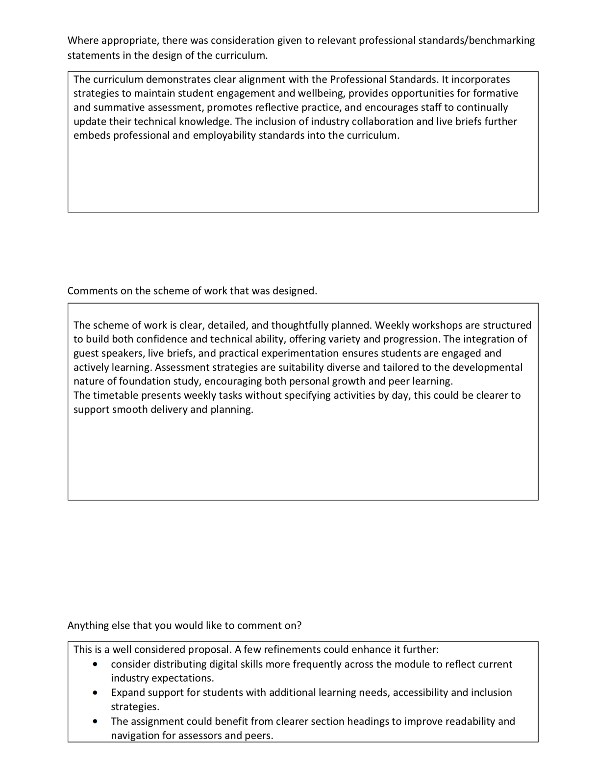
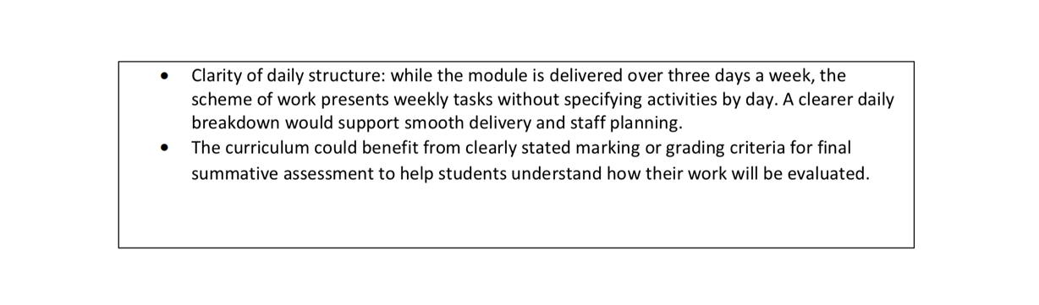
Peer review #5
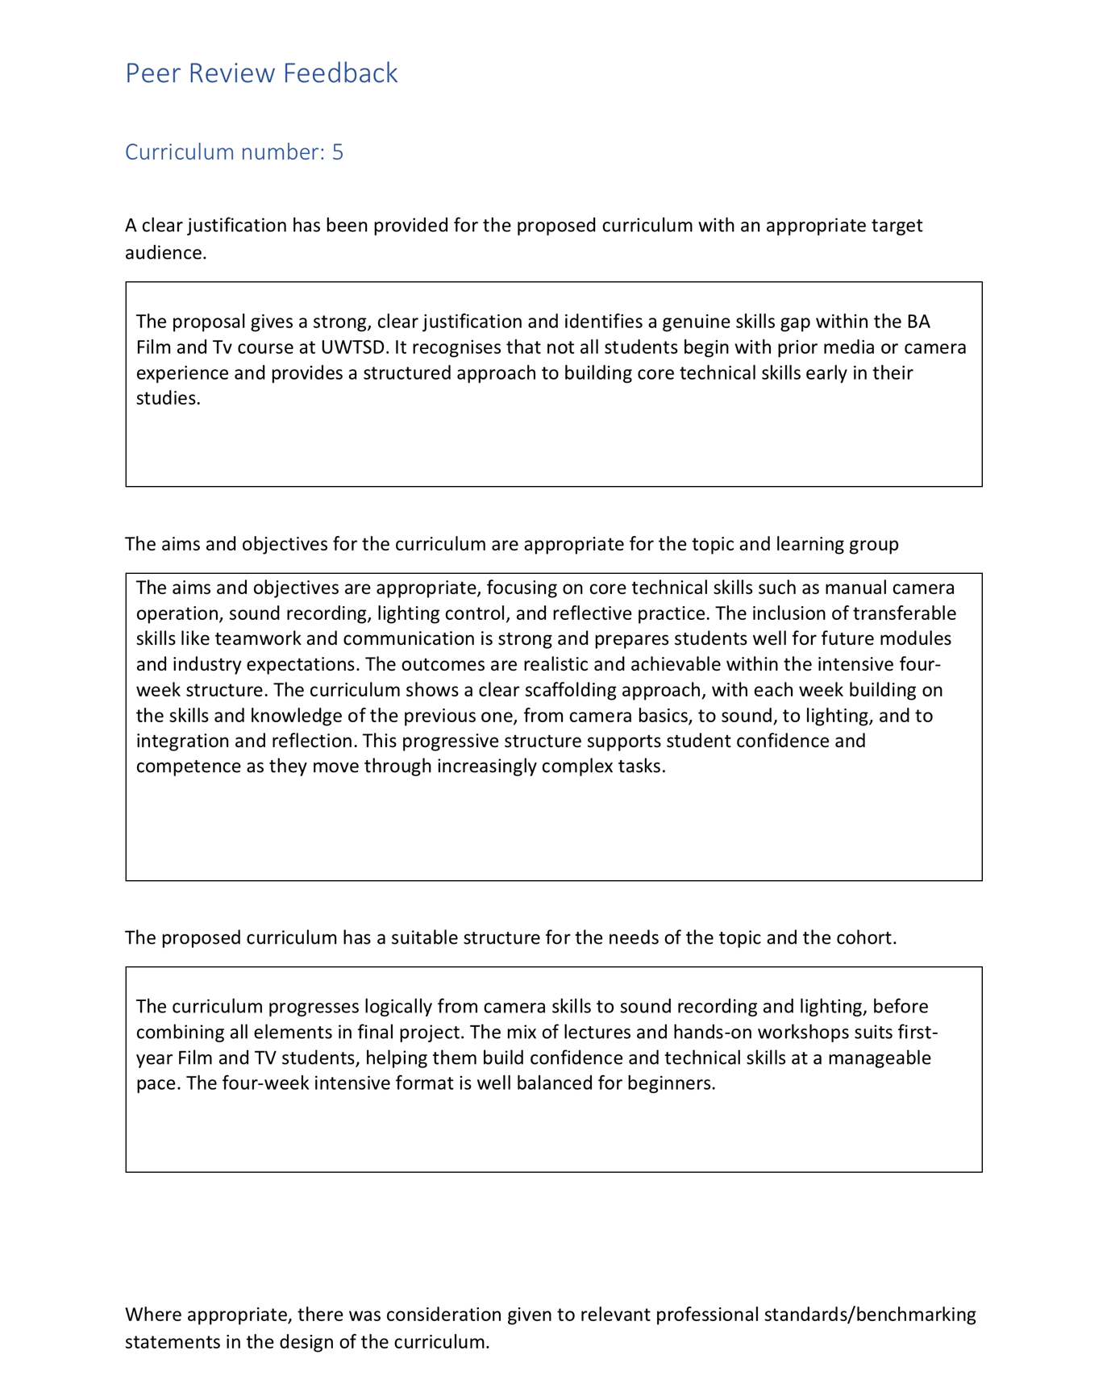

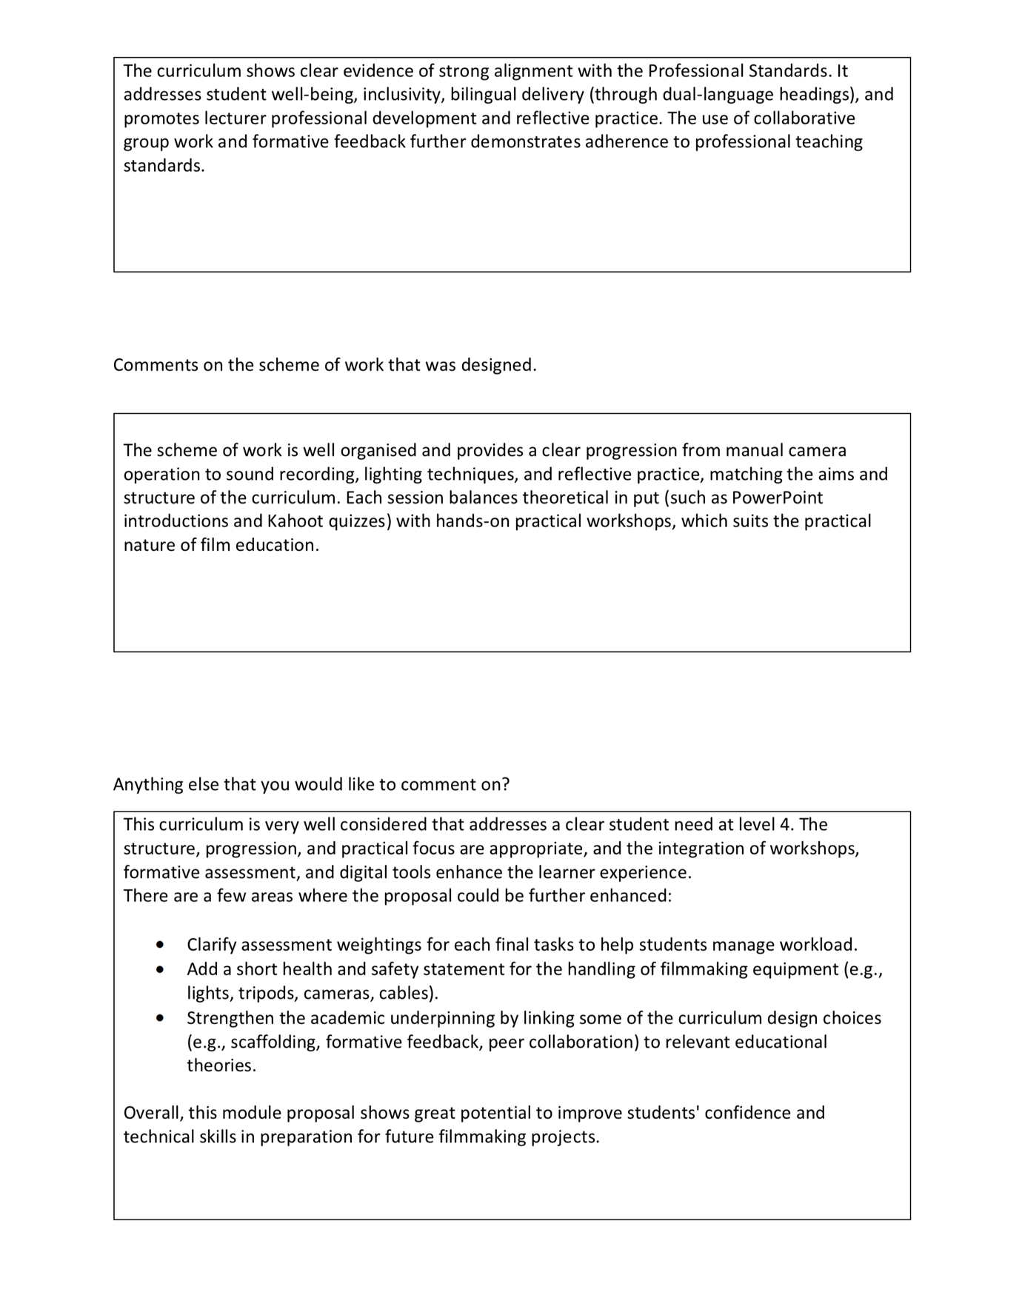
Peer review #2


