

MODULE CODE: Digital Skills for Personal Development and Business Growth BMSW4008

ASSESSMENT COMPONENT: PORTFOLIO

STUDENT NAME: Rafal Sroczynski

STUDENT NUMBER: 2507392

LECTURER: Philippa Fitzgerald

DATE: 12.12.2025
Contents
Cover Page……………………………………………………………………………..1
AI Acknowledgement……………………………………………………………….2
Task 1: Assessment of digital skills………………………………………..3-5
References…………………………………………………………………….5-6
Task 2: LinkedIn Learning Certificates for Office365………………..6-8
Task 3: Essay on Relevance of Excel……………………………………..9-12
References………………………………………………………………….11-12
Excel Spreadsheet…………………………………………………………..11
Task 4: Digital Skills Presentation…………………………………………….12

I confirm that I have not presented any AI-generated materials as my own work.
I confirm that I have copies of my drafts, notes, and other resources I used, which I may be asked to provide in evidence.

Task 1

Assessment of Digital Skills
Portfolio Example
Image 1
Screenshot of your JISC report
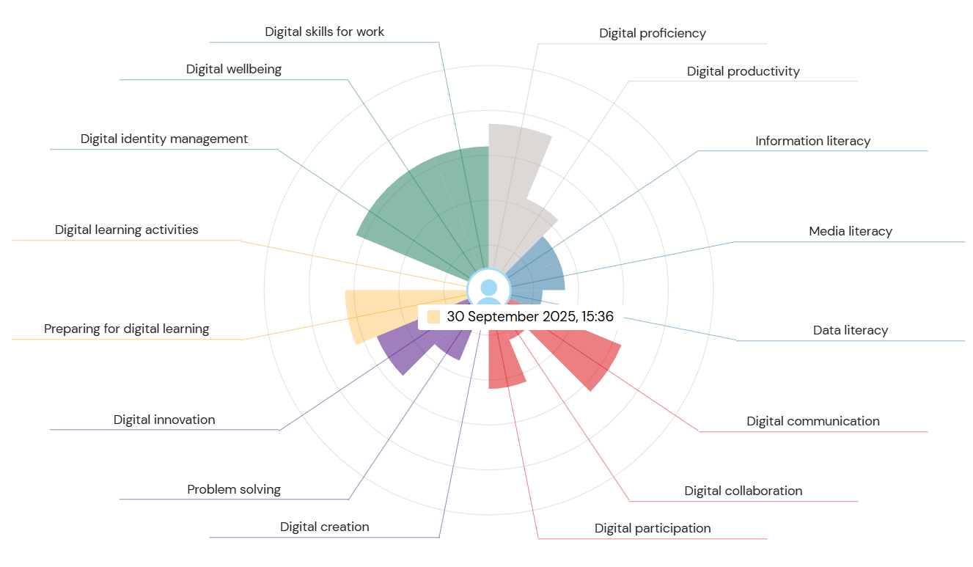
The rapid growth of digital technology in higher education underscores the importance of clear frameworks that help both staff and students build their digital skills (Ahuja, 2025). My assessment of digital skills taught me a lot and provided valuable insights into my own strengths and weaknesses. As an older student, I understood my digital skills were not as refined as they could be. Nevertheless, the assessment was instrumental.
I found that my digital proficiency skills, meaning the ability to use digital devices and software, are good. This gives me a strong foundation for learning additional digital skills and working on areas that are less developed. Digital database resources have a significant impact on stimulating the research culture in higher education (Rafi, JianMing and Ahmad, 2019).
My digital productivity is similar. This means I can reliably choose the right software and application for whatever the task at hand demands and have the right mindset to approach it.
I found that my information literacy skills are still developing, as evidenced by my recent assessment. Information literacy is the ability to find and evaluate information online for whatever purpose is necessary. This is a critical skill in academic research.
Similarly, my media literacy skills are also developing. Social media quickly became popular within a few years. It serves as a platform for social interaction, and many people are amazed by the changes in communication methods, particularly among different generations. And many are awed by the transformation of communication processes (Icha and Agwu, 2015).
This is particularly important in a world dominated by AI, where misinformation runs rampant online. The assessment of my data literacy skills also provided a similar score, which is to say how I handle my own personal data online. This is another important thing online today, as there are significant security risks associated with the mishandling of data such as passwords and addresses.
The assessment gave me a ‘capable’ score in digital communication, which means I can communicate through various media, such as video and photos, and tailor my communication to the audience and the medium's regulations. The assessment scored me as ‘developing’ in digital collaboration, suggesting that I could develop my skills when working online as part of a team.
Integrating new digital technology products into the curriculum to enhance students’ creativity is a challenging task (Tang et al., 2022). My confidence level in digital creation, which is the production of content such as images and websites, was assessed as developing. I think this is a fair assessment.
However, my skills in problem-solving (strictly digital) are much stronger. This means I was assessed as capable of making decisions and answering questions, difficult or not, by using research and digital evidence. This is a skill used every day but requires knowledge of the correct methods for solving problems. Similarly, my skills in digital innovation are reasonably advanced. This means that I am willing to test new strategies and use technology to discover clever solutions to various problems.
I was assessed as capable of preparing for learning. I am proficient at getting myself ready to learn by setting up the right media or using the right tools to learn as efficiently as possible.
I found that my skills in digital identity management are also capable. Digital identity management refers to how you develop and reflect on a digital identity, or identities, as well as how they are linked, or not linked, and how they work together, or don’t. In the modern era, where any given person may have multiple profiles, each projecting a different version of the same person, it is essential to maintain the image you wish to keep, depending on the platform.
I have also been assessed as capable in the skill of digital wellbeing. This refers to the impact of the ever-growing digital world on the real person and their health and wellbeing. I have found that removing myself from most social media platforms has given me a newfound sense of freedom from a world where posting everything online has become a priority for some people. It is also a case of online security, as bullying, scams, and stalking become easier, and it is increasingly important to stay safe online and remember that the person is more important than the persona online.
I have also found that my digital skills for work are strong. The computer has completely revolutionised the modern workplace, so being proficient in the various unique systems is invaluable for digital employability. Digital education has made significant changes worldwide. From blackboard to whiteboard, the conventional classroom system took a leap of faith, swimming with the tide and navigating the rough waters during the pandemic. Written data soon migrated to digital form, replacing traditional teaching and learning methods (Krishnan, Al-Harthy, Fatma Nasser and Singh, 2022).

In summary, this assessment showed me a lot about what skills I can build on, and which skills I can focus on so that my future work, in school and in the workplace, are of the highest possible standard.

References
Ahuja, H. (2025). The JISC Digital Capability Framework: Development, Implementation, Evidence, and Future Directions. Library Waves , [online] 11(1), pp.147–162. Available at: https://www.librarywaves.com/index.php/lw/article/view/248 [Accessed 10 Dec. 2025].
Icha, O. and Agwu, E. (2015). Effectiveness of Social Media Networks as a Strategic Tool for Organizational Marketing Management. [online] Ssrn.com. Available at: https://papers.ssrn.com/sol3/papers.cfm?abstract_id=3122422.
Krishnan, C., Al-Harthy, Fatma Nasser and Singh, G. (2022). Technology Training for Educators From Past to Present. IGI Global.
Rafi, M., JianMing, Z. and Ahmad, K. (2019). Evaluating the impact of digital library database resources on the productivity of academic research. Information Discovery and Delivery, 47(1), pp.42–52. doi:https://doi.org/10.1108/idd-07-2018-0025.
Tang, C., Mao, S., Xing, Z. and Naumann, S. (2022). Improving Student Creativity through Digital Technology Products: a Literature Review. Thinking Skills and Creativity, [online] 44(44), p.101032. doi:https://doi.org/10.1016/j.tsc.2022.101032.

Task 2

LinkedIn Learning Certificates for Office365

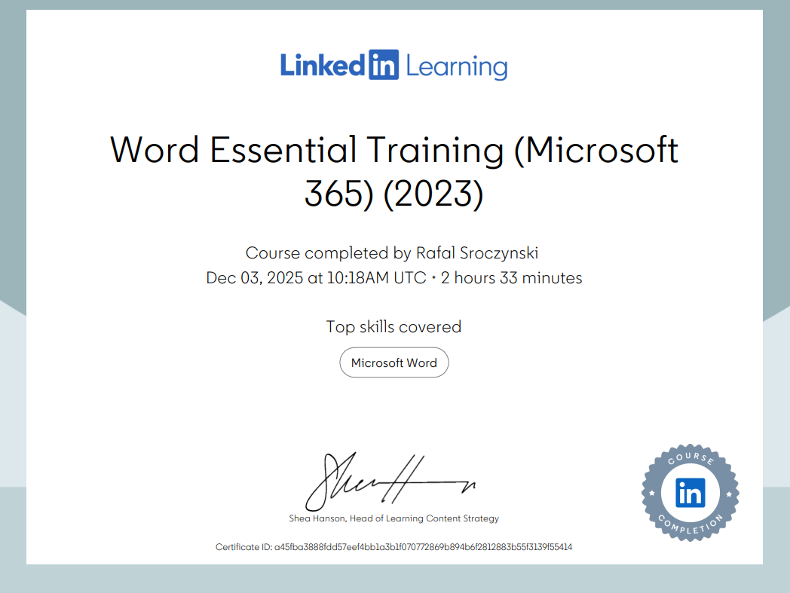

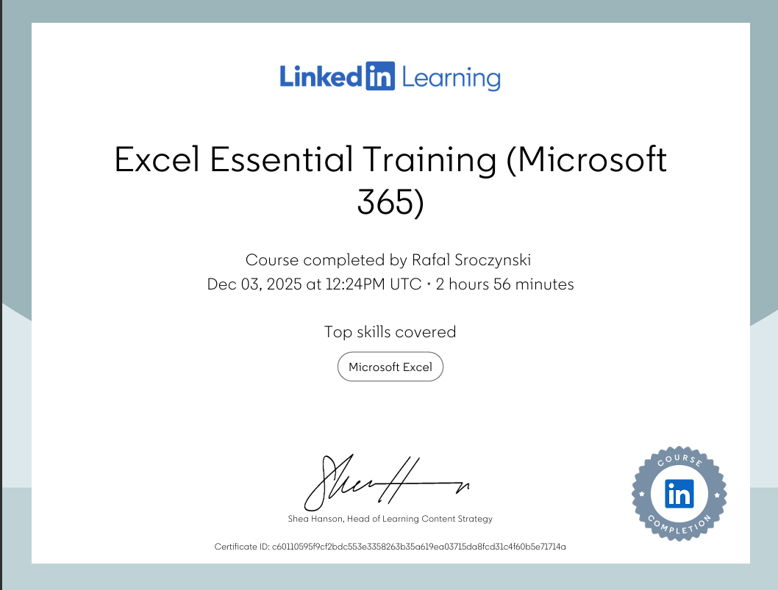

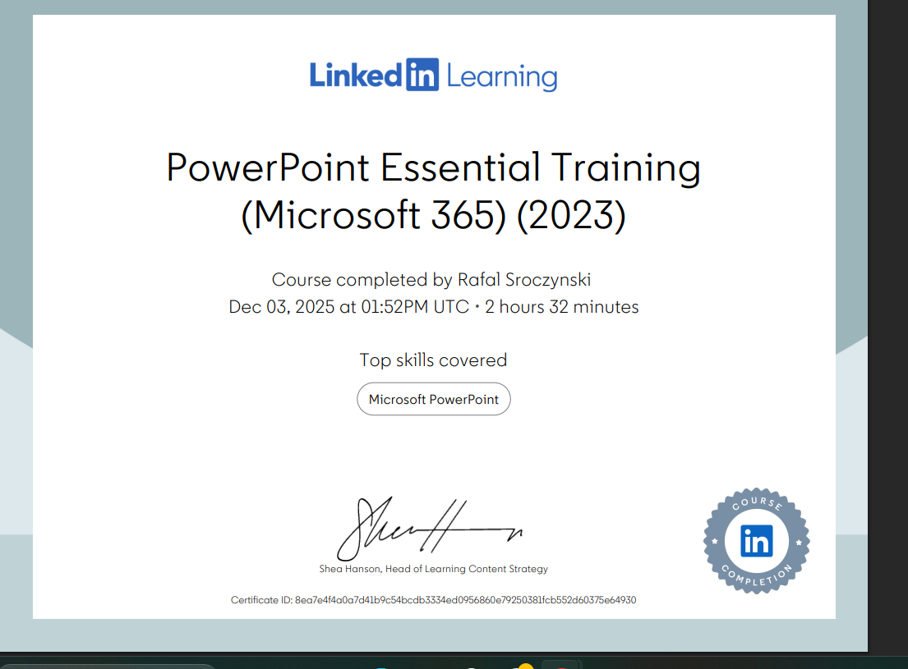

Task 3

Essay on Relevance of Excel in professional and personal life
In contemporary society, digital competence has become a vital requirement in both professional and personal life. Among the many digital tools used today, Microsoft Excel remains one of the most significant due to its flexibility, accessibility, and wide range of applications. While some people associate Excel mainly with accounting or data-heavy professionals, research shows that spreadsheets are used in almost every industry and organisational environment (Thorne and Hancock, 2019). Because of its ability to store, structure, and process information clearly, Excel supports both daily workplace and personal decision-making. This essay explores Excel's relevance in professional contexts, its growing value in everyday life, and the reasons it remains a core digital skill. From a professional perspective, Excel has become essential for administrative work, data management, and organisational planning. In sectors such as finance, education, and business administration, spreadsheets are used to record information, track progress, and generate reports that support operational decisions. Large-scale studies have shown that organisations produce and rely on thousands of spreadsheets every year, especially in finance departments, where accuracy and structured data storage are crucial (McDaid et al., 2011). Excel offers a systematic, grid-based layout that allows employees, even those without advanced skills, to manage information effectively and transparently. Excel's importance becomes even more evident in analytics and decision-making roles. Many businesses rely on data-driven insights, and Excel provides accessible tools that support this process. Functions such as “SUM, IF, VLOOKUP” enable quick calculations, comparison, and analyses, while PivotTables allow users to summarise large datasets and identify key patterns. These features help organisations produce clearer and more reliable evaluations. Microsoft notes that Excel is specifically designed to reduce the time people spend gathering data and increase the time spent on analysis. (Microsoft, n.d.-a). In addition, modern Excel tools -such as forecasting, scenario planning, and What-if Analysis make it easier for employees to produce accurate projections and strategic recommendations. Another essential aspect of Excel's professional relevance is its support for structured thinking. Spreadsheet use encourages logical organisation and step-by-step problem solving, which improves overall productivity and communication within teams. Some researchers point out that spreadsheets essentially function as “data browsers,” allowing users to reshape, restructure, or reorganise information as tasks evolve (Samar and Patni, 2008). This adaptivity makes Excel suitable not only for routine administrative work but also for more complex modelling and reporting in fast-changing environments. Other studies highlighted that spreadsheets can be reshaped and customised as organisational needs shift, demonstrating Excel's long-term usefulness (Pain, Tek and Williamson, 2008). Beyond professional settings, Excel is gaining increasing significance in personal life. One of the most common personal uses is budgeting and financial planning. With rising living costs, many individuals rely on spreadsheets to monitor their spending, track bills, and plan future savings. Excel's automatic calculation helps ensure accuracy, and its visual layout makes finances easier to understand. Articles discussing digital literacy note that Excel remains one of the most practical tools for household budgeting because it's simple, customisable and widely available (School of Coding UK, 2024). For adults managing work, family, and professional responsibilities, this kind of clarity can reduce stress and support better financial decisions. Excel is also valuable for long-term planning and personal organisation. People use it to track fitness goals, plan home projects, monitor study progress, or organise appointments. Because Excel can be customised for almost any purpose, it often replaces multiple specified apps. Its adaptability gives users complete control over how information is presented and updated. Industry discussions indicate that Excel continues to be preferred over specialised apps because it offers both flexibility and transparency in data management (IT Pro, 2023). Additionally, Excel develops transferable skills that benefit individuals in both professional and personal contexts. Using spreadsheets requires strengths in logical reasoning, attention to detail, and the ability to work systematically with information. These skills are valuable not only in data-related fields but also in everyday life problem-solving and planning. Research on workplace digital skills emphasises that spreadsheet literacy is now considered a fundamental part of digital competence, making Excel particularly important for lifelong learners and mature students returning to education (Thorne and Hancock, 2019).
In conclusion, Microsoft Excel remains highly relevant in both professional and personal life because of its flexibility, analytical capabilities, and ability to organise information clearly. In professional settings, Excel supports productivity, decision-making, and communication, and its widespread use across industries demonstrates long-term value (McDaid et al., 2011). In personal life, Excel provides practical tools for budgeting, goal tracking, and everyday organisation, helping individuals manage responsibilities more effectively. Whether used for complex business planning or simple household budgeting, Excel strengthens digital confidence and supports clearer, more informed decision-making. For those reasons, it remains one of the most essential tools in modern life.
Embed your Excel here.
Excel spreadsheet.xlsx

References

McDaid, K., MacRuairi, R., Clynch, N., Logue, K., Clancy, C. and Hayes, S. (2025). Spreadsheets in Financial Departments: An Automated Analysis of 65,000 Spreadsheets using the Luminous Technology. [online] arXiv.org. Available at: https://arxiv.org/abs/1111.6866.
Paine, J., Tek, E. and Williamson, D. (2025). Rapid Spreadsheet Reshaping with Excelsior: multiple drastic changes to content and layout are easy when you represent enough structure. [online] arXiv.org. Available at: https://arxiv.org/abs/0803.0163 [Accessed 19 Nov. 2025].
published, K.O. (2023). Using Excel for data analysis vs management. [online] ITPro. Available at: https://www.itpro.com/security/data-protection/using-excel-for-data-analysis-vs-management.
Samar, V. and Patni, S. (2025). Controlling the Information Flow in Spreadsheets. [online] arXiv.org. Available at: https://arxiv.org/abs/0803.2527 [Accessed 19 Nov. 2025].
School of Coding & AI. (2025). Importance of Microsoft Excel in Business: 10 Reasons. [online] Available at: https://schoolofcodinguk.com/blog/importance-of-microsoft-excel-in-business/.
Thorne, S. and Hancock, J. (2019). A Case Study of Spreadsheet Use within the Finance and Academic Registry units within a Higher Education Institution. [online] arXiv.org. Available at: https://arxiv.org/abs/1909.07462 [Accessed 19 Nov. 2025].

Task 4

Reflective Presentation
DIGITAL SKILLS PRESENTATION.pptx

