- A transmission line has a characteristics impedance of 50 $Ω$ and a load impedance of $Z_{L}=40+j60Ω.$ Calculate the SWR, Voltage reflection coefficient and input impedance for 0.18𝜆 long transmission line. Use smith chart to calculate.
Answer:
- VSWR
Normalised load impedance ${\overline{Z}}_{L}=\frac{Z_{L}}{Z_{0}}=\frac{40+j60}{50}$
${\overline{Z}}_{L}=0.8+j1.2$
VSWR =3.59 (From smith chart)
- Voltage reflection Coefficient
$Γ=0.56$ (From smith chart)
- Input impedance of the line, given that the line is 0.18𝜆 long.
${\overline{Z}}_{in}=0.82-j1.22$ (From smith chart)
${\overline{Z}}_{in}=\frac{Z_{in}}{Z_{0}}$
$Z_{in}={\overline{Z}}_{in}Z_{0}=(0.82-j1.22)50$
$Z_{in}=(41-j61)$Ω

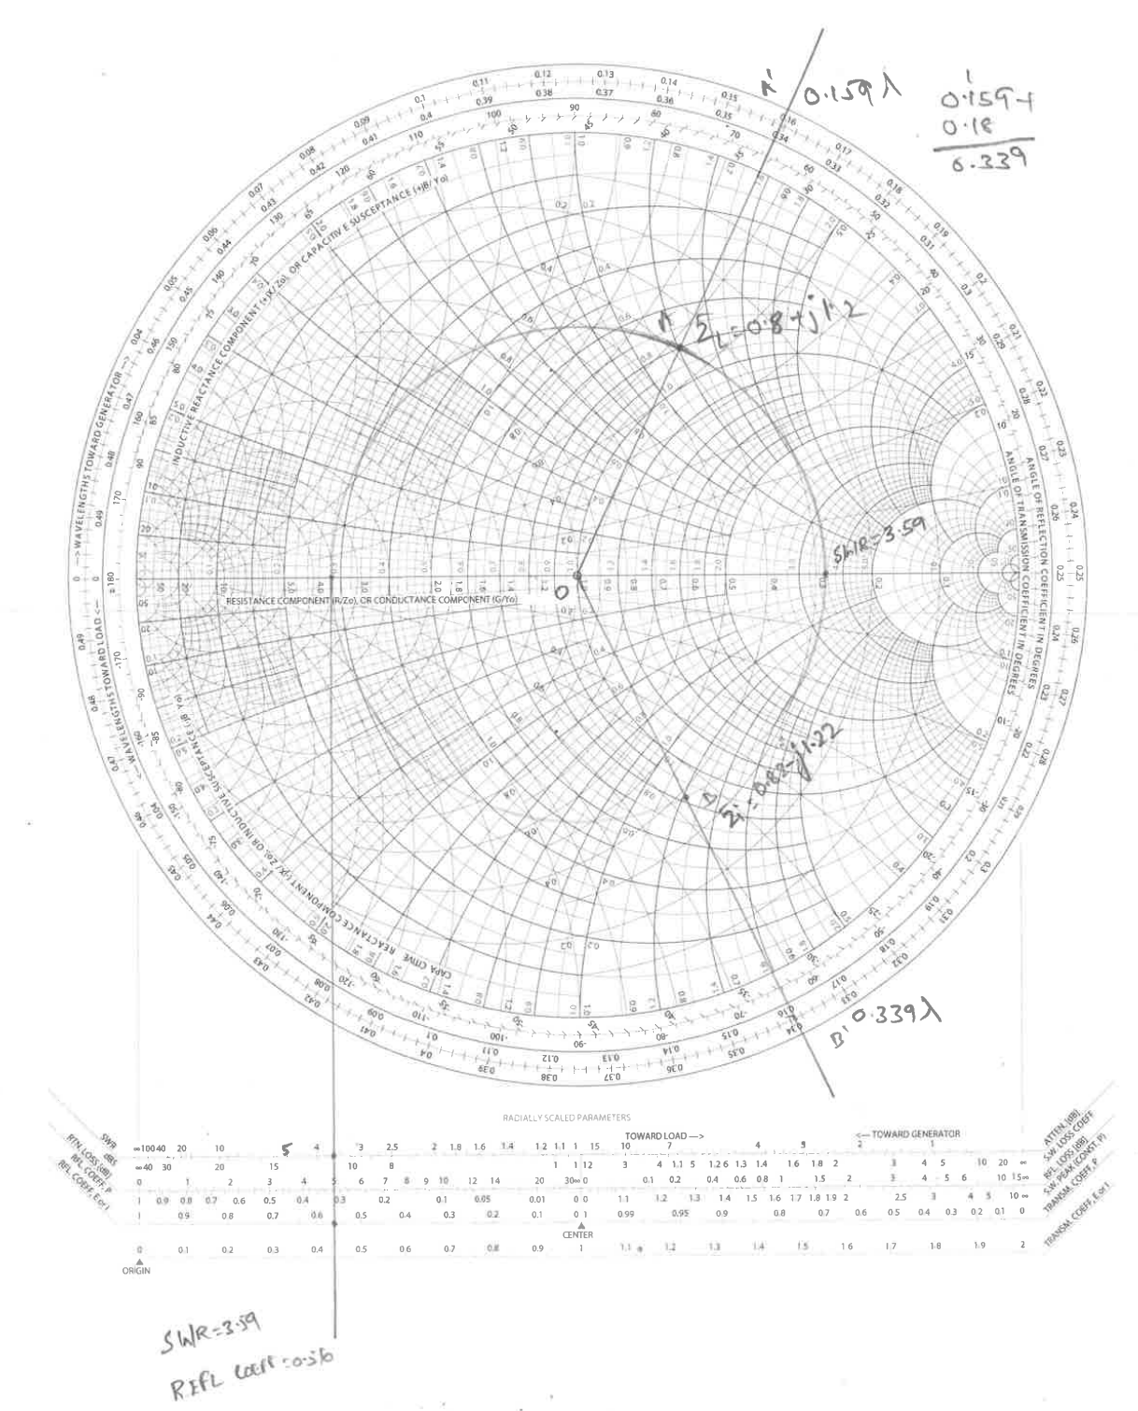
Fig: 1

- A transmission line is terminates at a load impedance of $Z_{L}=25+j50Ω.$ Determine the following if the characteristics if the characteristic impedance of 50$Ω$. Use smith chart to calculate the following
- VSWR
- Voltage Reflection Coefficient
- Return loss
- Input impedance of the line, given the line is 3.3𝜆 long
- Input admittance of the line.
Answer:
- VSWR
Normalised load impedance ${\overline{Z}}_{L}=\frac{Z_{L}}{Z_{0}}=\frac{25+j50}{50}=0.5+j1$
${\overline{Z}}_{L}=0.5+j1$
VSWR =4.3 (From smith chart)
- Voltage reflection Coefficient
$Γ=0.62$ (From smith chart)
- Return loss
Return Loss = 4.05db (From smith chart)
- Input impedance of the line, given that the line is 3.3𝜆 long.
${\overline{Z}}_{in}=0.28-j0.4$ (From smith chart)
${\overline{Z}}_{in}=\frac{Z_{in}}{Z_{0}}$
$Z_{in}={\overline{Z}}_{in}Z_{0}=(0.28-j0.4 )50$
$Z_{in}=(14-j20)$Ω
- Input admittance of the line.
${\overline{Y}}_{in}=1.15+j1.66$ (From smith chart)
${\overline{Y}}_{in}=\frac{Y_{in}}{G_{0}}$
$Y_{in}={\overline{Y}}_{in}G_{0}$
$Y_{in}=\frac{{\overline{Y}}_{in}}{Z_{0}}=\frac{1.15+j1.66 }{50}$
$Y_{in}=0.023+j0.0332$

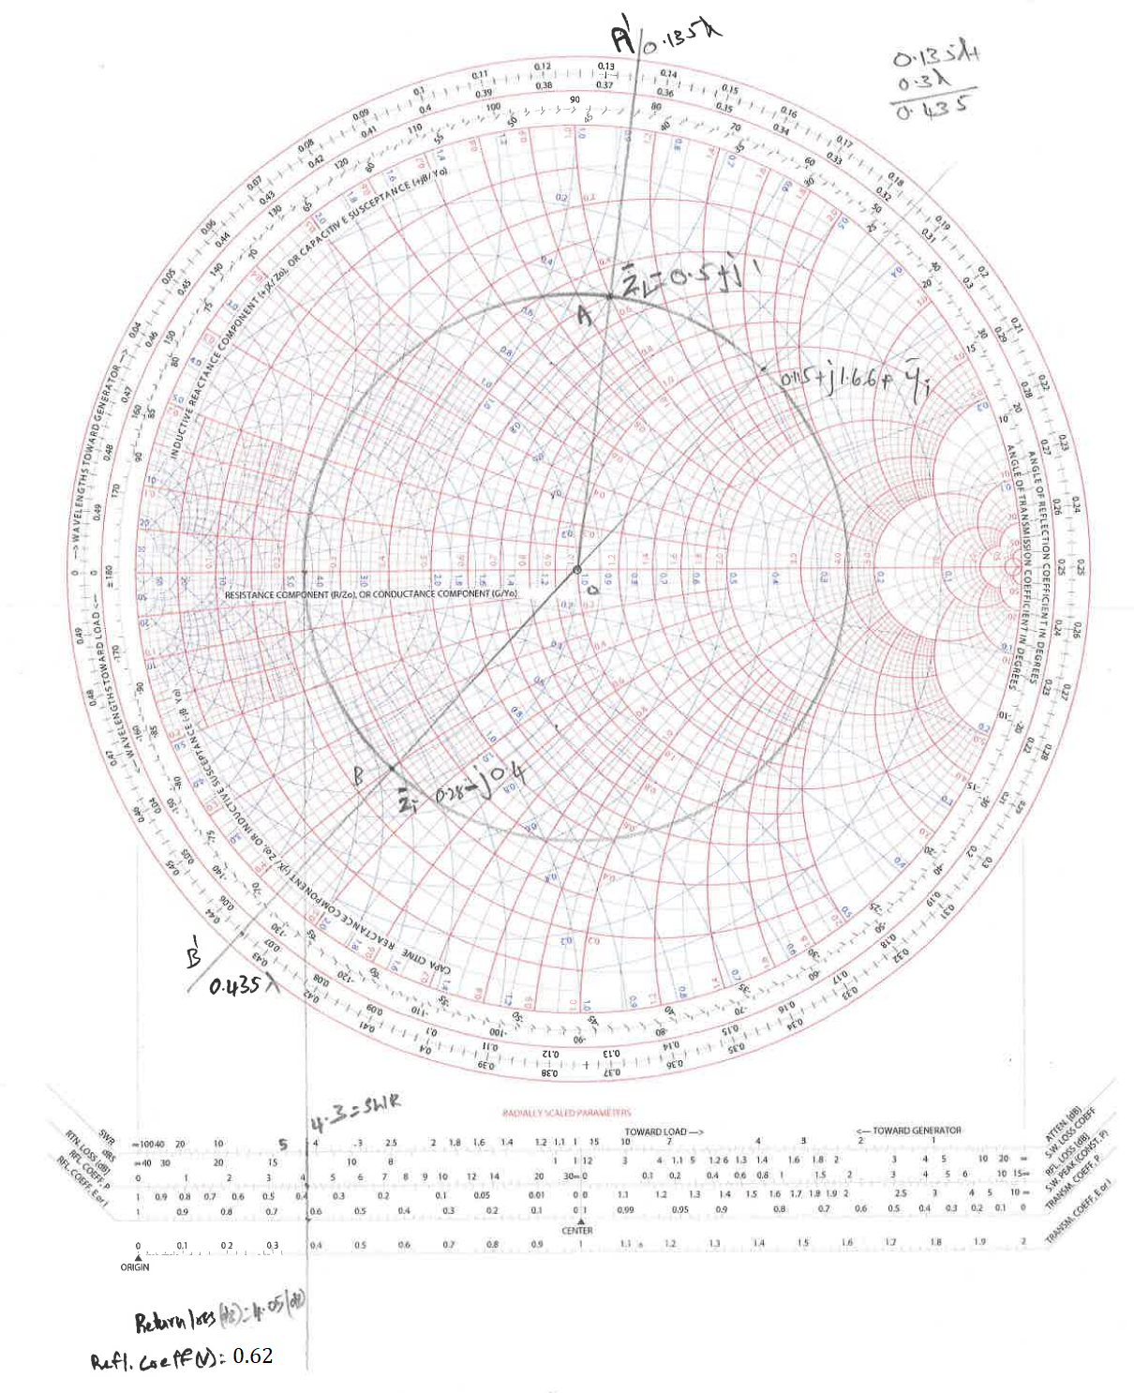
Fig: 2

- A transmission line with a length of $0.1λ$has a characteristic impedance of 75$Ω$. The line is terminated at a load impedance of $Z_{L}=35-j75Ω$. Use the smith chart to calculate the following
- VSWR
- Voltage Reflection Coefficient
- Return loss
- Input impedance of the line, .
- Input admittance of the line.
Answer:
- VSWR
Normalised load impedance ${\overline{Z}}_{L}=\frac{Z_{L}}{Z_{0}}=\frac{35-j75}{75}$
${\overline{Z}}_{L}=0.47-j1$
VSWR =4.4 (From smith chart)
- Voltage reflection Coefficient
$Γ=0.64$ (From smith chart)
- Return loss
Return Loss = 4db (From smith chart)
- Input impedance of the line, given that the line is 0.1𝜆 long.
${\overline{Z}}_{in}=0.23-j0.2$ (From smith chart)
${\overline{Z}}_{in}=\frac{Z_{in}}{Z_{0}}$
$Z_{in}={\overline{Z}}_{in}Z_{0}=(0.23-j0.2)75$
$Z_{in}=(17.25-j15)$Ω
- Input admittance of the line.
${\overline{Y}}_{in}=2.3+j2.1$ (From smith chart)
${\overline{Y}}_{in}=\frac{Y_{in}}{G_{0}}$
$Y_{in}={\overline{Y}}_{in}G_{0}$
$Y_{in}=\frac{{\overline{Y}}_{in}}{Z_{0}}=\frac{2.3+j2.1 }{75}$
$Y_{in}=0.031+j0.028$

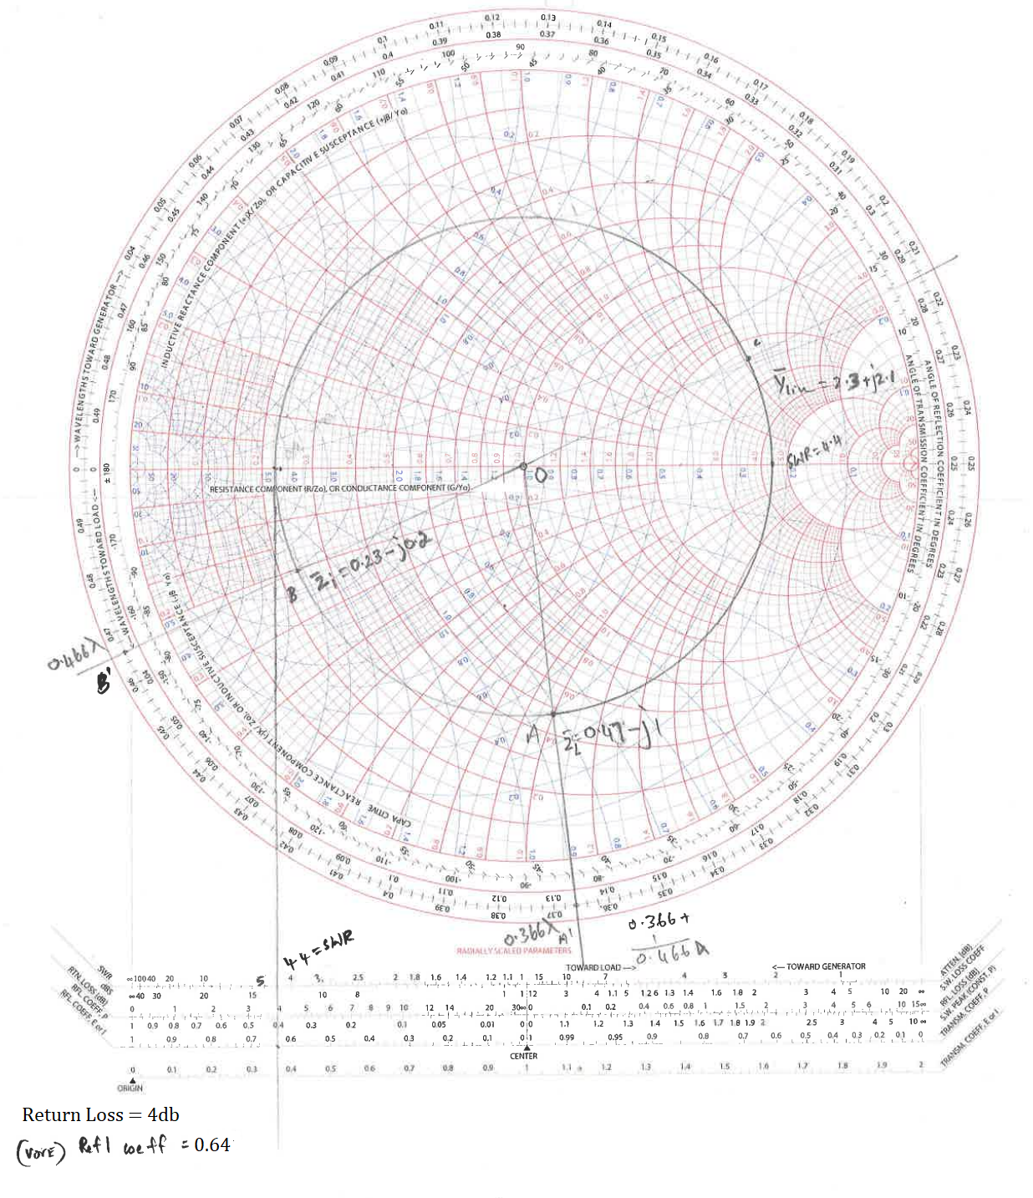
Fig: 3

- A RF transmission line with a length of $2.5cm$ and a frequency of 3GHz, has a characteristic impedance of 50$Ω$. The line is terminated at a load impedance of $Z_{L}=50+j40Ω$. Use the smith chart to calculate the following
- VSWR
- Voltage Reflection Coefficient
- Return loss
- Input impedance of the line, .
- Input admittance of the line.
Answer:
- VSWR
Normalised load impedance ${\overline{Z}}_{L}=\frac{Z_{L}}{Z_{0}}=\frac{50+j40}{50}$
${\overline{Z}}_{L}=1+j0.8$
VSWR =2.2 (From smith chart)
- Voltage reflection Coefficient
$Γ=0.38$ (From smith chart)
- Return loss
Return Loss = 8.5db (From smith chart)
- Input impedance of the line
$λ=\frac{c}{f}=\frac{3×{10}^{8}}{3×{10}^{9}}=0.1m=10cm$
Length of the transmission line is = 0.25 $λ$
${\overline{Z}}_{in}=0.6-j0.5$ (From smith chart)
${\overline{Z}}_{in}=\frac{Z_{in}}{Z_{0}}$
$Z_{in}={\overline{Z}}_{in}Z_{0}=(0.6-j0.5)50$
$Z_{in}=(30-j25)$Ω
- Input admittance of the line.
${\overline{Y}}_{in}=1+j0.8$ (From smith chart)
${\overline{Y}}_{in}=\frac{Y_{in}}{G_{0}}$
$Y_{in}={\overline{Y}}_{in}G_{0}$
$Y_{in}=\frac{{\overline{Y}}_{in}}{Z_{0}}=\frac{1+j0.8 }{50}$
$Y_{in}=0.02+j0.016$

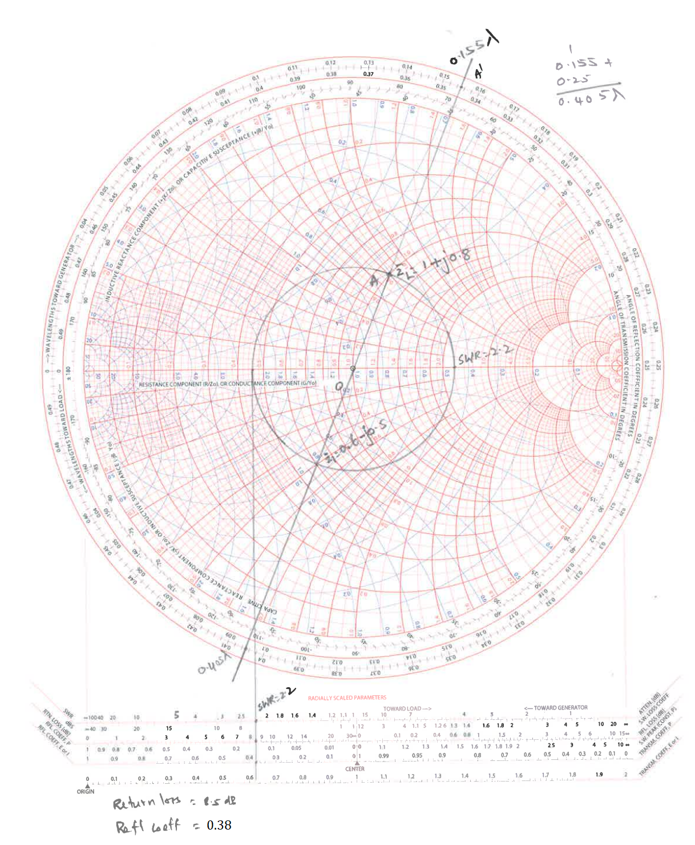
Fig: 4

- A transmission line with a length of $0.07λ$has a characteristic impedance of 50$Ω$, frequency of $21MHz$ and input impedance of $R=40Ω$and $C=180PF$. The line is terminated at an unknown load impedance of $Z_{L}$. Use the smith chart to calculate the following
- VSWR
- Voltage Reflection Coefficient
- Return loss
- Load impedance .
Answer:
- VSWR
$X_{L}=\frac{1}{2πfc}=\frac{1}{2π×21×{10}^{6}×180×{10}^{-12}}=63Ω$
$R=40Ω$
$Z_{i}=R-{jX}_{C}=40-j63$
Normalised input impedance ${\overline{Z}}_{i}=\frac{Z_{i}}{Z_{0}}=\frac{40-j63}{50}$
${\overline{Z}}_{i}=0.8-j1.26$
VSWR =3.7 (From smith chart)
- Voltage reflection Coefficient
$Γ=0.57$ (From smith chart)
- Return loss
Return Loss = 4.8db (From smith chart)
- Load impedance, given that the line is 0.07𝜆 long.
${\overline{Z}}_{L}=3.1-j1.4$ (From smith chart)
${\overline{Z}}_{L}=\frac{Z_{L}}{Z_{0}}$
$Z_{L}={\overline{Z}}_{L}Z_{0}=(3.1-j1.4 )50$
$Z_{L}=(155-j70)$Ω

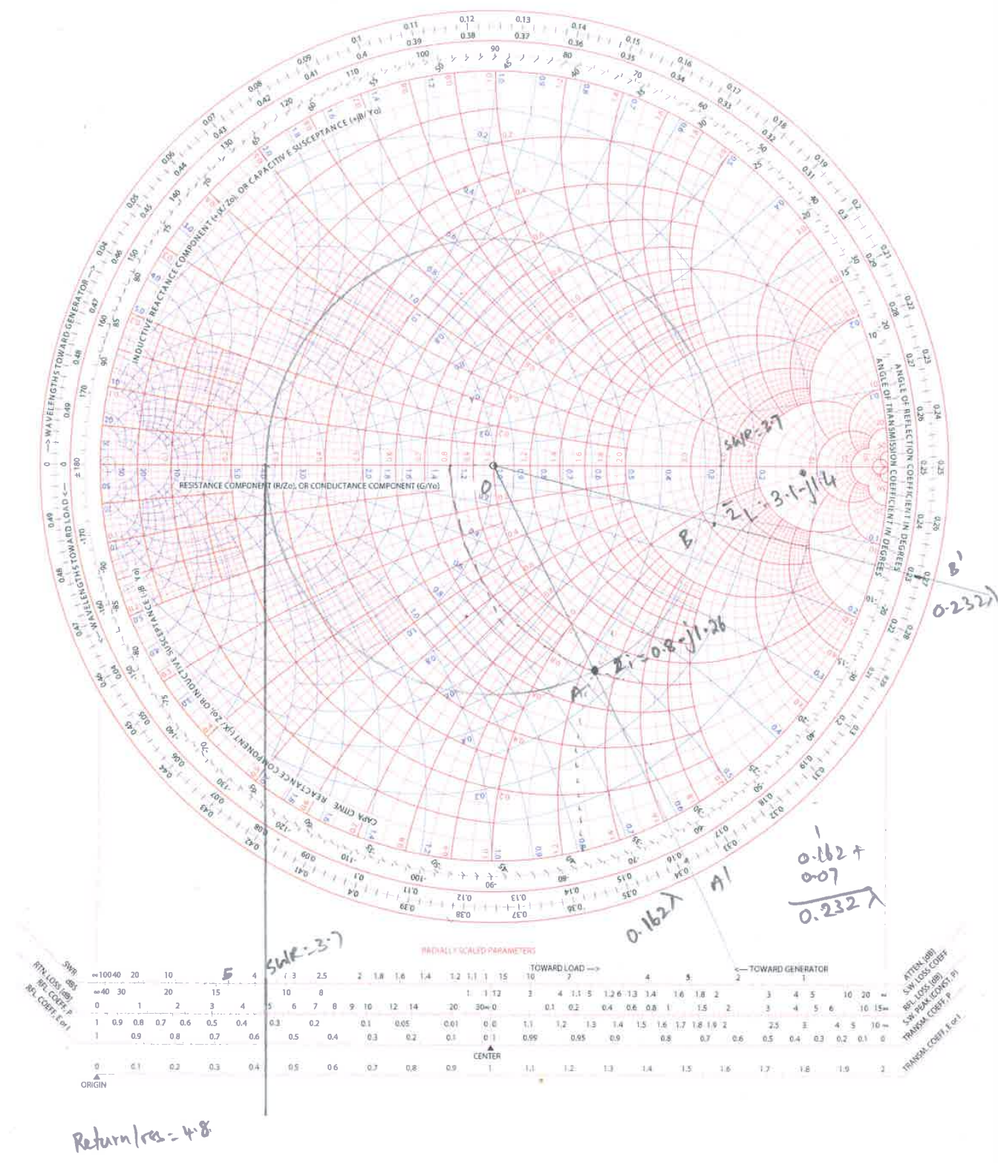
Fig: 5

