RESEARCH IN PRACTICE PROPOSAL
By Lucy De-la-Haye

Student name: Lucy De-la-Haye
Student Number: 1902404
Programme of Study: Graphic Design (BA)
Module: ADAD5004 Research in Practice
Word count: 2746
Tutors Name: Donna Williams
Three Keywords: Cosmetics, Branding and Packaging Design
When considered as an Art form, Makeup can be a powerful and formidable tool. It’s a medium which can be used to instil confidence, accentuate one’s natural beauty, or become a colourful means of self-expression and appreciation. Therefore, as a creative person who finds value in the therapeutic release that comes with using makeup, I am intrigued as to how cosmetic brands utilise/present these affirmations and empowerments through the design of their branding. This proposal for my dissertation will investigate the meaning of three keywords: Cosmetics, Branding and Packaging Design within the context and relevance of Graphic Design. With profound research, along with supporting perspectives from philosophers and theorists, I believe these keywords will act as a catalyst towards my understanding and all the while, forming a question for my independent inquiry.

Cosmetics

The word 'cosmetic' dates back to the 17th century, deriving from an Ancient Greek term meaning "the art of dress and ornament" and was further modified into a Latin form to mean "the art of beautifying, art of anointing or decorating the human body" (Harper, n.d.). However, the semantics of this word steadily changed throughout the centuries, with the connotations closely aligning to "masking, concealing and camouflaging" as it was believed that "true beauty originates from the inner being and could not be created externally" (Lall et ak, 2020: 1).

The act of using cosmetics or 'makeup' is "as old as, perhaps older than, civilization" (Porta, 2018). Ancient Egyptians are said to be the earliest historical civilisation to use cosmetics- and the vessels which held their cosmetics were monumental to them. Constructed to conceal their cosmetic essentials for the afterlife, these boxes, or packaging, were carved out of different materials and were sometimes inlaid with semi-precious stones (El-Kilany and Raoof, 2017: p.1-2). Nevertheless, while cosmetics were a valued funerary keepsake for the Egyptians, not all civilisations considered them so highly. Seen in the Socratic dialogue Gorgias, written by the Athenian philosopher Plato (lived c. 429 – c. 347 BCE), Socrates condemns rhetoric as a dishonest pretence. In section 465b, as a tool for comparison, he denounces cosmetics as a dishonest impersonation of physical fitness- he labels it as "[...] villainous, deceptive, low-born, and slavish". Socrates argues that cosmetics deceive men by tricking them with 'foreign' beauty instead of natural beauty found through exercise (McDaniel, 2021).

This equivocation between disdain and admiration for makeup continued throughout the centuries. For example, The Victorians did not like prominent makeup; a young Queen Victoria believed makeup appertained to Actresses and prostitutes. Simultaneously, skin pigmentation, such as freckles and blemishes, was deemed shameful. Clear faces, bright eyes, and tinted lips were desirable when considered natural; therefore, driven by the societal and economic benefits associated with makeup, it bought, hidden, and worn in secret. However, in the Edwardian era, a mere few years later, the popularity of cosmetics surged as magazines printed makeup adverts and skincare advice- but women would still buy their makeup discreetly. (Preston Park Museum and Grounds, n.d.) During this period in the modern era, specifically from the 19th century to the mid-20th century, graphic design aesthetics flourished through advertising in newspapers and magazines. Inspired by movements like Art Nouveau, Bauhaus, and Swiss Style, functionalism and simplicity in design were replete. Designers favoured a minimalistic approach to visual communication, reflecting objectivity, seriousness, precise structure, and reason (Kusumandyoko and Ardani, 2023). However, advertising, including cosmetic advertising, got increasingly entwined with social and political problems, such as sexism.
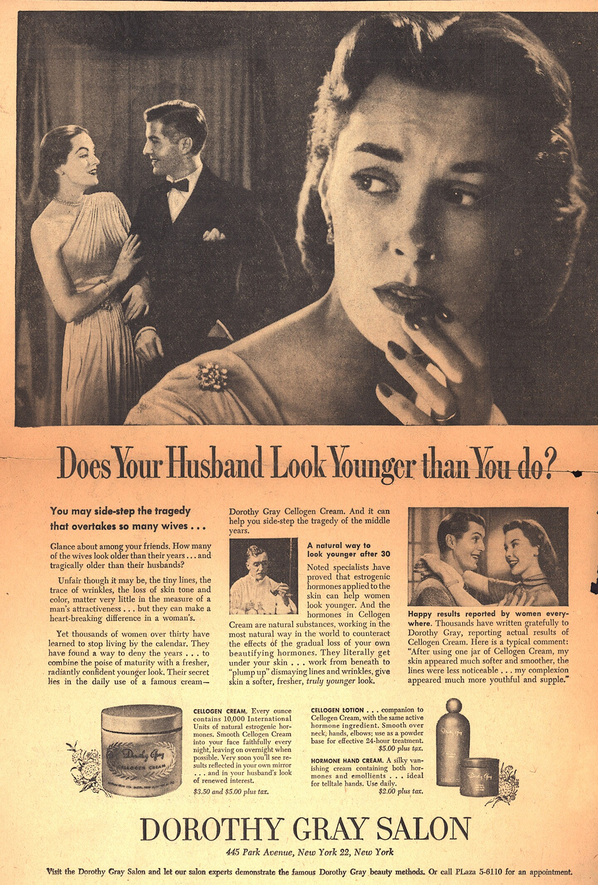
Figure 1: Dorothy Gray Salon, 1951.
Figure 1 depicts an anti-wrinkle advert from a newspaper in 1951, in which Dorothy Gray Salon encourages women over 30 to purchase their creams to rescue their youthful complexions- and the love of their uninterested husbands. This advert plays upon double standards and nurtures the idea that men can age- but women should not. During the 50's, "advertising in women's magazines, perpetuated the denigration of women" (Catalano, 2002).
One of the many sexist stereotypes amongst adverts in the 50s, according to Alice Courtney and Sarah Wernick Lockeretz, was that "Men regard women primarily as sexual objects; they are not interested in women as people" (1971). This ignominious statement is visualised in Figure 1 by the concept that their husbands will only be interested if they look 'youthful', and the 'ideal' beauty is about pleasing the opposite sex.

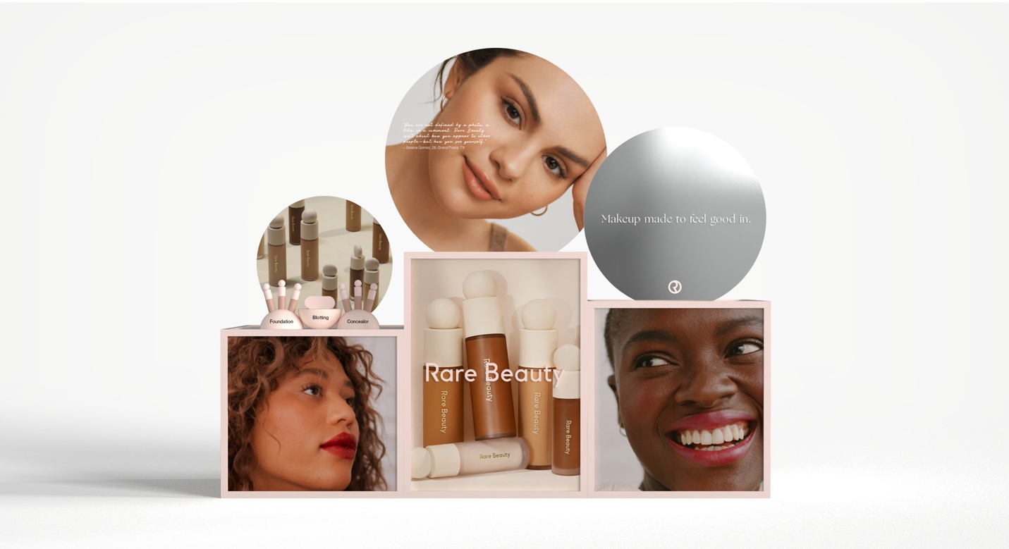
Whilst the 1960s feminist movement presented a new era of change, sexism was and still can be a prevailing problem within advertising (Croud, 2020). However, as the years have progressed, companies have started comprehending the importance of depicting women as independent, strong individuals whose lives do not revolve around men. "Advertising is no longer overtly misogynistic" (Fisher, 2022).
Figure 2: Rare Beauty Advertising, n.d.

This postmodern appreciation of women and makeup has allowed individuals to express their personalities and emotions creatively through colours and application techniques. It is no longer just a beautification tool but a medium to channel confidence (Kusumadinat, Chaniago, and Hasbiyah, 2024). As seen in Figure 2, the Rare Beauty brand, created by Selena Gomez in 2019, is about "celebrating who you are and what makes you different" (ARNSTADT, n.d.). The makeup shades, advertising, and packaging, made explicitly with accessibility in mind, all contain diversity and inclusivity. Cosmetic advertising has become a means of promoting individuality and freedom.

Branding

In today's densely crowded and competitive market, a brand's visual identity is a key differentiator. Companies continuously aim to become irreplaceable, conspicuous, and dependable in hopes of forming a robust, perpetual relationship with their consumers. A company's branding is a disciplined process that strengthens these intentions, allowing customers to perceive success, thus creating loyalty and trust (Wheeler, 2013). According to the Cambridge Dictionary (2024), the definition of branding is as follows: "the activity of connecting a product with a particular name, symbol, etc. or with particular features or ideas, in order to make people recognize and want to buy it." It is within this process where a Graphic Designer is at their most beneficial to a brand- as stated by Davis and Baldwin in their book More Than a Name: An Introduction to Branding (2005, p.8), "Brands and branding have always been hugely influenced by Graphic Designers. The visual interpretation and translation of brands to an audience is a fundamental element of branding." Davis and Baldwin further argue that a Graphic Designer's knowledge of an attractive identity has the ability to express and emote brand values, and a failure to comprehend this role will "ultimately undersell the brand."

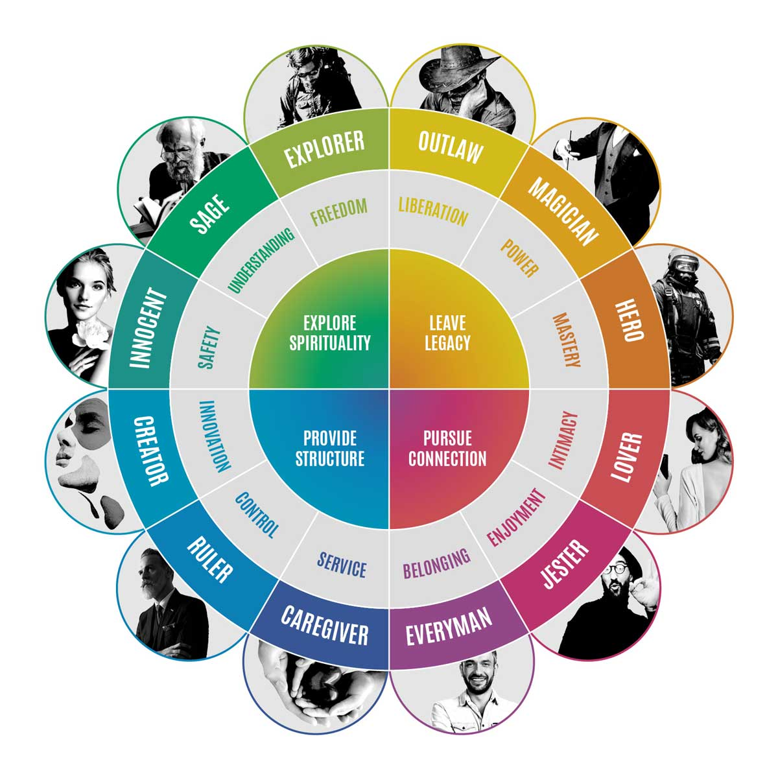
Davis and Baldwin's encapsulation of branding and the idea that successful, 'attractive' branding must be designed with prior knowledge of a company's ethos enticed me into looking at content strategies for branding. It led me to wonder: how does the visualisation of a brand’s personality and purpose ultimately result in a specific audience? This interest was how I came across the theory of 'Brand Archetypes' originally devised by Swiss Psychologist Carl Jung in 1919 and later developed by author Carol S. Pearson and brand strategist Margaret Mark in their book The Hero and the Outlaw (2001). These academics' notion that archetypal marketing was once "an interesting bonus to effective marketing [but] is now a prerequisite" (p.8), and this can also be supported by Douglas Holt when he states that an iconic brand should "provide extraordinary identity value because they address the collective anxieties and desires" (2004, p.6). This argument inaugurates the idea that customers will naturally be drawn to stories and personalities that mirror their desires and aspirations, therefore, a company should align its personality with its brand identity to attract its niche target audience. The notion of stories and archetypes can also be seen within Joseph Campbell's Monomyth called The Hero's Journey (1949), whose framework inspired author Donald Miller to adapt the concept into a marketing context, creating the 'Storybrand.' Both theories follow a similar context- Campbell proclaimed, "The hero faces challenges, seeks guidance, and ultimately transforms. Miller adapts this into a marketing context, urging businesses to cast their customers as the heroes and position themselves as the guide" (Results and Co, 2023). These concepts enforce how it is subsequently the Company's and Graphic Designer's job as the 'guides' to portray the brand's traits, using archetypal recurring symbols, brand logos, and other tangible symbols (Campbell, 1949; Roberts, 2010). Designers must adapt the brand visuals, colours, typography, and images to visually represent this personality to create successful, 'attractive' branding. This idea introduces semiotics within branding, which will be examined later in this proposal.
Figure 3: Brand Archetypes, 2018.

These concepts and strategies can be applied to Cosmetic branding, a market predicted to reach 758 billion USD by 2025 (Statista, 2024). Cosmetics have become an essential in women's daily routines as they continue to relentlessly follow trends to establish that they belong to a high social class group (Mobil et al., 2019; Kapefer, 2012). Through the branding of the makeup company NARS, designed by the creative director and designer Fabien Baron in 1994, we can understand how a longstanding cosmetic brand has managed not only to survive but thrive through the use of these strategies.

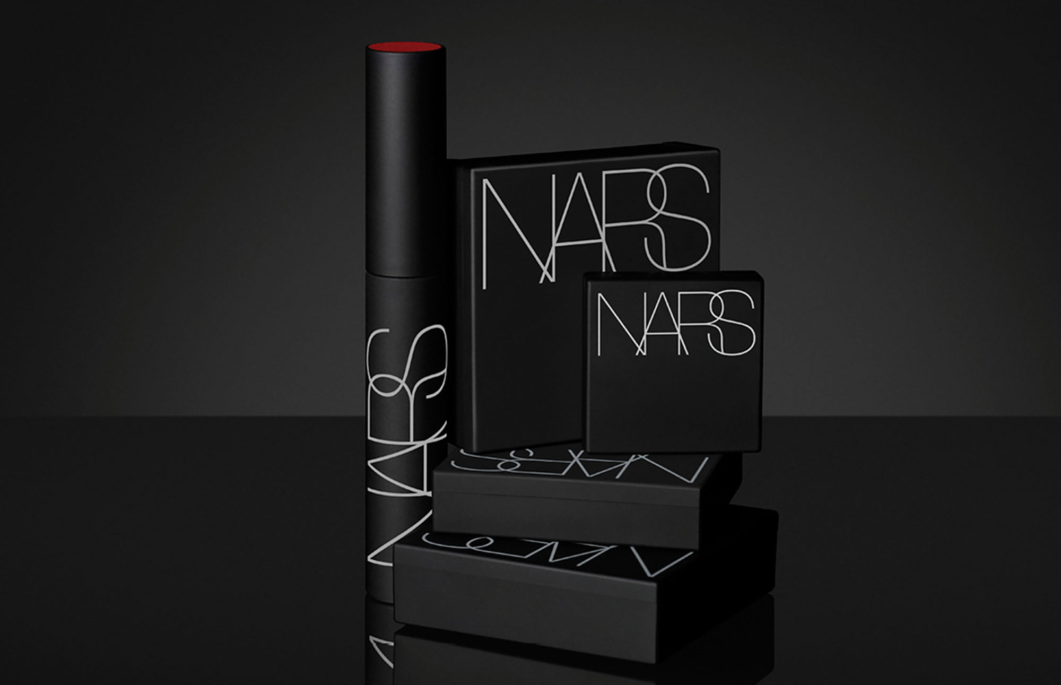
Within the NARS Brand Film, founder François Nars is quoted saying: "We are not afraid to be a bit different"; "Rules are boring" (NARS Cosmetics, 2020). In an interview, he states his makeup philosophy is "allowing the skin to show through" and bringing "transparency to complexion" (Latest in Beauty, 2019). These statements can be linked to the 'The Lover' archetype, as value promoting self-love while encouraging customers to be themselves. (Jadhav, 2019). Understanding this archetype, Baren describes NARS' identity using a concoction of adjectives: bold, audacious, liberating, and empowering (Baren-Baren, n.d.). He understands the brand's need for boldness by stating that it should not be like other cosmetic brands, which have little logos that are very pretty, well-written, and positioned- the logo should be significant and blasted on the packaging, as seen in figure 2. He then suggests that Nars had the same idea through the names of product colours- they were both aiming to break the rules and be less precious, and he believes this was done successfully through branding (models.com, 2018).
Figure 4: NARS Packaging, 2018.

Packaging Design

Packaging design is the process of designing and developing a container (pack-age) to contain, protect, transport, dispense, store, identify, and promote a product (Klimchuk and Krasovec, 2018, cited in Srivastava et al., 2022). This definition elucidates how a designer's role within the Packaging process is crucial. Designs must be attractive whilst based on consumers' preferences; they must persuade and stimulate purchasing behaviour and, at the same time, serve as a brand communication vehicle (Srivastava et al., 2022; Mohamed, Romo, and Medina, 2018). And when it comes to cosmetics, these objectives are augmented.

A cosmetic store is a place of sensory stimuli; therefore, innovative and aesthetically pleasing packaging has a "high propensity of attracting a first-time buyer of a beauty product who has no prior contact of the product" (Adofo, 2014: p.14). This argument is strengthened by Kauppinen-Räisänen when he explains, "70% of all brand decisions are made in-store, even if consumers enter the store with the intention of buying certain products" (2014). Gelici-Zeko et al. suggest in their study that "the importance of communicating appropriate product and brand signals on the packaging is considerable as well as achieving the level of visual stand out" (2012). They later say that packaging generates expectations about products, emerging from design cues such as colours, words, symbols, materials, shapes, and images. Thus, indications on packaging may carry "specific semiotic significance."

Semiotics theory, developed simultaneously by philosopher Charles S. Peirce and linguist Ferdinand de Saussure, provides a framework for understanding how humans study signs and sign processes in culture and nature (Nöth, 2018). While language is a dominant means of communication, humans coincidently converse by several nonverbal means: gestures, facial expressions, clothing, accents, and hairstyles to complete information release, convey, and receive. A human's five senses are instrumental in the symbolisation of 'things' and are labelled the symbol makers and receivers (Wu et al., 2009). And whilst interpersonal communication can be recognised in human society, so can it be perceived in design. Packaging design uses a variety of performance factors, as mentioned earlier by Gelici-Zeko et al. (2012)- "these factors form a 'language', which is a common symbol to express the semantics of goods" (Wu et al., 2009). Through this concept of language for design, "the release, transmission and reception of goods information can be completed" (Wu et al., 2009). Consequently, when a designer understands the semiotics of objects, communicating a product's intended messages and purpose through packaging will be more effective, augmenting the product's brand, identity, and marketability "while avoiding potential design flaws or misinterpretations" (Edwin, 2023). This is reinforced by the results of Mohamed, Romo, and Medina's questionnaire, where they discovered that "88.37% said that they could differentiate products depending only on their packaging designs", and additionally "[…] the majority of the respondents confirmed their ability to identify the brand, using only the packaging design (2018). Ergo, Packaging "is not merely a protective casing or a container, but a silent ambassador, whispering the brand's story into the consumer's consciousness" (PackMojo, 2023).

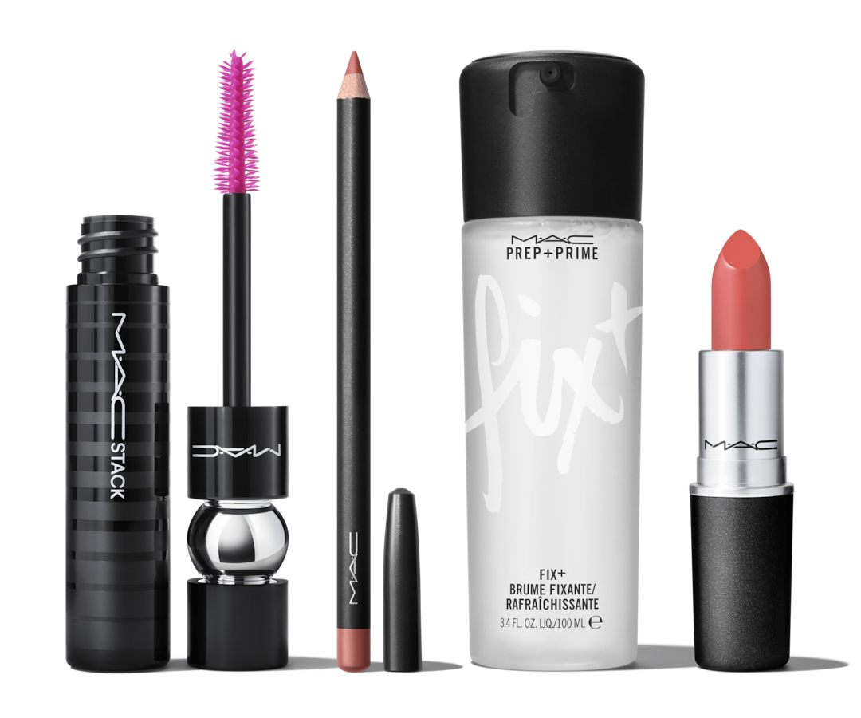
To further understand the impact of visual mnemonics within cosmetic packaging design, we can look into the makeup brand MAC Cosmetics, seen in Figure 3. MAC was launched in 1984 in Canada by makeup artist and photographer Frank Toskan and beauty salon owner Frank Angelo. The duo created their first lipstick in the kitchen of Angelo's salon- packaged adroitly in black, sleek pots, it was pertinently presenting the luxurious brand to their high-fashion clientele (Fashionabc, 2023; Kleimenova, 2015). And even as the company prospered and its target audience widened, the branding and packaging did not falter.
Figure 5: MAC Cosmetics Packaging, 2024.
To fully understand MAC's branding, we can look at Figure 4: a Brand Identity Prism, a model developed by Jean-Noël Kapferer in 1996 that Academic Olga Kleimenova has adapted to investigate MAC branding (2015).
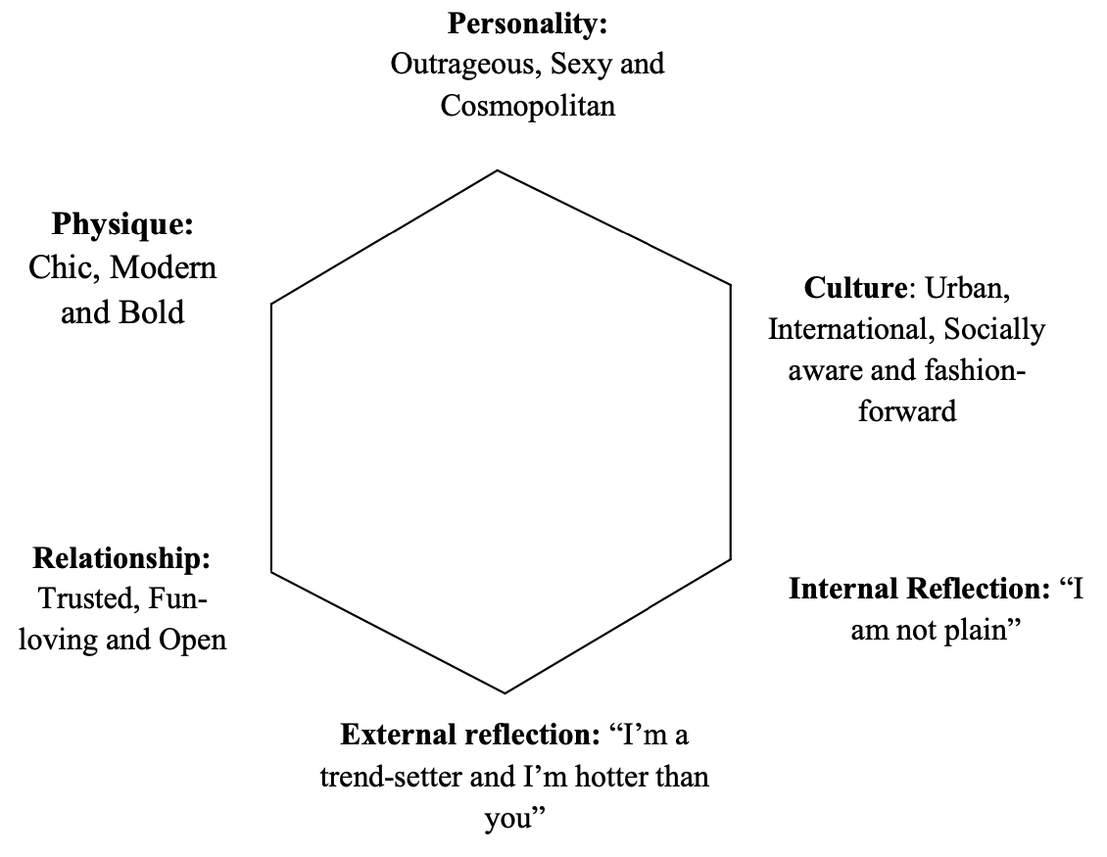
In an interview, MAC's creative director, Drew Elliot, stated, "Our approach to packaging is to keep the elements you love from MAC, the colour codes and the ease of use while bringing modernity". "The packaging was historically made for ease of use for professional artists" (2023). Its heavy use of black in the packaging connotates modernity, whilst the white logo shows openness- "it tells about the professional level of cosmetics and shows that the company focuses more on what is inside the package, not outside" (Kleimenova, 2015). This also aligns with their slogan 'All ages, all races and all sexes', the idea that it doesn't matter what you look like; makeup is a means of creative expression.
Figure 6: MAC Brand Identity Prism, 2015.

These keywords have been instrumental in my understanding of cosmetic branding. Through 'Cosmetics', I learned the historical opinions of makeup and how astronomical the impact of advertising has been in promoting a brand's perspective and values. This led me to investigate the postmodern marketing strategies and psychologies behind 'branding' and how Graphic designers can use these to their advantage. The mention of semiotics within branding directed me to research visual elements' influence on cosmetic 'packaging' and how they align with consumer buying intentions. Each keyword, along with the supporting theories and artworks, allowed me to intricately dissect the value of Graphic Design in the branding industry through different mediums. Concurrently, they guided me to explore the significance of branding from an analytical, psychological perspective and discover how visual messages can have a more effective result than words on consumers when used correctly. This proposal has only skimmed the vast amount of research into cosmetic branding. This acknowledgement has, therefore, intrigued me to question what further design implements could be applied to enhance branding and how important it has become to target all genders and sexes interested in the art of makeup.
The sub-questions raised were 'How can we use marketing strategies and visual elements to elevate a cosmetic brand, broadening the audience and not solely focusing on females?', 'How do cosmetics brands specifically and successfully target male audiences?' and 'How do makeup brands help customers to embrace pride and identity within the LGBTQ+ community?'. Consequently, based on these ideas, my proposed question for the Independent Project will be, 'How can a graphic designer make a cosmetic brand more prosperous and inclusive?' A possible practice-based project could be designing branding that fits all genders and sexes by studying psychological marketing strategies and the principles of design elements.

Reference List

Adofo, A, O. (2014), The effect of beauty product packaging on consumer buying decision. (A case of selected shops in the New Juabeng Municipality, Ghana). London: Centre for Business & Economic Research. Available at: https://www.proquest.com/conference-papers-proceedings/effect-beauty-product-packaging-on-consumer/docview/1629605342/se-2?accountid=130472 (Accessed: 14 April 2024).
ARNSTADT (n.d.), Rare Beauty Launch. Available at: https://arnstadt.co/Rare-Beauty-Launch (Accessed: 19 April 2024).
Baron & Baron (n.d.), NARS. Available at: http://baron-baron.com/beauty/nars/ (Accessed: 13 April 2024).
Cambridge Dictionary (2024), Branding Definition & Meaning. Available at: https://dictionary.cambridge.org/dictionary/english/branding (Accessed: 11 April 2024).
Campbell, J. (1949), The hero with a thousand faces. Princeton, NJ: Princeton University Press.
Catalano, C. (2002), Shaping the American Woman: ‘Feminism and Advertising in the Shaping the American Woman: Feminism and Advertising in the 1950s’. Constructing the Past. Volume 3. Available at: https://digitalcommons.iwu.edu/cgi/viewcontent.cgi?article=1054&context=constructing#:~:text=Furthennore%2C%20they%20claim%20that%20mass,claim%20this%20is%20historical%20truth. (Accessed: 18 April 2024).
Courtney, A.E and Lockeretz, S.W. (1971), ‘A Woman's Place: An Analysis of the Roles Portrayed by Women in Magazine Advertisement’. Journal of Marketing Research. Vol. 8, No. 1 (February) p.p. 92-95. Available at: https://www.jstor.org/stable/3149733 (Accessed: 19 April 2024).
Croud (2020), From Then To Now: Women In Advertising. Available at: https://croud.com/en-gb/resources/from-then-to-now-women-in-advertising/ (Accessed: 19 April 2024).
Davis, M. and Baldwin, J. (2005), More than a name: an introduction to branding. Lausanne: AVA.
Edwin, A (2023), Designing for Perception: The Role of Product Semantics in Creating Meaningful Products. https://bootcamp.uxdesign.cc/designing-for-perception-the-role-of-product-semantics-in-creating-meaningful-products-6035bf281e6b#:~:text=The%20Importance%20of%20Product%20Semantics%20in%20Product%20Design&text=By%20understanding%20how%20people%20interpret,branding%2C%20identity%2C%20and%20marketability. (Accessed: 15 April 2024).
El-Kilany, E. and Raoof, E. (2017), Facial Cosmetics in Ancient Egypt. Egyptian Journal of Tourism Studies, Vol.16. Available at: https://d1wqtxts1xzle7.cloudfront.net/53547290/Facial_Cosmetics_in_anient_Egypt-libre.pdf?1497639948=&response-content-disposition=inline%3B+filename%3DFacial_Cosmetics_in_Ancient_Egypt_By.pdf&Expires=1713399290&Signature=OvZAv2N4KEH3sAiE3FCsgwJrY624cDSJM9Mn7g4wNqBWcjKJDtE2nCVMrhxTVECZvMpvY9wIC1xAsACGdnNm4iEGXfVwehLmh~l8rzQmiQbovbMFIoikYmngRUAguxipdLIK2taquxLFd0RupWzSYU~7fj2dwNMqbpLG7X7LLEDi56uIWUru7Gzqk11mRh~R6VhypqrqS4gjWyh-~bUWX61Xv3~c9V6NXshGGJybomm8KzX9T415ej8wYpmTHjIx~3VOCr648d4IM~5B9c6ulET~HxX2wwXsRyXyD~ccg9S9tAqZgV-9Qpnksr3iKwHgs84oc-LfpKdJeWnuA1tTOw__&Key-Pair-Id=APKAJLOHF5GGSLRBV4ZA (Accessed: 17 April 2024).
Elliot, D. (2023), ‘How MAC Approaches Color Cosmetics Packaging Design’. Interview with Jamie Matusow. Beauty Packaging. 3rd June. Available at: https://www.beautypackaging.com/contents/view_online-exclusives/2023-03-06/how-mac-approaches-color-cosmetics-packaging/ (Accessed: 16 April 2024).
Fashionabc (2023), MAC Cosmetics. Available at: https://www.fashionabc.org/wiki/mac-cosmetics/ (Accessed: 16 April 2024).
Fisher, E. (2022), Sneaky Sexism: Why Sexist Advertising Still Exists. Available at: https://www.adaptworldwide.com/insights/2022/sneaky-sexism-why-sexist-advertising-still-exists (Accessed: 19 April 2024).
Gelici-Zeko, M.M., Lutters, D., Klooster, R.T., Weijzen, P. (2012), Studying the influence of packaging design on consumers perceptions (of dairy products) using categorizing and perceptual mapping. Packaging Technology and Science Journal. 26(4). Available at: https://ris.utwente.nl/ws/files/6590772/studying.pdf (Accessed: 15 April 2024).
Harper, D. (n.d). ‘Etymology of Cosmetic’. Online Etymology Dictionary. Available at: https://www.etymonline.com/word/cosmetic#etymonline_v_19125 (Accessed: 9 April 2024).
Holt, D. (2004), How brands become icons: The principles of cultural branding. Boston: Harvard Business School Press.
Jadhav, A. (2019) ‘The 12 Brand Archetypes: What They Are and Why You Should Care (Part 2)’, Amit Jadhav: Empowering Social Media to Deliver, 15 February. Available at: https://amitsocialmedia.wordpress.com/about/ (Accessed: 14 April 2024).
Kapferer, J.N., Bastien, V. (2009), The Luxury Strategy: Break the Rules of Marketing to Build Luxury Brands. Kogan Page: London.
Kauppinen-Räisänen, H. (2014), Strategic Use of Colour in Brand Packaging. Packag. Technol. Sci., 27: 663-676. Available at: https://doi.org/10.1002/pts.2061 (Accessed: 14 April 2024).
Kleimenova, O. (2015), Package as a Part of Brand. Case Study Mac Cosmetics Brand. Available at: https://www.theseus.fi/bitstream/handle/10024/87291/Kleimenova_Olga.pdf?sequence=1&isAllowed=y (Accessed: 16 April 2024).
Kusumadinata, A. A., Chaniago, N. F. and Hasbiyah, D. (2024), ‘Art of Makeup as a Visual Medium’. Formosa Journal of Science and Technology. 3(3), p.p. 613–622. Available at: https://journal.formosapublisher.org/index.php/fjst/article/view/8421/8615 (Accessed: 19 April 2024).
Kusumandyoko, T.C. and Ardani, M.W. (2023), ‘Aesthetic Principles in Graphic Design: A Comparative Study of Modern and Postmodern Approaches’. Proceedings Of The International Joint Conference On Arts And Humanities 2023 (IJCAH 2023). p.p 831- 839. Available at: https://doi.org/10.2991/978-2-38476-152-4_80 (Accessed: 18 April 2024).
Lall, N. et al. (2020) ‘Editorial: Cosmeceuticals from medicinal plants’, Frontiers in Pharmacology, 11. doi:10.3389/fphar.2020.01149. p.p 1-3 (Accessed: 9 April 2024).
Latest in Beauty (2019), An interview with François Nars. Available at: https://www.latestinbeauty.com/blog/an-interview-with-francois-nars/ (Accessed: 14 April 2024).
Mark, M. & Pearson, C. (2001), The Hero and The Outlaw: Building Extraordinary Brands through the Power of Archetypes. New York: McGraw-Hill.
McDaniel, S. (2021), ‘The Shocking Truth about Ancient Greek Makeup’. Tales of Times Forgotten. 28th August. Available at: https://talesoftimesforgotten.com/2021/08/28/the-shocking-truth-about-ancient-greek-makeup/ (Accessed: 17 April 2024).
Merriam-Webster (2024). ‘Cosmetic Definition & Meaning’. Merriam-Webster. Available at: https://www.merriam-webster.com/dictionary/cosmetic (Accessed: 8 April 2024).
Mobil, S.S. et al. (2019), Influence of Perceived Quality and Self-Esteem on Women’s Purchase Intention: Luxury Makeup Brands. Journal of International Business, Economics and Entrepreneurship: Volume 4. Available at: https://ir.uitm.edu.my/id/eprint/28922/1/28922.pdf (Accessed: 13 April 2024).
Models.com (2018), Pep Gay on Fabien Baron, NARS, and What Makes Outstanding Product. Available at: https://models.com/mdx/pep-gay-on-fabien-baron-nars-and-what-makes-outstanding-product/# (Accessed: 13 April 2024).
Mohamed, H., Romo, Z.G., Medina I.G. (2018), The Effect of Cosmetics Packaging Design on Consumers’ Purchase Decisions. Indian Journal of Marketing 48(12):50. Available at: https://www.researchgate.net/publication/329393239_The_Effect_of_Cosmetics_Packaging_Design_on_Consumers%27_Purchase_Decisions (Accessed: 14 April 2024).
NARS Cosmetics (2020), NARS Brand Film. Available at: https://www.youtube.com/watch?v=BiR6dJb5p3g&t=2s (Accessed: 14 April 2024).
Nöth, W. (2018), ‘From Plato to Peirce, an Interview with Winfried Nöth’. Interviewed by Philosophasters. Philosophasters. 13th August. Available at: https://philosophasters.org/blog/2018/8/13/from-plato-to-peirce-an-interview-with-winfried-noth (Accessed: 15 April 2024).
PackMojo (2023), Impact of Packaging on Cosmetic Product Appeal. Available at: https://packmojo.com/blog/impact-of-packaging-on-cosmetic-product-appeal/ (Accessed: 15 April 2024).
Porta, M. (2018) "cosmetics." A Dictionary of Public Health. Ed. Last, John M.. : Oxford University Press, , 2018. Oxford Reference. Available at: https://www-oxfordreference-com.ezproxy.uwtsd.ac.uk/view/10.1093/acref/9780191844386.001.0001/acref-9780191844386-e-928. (Accessed: 9 April 2024).
Preston Park Museum and Grounds (n.d.), Victorian Beauty. Available at: https://prestonparkmuseum.co.uk/victorian-beauty/ (Accessed: 17 April 2024).
Results and Co (2023), Unveiling the Power of StoryBrand: Donald Miller's Impact on Marketing and Results & Co. Available at: https://medium.com/@resultsandcous/unveiling-the-power-of-storybrand-donald-millers-impact-on-marketing-and-results-co-201aababacbf (Accessed: 13 April 2024).
Roberts, C. (2010), Exploring Brand Personality through Archetypes. Electronic Theses and Dissertations. Paper 1691. Available at: https://dc.etsu.edu/etd/1691 (Accessed: 13 April 2024).
Srivastava, P., Ramakanth, D., Akhila, K., Gaikwad, K.K. (2022), Package design as a branding tool in the cosmetic industry: consumers’ perception vs. reality. SN Bus Econ 2, 5. Available at: https://doi.org/10.1007/s43546-022-00222-5 (Accessed: 14 April 2024).
Statista (2024), Value of the Cosmetics Market Worldwide From 2018 to 2025. Available at: https://www.statista.com/statistics/585522/global-value-cosmetics-market/ (Accessed: 13 April 2024).
Wheeler, A. (2012), Designing Brand Identity: an essential guide for the whole branding team (Third edition.) [Online]. John Wiley & Sons, Inc. Available at: https://r2.vlereader.com/Reader?ean=9781118418741 (Accessed: 11 April 2024).
Wu, P., Bao, Z., Song, W., Hu, Z. (2009), Research on Semantics of Packaging Design. IEEE 10th International Conference on Computer-Aided Industrial Design & Conceptual Design, Wenzhou, 2009, pp. 316-318. Available at: https://ieeexplore.ieee.org/abstract/document/5374911 (Accessed: 15 April 2024).

Bibliography
Chukwu, E., Ahumaraeze, C, I. (2022), Unpacking Semiotic Resources in Cosmetic Advertisements. GPH-International Journal of Social Science and Humanities Research, 5(05), pp. 64-80. Available at: https://doi.org/10.5281/zenodo.6767870 (Accessed: 15 April 2024).
Consumer’s Buying Behavior. Academic Research International Vol. 6(5). Available at: https://d1wqtxts1xzle7.cloudfront.net/92720203/20156.5-14-libre.pdf?1666210672=&response-content-disposition=inline%3B+filename%3DImpact_of_Packaging_Designs_of_Cosmetics.pdf&Expires=1713276999&Signature=LoGup5Nu16KZWTqwNBNzj77nUcHzfJmHUYEEoxvVgomY43M9aVNsIwjNSRUwpb3MuPp4v8WWqSD9KyxPJDdUzXVYP5pZN9avim8APIsjsPI2DBnMxAbrU~iESOCX3W03NcQOJRcB6FRBN4HV3BHE2ue6rQTTQNm5RDidjqA1Su57MS-UoCTryBKP7OhMmSVY0Q1LiWLCTJGO6lkQtubSa02xJ6pFdcDVCVH97LiTE7-B5SNMQHLlYzdcnbokEs5AHhlgh4WgfGeCCRrsvquIxpoL5hu9MJBYm-reKXDSkM9MvAmMi3L5BvOB3urdAQr2xScRWF1f~GSl0uWJwJHOPw__&Key-Pair-Id=APKAJLOHF5GGSLRBV4ZA. (Accessed: 15 April 2024).
Fagerhus, A. & Melker, I. (2021), Beauty and the Brand: A Study About Relationships Between Consumers and Cosmetic Brands. Available at: https://lup.lub.lu.se/luur/download?func=downloadFile&recordOId=9050388&fileOId=9050403 (Accessed: 13 April 2024).
Getabstract (n.d.), The Hero and the Outlaw Free Summary by Carol S. Pearson and Margaret Mark. Available at: https://www.getabstract.com/en/summary/the-hero-and-the-outlaw/1499 (Accessed: 13 April 2024).
Johnson, R. (n.d.) ‘Designing with Archetypes’, 3.7 Designs. Available at: https://3.7designs.co/blog/designing-with-archetypes/#:~:text=Archetypes%20are%20an%20incredible%20tool,one%20best%20fit’s%20your%20brand. (Accessed: 14 April 2024).
Miller, D. (n.d.), Building a Storybrand. Available at: https://www.shortform.com/app/book/building-a-storybrand/chapter-6 (Accessed: 13 April 2024).
Riaz, S., Wasif, S., Nisar, F., Farwa, U., Rashid, A. (2015), Impact of Packaging Designs of Cosmetics on Female
Simone, A. (2021), ‘Brand Archetypes: Carl Jung Didn’t Invent Them. So Who Did?’, CONTENT & COACHING Anne Simone, 8 December. Available at: https://www.annesimone.com/brand-archetypes-carl-jung/ (Accessed: 13 April 2024).

Lists of Figures
Figure 1: Dorothy Gray Salon (1951), Does Your Husband Look Younger Than You Do? New York Herald Tribune. Available at: https://repository.duke.edu/dc/adaccess/BH1920 (Accessed: 17 April 2024).
Figure 2: ARNSTADT (n.d.), Rare Beauty Launch. Available at: https://arnstadt.co/Rare-Beauty-Launch (Accessed: 19 April 2024).
Figure 3: Iconic Fox, 2018. Brand Archetypes: The Definitive Guide. Available at: https://iconicfox.com.au/brand-archetypes/ [Viewed: 13 April 2024].

Figure 4: Models.com. NARS Packaging. Available at: https://models.com/mdx/pep-gay-on-fabien-baron-nars-and-what-makes-outstanding-product/#:~:text=As%20the%20man%20behind%20the,company%20since%20its%20very%20start. [Viewed: 13 April 2024].
Figure 5: Kleimenova, O. (2015), Package as a Part of Brand. Case Study Mac Cosmetics Brand. p.15. Available at: https://www.theseus.fi/bitstream/handle/10024/87291/Kleimenova_Olga.pdf?sequence=1&isAllowed=y (Accessed: 16 April 2024).
Figure 6: MAC Cosmetics (2024), Bestsellers Bundle. Available at: https://www.maccosmetics.co.uk/product/27145/103872/products/kits/bestsellers-bundle (Accessed 15 April 2024).

