Business Management BABM
Data Handling and Business Intelligence
Individual report

University Of Wales
Trinity Saint David

Business Intelligence and Its Importance
For the Organizations

Student Name: George Iulian Chiras
ID number: 2120095
Module Code: LCBB5000
Lecturer: Dr. Molly Jack
Date:20/07/2024
Contents
Introduction 3
Why BI Trends, Tools, and Applications are the Future for the Business 4
Enhanced Decision Making 4
Operational Efficiency 5
Customer Experience Enhancement 6
Current Business Intelligence Trends; Critical Evaluation 7
Artificial Intelligence and Machine Learning Integration 7
Self-Service Business Intelligence 7
Data Visualization 7
Mobile Business Intelligence 8
Cloud-Based BI 8
Conclusion 9
References 10

Introduction
Business Intelligence (BI) is a crucial element in today's corporate environment, as it integrates structures, technology, and approaches to transform unprocessed data into practical and valuable insights. These observations facilitate strategic and astute decision-making, which is essential for achieving operational success. As the operational manager of retail business, the responsibility is to make efficient and timely choices on a daily basis that have a direct influence on the success and growth of the organisation.
Recent figures highlight the importance of business intelligence (BI), indicating that 40% of firms do not have significant problems with BI, while 12% encounter difficulties due to inadequate governance and data quality, and 10% attribute their obstacles to insufficient training in the sector. Notwithstanding these obstacles, the worldwide business intelligence (BI) market is expected to see substantial growth, with projected revenues increasing from $28,216.8 million in 2023 to $56,200.9 million by 2028. This growth reflects the growing dependence on decision-making data analysis.
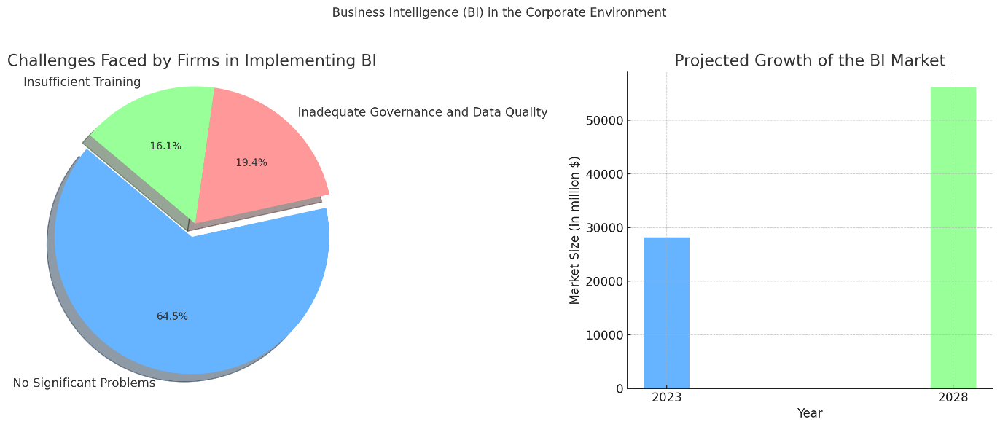
Figure 1 BI Trends statistics
Based on these observations, it is essential for company to embrace contemporary business intelligence trends, tools, and apps in order to improve our decision-making processes, operational efficiency, and overall competitive advantage. This report elucidates the justifications for this imperative adoption and its potential to transform the corporation processes.

Why BI Trends, Tools, and Applications are the Future for the Business

Enhanced Decision Making
Advanced data analytics offer a comprehensive comprehension of many aspects of a business, aiding in the identification of market trends, the detection of changes in client behaviour, and the proactive adjustment of strategy (Medina-López, 2024). Through the analysis of consumer preferences and purchasing patterns, the organisation may tailor marketing efforts, precisely predict inventory requirements, and maintain ideal stock levels according to Infodesk, 2024, in “Top Business Intelligence Trends of 2024: A Comprehensive Guide”.
Predictive analytics play a vital role in projecting future patterns and behaviours. This enables the organisation to forecast sales patterns, strategize for fluctuations in demand, and establish realistic sales targets (Wamba et al., 2020). Predictive models are also useful in formulating precise marketing plans and making informed decisions about resource allocation in the long run (Coursera, 2024).
Real-time data analytics facilitate expedited decision-making by offering immediate access to vital information. This allows the organisation to promptly deal with problems and take advantage of opportunities, therefore preserving a competitive advantage (Gartner, 2023). Utilising real-time sales monitoring enables the rapid identification of failing items or outlets and facilitates the timely implementation of corrective actions (SelectHub,2024).
Dashboards enable the ongoing monitoring of key performance indicators (KPIs), providing a comprehensive perspective on corporate performance. Through the process of detecting inefficiencies and pinpointing areas that require improvement, the organisation may optimise its processes, decrease expenses, and boost overall efficiency (Infodesk, 2024).

Operational Efficiency
Business intelligence technologies streamline the process of generating reports, resulting in time savings and minimising mistakes (Stonebraker and Ilyas, 2020). Frost & Sullivan, 2024 explain in “'Global Healthcare Cloud Computing Market”, this enables employees to dedicate their attention to more important and strategic responsibilities.
Advanced analytics greatly enhance inventory management by properly predicting demand and optimising stock levels, resulting in reduced instances of overstocking and stockouts. This guarantees the availability of items when required, enhancing customer satisfaction and minimising inventory expenses (Wamba et al., 2020).
Dashboards offer immediate and ongoing monitoring of critical performance metrics, enabling managers to promptly detect and resolve any inefficiencies. This proactive strategy ensures the maintenance of high operational standards and the seamless functioning of activities (Medina-López, 2024).
BI insights enhance resource allocation. Comprehensive information about staff performance, resource utilisation, and operational expenses allows for well-informed decision-making, leading to waste reduction and process improvement (Coursera, 2024).

Customer Experience Enhancement
Using advanced data analytics, the organization gains valuable insights into customer preferences and purchase patterns. This enables the creation of personalized marketing programs tailored to individual customer needs, resulting in higher engagement and loyalty. By analysing past purchase history and browsing behaviour, personalized offers and suggestions enhance the customer's sense of being valued (Alharti et al., 2020).
BI improves customer segmentation by classifying consumers into specific categories based on demographics, buying behaviour, and preferences. This targeted approach allows for tailored strategies for different customer groups, increasing marketing effectiveness and enhancing the overall customer experience (Gartner, 2023).
Feedback analysis is another critical area improved by BI. By examining customer feedback from surveys, social media, and reviews, the organization gains a comprehensive understanding of customer satisfaction and identifies areas for improvement. Sentiment analysis detects patterns in customer opinions, enabling proactive issue resolution and product or service enhancements.
Real-time data analytics allow the organization to promptly address customer needs and preferences. Continuous monitoring of customer interactions and feedback enables quick adjustments to offerings and services, meeting customer expectations more effectively. This adaptability helps maintain a positive customer experience and fosters long-term loyalty (Wamba et al., 2020).

Current Business Intelligence Trends; Critical Evaluation

Artificial Intelligence and Machine Learning Integration
The integration of AI and machine learning into BI tools allows for more advanced data analysis and predictive modelling. This trend enables businesses to automate insights, detect patterns, and make more accurate forecasts (Stonebraker and Ilyas, 2020). For example, AI-powered BI can predict customer behaviour and optimize marketing strategies based on those predictions.
While AI and machine learning integration in BI enhances advanced data analysis, predictive modelling, and automation of insights leading to more accurate forecasts and optimized strategies, it also poses high complexity and cost of implementation, with a risk of over-reliance on automated insights without proper human oversight (Infodesk, 2024).

Self-Service Business Intelligence
Self-service BI tools empower non-technical users to access, analyse, and visualize data without needing extensive IT support. This trend democratizes data, allowing employees across the organization to make data-driven decisions. Tools like Tableau and Power BI provide intuitive interfaces that make it easier for users to generate their own reports and dashboards (SelectHub, 2024).
Self-service BI tools empower non-technical users to independently access, analyse, and visualize data, democratizing data and enabling organization-wide data-driven decisions through intuitive interfaces like Tableau and Power BI, but can lead to data silos, inconsistencies, and misinterpretation without proper governance and training (Alharti et al., 2020).

Data Visualization
Advanced data visualization techniques are becoming increasingly popular, as they help users understand complex data sets quickly and easily. Interactive dashboards and visual analytics tools allow users to explore data through graphs, charts, and other visual formats. This trend makes it easier to identify trends, outliers, and patterns in the data (Infodesk, 2024).
Advanced data visualization techniques, which help users quickly and easily understand complex data sets through interactive dashboards and visual analytics tools like graphs and charts, make it easier to identify trends, outliers, and patterns; however, they can also lead to oversimplification and misinterpretation of data if not accurately represented (Gartner, 2023).

Mobile Business Intelligence
Mobile BI refers to the ability to access BI data and analytics on mobile devices. This trend supports the growing need for remote work and on-the-go decision-making. Mobile BI applications ensure that decision-makers have access to critical data and insights anytime and anywhere, enhancing agility and responsiveness (Coursera, 2024).
Mobile BI, which allows access to BI data and analytics on mobile devices, supports the growing need for remote work and on-the-go decision-making, enhancing agility and responsiveness by providing decision-makers with critical data anytime and anywhere; however, it also raises concerns about data security and may offer limited functionality compared to desktop applications (Medina-López, 2024).

Cloud-Based BI
The adoption of cloud-based BI solutions is on the rise, offering scalability, flexibility, and cost savings. Cloud BI tools allow organizations to store, manage, and analyse large volumes of data without the need for significant on-premises infrastructure. This trend also facilitates collaboration, as cloud-based platforms can be accessed by users from different locations (MarketsandMarkets, 2024).
The adoption of cloud-based BI solutions is on the rise, offering scalability, flexibility, and cost savings by allowing organizations to store, manage, and analyse large volumes of data without significant on-premises infrastructure; however, it also raises concerns about data security and privacy, and the potential for downtime with cloud providers (Gartner, 2023).

Conclusion
Business Intelligence (BI) is indispensable in today’s corporate environment, transforming raw data into valuable insights that drive strategic and effective decision-making, essential for operational success. Despite challenges such as inadequate governance, data quality issues, and insufficient training faced by some firms, the BI market is set to grow significantly, highlighting its importance.
To maintain a competitive edge and enhance decision-making, operational efficiency, and customer experience, it is essential for the company to adopt contemporary BI trends, tools, and applications. Advanced data analytics enable a comprehensive understanding of business facets, predictive analytics facilitate future planning, and real-time data analytics support swift decision-making. Additionally, BI tools optimize reporting, inventory management, and resource allocation, while advanced data visualization and mobile BI enhance user experience and agility.
While integrating AI and machine learning, self-service BI, data visualization, mobile BI, and cloud-based BI offer significant benefits, they also present challenges such as high implementation costs, data security concerns, and the need for proper governance. By addressing these challenges, the organization can fully leverage BI’s potential to drive growth and success.

References
Alharti, A., et al. (2020) 'Addressing barriers to big data', Business Horizons, 60(3), pp. 285-292. Available at: https://www.elsevier.com ,
(Accessed: 17 July 2024).
Coursera (2024) 'Top Business Intelligence Trends in 2024'. Available at: https://www.coursera.org, (Accessed: 17 July 2024).
Frost & Sullivan (2024) 'Global Healthcare Cloud Computing Market'. Available at: https://store.frost.com, (Accessed: 17 July 2024).
Gartner (2023) 'Decision Intelligence: A New Paradigm for Decision-Making'. Available at: https://www.gartner.com, (Accessed: 17 July 2024).
Infodesk (2024) 'Top Business Intelligence Trends of 2024: A Comprehensive Guide'. Available at: https://www.infodesk.com, (Accessed: 17 July 2024).
MarketsandMarkets (2024) 'Decision Intelligence Solutions Market by 2027'. Available at: https://www.marketsandmarkets.com, (Accessed: 17 July 2024).
Medina-López, A. (2024) 'Leveraging Business Intelligence Systems for Enhanced Corporate Competitiveness: Strategy and Evolution', Systems, 12(3), pp. 94. Available at: https://www.mdpi.com/journal/systems, (Accessed: 17 July 2024).
SelectHub (2024) 'Future of Business Intelligence (BI) for 2024'. Available at: https://www.selecthub.com, (Accessed: 17 July 2024).
Stonebraker, M. and Ilyas, I. (2020) 'Data integration: The current status and the way forward', IEEE Data Engineering Bulletin, 41(2), pp. 3-16. Available at: https://www.ieee.org, (Accessed: 17 July 2024).
Wamba, S. F., et al. (2020) 'How ‘big data’ can make big impact: Findings from a systematic review and a longitudinal case study', International Journal of Production Economics, 165, pp. 234-246. Available at: https://www.sciencedirect.com, (Accessed: 17 July 2024).

