

Software development (Phyton)

ASSIGNMENT 1

Software development in Python | 07.11.2023
Tünde Debreczeni (2115195)

Contents
Software development (Phyton) 1
Part A (Understanding and answering) 3
3 4
Part B (Implementation) 7
7
1 7
2 8
3. 10
Bibliography 12

Part A (Understanding and answering)

- What is a variable and why are they important in writing programs? Discuss the way variables are handled in the programming language you have studied (e.g. static vs dynamic typing)

Variables are used to store a value in a program, example like a container or a box for various types of information, which can be named after preferences. [1] Using variables, it's easier to reference information in a programme. There are different types of variables for different types of information.
INT variables store integers, 2, 100, -1,5,86,
DUBLE, FLOAT, AND LONG variables store decimals, 2.22, 3.14, -100,
CHAR variables store letters and characters, a, z, D, he
STRING variables store words, computer, technology, hi
BOOL variable's store Boolean values, true, false
Variables name must start with a letter or an underscore ex (myName), it is case sensitive and can’t contain special characters.
In programming there is two types of introducing the data static typing and dynamic typing. [2] If the type checking is done at compiling time, that means that type of the data that we defined is checked at the compilation faze, it means that is Static typing. Explicit type declaration is needed. This way errors are detected earlier. Variable reassignment is not possible, Whereas in Dynamic typing the same type checking is done when the programme is executed, explicit type declaration is not needed. This case errors are not detected unless the programme is executed. Variable reassignment is possible, can be reassigned to a different value of a data type and the same variable can be assigned to a different value of a different data types. In static typing a more memory optimised machine code is produced, since we define the type of the data that is needed in the programme. [3] The computer is in a better position to calculate the required memory by the programme, and this comes up with a more memory optimised machine code. In the case of static typing whereas in case of dynamic typing less memory optimised machine code is produced the computer comes across the type of the data that we need in the programme at execution time, and accordingly calculates the memory.
Python is a dynamically typed language we do not need to explicitly define the type of the variable that we need in the programme. [4] The computer doesn't need to know about the type of the variable until the code is executed, it allocates the memory at runtime as per the type of the variable and then binds the variable name to that memory location we have the same code as an example. We define two variables one with an integer value and the other with a string value now both will have the memory allocated with respect to the values that are assigned to them, and which will eventually determine their data types. [5]

- Explain what an if/else statement is, how and why they are used, and give a code example of when you would use one. Include in your answer a discussion of the use of multiple conditions.
When coding in Python you will frequently encounter a fork in the road depending on the values of certain data you may want to go in One direction or the other. [6]There may be even more than two directions for you to choose the if then else statements help you navigate these situations. If and else's statement allow you to handle any number of cases in your cod, they let you control the flow of your code.
X=5
Y=8
ifX>Y:
print (“X is greater than Y”)
else:
print (“X is not greater than Y”)

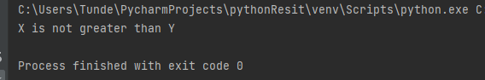

3 Explain why loops are needed in a program and when you might use a for and a while loop. Give suitable examples of each in the programming language you have studied.
When programming we often have to introduce the same section of code, for this we use loops, to create repetition [7]. Loops have a set of number of iterations, meaning the number of times the section of code is repeated. In python usually we differentiate three types of loops, for loop, while loop, and nested loop.
For Loop:
A for loop in Python is used to iterate over the items, or elements present in a sequence. |The items present in a sequence can be in the form of a list, tuple, dictionary or even a string [8]. A for loop in Python uses the range function to iterate over specific number of times.

s=’learn’
for i in s:
Print(s)
#Use for loop in a list
programming = [“Java’Python’Ruby’Html”]
for iter in programming:
print(iter)

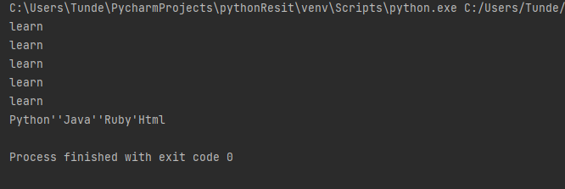

While Loop:
A while loop in Python, specifies a condition or a block of code that is to be executed until the condition evaluates to false, or the loop is explicitly ended, with the break statement [9].

count= 0
while count <= 5:
print (“The condition is true”)
count = count+1
print (“End of loop”)

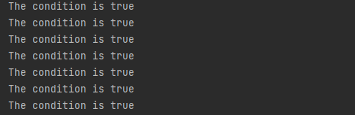

Nested Loop:
A Nested loop in Python programming language allows you to use one loop inside another loop this is known as nested loop. It is present inside the body of the outer. [10]
count=1
var=1
while count<= 10:
print(count)
count+=1
var=1
while var<2:
print("hello")

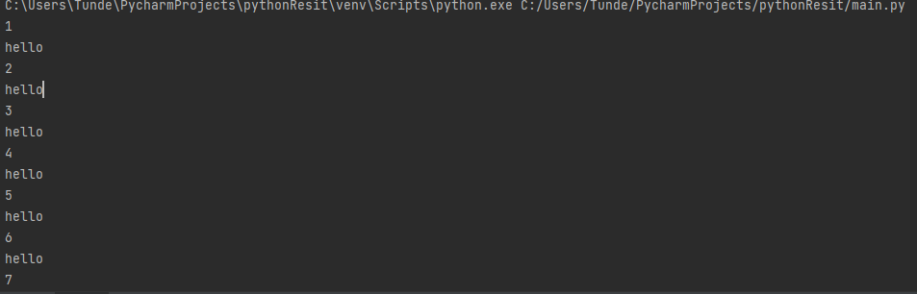

Part B (Implementation)
name= input(“Please enter your name”)
height = float(input(“Please enter your height in meters (e.g. 1.84): “))
age = int(Input(“Please enter your age: “))
print(“Name: ”+name)
print(“Height:”+str(height)+”m”)
print(“Age: ”+str(age)+ “years old”)

1

In this example we declare three variables name height and age. We use the input function to prompt the user to enter values for these variables. The height variable is of the type of float since it represents a decimal value, and the age variable is of type int since it represents a whole number. We converted the height and age inputs to their appropriate types using the float and int functions.
Finally, we print out the value of each variable using the print function. The str function is used to convert the height and age variables two strings so that they can be concatenated with the other strings pass to the print function.

2
import math

# Input the radius of the circle
radius = float(input("Please enter radius of circle:\n"))

# Input the side of the square
side = float(input("Please enter side of square:\n"))

# Input the width of the rectangle
while True:
width = float(input("Please enter width of rectangle:\n"))
if width <= 10:
break
else:
print("That seems a little big, please try again:")

# Input the length of the rectangle
length = float(input("Please enter length of rectangle:\n"))

# Calculate the area of the circle
circle_area = math.pi * (radius ** 2)

# Calculate the area of the square
square_area = side ** 2

# Calculate the area of the rectangle
rectangle_area = width * length

# Calculate the shaded area
shaded_area = circle_area - (square_area + rectangle_area)

# Print the result
print(f"The shaded area is {shaded_area:.2f} cm")
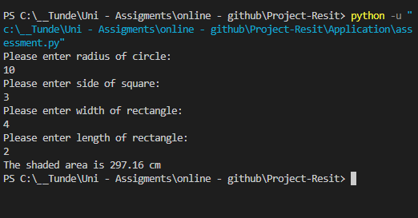

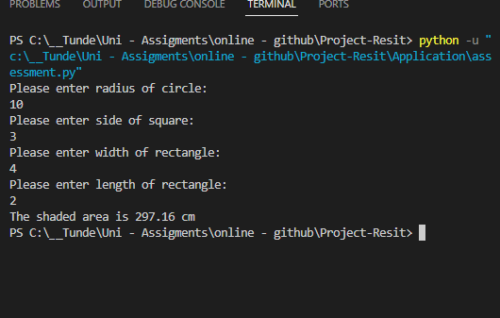

3.

# Initialize variables
milage _list = []
total _milage = 0
total _ cost =0
#promt user to enter milage foe each day of the week
For I in range (7):
milage = float(input( “Enter milage for day ”+str(i+1) + “:”))

milage _ list.append(milage)
total _ milage += milage

#Calculate total cost of petrol
petrol _ rate =1.35 #cost per litre
milage_ per _ litre =11.2 #miles per litre
total _ litre = total _ milage /milage per litre
total _ cost= total _titres * petrol rate

# print results
print( “ Total milage for the week: {:.2f} miles”.format(total _ milage))
print( “Total cost of petrol for the week: £{:.2f}”.format(total _ cost))

initialize variables
mileage_list = []
total_mileage = 0
total_cost = 0

# prompt user to enter mileage for each day of the week
for i in range(7):
mileage = float(input("Enter mileage for day " + str(i+1) + ": "))
mileage_list.append(mileage)
total_mileage += mileage

# calculate total cost of petrol
petrol_rate = 1.35 # cost per litre
mileage_per_litre = 11.2 # miles per litre
total_litres = total_mileage / mileage_per_litre
total_cost = total_litres * petrol_rate

# print results
print("Total mileage for the week: {:.2f} miles".format(total_mileage))
print("Total cost of petrol for the week: £{:.2f}".format(total_cost))

In this example we first initialise three variables milage_ list, total_ milage and total_ cost. We use a for loop to prompt the user to enter the car mileage for each day of the week and upped the mileage to the mileage_ list. We also update the total _mileage variable with the mileage entered.

Next, we calculate the total _cost off petrol for the week by using the given petrol rate of £ 1.35 litres and the given mileage per litre of 11.2 mileage. We calculate the total litters of petrol used by dividing the to total _mileage bye mileage_ power_ litter, and then multiply these values by the petrol _rate to get the total cost.

Finally, we print out the total _mileage and to total _cost using the print function with formatting to display the value with two decimal places and with the appropriate currency symbol.

Bibliography

[1] | C. C. a. M. Jackson, Python, Somerville, Mass: Candlewick Press, 2016.
[2] | R. Miles, Begin to Code with Python, Microsoft Press, 2017.
[3] | M. Anaya, Clean code in Python : develop maintainable and efficient code, Birmingham: Packt Publishing, 2021.
[4] | P. Sharma, Programming in Python, Mumbai: Published By Manish Jain For Bpb Publications, 2017.
[5] | S. F. Lott, Python essentials : modernize existing Python code and plan code migrations to Python using this definitive guide, Birmingham: UK: Packt Publishing, 2015.
[6] | J. Mueller, Beginning programming with Python. For Dummies, Hoboken, Nj, 2018.
[7] | F. Romano, Learning Python : learn to code like a professional with Python--an open source, versatile, and powerful programming language, Birmingham: Packt Publishing Limited, 2015.
[8] | J. Unpingco, Python For Probability, Statistics, And Machine Learning. S.L, Springer Nature, 2020.
[9] | C. Shah, A hands-on introduction to data science Cambridge, United Kingdom, New York, Ny, Usa: Cambridge University Press, 2020.
[10] | M. L. Hetland, Beginning Python, Apress, 2006.

