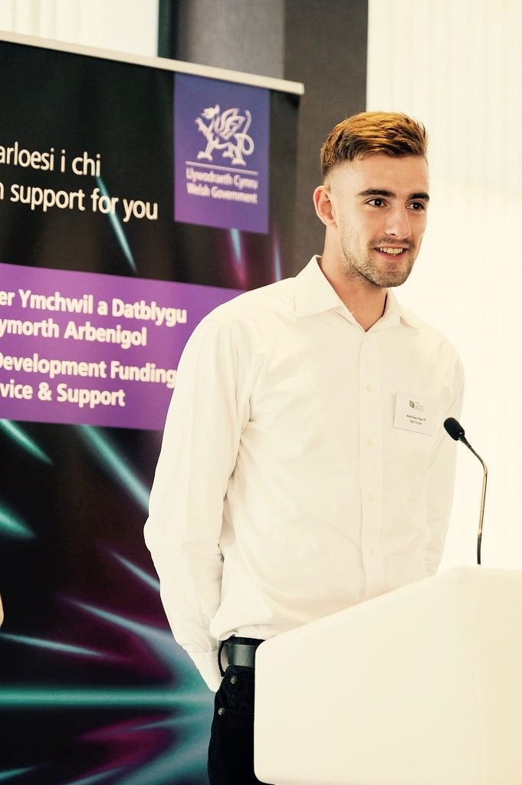  Internship and Volunteering  BMSP 6003 | Matthew Edward Kilgariff 1705241  University of Wales  Trinity Saint David  Jessica Shore

Table of Contents

Executive Summary 4
Introduction 5
2.0 - Main Findings 6
Personal Reflection 10
3.0 – Conclusions 12
4.0 – Recommendations 12
References 13
Appendix A: Pre-Placement Skills Audit 16

Executive Summary
This report is a critical reflection of my experience as an intern within Egni Co-op, a community owned renewable energy provider. A pre and post placement skills audit and a placement feedback form were used to identify changes in skills and areas of personal improvement. These can be found within the appendices. The report found that internships provide valuable practical experiences that can lead to improved future employability.
Recommendations discussed include;
- Personal recommendations – strategies to improve areas of weakness.
- University recommendations – for adaptations to their internship program.
- Host company recommendations – to improve future internships.

The limitations of the internship included its length of only 20 days, the size of the company and staffing.

Introduction
This report is a critical appraisal of my experience as an intern within Egni Coop. Internships are a short, structured period of work for an organisation with the aim of providing an insight into a particular company and industry (Chaita, M. (2016). Businesses need a varied and well-educated workforce to adapt to changing markets and internships can create opportunities to encourage diversity and opportunity (Schambach, T., & Dirks, J. (2002).
Students face challenges when transitioning from the classroom to professional life (Anjum, S. (2020). Internships provide students with practical experience and the chance to apply academic knowledge to a real-life work setting. This prepares them for the work environment and may accelerate job performance (Maertz, C., Stoeberl, P., & Marks, J. (2014). Most graduates find field work a valuable and a memorable part of their learning experience (Kiser, P. (2012). It is difficult to recreate this kind of experience within a classroom setting (Sweitzer, H., & King, M. (2014). Internships also increase the probability of students finding employment and earning more money (Saniter, N., & Siedler, T. (2014). This may be because employers know that exposure to the workplace will help new staff adapt better to new tasks (Chaita, M. (2016).
Internship also has benefits for the host company by reducing recruitment and training costs and bringing young talent into their companies (Dobratz, C., Singh, P., & Abbey, A. (2014). Unfortunately some placement providers have been criticised for viewing internship as a mode of cheap labour rather than a valuable educational experience. Disney had the reputation for giving interns only unskilled jobs, with little to no educational time (Perlin, R. (2012). This shows the dependence on the internship host company to provide a worthwhile experience for the participant. The Quality Assurance Agency for Higher Education (QAA) has set standards for placement providers focusing on student outcomes (QAA (2019). This ensures the provider has sufficient facilities, resources and support for students to enrich their experience and provide a quality placement.

Internships and future livelihood
A study by Jack Gault, John Redington, and Tammy Schlager (2000) measured the relationship between 500 American undergraduate business students and early career success. They questioned 250 students who had been interns and 250 non-interns, 5 years after graduation. They researched both intrinsic (income, time to obtain a job) and extrinsic factors (job satisfaction) to assess the students. Business graduates who had completed an internship earned on average 9.23% higher than non-interns. They also found that the students who had taken part in an internship secured a job significantly earlier than those who had not been interns (average 2months earlier). Surprisingly non-interns were just as intrinsically satisfied and fostered equally successful relationships within the workplace (Gault, J., Redington, J. & Schlager, T. (2000). This may be because the students who put themselves forward for internships could be more ambitious and in a better financial position to take up the opportunity. The process can be competitive and only confident and forward thinking students are likely to apply. Students who have not accessed internships may still be successful in the work place but there seems to be some disadvantages in not accessing the internship process.
The placement at Egni Co-op was with another business student which provided opportunities for support and joint working. Paired placements have benefits in efficiency but it is important that there is no competitiveness or animosity. There were no problems with this paired placement but we did not spend much time together because of the culture of working independently away from the office environment.

2.0 - Main Findings
Pre placement

The National Union of Students organised the internship through the Placements for Good program. I was matched with Egni Co-op which is a community energy co-operative based in Cwmllynfell, South Wales. They are a social enterprise business specialising in the installation of solar PV systems on community buildings, converting them to renewable energy (Egni Co-op. (2020). The internship role was to develop marketing strategies. Responsibilities included creating a marketing plan, increasing social media awareness and booking advertisements with the aim of increasing investments. This was a good match as it aligned well with my undergraduate degree. The Business and Management course at University Trinity St David’s has been adapted to incorporate sustainability within a business context (UWTSD. (2020). This meant I had some basic understanding of the environment pre-placement.
The preparation session was via skype because I was studying abroad at the time. Technologies such as skype are an effective way of communicating over distances but have some disadvantages over face to face contact (Sun, P., & Cheng, H. (2007). The advisors from the Placements for Good were supportive throughout the initiation process. They clarified overall standards and expectations which is important in the preparation of an internship.
An action plan was developed with University of Wales with three main SMART aims and objectives. These were derived from the strengths and weaknesses identified in the pre placement skills audit (Appendix A). They were entered into a Gantt Chart which is an organisational tool used to keep track of progress (Tissington, P., & Orthodoxou, C. (2013). This scheduled the time frame for attainment objectives (seen in Figure 1.0 below).
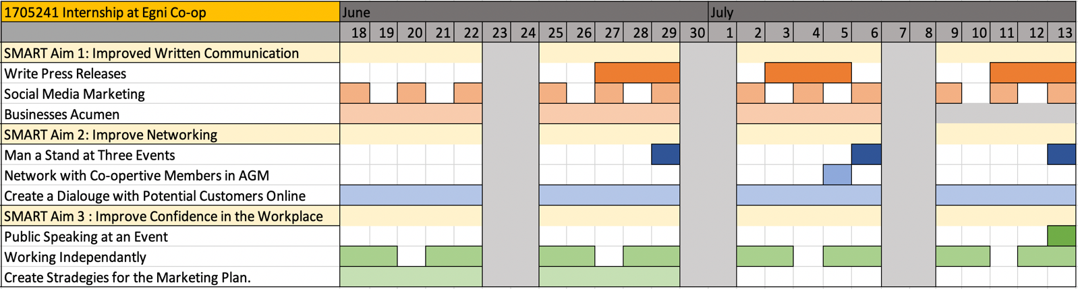
Figure 1.0; Gantt chart showing SMART aims and objectives completion timeframe.

The SMART aims and objectives provided clarity for progression and were measurable, making it possible to record outcomes (Lawlor, K. (2012). However it can be discouraging and challenging if objectives only focus on areas of weakness. Enhancing strengths may also be worthwhile and valuable to the workplace.
The Gantt chart was a valid tool for preparing for the placement but operationally it was less useful because the director had different priorities. It was completed prior to the placement with no input from the placement provider. This limited its success.

During the internship
An induction was carried out by the Company Director on commencement of the placement. It included health and safety procedures as well as an introduction to the team. The work schedule was flexible, with a majority of work being home based. This method of working saves on travel but requires a high level of self-discipline. Egni is a small company with only three full time employees so it was not always possible to access staff members to clarify tasks. This meant that decisions needed to be made independently to keep to deadlines. The expectations from the company were high as information released to the public needed to reflect well on the company.
Despite a few initial mistakes, I learnt to understand the standards expected and to trust my own decision making. The freedom and creativity of a more relaxed style of supervision suited my personal strengths and learning style i.e. using trial and error find solutions to problems. An awareness of learning styles can be beneficial to managers and individuals because adhering to a preferred learning channel can lead to better results (Hein, T., & Budny, D. (2000). Each person has their own way of learning and a traditional approach is not the most effective for everyone (Kolb, A., & Kolb, D. (2005).
However a relaxed management style can cause stress and uncertainty because there is less direction. The position of intern can make you feel vulnerable and more support would have been appreciated at times. Multiple tasks were allocated simultaneously and it was sometimes difficult to prioritise which created pressure.
During the internship, I attended functions and events on behalf of the company with the aim of networking with potential investors and other industry firms. This matched a SMART aim and objective (previously defined in Figure 2.0) so I appreciated this opportunity although it was challenging talking to industry experts. These events varied from large national conferences to small local agricultural fairs which allowed me to connect with a range of different people including potential future employers. They also brought insight about the industry, with talks from leading experts and state of the art technology on display. This was beneficial for considering future career prospects and getting a better understanding of the industry and its challenges.
Writing press releases was a particular challenge because of their importance and the fact that written communication is not a strength of mine (as previously established in the skills audit). It took time to learn the skill of writing concisely so that Egni Co-op’s message was clear to the public. The aim was to attract investors to the company and spread information about Egni Co-op’s ethos and plans.
Later on in the internship I was trusted with booking £15,000 worth of advertisements in national newspapers such as The Guardian, The Times and the Telegraph and local papers such as The Tenby Observer and the Western Mail. This high monetary budget created considerable pressure but felt rewarding. I learnt to use computer applications including Google Analytics, WordPress and Mailchimp. The skills audit did not have a section for the learning computer applications although it has been described as one of the top six most significant skills to employers since the 1990s (Kelley, C., & Gaedeke, R. (1990).
Completing these task pushed me outside my comfort zone and provided experience of the pressure and intensity of a busy workplace. The transition from student to intern is a challenge because the workplace is more unpredictable and chaotic than the controlled classroom (Peach, D., Ruinard, E., & Webb, F. (2014).

Results of Pre/Post Skills Audit
Prior to the commencement of the internship, a pre placement skills audit (Appendix A) was carried out. Skills audits measure a student’s ability to reflect, progress and identify their weaknesses and strengths. Chaita, M. (2016) states that some graduates overestimate the importance of academic qualifications and underestimate the value of experience. Employers need evidence of how skills have been acquired rather than just a list. That is why it is important to have exposure to the practical application of skills. The skills audit includes examples of practical skills within an academic or workplace environment which enables the intern to relate skills to experience.
Figure 2.0 shows the results of the pre and post internship skills audit (Appendix B) The black Xs represent post internship and red Xs represent pre internship. Eleven of the twenty skills showed improvement through practical learning with Egni Co-op. There were nine skills that stayed the same, these were already areas of relative strength.
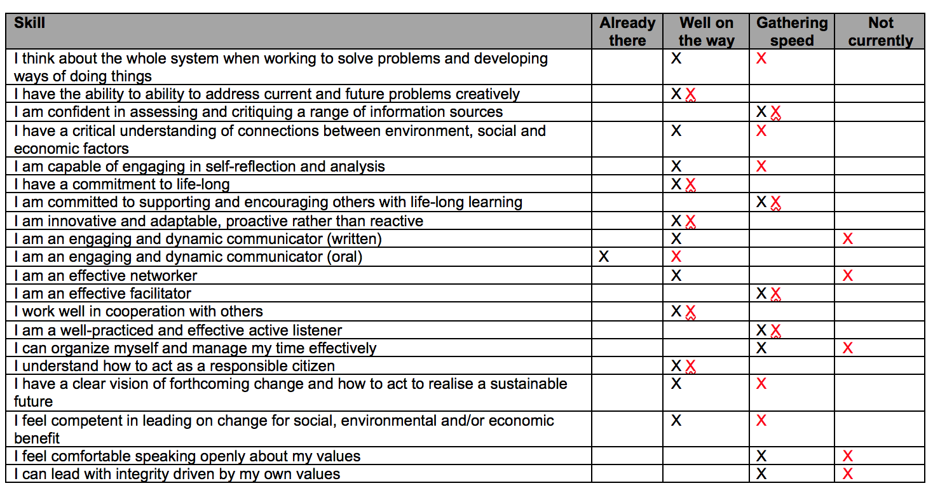
Figure 2.0; Table showing pre and post skills audit results.
Exposure to a range of experiences during the 20 day placement provided opportunities to build confidence in previously less competent skills. The skills that showed the most improvement were written communication and networking. This was because the job role of marketing assistant included tasks requiring these skills so there was ample opportunity to practice. The skills that did not progress as well included co-operation with others and being a responsible citizen. These were relative strengths and the placement required a high level of independent working so there was less opportunity to improve in these areas. The skill that I found hardest to improve on was time efficiency.
Kelley and Gaedeke’s (1990) investigation found six career preparation skills to be particularly significant for employers when hiring: oral communication, written communication, problem solving, analytical skills, computer applications, and leadership/ teamwork skills. The internship process allowed me to practise these career preparation skills. They can be added to my CV, and included in a Linked In profile to enhance future career prospects.

Placement Feedback
According to the U.S. Office of Personnel Management (2020), effective feedback is a critical component of success and should be used in conjunction with setting and achieving goals. Feedback provides students with an understanding of how to close the gap between current and expected performance (Peach, D., Ruinard, E., & Webb, F. (2014). The skills audit is a subjective tool for self-reflection so feedback from the placement provider is
needed for a more objective perspective on work performance.
Positive | Negative
Enthusiastic/ good work ethic. | Minor errors (spellings, translations), lack of attention to detail.
Did well independently . | Organisation skills.
Initiative and creativity. | Time management.
Communication skills. | Difficult to contact at times.

Figure 3.0. Placement Providers Feedback.
A post placement feedback form (Appendix C) was completed by the internship director. Figure 3.0 summarises the positive and negative feedback. This feedback is important for future planning and giving insight in to the type of jobs that could suit my skill set.
The company director described me as enthusiastic and creative which were valuable assets to the business. He realised that there was a high level of responsibility in the role and appreciated it when I checked work with him. He identified some issues such as not always being able to contact me and this were addressed by communicating regularly via skype or telephone. Time management and organisational skills were identified as weaknesses so utilising tools such as an online diary is a useful practical strategy. Spelling is another challenge so tools such as spell check were used to ensure written work was of the correct standard. Also the company expected their posts to be translated in to Welsh to adhere to Welsh Language Regulations. I am not a fluent Welsh speak so sometimes had to resort to online translation services, which were not always accurate.
The majority of the feedback was positive and reflects the good experience I had with the internship. The feedback from the company gave me confidence in my own abilities but also an awareness on how to improve in the future.

3.0 – Conclusions

The internship was a positive experience. This was because it was in a field that interested me (renewable energy) and my values were in line with those of the company. The skills audit showed improvement due to guidance and exposure to a range of new and challenging tasks. Feedback from Egni was positive but with some constructive criticism to enable me to progress. The timeframe of the internship was sufficient to allow me to gain insight in to the industry, company and job role. Although some of the tasks set by the placement provider were not fully achievable in the timeframe.
The internship has improved my employability because I have learnt new skills which are directly relatable to the work place. Paid internships and placements are under high demand and graduate jobs even more so. “So many people get degrees, you have to stand out and now 61% of graduates end up working for the company they have interned for. It's how it works now." Ollie Sidwell, founder of hit site Rate My Placement for BBC News (2015). Financial services organisation Deloitte Ltd receives 10,000 applicants for every 350 placements so competition is fierce. This internship has taught me new skills and is a valuable asset to my CV and future career prospects.
The internship with Egni Co-op has inspired me to be more sustainable and socially responsible in my own life because of its emphasis on the community, renewable energy and protecting the planet. It is an industry that is forward thinking and relates to current concerns regarding climate change and the depletion of finite resources.
Hopefully Egni Co-op have benefited from the internship process and will take on interns in the future. The fact that the internship was paid was significant because it reduced financial strain and showed a commitment to the process. It also encourages students from more diverse backgrounds to apply for internships.
This placement gave me an insight in to the role of a marketing assistant. There were elements that I enjoyed such as participating in events and designing advertisements but I found the pressure of trying to promote the company at every occasion too demanding. This experience has given me valuable insight into my own future development.

4.0 – Recommendations
Personal recommendations;

- Organisational skills and time management were identified as areas for development. Improvement can be achieved by creating and keeping schedules to ensure tasks are on track . Prioritising and delegating tasks are important to reduce work load pressure and confirm that the most important tasks are completed first.
Simple strategies such as getting up earlier can help with time management.
- There can be a tendency to rush to complete tasks when under pressure in a busy working environment. Reviewing work carefully ensures there are no careless errors and ultimately saves time by avoiding unnecessary mistakes. A greater attention to detail will make sure that all work is of a consistent high standard. A quiet, distraction free environment is important to aid concentration for more creative tasks such as writing press releases.
- The internship gave the opportunity to network and gain knowledge on the renewable energy industry which was enjoyable and stimulating. Whilst participating in conferences as an Egni representative, there were opportunities to connect with industry employers. This highlighted the importance of networking and being up to date with the latest research. It is essential to gain knowledge about a chosen industry through forums, literature, networking and attending events.
- An up to date CV and Linked In account based on my internship experience will help employers differentiate me in a competitive market. Employers are often look at social media accounts too so this needs to reflect core values too.

University recommendations;
- At the pre-assessment stage it would be beneficial to collaborate with the placement provider. The SMART aims and objectives and a Gantt chart would have been more relevant if devised in partnership with the company.
- There needs to be a process in place for the placement provider to gain feedback from the intern. This will help to shape future internship programmes.

Host company recommendations;
- Internships with small companies have the advantage that interns gain access to the whole structure and therefore feel integral to the business. Larger companies may split interns between departments so experience can be limited to specific sectors. Small companies are usually fast paced so interns must adapt quickly ,without taking too much time away from busy staff. Some interns thrive in this environment but others need more guidance. Therefore it is important that Egni attracts the right kind of intern who can cope in a small company with few staff.
- Even in a small, busy company there needs to be a structured approach when providing internships. It is useful to provide time tables and designated slots for face to face meetings with supervisors. This takes planning but will ensure that progress is monitored and problems resolved promptly.

References

Anjum, S. (2020). Impact of internship programs on professional and personal development of business students: a case study from Pakistan. Future Business Journal, 6(1). doi:10.1186/s43093-019-0007-3

BBC News. (2015). How hard is it to get an internship?. https://www.bbc.co.uk/news/business-22818555

Chaita, M. (2016). Developing graduate employability skills. Boca Raton: Universal Publishers.

Dobratz, C., Singh, P., & Abbey, A. (2014). Using Formal Internships to Improve Entrepreneurship Education Programs. Journal of Entrepreneurship Education; Arden, 17(2), 62– 76.

Egni Co-op. (2020). Wales Solar PV Co-op. https://egni.coop/

Gault, J., Redington, J. & Schlager, T. (2000). Undergraduate business internships and career success: Are they related? Journal of Marketing Education, Vol. 22 No. 1, April 2000 45-53

Gerken, M., Rienties, B., Giesbers, B., & Könings, K. (2012). Enhancing the Academic Internship Learning Experience for Business Education—A Critical Review and Future Directions. New York: SAGE. 10.1007/978-94-007-2846-2_2.

Hein, T., & Budny, D. (2000). Teaching to students' learning styles: approaches that work. FIE'99 Frontiers In Education. 29Th Annual Frontiers In Education Conference. Conference Proceedings. (IEEE Cat. No.99CH37011. doi: 10.1109/fie.1999.841622

Kelley, C., & Gaedeke, R. (1990). Student and Employer Evaluation of Hiring Criteria for Entry-Level Marketing Positions. Journal of Marketing Education, 12(3), 64–71. https://doi.org/10.1177/027347539001200309

Kiser, P. (2012). The human services internship. Belmont, CA: Brooks/Cole, Cengage Learning.

Kolb, A., & Kolb, D. (2005). Learning Styles and Learning Spaces: Enhancing Experiential Learning in Higher Education. Academy Of Management Learning & Education, 4(2), 193-212. doi: 10.5465/amle.2005.17268566

Lawlor, K. (2012). Smart Goals: How the application of smart goals can contribute to achievement of student learning outcomes. Developments in Business Simulation and Experimental Learning, Vol 39. Pg. 259 – 267.

Mark, G. (2006). The Cost of Interrupted Work: More Speed and Stress. University of California Press; CA.

Maertz, C., Stoeberl, P., & Marks, J. (2014). Building successful internships: lessons from the research for interns, schools, and employers. Career Development International, 19(1), 123–142. https://doi.org/10.1108/CDI-03-2013-0025

QAA (2019). Quality and Standards Review for Providers Applying to Register with the Office for Students: Guidance for Providers. https://www.qaa.ac.uk/docs/qaa/guidance/quality-and-standards-review-guidance-for-providers.pdf?sfvrsn=73cfe81_2

Peach, D., Ruinard, E., & Webb, F. (2014). Feedback on student performance in the workplace: The role of workplace supervisors. Asia - Pacific Journal of Cooperative Education, 15(3), pp. 241-252.

Perlin, R. (2012). Intern nation. London: Verso.

Saniter, N., & Siedler, T. (2014). Door Opener or Waste of Time? The Effects of Student Internships on Labour Market Outcomes. IZA Discussion Papers 8141, Institute for the Study of Labour (IZA). https://ideas.repec.org/p/iza/izadps/dp8141.html

Schambach, T., & Dirks, J. (2002). Student Perceptions of Internship Experiences. In: Proceedings of the International Academy for Information Management (IAIM) Annual Conference: International Conference on Informatics Education Research (ICIER) (17th, Barcelona, Spain, December 13-15, 2002).

Sweitzer, H., & King, M. (2014). The Successful Internship: Personal, Professional, and Civic Development in Experiential Learning, Fourth Edition. Belmont: Brooks/ Cole.

Sun, P., & Cheng, H. (2007). The design of instructional multimedia in e-Learning: A Media Richness Theory-based approach. Computers & Education, 49(3), 662-676. doi:10.1016/j.compedu.2005.11.016

Tissington, P., & Orthodoxou, C. (2013). Study skills for business and management. London: SAGE.

U.S. Office of Personnel Management. (2020). Feedback is Critical to Improving Performance. https://www.opm.gov/policy-data-oversight/performance-management/performance-management-cycle/monitoring/feedback-is-critical-to-improving-performance/

UWTSD. (2020). INSPIRE: Embedding Sustainability - University of Wales, Trinity Saint David. https://www.uwtsd.ac.uk/professional-services/inspire-embedding-sustainability/

Appendix A: Pre-Placement Skills Audit
Name: Matthew Kilgariff Placement Provider: Egni Coop Date: 09/06/19
Skill | Already there | Well on the way | Gathering speed | Not currently
I think about the whole system when working to solve problems and developing ways of doing things |  |  | X
Example:Previously running a business has taught me the value of looking at the larger picture and understanding the impact of decisions on the business.
I have the ability to address current and future problems creatively |  | X
Example: The company was the first of its kind in Carmarthen and so I had to be creative to inform customers and make use of a limited budget.
I am confident in assessing and critiquing a range of information sources |  |  | X
Example: I have learnt to analyse data and look at research critically since starting university.
I have a critical understanding of connections between environment, social and economic factors |  |  | X
Example: I wrote an article about the impact of the fashion industry on the external environment. This highlighted connections between environmental and social change and its effects on the wider economy.
I am capable of engaging in self-reflection and analysis |  |  | X
Example: Self-analysis was encouraged in a previous role with a global business. This helped me in become more accurate within my self-reflection.
I have a commitment to life-long |  | X
Example: I have demonstrated a commitment to life-long learning by working, studying and emerging myself in other cultures. I have taken opportunities to work and live abroad.
I am committed to supporting and encouraging others with life-long learning |  |  | X
Example: I have previously worked in a managerial role in a business that used volunteers. I supported the volunteers who often had additional learning needs.
I am innovative and adaptable, proactive rather than reactive |  | X
Example: Winning Carmarthenshire Young Entrepreneur of the year award was recognition of the innovative and proactive work I was doing at the time.
I am an engaging and dynamic communicator (written) |  |  |  | X
Example: I have learnt to change my style of writing to match the task and to check spelling and grammar carefully. I have achieved good grades for written assignments at university.
I am an engaging and dynamic communicator (oral) |  | X
Example: Whilst studying in Canada I had to carry out a 20-minute presentation on a business project in front of a large diverse class. Feedback from the tutor and class was good.
I was able to reflect on aspects that could be improved.
I am an effective networker |  |  |  | X
Example: When I was a self-employed shop owner connecting with other local small businesses was key to attracting new customers.
I am an effective facilitator |  |  | X
Example: I have given practical advice and insights from my own experience of studying abroad to UWTSD students who are considering this option.
I work well in cooperation with others |  | X
Example: I have gained experience working for companies such as H&M and Aldi UK with large teams and understand the importance of effective team working.
I am a well-practiced and effective active listener |  |  | X
Example: Being course representative for Carmarthen Business School meant I had to listen to the concerns of many of my classmates.
I can organize myself and manage my time effectively |  |  |  | X
Example: I have managed to hand in assignments on time but they are often last minute which is stressful.
I understand how to act as a responsible citizen |  | X
Example: Having worked previously for charities and social enterprises I believe I am a responsible citizen.
I have a clear vision of forthcoming change and how to act to realise a sustainable future |  |  | X
Example: University has helped me define ideas of potential change on a global scale and the types of actions that could lead towards a more sustainable future.
I feel competent in leading on change for social, environmental and/or economic benefit |  |  | X
Example: Being course representative for Carmarthen Business School gave me a chance to take a lead on change for my year group and future students.
I feel comfortable speaking openly about my values |  |  |  | X
Example: I believe that my values have been expressed in presentations and in discussions with colleagues. I am gaining experience with being open and responding to other people’s viewpoints
I can lead with integrity driven by my own values |  |  |  | X
Example: My values are the core to everything I aim to achieve and how I would define success.

Appendix B – Post-Placement Skills Audit
Name: Matthew Kilgariff

Placement Provider: Egni Coop

Date: 09/06/19
Skill | Already there | Well on the way | Gathering speed | Not currently
I think about the whole system when working to solve problems and developing ways of doing things |  | X | X
Example: Working as part of a small group in Egni taught me the interdependence of our roles and had to incorporate it into my decision making.
I have the ability to ability to address current and future problems creatively |  | X X
Example:
I am confident in assessing and critiquing a range of information sources |  |  | X X
Example:
I have a critical understanding of connections between environment, social and economic factors |  | X | X
Example: My time with Egni opened my eyes to the connection between the normal community members and the effect they can have as a collective.
I am capable of engaging in self-reflection and analysis |  | X | X
Example: My time writing reflective blogs using a theoretical framework has improved my capability in undertaking self-reflection.
I have a commitment to life-long |  | X X
Example:
I am committed to supporting and encouraging others with life-long learning |  |  | X X
Example:
I am innovative and adaptable, proactive rather than reactive |  | X X
Example:
I am an engaging and dynamic communicator (written) |  | X |  | X
Example: Having practical experience of writing press releases, marketing plans and communicating professionally has really helped me in developing my written communication.
I am an engaging and dynamic communicator (oral) | X | X
Example: Speaking with members at events, giving talks has given me confirmation that oral communication is a skill of mine.
I am an effective networker |  | X |  | X
Example: The need to network with other companies at awards and events with Egni has given me some practice in networking. Although, it is still a skill that I could work on.
I am an effective facilitator |  |  | X X
Example:
I work well in cooperation with others |  | X X
Example:
I am a well-practiced and effective active listener |  |  | X X
Example:
I can organize myself and manage my time effectively |  |  | X | X
Example: Having to work independently within my role in Egni made me improve my organisation. I feel the experience has help me put better procedures into place.
I understand how to act as a responsible citizen |  | X X
Example:
I have a clear vision of forthcoming change and how to act to realise a sustainable future |  | X | X
Example: My time with Egni director taught me a lot about how environmental concerns can be battled at a local level.
I feel competent in leading on change for social, environmental and/or economic benefit |  | X | X
Example: Working for a social enterprise has further increased my confidence on leading for social and environmental change within business.
I feel comfortable speaking openly about my values |  |  | X | X
Example: I feel now my values have been better defined, as I further know what I feel is acceptable within the workplace and where I personally find important.
I can lead with integrity driven by my own values |  |  | X | X
Example: As my workplace confidence improves so will my integrity.

Appendix C: Post placement student review
Placement Coordinator
Awel Aman Tawe
76-78 Heol Gwilym
Cwmllynfell
Abertawe/Swansea SA92GN
admin@awel.coop 01639 830870

Name of provider’s organisation: |  | Egni Co-op
Name of student: |  | Matthew Kilgariff
What were the positive aspects?
Matthew was enthusiastic and had a good work ethic. He communicated well with our members and when representing Egni at a series of events. The role involved some independent work and he showed initiative and creativity. He was responsible for independently booking advertisements and managing our social media.This required a specific set of skills and Matthew was confident enough to check that everything was correct before committing .He was able to take some responsibility, even with quite large budgets.

This was our first experience of taking on interns and it was a positive experience. They can bring fresh ideas and knowledge. Matthew was enthusiastic and this was infectious. I hope Matthew found the experience to be positive too.
Were there any problems?
There were no major problems, both interns took a while to get used to the way we operate which was understandable. Matthew made some mistakes with translations/ spelling but generally completed most tasks as expected. Initially the interns could be difficult to get hold of but as the placement proceeded I found them to be more present and accountable. We were able to skype and talk on the telephone regularly.
Do you have any recommendations for enhancement for the future?
Matthew needs to gain experience to build on the skills he already has. He has good people skills but needs to focus on time management and organisation.
I wish him all the best in the future.
Signed: | D. McCallum
Name: | Dan McCallum
Position (please tick one): | ☒ Placement Provider  ☐ Student  ☐ Placement Tutor |  | Date: | 23/03/19

