

Student Name: Mohammed Mobarok Ali
Assessment 1 – Reading Task Template

PART 1: A3 in-class notes
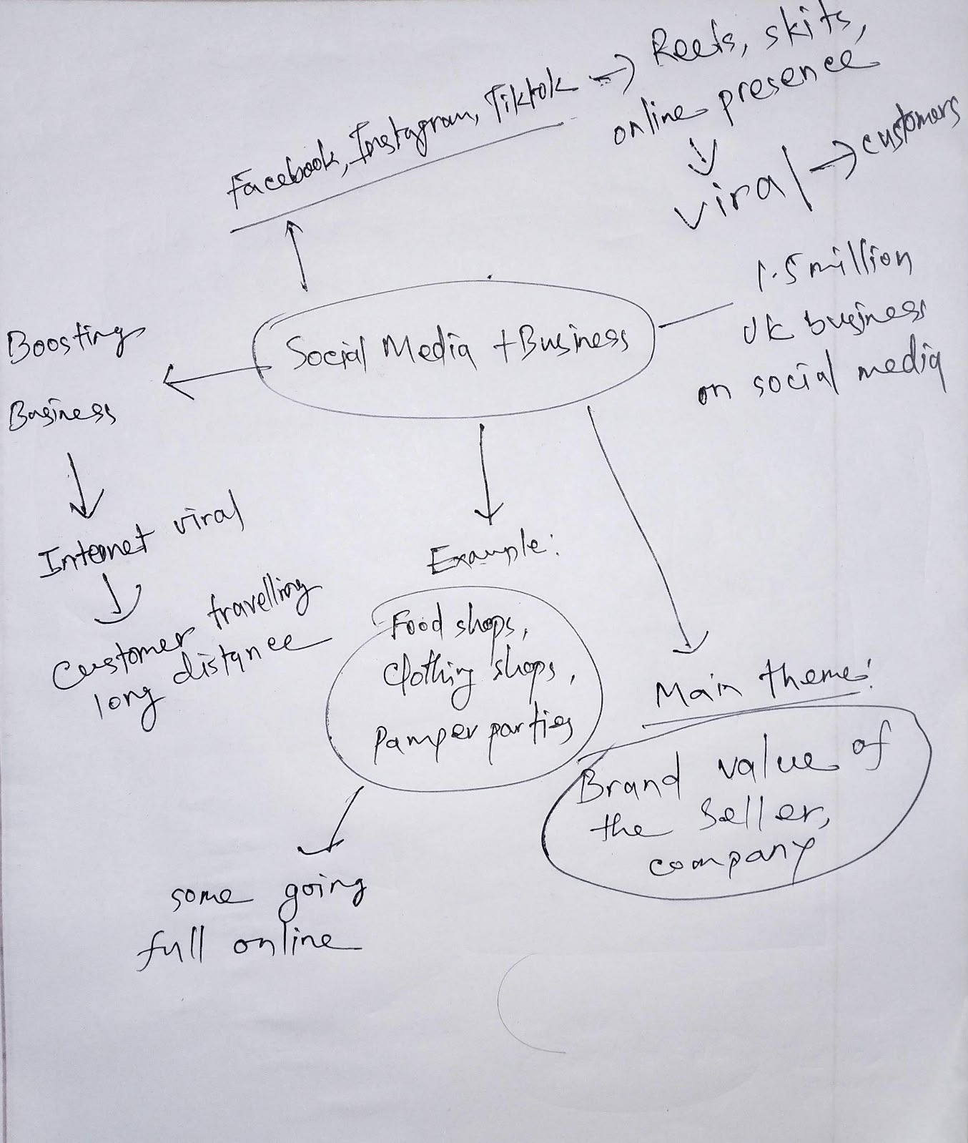

PART 2:
- What is the main idea of the whole text?

The main idea is that social media, such as TikTok and Instagram, have enabled small businesses to blossom and thrive fast, attracting customers, even from overseas, and even changing the lives of small business owners in certain instances. The article demonstrates this with some Essex companies that went 'viral'.

- What is one key point that supports the main idea, and which specific example from the text shows this?
A key point is that social media can attract clients from a very long distance. For instance, customers in Basildon were traveling three hours to go to Murat Mutlu's Honywood Sandwich Shop for his chicken burger after a regular posting about the restaurant both from the owner and mainly the videos posted from the customer themselves.

- What is a different key point that supports the main idea, and which specific example from the text shows this?

Another key point to note is that the social media can change the mode of functioning of a business and the owner. One such example is Linda Hunter aka "Lindy Loo" who began posting during the pandemic and relocating her market stall after 46 years and eventually moving her business 100% online, shipping outfits all over the UK and Australia.

- Which part of the text do you think is most important, and why?
I think the most significant aspect is the last section about “People buy from people”, where the marketing expert Faye Martin shares that people don't want to be sold to and want content that is human and relatable. It's important because it's a way of understanding why social media is effective for small businesses, tying all the examples together.

Reflection:
- What did you find difficult in this task (including in-class components), and why was it difficult?
The most difficult aspect was the main idea in only a sentence or two. There are so many businesses in it, including the sandwich shop, the prom dress shop, the mobile pamper bus, I wanted to include them all. I kept on adding more and more, but I had to cull it down in the end.

- What helped you with this difficulty, and how did it help you?

The one thing that aided was asking myself, “What is the one message that is shared by all of these businesses?” That question gave me the answer: social media is the key to growing small businesses and the individual businesses were just examples. Talking about it with my classmates during class was also helpful in determining which parts to leave out.

