This portfolio is going to look at three different structures of ‘family’ and explore critically how the ‘mother’ is positioned within these constructs. It will start with a definition of ‘family’ and consider how one definition cannot cover the wide and diverse range of families in the 21st century. The families that will be explored in this portfolio are a nuclear family, single parent family and a Muslim family. It will critically examine the relationship between the mother, her family and todays sustainable society. Furthermore, it will provide a critical reflection on the potential tensions between the mother, family and contemporary society in the postmodern age.

According to Murdock (1949), the family is a ‘social group characterized by common residence, economic cooperation and reproduction. It includes adults of both sexes, at least two of whom maintain a socially approved sexual relationship, and one or more children, own or adopted, of the sexually cohabiting couple’. Murdock's definition is no longer accurate. He suggests that families are a social group and suggests living together as a characteristic which may be the case for many families however, over the last 40 years there have been significant changes. According to UNESCO (1992 cited in Sharma, 2013) a family is a social unit that even when the members do not live in the same household, they are still a family. This broad definition encompasses the very wide variety of contemporary families.

Since the 1960s/70s family constructs have radically changed across Europe. Most significantly family sizes are smaller, partly due to a decrease in fertility levels across most of Europe. Also, linked to this the structure of many families has altered. Research highlights the notion that the “nuclear family model” is increasingly being replaced by a variety of different alternative family forms and lifestyles (Kapella et al. 2009 cited in Beier et al., 2010). The formation of families, the structure of households and the balance of work and life have all impacted on family life. With marriage rates decreasing and divorce rates increasing more children are growing up in lone parent or blended families (Jenkins, Pereira and Evans, 2009). In addition, both men and women need to pursue careers before having children and as a result the age of mothers at first childbirth has substantially increased. Furthermore, the numbers of working mothers have also risen radically (Beier et al., 2010). This suggests demographic changes and the economy are major factors in changing trends.

The first family structure will be a typical nuclear family (see appendix 1) with a mother, father and their children as defined by Murdock (1949), who argues that the family unit forms a foundation from which more complicated relationships can be built. This functionalist approach argues that the family serves four fundamental purposes, without which society could not exist: the regulation of sexually approved behaviour, reproduction, economic function by providing shelter and food, and educating the children through discipline and socialising. (Murdock, 1949). Parsons (1951) added two more important functions of the family, expressive and instrumental. He saw the woman’s role as expressive because she was responsible for nurturing and raising her children in the home and teaching them the norms and values of society. The man’s role was instrumental because it was his job to provide financial security by going out to work.

This notion is supported by Giddens and Sutton (2013), who point out that, in the 1950s, women were very much ‘confined’ to the home and were responsible for all the housekeeping and looking after and their children whilst men were the ‘breadwinners’ and went out to work to provide an income for the family. These concepts can be seen in appendix 1 as the man is standing behind his family, with his arms around them in a protective manner. The mother is less dominant but also has her arms around her children. The image (see appendix 1) also illustrates the reality that women were more economically dependent on men and the woman in this family would need the support of her husband to raise the children. Although it could be argued that the husband in this image is being protective, another view could be that he was regarding his family, including his wife, as his property. In previous times the law of coverture meant that married women had no right to their own property as everything was owned by their husband (Walby, 1990). This did not change until the 1870 Married Women’s Property Act but, even after this change the concept of coverture helped perpetuate the pervading view that women were the property of men (McGee and Moore, 2014)

Feminist theory considers the nuclear family to be unequal and oppressive to the women and argues that the structure of the nuclear family, and the role of the woman within it, perpetuates the notion of a patriarchal society. This is supported by Parson’s (1951) view where he argues that women were the role models for girls and men were the same for boys. The feminist argument is that the nuclear family structure taught girls to be subservient like their mothers and that boys were stronger and therefore better, like their fathers. Women were essentially meant to be feminine and that was the only role available to them. However, Lorber (2010) argues that it is the ‘western culture’ that is oppressive to women as in many ‘non-western’ countries, women are not just regarded as housewives and child carers but are also viewed productive workers within their families.

Whilst Murdoch’s (1949) definition of the family has not changed much since the 1900s, Coltrane and Collins (2001) argue that each era in British society has its own definition and idea of what a family is, including who is in a family, and what their rights and responsibilities are towards children and other family members. This can be seen during the 1940s, when the role of women did begin to change (Goldin, 1991). During the second world war with thousands of men having to serve in the army, women then undertook many jobs both domestically and on the home front (Ministry of Defence, 2015). Single women aged between 20 and 30 were employed in various roles from 1941, however by 1943 roughly 90% of all single women and 80% of women that were married were in employment (Ministry of Defence, 2015).

At the end of the war it can be said that women’s roles reverted back to being housewives and mothers. Smith (cited in Summerfield, 2013), suggests that changes during the war to the roles of women were temporary and that in 1945 women wanted to return to how things were previously. However, whilst some women may have been happy to return to their traditional role in the home, Goldin (1991) argues that some had enjoyed the world of work and were now feeling trapped and ‘constrained’. Married women’s involvement in paid employment increased during the war and were retained afterwards through the increase in part time work as a method of meeting the shortage of workers (Summerfield, 2013). It appears that the war helped in the transformation of women’s personal lives and establishing a role for themselves outside the home environment. This legacy continues today. In the contemporary world the basic structure of the nuclear family still exists (see appendix 2) however, more women now are able to work and provide equally for their families and according to Catalyst (2020) over 72% women who are of working age in the UK are in employment. The mother in Appendix 2 is now more likely to have a job however, it can be said that she now has a double ‘burden’ as the housework and childcare is still mainly the responsibility of the mother (Davis and King, 2018; Bratberg et al., 2002). Although mothers in the 21st century have more employment opportunities it can also be argued that they are still finding it a challenge to fit full time employment around family life and childcare responsibilities. This often results in taking part time jobs or those with less pay or career development opportunities. Added to this, Catalyst (2020) states that there is still a significant gender wage gap.

Over the years, there has been a reduction in the numbers of ‘middle class nuclear families’ as a result of less institutionalised family relationships such as marriage and lifetime partners. Another factor is the increased numbers of babies born out of wedlock. Marriage is no longer a prerequisite for starting a family (Kiermann, 2004 cited in Beier et al).

Although in the 1950s a woman’s role was still predominantly as a housewife and mother, the change that began after the war accelerated and the rise in single parent families headed by the mother became more apparent during the 1960s and 70s. This was largely due to the changes in divorce laws (Bianchi, 2008). The introduction of more readily available contraception also impacted on sexual activity outside of marriage (Beauchamp and Pakaluk, 2019). During the 1980s this slowed down a little, and different factors such as delayed marriage and giving birth outside of wedlock was the cause of a lot more single mother families rather than divorce or separation (Bianchi, 2008).

This second part of this portfolio will now focus on the role of a woman as a mother in a single parent family (see appendix 3). Stack and Merdith (2017) point out that around one in four children in the United Kingdom are living in lone parent families, furthermore, as illustrated in appendix 4 according to the Office for National Statistics (ONS) 86% of these families are headed by single mothers (ONS, 2019). This poses the question, why do families with one parent still face stigma despite making up one quarter of families in the United Kingdom? Alarmingly, Carroll (2019) points out that recent research identified that 75% of single parents still encounter some form of stigma. Smart (1992) argues that single women are stigmatised because of the threat their ‘unregulated’ sexuality poses to the status quo. This has led them to be the focus of much attention in terms of their behaviour. This stigma could possibly prevent the mother from effectively carrying out her roles as both the ‘breadwinner’ and caregiver in this family structure as society's view of single mothers is often negative and add stress to an already difficult situation (Morris and Munt, 2019).

For many parents in society today balancing work and homelife proves a challenge (Kalliath & Brough, 2008). However, this challenge is not equal for all. In contrast to couples that are living together, married or childless, single parents have the hardest job of balancing their family life and work (Van den Eynde et al., 2019). This could be due to a greater amount of time needed to be spent working after becoming a lone parent (Thielemans & Mortelmans, 2019) to compensate for only one source of income.

Being a single parent carries negative implications as single parent families are often linked with poverty and social problems. And although these connotations are linked to a label which is ‘gender neutral’ generally, people make connections between social difficulties to parenting by single mothers because they do the majority of parenting in lone parent families (Dowd, 1997). Bagger et al (2008 cited in Van Gasse and Mortelmans, 2020) argue that balancing work and homelife is a ‘gendered issue’ as the tension of roles for mothers is often worse. Finding work that fits around looking after children is difficult and many single mothers find it difficult to work which can lead to long term poverty (Haralambos and Holborn, 2008).

Government policies have tried to meet the needs of single mothers by addressing their inability to work because of unavailable or unaffordable childcare (Wattis et al., 2006 cited in Wattis et al.2012). Solutions have focused on working tax and child tax credits to encourage women back into work and alleviate child poverty (Stewart, 2009) However, Murray (1996) argues that the benefit system encourages women who in normal circumstances would not be able afford children, to have them. Furthermore, Lorber (2010) points out that single women that do work, are often employed for wages that are substantially less than what would be paid to men.

Unlike the mother in a traditional nuclear family (see appendix 1), a single mother has to carry out both the functionalist roles of expressive and instrumental, as defined by Parsons (1951). Van Gasse and Mortelmans (2020) discuss this using a General Strain Perspective that argues single mothers, in carrying out both roles, face financial strain and role strain. They state that single mothers have the added pressure of ‘living up to’ the traditional parenthood ideology. Henderson (et al.,2015) supports this and suggests that mothers that feel guilty about not meeting the ‘expectations’ of parenting are often said to experience increased levels of stress and anxiety and a decrease in ‘self-efficacy’ (see appendix 4). Single mothers face the dilemma of deciding whether to work full time, which provides better financial security for her family but also induces guilt as they cannot spend as much quality time with their children or complete essential household chores. However, if they decide to stay at home they then face the guilt and stigma of being on benefits (Morris and Munt, 2019)

This next family structure will discuss the role of a mother in a Muslim family in the UK (See appendix 5). We now live in a multicultural, diverse society that includes families from different cultural backgrounds and with more acceptance of less traditional family structures (Ashcroft and Bevir, 2017). However, for Muslim families in the United Kingdom (UK), Islam takes a more conventional view, believing that the family is an ‘inspired’ religious organisation, with wedlock at the very centre. (Dhami and Sheikh, 2000)

Traditional families are at the core of every Muslim community, and Muslims believe they must sustain society by replicating the Prophet Mohammed who raised his family within wedlock (Berthoud, n.d). The traditional Muslim family is often extended (Dhami and Sheikh, 2000) and comprises of parents, grandparents, and elderly relations (see appendix 5). The majority of Muslims believe that greater stability support and love are created by extended families. As with many other traditional religions and cultures, Muslims treat their elders with respect and value their opinions. When women marry into a traditional family, they are expected to move into the home of their husband (Dhami and Sheikh, 2000). Therefore, the woman in Appendix 5 would be living in her mothers-in-law house and would be expected to adopt the same customs and routines in running the household as her. This could cause tension, especially if the wife wishes to do things in her own way. Perhaps, for instance, she might want to work and this could cause conflict with the traditional views of the family she has married into.

This is one example of how Muslim women traditionally have been shown to be oppressed and in dire need of releasing from the Muslim patriarchal culture that holds them back (Dhami and Sheik, 2000). However, historically, they were encouraged to marry young but in more western societies, especially with second generation Muslims and those in less traditional families, they have begun to marry later, and young Muslims have more lifestyle options available to them than in their more traditional culture (Janmohamed, 2016 cited in Mckenna and Francis, 2018) The opportunities which provide more freedom in a nuclear family by some are viewed more beneficial than living in the typical extended family. Goodhue (2012) highlights that it is stated in Islamic religion and expected in the culture that a wife must be subservient to her husband. Furthermore, she states that a Muslim woman is not allowed to be brought up to the same level or status as a Muslim man. In this religion, the man is referred to first before the woman and this is irrespective of higher education and income. A Muslim mother's incentive for being subservient to her husband is the opportunity to raise children in a good family (Goodhue, 2012).

The role of a mother in a Muslim family can be compared to the role of the mother in the traditional Christian nuclear family where the mother does not work outside of the home and is the homemaker. Both religions view marriage as a gift from God and would argue that children should expect to be raised in a home with two married parents that provide security and stability and that teaches them religious values and morals (Dhami and Sheikh, 2000; Christian Institute, 2008). The mother in Appendix 5 would be expected to carry out this role within the home as Al-Jayyousi and Myers-Bowman (2019) point out that a Muslim mother is not only responsible for reproduction and generational continuity, but she also is responsible to educate her children about Islamic values, faithfulness, good behaviour and moralities.

In this traditional family picture (Appendix 5) each family member would have different roles.
The following quote from the Hadith highlights the different responsibilities of men and women. The members of this family would regard these roles as complimenting each other. They would therefore not see the woman’s, although subservient, as having less value.

Allah's Apostle said "Surely! Everyone of you is a guardian and is responsible for his charges; The Imam (ruler) of the people is the guardian and is responsible for his subjects; a man is the guardian of his family (houshold) and is responsible for his subjects; a woman is the guardian of her husband's home and of his children and is responsible for them; and the slave of a man is a guardian of his master's property and is responsible for it. Surely, everyone of you is a guardian and responsible for his charges” (Khan n.d).

To conclude, from looking at all three of these family structures, whilst they are diverse have the common similarity in that the mother is predominantly the carer and homemaker. Even in today’s more liberal society in the UK women clearly have the more dominant role in raising children in the home, whilst policies are in place to help balance both work and homelife it is apparent that many mothers still find it difficult to balance both. Although many would argue that the UK is more accepting of less traditional family structures and women today have more equality, the vestiges of traditional patriarchy are still very prominent (Ormsby, 2010; Jenkins, Pereira and Evans, 2009).

References

Al-Jayyousi, G. and Myers-Bowman, K (2019). Health-related maternal practices of immigrant Muslim mothers in the United States. Journal of Family Studies, pp.1-25.

Ashcroft, R. and Bevir, M (2017) Multiculturalism in contemporary Britain: policy, law and theory, Critical Review of International Social and Political Philosophy, 21(1), pp. 1-21.

Beauchamp, A. and Pakaluk, C (2019). THE PARADOX OF THE PILL: HETEROGENEOUS EFFECTS OF ORAL CONTRACEPTIVE ACCESS. Economic Inquiry, 57(2), pp.813-831.

Beier, L., Hofäcker, D., Marchese, E. and Rupp, M (2010). Family Structures & Family Forms – An Overview of Major Trends and Developments Working Report. Family Platform.

Berthoud, R (n.d). Family Formation In Multi-Cultural Britain: Three Patterns Of Diversity1. Iser.essex.ac.uk. Available at: <https://www.iser.essex.ac.uk/files/iser_working_papers/2000-34.pdf> (Accessed 16 December 2020).

Bianchi, S (2008). The Changing Demographic and Socioeconomic Characteristics of Single Parent Families. Marriage & Family Review, 20(1), pp.71-97.

Bratberg, E., Dahl, S. and Risa, A (2002). 'The Double Burden': Do Combinations of Career and Family Obligations Increase Sickness Absence among Women?. European Sociological Review, 18(2), pp.233-249.

Carroll, N (2019). Why Do Single Parents Still Suffer Stigma?. University of Huddersfield. Available at: <https://www.hud.ac.uk/news/2019/december/single-parent-sigma/> (Accessed 10 December 2020).

Catalyst (2020). WORKPLACES THAT WORK FOR WOMEN. Catalyst.org. Available at: <https://www.catalyst.org/research/women-in-the-workforce-uk/#:~:text=More%20women%20are%20working%20than,Statistics%20began%20recording%20this%20data.> (Accessed 16 December 2020).

Christian Institute (2008). Marriage Is Sacred - The Christian Institute. Christian.org.uk. Available at: <https://www.christian.org.uk/who-we-are/what-we-believe/marriage-is-sacred/> (Accessed 16 December 2020).

Coltrane, S and Collins, R ( 2001). Sociology of Marriage & the Family, Belmont: Wadsworth / Thomson Learning.

Davis, A. and King, L (2018). Gendered Perspectives on Men's Changing Familial Roles in Postwar England, c.1950-1990. Gender & History, 30(1), pp.70-92.

Dhami, S. and Sheikh, A (2000). The Muslim family: predicament and promise. Western Journal of Medicine, 173(5), pp.352-356.

Dowd, N (1997). In Defence of Single Parent Families, New York: University Press

Henderson, A., Harmon, S. and Newman, H (2015). The Price Mothers Pay, Even When They Are Not Buying It: Mental Health Consequences of Idealized Motherhood. Sex Roles, 74, pp.512-526.

Giddens, A and Sutton, P (2013). Sociology, Cambridge: Polity Pres.

Goldin, C (1991). The role of World War II in the rise of women's employment, American Economic Review, 81(4), pp.741-756
Goodhue, E., 2012. The Role Of Mothers In Muslim Families In Ouakam, Dakar: Navigating Traditional Gender Roles In A Modern Context. Digitalcollections.sit.edu. Available at: <https://digitalcollections.sit.edu/cgi/viewcontent.cgi?article=2422&context=isp_collection> (Accessed 15 December 2020).

Jenkins, S., Pereira, A. and Evans, N (2009). Families In Britain The Impact Of Changing Family Structures And What People Think. Ipsos.com. Available at: <https://www.ipsos.com/sites/default/files/publication/1970-01/sri_families_in_britain_2008.pdf> (Accessed 16 December 2020).

Khan, M (n.d). Sahih Bukhari, Islamic University

Kalliath, T. and Brough, P (2008). Work–life balance: A review of the meaning of the balance construct. Journal of Management & Organization, 14(3), pp.323-327.

McGee, S and Moore H (2014) Women’s Rights and thier Money Available at: https://www.theguardian.com/money/us-money-blog/2014/aug/11/women-rights-money-timeline-history

McKenna, U. and Francis, L (2018). Growing up female and Muslim in the UK: an empirical enquiry into the distinctive religious and social values of young Muslims. British Journal of Religious Education, 41(4), pp.388-401.

Merriam- Webster (2020). The History Of 'Nuclear Family'. Merriam-webster.com. Available at: <https://www.merriam-webster.com/words-at-play/nuclear-family-history-origin> (Accessed 10 December 2020).

Ministry of Defence (2015) The Women Of The Second World War. GOV.UK. Available at: <https://www.gov.uk/government/news/the-women-of-the-second-world-war#:~:text=With%20thousands%20of%20men%20away,food%20in%20allotments%20and%20gardens.> (Accessed 30 November 2020).

Morris, C. and Munt, S (2018). Classed formations of shame in white, British single mothers. Feminism & Psychology, 29(2), pp.231-249.

Murdock, GP (1949) Social Structure, New York: Macmillan

Murray, C (1996). Charles Murray And The Underclass. London: IEA Health and Welfare Unit.

ONS (2019). Families And Households In The UK - Office For National Statistics. Ons.gov.uk. Available at: <https://www.ons.gov.uk/peoplepopulationandcommunity/birthsdeathsandmarriages/families/bulletins/familiesandhouseholds/2019> (Accessed 8 December 2020).

Ormsby, A (2010). UK "More Tolerant" Than Most European Countries. U.K. Available at: <https://uk.reuters.com/article/us-britain-attitudes/uk-more-tolerant-than-most-european-countries-idUKTRE60P4B220100126> (Accessed 16 December 2020).

Parsons, T (1951). The Social System, New York, Free Press.

People Images (n.d). Muslim Family Stock Images And Photos - Peopleimages. Peopleimages.com. Available at: <https://peopleimages.com/search/muslim-family> (Accessed 15 December 2020).

Sasse, B (2017). Ben Sasse: The Downfall Of American Adolescence. The History Reader. Available at: <https://www.thehistoryreader.com/us-history/ben-sasse/> (Accessed 10 December 2020).

Shapiro, R (2018). Single Mother "By Choice" – Pregnantish. pregnantish. Available at: <https://pregnantish.com/single-mother-by-choice/> (Accessed 15 December 2020).

Sharma, R (2016). The Family and Family Structure Classification Redefined for the Current Times. Journal of Family Medicine and Primary Care, 2(4), p.306.

Stack, R. and Meredith, A. (2017). The Impact of Financial Hardship on Single Parents: An Exploration of the Journey From Social Distress to Seeking Help. Journal of Family and Economic Issues, 39(2), pp.233-242.

Stewart, K. (2009). Employment and wage trajectories for mothers entering low-skilled work: Evidence from the British Lone Parent Cohort. Social policy and Administration, 43(5), pp.483-507.

Summerfield, P (2013) Women Workers in the Second World War: Production and Patriarchy in Conflict, Oxon: Routledge.

Thielemans, G. and Mortelmans, D (2019). Female Labour Force Participation After Divorce: How Employment Histories Matter. Journal of Family and Economic Issues, 40, pp.180-193.

Van den Eynde, A., Vercruyssen, A. and Mortelmans, D (2019). The Experience of Work–Family Conflict Among Divorced Parents in Flanders. Journal of Divorce & Remarriage, 60(6), pp.447-478.

Van Gasse, D. and Mortelmans, D (2020). Single Mothers’ Perspectives on the Combination of Motherhood and Work. Social Sciences, 9(5), p.85.

Walby, S (1990). Theorising Patriarchy. Blackwell, Oxford

Wattis, L., Standing, K. and Yerkes, M (2012). Mothers and work–life balance: exploring the contradictions and complexities involved in work–family negotiation. Community, Work & Family, 16(1), pp.1-19.

Appendices

Appendix 1 – Image of Traditional Nuclear Family



(Sasse, 2017)

Appendix 2 – Image of Modern Nuclear Family


(Merriam-Webster, 2020)

Appendix 3 – Image of single parent family headed by a mother.

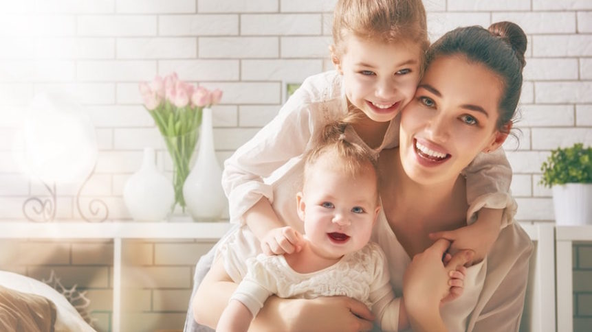

(Shapiro, 2018)

Appendix 4 – Graph illustrating number of single parent families

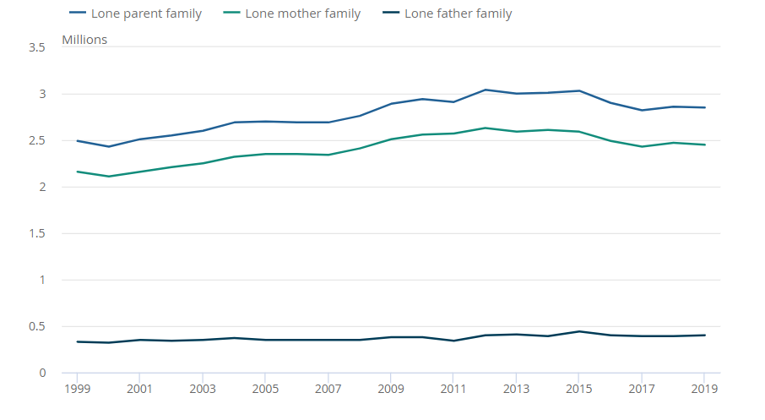
(ONS, 2019)

Appendix 5 – Image of Multigenerational Muslim family.

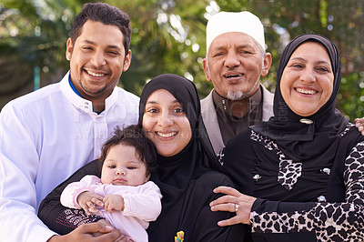

(People Images, n.d)

