Marketing plan

Name: Anisha Suleman Anwar
Student ID: 2234357
Module Title: Marketing essentials BMIH4005
Lecturer’s name: Luciana Suardi
Word count: 1202

Introduction
The definition of marketing is “the management process responsible for identifying, anticipating and satisfying customer requirements profitably”(Chartered Institute of Marketing). My marketing plan will be talking about a customer service issue within the Premier Inn hotel and how I can improve this issue with a communications strategy and other factors. I will use the 4Ps, 5C’s, Bowman’s strategy clock, and SOSTAC, an abbreviation for situation analysis, objectives, strategy, actions, and control to talk about all the different ways in which the Premier Inn hotel can improve on its issues to attract a wide range of customers including those with disabilities, ethnicities etc.
Situation Analysis
The Premier Inn is a 3-star hotel and is the UK’s largest hotel brand with over 800 hotels throughout the UK. I will be talking about the 5cs of the Premier Inn hotel and the impact they have. The first c stands for the company and this talks about the SWOT analysis. SWOT is an abbreviation of strengths, weaknesses, opportunities, and threats. The strengths of the Premier Inn hotel are that it is the UK’s largest hotel brand and that it is mostly located near airports, tourist attractions, and universities. This attracts a wide range of customers from tourists to students and to people who travel a lot. A weakness is the reviews of their customer services*. However, an opportunity for Premier Inn is that if they focus on making customers happy by developing their customer service skills, they are likely to attract more customers, increasing their sales. A threat to the Premier Inn hotel is its competitiveness with other similar hotels like Travelodge and Ibis.
The second c stands for customers and the customer profiles targeted by the Premier Inn hotel are mainly couples aged 25 – 34-year-olds at 25.93%. Premier Inn also targets families as they have a variety of different family-friendly hotels.
The third c stands for competitors, Bowman’s strategy clock is a strategy tool that provides alternatives for positioning within a market depending on price and value. Premier Inn would be placed in position 3 at hybrid which is low price and differentiation, and this attracts more customers as they know this is good value at a low price.
The fourth c stands for collaborators, Whitbread is the parent company of Premier Inn, and this provides several advantages for Premier Inn as it provides financial stability and brand recognition, etcetera for them. Premier Inn collaborates with Costa coffee to provide their customers with quality coffee and snacks, Tesco to give their customers access to other necessities through Tesco Direct, Booking.com to advertise and sell their rooms and O2 to provide their customers with 24/7 free Wi-Fi.
The fifth and last c stands for climate which is a macro analysis of the PESTLE factors and tells us about the different factors that might affect the growth of Premier Inn. The p stands for political and politically, the government regulations impact how hotels, in general, are run which means that travel bans may have a negative impact. Economically, inflation rates in the UK are high because of the high cost of living which can be very disadvantageous for Premier Inn. Socially, Premier Inn needs to improve the quality of its customer service to attract more customers and decrease the number of negative reviews. Technologically, to stay competitive and satisfy customers’ needs, Premier Inn must consistently make technology investments.
Objectives
The objective of my marketing plan is to present a solution on how Premier Inn can develop its customer service to attract more customers and increase sales. This would give Premier Inn more recognition and put them above other competitive hotels. The Smart targets would be used to make sure that the goals are specific, measurable, achievable, relevant, and time bound.
Strategy
The best way to achieve this objective would be for Premier Inn to open call centres abroad as they are cost-effective and in consideration of time zones, the call centres would be open 24/7 with alternating employees. In the call centres, it would be best for the hotel to have a time limit of 24 hours in which they respond to customers' complaints to make customers happy. A cost-effective and common country to open a call centre would be India as according to my investigations, it would cost around 50 lakhs in Indian rupees (approximately £38000-£40000, depending on the daily rates). “Aside from 24/7 customer support, it boasts cheap fees, top-of-the-line equipment, and strong English proficiency of its agents.”
Tactics
The four marketing mix areas known as the 4P’s are identified to help the hotel to improve their business. The first p is product and this is the goods or services that the business provides its customers. In numerous places around the UK and in some other countries, the hotel brand Premier Inn provides affordable lodging. Its main offering is to give both leisure and business visitors cheap, cosy rooms with premium bedding, complimentary Wi-Fi, and other essential facilities.
The second p stands for place which is the location or avenue of distribution via which the customer can get the good or service are referred to as the place. Customers can locate Premier Inn via Premier Inn’s own website or mobile app, other booking sites such as booking.com, or call their customer service to inquire about the hotel locations.
The third p stands for price, the price policy of Premier Inn is built on providing economical lodging without sacrificing quality. Premier Inn's rates are subject to vary in response to market conditions because of its flexible pricing. Customers can take advantage of their year-round promotions, specials, and discounts to save money on their reservations.
The fourth p stands for promotion, to advertise their hotels, Premier Inn use a variety of marketing strategies by advertising their hotels via Tv advertising, digital advertising, email marketing and content marketing. To reach its target audience and increase brand awareness, the hotel company uses a combination of traditional and digital platforms.
Action
The Gannt chart displays the start and end dates to show the timeline of the project and visualise any issues within the sales. They are also used to track progress and will allow Premier Inn to identify and solve any issues.
Control
The monitoring of success for the Premier Inn hotel would be controlled by analysing sales to see whether there is a positive correlation between the opening of call centres and profits. The success can also be measured by seeing if there has been an increase in customers and customer satisfaction rates. By developing their customer service, Premier Inn will be in an advantageous position for increasing profits as well as customers.
Conclusion
The conclusion of my marketing plan focuses on developing the customer service of the Premier Inn hotel to increase their sales by attracting more customers. My main recommendation to the Premier Inn hotel is for them to introduce discount schemes and loyalty cards. The loyalty cards would work for customers continuously coming to the hotels and receiving points and eventually receiving some sort of discount as their loyalty increases, this will attract more customers. Another recommendation is for Premier Inn to increase their global presence by opening more hotels abroad and opening call centres.

References
Al Badi, K.S. (2018) “The impact of marketing mix on the competitive advantage of the SME sector in the al buraimi governorate in Oman,” SAGE Open, 8(3), p. 215824401880083. Available at: https://doi.org/10.1177/2158244018800838.

Ekawati, Wayan, N. Yasa, Kerti, N N. (2018) ‘Service marketing mix strategy and service loyalty towards hotel’s success’ Global Business & Finance Review, Vol. 23 (issue 1), pp. 63-74, Available at: https://www.econstor.eu/bitstream/10419/224395/1/gbfr2018-23-1-063.pdf (Accessed 28 Feb 2023)

Epuran, G. Ivasciuc, S, I. Micu, A. (2015) ‘From 4P’s to 4E’s –‘ How to avoid the risk of unbalancing the marketing mix in today hotel businesses’. Available at: https://www.researchgate.net/profile/Ioana-Ivasciuc-2/publication/294258820_From_4P's_to_4_E's_-_How_to_Avoid_the_Risk_of_Unbalancing_the_Marketing_Mix_in_Today_Hotel_Businesses/links/56bf315508ae2f498ef7e5a5/From-4Ps-to-4-Es-How-to-Avoid-the-Risk-of-Unbalancing-the-Marketing-Mix-in-Today-Hotel-Businesses.pdf (Accessed 28 Feb 2023)

Gallimore, Darek (2023, Business.com)'Top Countries f, or Business Process Outsourcing (and How to Start)', Business.com 3rd March 2023. Available at: https://www.business.com/articles/countries-for-business-process-outsourcing/ (Accessed 3rd March 2023)

Graziano, G. (2023) Premier Inn launches sale on its new 'luxury' rooms - with stays from £30, The Sun. The Sun. Available at: https://www.thesun.co.uk/travel/21385949/premier-inn-plus-rooms-deals/ (Accessed 3rd March 2023).

Gursoy, D. Buttle, F. Bowie, D. (2022) ‘Hospitality Marketing’ 4th edn, Routledge.

Hutt, D, M. Seph,W,T. (2010) ‘Business Marketing Management’ 10th edn, South Western, Cengage Learning

Introduction to Bowman's strategy clock. Lucidity. Available at: https://getlucidity.com/strategy-resources/introduction-to-bowmans-strategy-clock/ (Accessed 6th March 2023).

Jain, K, M (2013) ‘An analysis of marketing mix: 7Ps or More’ Asian Journal of Multidisciplinary Studies, Vol 1 (issue 4), pp. 23-28, Available at: https://core.ac.uk/download/pdf/229673197.pdf (Accessed 1 March 2023)

Johnson, B. (2014) Premier Inn aims to shake up hotel advertising, Marketing Week. Marketing Week. Available at: https://www.marketingweek.com/premier-inn-aims-to-shake-up-hotel-advertising/ (Accessed: 7th March 2023).

Masterson, R. Philips,N. Pickton,D. (2021) ‘Marketing an introduction’ 5th edn, SAGE Publications.

PremierInn (2023) About us. Available at: https://www.premierinn.com/gb/en/why.html (Accessed 2nd March 2023)

Rahman, M (2022, Howandwhat) 'PESTEL analysis of Premier Inn', Howandwhat 2nd July 2022. Available at: https://www.howandwhat.net/pestel-analysis-premier-inn/ (Accessed 3rd March 2023)

Room rates: Faqs: Premier inn Room rates | Premier Inn. Available at: https://www.premierinn.com/gb/en/faq/room-rates.html (Accessed: 7th March 2023).
Similarweb. (2023) PremierInn.com. Available at: https://www.similarweb.com/website/premierinn.com/#demographic (Accessed 1st March 2023)

Trustpilot. (2023) Premier Inn. Available at: https://uk.trustpilot.com/review/www.premierinn.com (Accessed 2nd March 2023) ​

Twin, A. (2022) The 4 PS of Marketing and how to use them in your strategy, Investopedia. Investopedia. Available at: https://www.investopedia.com/terms/f/four-ps.asp (Accessed 6th March 2023).
Whitbread. (2023) Our brands. Available at: https://www.whitbread.co.uk/about-us/our-brands/ (Accessed 2nd March 2023) ​

Appendix
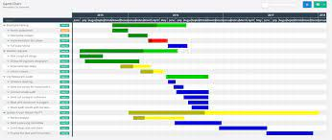
- Gannt Chart

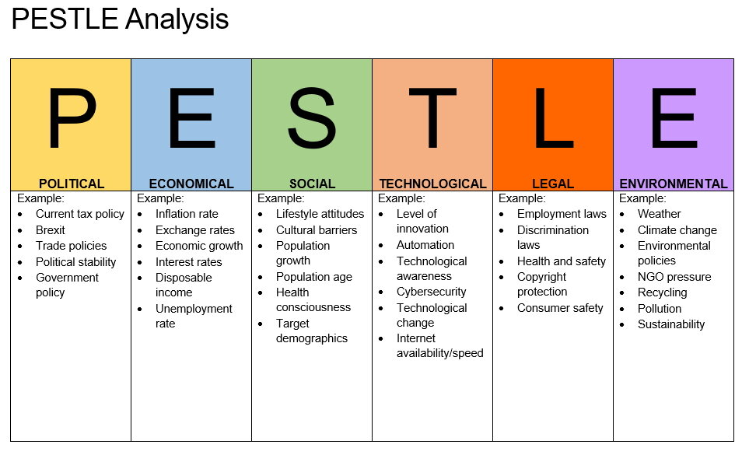
- Pestle Analysis

- Bowmans Clock


