

STUDENT NAME – PARTH KAMLESHKUMAR SUTHAR
STUDENT ID – 2434584
SUPERVISOR – MD SHANTNU ISLAM
PROGRAMME NAME – MSC DATA AND AI
ASSIGNMENT TITLE – FINAL PROJECT
MODULE CODE – ACFA7003
MODULE NAME – MASTER’S PROJECT

A Machine Learning Approach to Credit Card Fraud Detection Using Imbalanced Financial Transaction Data

Abstract-- This dissertation investigates machine learning for credit card fraud detection using the highly imbalanced ULB transaction dataset. The study evaluates Logistic Regression, Random Forest and XGBoost under three imbalance treatments: original class distribution, class weighting and SMOTE. The dataset contained 284,807 transactions, including 492 fraud cases, giving a fraud prevalence of 0.1727%. A leakage-safe workflow was implemented using stratified train-test splitting, fold-contained preprocessing, three-fold cross-validation, threshold selection and untouched test-set evaluation. Average precision was used as the primary selection metric because fraud is the rare positive class. The strongest configuration was XGB_original. At the default threshold it detected 76 of 98 test frauds with 9 false positives. Using the F2-selected threshold improved detection to 84 frauds with 24 false positives. The results show that careful metric selection and threshold selection are essential for practical fraud detection, realistic financial transaction screening and model governance decisions under extreme imbalance in banks.

Table of Contents
I. CHAPTER 1: INTRODUCTION 7
A. Background to the study 7
B. Problem statement 7
C. Research aim 8
D. Research questions 8
E. Research objectives 9
F. Scope and delimitations 9
G. Significance of the study 9
H. Dissertation structure 10
II. CHAPTER 2: LITERATURE REVIEW 13
A. Introduction 13
B. Credit card fraud detection as a learning problem 13
C. From rules to machine learning 14
D. The class-imbalance problem 14
E. Data-level approaches 16
F. Algorithm-level and ensemble approaches 17
G. Evaluation under severe imbalance 18
H. Threshold selection, probability calibration and cost 19
I. Explainability and responsible use 20
J. Concept drift, verification latency and dataset limitations 20
K. Synthesis and research gap 21
III. CHAPTER 3: METHODOLOGY 23
A. Introduction 23
B. Research philosophy and approach 23
C. Research design 23
D. Dataset selection and provenance 24
E. Data acquisition, integrity and exploratory analysis 25
F. Partitioning and leakage control 26
G. Preprocessing and feature treatment 27
H. Imbalance treatments 28
I. Model specification and tuning 28
J. Performance measures and statistical analysis 30
K. Model interpretation and error analysis 31
L. Reliability, validity and reproducibility 31
M. Ethical, legal and data-management considerations 32
IV. CHAPTER 4: IMPLEMENTATION AND RESULTS 33
A. Introduction 33
B. Implementation environment and reproducibility 34
C. Dataset source and validation 37
D. Class imbalance 40
E. Train-test split 42
F. Training-set exploratory analysis 44
G. Model configurations 49
H. Cross-validation screening 53
I. Test-set results at the default threshold 56
J. Final model selection 57
K. Threshold selection 58
L. Locked-threshold test-set results 59
M. Bootstrap confidence intervals 62
N. Calibration and interpretation 63
O. Error analysis 65
P. Summary 66
V. CHAPTER 5: DISCUSSION 67
A. Introduction 67
B. Class imbalance and the limits of accuracy 67
C. Relationship between model behaviour and prior studies 67
D. Imbalance treatment: SMOTE and class weighting 68
E. Evaluation metrics and the importance of precision-recall analysis 69
F. Threshold selection and operational trade-off 69
G. Explainability and responsible use 70
H. Overall interpretation of the findings 71
VI. CHAPTER 6: CONCLUSION, LIMITATIONS AND RECOMMENDATIONS 72
A. Introduction 72
B. Conclusions 72
C. Limitations 73
D. Recommendations for future work 73
E. Final statement 74
REFERENCES 75

I. CHAPTER 1: INTRODUCTION

A. Background to the study
Payment cards facilitate fast, frictionless commerce, and the same pace and magnitude complicate fraudulent transactions prior to a transaction being approved. The types of fraud can be stolen physical cards, stolen credentials, taking over accounts or making purchases without physical presence by means of card details obtained during phishing and data breaches. Modern payment controls have mitigated certain types of fraud, but attackers evolve in response to new authentication schemes and move their attacks to their new routes where identity and intent become more difficult to detect. According to the European Banking Authority and European Central Bank, robust customer authentication has not lost effectiveness against the types of fraud it was intended to deal with and the overall value of payment fraud in the European Economic Area had increased to EUR 4.2 billion in 2024 [1]. The United Kingdom records GBP 1.28 billion in payment-fraud losses in 2025 and remote-purchase card fraud alone in 2025 costs GBP 423.5 million [2].
These statistics put fraud detection as a technical classification task, and an ongoing business-risk problem. The conventional fraud systems involve the use of a combination of rules, experience, and authentication and human investigation. Rules can be clear and prevent known patterns but in case real behaviour is changed by customers and fraud strategies are changed then the static rules cannot work. Machine learning (ML) provides a complementary facility: the probability that a transaction is a fraud can be predicted by combinations of attributes that individually may be not very informative but jointly will be powerful. Linear models, decision trees, support-vector-machines, neural networks and anomaly-detection techniques have been applied to this problem in research [3], [4], [5]. The actual question is not whether or not ML can yield a high headline score, but whether it can detect infrequent fraud occurrences, and whether it can control false alerts, be interpretable and free of leakage evaluation.

B. Problem statement
The statistics of credit card fraud are typically highly skewed: a large number of authentic transactions about equally match the number of frauds confirmed. The best classifier that makes 99.827% predictions on the ULB dataset would be on the 492 cases of fraud, yet predicts all the legal transactions. Accuracy thus favors prediction by the majority-class and can mask total failure on the interest class. In a broader sense, imbalance alters the learning problem in that a conventional empirical-risk minimisation can provide minority cases with an undue role especially when the minority cases coincide with legitimate transactions or constitute small non-homogenous subsets [6], [7].
Practical implications of the two main mistakes are not symmetric as well. Fraud will succeed via a false negative and could lead to loss of money, investigation cost, compensation and negative publicity. False positive can refuse or postpone a real purchase, inconvenience a customer and create the cost of the reviews. Optimising recall but not precision: This may optimise the number of truly valid transactions under investigation; and maximising accuracy may forego a lot of fraud. A practical detector would need to trade off, instead of optimise, a single context-free measure.
Published research tends to give high results with balancing of the entire dataset, based on accuracy, or random split without explicit separating between resampling, tuning and final evaluation. Oversampling followed by cross-validation could inform the training process with information based on the validation observations, and this can result in optimistic estimates [8]. They can likewise make unfair comparisons when each model is given a dissimilar split or assessment threshold. These issues are tackled in this dissertation by an experimental design that is common, leakage-safe, and by an untouched test set.

C. Research aim
This research explores the creation of a repeatable machine learning strategy to discover and critically analyze credit card fraud detection with severely imbalanced transaction facts, especially minority-class detection, false-positive correcting, threshold selection and model interpretability.

D. Research questions
- How effectively do Logistic Regression, Random Forest and XGBoost detect fraud when trained on the original imbalanced transaction distribution?
- To what extent do class weighting and SMOTE change PR-AUC, fraud recall, precision, F1-score and Matthew’s correlation coefficient for the selected classifiers?
- Which model-and-treatment combination provides the best results between detecting fraud and limiting false positives under alternative error-cost scenarios?
- Which anonymised transaction features most strongly influence the predictions of the selected model, as assessed using SHAP?

E. Research objectives
- To examine the structure, quality and degree of class imbalance in the ULB credit card transaction dataset.
- To implement reproducible Python pipelines for Logistic Regression, Random Forest and XGBoost.
- To compare unchanged class distributions with class weighting and SMOTE under a common cross-validation and test protocol.
- To evaluate models primarily using PR-AUC and additionally using recall, precision, F1-score, MCC, ROC-AUC and confusion matrices.

F. Scope and delimitations
The scope of the empirical research is binary, supervised classification based on the publicly available ULB dataset on Kaggle [9]. The data include card transactions of European cardholders in two days in September 2013. The predictors include Time, Amount and 28 anonymised principal components (V1 to V28); Class is a binary outcome. There are no names, card numbers, merchant identifiers or demographics variables. Python and pandas, NumPy, scikit-learn, imbalanced-learn, XGBoost, Matplotlib, Seaborn and SHAP will be used in the study.
The project makes comparisons among known tabular classifiers instead of creating a deep neural network. There are model transaction rows in the data but no identifiable public cardholder column nor sequence format, which limits realistic behaviour aggregation and recurrent modeling. Linear, bagging and boosting methods are more easily interpretable and computationally feasible to compare on a controlled basis when it comes to a master project. The work is an offline benchmark, not a production system of payment-authorisation; it will not purport real-time responsiveness, real-time adaptation of the concept-drift prevention or, real-time loss prevention. External validity is also restrained by the short, historical, anonymised nature of the data. These constraints are explicitly addressed rather than being covered by high tests ledgers.

G. Significance of the study
Methodologically, it maintains the original prevalence of classes in the test set, retains SMOTE in training folds and reports metrics that reveal minority-class behaviour. This is in reaction to findings that PR analysis is more informative than ROC analysis when there are more negatives than positives [10] and the four cells of the confusion-matrix are to all be taken into consideration in imbalanced classification [11]. The comparison of the identical algorithms under identical imbalance treatments isolates whether an apparent enhancement is due to the classifier or is a result of the sampling strategy or the decision threshold.
In practice, the design takes into consideration the fact that it is only after transformation into action that a fraud score will be useful. The threshold and cost-scenario analysis will demonstrate how a technically good ranking model could lead to various operational results. The presence of both a clear Logistic Regression base, and SHAP clarifications of the chosen complicated model is as well a response to the conflict between forecast capability and responsible decision support. This is relevant when there are automated judgements that have a profound impact on people and human judgment might be needed [12].
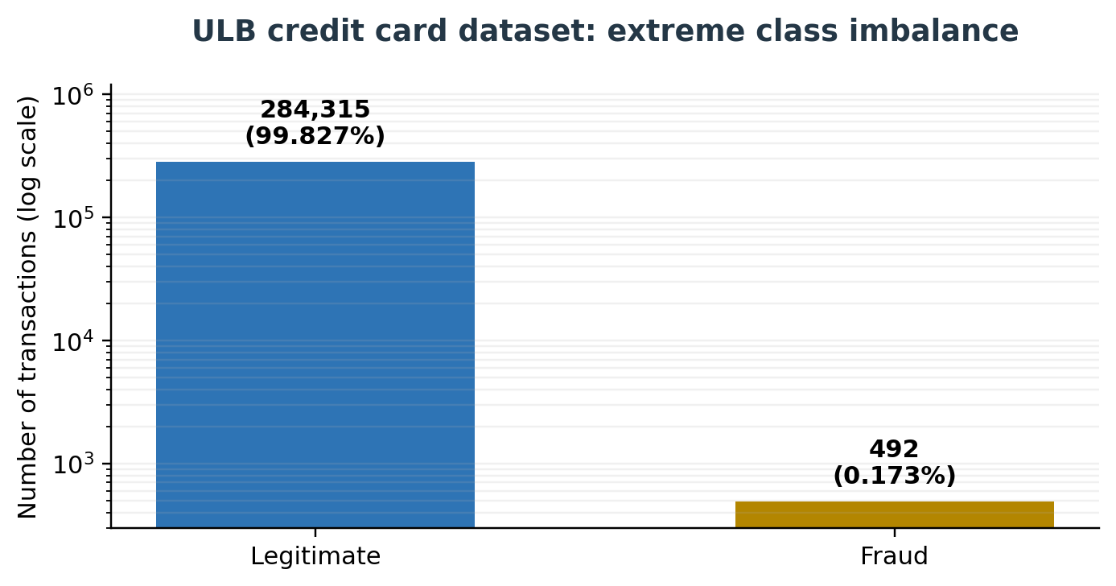
Figure 1: Class distribution in the ULB credit card fraud dataset (logarithmic scale)
(Self-Developed)
Figure 1 plots the extent of the chosen benchmark. The almost-invincible aspect in a conventional linear plot would be to have the fraud bar to be invisible, so the logarithmic scale reveals the classes at the expense of being able to reveal the approximately 578:1 imbalance. The figure is a description of the entire data set and is not an experimental outcome.

H. Dissertation structure
Table 1: Dissertation Structure Table
Chapter | Chapter name | Focus
Chapter 1 | Introduction | Introduces the research problem, aim, research questions, objectives, scope and importance of the study.
Chapter 2 | Literature Review | Critically evaluates literature on fraud detection, imbalanced learning, candidate algorithms, evaluation metrics, thresholding, explainability and methodological gaps.
Chapter 3 | Methodology | Defines the quantitative experimental design, data preparation, leakage controls, model selection, hyperparameter approach, evaluation strategy, ethics and reproducibility arrangements.
Chapter 4 | Implementation and Results | Presents the implementation and results of the fraud-detection experiment.
Chapter 5 | Discussion | Discusses the findings in relation to the literature reviewed in Chapter 2.
Chapter 6 | Conclusion, Limitations and Recommendations | Presents the study conclusions, limitations and recommendations for future work.

II. CHAPTER 2: LITERATURE REVIEW

A. Introduction
The chapter places the current experiment under breadth of literature concerning the detection of financial fraud and imbalanced classification. It lays greater emphasis on the peer-reviewed literature and also relies only with the official industry or regulation evidence in the context of identifying the problem. The review is structured in terms of decisions that the research questions require, how the notion of fraud is contrasted with normal classification, how imbalance can be handled, which models can constitute a defensible comparison, how the notion of performance should be measured, and what methodological validity and interpretability should be controlled.

B. Credit card fraud detection as a learning problem
Fraud detection involves a combination of classification, decision-making and ranking. Supervised classification This method estimates a mapping between transaction features (Features) and Class using historical transactions that were correctly labeled. In ranking, cases are ranked in descending order of risk allowing investigators to view the riskiest of cases. Within decision-making, a probability or score is matched to a threshold that initiates a decline, authentication or manual review. These are not equal tasks to treat these two as and this is why some confusion can occur where a model can rank transactions well yet make poor decision at a default threshold of 0.5 particularly where the size of the prior class used to train the model is very small, or where it was scaled during training.
It identifies three interrelated difficulties in operational credit card fraud detection: class imbalance, concept drift and verification latency [13]. Class imbalance This implies that the learning is numerically dominated by legitimate transactions. The concept drift is due to the fact that the behaviour of the customers, the payment channels and the strategies used by attackers evolve with the time. The latency of verification is due to the unavailability of labels instantly; not all of the alerts are immediately investigated, but while chargebacks might take some time to be visible. These attributes make the operational fraud detection different to the case of a textbook classification task.
The ULB data gives a convenient benchmark since they maintain extreme imbalance and acquired in actual transaction activity. It includes just two days and provides final binary label, excludes cardholder, devices, merchant and geographic identifiers. Consequently, it aids in controlled comparisons of classifiers, but does not function to fully evaluate delayed labels, customer level behaviour or long-term drift. This difference is important since contribution to a publicly agreed benchmark should not be delivered as an indicator of readiness to deploy.

C. From rules to machine learning
Rule-based systems can still be helpful in situations where the fraud patterns are familiar and a decision should be reported straight. Examples are velocity limit, impossible travel, uncharacteristic transaction value/ repeated failed authentication. They are weak: rules need to be revised, interrelating rules are hard to keep, thresholds discouraging fraud can also block valid purchases. ML is able to determine nonlinear and multivariate relationships without programming each pattern explicitly. In the systematic reviews, systematic use of supervised ML is thus reported, as well as ensemble models and, more and more, deep learning in card-fraud studies [3], [14], [5].
However, more complicated models do not necessarily alleviate the constraining factors. The model trained on an artificially balanced dataset can be poorly calibrated; the small number of fraud observations can be overfitted by a deep model, and can yield an operationally meaningless result based on accuracy. Studies demonstrate, there exists up-to-date literature covering sampling, feature selection, metaheuristics, ensembles and neural architecture, yet due to such methodological variety, the comparison becomes challenging [5]. Some studies are also giving special priority to privacy in that realistic financial characteristics are confidential and not easily pledged [4]. Public datasets thus promote reproducibility but reduce the space of features.
Three different learning biases (in respect to the current research) are Logistic Regression, Random Forest and XGBoost. Logistic Regression offers regularised linear and relatively transparent base. TheRandom Forest tests bagged nonlinear trees that are able to model interactions and are relatively scale independent. XGBoost tests sequential gradient-boosted trees explicitly regularised and with weighted classes. That comparison has deliberated limits; more algorithms would be included, at least without causing corresponding insight improvements.

D. The class-imbalance problem
The imbalance on the classes is not just the disparity in numbers. The effect of it varies based on the overlap between classes, noise in labels, sample size, and the distribution of the minority sub-concepts and the loss functional of the algorithm [7], [15]. On average, every minority example has a significant impact with 492 cases of fraud. In case a few of them are noisy or isolated, then the noise can be magnified by the oversampling. Frauds can supplant legitimate observations to delineate their extent, so that random undersampling can eliminate evidence of them, particularly when they occupy multiple small patches of feature space. Hence, there is no balancing method which can be thinkable to enhance all the classifiers.
The overall error reduction criterion optimised by an unweighted learner can give inequitable preference to the majority class since the overall loss can be minimised by classifying more legitimate cases than fraud cases. This is why such behaviour makes the issue of accuracy particularly worrisome. However, the apparent prior probability of fraud also shifts with balancing to 50:50. A model is a classifier that has been trained on that distribution, it might produce scores that can be helpful at ranking but not calibrated to the actual prevalence. The under sampling alters the class priors and leads to biases in posterior probabilities unless there is the corrective recalibration [16]. The same broad warning applies to the case of synthetic oversampling of the training distribution.
The literature divides solutions to imbalance into data, algorithm level and decision solutions. The data-level approaches modify the training observations by oversampling, undersampling or combining both cleaning. The loss is modified by algorithm-level means by the use of class or instance weights. Decision-level methods store the trained scores, but modify the threshold or action rule. The levels are complimentary. This experiment hence compares a data-level approach (SMOTE) to one algorithm-level approach (class weighting) and performing threshold selection based on validation following training.
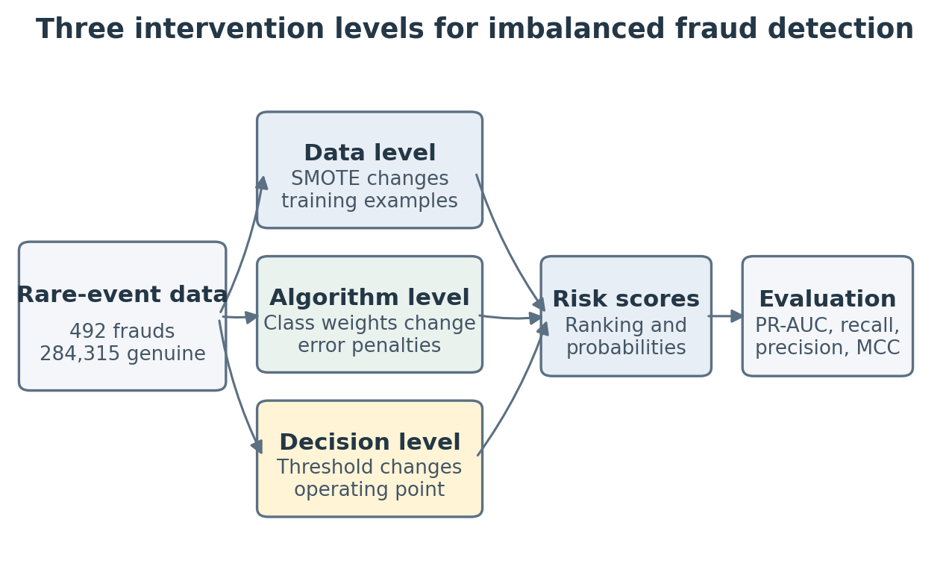
Figure 2: Data-, algorithm- and decision-level responses to class imbalance.
(Source: Self-Developed)

E. Data-level approaches
Random oversampling repetitions contain minority observations. It is easy and retains observed instances, yet replications do not provide new data and can promote overfitting. Random under sampling minimizes training time and majority dominance, but eliminates potentially useful legitimate transactions. Under severe oversampling like in 284,315 valid observations compared to 492 frauds, the majority could be eliminated by aggressive under sampling over 99%. This can simplify the boundary at the expense of false positives and wildly swinging probability estimates.
SMOTE is a technique that generates synthetic samples of minority by interpolating a minority observation with a few chosen minority neighbours [17]. Its power lies in the fact that it does not precisely duplicate the minority areas. Its weakness is also significant: the procedure presupposes that the interpolation between neighbours is a plausible assumption. Synthetic points may blur the boundary where there is an area of minority and minority; when the minority examples are data outliers, SMOTE can propagate noise areas. Generation improve via distance is also sensitive to feature scale, thus fold-specific scaling is a required step in the pipeline.
Empirical studies of fraud often claim better results with SMOTE or hybrid sampling, although the results are not consistent. The balancing methods on unbalanced card data and demonstrate that there is an interaction between resampling and classifier [18]. SMOTE use in combination with AdaBoost and show that imbalance remedy can lead to a significant change in detection measures [19]. More current literature discusses feature selection, clustering and ensemble combinations of severe imbalance [20], [21]. The performance on a resampled validation set, however, is not an indication of how it will perform at the natural fraud rate.
The current experiment restricts data level treatment to conventional SMOTE, not due to its universal superiority but simply because it exists and can be identified by an imbalanced-learn and interpreted with solid interpretability to provide a controlled baseline. It will be used in only one training fold. There will be no additional resampling of the hold-out test set. It is a design that approximates the performance in a distribution to which the model is supposed to perform and avoids the synthetic points that arise due to information either in validation or tests.

F. Algorithm-level and ensemble approaches
Class weighting amplifies the loss incurred on fraud observations that were incorrectly classified, but leaves the data unchanged. Balanced weights in scikit-learn are directly proportional to the class frequencies: XGBoost has a similar feature named scale-pos-weight. The weighting retains all observations and does not create artificial transactions which is desirable when there is a limited number of cases of frauds or when the frauds are noisy. A big weight, however, can cause the decision boundary to be sensitive to minority cases. The weight is instead to be adjusted within cross-validation instead of being accepted in automatically optimal form.
The Logistic Regression is a linear combination model of predictors that estimate the log-odds of fraud. Its coefficients give guidance and relative power, which is complicated by the fact that V1-V28 are hidden elements not business concepts. Variance and multicollinearity can be controlled by regularisation. A linear decision surface is the primary limitation unless explicitly designed interactions or transformations. It is a critical foundation since a multifaceted model must show appreciable advantage over a transparent substitute, but not just result better than an unsophisticated or untuned competitor.
Random Forest builds large numbers of bootstrap-selected trees based on different random selections of features, then averages their outputs [22]. Bagging minimizes the variation of single trees and in the process, nonlinear interactions without prior specification can be realized. A forest is relatively insensitive to monotonic scaling as well as using class weights. However extreme imbalance might include only a small number of minority cases in bootstrap samples and impurity-based importance is deceptive. The deepening of depth can accommodate rare observations without giving rise to stable generalisation. Tuning is concerned then with the number of trees, tree depth, smallest leaf size, feature sampling and feature weight.
XGBoost constructs the trees one after the other, such that each step attempts to fill in scraps of previous-ensemble error, and complexity is curbed with regularisation, shrinkage and subsampling [23]. It is convenient with a tabular data and can be weighted using positive-class. Boosting can put a lot of emphasis on hard minority cases, yet frauds mislabeled or noisy can be a topic of interest as well. This flexibility results in a bigger hyperparameter space and increases the chances of optimistic tuning. Cross-validation randomised search is more justifiable than setting selection on the final test set.
There is a tendency in the literature on fraud to report good ensemble performance. Some studies use a combination of several learners and the comparison of Logistic Regression, Decision Tree and Random Forest in supervised fraud prediction [24][21]. Some literature also pays special attention to the imbalanced and overlapping credit cards classes [25]. These studies justify inclusion of ensembles, and do not achieve a generally widely winning model, since datasets, prevalence, validation protocols and metrics are different. This dissertation thus considers the superiority of models as an empirical question by a fixed protocol.

G. Evaluation under severe imbalance
The process of evaluation starts with confusion matrix: false positives are frauds that were rightfully identified; false negatives are the missed frauds; false positives are the legit transactions that were mistakenly identified, and true negatives are the valid transactions that were rightfully identified. Recall or sensitivity, TP/(TP+FN), is the percentage of fraud that was detected. Precision, TP/(TP+FP) is an indicator that shows the ratio of real alerts. F1 is their harmonic mean. The coverage of loss-prevention is explained by the term recall in fraud operations, which is the indicator of alert burden, whereas the real cost depends not only on the value of transactions and the ability to review them but also on the type of fraud operations.
ROC-AUC estimates the ranking based on both true-positive and false-positive. It is still viable in case of discrimination, although a low false-negative rate may tantamount to high number of false alarms when there is high quantity of valid transactions. Precision-recall curves concentrate on the positive class and vary according to prevalence. It is known that imbalanced binary tasks using PR plots are more informative than ROC plots [10]. To this end, the only metric to consider is PR-AUC (used as an average precision to select the model) and ROC-AUC has been kept to ensure that the metrics can be compared.
The cells of the confusion-matrix are added together in MCC, and the best classification (the top left cell) is 1, then that follows 0 that has no better performance than is expected of chance association, and finally, -1 that has no connection at all. MCC is more informative than accuracy and F1 in most imbalanced environments due to the fact that it necessitates a balance of performance both on positive and negative cases [11]. There is not a single measure that suffices, however. A model might have high PR-AUC and generate bad decisions at the desired threshold; concurrently, a threshold tuning may enhance the value of a specific F-score without altering the underlying ranking. There will thus be a reporting of threshold-independent curves as well as threshold-dependent confusion matrices in the dissertation.
The confidences and variability are also important since there are just 492 cases which are positive. The mean and the standard deviation will be used to summarise cross-validation scores. In the last test set, non-parametric bootstrap confidence intervals will be generated on key measures where it is computationally possible. The comparisons will be based on the magnitude and consistency of differences, not exclusively on the maximum point estimate estimate.

H. Threshold selection, probability calibration and cost
The operationally justified default probability threshold of 0.5 is a conventional and not operationally justified default probability threshold. Having a small error cost and an unbalanced error likelihood, a smaller threshold will report more frauds but with higher number of false alerts. The threshold selection should be done on the validation predictions, as thresholding of the test set would make the test set a tuning resource. This analysis will obtain out-of-fold training probability, will choose thresholds based on an F2 objective which places greater emphasis on recall than on precision and will compute false-negative to false-positive ratios of 10:1, 50:1 and 100:1 expected costs individually. It is better to use a scenario analysis than creating a one-secret banking cost [26].
Even with ranking that increases, sampling and weighting of classes can bias probability estimates. As the secondary diagnostics [6], the Brier score and the calibration plots, will be checked. In case the chosen model is fit materially poorly, we will fit sigmoid calibration only with training data and will test on the untouched test set. Calibration will not be permitted to cover-up bad discrimination; it is another decision quality measure.

I. Explainability and responsible use
Complex fraud models have impacts on customers, investigators and financial institutions. Global feature importance may be used to determine variables that the model is using, and local explanation may be used to explain why a transaction was highly scored. SHAP attributes the additive contributions of features using a game-theoretic model and provides coherent local and global summaries [27]. It applies to tree collections and will be used on the untouched test prediction of the model of choice. Interpretability is constrained by anonymization and it is possible that a discovery that V14 has high SHAP magnitude is technically reproducible but cannot be mapped to a customer or merchant behaviour, without the original feature mapping. SHAP explains model behaviour as well as causal fraud mechanisms, and correlated predictors may apportion importance non-uniquely. The analysis will thus not involve the use of causal terms and will match world summaries with arbitrary true-positive, false-positive and false-negative cases.
Human responsibility involves human monitoring and challenge. According to European data-protection guidance, people are usually not supposed to receive only automated decisions with no legal or other similarly important consequences, unless there are specified exceptions and protections [12]. The anonymous secondary data employed in this dissertation is the data that is not connected to a particular individual, and no conclusion is reached regarding whether this particular person has been deployed or not, but the discussion on deployments is going to draw a line of decision support and an entirely automated decline.

J. Concept drift, verification latency and dataset limitations
They are based on the assumption that training and test observations have been obtained based on a sufficiently similar distribution, which is known as static random validation. This assumption is violated by fraud when behaviours change. Many literatures study demonstrates concept drift and delayed verification as core in realistic modelling and show the importance of transaction sequences in the presence of customer histories [13] [28]. Setting one cannot be completely replicated in the ULB public file: its two-day horizon is too short to drift long-term, and anonymous rows cannot be clustered as reliably by a cardholder. A chronological split can be more deployment like than a random split in the sense that it is trained on earlier transactions and tested on later, transactions. However, the short time span and highly skewed positive of the dataset imply that fraud counts might be unreliable or under representative when there is just one chronological boundary.
The main analysis will be based, thus, on a stratified random holdout to provide a stable benchmark but the chronological analysis of sensitivity will be tested and disclosed transparently in case both partitions have sufficient fraud cases. This is a trade-off between operational realism and reproducibility, and does not imply that the benchmark is live data. Reuse of datasets is also prone to overfitting benches at the research-community level: models and pre-processing options might have been fit repeatedly to the identical 2013 file. The anonymised PCA-based features guarantee the confidentiality but limit domain-based feature engineering, examinations into fairness, and clarifications. These boundaries encourage claims that are conservative and make it impossible to extrapolate a limited amount of data to all issuers, regions, or forms of frauds.

K. Synthesis and research gap
What the literature confirms is that detecting imbalance-aware fraud needs more than just selecting an effective classifier. SMOTE is capable of fortifying minority representation at the expense of generating ambiguous or noisy instances; weighting maintains the data at the expense of emphasising rare instances; ensemble learners confine the nonlinearity but must be carefully tuned and explain. PR-AUC, recall, precision, and MCC are a few of the aspects of performance, whereas threshold selection converts scores into action-based operations. Public benchmarks and deployment: concept drift, delayed labels and privacy further decouple public benchmarks and deployment. This study is defined by three gaps that are recurring. First, there is always a number of factors that vary in published comparisons, it is not clear whether the performance differences are due to the model, the imbalance treatment, split or threshold. Second, resampling may not necessarily be incorporated within cross-validation which poses leakage. Third, accuracy or ROC-AUC of the headlines can be stressed, but the natural prevalence of alert volume and cost sensitivity may not be displayed.
Recent reviews have recommended more extensive, more systematic assessment and focus on privacy and explainability [3], [4],[5]. The suggested contribution is not an original algorithm but an attainable and repeatable comparison. All the classifiers will be tested using the identical data partitions and imbalance strategies. Resampling, scaling and tuning will only be limited to the training folds, the final prevalence in the tests will be unaltered. The PR-AUC will be used to select the model, though, the conclusion will be made based on the consideration of the recall of fraud, precision, MCC, calibration, falsely alerted numbers and cost situations. The importance of SHAP will be to assess the capacity of the strongest model to be elucidated within the bounds of the anonymous PCA properties. This congruency links the research questions with the design outlined in Chapter 3.

III. CHAPTER 3: METHODOLOGY

A. Introduction
In this chapter, the way the research questions will be addressed is defined. It explains the philosophical stand, data experiment design, dataset, pre-processing, model pipelines, imbalance interventions, validation, performance evaluation, explainability, ethics and reproducibility controls. Separation is the key principle of design: exploratory analysis should come before modelling, the test set should not be changed, and all modifications learned on data should be applied only to training observations.

B. Research philosophy and approach
The research takes a post-positivist quantitative stance. Model performance is seen as being quantifiable in terms of the observable prediction results, and it is realised that performance depends on the data, labels, split, metric and cost models. The significance of this qualification is that only one benchmark cannot be used to uncover a universal best fraud detector. It is not assumed in the study that XGBoost or SMOTE has to win. Outcomes with no enhancement, unsteadiness among folds or massive false-positive load will be categorized as substantive outcomes.

C. Research design
The research is a secondary-data, computer-based controlled study. The explicit variables include family of the classifier and imbalance treatment. The classifier factor consists of Logistic Regression, Random Forest and XGBoost. The imbalance-treatment factor encompasses the initial imbalanced distribution, the weighting of classes and SMOTE. This yields nine scheduled setups tested using the same train-test split, cross-validation strategy and performance indicators.
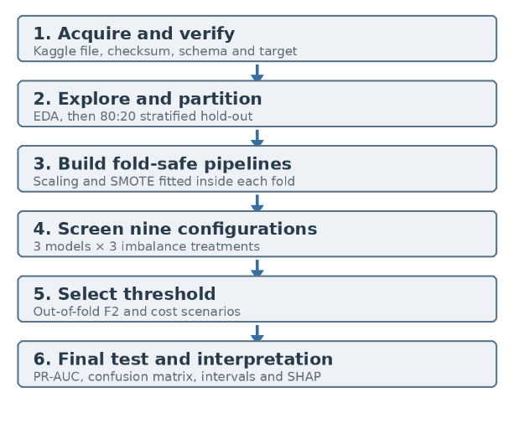
Figure 3: Proposed experimental workflow
(Source: Self-Developed)
Due to the large size of the dataset (284,807 transactions) and the computational cost of the full hyperparameter search over all nine configurations, the implementation follows a two-stage modelling strategy. First, all configurations are screened using stratified cross-validation with fixed, literature-informed baseline hyperparameters. Second, the best structure is taken to the threshold selection, cost-scenario analysis, test-set evaluation and interpretation. This maintains the controlled comparison as far as allowing the experiment to be reproducible and computable.

D. Dataset selection and provenance
The chosen dataset is creditcard.csv which was released by the machine learning group of ULBS and is distributed over Kaggle. It documents 284,807 transactions being undertaken by European cardholders in September 2013 where 492 were said to be frauds and 284,315 were genuine transactions [9]. It has a fraud prevalence of 0.1727 % (492/284,807) and the majority-minority ratio is about 578:1.
The dataset is appropriate, as it is large enough to be used with conventional ML but has a realistic ratio of rare events, a binary target, and is also widely used, making it possible to compare it with previous studies. On standard hardware, it can also be computationally managed in Python. Its shortcomings are also material: the usability of the observation window is confined to two days; the majority of predictors are anonymous; the information is historical; the labels cannot be audited independently; and the absence of entity key-supported validation of the cardholders. Threats to validity will be noted in these constraints.
Data dictionary
Table 2: Data dictionary for the selected ULB dataset
Field | Role/type | Description | Planned treatment
Time | Predictor / numeric | Seconds elapsed since the first transaction in the file. | Scale within training folds.
Amount | Predictor / numeric | Transaction value; potentially right-skewed. | Describe robustly and scale within folds.
V1-V28 | Predictors / numeric | Anonymised principal components supplied by the data owner. | Retain; standardise where required by pipeline.
Class | Target / binary | 0 = legitimate; 1 = fraudulent. | Separate before preprocessing; preserve test prevalence.
They do not have their original semantics and pre-processing parameters. Time is the number of seconds taken between files in terms of transaction and the first transaction and Amount is the amount of the transaction. Class=1 indicates fraud and immediately after the validation, the target will be saved separately in which predictors will be made.

E. Data acquisition, integrity and exploratory analysis
The data is downloaded from the Kaggle and retained unchanged in a read-only data/raw directory. A checksum of SHA-256 will be written, which will be used to confirm identity at the level of every single byte in a future run. The Python script will claim the anticipated 284,807 rows, 31 columns, column names, numeric dtypes, binary target values, and counts of classes. Duplicate rows, missing values, infinite values and implausible target codes would be reported prior to an alteration. Precise replicas will not be deleted automatically since separate legitimate transactions might have the same anonymised properties; their impact will be recorded in a sensitivity check.
Expositional analysis will cover their frequency and prevalence of classes, descriptive statistics, distributions of Time and Amount to classes, the robust summaries of skewed values, pairwise correlations, and univariate comparisons of skewness anonymised components. Visualisations are descriptive and will be generated prior to model claims. The training partition will be inspected by a detailed feature inspection to avoid informal test-set tuning; all schema and basic schema and count validation will be done with the entire file.

F. Partitioning and leakage control
The data will be partitioned once into 80% training data and 20% final test data using train_test_split with stratification. This should send about 394 cases of fraud to the development set and 98 cases of fraud to the final test set. The test set will maintain the natural prevalence of fraud and there will be no feature selection, resampling, model screening, calibration choice or threshold tuning. In the development partition, three-fold StratifiedKFold cross-validation with shuffling and a fixed seed will be employed. A decision of three folds is chosen as a balanced trade-off based on the fact that computing (284,807) transactions and rerun the modelling is not as cheap. The folds will be placed uniformly on all model configurations to enable equal comparison. Scikit-learn or imbalanced-learn pipelines will have all learned pre-processing. Hence, scaling will only be adapted on the training part of each fold, and SMOTE will only produce synthetic samples based on the observations of the training part of each specific fold.
This avoids the false hope of having the over sampling prior to cross-validation [8]. Group-aware splitting is not possible because the dataset does not include cardholder identifiers. Chronological sensitivity check A chronological sensitivity check will sort the observations with Time, assigning earlier ones to training and later ones to testing, and checking counts of positive-classes prior to interpretation. This will be indicated as a robustness check as opposed to ranking models. In case any of the chronological partitions has fewer than enough instances of fraud to be defensibly inferred, it will be indicated but not used to structure the model comparison.
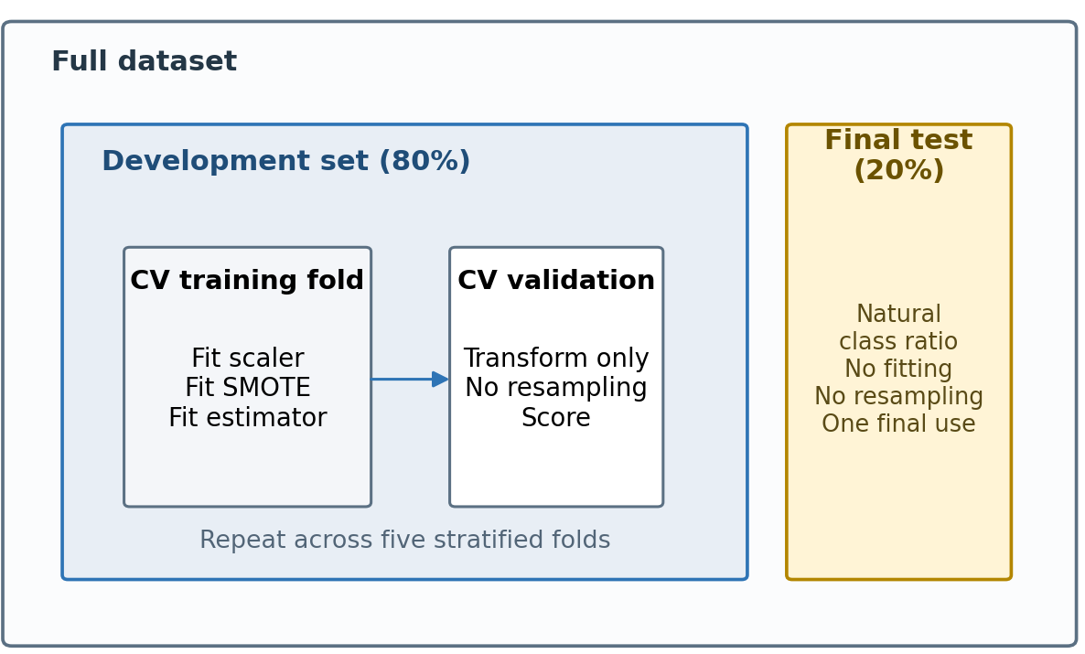
Figure 4: Leakage-safe partitioning and fold-contained preprocessing
(Self-Developed)

G. Preprocessing and feature treatment
There is no need to imply categorical encoding and text processing since all predictors are numeric. In case of missing values, median imputation learned in each training fold will be applied and the difference between the source description reported. In the case of Logistic Regression, each of the predictors will be standardised within folds. Scaling SMOTE configurations: Smoothing Each neighbour-based synthesis will be performed prior to scaling to avoid large numeric ranges dominating distance. The process to select splits does not need scaling in tree estimators but the same scaling before SMOTE will be applied where synthetic samples will be created; non-SMOTE tree pipelines will be left with original numeric data. The transformations are specific to the pipelines, and they are not performed on the entire dataset.
There will be no further PCA fitting since 28 variables are already principal components and the original feature space is not available. There are no domain-based features that can be built such as customer velocity, merchant risk or geographical distance. Removal of exploratory features will not occur unless a reported bottleneck of zero-variance or data-quality issue is identified. This minimizes degrees of freedom on the part of the researcher, and maintains comparability.

H. Imbalance treatments
The data provided to the models will consist of the same fold training and no per-class penalty. Balanced or tuned class weights will then be fitted to Logistic Regression and Random Forest. In the case of XGBoost, scale_pos weight is searched within the range of negative to positive ratio during training of the fold but not with a complete dataset. The sampling ratio and the number of neighbours will be set in a conservative manner. A conservative SMOTE setting was used, with sampling_strategy = 0.10 and k_neighbors = 5. This increased the representation of fraud cases during training without forcing a full 1:1 class balance. This setting was chosen to reduce class imbalance while avoiding the creation of an unrealistically large number of synthetic fraud transactions. The experiment will not have SMOTE and class weighting implied on the primary matrix since this will blur the attribution, and widen the search space; a joint treatment may be standard in the future.
SMOTE Resampling Strategy
The dataset was highly imbalanced, with a much larger number of legitimate transactions than fraud transactions. In order to address this issue, SMOTE resampling was applied in the machine-learning pipeline. SMOTE was used in the LR_SMOTE, RF_SMOTE and XGB_SMOTE configurations. Resampling was applied only to the training data and not to the final test set. This was to prevent leakage of data as well as make the final evaluation realistic. If the full dataset had been balanced before splitting, synthetic fraud examples could have influenced the test data and produced over-optimistic results.
A conservative SMOTE ratio of sampling_strategy = 0.10 was used. This increased the number of fraud examples during training without forcing a full 50:50 balance. Therefore, the models were trained with improved minority-class representation while the final test results still reflected real fraud-detection conditions.

I. Model specification and tuning
Table 3: Principal experimental matrix
Classifier | Original distribution | Class weighting | SMOTE
Logistic Regression | Unweighted L2 baseline | Class-weighted L2 model | Fold-contained synthetic sampling
Random Forest | Constrained bootstrap forest | Class-weighted constrained forest | Fold-contained synthetic sampling
XGBoost | Unweighted boosted trees | Boosted trees using scale_pos_weight | Fold-contained synthetic sampling

Logistic Regression will maintain L2 regularisation, and standardisation will be within the pipeline. The original condition will give a transparent baseline which is unweighted and create the weighted condition which will penalize the misclassified fraud observations. Synthetic oversampling will only be used during the training folds in the SMOTE condition before fitness the model. Random Forest will be used as a nonlinear bagging-based comparator. Because repeated fitting on 284,807 transactions is computationally expensive, constrained baseline settings will be used, including a limited number of trees, restricted depth, minimum leaf-size control, square-root feature sampling and bootstrap subsampling. Class weighting will be used in the weighted condition and fold-contained oversampling will be done in the SMOTE condition. XGBoost will be used as a regularised boosting-based comparator for tabular data. The original will take scale pos weight=1, the weighted will take the scale pos weight based on the legitimate to fraud ratio in the training partition. The SMOTE condition shall also adopt the scale_pos_weight=1 to distinguish sampling effects and algorithm-level weighting.
Full randomised hyperparameter optimisation across all nine configurations was not used because of computational cost. Rather, fixed, literature-optimized and computationally-limited baseline environments allow a reproducible comparison. None of it is based on early stopping; model comparison involves the stratified cross-validation with fixed estimator limits. The most common comparative measure is average precision and ROC-AUC, recall, precision and F1 are used to interpret the results. Reproducibility is facilitated by fixed random seeds and exported version of packages.

J. Performance measures and statistical analysis
Table 4: Evaluation measures and their role in the study
Measure | Definition / focus | Role
PR-AUC / average precision | Precision-recall ranking across thresholds | Primary comparison measure for the rare fraud class
Recall | TP / (TP + FN) | Fraction of fraud cases detected
Precision | TP / (TP + FP) | Fraction of fraud alerts that are correct; indicates alert burden
F1 and F2 | Harmonic precision-recall summaries | F1 reports balance; F2 supports recall-oriented threshold selection
MCC | Correlation using TP, TN, FP and FN | Balanced threshold-dependent summary under severe imbalance
ROC-AUC | TPR-FPR ranking across thresholds | Secondary comparison with prior literature; not sufficient alone
Expected cost | C_FN × FN + C_FP × FP | Scenario analysis at 10:1, 50:1 and 100:1 error-cost ratios

Average precision / PR-AUC will be used as the primary comparison measure because it focuses on precision-recall performance for the rare positive class. Thresholds dependent performance will be characterized by recall, F1, F2, MCC, balance accuracy, and counts of a confusion-matrix as discussed before. ROC-AUC will be retained as a point of comparison with previous literature and the accuracy will be reported as a warning context measure but not as means of comparison of the model. Three-fold stratified cross-validation will be used in the development partition, and results will be presented as mean and standard deviation across folds. Since the data set size of cases of fraud is small, and the number of folds is limited, analysis will focus on practical differences in the average precision and recall, precision, MCC and false-positive burden instead of formal testing of significance. If the prediction of key metrics on the locked test-set is computationally feasible, bootstrap confidence intervals will be computed using the locked test-set predictions.
Out-of-fold development probabilities from the selected configuration will support threshold tuning. One threshold will maximise F2, giving more weight to recall, while additional cost-based thresholds will be identified using false-negative to false-positive cost ratios of 10:1, 50:1 and 100:1. These locked thresholds will then be applied once to the untouched test set, and results will report frauds detected, frauds missed and legitimate transactions flagged.

K. Model interpretation and error analysis
A plot of a global summary will rank features based on mean absolute SHAP values and indicate whether high or low feature values drive predictions towards fraud. Dependency diagrams will be reduced to the most significant variables to prevent over exploration. Corresponding baseline explanation will be given by the logistic Regression coefficients, where they are standardised.
Local explanations will be examined for a small, predefined set of test cases: correctly detected frauds, missed frauds, high-confidence false positives and borderline genuine transactions. The analysis will involve comparing features contributions against any predicted score but will not draw conclusions as to causality or the reconstruction of the otherwise unobtrusive significance of PCA components. The analysis of errors will also be conducted comparatively regarding the value of transactions and the time positions between the confusion-matrix groups to find systematic weaknesses.

L. Reliability, validity and reproducibility
Internal validity will be protected through an untouched test set, fold-contained transformations, identical cross-validation folds, fixed seeds and a prespecified primary metric. Construct validity is still thus limited since Class is the verified label of the manager of the dataset as to fraud, costs and usefulness to investigation are approximated through measures and situations. The limitation to external validity occurs through the two-day European sample, historical date of collection and anonymous characteristics. The fold variability and bootstrap intervals will contribute to conclusion validity but will be limited by just 492 positive observations.
Reproducibility will be aided with a project directory that includes raw-data check, exploratory notebooks, re-usable training code, configuration files, metrics and figures saved. The last notebook will operate on the validation of raw-files to reported tables without copying. The results of model-selection, seeds, package versions and hardware/software environment will be noted. Code changes will be monitored by Git version control and the data will be referenced, not redistributed in case of no licensing conditions.

M. Ethical, legal and data-management considerations
The study will utilise an existing, anonymised, study with the aim of not recruiting participants or attempting re-identification. There are no direct identifiers within the file that can be used by the researcher. The project will store most of it locally and access it only to conduct analysis and then remove/archive it as per the university regulation following evaluation. The original set of data and the derived sets will be indicated apart, and no artificial SMOTE datasets as real transactions will be introduced. Anonymisation minimises but does not do away with ethical obligations. The dissertation will reference the provider, keep the definition of target fixed and do not make the claim that the group is safeguarded since demographic characteristics cannot be shared. The unavailability of demographic data also implies that there is no way to test algorithmic fairness; the fact that there is not an indication of disparity does not imply that there is fairness. This will necessitate up-to-date institution-specific data, controls over data security, drift monitoring, calibrated costs, human oversight and a discipline to dispute unfavorable determinations by customers in any deployment recommendation. These protections are in accordance with European advice on important solely automated decisions [12].

IV. CHAPTER 4: IMPLEMENTATION AND RESULTS

A. Introduction
This chapter presents the implementation and results of the credit-card fraud detection experiment. The objective was to test machine-learning models to detect fraudulent transactions with gross imbalance of classes. Three family of classifiers were compared: Logistic regression, random forest and XGBoost. Both were trained with: the original distribution, the class weighting and SMOTE. This produced nine experimental configurations: LR_original, LR_weighted, LR_SMOTE, RF_original, RF_weighted, RF_SMOTE, XGB_original, XGB_weighted and XGB_SMOTE. The implementation took an approach that was leakage-manageable. The dataset was validated, predictors and target were separated, and the data was split once into 80% training and development data and 20% final test data. Only the training set was analyzed using exploratory analysis [29]. Three-fold stratified cross-validation was employed in model comparison and average precision was a key selection criterion. The chosen model was XGB_original. At the F2 threshold, it detected 84 of 98 fraud cases with 24 false positives.

B. Implementation environment and reproducibility
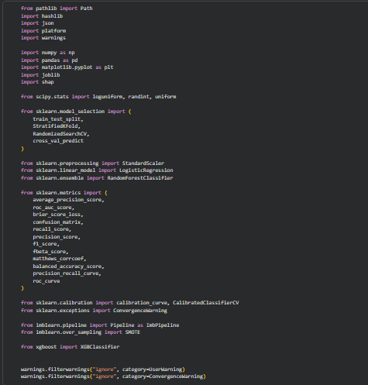
(Developed in python)
The implementation was carried out in Python using a Colab notebook. The code imported the packages numpy, pandas, matplotlib, joblib and shap to do numerical handling, data manipulation, plotting, model persistence and explanation. The scikit-learn library was used for splitting, cross-validation, preprocessing, model evaluation and calibration. Fold-contained SMOTE was performed with the imbalanced-learn library and XGBoost was performed with gradient-boosted trees modelling. Other metrics imported to the code include average precision, ROC-AUC, brier score, recall, precision, F1, F2, MCC, balanced accuracy, precision-recall curves and ROC curves [29], [30].
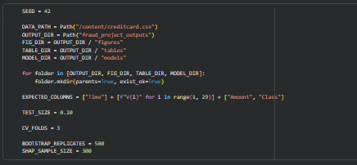
(Developed in python)
The configuration block fixed the random seed at 42, set the dataset path to /content/creditcard.csv, created output folders for figures, tables and trained models, and defined the expected dataset columns. The test size was set to 0.20, the number of cross-validation folds was set to 3, the number of bootstrap replicates was set to 500, and the SHAP sample size was reduced to 300 for computational feasibility.
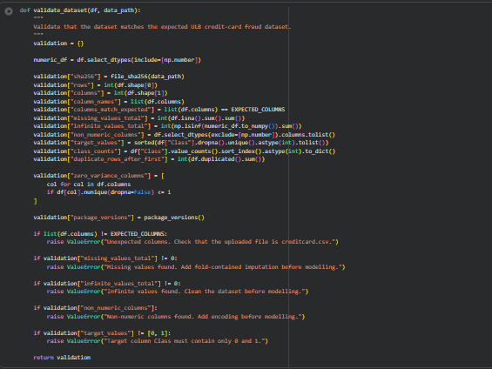
(Developed in python)
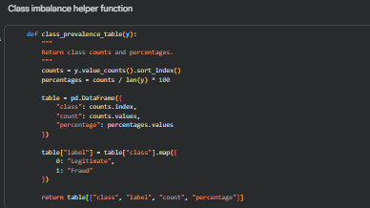
(Developed in python)
Reproducibility was strengthened through helper functions. The file_sha256() function generated a checksum of the dataset file, allowing the exact input file to be identified. Such dictionaries as split summaries and validation summaries were saved with the help of the save_json() function. The package_versions() function recorded versions of Python, platform, pandas, NumPy, scikit-learn, imbalanced-learn, XGBoost and SHAP. The validation output reported Python 3.12.13, pandas 2.2.2, NumPy 2.0.2, scikit-learn 1.6.1, imbalanced-learn 0.14.2, XGBoost 3.3.0 and SHAP 0.52.0. The implementation used computationally constrained baseline settings rather than full randomised hyperparameter optimisation. This was necessary because repeated fitting of nine configurations on 284,807 transactions is computationally expensive [31]. The code thus emphasized on a comparable reproduction and controlled comparison with the same data partitions and evaluation measures.

C. Dataset source and validation
The dataset used in this study was the Credit Card Fraud Detection dataset from Kaggle, provided by the Machine Learning Group at ULB. According to the description of the dataset, an anonymised credit-card transaction is included and the data is either fraudulent or genuine. The transactions were made by European cardholders in September 2013 and cover a two-day period. The context of the dataset is fraud recognition, where the goal is to identify fraudulent transactions so that customers are not charged for items they did not purchase. The dataset description also explains that the input variables are numerical. Most of the variables are transformed using PCA due to confidence [32]. Thus, V1 to V28 are anonymised principal components and cannot be read out as the original transaction attributes. Time and Amount are the two non-PCA variables. The target variable is Class, where 0 represents a legitimate transaction and 1 represents fraud.
This implies that the model interpretation should be handled cautiously: SHAP or feature-importance analysis can uncover model-input explanations but it can never give real-world behavioural drivers like the type of merchant, cardholder location or device information.
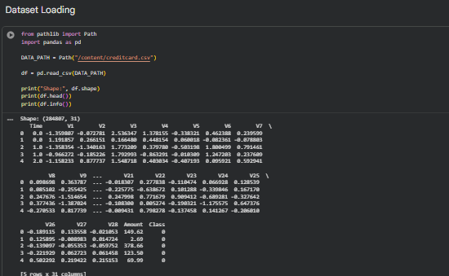
(Developed in python)
The dataset was loaded successfully from /content/creditcard.csv. The shape was 284,807 rows and 31 columns. The initial rows had the anticipated design: Time, anonymised variables V1 to V28, Amount and Class. The information output confirmed that all 31 columns were non-null and numeric, with 30 floating-point predictors and one integer target column [9], [33].
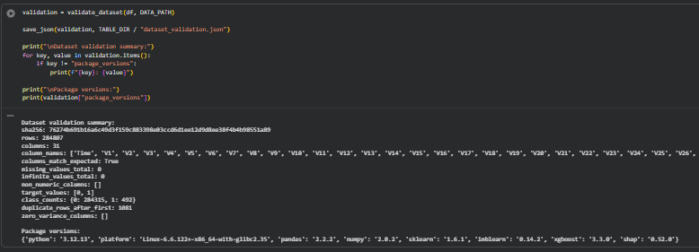
(Developed in python)
The validation feature was used to ensure that the dataset was as per the expected ULB credit-card fraud dataset. The checksum was generated, the row count was 284,807, the column count was 31, the column names matched the expected list, missing values were zero, infinite values were zero, non-numeric columns were absent, target values were [0, 1], and zero-variance columns were absent [9]. The legitimate and fraud counts of the classes were 284,315 and 492 respectively. The function also discovered 1,081 duplicate rows in the initial occurrence. The duplicate rows were not automatically deleted but set as a data-quality characteristic [34]. This was suitable since the publicly available data is not given cardholder identifiers or original transaction identifiers. Without these identifiers, it is not possible to distinguish with certainty between true duplicate records and repeated transactions with identical transformed values.

D. Class imbalance
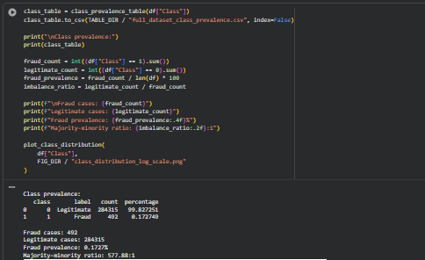
(Developed in python)
The full-dataset class-prevalence table showed that legitimate transactions made up 99.827251% of the dataset, while fraud transactions made up only 0.172749%. In absolute terms, the legitimate cases were 284,315 and the fraud cases were 492. The proportion between the majority and the minority stood at 577.88:1.
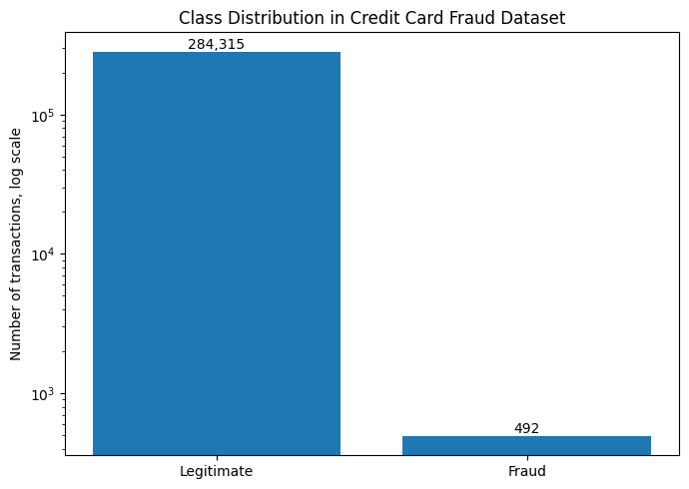
Figure 5: Class Distribution in Credit Card Fraud Dataset
(Developed in python)
The class-distribution graph used a logarithmic y-axis. This graph was a clear indication of the magnitude of the imbalance: the legitimate class had the highest number of examples in the dataset, and the count of the fraud class was very low. A log scale had to be used since a normal linear scale would shrink the fraud bar visually and result in an inability to compare the two. Therefore, the graph justifies why accuracy was not used as the main performance measure. A classifier could predict every transaction as legitimate and still obtain very high accuracy, but such a model would detect no fraud. This imbalance shaped the whole modelling strategy. Average precision was used as the primary model-selection metric because it focuses on precision-recall behaviour for the rare positive class [34]. Recall, precision, F1, F2, MCC and confusion-matrix counts were used to analyse threshold-dependent behaviour. ROC-AUC was also reported, but it was not considered sufficient on its own, as ROC-AUC also can be large when precision with its rare positive class is poor [35].
Due to this severe imbalance, the modelling strategy included imbalance-handling techniques rather than relying only on the original class distribution. Three methods were compared: original imbalanced data training, class weighting, and SMOTE resampling. Only the LR_SMOTE, RF_SMOTE and XGB_SMOTE configurations of the training pipeline utilized SMOTE. The entire dataset was not resampled prior to splitting and the test set ultimately retained its imbalanced nature. This avoided data leakage and allowed the models to be evaluated under realistic fraud-detection conditions. A conservative SMOTE ratio of sampling_strategy = 0.10 was used to increase the representation of fraud cases during training without forcing an artificial 50:50 balance.

E. Train-test split
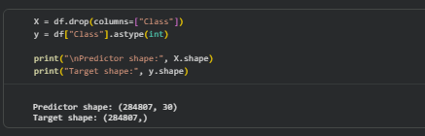
(Developed in python)
The predictors and target were separated before modelling. The predictor matrix X contained 30 features, while the target vector y contained the integer-coded Class variable. The code output confirmed a predictor shape of (284807, 30) and a target shape of (284807,).
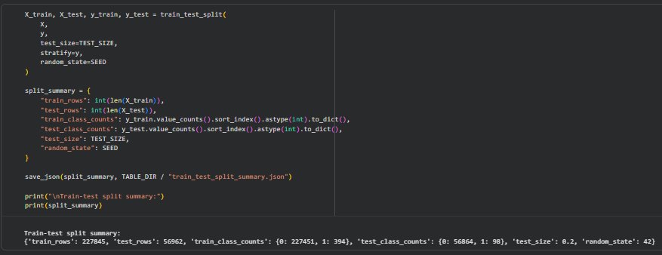
(Developed in python)
The data was split once into training and test partitions using train_test_split. The test size was 0.20, stratification was applied using stratify=y, and the random state was fixed at 42. The training set resulted in 227,845 transactions and the test set consisted of 56,962 transactions. The training sample included 227, 451 legitimate and 394 fraud transactions. The test set contained 56,864 legitimate transactions and 98 fraud transactions. This division retained the level of fraud in the two divisions. It also created a sufficiently large test set for final reporting, although the number of fraud cases remained small. As the test set was limited to 98 frauds, individual cases of a fraud significantly impacted recall [35]. For example, one additional missed fraud changes recall by about one percentage point. Thus, the interpretation of results was performed based on both the metric values and the uncoded confusion-matrix counts.

F. Training-set exploratory analysis
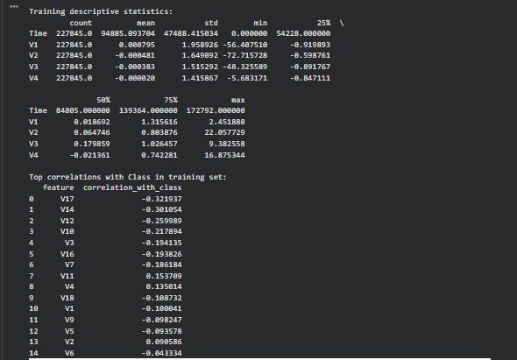
(Developed in python)
After the split, exploratory data analysis was performed on the training partition and was not done on the test partition. The code generated train-df by taking X-train and then appending to this Class labels of Y-train. This ensured that the last set of tests affected no feature inspection or modelling decisions. The descriptive statistics revealed that the training set had 227,845 observations [9]. The Time variable was with a mean of about 94,885 seconds, the values were between 0 and 172,792. Means of the anonymised PCA features are near zero, anticipated or transformed features. Strongest absolute Pearson correlations with the target in training data were discovered using the top feature-correlation table. The strongest negative correlations were V17 (-0.321937), V14 (-0.301054), V12 (-0.259989), V10 (-0.217894), V3 (-0.194135), V16 (-0.193826) and V7 (-0.186184). The stronger positive correlations included V11 (0.153709), V4 (0.135014) and V2 (0.090586).
The correlations were merely descriptively employed. They were not used for feature selection. This difference is significant since when choosing features by using the entire dataset or by using test-set information, leakage would be included. Under this implementation, none of the features was dropped and the correlation results were utilized solely to aid interpretation.
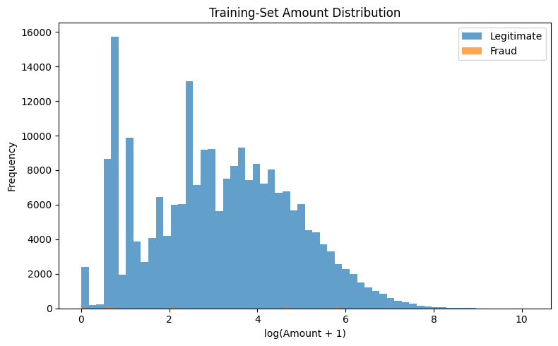
Figure 6: Training-Set Amount Distribution
(Developed in python)
The training-set amount distribution graph used log (Amount + 1). This was an appropriate transformation since there was right skewness in the number of transactions. The histogram revealed that the number of transactions related to legitimacy was the most dominant in terms of its visual representation due to a class imbalance. The distribution of the fraud was only evident as a minor overlay, which once again proved that raw plots are heavily influenced by the very minor number of frauds [36]. The graph demonstrated that the fraud transactions were scattered through a series of log-amounts as opposed to having just a single band of amount.
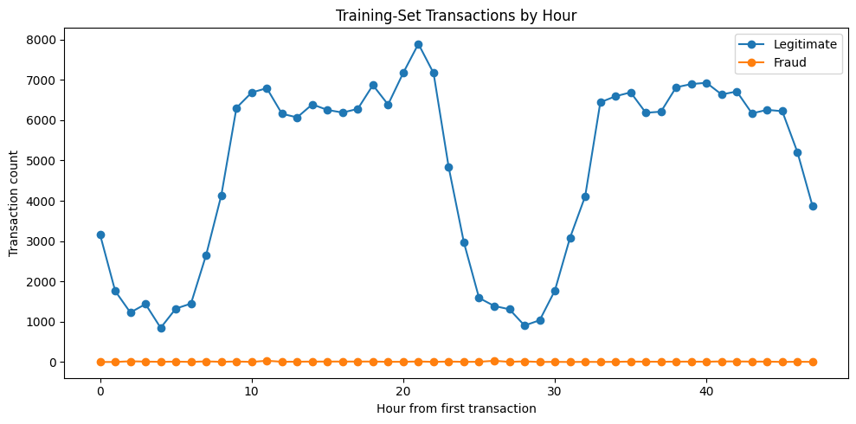
Figure 7: Training Set Transactions-by-Hour
(Developed in python)
The training-set transactions-by-hour graph clumped transactions based on the hour after the initial transaction. The legitimate transaction counts were characterized by a strong time trend, with high-volume periods and low-volume periods. The fraud line was almost straight due to the fact that the number of frauds was significantly insignificant in comparison with the cases of legitimacy. This graph helped to display patterns of transaction-volumes, but not much to indicate the risk of fraud since the actual number of frauds was relatively small and was visually swamped by legitimate transactions [37].
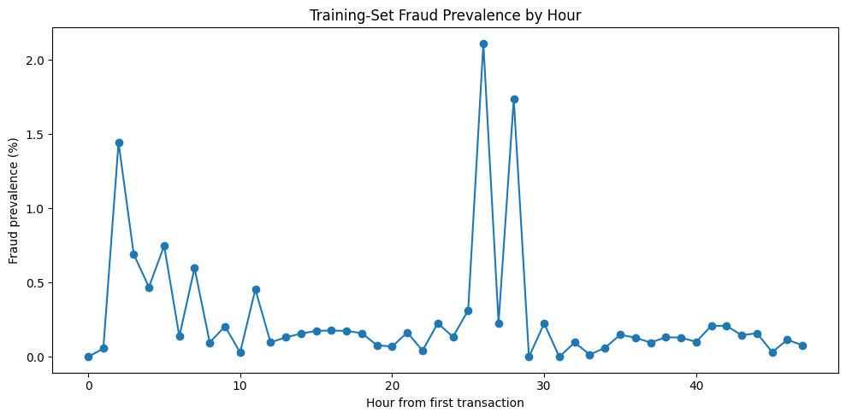
Figure 8: Training Set Fraud Prevalence by Hour
(Developed in python)
Due to that, the plot of prevalence-by-hour-of-fraud was more informative. It calculated fraud prevalence as a percentage within each hour. This showed local peaks in the prevalence of fraud up to peaks greater than 2 percent around the midpoint of the timeline [37]. These spikes are not to be overread as certain hourly groups might have a relatively small number of fraud cases holding that prevalence of fraud was not a perfectly linear distribution over time. This supports the inclusion of Time as a predictor, while also justifying the planned caution around chronological robustness.
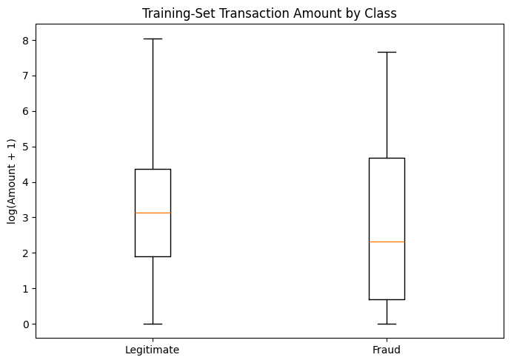
Figure 9: Training Set Transactions Amount by Class
(Developed in python)
The amount boxplot by class compared log (Amount + 1) between legitimate and fraud transactions. It was indicated that the median and the range of fraud class was broader in the plot as compared to the legitimate class. This suggests that fraudulent transactions were not simply higher-value transactions. Instead, fraud appeared across a broader range of amounts, including many relatively low-value transactions. This is relevant operationally because a fraud-detection model based only on high transaction amounts would miss many fraud cases [31].
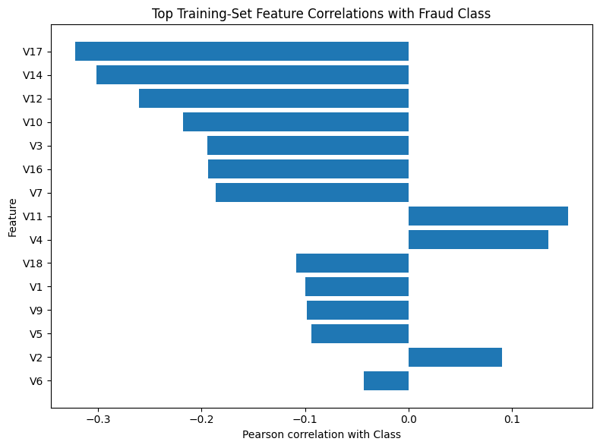
Figure 10: Top Training Set Feature Correlations with Fraud Class
(Developed in python)
The top-correlation graph visually confirmed the training correlation table. Features V17, V14, V12, V10, V3, V16 and V7 had the largest negative associations with fraud, while V11, V4 and V2 had positive associations. Since the features are PCA components, the graph cannot be interpreted in terms of original customer behaviour. However, it confirms that the anonymised feature space contains useful discriminatory information.

G. Model configurations
There were nine model configurations of implementation. The configuration list was initially cleared to avoid duplicated models in case of rerun of the notebook cells. The training imbalance ratio was calculated from the training labels and used where required for weighting. SMOTE was configured with a sampling strategy of 0.10 and k_neighbors=5.
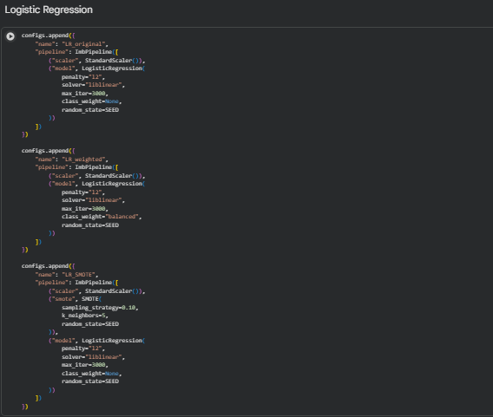
(Developed in python)
The Logistic Regression settings adopted standardisation within the pipeline, L2 regularisation, liblinear solver, 3,000 iterations (maximum) and the fixed random seed. The early model of Logistic Regression had no weighting of classes. The weighted version used class_weight="balanced". The SMOTE version included StandardScaler, SMOTE and the Logistic Regression within an imbalanced-learn pipeline.
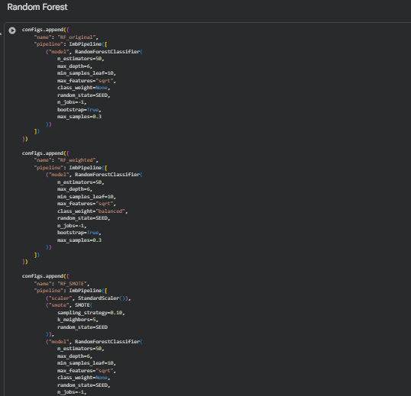
(Developed in python)
The Random Forest configurations used constrained settings for computational feasibility. Each Random Forest utilized 50 estimators, a maximum depth of 6, a minimum leaf size of 10, square-root sampling of features, bootstrap sampling and max_samples=0.3. In the first version, no weighting of the classes was used. The weighted version used class_weight="balanced". The SMOTE version employed fold-contained SMOTE and then fitted the forest.
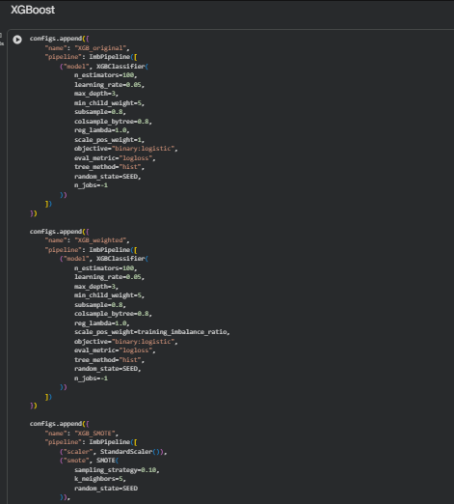
(Developed in python)
The XGBoost configurations used 100 estimators, learning rate 0.05, maximum depth 3, minimum child weight 5, subsample 0.8, column subsample 0.8, reg_lambda=1.0, binary logistic objective, log-loss evaluation metric and histogram tree construction. The initial XGBoost model was that of scale_pos weight=1. The weighted model employed the course of training Imbalance ratio scale_pos_weight. The SMOTE model used fold-contained SMOTE and kept scale_pos_weight=1, so that sampling and algorithm-level weighting were not combined [31].
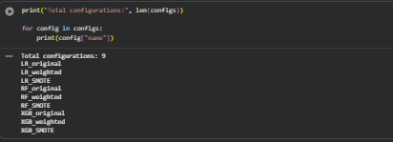
(Developed in python)
The output confirmed exactly nine configurations. This fixed an earlier notebook issue where rerunning cells had duplicated Random Forest configurations.

H. Cross-validation screening
The notebook was stratified three times cross-validation using shuffling and constant random seed. The scoring dictionary consisted of average precision, ROC-AUC, recall, precision and F1. Each of nine model pipelines was checked by cross validate with njobs=1 to alleviate the load of parallel-processing. Then the summary table was sorted by the mean, cross-validation, average precision, which served as the key model-selection criterion as the clustering of fraud was extremely rare [38].
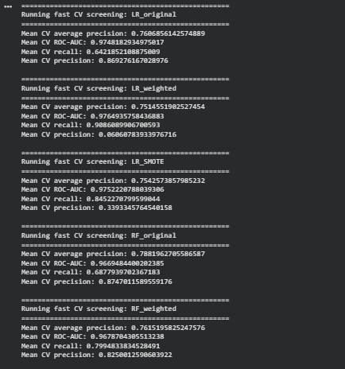

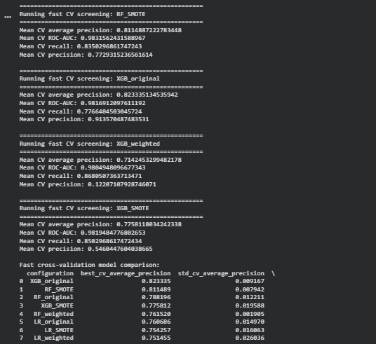
(Developed in python)
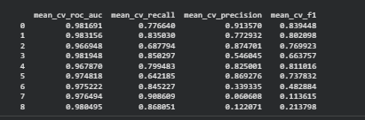
(Developed in python)
The best cross-validation result was achieved by XGB_original, with a mean average precision of approximately 0.8233. The model from which the performances were strong in terms of secondary is also that the mean ROC-AUC is 0.9862, the mean recall is 0.7766, the mean precision is 0.9136 and the mean F1 is equal to 0.8394. RF_SMOTE was secondly ranked in average precision with around 0.8115, Roc-auc of about 0.9832, Recall of about 0.8350, Precision of about 0.7729 and F1 of about 0.7988. RF_original ranked third, with average precision around 0.7882, ROC-AUC around 0.9670, recall around 0.6878, precision around 0.8747 and F1 around 0.7673. The remaining models performed less strongly by the primary metric. XGB_SMOTE had a mean precision of about 0.7758, whereas LR_original and LR_SMOTE were nearly equal, at about 0.7607 and 0.7543 respectively. There was a distinct pattern of recall orientation in the weighted configurations.
For example, LR_weighted achieved very high recall, around 0.9087, but its mean precision was only around 0.0600. Similarly, XGB_weighted reached a recall of approximately 0.8609, although the mean precision was approximately 0.1221. These results show that imbalance treatment was not uniformly beneficial. SMOTE improved Random Forest compared with its original and weighted versions, but it did not improve XGBoost enough to outperform XGB_original. It also becomes obvious why ROC-AUC did not become the adequate choice of the selecting measure. A few weighted models had high ROC-AUC and recall, but due to low precision, they would issue too many false alerts. Thus, the XGB_original was chosen as it prevented the best average-precision ranking and revealed the optimal compromise between recall and precision.

I. Test-set results at the default threshold
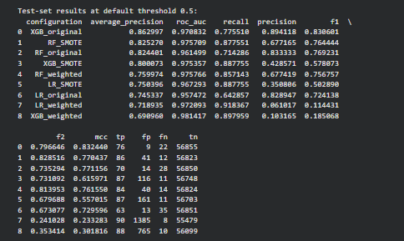
(Developed in python)
After cross-validation screening, all nine pre-specified configurations were evaluated on the untouched test set at the default threshold of 0.5. These test results were reported for transparency, but the final model selection was based on cross-validation average precision rather than test-set ranking. The best test-set average precision was achieved by XGB_original, with average precision 0.862997, ROC-AUC 0.970832, recall 0.775510, precision 0.894118, F1 0.830601, F2 0.796646 and MCC 0.832440. It classified 76 fraud cases, 9 false positives, 22 fraud cases all missed and identified 56,855 legitimate transactions. RF_SMOTE achieved the second-highest average precision, 0.825270, with ROC-AUC 0.975709, recall 0.877551 and precision 0.677165. It detected 86 frauds and missed only 12, but produced 41 false positives. RF_original achieved average precision 0.824401, recall 0.714286 and precision 0.833333, with 70 true positives, 14 false positives and 28 false negatives. These results show that Random Forest with SMOTE improved recall but at the cost of precision compared with the original Random Forest [38].
XGB_SMOTE had average precision, 0.800073 and recall, 0.887755, but the precision was only 0.428571 due to its 116 false positives. XGB_weighted was the best XGBoost model with an ROC-AUC of an approximate of 0.9814, with an average precision of 0.690960 and precision of 0.103165 due to 765 false total positives produced. This once more illustrates that ROC-AUC is in itself misguiding when there is gross imbalance in the classes. The Logistic Regression models reflected the same pattern. LR_original had average precision 0.745337, recall 0.642857 and precision 0.828947. LR_SMOTE boosted recall to 0.887755, and accuracy had declined to 0.350806. LR_weighted identified 90 frauds and did not identify 8, however, with 1,385 false positives and precision of 0.061017. Therefore, class weighting made Logistic Regression highly sensitive to fraud but operationally inefficient because too many legitimate transactions were flagged.
The precision-recall curves confirmed these findings. RF original and RF SMOTE had better average precision than the Logistic Regression variants with RF SMOTE having a good recall with less precision at high recall levels. In the XGBoost curves, there were no good performance curves across all of the XGBs, with XGB_original having the best ranking quality and XGB_weighted had a weaker precision-recall curve although it had a good ROC-AUC. This reinforced the decision to select XGB_original.

J. Final model selection
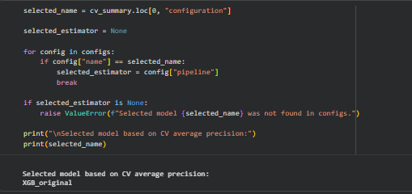
(Developed in python)
The final model selected was also the one with cross-validation average precision. This code selected the top row of cv_summary, then accessed the corresponding pipeline in the list of configurations. The result of the notebook showed that the chosen model is XGB_original. This selection is defensible for two reasons. First, it was based on development-set cross-validation, not on the final test set. Second, it employed average precision, which is more suitable than accuracy or ROC-AUC when there is extreme imbalance in the fraud detection. The selection was thus an indicator of the performance of the model to prioritise rare cases of frauds whilst achieving a useful precision [34]. The chosen model was an unweighted XGBoost classifier that was trained using the original biased distribution. This is a significant finding as it indicates that the most complicated imbalance treatment was not always the best to derive a model.
SMOTE improved Random Forest performance, but it did not improve XGBoost enough to outperform the original XGBoost model. Some models were recall-enhancing by being weighted by class, but tended to inflate false positives.

K. Threshold selection
After selecting XGB_original, threshold tuning was performed using out-of-fold training probabilities. The code used cross_val_predict with method="predict_proba" on the training partition and the same three-fold cross-validation object. This produced development-set probability estimates that were not generated by models trained on the same observations. These out-of-fold scores were then used to select thresholds.
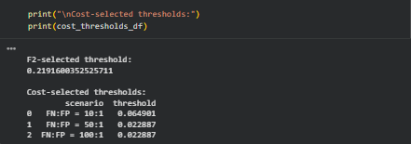
(Developed in python)
The threshold of F2-selection was 0.219160. F2 is more appropriate than precision as recollection F2 minimizes the importance of precision and when it comes to fraud detection, missed frauds tend to be more expensive than false alarms. Cost-sensitive thresholds were picked based on false-negative and false-positive-cost ratios of 10:1, 50:1 and 100:1. The 10:1 threshold was 0.064901, while both the 50:1 and 100:1 scenario selected 0.022887. These thresholds demonstrate how operating points vary with increasing the punishment on missed frauds. The threshold of the default is 0.5, this is a conservative precision-oriented threshold [33]. The decision boundary is reduced at F2 to reduce the number of frauds missed by the model. The cost thresholds reduce it even more so the 50:1 and 100:1 case, where the model is more aggressive in demarcating suspected fraud.

L. Locked-threshold test-set results
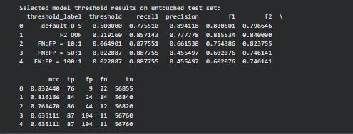
(Developed in python)
The chosen XGBoost model was trained on the entire set of training and tested on the remaining test set using the locked thresholds. With the default threshold of 0.5, the model identified 76 frauds, missed 22 and obtained 9 false positives. Recall was 0.775510, precision was 0.894118, F1 was 0.830601, F2 was 0.796646 and MCC was 0.832440. At the F2 threshold of 0.219160, recall increased to 0.857143 and the model detected 84 frauds. False negatives fell from 22 to 14. Precision decreased from 0.894118 to 0.777778, and false positives increased from 9 to 24. F2 improved to 0.840000, while MCC remained strong at 0.816166. This operating point gave a higher balance against frauds than the default threshold since it identified eight more frauds but incurred fifteen more false positives.
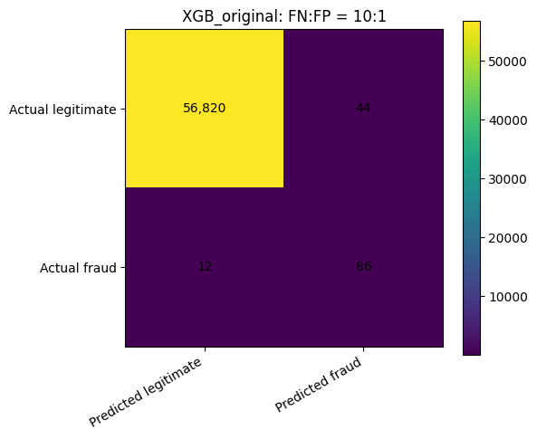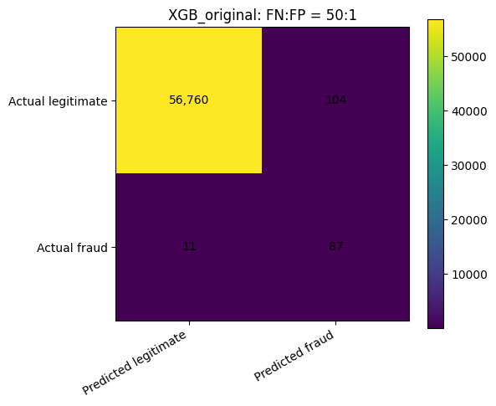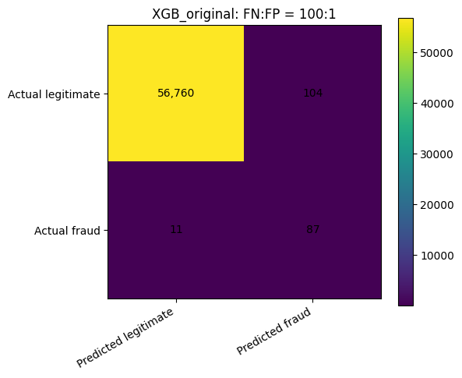
Figure 11: Comparison of XGBoost Confusion Matrices Across FN:FP Cost Ratios (10:1, 50:1, and 100:1)
(Developed in python)
At the 10:1 cost threshold, the model detected 86 frauds and missed 12. Recall rose to 0.877551, but precision fell to 0.661538 because false positives increased to 44. At the 50: 1 and the thresholds of 100: 1, 87 frauds were observed and 11 frauds were missed by the model, however, false positives rose to 104 and the precision dropped to 0.455497. These cutoff points demonstrate the anticipated tradeoff, the more the model focuses on detecting fraud, the more it identifies fraud cases at the expense of falsely deterred alerts. This trade-off is illustrated graphically in the confusion-matrix graphs. The default-threshold matrix indicates that there are 56,855 true negatives, 9 false positives, 22 false negatives and 76 true positives. F2 gives 56840 true negativities, 24 false positivities, 14 false negativities and 84 true positivities. The 10:1 matrix shows 56,820 true negatives, 44 false positives, 12 false negatives and 86 true positives. The matrices 50:1 and 100:1 indicate that there were 56,760 true negatives, 104 false positives, 11 false negatives and 87 true positives.
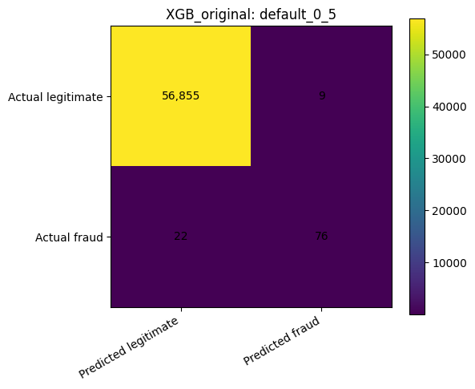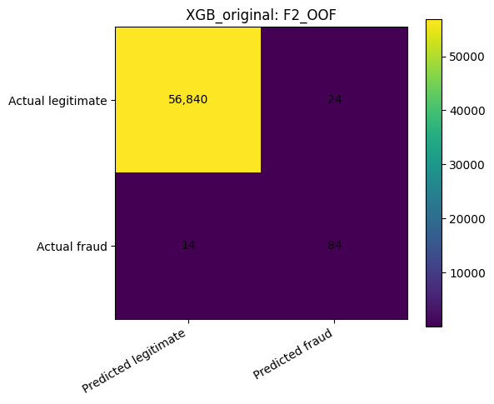
Figure 12: Comparison of XGBoost Confusion Matrices: Default Threshold vs. F2-Optimized Threshold
(Developed in python)
The F2 threshold is therefore the recommended operating point. It significantly decreases missed frauds over the default threshold but maintains the false-positive burden at manageable levels. The more aggressive cost threshold rates fewer more frauds, but even this difference is minor relative to the number of falsely detected.

M. Bootstrap confidence intervals
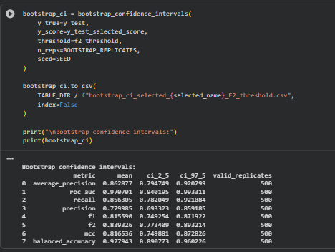
(Developed in python)
Bootstrap confidence intervals were calculated for the selected model at the F2 threshold using 500 valid bootstrap replicates of the test-set predictions. The mean average precision was 0.862877, with a 95% interval from 0.794749 to 0.920799. The mean ROC-AUC was 0.970701, with an interval from 0.940195 to 0.993311. Recall had a mean of 0.856305, with an interval from 0.782049 to 0.921084. Precision had a mean of 0.779985, with an interval from 0.693323 to 0.859185. The mean F1 score was 0.815590, with an interval from 0.749254 to 0.871922. The mean F2 score was 0.839326, with an interval from 0.773409 to 0.893214. MCC had a mean of 0.816536, with an interval from 0.749881 to 0.872826. Balanced accuracy had a mean of 0.927943, with an interval from 0.890773 to 0.960226.
These intervals suggest that the selected model’s performance was robust under resampling of the test predictions. However, the intervals should not be interpreted as proof of deployment performance. The public dataset covers only a specific historical two-day period, and the test set contains only 98 fraud cases. The bootstrap intervals are thus measures of uncertainty in this test sample but not in uncertainty at future fraud environments.

N. Calibration and interpretation
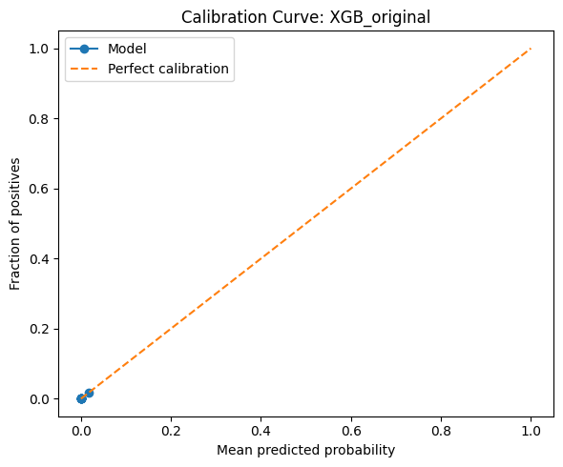
Figure 13: XGBoost Probability Calibration Curve
(Developed in python)
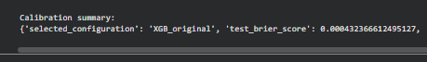
(Developed in python)
The calibration diagnostics produced a calibration curve and a Brier score summary. The test Brier score for XGB_original was 0.0004323666. Such a low value indicates that on average probabilities predicted were close to those observed. The Brier score must be interpreted cautiously under extreme imbalance because the majority class dominates the loss. A model can achieve a low Brier score by giving out very small probabilities to the majority of legal transactions. Thus, the calibration curve has to be checked along with the Brier score. The code contained optional sigmoid calibration, disabled. This was suitable as calibration should not be automatically applied without justification by the calibration curve [37]. This project focused primarily on classification and threshold analysis and not probability forecasting.
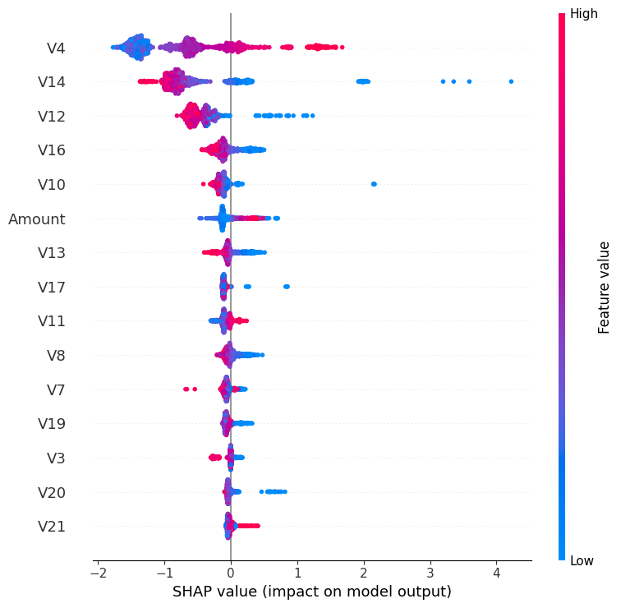
Figure 14: SHAP Summary Plot for XGBoost Feature Importance
(Developed in python)
Model interpretation was implemented using SHAP for tree models and coefficient analysis for Logistic Regression. As the model chosen was XGB_original, SHAP branch was applied. The code sampled 300 test observations, and inferred time transformations inference-time and then produced a SHAP summary plot. It did not use SMOTE during the interpretation since it is a training-only sampler. The interpretation of the SHAP results is that they explain anonymised model inputs, not causal explanations in the real-life. V17, V14, V12 and V10 features can be influential, but the original meaning of the features has been obscured due to a PCA transformation. Thus, SHAP plot does not clarify the business reasons of fraud but supports transparency of technical models.

O. Error analysis
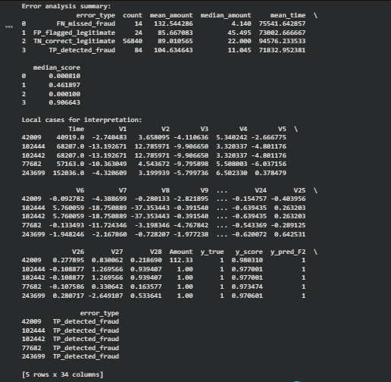
(Developed in python)
The error-analysis code classified each test transaction into one of four categories using the F2 threshold: true positive detected fraud, false negative missed fraud, false positive flagged legitimate transaction and true negative correctly classified legitimate transaction. The code included the true label, predicted score, F2 prediction and error type to the test feature data frame. It then summarised error groups by count, mean amount, median amount, mean time and median score. The model performed 84 and missed 14 fraud cases, respectively, at the F2 threshold. It also flagged 24 legitimate transactions and rightly classified 56,840 legitimate transactions. This indicates that the large residual problem in question was the 14 cases of frauds that fell below the chosen threshold [37]. These false negatives are significant since they represent fraud transactions that do not involve a triggering alert.
The usefulness of the error analysis is that it does not give the account of the type of observations that are missed using aggregate measures. By comparing error groups, the researcher can examine whether missed frauds have lower scores, different transaction amounts or different temporal patterns. Since the data is anonymised, this analysis cannot identify customer-level explanations, but it can still show how prediction errors are distributed across available variables.

P. Summary
In this chapter, a credit-card fraud detection pipeline was deployed and tested using a highly imbalanced dataset of 284,807 transactions, of which only 492 were frauds. The desired schema, numeric variables, binary target labels, and none of the missing and infinite data set has been validated. The prevalence of fraud cases was merely 0.1727 and provided a propensity of majority-minority of 577.88:1. The 80/20 division yielded 227,845 training and 56,962 test samples and produced 394 and 98 frauds in the training and testing division respectively. EDA revealed extreme imbalance, time variation, and advantageous anonymised PCA characteristics like V17, V14, V12 and V10. A total of nine configurations were considered. Cross-validation average precision was used to select XGB_original. At threshold 0.5, it detected 76 frauds. The F2 threshold gave the best detection of 84 frauds and had 24 false positives, thus recommended operating point.

V. CHAPTER 5: DISCUSSION

A. Introduction
In this chapter, the discussion of the empirical findings is done against the review of the literature conducted in Chapter 2. The aim is to not only repeat the numerical results, but to explain what it translates to credit-card fraud detection in extreme cases of class imbalance. Chapter 2 stated that fraud detection is a classification, ranking, and decision problem: a modeling needs to rank suspicious transactions efficaciously, however, it also needs to transform the scores into working alerts utilizing a suitable benchmark. This is backed up by the findings in Chapter 4. XGB_original had the best ranking performance of cross-validation average precision, although default threshold 0.5 did not have the most helpful fraud-detection choice. The threshold selected by F2 identified more frauds at a fairly manageable false-positive cost, indicating that model choice and threshold choice are non-overlapping but related choices.

B. Class imbalance and the limits of accuracy
The ULB dataset had 284,807 transactions and 492 frauds; hence, 0.1727 percent of the data was comprised of fraud. This proved the key issue revealed in the literature: the sheer number of legitimate transactions may justify a traditional assessment being counterproductive [6], [7], [15]. As observed in Chapter 2, a model may seem very accurate and yet minorities class may not be identified. Findings are the reason why the warning is justified. The use of accuracy was not determined as the main measure because the research issue of interest was not general correctness on all the transactions but correct detection of rare cases of fraud. The analysis of the class distribution graph, the decision about fraud prevalence table and the stratified split all indicated that the evaluative weight of each fraud observation of observation was quite high. The number of fraud cases in the test set was only 98. Hence, a shift of a few fraud cases resulted in a noticeable shift in recall. This is why the discussion should be on the true positives, false negatives, false positives, precision and recall than accuracy.

C. Relationship between model behaviour and prior studies
The three experimented with Logistic Regression, Random Forest and XGBoost compared them as Chapter 2 determined them to be representative linear, bagging and boosting methods. The findings indicated that the chosen model was XGB original, which is aligned with the literature that tends to find significant performance of the ensemble and boosting models on tabular fraud data [23], [5], [21]. XGBoost is capable of nonlinear interaction modelling and regularisation, shrinkage and subsampling and thus, it can be subjected to intricate structure without the help of a strictly linear decision boundary. Logistic Regression could still be utilized as a clear benchmark, although not as effective as the best tree-based models. Random Forest also fared well with the primary cross-validation measure, and did so in combination with SMOTE, yet it failed to be better than the original XGBoost model.
This interpretation is also supported by recent literature (2024). Breskuviene and Dzemyda consider imbalanced credit-card fraud statistics, whereas Khalid et al. analyse the same problem using ensemble learning, Hafez et al. review AI-enhanced methods of detecting fraud [20], [5], [21]. Such studies support the importance of ensemble strategies and imbalance-sensitive evaluation, whereas the current dissertation is different by fixing the protocol of the comparison to all the corresponding nine configurations, as well as by applying threshold selection out-of-fold and then performing the final test. This causes the outcome to be less reliant on a single favourable split or a single default threshold.
The outcome also helps in affirming the evidence in literature that fraud detection cannot be detected by any single, best classifier. Chapter 2 reported that the results of the studies vary due to differences in datasets, sampling procedures, validity procedures and measures. To have control over these factors in this experiment, all of the nine configurations were tested with equal split, folds, and metrics. With that controlled protocol, the model that produced the best results was not the most heavily treated to imbalance model, but the regularised boosted tree model trained in the original distribution.

D. Imbalance treatment: SMOTE and class weighting
One of the most important findings is that imbalance treatment was not uniformly beneficial. In chapter 2, they defined imbalance remedies (data-level, algorithm-level and decision-level). SMOTE was the data-level strategy, weighting the class by the algorithm is the algorithm-level strategy and choosing the threshold was the decision-level strategy. It was indicated that the approaches act variously on different algorithms.
SMOTE increased the performance of Random Forest. Cross-validation RF_SMOTE obtained the second-best average precision and a good test recall. This will coincide with reports that minority-class representation could be enhanced by synthetic oversampling in cases where the majority-class influences the baseline learner [17], [18], [19]. But SMOTE did not enhance XGBoost to be better than XGB_original. XGB_SMOTE achieved high recall on the test set, however it had more false positives and lower precision compared to XGB original. This correlates with the warning by the literature that synthetic points may confuse class boundaries or cause less reliable regions of decision when the minority examples are sparse or noisy [17], [7].
Weighting of classes resulted in an even more pronounced trade-off. Weighted Logistic Regression and weighted XGBoost boosted recall, but at the cost of dramatically reduced precision. As an illustration, LR_weighted identified a significant number of frauds, but with a test set of 1385 false positives, whereas XGB_weighted had 765 false positives. These findings affirm the claim that an increase in weighting at an algorithm level can turn a model into a model sensitive to the minority class but too sensitive can result in operational alert overburdening. In real-world fraud detection, a high-recall model is not necessarily preferable when the volume of possible false alarms exceeds the available capacity to review or causes the customer undue friction.

E. Evaluation metrics and the importance of precision-recall analysis
The results support the Chapter 2 argument that precision-recall analysis provides more decisions than ROC analysis in imbalanced fraud detection with high level of strength. Some models yielded high ROC-AUC values, with a significant difference in their accuracy. The case of XGB_weighted, which had a big ROC-AUC, small average precision, and low test precision was the most evident instance; it was declaring too many valid transactions. Likewise, LR_weighted was recalling well but with very low precision. This shape proves the assertion by Saito and Rehmsmeier that precisionrecall plots are more insightful than ROC plots in cases where the negative category is predominant [10].
Mean accuracy was thus a suitable common selection statistic. It was indicative of the ranking capacity of the model in rare frauds without loss to usefulness. Another strength of MCC was its ability to evaluate all the four cells of the confusion matrix and is advisable in imbalanced binary classification [11]. The last model chosen worked fine in both ranking and threshold dependent measures. At the default test threshold, XGB_original achieved average precision of 0.862997, ROC-AUC of 0.970832, recall of 0.775510, precision of 0.894118 and MCC of 0.832440. These values imply that it was discriminative as well as had equal rates of false positives and false negatives.

F. Threshold selection and operational trade-off
One of the best contributions of the dissertation is the threshold analysis. Chapter 2 made the argument that the conventional and operationally justified probability threshold is 0.5. These findings proved this argument. With the default threshold, XGB_original revealed 76 false positives out of the 98 fraud and only 9 false positives. It was a very accurate model, though, it failed to spot 22 frauds. In fraud detection, misses are relevant cases since false negatives are a successful fraud case.
The 2-selected F2 threshold skewed the model to a greater recall. The model at threshold 0.219160 caught 84 frauds, it missed 14 and gave 24 false positives. It implies that there were eight more frauds found than the default threshold, and the number of false-positives was moderate. This finding indicates that the choice of threshold must be involved in the modelling process, and it cannot be left to chance. The F2 threshold placed greater emphasis on recall that is correct when the cost of missing fraud is higher than the cost of an unwarranted alert.
The trade off was also proven by the cost-sensitive thresholds. The 10:1 cutoff identified 86 frauds, but raised the false positives to 44. The thresholds of 50:1 and 100:1 identified 87 frauds but that number of false positives rose to 104. This represents diminishing returns to sales: transitioning between the F2 threshold and the most aggressive, cost thresholds only three more frauds were found, and 80 more false positives were observed. Thus, the most justifiable practical suggestion in the dissertation is the F2 threshold.

G. Explainability and responsible use
The SHAP analysis dealt with the interpretability issue that was mentioned in Chapter 2. SHAP can be well used in explaining the complex models of trees since it gives summaries of features to translate predictions [27]. The model chosen was anonymised PCA features in which the highest descriptive correlations were features of V17, V14, V12 and V10. SHAP may indicate how such variables affect model scores, but original meanings of these variables are obscured. Hence, interpretation should not be causal but technical.
This restriction is directly related to responsible use. As mentioned in chapter 2, automated decisions on fraud can have consequences on customers and may need to be governed, explained, and under human supervision [12]. The findings justify the application of the model as a decision support system, as opposed to an automatic decline system. Ranking and flagging transactions can be used, but final action needs to be decided by investigators or other authentication rules that should be considered particularly to the border of scores and false-positive-prone thresholds.

H. Overall interpretation of the findings
Overall, the findings answer the research questions. Logistic Regression, Random Forest and XGBoost are able to detect fraud under the original distribution, but they behave significantly differently. SMOTE and class weighting transform recall and precision differently, with one not necessarily being better than the other. XGB_original was the best over-ranking as well as the good threshold-dependent balance. The F2 threshold generated the most practical operating point as it enhanced the fraud detection without generating an overburden of alerts.
The results thus confirm the research gap that is in Chapter 2. Only headline accuracy or ROC-AUC should not be reported in the research on fraud-detection. It ought to maintain natural prevalence in the last test set, resample within training folds, measure precision-recall performance and display threshold-based confusion matrices. This dissertation has shown that operationally meaningful conclusions can be drawn using a reproducible and leakage-safe comparison that generates more conclusions about an operationally meaningful result than a single high value.

VI. CHAPTER 6: CONCLUSION, LIMITATIONS AND RECOMMENDATIONS

A. Introduction
This chapter is the summary of the key conclusions of the dissertation and presents the research limitations and and future research suggestions. It was tested in the study as to whether machine-learning techniques could offer a justifiable strategy to credit-card fraud protection in cases where the positive category is extremely uncommon. The experiment utilized ULB credit-card fraud data and evaluated the performance of the Logistic Regression, random forest and XGBoost with original, weighted, and SMOTE-based imbalanced nature.

B. Conclusions
The first conclusion is that the accuracy cannot be used as a criterion in evaluating credit-card fraud detection. The data set consisted of 284,807 transactions with only 492 of them fraudulent. Such a radical skew implies a model might seem to be working yet fail to detect fraud. Average precision was therefore used as the main model-selection measure, and was justified by ROC-AUC, recall, precision, F1, F2, MCC and confusion matrices. Such a strategy aligns with the imbalanced learning theoretical literature and precision-recall assessment [11], [10].
The second conclusion is that the best overall model was XGB_original. It had the highest cross-validation average precision and was chosen prior to the end test evaluation. On the untouched test set at the default threshold, it achieved average precision of 0.862997, ROC-AUC of 0.970832, recall of 0.775510, precision of 0.894118 and MCC of 0.832440. It was also found to identify 76 of the 98 detected test frauds and had only generated 9 false positives.
The third conclusion is that there are no promise imbalance treatments. The SMOTE increased the Random Forest but failed to surpass the initial XGBoost model. The class weighting helped recall some models but also resulted in a large number of false positives. This proves that data and algorithm-level repair strategies need to be empirically rated as opposed to presumed being helpful [17], [7].
The fourth conclusion is that the operational value of the selected model was altered at least significantly by the choice of thresholds. The F2 of 0.219160 detected 84 of the 98 frauds, 14 of the 98 frauds were missed and 24 false positives was obtained. This was the suggested operating point because it was a better balance at detecting fraud when compared to the default threshold without causing a bulky alert load. Stricter cost cut-offs identified an additional few frauds but yielded much higher false positives.

C. Limitations
The biggest constraint is the data itself. The ULB data is open, has extensive and reproducible usage, but it includes only two days of transactions on European cardholders in September 2013 [9]. It is historical and is not likely to reflect upon present-day methods of fraud, authentication, payment methods or customer habits. Consequently the results can be construed as benchmark evidence as opposed to actual evidence of production readiness.
Anonymisation is a second limitation. V1-28 represents PCA-transformed variables, thus their business meaning is not available. This preserves confidentiality, and restricts feature engineering and analysis. SHAP will tell us which the anonymised inputs that affected the chosen model but it will not tell us the real-world causes of fraud [27].
The third limitation is that it does not provide cardholder, merchant, device and location identifiers. Due to this, the study was unable to generate behavioural velocity features, customer histories, sequence models or group-aware validation. Modifying concept drift and verification latency are the focus of the literature on operational fraud detection [13], [28], and the problems cannot be wholly observed in the public dataset.
The fourth limit is the limit of computation. Nine controlled configurations had been compared in the dissertation but exhaustive hyperparameter optimisation, deep learning, online learning and stacking were not performed. This fit a conveniently reproducible master level exploration, though more extempore models can exhibit variation when scaled to bigger tuning allocations.

D. Recommendations for future work
The workflow needs to be tested on later and longer period transaction data, which will be tested in the future research. States including customer identification details, category of merchant, location details, and device identification would enable more powerful behavioural attributes and more authentic time validation. Chronological and streaming evaluation must be given priority in order to test model robustness in the presence of concept drift.
Real operational costs should also be used in the future. In the current research, the false-negative to false-positive ratio was 10:1, 50:1 and 100:1, whereas in fact, the loss value, review capacity and customer-friction cost in real banks can vary. An organization-specific thresholds and a warning policy could be enabled by a more realistic model of cost.
The choice of XGBoost model should be compared to superior ensemble, deep learning and sequence models in the coming research. No comparison of this caliber, however, should lose the leakage controls that feature in this dissertation: natural test prevalence, fold-contained resampling, fixed train-test separation and threshold selection not in the final test set.
Lastly, explainability and governance should be empowered in future research. Where demographic or proxy variables are known, SHAP-based explanations ought to be coupled with human evaluation processes, calibration monitoring and fairness evaluation. Decision-making in production should be assisted with the aid of fraud models, not to eliminate human responsibility when such alerts can have an impact on individual customers.

E. Final statement
This dissertation demonstrates that a leakage-safe, metric-aware and threshold-aware machine-learning workflow can generate practical results in fraud-detection in the presence of severe imbalance. XGB_original was the most robust model and F2-selected threshold offered the most justifiable trade-off between the detection of fraud and false positives.

REFERENCES
[1] European Banking Authority and European Central Bank (EBA and ECB) (2025) 2025 Report on Payment Fraud. https://www.eba.europa.eu/sites/default/files/2025-12/1709846a-84d9-47cf-86a0-b155efb34d66/EBA%20and%20ECB%20Report%20on%20Payment%20Fraud.pdf
[2] UK Finance (2026) Annual Fraud Report 2026. https://www.ukfinance.org.uk/system/files/2026- 06/UK%20Finance%20Fraud%20Report%202026.pdf
[3] Ali, A., Abd Razak, S., Othman, S.H., Eisa, T.A.E., Al-Dhaqm, A., Nasser, M., Elhassan, T., Elshafie, H. and Saif, A. (2022) 'Financial fraud detection based on machine learning: A systematic literature review', Applied Sciences, 12(19), 9637. https://doi.org/10.3390/app12199637
[4] Bin Sulaiman, R., Schetinin, V. and Sant, P. (2022) 'Review of machine learning approach on credit card fraud detection', Human-Centric Intelligent Systems, 2, pp. 55-68. https://doi.org/10.1007/s44230-022-00004-0
[5] Hafez, I.Y., Hafez, A.Y., Saleh, A., Abd El-Mageed, A.A. and Abohany, A.A. (2025) 'A systematic review of AI-enhanced techniques in credit card fraud detection', Journal of Big Data, 12, 6. https://doi.org/10.1186/s40537-024-01048-8
[6] Branco, P., Torgo, L. and Ribeiro, R.P. (2016) 'A survey of predictive modeling on imbalanced domains', ACM Computing Surveys, 49(2), Article 31. https://doi.org/10.1145/2907070
[7] He, H. and Garcia, E.A. (2009) 'Learning from imbalanced data', IEEE Transactions on Knowledge and Data Engineering, 21(9), pp. 1263-1284. https://doi.org/10.1109/TKDE.2008.239
[8] Demircioğlu, A. (2024) 'Applying oversampling before cross-validation will lead to high bias in radiomics', Scientific Reports, 14, 11563. https://doi.org/10.1038/s41598-024-62585-z
[9] Machine Learning Group - ULB (2018) Credit Card Fraud Detection. Kaggle dataset. https://www.kaggle.com/datasets/mlg-ulb/creditcardfraud
[10] Saito, T. and Rehmsmeier, M. (2015) 'The precision-recall plot is more informative than the ROC plot when evaluating binary classifiers on imbalanced datasets', PLOS ONE, 10(3), e0118432. https://doi.org/10.1371/journal.pone.0118432
[11] Chicco, D. and Jurman, G. (2020) 'The advantages of the Matthews correlation coefficient (MCC) over F1 score and accuracy in binary classification evaluation', BMC Genomics, 21, 6. https://doi.org/10.1186/s12864-019-6413-7

[12] European Commission (2026) Are there restrictions on the use of automated decision-making? https://commission.europa.eu/law/law-topic/data-protection/information-business-and-organisations/dealing-requests-individuals/are-there-restrictions-use-automated-decision-making_en
[13] Dal Pozzolo, A., Boracchi, G., Caelen, O., Alippi, C. and Bontempi, G. (2018) 'Credit card fraud detection: A realistic modeling and a novel learning strategy', IEEE Transactions on Neural Networks and Learning Systems, 29(8), pp. 3784-3797. https://doi.org/10.1109/TNNLS.2017.2736643
[14] Cherif, A., Badhib, A., Ammar, H., Alshehri, S., Kalkatawi, M. and Imine, A. (2023) 'Credit card fraud detection in the era of disruptive technologies: A systematic review', Journal of King Saud University - Computer and Information Sciences, 35(1), pp. 145-174. https://doi.org/10.1016/j.jksuci.2022.11.008
[15] Krawczyk, B. (2016) 'Learning from imbalanced data: Open challenges and future directions', Progress in Artificial Intelligence, 5, pp. 221-232. https://doi.org/10.1007/s13748-016-0094-0
[16] Dal Pozzolo, A., Caelen, O., Johnson, R.A. and Bontempi, G. (2015) 'Calibrating probability with undersampling for unbalanced classification', 2015 IEEE Symposium Series on Computational Intelligence, pp. 159-166. https://doi.org/10.1109/SSCI.2015.33
[17] Chawla, N.V., Bowyer, K.W., Hall, L.O. and Kegelmeyer, W.P. (2002) 'SMOTE: Synthetic minority over-sampling technique', Journal of Artificial Intelligence Research, 16, pp. 321-357. https://doi.org/10.1613/jair.953
[18] Gupta, P., Varshney, A., Khan, M.R., Ahmed, R., Shuaib, M. and Alam, S. (2023) 'Unbalanced credit card fraud detection data: A machine learning-oriented comparative study of balancing techniques', Procedia Computer Science, 218, pp. 2575-2584. https://doi.org/10.1016/j.procs.2023.01.231
[19] Ileberi, E., Sun, Y. and Wang, Z. (2021) 'Performance evaluation of machine learning methods for credit card fraud detection using SMOTE and AdaBoost', IEEE Access, 9, pp. 165286-165294. https://doi.org/10.1109/ACCESS.2021.3134330
[20] Breskuvienė, D. and Dzemyda, G. (2024) 'Enhancing credit card fraud detection: Highly imbalanced data case', Journal of Big Data, 11, 182. https://doi.org/10.1186/s40537-024-01059-5
[21] Khalid, A.R., Owoh, N., Uthmani, O., Ashawa, M., Osamor, J. and Adejoh, J. (2024) 'Enhancing credit card fraud detection: An ensemble machine learning approach', Big Data and Cognitive Computing, 8(1), 6. https://doi.org/10.3390/bdcc8010006
[22] Breiman, L. (2001) 'Random forests', Machine Learning, 45, pp. 5-32. https://doi.org/10.1023/A:1010933404324
[23] Chen, T. and Guestrin, C. (2016) 'XGBoost: A scalable tree boosting system', Proceedings of the 22nd ACM SIGKDD International Conference on Knowledge Discovery and Data Mining, pp. 785-794. https://doi.org/10.1145/2939672.2939785
[24] Afriyie, J.K., Tawiah, K., Pels, W.A., Addai-Henne, S., Dwamena, H.A., Owiredu, E.O., Ayeh, S.A. and Eshun, J. (2023) 'A supervised machine learning algorithm for detecting and predicting fraud in credit card transactions', Decision Analytics Journal, 6, 100163. https://doi.org/10.1016/j.dajour.2023.100163
[25] Islam, M.A., Uddin, M.A., Aryal, S. and Stea, G. (2023) 'An ensemble learning approach for anomaly detection in credit card data with imbalanced and overlapped classes', Journal of Information Security and Applications, 78, 103618. https://doi.org/10.1016/j.jisa.2023.103618
[26] Carcillo, F., Dal Pozzolo, A., Le Borgne, Y.-A., Caelen, O., Mazzer, Y. and Bontempi, G. (2018) 'SCARFF: A scalable framework for streaming credit card fraud detection with Spark', Information Fusion, 41, pp. 182-194. https://doi.org/10.1016/j.inffus.2017.09.005
[27] Lundberg, S.M. and Lee, S.-I. (2017) 'A unified approach to interpreting model predictions', Advances in Neural Information Processing Systems, 30. https://proceedings.neurips.cc/paper/2017/hash/8a20a8621978632d76c43dfd28b67767-Abstract.html
[28] Jurgovsky, J., Granitzer, M., Ziegler, K., Calabretto, S., Portier, P.-E., He-Guelton, L. and Caelen, O. (2018) 'Sequence classification for credit-card fraud detection', Expert Systems with Applications, 100, pp. 234-245. https://doi.org/10.1016/j.eswa.2018.01.037
[29] Dornadula, V. N., & Geetha, S. (2019). Credit card fraud detection using machine learning algorithms. Procedia computer science, 165, 631-641. https://www.sciencedirect.com/science/article/pii/S187705092030065X/pdf?md5=5d8441a61d34c23f8f24813729334508&pid=1-s2.0-S187705092030065X-main.pdf
[30] Thennakoon, A., Bhagyani, C., Premadasa, S., Mihiranga, S., & Kuruwitaarachchi, N. (2019, January). Real-time credit card fraud detection using machine learning. In 2019 9th international conference on cloud computing, data science & engineering (Confluence) (pp. 488-493). IEEE. https://www.researchgate.net/profile/Nuwan-Kuruwitaarachchi/publication/334761474_Real-time_Credit_Card_Fraud_Detection_Using_Machine_Learning/links/5d3ff7534585153e592d0d8e/Real-time-Credit-Card-Fraud-Detection-Using-Machine-Learning.pdf
[31] Rubaidi, Z. S., Ammar, B. B., & Aouicha, M. B. (2022). Fraud detection using large-scale imbalance dataset. International Journal on Artificial Intelligence Tools, 31(08), 2250037. https://www.worldscientific.com/doi/pdf/10.1142/S0218213022500373
[32] Baisholan, N., Dietz, J. E., Gnatyuk, S., Turdalyuly, M., Matson, E. T., & Baisholanova, K. (2025). A systematic review of machine learning in credit card fraud detection under original class imbalance. Computers, 14(10), 437. https://www.mdpi.com/2073-431X/14/10/437
[33] Mazumder, P. T. (2026). Explainable and fair anti-money laundering models using a reproducible SHAP framework for financial institutions. Discover Artificial Intelligence, 6(1), 262. https://link.springer.com/content/pdf/10.1007/s44163-026-00944-7.pdf
[34] Diallo, R., Edalo, C., & Awe, O. O. (2024). Machine learning evaluation of imbalanced health data: a comparative analysis of balanced accuracy, MCC, and F1 score. In Practical Statistical Learning and Data Science Methods: Case Studies from LISA 2020 Global Network, USA (pp. 283-312). Cham: Springer Nature Switzerland. https://link.springer.com/chapter/10.1007/978-3-031-72215-8_12
[35] Abedin, M. Z., Guotai, C., Hajek, P., & Zhang, T. (2023). Combining weighted SMOTE with ensemble learning for the class-imbalanced prediction of small business credit risk. Complex & Intelligent Systems, 9(4), 3559-3579. https://link.springer.com/content/pdf/10.1007/s40747-021-00614-4.pdf
[36] Liu, G. (2024). Leveraging machine learning for telecom banking card fraud detection: a comparative analysis of logistic regression, random forest, and XGBoost models. Computers and Artificial Intelligence, 1(1), 13-27. https://journals.zeuspress.org/index.php/CAI/article/download/66/77
[37] Höppner, S., Baesens, B., Verbeke, W., & Verdonck, T. (2022). Instance-dependent cost-sensitive learning for detecting transfer fraud. European Journal of Operational Research, 297(1), 291-300. https://arxiv.org/pdf/2005.02488
[38] Sangeetha, J. (2026). A high-recall cost-sensitive machine learning framework for real-time online banking transaction fraud detection. arXiv preprint arXiv:2601.07276. https://arxiv.org/pdf/2601.072
[39] Abdallah, A., Maarof, M.A. and Zainal, A. (2016) 'Fraud detection system: A survey', Journal of Network and Computer Applications, 68, pp. 90-113. https://doi.org/10.1016/j.jnca.2016.04.007
[40] Lemaître, G., Nogueira, F. and Aridas, C.K. (2017) 'Imbalanced-learn: A Python toolbox to tackle the curse of imbalanced datasets in machine learning', Journal of Machine Learning Research, 18(17), pp. 1-5. https://www.jmlr.org/papers/v18/16-365.html
[41] Pedregosa, F. et al. (2011) 'Scikit-learn: Machine learning in Python', Journal of Machine Learning Research, 12, pp. 2825-2830. https://www.jmlr.org/papers/v12/pedregosa11a.html
[42] Duman, E. (2022). Implementation of XGBoost method for healthcare fraud detection. Scientific Journal of Mehmet Akif Ersoy University, 5(2), 69-75. https://dergipark.org.tr/en/download/article-file/2848500

