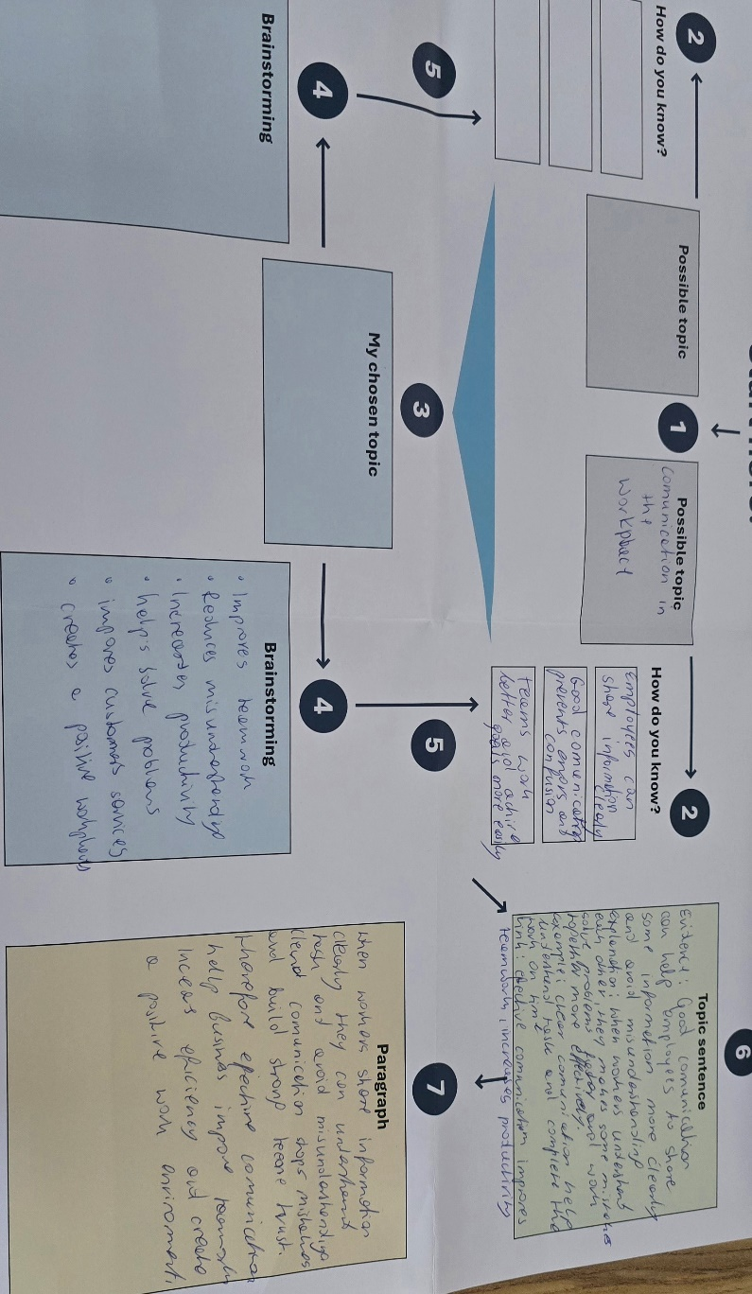

Read the paragraph below.

Show the TEEL structure in the paragraph.

Write the correct part of TEEL next to each sentence in the square brackets.

- T: Topic Sentence
- EXP: Explanation
- E: Evidence / Example
- L: Link Sentence

Paragraph
[T] Using data to make business decisions improves efficiency and reduces risk. Many businesses now analyses data to guide pricing, stock levels, and planning. [E] Research from McKinsey Global Institute (2017) found that data-driven organizations are significantly more likely to acquire customers and be profitable than those that rely on intuition. [E] This shows that using data can directly improve business performance. [EXP] It is not just about collecting information. [EXP] Additionally, businesses must also use the data to make informed decisions. [E] For example, data can highlight which products are selling well and which are not. [EXP] This allows managers to adjust quickly and reduce waste. [EXP] Over time, these small decisions can lead to higher profits and better use of resources. [L] Overall, using data supports more accurate and effective business decision making.

Find the cohesive devices in the above paragraph and highlight or underline them. Then fill in the answers for each of the below.

- Device: Over time Purpose: Show development or introduce a summary of the text
- Device: For Example, Purpose: Give some information and add examples

- Device: This These Purpose: Refer earlier sentences and help avoid repeating
the same words.

Choose the strongest topic sentence from the options below.

- Time management is important.
- Time management is important because it helps people organise their work.
- Time management is important because it helps employees prioritise tasks, meet deadlines, and reduce workplace stress, leading to higher productivity.

Choose the strongest explanation sentence.
Topic Sentence:
Good teamwork is important in the workplace because it helps employees achieve shared goals efficiently.
Which is the best explanation?
A) Teamwork happens in many workplaces.
B) When employees collaborate effectively, they can share ideas, solve problems faster, and support each other’s strengths.
C) Some people prefer to work alone.
Choose the strongest evidence/example.
Topic Sentence:
Workplace training is essential because it helps employees improve their skills and performance.
Explanation:
When employees receive proper training, they become more confident and capable in their roles.
Which is the best evidence/example?
a) Training is something companies often provide.
b) A study by LinkedIn (2023) found that 94% of employees said they would stay longer at a company that invests in their learning.
c) Employees go to work every day.

Choose the best linking sentence.
Topic Sentence:
Flexible working hours can improve employee satisfaction and productivity.
Explanation + Evidence:
When employees can manage their own schedules, they are better able to balance work and personal responsibilities. For example, many companies report increased performance after introducing flexible working policies.
Which is the best linking sentence?
A) Flexible work is becoming more common.
B) Employees like flexibility.
C) Overall, flexible working hours contribute to a more productive and satisfying workforce.

Write the final draft of your TEEL paragraph on your chosen topic here. This is the final draft of the paragraph you started in class!
TEEL FINAL DRAFT:
Effective workplace communication is crucial because it helps colleagues understand company expectations and perform their tasks correctly and efficiently. Key points include using simple, direct language while avoiding unnecessary jargon. When information is conveyed clearly, everyone understands the tasks, and misunderstandings are avoided. Effective communication involves concise information focused on the primary objective. Focusing on specifics and facts enables the implementation of any workplace changes. Effective communication also helps resolve problems faster and ensures better customer service. Employees make significantly fewer errors, perform their work more efficiently, and build trust among colleagues. As a result, the workplace atmosphere improves, making the environment more productive and positive. Moreover, proper communication enhances teamwork, boosts productivity, and contributes to the company’s success.

