
ViVA LA Cuba
Revolutionaries and Rum; An Industry Destination Review

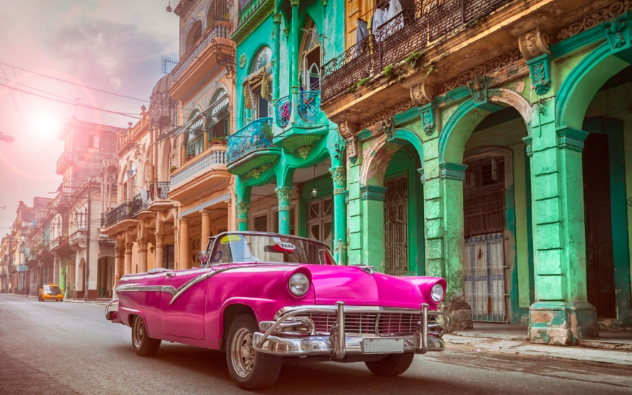
May 29, 2020
Ranad haddi (1707586)
Global Destination Management (M6X01932)

Welcome to Cuba

Cuba is the largest island in the Caribbean located south of the United States, north of Jamaica and east of Mexico. With a population of 11,179,995 across a total area of 110,860km², this lively nation’s age structure sees over 71% of the population being under 65. Cuba is differentiated by vast mountains covering over one third of the total land area whilst the remaining portion is flat land. Throughout Cuba there are 200 bays and 289 beaches, most of the rivers being shallow (WorldAtlas, 2020).

Cuba has a rich vegetation and is an ideal environment for agriculture with much of the island being forested. Nearly 7000 species of plants can be found in Cuba with around 50% being native to the island. Orchids are prominent amongst the varied flora, in vibrant colours and flawless shapes, existing in over 300 species. The national flower being a butterfly jasmine, a tiny orchid with white petals and the national tree is the Royal Palm. The fauna is distinguished by rich wildlife and an abundance of birds. Forming an exuberant image of the Cuban landscape, the flora and fauna of Cuba are one of the primary attractions of this island (Maps of the World, 2020)

Cuba’s plentiful offerings include famous architecture, the fine cigars and vintage cars that are a norm in Cuba as a result of the 1958 embargo. Not to mention the vibrant music and colourful artwork all attracting tourists to this Caribbean country, continuously increasing the tourist market, with contribution to GDP in 2018 being $2.55bn, an increase of $400mn from 2014 (Statista, 2020). Cuba has been described by photographers as an enchanting yet misunderstood gift; an island trapped in the 50’s, untouched by modernisation or the corporate world.

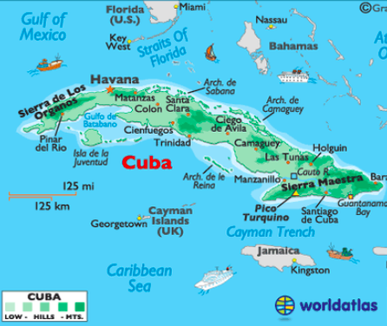
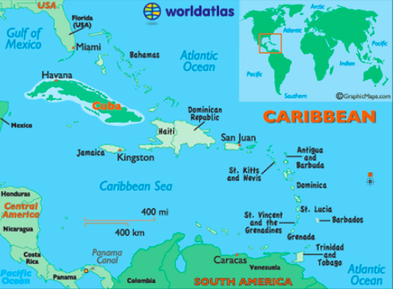

(World Atlas, 2020)
Cuban Culture and Heritage

Despite the socio-cultural privilege attached to whiteness causing many mixed African-European descendants, Mulattos, to minimise their African heritage, at least 50% of the population is classified as Mulatto. Majority of Cubans speak Spanish exclusively with languages of the indigenous population being extinct. Slave-holding European refugees from the 1971 Haitian revolution spoke French but this has since died out (EveryCulture, 2020).

Cuba has one of the highest literacy rates of the world. Whilst this could be a result of the free education system, it can also be argued that communist states operating command economies, such as Cuba, have a tendency to exaggerate government statistics. Nonetheless, it is known that Cuba has a highly skilled workforce. Cuba’s deep-rooted culture is undeniable, enhanced through having undergone a major transformation since the revolution. For example, nearly 20 times the number of libraries and museums opened up throughout the country. Additionally, over 200 neighbourhood cultural centres offering workshops in all depths of the arts and regularly displaying the work of Cuban artists (Britannica, 2020). Music, dance, drums and art all being pillars of the Cuban culture.

A study testing cultural tourism typology was carried out and face-to-face interviews were conducted in the Departure Lounge of Hong Kong International Airport. The study, conducted by eight researchers via a multistage cluster sampling design was carried out over two months. This showed that cultural distance explicitly influences participation, those from more culturally distant countries had increased motivation for cultural travel and seeking deeper experiences (Cros, 2003). The tourist market is becoming more aware of the need for self-actualisation, as Maslow explains. Knowledge gained through new experiences, that niche destinations such as Cuba can provide, can enhance this. In turn, more consumers are basing destination decisions on less materialistic aspects thus changing market trends and making way for new emerging markets.
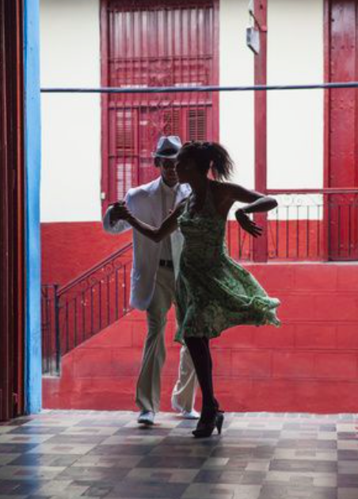
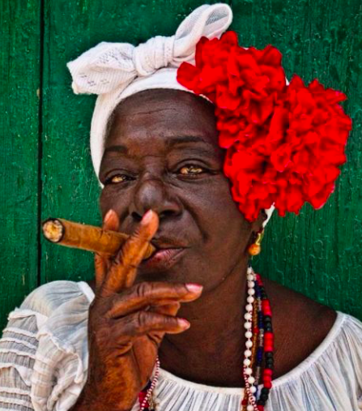
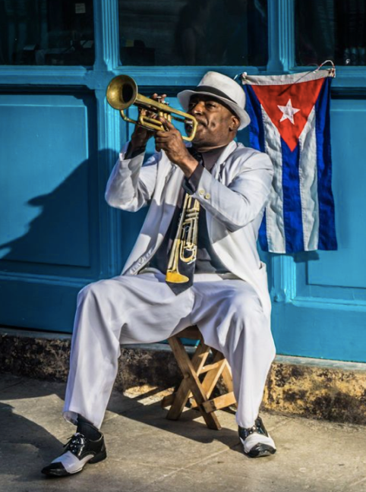

Unique Selling Points and Key Tourist Attractions

- A living museum; sustainability and preservation
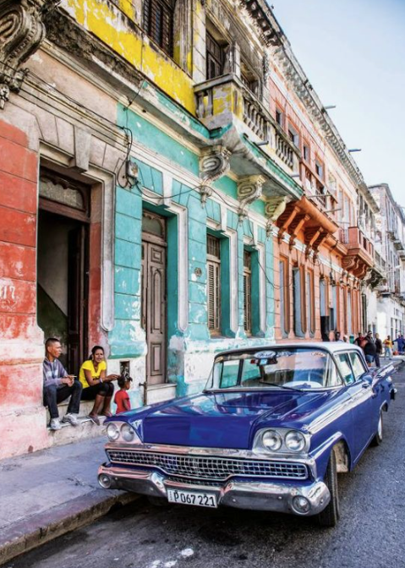
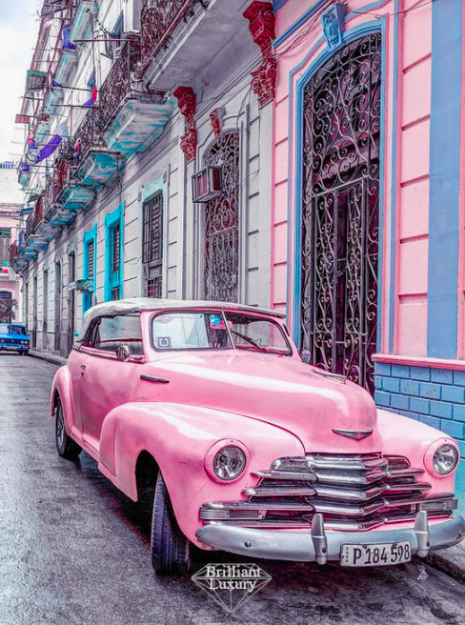
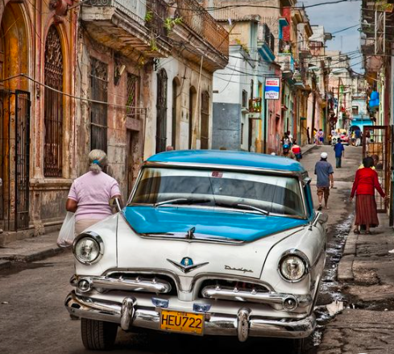
Although Cuba is an exasperated country, placed under strict rations and an embargo leading to vast shortages of essentials, its people exhibit extraordinarily admirable resilience, necessity leading to inventiveness in the face of hardship. Cuba has become a living museum of old cars as the skill of its inhabitants have kept cars from the 1950s in good running and cosmetic condition, without the original spare parts. Due to this, it is the prime destination of choice for vintage-car collectors from the United States and Europe.

- Experience socialism first-hand
Cuba exhibits one of the last remnants of real socialism in the world. Giant ads and marketing campaigns for consumer products from multinational companies are nowhere to be seen, all branded items are prohibited, labels must be taken off all American goods such as Coca Cola by tourists entering the country. Public rallies are still held on historic anniversaries, large billboards are displayed with political messages and there are parks, statues and institutions named after ideological heroes like Vladimir Lenin and Karl Marx (Maseda, 2019).
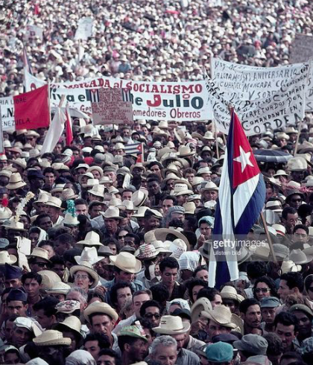
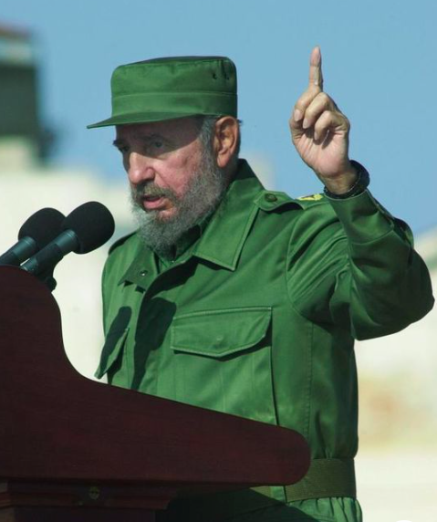
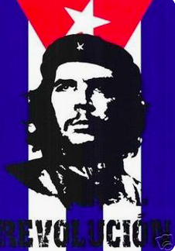

- World-famous cigars
Cuban cigar rollers are considered among the best in the world, with their factory tours being highly popular amongst tourists. These cigars possess unique qualities signified by their reputation and history. This also enhances the notion of a “morally good” market transaction in a carefully regulated environment, demonstrating showmanship and expertise (Simoni, 2009).




- Caribbean food, Rum and Coffee
Gastro-tourism is a niche that attracts billions of tourists worldwide. Emerging markets in underdeveloped countries, such as Cuba, enveloped by developed nations such as the US can maintain successful gastro-tourism figures, providing basic infrastructure elements are met for the average tourist (Omar, 2014). Famous for its locally produced rum and coffee, although with limited food supplies, Cuba offers wholesome, natural food, all MSG and preservative free, a major attraction for an increasingly health-conscious tourist market.

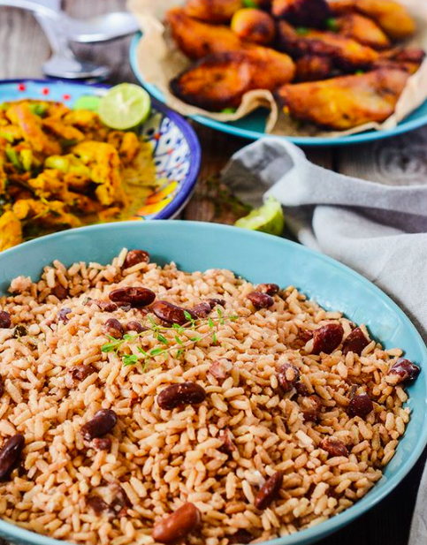
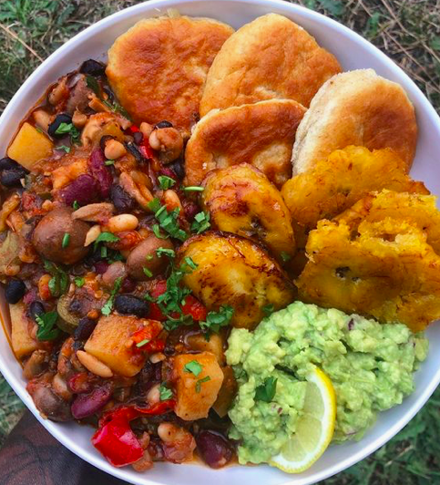

Applying Plog’s model of tourist behaviour, Cuba would attract the more allocentric tourist, meeting new people in unknown environments and experiencing foreign cultures. Understanding tourist motivations, personality traits and in turn behaviour, allows for audience-specific marketing and tailoring consumer experience. As a result, ensuring repeat custom and maximising revenues. On the other hand, other parameters aside from the psychological must be explored to give greater strategic direction as there remain substantial unanswered questions arising from Plog’s findings (Schmierer, 2000).

Although consumer behaviour remains one of the most researched topics in the field of tourism, the research can be seen as fragmented, “it can be argued that tourist motivation is characterised neither by a behaviourist nor by a cognitivist approach but rather by a combination of both” (McCabe, 2000). The push/pull method is widely accepted by many researchers. Whilst Cuba fulfils the intrinsic motivators throughout the push factors such as escapism, rest and relaxation, adventure, it also fulfils pull factors due to the attractiveness of its beaches, tropical climate and cultural attractions (Uysal, 1994). Traditionally, more importance has been placed on push factors in initiating the desire to travel whilst pull factors create more decisive explanations of destination choice (Crompton, 1979).

The Tourist Market and Tourism Development

The Economist reported there are few places as naturally alluring as Cuba and predicted tourism to rise, stating there are far less tourists than there ought to be (Economist, 2017). The people are welcoming, the rum is crisp, the music is a vibrant blend of African and Latin rhythms and the western hemisphere’s largest pool of “free-spending holidaymakers” are just a short distance away.

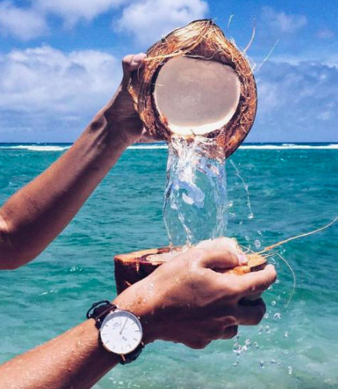
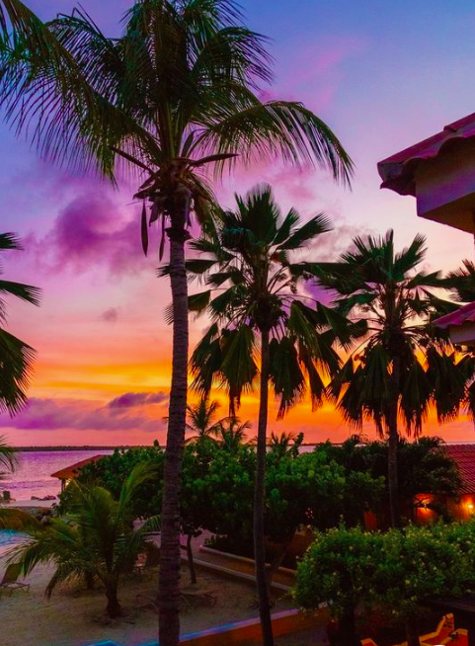

Amongst an economic crisis in the 90’s, the Cuban government invested over $3.5 billion in infrastructure between 1990-1999, the number of rooms available to tourists tripled to 35,000 from 12,000. Substantial resources were devoted to building airports, connecting causeways and tourist facilities, playing on their strengths and shifting production from goods to services.
In February 2019 Cuba had planned to welcome 5 million tourists, aiming to generate an income of over $3billion. If the island had reached their goal, they would have seen a 12th consecutive year of growth in tourism numbers (Forbes, 2019).
Instead, the tourism industry within Cuba saw a sharp decline by February 2020. The number of tourists dropped by almost 10% following mounting pressure from the US limiting transport options of cruise ships and airlines, rounding the year off with a ban on charter flights which contribute to 32% of the Cuban tourism market. Another blow to the Cuban economy arises from the collapse of European visitors with a loss of 28.8% over 2019 as a result of political and economic problems. One major blow being the bankruptcy of one of Cuba’s most prominent tour operators, Thomas Cook, immediately stopping thousands of tourists from visiting Cuba (Havana Times, 2020).

A dual-currency system operates in Cuba, with the convertible peso (CUC) used by tourists whilst locals use Cuban peso (CUP). Income generated by tourism is crucial in giving Cubans access to much more valuable CUC and supporting entrepreneurs who are driving taxis, opening restaurants and opening up their homes to tourists. Being a communist nation, these are some of the select few forms of permitted private enterprise. These would otherwise generate an average state salary of just $15-$25 per month, buying next to nothing at the local market. Cuban infrastructure was unable to sustain the rapid pace of change as new airlines began flying into the island and huge cruise ships were docking in its ports, unloading thousands of tourists at a time into the beaches and the cities. Prices of Havana hotels rose more than 125% over two years. Around 4,000 private rooms were added to Airbnb Cuba in 2016 alone (Harvard University, 2020).
This shows that the real challenge is remaining structurally competitive whilst allowing tourism to develop sectors of the domestic economy that may not be truly competitive. A basic principle has allowed for sustained utilization of tourist demand, by not forcing any tourist to buy national products, especially products not considered internationally competitive. Thus, the government does not provide support to national products in the context of the tourism industry.
Market sectors relating to tourism operate within a competitive environment with 61% of the sector’s purchases being domestic, rising from only 18% in 1990, resulting in 198,000 jobs being recovered or created (Gaspar, 2020).

Effective application of the Butler model allows for increased return on promotional campaigns, enabling analysis of the current market and extending the life of future growth through adapting the country’s approach as it progresses through its life cycle.
Cuba has overcome its development stage, has experienced successful tourism and is now the second most popular tourist destination in the Caribbean region. However, a risk of stagnation exists within every tourist market. Tourist trends are volatile and ever-changing. Many of Cuba’s early tourists are now seeking cheaper alternatives which are widely available. Several Mediterranean countries have since developed their tourist potential causing these established resorts throughout Cuba to see a fall in their client base. Nonetheless, a highly educated population and improved infrastructure of communications and roads has enabled successful tourism. The Cuban government’s support mechanisms and economic policies compliment its advantages and create a secure environment for a thriving tourist market.
With continuous restrictions from the US, the public have a responsibility to continue to promote, educate and ensure this country remains at the forefront of consumers’ minds in order to ensure growth. This would in turn require continued promotional spend (IMS, 2020).
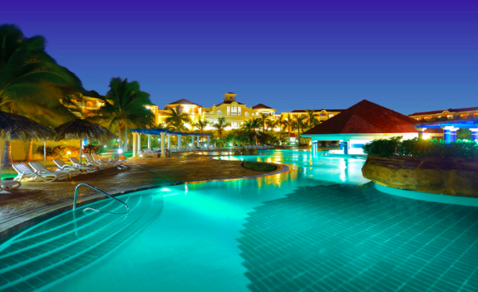
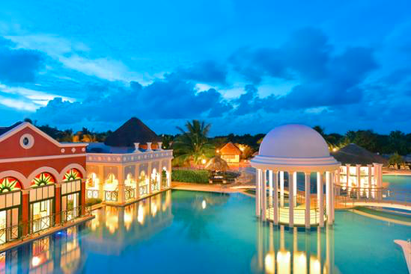

Increased tourist spend from inbound markets has direct, indirect and induced effects on the host destination, creating increased demand leading to increased production and employment. This is imperative for individual humanitarian growth, even more so within a socialist society. The effects of this injection of expenditure on domestic output enhances the multiplier effect created through links between tourism and other business sectors, reducing import leakages, essential for an already restricted Cuba. However, this view is often considered misleading and superficial as an economy-wide effect must be considered when determining the impact increased tourism expenditure has on a destination (Larry Dwyer, 2000).

Tourist Demographics

Leading source countries for international tourists in Cuba in 2018 were reportedly Canada and the United States which may prove problematic due to the economic boycott of the US and recent travel restrictions. This shows that increased investment in widening tourist demographics is required.
According to TripAdvisor and other social media networks, Cuba is popular amongst both group and solo travellers. Those that book tour guides and others who seek adventure and Instagram worthy photos from their experiences, particularly throughout tourists aged 20-35.
Hence, there is a wide scope of opportunity for engaging new audiences.

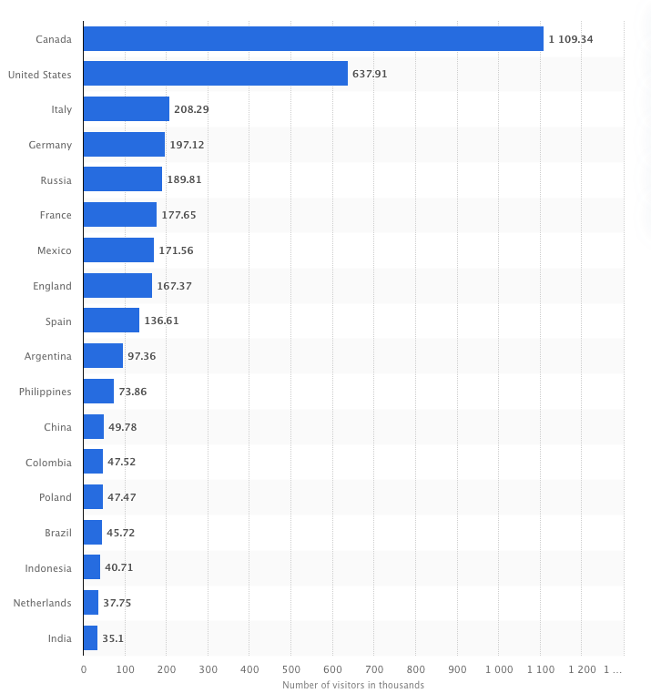

(Statista, 2018)

The number of same-day and overnight visitors are relatively equal with the average number of travellers being 2, staying for an average of 2 days. Despite having gathered these statistics from the UNWTO, further inspection creates doubt. There are few statistics surrounding Cuba’s visitor profile, the lack of accurate statistics is a common theme across Latin America as limitations have resulted in gathering statistics from secondary sources (Mesa-Lago, 1969).

Future Tourism Growth

Although the new restrictions put in place by the U.S. government will not have a great effect in practice, it does produce collateral damage by altering visitors’ perceptions of travelling to Cuba, once again creating confusion amongst Americans on their ability to travel to this country. These new regulations are an attempt to reduce the overall income generated from tourism and penalize the Cuban government by preventing Americans from flying into any airport except Havana (Forbes, 2020).
Cuba’s economic hardship paired with extensive bureaucracy impacts development here, many new resorts are planned but their construction will take time. The development of tourism on this island depends heavily on high quality air transportation and with the regional air hub for the Caribbean being Miami, in order to meet the needs of its tourist industry, Cuba must reframe its air traffic capacity or extensively promote cruise travel, creating positive opportunity cost.
Additionally, there is new scope for medical tourism throughout Cuba as a result of the low cost of medical facilities and the highly skilled workforce. Medical tourism is on the rise across the new generation, with destinations such as Turkey and Thailand experiencing sky rocketing figures in this sector. Many patients across USA and Canada are looking into Cuba as a possible destination for a wide range of treatments.
Investment in hotels is increasing exponentially. This poses a challenge to the Cuban government to reduce the speed of growth and accelerate investment into non-hotel facilities and tourist infrastructure. Despite the comparatively low investment in these sectors, these amenities generate 18% of industry income. In the outset of developing Cuba’s tourist market, the emphasis was on attracting large quantities of visitors through all-inclusive packages. This proposed shift requires changing mentalities surrounding the conception of tourism. Is it worthwhile to continue to create a surplus of hotel capacity in such excess as opposed to offering tourists additional infrastructure beyond resorts? Will tourists continue to flock if amenities are stagnant purely for the cultural value of this country? Over time, this is highly unlikely, and these new streams must be looked into to preserve the current tourist market as well as growing a fruitful future market (Gaspar, 2020).
Applying Poon’s theory of competitive strategies, Cuba currently demonstrates a broad differentiation strategy. Successful differentiation allows Cuba to command a premium price from tourists which they are willing to pay for due to the differentiated features and vastly increase visitor numbers. For continued growth, Cuba can enhance this differentiation through striving for greater innovation, a trait well known amongst the Cuban people and offering a high level of customer service by improving knowledge and training in these areas. This would in turn overshadow restrictions and potential weaknesses.
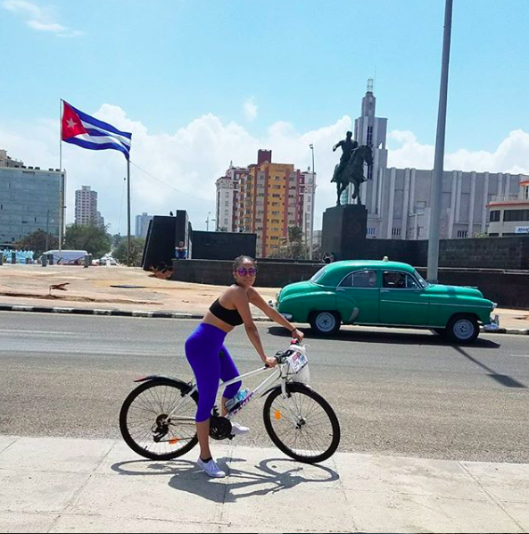
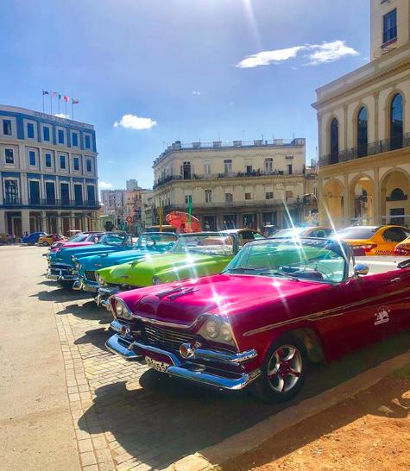
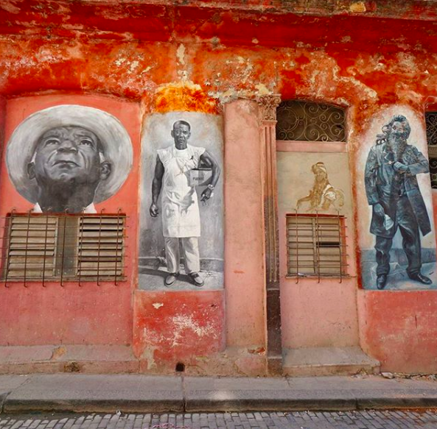

Challenges, Safety and Security

Despite recent advancements, there remain several challenges throughout this nation which may impact tourists both consciously and subconsciously, this is especially the case when delving into the welfare of the Cuban people.
Internet access and usage remains severely restricted, with only 5% having internet access at home. Throughout 2016, the Cuban government approved over 40 wi-fi hot-spots around Havana and other major cities. From then on, entire families began crowding these hot-spots, excited to contact loved ones and see their face via web stream for the first time in decades. However, despite lowering the price of this usage, it remains overly expensive for the vast majority of Cubans (BBC, 2016). Cuba still exhibits the most censored internet access in the western hemisphere.
Freedom of speech and expression can incur jail time in Cuba. For example, a local graffiti artist was imprisoned for majority of 2015 without facing a judge or being formally charged. He was accused of contempt for painting the names of the Castro brothers, Raúl and Fidel, on the back of two live pigs. Before the artist could release the pigs, he had already been arrested. This, among several similar stories may deter potential tourists especially as Amnesty International and other human rights monitors aren’t allowed access to Cuba (Amnesty , 2016).
Political prisoners cause worry for potential tourists. Although the Cuban President was insistent that there are no political prisoners, it is known that Cuba exercises a weekly ritual of arresting and releasing citizens demanding increased human rights. This has proved distressing for some tourists, however, opposing parties continue to work towards change. 2015 saw the release of 53 people named political prisoners by the United States, as part of the deal to normalise trade relations, despite the regime denying their existence for decades (Qiu, 2016).
Tourists must implement responsible travel measures to reduce the risk of overtourism and consumption whilst also being conscious of the host society.

Conclusion

Cuba does not see tourism as a short-term solution, nor is it seen as a “necessary evil” embedded amongst a socialist society, as is often described by journalists. Cuban tourism embodies strategic development and falls in line with creating new concepts of sustainable tourism from an economic and social perspective. Weaknesses linked to both objective and subjective factors, such as those explored throughout, must be resolved through a coherent strategy that efficiently uses Cuba’s human capital as it’s principle economic resource (Harvard University, 2020).
The resilience of the Cuban people is demonstrated throughout the country, developing solutions to complicated social and economic problems making it famous for its imaginative and resourceful spirit. The cold war has long finished, and the sun is now setting on the reign of the communist regime that has captivated the heart of millions for decades. Viva La Cuba.

References
Amnesty , 2016. Six facts about censorship in Cuba. [Online]
Available at: https://www.amnesty.org/en/latest/campaigns/2016/03/six-facts-about-censorship-in-cuba/
[Accessed 28 may 2020].
BBC, 2016. Cuba internet access still severely restricted. [Online]
Available at: https://www.bbc.co.uk/news/world-latin-america-35865283
[Accessed 28 may 2020].
Britannica, 2020. Cuba. [Online]
Available at: https://www.britannica.com/place/Cuba/Cultural-life
[Accessed 5 may 2020].
Crompton, J., 1979. Motivations for pleasure vacation. Annals of Tourism Research, 6(4), pp. 408-424.
Cros, B. M. a. H. D., 2003. Testing a cultural tourism typology. International Journal of Tourism Research, 5(1), pp. 45-68.
Economist, 2017. Sun, Sand and Socialism; What the tourist industry reveals about Cuba. The Americas , 1st April.
EveryCulture, 2020. Cuba. [Online]
Available at: https://www.everyculture.com/Cr-Ga/Cuba.html
[Accessed 5 may 2020].
Forbes, 2019. Cuba To Welcome 5 Million Visitors In 2019. [Online]
Available at: https://www.forbes.com/sites/alexandratalty/2019/02/07/cuba-to-welcome-5-million-visitors-in-2019/#515f398e7b70
[Accessed 10 may 2020].
Forbes, 2020. Travel Talk: Overtourism, Pets On Planes, New Restrictions On Cuba. [Online]
Available at: https://www.forbes.com/sites/willmcgough/2020/01/24/travel-talk-overtourism-pets-on-planes-new-restrictions-on-cuba/
[Accessed 28 May 2020].
Gaspar, O. G. C. a. N. G., 2020. PILLARS OF TOURISM DEVELOPMENT STRATEGY. [Online]
Available at: https://revista.drclas.harvard.edu/book/tourism-development-cuban-economy-english-version
[Accessed 12 may 2020].
Gaspar, O. G. C. a. N. G., 2020. Tourism Development for the Cuban Economy. [Online]
Available at: https://revista.drclas.harvard.edu/book/tourism-development-cuban-economy-english-version
[Accessed 28 May 2020].
Harvard University, 2020. Tourism Development for the Cuban Economy. [Online]
Available at: https://revista.drclas.harvard.edu/book/tourism-development-cuban-economy-english-version
[Accessed 28 May 2020].
Harvard University, 2020. Tourism Development for the Cuban Economy (English version). [Online]
Available at: https://revista.drclas.harvard.edu/book/tourism-development-cuban-economy-english-version
[Accessed 10 may 2020].
Havana Times, 2020. Cuba’s Tourism Industry Suffers Sharp Decline. [Online]
Available at: https://havanatimes.org/news/cubas-tourism-industry-suffers-sharp-decline/
[Accessed 10 May 2020].
IMS, 2020. True Benefits of Product Life Cycle Management. [Online]
Available at: https://www.imsmarketing.ie/news/true-benefits-of-product-life-cycle-management/
[Accessed 28 May 2020].
Larry Dwyer, P. F. J. M. R. S., 2000. Current Issues in Tourism. Economic impacts of inbound tourism under different assumptions regarding the macroeconomy, 3(4), pp. 325-363.
Maps of the World, 2020. Geography of Cuba. [Online]
Available at: https://www.mapsofworld.com/cuba/geography-of-cuba.html
[Accessed 4 may 2020].
Maseda, B., 2019. 10 Reasons Why You Need to Visit Cuba. [Online]
Available at: https://theculturetrip.com/caribbean/cuba/articles/10-reasons-you-need-to-visit-cuba/
[Accessed 6 may 2020].
McCabe, S., 2000. Tourism Motivation Process. Annals of Tourism Research, 27(4), pp. 1049-1052.
Mesa-Lago, C., 1969. Latin American Research Review. Availability and Reliability of Stastistics in Socialist Cuba (Part One), 4(1), pp. 53-91.
Omar, H. A. w. &. R. L. W. J. &. M., 2014. Gastro-tourism as destination branding in emerging markets. International Journal of Leisure and Tourism Marketing, 4(1), pp. 1-18.
Qiu, L., 2016. Are there political prisoners in Cuba?. [Online]
Available at: https://www.politifact.com/factchecks/2016/mar/22/raul-castro/are-there-political-prisoners-cuba/
[Accessed 28 may 2020].
Schmierer, M. S. J. &. G. N. W. &. C. L., 2000. Predicting tourism destination choices: Psychographic parameters versus psychological motivations. CATHE 2000: Peak Performance in Tourism and Hospitality Research; Proceedings of the Tenth Australian Tourism and Hospitality Research Conference, February, pp. 2-5.
Simoni, V., 2009. Scaling Cigars in the Cuban tourism economy. Etnografica. Revista do Centro em Rede de Investigacao em Antropologia, 13(2), pp. 417-438.
Statista, 2018. Cuba: main source countries for international tourists 2018. [Online]
Available at: https://www.statista.com/statistics/661579/leading-source-countries-for-international-tourists-cuba/
[Accessed 27 May 2020].
Statista, 2020. Direct contribution of the travel and tourism sector to gross domestic product in Cuba from 2010 to 2018. [Online]
Available at: https://www.statista.com/statistics/528443/direct-contribution-travel-tourism-gdp-cuba/
[Accessed 4 may 2020].
Uysal, M. a. J. C., 1994. Testing the push and pull factors. Annals of Tourism Research, 21(4), pp. 844-846.
World Atlas, 2020. Cuba Geography. [Online]
Available at: https://www.worldatlas.com/webimage/countrys/namerica/caribb/cuba/culand.htm
[Accessed 4 May 2020].
WorldAtlas, 2020. Cuba Geography. [Online]
Available at: https://www.worldatlas.com/webimage/countrys/namerica/caribb/cuba/culand.htm
[Accessed 4 may 2020].

