student name: Rahela begum
student number: 1704788
module: Management & organisational behaviour
module code: BMIH5004
assignment No: 2/2

Hilton Hotel Group

Table of Contents
1. Introduction 3
2. Organisational structure 4
3. Recent change initiatives and its impact, and the ways of managing these 7
4. Organisation's Strategic Direction & Current Business Performance 9
5. Conclusion 11
6. References 12

1. Introduction
For more than a century, Hilton Hotel Group has established its reputation on rising standards of guest experience. Hilton Hotel Group is a global brand of hotels and resorts. Hilton Hotel Group is the flagship company of USA-based multinational hospitality brand Hilton. The original company was founded by Conard Hilton in 1919. As of 2019, Hilton Hotel Group has approximately 584 hotels and resort properties along with around 216,379 rooms around 94 countries worldwide in six continents (Reidhead, 2020). In the year 2020, the Fortune Magazine declared Hilton Group number one in their list (Reidhead, 2020). The hotel group targets both leisure and business travelers with its locations in major areas like city centers, convention centers, near airports, famous tourist destinations all around the world. Th customers who directly book through its channel receive unique discounts and facilities like figital check-in, fee Wi-Fi, key less entry and use mobile app to book specific rooms of their choice.
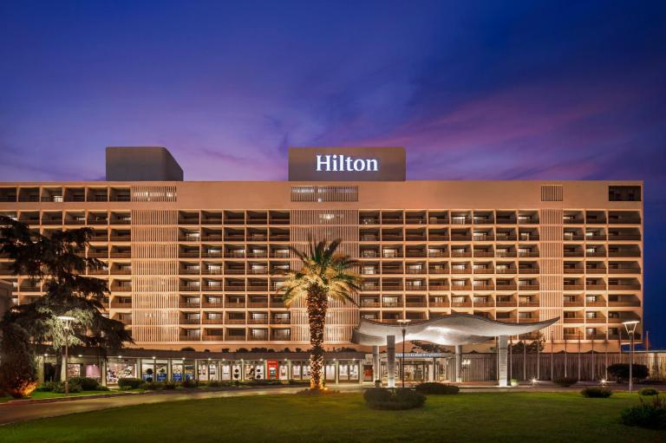
Figure: Hilton Hotel
(Source: https://www.agoda.com/hilton-istanbul-bosphorus/hotel/istanbul-tr.html?cid=1844104)

The assignment is going to discuss organisational structure, culture and goals of Hilton Hotel Group. The assignment will light upon recent change initiative taken by the international hotel group and how the initiatives have impacted its business performance and how the brand has managed recent challenges. The report will discuss strategic direction of the organisation and current business performance.

2. Organisational structure
The organisation structure is an arrangement that outlines how the operations and activities can be achieved within the company (Hirsch, 2018). These activities can include rules and regulations and responsibilities depending on the responsibilities of the position. The flow of information is determined by the organisational structure between the levels of the company.
Hilton Hotel’s organisational structure can be described as a divisional organisational structure. Under a divisional organisation system, a company divides its employees into various departments based on products or markets and services, as opposed to their job roles. The advantage of an organisational structure is that they are specific and efficient. The operational department has a team of its own and they can operate on their own without much interference from other departments (Rutherford, 2021). However, the drawback to this type of organisational structure is that even though every functional department has authority to operate they are reluctant to cooperate with other departments leading to clashes in the company.

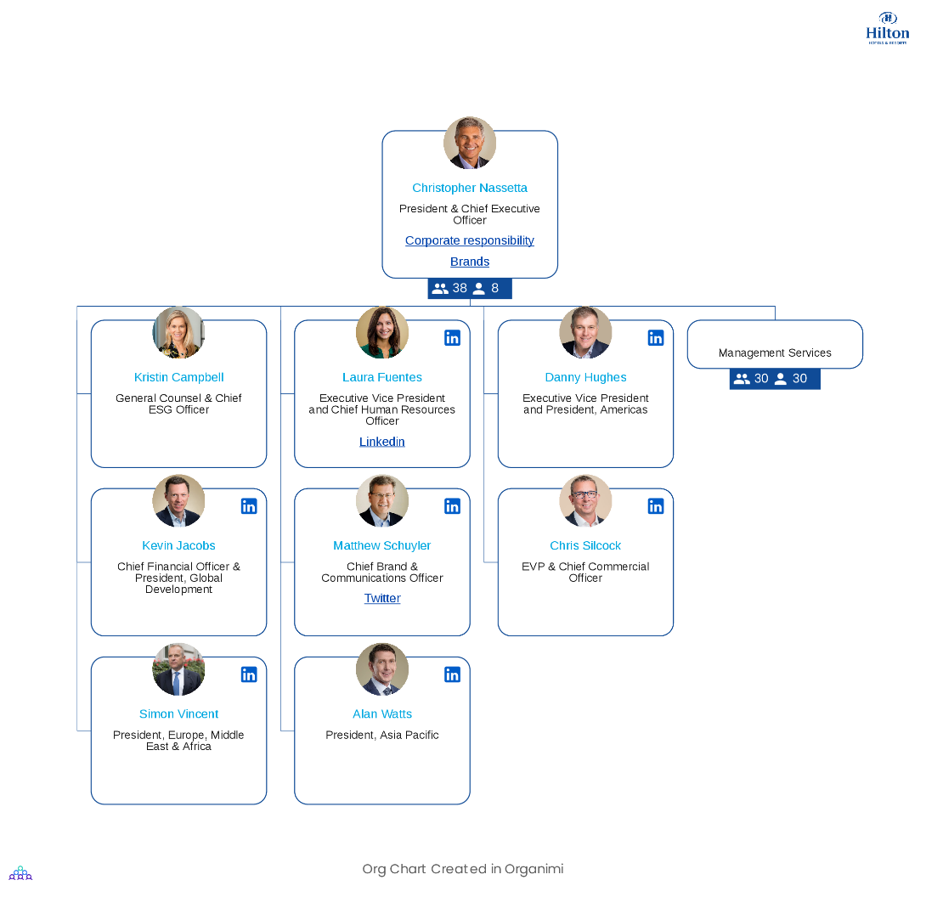
Figure: Organisational structure
(Source: https://www.organimi.com/organizational-structures/hilton/ )
Since Hilton Hotels and Resorts is a global brand chain of hotels, it has to have a divisional organisation system (Gheribi, 2018). The independent division helps to work smoothly and as a whole, the hotel brand has a good name is renowned and well known for its hospitality. There are more than 6800 properties in 94 countries. Hilton is responsible for managing a range of functional and geographic functions since the business itself is divided into so many properties which are divided into three areas:
Ownership: properties solely owned by Hilton
Management and franchise: properties that are managed by Hilton, or the company has franchised their property to others to handle.
Timeshare: grand vacations of the Hilton properties.
The first two, divisions fall under the leadership of Hilton Hotels & Resorts but the third division falls under Hilton Grand Vacations which is a separate entity altogether. In the hotel industry chain of command is important because it is very important that every employee listens to the instruction and abides by them. By following the chain of command, staff members can work efficiently (Nawari, and Ravindran, 2019). The chain of command process usually supports all employees and there is place for delegation. This process helps the employees to understand where they fit into the organisation. Decision-making by the senior management becomes easy if the top to bottom hierarchy structure is followed.
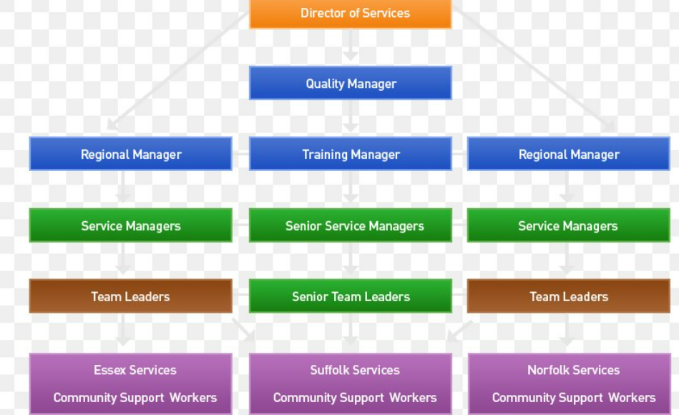
Figure: Chain of Command
(Source: https://favpng.com/png_view/hilton-hotels-resorts-organizational-chart-hilton-hotels-resorts-corporation-png/FWVPyD7M )
The organisational structure includes the company culture as well and it is equally important as the organisational structure. It includes the value of the work environment, behaviour and attitude of the employees. Employees of the hotel have to behave cordially and be polite to their customers. There is a mutual relation between organisational structure and organisational culture and they go hand in hand (Winnubst, 2017). The organisational culture that Hilton Hotels follow is based on hospitality. To the management of the company, being hospitable to the customers who come to stay there is their utmost priority. Delivering an exceptional experience to the guests of the hotels will gain customer satisfaction.

3. Recent change initiatives and its impact, and the ways of managing these
In recent times the international hospitality industry gets affected due to events like Brexit and Covid- 19 pandemic. The CEO of Hilton revealed that Hilton’s business in the UK market is growing at much slower rate. On the other hand, the pandemic disrupted the supply chain of the Hilton Hotel chain worldwide. As the pandemic spread across the whole world, the main focus of the governments and businesses were safety of the people. The pandemic has made a huge impact on the business of the Hilton Hotel Groups around the world. Like most of the resorts and hotels, the primary challenge of the Hotel group was to handle the result from cancellations (Chang, Ku and Chen, 2019). However, with time, the challenge posed by the pandemic became a common sentiment towards travel and in order to overcome the challenges the hotel group took several measures, strategies and tried to adopt new business models in order to survive during the unpredictable adverse situation (Çetin, Ultav and Funda, 2019). The company brought several product innovation and marketing creativity in order to hold their grip in the market.
The Hilton Hotel Group is a renowned hotel chain which has recently been affected for several reasons. This, in turn, has changed the way of their operations. The pandemic situation has drastically affected the global hospitality industry, and the Hilton hotel group is not out of that. While the effect of covid-19 has been devastating across the board, the travel and hospitality industry was hit hardest (Shin et al., 2020). Along with Brexit, the pandemic situation also created an initial challenge for Hilton: managing the fallout from the cancellation. It has directly affected the company’s revenue, and the contribution to the GDP by the hotel decreased. The concerned company has also faced challenges due to its employees’ motivations (Reidhead, 2020). Taylor’s theory of scientific management is important in this aspect.
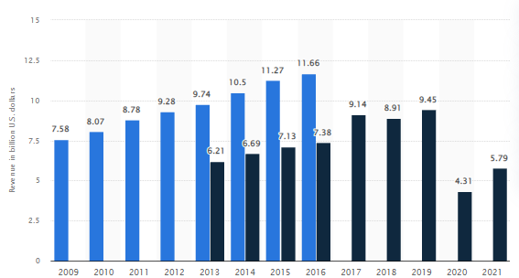
Figure: Revenue of Hilton Hotel (2009-2021)
(Source: https://www.statista.com/statistics/297760/revenue-of-hilton-worldwide-holdings-inc/)
The theory has evaluated that motivating the employees enhances the employees’ remuneration. They don’t like working, and for that reason, managers have supervision and split their work (Khorasani and Almasifard, 2017). Nowadays, the hotel group has implemented a great level of employment strategies in the direction of enhancing productivity. The strategy of the hotel chain is to inspire renewed trust as well as confidence in both travel and the appearance of the brand in order to include three insight-driven pillars- customer connection, product innovation, and marketing creativity. With the help of these ways, the company can bring changes in respect of challenges ((Hinterhuber and Liozu, 2017)). The financial and operational condition of the hotel group is also rapidly changing because of the Brexit and pandemic situation.
The overall hotel group is facing these challenges in which customers are not willing in the direction of staying outsides. The hotel has evaluated that the percentage of consumers has reduced approx. 50% to 60%, and that directly impacted the revenues and the growth (Hinterhuber and Liozu, 2017). In the direction of bringing changes in this aspect, the company needs to establish a process range as well as procedures for reducing the resistance and consumers’ hesitations to travel and stay within the hotel (Le and Phi, 2021). The company has also created a program which would be assured the same care and diligence in cleaning their rooms of hotels.

4. Organisation's Strategic Direction & Current Business Performance
Being an industry pioneer, Hilton Hotel successfully manages its strategy and keeps its leading position in the global hotel industry. Its strategy is to address the evolving needs of today’s hotel guests and stay ahead of the globalisation challenges through reinventing the hospitality experience. An organisational strategy is all about thinking ahead of the key issues (Okumus et al., 2019). Strategic direction helps Hilton Hotel Group to determine long-term objectives and goals and allocate necessary resources in order to carry out their organisational goals. Hilton Hotel’s strategic direction is based on adopting a course of action in order to achieve the objectives and goals. Mintzberg’s 5 Ps of the strategic framework suggested that there are five stages in strategic management: pattern, position, plan, perspective and ploy (Khalifa, 2022). All these five stages together allow an organisation to incorporate an effective strategy.

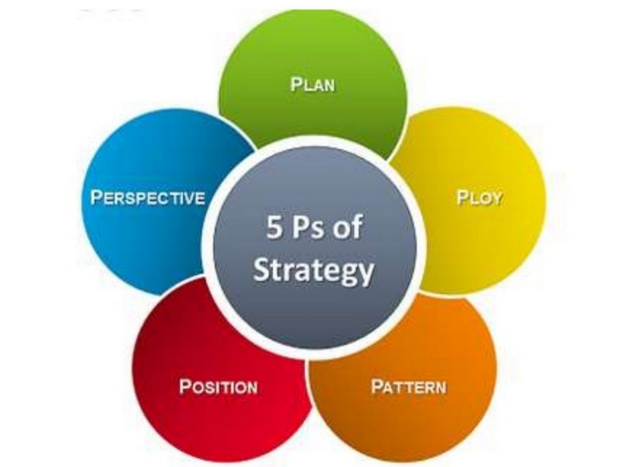
Figure: Mintzberg’s 5 Ps of Strategic Direction
(Source: https://www.marketing91.com/the-5-ps-of-strategy-explained)
Hilton Hotel Group's strategic direction involves different aspects of the organisation, aims for a sustainable future and is concerned with its long-term goals. In order to develop a strategy to deal with a situation, it is essential to plan before taking possible actions. Implementing a strategy requires identifying patterns in the flow of decision-making. Before implementing a strategic direction, it is important for Hilton Hotel to determine the organisational position before. Another vital part of the strategic plan is to discover how different audiences perceive the hotel. The final stage of strategic direction is to utilise a ploy that the competitors would not expect (Khalifa, 2022).
Hilton Hotel's strategic direction is driven by three pillars: customer connection, marketing creativity and product innovation. In terms of product innovation, amid the pandemic, in order to satisfy customers' changing demand for protection and cleanliness, Hilton Hotel launched a cleaning program for all its hotels (Zeng, 2021). Hilton Hotel has launched a creative marketing campaign, namely To New Memories, to reignite travellers' passion for travelling.
Business Performance
With over 700 sales executives worldwide, Hilton Hotel is engaged in offering a differentiated selling platform. The company is successful in growing its market share globally. Hilton Hotel conducts its business operations in 42 different languages and daily serves more than 25000 customers in over a hundred countries globally. During the 3rd quarter of the 2021 financial year, the hotel observed growth in its revenue in the post-pandemic world. In the 3rd quarter of 2021 net income of Hilton Hotel was almost 240 million USD worldwide which is a 132% growth as compared to the past year (Tesse 2021). The occupancy rate in Hilton Hotels is reportedly near 70% in the last six months of 2021. Hilton Hotel reportedly added more than 14700 rooms which have contributed to 6.6% growth annually in the current year (Tesse 2021).
The net income of the hotel chain at the end of the year (2021) was $407 million, which has been reduced due to the impact of the pandemic situation (Business Wire, 2022). As of December 2021, Hilton had $8.9 billion of long-term debt, excluding the deferred discount and financing cost (Business Wire, 2022). Currently, the company has connected itself with the customers in the direction of enhancing their revenue and mitigating the overall challenges they are facing recently.

5. Conclusion
The study has evaluated that the company has faced a major challenge by the Brexit and covid situation. Along with that, the company has also faced some dynamic challenges because of their employees. In order to bring improvement to the company, management authority should be focused on customer connection, product innovation, and marketing creativity. For more than 100 years, Hilton Hotel Group successfully maintained its brand reputation by raising the benchmark of guest experience worldwide. In addition to this, many of the new hotel brands offer hospitality services like a central reservation system, minibar, room service etc. facilities which Hilton Hotels invents. With its innovation and strategic direction, the hotel group successfully held the industry position. Hilton Hotel Group’s organisational structure is divisional as Hilton’s C-suite is responsible for handling a wide range of geographical and functional divisions and the business has divided itself into various properties and they are owned by, franchised or managed by various operators under different brand names (Chang, Ku and Chen, 2019).

6. References
Business Wire, (2022). Hilton reports fourth quarter and full year results. Available at: https://www.businesswire.com/news/home/20220216005103/en/Hilton-Reports-Fourth-Quarter-and-Full-Year-Results#:~:text=Net%20income%20(loss)%20and%20Adjusted,months%20ended%20December%2031%2C%202020. [Accessed July 2, 2022].
Çetin, H.A., Ultav, Z.T. and Funda, U.Z., (2019). Reflections of the Istanbul Hilton Hotel on Mid-century Hotel Buildings in Turkey. Art-Sanat Dergisi, (12), pp.57-88.
Chang, Y.C., Ku, C.H. and Chen, C.H., (2019). Social media analytics: Extracting and visualizing Hilton hotel ratings and reviews from TripAdvisor. International Journal of Information Management, 48, pp.263-279.
Gheribi, E., (2018). Competition Strategies of Selected International Hotels Groups on the Polish Market. J Tourism Hospit, 7(381), pp.2167-0269.
Hinterhuber, A. and Liozu, S.M., (2017). Is innovation in pricing your next source of competitive advantage? 1. In Innovation in Pricing (pp. 11-27). Routledge.
Hirsch, P.M.,( 2018). Processing fads and fashions: An organization-set analysis of cultural industry systems. In The sociology of economic life (pp. 340-356). Routledge.
Khalifa, A.S., (2022). Contesting Mintzberg's five Ps for strategy: it is time for a product recall. Journal of Strategy and Management, (ahead-of-print).
Khorasani, S.T. and Almasifard, M., (2017). Evolution of management theory within 20 century: A systemic overview of paradigm shifts in management. International Review of Management and Marketing, 7(3), pp.134-137.
Le, D. and Phi, G., (2021). Strategic responses of the hotel sector to COVID-19: Toward a refined pandemic crisis management framework. International Journal of Hospitality Management, 94, p.102808.
Nawari, N.O. and Ravindran, S., (2019(. Blockchain and the built environment: Potentials and limitations. Journal of Building Engineering, 25, p.100832.
Okumus, F., Altinay, L., Chathoth, P. and Köseoglu, M.A., (2019). Introduction to strategic management. In Strategic management for hospitality and tourism (pp. 3-21). Routledge.
Reidhead, C., (2020). Impact of organizational culture on employee satisfaction: A case of Hilton hotel, United Kingdom. Journal of Economics and Business, 3(1).
Rutherford, D.G., (2021). Hotel management and operations.
Shin, H., Sharma, A., Nicolau, J.L. and Kang, J., (2021). The impact of hotel CSR for strategic philanthropy on booking behavior and hotel performance during the COVID-19 pandemic. Tourism Management, 85, p.104322.
Tesse Fox, J., (2021). Hilton reports revenue improvements in Q3. [online] Available at: <https://www.hotelmanagement.net/operate/hilton-reports-revenue-improvements-q3#:~:text=Hilton%20also%20added%2014%2C700%20rooms,5%20percent%20and%205.5%20percent.> [Accessed 2 July 2022].
Winnubst, J., (2017). Organizational structure, social support, and burnout. In Professional burnout (pp. 151-162). Routledge.
Zeng, L., (2021). Analysis of Hilton Worldwide Hotel Group’s Transnational Operation Strategy. Academic Journal of Business & Management, 3(11).

