Essay on
Managing Economics
By
Svetla Aleksandrova
Student ID:2029252
Course: Business and Management
Module: Managing Economics
Module code: LCBB5003_BIRM
Module leader: Vasilios Tavlaridis
Uwtsd


Contents
Introduction 3
Economics Market structures 3
Perfect Competition 4
Monopoly 6
Monopolistic competition 8
Duopoly 10
Oligopoly 11
Conclusion 12
Reference List 13

Introduction

Using suitable economic ideas, the essay describes each market form -Perfect Competition Monopoly, Monopoly, Monopolistic competition, Duopoly, Oligopoly. Including graphs for each market structure, providing acceptable instances of managerial choice making in a selected firm, the essay demonstrates the effect of market structure on managerial decision making using appropriate examples.

Economics Market structures

Theories that examine market conditions can be traced back to the idea of market structure. Economists have pinpointed three defining features of market structure: the number, size, and size distribution of sellers and customers; the degree of product differentiation; and the entry requirements. Market structure refers to the conditions under which a business operates. The "discipline" or application of the rule of competition on a firm occurs within the context of the market system. Therefore, it is conceivable to say that market structure is made up of the few, but crucial, strategic environmental factors that affect the firm's core operations. Market structure is embedded within the broader context of a company's operating environment. (Uzonwanne C., Ezenekwe U., 2018)
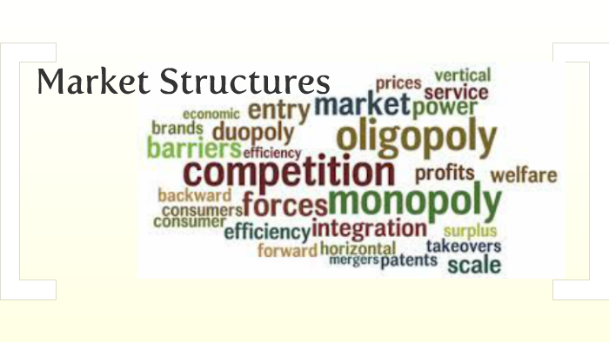

(DreamsTime,2022)

Perfect Competition
Four conditions typically characterise perfect competition:
- Numerous businesses supply a product or service to a market with a large number of consumers. (Marks, SG, 2014, p.219)

- There are no barriers preventing new companies from entering the market. Consequently, the typical competitive firm will generate no economic profit. (Marks, SG, 2014, p.219)
- All companies manufacture and sell identical standard products. Therefore, firms compete solely based on price. Additionally, all consumers have complete knowledge of competing prices. Thus, all goods must be sold at the same price on the market. (Marks, SG, 2014, p.219)

- Companies and customers are price takers. Each company sells a small portion of the industry's total output; therefore, its actions have no effect on price. Each company accepts the price as it is, which is determined by supply and demand. Similarly, every consumer is a price taker who has no impact on the market price. (Marks, SG, 2014, p.219)

It is crucial to remember that these circumstances serve as the perfect representation of a competitive equilibrium. In the real world, certain competitive markets precisely satisfy all four requirements. Since their characteristics are similar to these, many other real-world marketplaces are actually totally competitive. For the time being, it will produce precise price and output predictions for markets with perfect competition using the best model. (Marks, SG, 2014, p.219-220)

Example of Ideal Competition
Typically, real markets fall somewhere between perfect competition and its theoretical opposite, monopolies, in which a single producer controls the entire market. Real-world examples resembling the ideal competition are as follows:

- Farmers' markets: The typical farmers' market is perhaps the most realistic example of perfect competition. Small-scale manufacturers sell nearly identical products at comparable costs. The entrance and departure of a few vendors has no effect on the market, and prices and product descriptions are uniform and transparent.
(Masterclass, 2022)

Emerging technology: Frequently, as in the case of early online retailers, there are no distinct market advantages, and many tech companies provide essentially the same services at comparable prices. As an example, consider the earliest social media companies: a number of new companies offered comparable services for nearly the same price. (Masterclass, 2022)

There may be cheaper versions of the same product available in supermarkets, such as cereal produced by different brands. None of these alternatives will differ significantly in price or quality, so they resemble a perfectly competitive marketplace. (Masterclass, 2022)

The picture below illustrates a diagram of Perfect Competition:

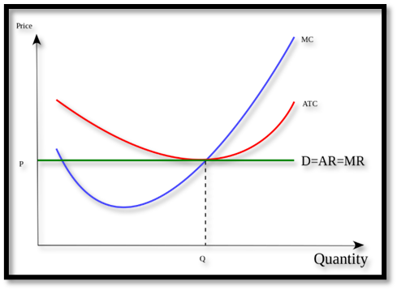



Monopoly

A market arrangement known as a monopoly consists of a single seller who has complete authority over a good or service. The prefix polein, which comes from Greek and means "to sell," and the word mono both indicate single or one. Therefore, "monopoly" literally means "one vendor.” (Kamble S.,2021)
A monopoly differs from other market structures due to its unique characteristics. These characteristics consist of the following:
- Single seller: A single seller is in charge of both making and selling a certain product or service. Also, this means that the seller has a monopoly on the market for the product it sells and has no competitors. (Kamble S.,2021)
- There are no comparable or nearby substitutes for the produced commodity or service by the monopolist..
(Kamble S.,2021)
- Entry-level restrictions - Competition is limited in a monopolised market by factors such as exclusive contracts, high entry barriers, and high production costs for new entrants.(Kamble S.,2021)
- A monopolist has the right to determine the cost of any goods or services it offers.(Kamble S.,2021)

There are few pure monopolies in existence. Government-approved and regulated monopolies in the telecommunications, gas, and electric industries provided some good instances in the past. But over the past few decades, not just in the United States but all throughout the world, these markets have been liberalised and made more competitive. In many areas, though, there are monopolies that are authorised by the local government; these monopolies offer services like local electricity distribution and trash collection. Patent laws can provide businesses momentary monopolies. Certainly, it can be claimed that the pharmaceutical sector makes money while its goods are covered by patents. (Keat, P.G., Young, P.K.Y. and Erfle, S.E. 2014)
In some industries, a firm may be sufficiently dominating that it is considered to have monopolistic status. The antitrust issues with Microsoft are a result of its dominance in PC operating systems. A company may occasionally possess monopoly status as a result of its unique environment. The solitary churrascaria in town or a "last chance" petrol station at the edge of the Mojave Desert are two straightforward examples that come to mind. (Keat, P.G., Young, P.K.Y. and Erfle, S.E. 2014)

Facebook as a Monopoly Life Example
The new market in the twenty-first century is social media. Services are provided without charge to users, yet businesses profit from advertising. Facebook nearly controls this market thanks to its enormous market share. The business is in front of all its rivals, including Twitter and Google+. Users have increased organically, and social media marketers and other businesses, such as WhatsApp and Oculus Rift, have been acquired. The corporation is so large that it was recently accused of influencing users' opinions about how elections are contested and swaying them in favour of a particular candidate or political party. (Srivastav A., 2022)
The picture below shows a monopoly graph:
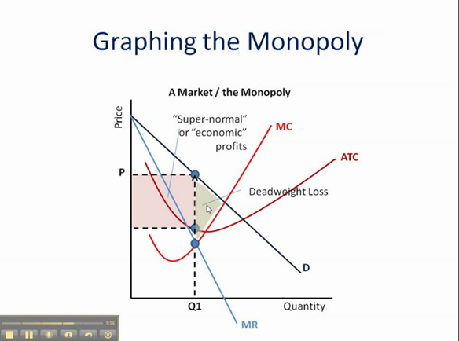
(Purpura K.,2009)

Monopolistic competition

Monopolistic competition describes a market system that falls between monopoly and perfect competition. This market system demonstrates traits of both perfect competition and monopoly. When an industry meets the following conditions:
- Numerous buyers and dealers are present. (Baye, M, & Prince, JT 2016, p.255)
- Each company in the industry manufactures a distinct product. (Baye, M, & Prince, JT 2016, p.255)
- Entry and exit are unrestricted in the industry. (Baye, M, & Prince, JT 2016, p.255)

There are various industries in which corporations develop products that are close equivalents, and the hamburger market is an excellent example. Numerous fast-food restaurants create hamburgers, however the burgers produced by one restaurant differ from those produced by other restaurants. Additionally, new companies can enter the hamburger market with considerable ease. The primary distinction between the models of monopolistic competition and perfect competition is that in monopolistic competition markets, each firm provides a product that differs slightly from the goods of other firms. The products are near, but not exact, replacements. (Baye, M, & Prince, JT 2016, p.255)

Example- Monopolistic competition
Some customers favour McDonald's burgers, while others have strong preferences for Wendy's, Burger King, or any of the other many restaurants that provide hamburgers. Some customers will choose to buy hamburgers from a competitor as the price of McDonald's products climbs. Even if McDonald's pricing are higher than those of competing restaurants, some customers may still choose to eat there. Products in a monopolistically competitive industry are not perfect replacements, therefore each company in the business faces a falling demand curve. The corporation knows it needs to lower prices to boost sales. This is one way in which a monopolistically competitive firm's demand curve diverges from that of a competitive firm. Markets that are monopolistically serviced differ significantly from those that are monopolistically competitive. To start, while a monopolistically competitive firm's demand for its product is declining, it is not alone in the industry; other companies provide substitutes. Furthermore, there are no impediments to entry in monopolistically competitive markets. (Baye, M, & Prince, JT 2016, p.255)

The picture below illustrates a monopolistic competition diagram.
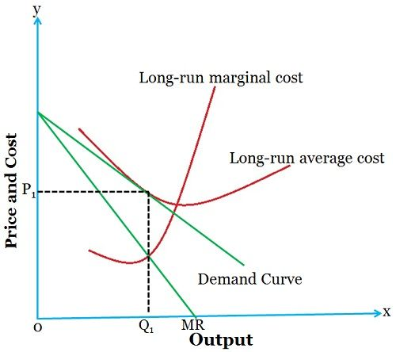
(Surbhi S.,2017)

Duopoly

In a duopoly, two businesses sell the same good to a lot of customers. The market is competitive on the buyers' side because no single customer has enough purchased power to change the product's market price. Duopoly is essentially a two-player variable-sum game as a result. The decisions made by each of the two duopolists will have an impact on both him and his opponent. Although the duopolists' interests are interwoven, neither they nor they are entirely in accord. The duopolists must both worry about what the other duopolist is likely to do, in contrast to the agents in competitive marketplaces. (Friedman J.,1989, p.133-138)
Example of Duopoly
- Visa and Mastercard- These two businesses, which account for 80–90% of the market share, process credit card transactions. This enables Mastercard and Visa to earn very lucrative commissions on the processing of payments. According to Reuters, Visa held 60% of the market share in 2020, followed by Mastercard with 30% and American Express with 8.5%. Mastercard and Visa have unusually high market shares, which prompted the EU Commission to look into monopoly power. Following this investigation's conclusion, the EU Commission ordered both businesses to lower their fees for visitors from other nations. (EconomicsOnline,2021)
- Apple and Android- A staggering 97.3% of the market is accounted for by these two mobile operating systems. Meanwhile, only 2.7% of the market is controlled by their competitors. (EconomicsOnline,2021)
- Boeing and Airbus- Due to their market dominance, Airbus and Boeing, two extremely successful manufacturers of aircraft, create a classic duopoly. Together, Airbus and Boeing control 99% of the market for commercial manufacture. Prior to Airbus' founding in 1970, Boeing held a monopoly; by the 1990s, the two had grown into formidable competitors. It wouldn't be practicable to have several competitors vying for the same market share in the aviation manufacturing sector, which has significant economies of scale and large fixed costs. (EconomicsOnline,2021)

- EasyJet and British Airways- These two airlines have a pure duopoly on the market for direct flights because they both provide service between London and Edinburgh. (EconomicsOnline,2021)

The picture below illustrates Duopoly graph example:
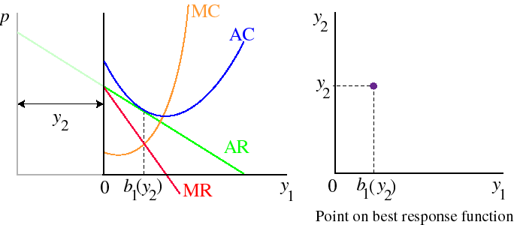
(Osborne M., 1997)

Oligopoly

Oligopoly is a market structure in which the number of firms is low enough to permit entry barriers to be erected. (Sloman, J, Jones, E, Jones, E, & Jones, E 2019, p.113)
Examples of Oligopoly
Oligopoly occurs when a small number of firms control the majority of an industry. Ford, Coca-Cola, Apple, and Tesco are examples of some of the most well-known corporations. The majority of oligopolists produce differentiated goods (e.g., automobiles, soap powder, soft drinks, and electronic devices), but a few may produce nearly identical goods (e.g., metals, petrol). Much of the competition between these oligopolies involves the marketing of their respective brand. Markets for toothbrushes (Wobbly response to oligopoly), supermarkets (Will the Big 4 become the Big 3? and an oligopoly price war), and energy (CMA referral for energy sector ­) are examples of industries dominated by powerful oligopolies. Similar to monopoly, there are obstacles to the entry of new businesses. However, the magnitude of the barriers varies from industry to industry. In some instances, entry is relatively straightforward, while in others, it is nearly impossible. (Sloman, J, Jones, E, Jones, E, & Jones, E 2019, p.121)
The blog Pizza price war on the Sloman Economics News website illustrates this concept of interdependence under oligopoly. When considering a price or product change, for instance, businesses frequently consider the likely responses of their competitors. It is therefore impossible to predict the effect of, say, a price change on a company's sales without first assuming the reactions of other companies. There are multiple oligopoly theories, each based on a distinct set of assumptions regarding how firms will react to a given market situation. (Sloman, J, Jones, E, Jones, E, & Jones, E 2019, p.121
The picture below shows a graph of Oligopoly:
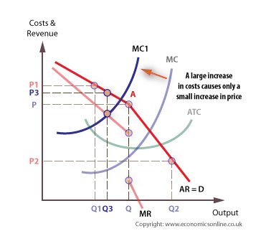
(EconomicsOnline, 2022)

Conclusion
The essay used appropriate economic concepts to define each type of market structure, including perfect competition, monopoly, monopolistic competition, duopoly, and oligopoly. In order to further demonstrate the differences between the various market structures, the essay includes charts and diagrams. Different types of business environments, including regions and enterprises, were used to illustrate the paper's Perfect Competition, Monopoly, Monopolistic competition, Duopoly, and Oligopoly models.

Reference List

- Baye, M, & Prince, JT (2016), Managerial Economics and Business Strategy, October 2022, McGraw-Hill Higher Education, NY. Available at: https://ebookcentral.proquest.com/lib/trinity/reader.action?docID=5471250 (Accessed:1st October 2022)
- Boyce P. (2021), Perfect Competition Definition, 29th March, Available at: Perfect Competition Definition (5 Characteristics, 3 Examples) - BoyceWire (Accessed: 29th September 2022)
- DreamsTime(2022), Available at: Stairs To Success Word Cloud. Stock Illustration - Illustration of tagcloud, cloud: 127972209 (dreamstime.com) (Accessed:29th September 2022)
- EconomicsOnline (2021), What Is a Duopoly?, 7th of June, Available at: https://www.economicsonline.co.uk/competitive_markets/what-is-a-duopoly.html/ (Accessed:1st October 2022)
- EconomicsOnline (2022), Oligopoly, 14th September, Available at: https://www.economicsonline.co.uk/business_economics/oligopoly.html/ (Accessed:1st October,2022)
- Friedman, J.W. (1989). Duopoly. In: Eatwell, J., Milgate, M., Newman, P. (eds) Game Theory. The New Palgrave. Palgrave Macmillan, London, Available at: https://link.springer.com/chapter/10.1007/978-1-349-20181-5_12#citeas (Accessed:1st October 2022)
- Kamble S. (2021), Monopoly: Definition, Types, Characteristics, & Examples, 17th July, Available at: Monopoly: Definition, Types, Characteristics, & Examples | Feedough (Accessed:29th September 2022)
- Keat, P.G., Young, P.K.Y. and Erfle, S.E. (2014) Managerial economics: economic tools for today’s decision makers. Seventh edition. Harlow, England: Pearson Education Limited, Available at: - VleReader (Accessed:29th September 2022)
- Marks, SG (2014), Managerial Economics, Wiley Textbooks, New York. Available at: ProQuest Ebook Central - Reader (Accessed: 29th September 2022).
- Masterclass (2022), Perfect Competition: 3 Examples of the Economic Theory, 31th August, Available at: Perfect Competition: 3 Examples of the Economic Theory - 2022 - MasterClass, (Accessed:29th September 2022)
- Osborne M. (1997), Cournot's duopoly model, Available at: https://www.economics.utoronto.ca/osborne/2x3/tutorial/COURNFRM.HTM (Accessed:12/10/2022)
- Purpura K., (2009), Monopoly: How to Graph It, Available at: (24) Monopoly: How to Graph It - YouTube (Accessed:29th September 2022)
- Sloman, J, Jones, E, Jones, E, & Jones, E (2019), Essential Economics for Business, Pearson Education, Limited, Harlow, 1 October 2022, Available at: https://ebookcentral.proquest.com/lib/trinity/reader.action?docID=5980535 (Accessed:1st October 2022)
- Srivastav A. (2022), Monopoly Examples, Vaidya D., CFA, FRM, Available at: Monopoly Examples -Top 8 Real-Life Examples, Explanations (wallstreetmojo.com) (Accessed:29th September 2022)
- Surbhi S. (2017), Difference Between Monopoly and Monopolistic Competition, 28th September, Available at: https://keydifferences.com/difference-between-monopoly-and-monopolistic-competition.html (Accessed: 1st October 2022)
- Uzonwanne C., Ezenekwe U. (2018), Economics Study Material, November, Amaka Dreams Ltd, Available at: https://www.researchgate.net/publication/337399007_MARKET_STRUCTURE#:~:text=A%20market%20structure%20describes%20the,and%20exit%20from%20the%20market (Accessed:25th September 2022)

