Referencing practice activity
In the following Activity you will find 9 different credible sources, comprising of books, journal articles and websites.

The actual websites and journal articles are connected to the website image with a link, so you can access the original source to look around for information if needs be. To access this please right click on the image and open the link.

For each source, please provide the citation (both variations) and the full reference.

Once complete, make sure you are happy and confident with your answers before submitting to the Turn-It-In link.
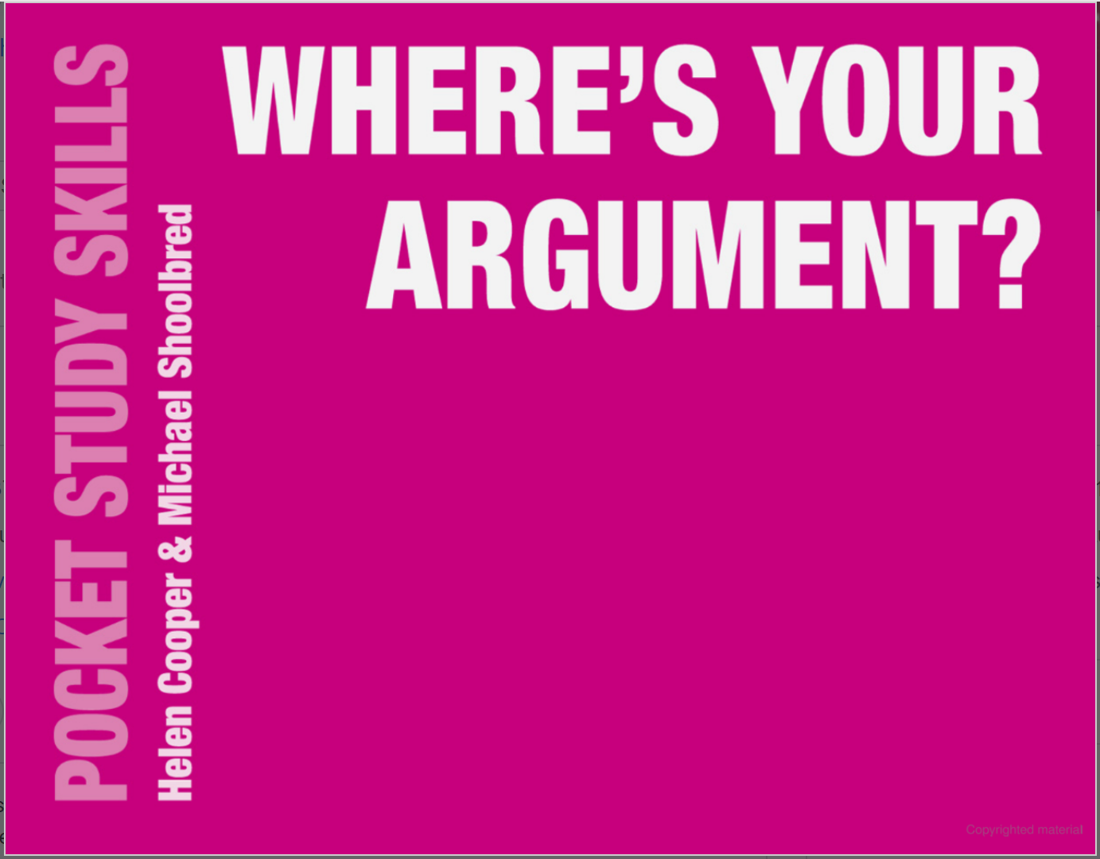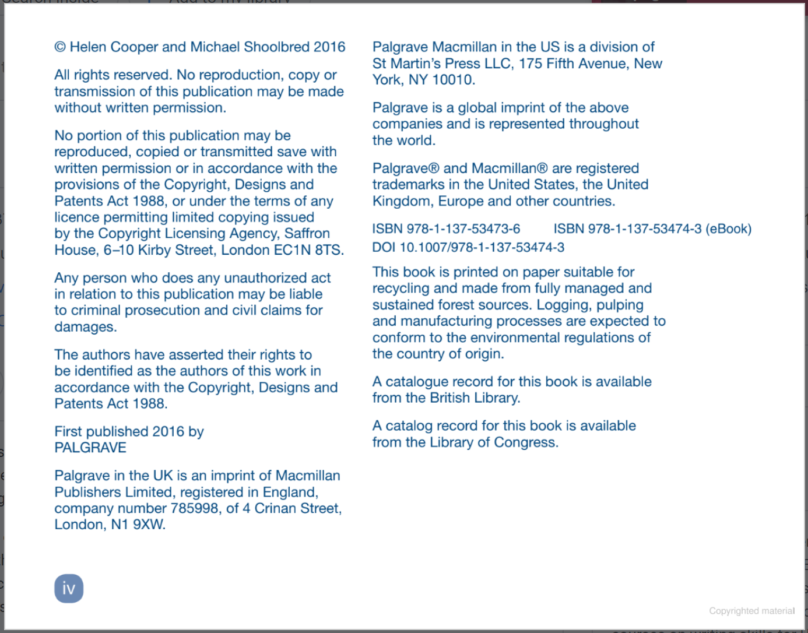

Citation: (Cooper, Shoolbred 2016) / Cooper and Shoolbred (2016) explain that
Reference: Cooper, H. Shoolbred, M. (2016) ‘Where’s your argument? Pocket study skills’. London, Palgrave Macmillan.
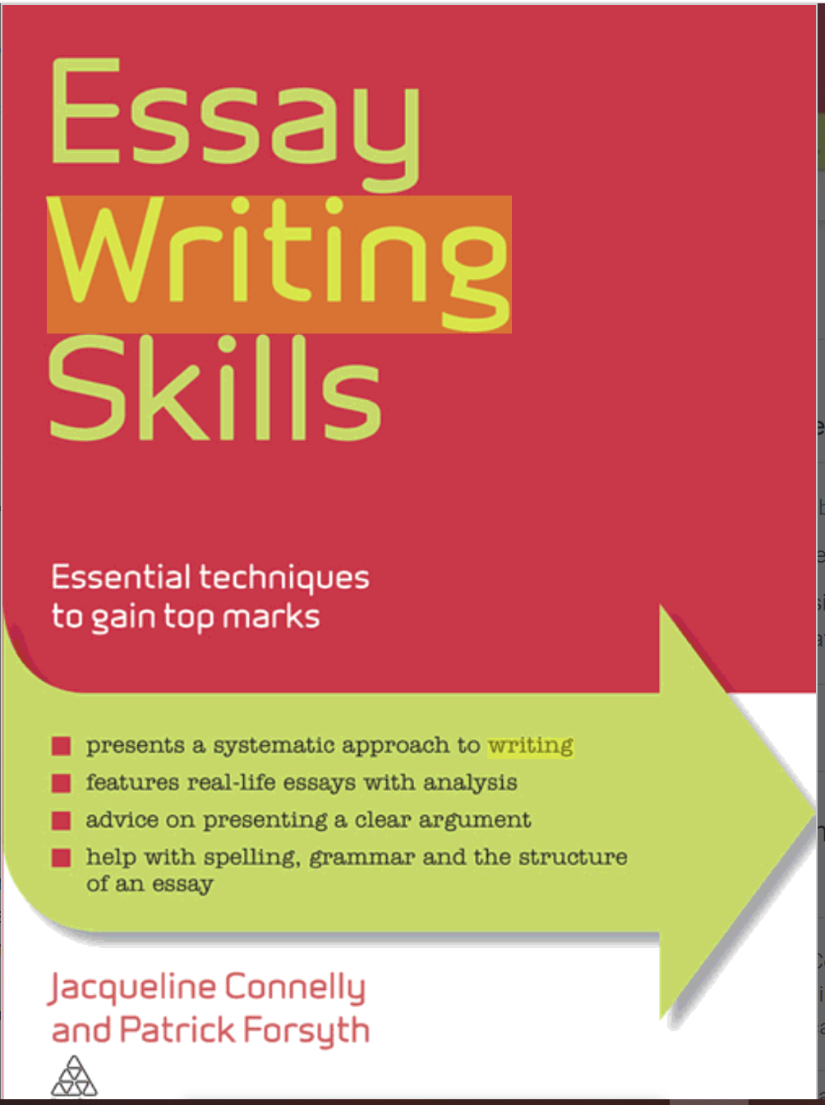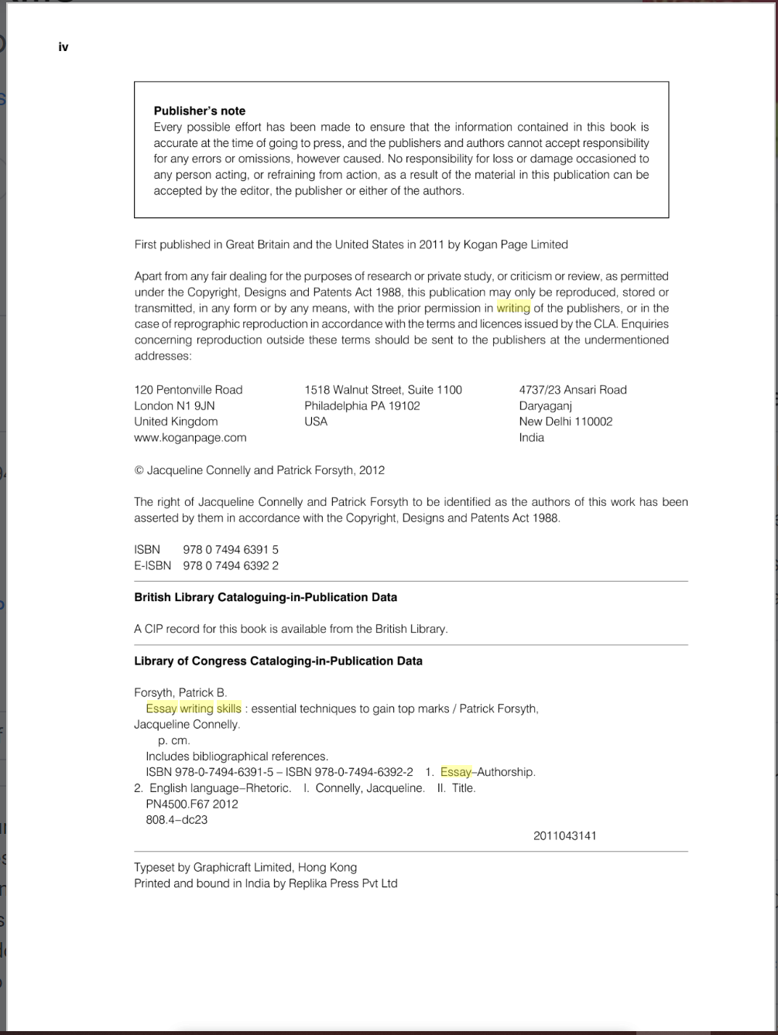
Citation: (Connelly and Forsyth, 2012) / Connelly and Forsyth (2012) state that
Reference: Connelly, J. and Forsyth, P. (2012) ‘Essay Writing Skills: Essential Techniques to Gain Top Marks’. London, Philadelphia: Kogan Page.

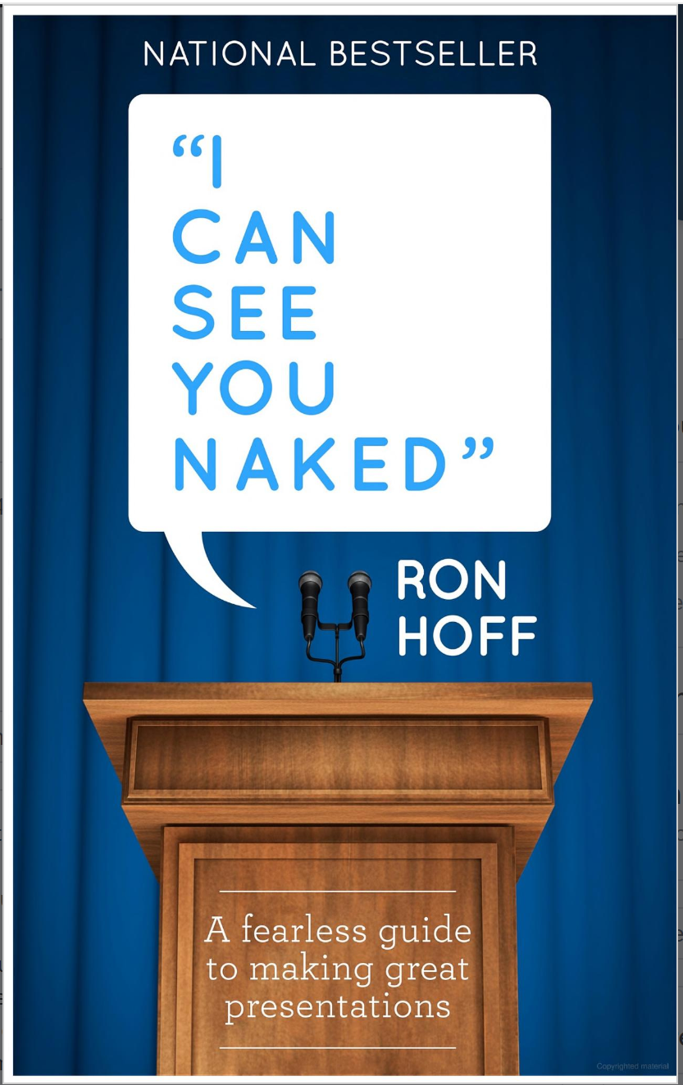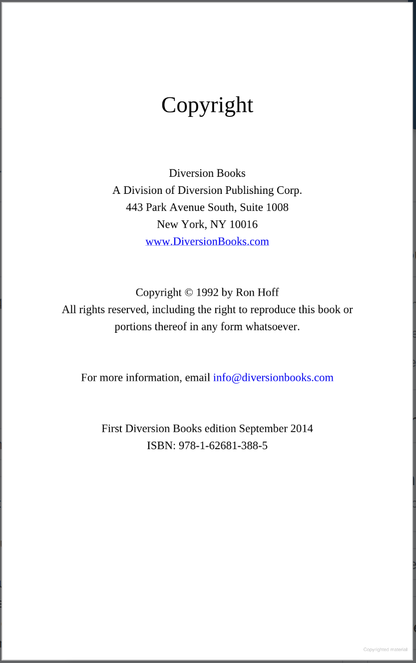
Citation: (Hoff, 2014) / Hoff (2014) explains that
Reference: Hoff, R. (2014) ‘I Can See You Naked: A Fearless Guide to Making Great Presentations’. New York: Diversion Books.
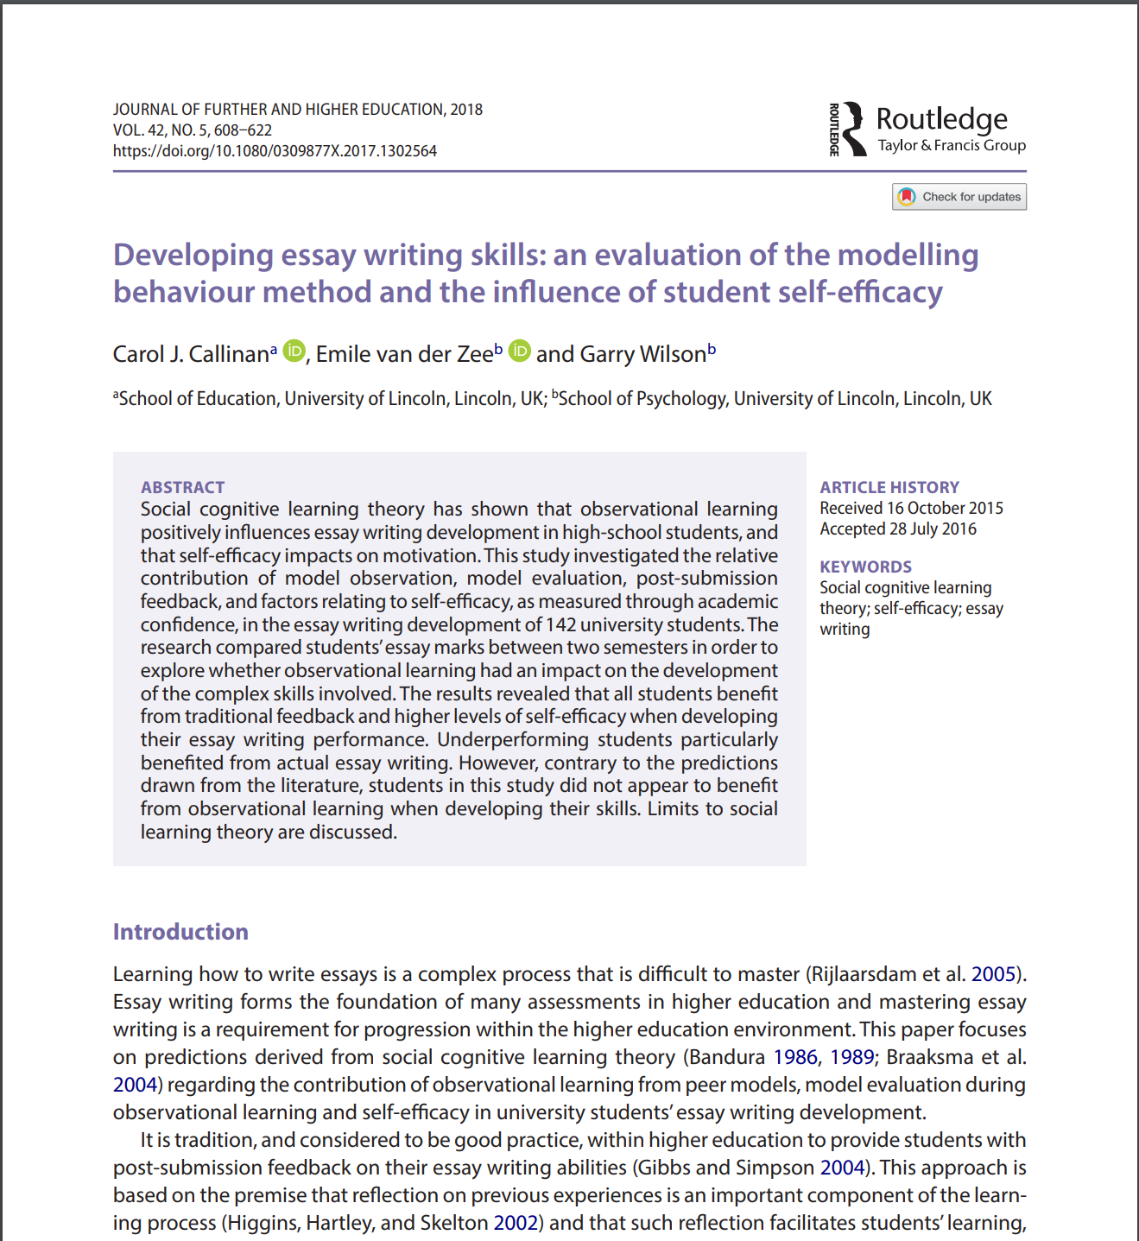
Citation: (Callinan, van der Zee and Wilson, 2018) / Callinan, van der Zee and Wilson (2018) are trying to educate that
Reference: Callinan, C.J., van der Zee, E. and Wilson, G. (2018) ‘Developing essay writing skills: an evaluation of the modelling behaviour method and the influence of student self-efficacy’, Journal of Further and Higher Education, 42(5), pp. 608–622.
Available at: https://doi.org/10.1080/0309877X.2017.1302564 (Accessed 24th September 2026)

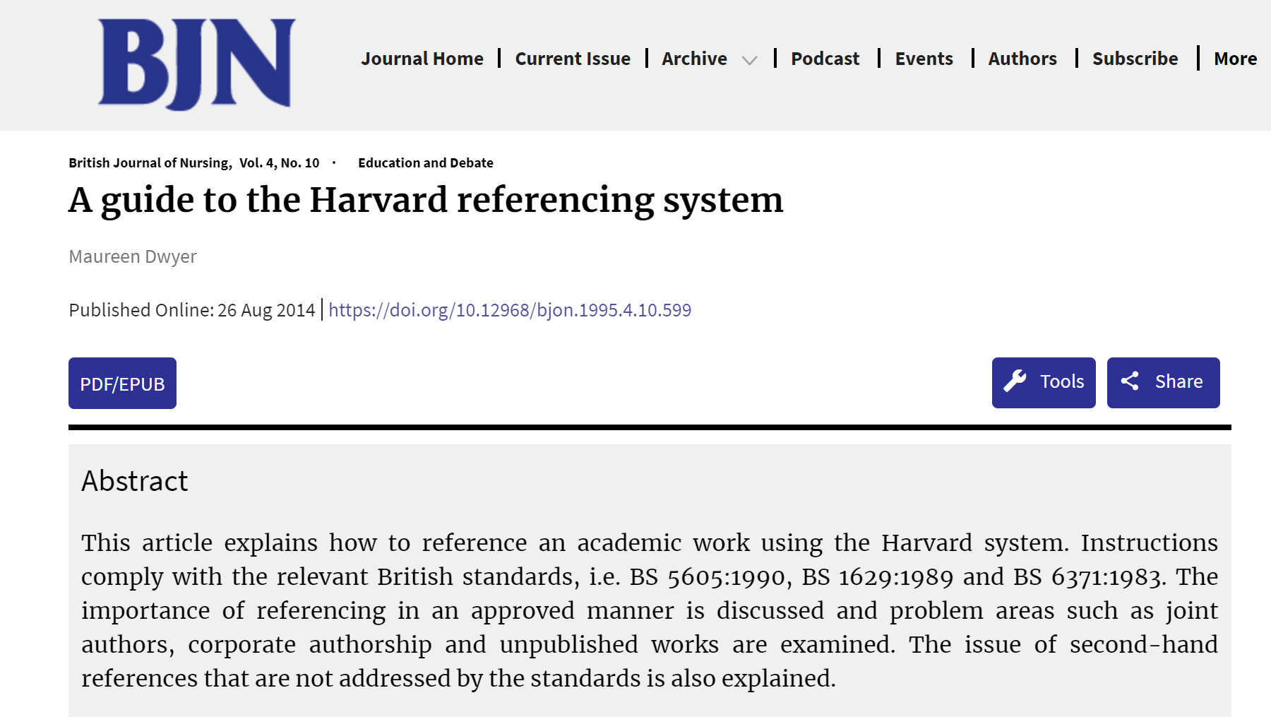
Citation: (Dwyer, 2014) / Dwyer (2014) explains that or (Dwyer, 1995) / Dwyer (1995) explains that
Reference: Dwyer, M. (2014) ‘A guide to the Harvard referencing system’, British Journal of Nursing, 4(10). Available at: https://doi.org/10.12968/bjon.1995.4.10.599 (Accessed: 24th September 2026)
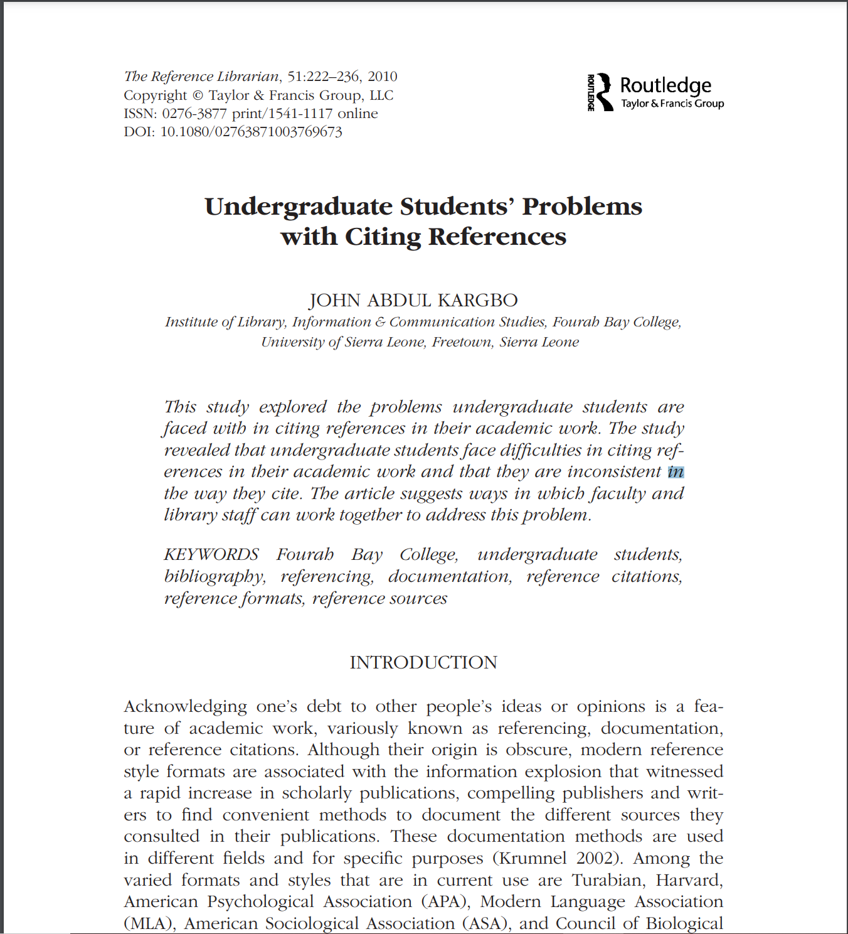
Citation: (Kargbo, 2010) / Kargbo (2010) acknowledges that
Reference: Kargbo, J.A. (2010) ‘Undergraduate students’ problems with citing references’, The Reference Librarian, 51(3), pp. 222–236. Available at: https://doi.org/10.1080/02763871003769673 (Accessed: 24th September 2026)

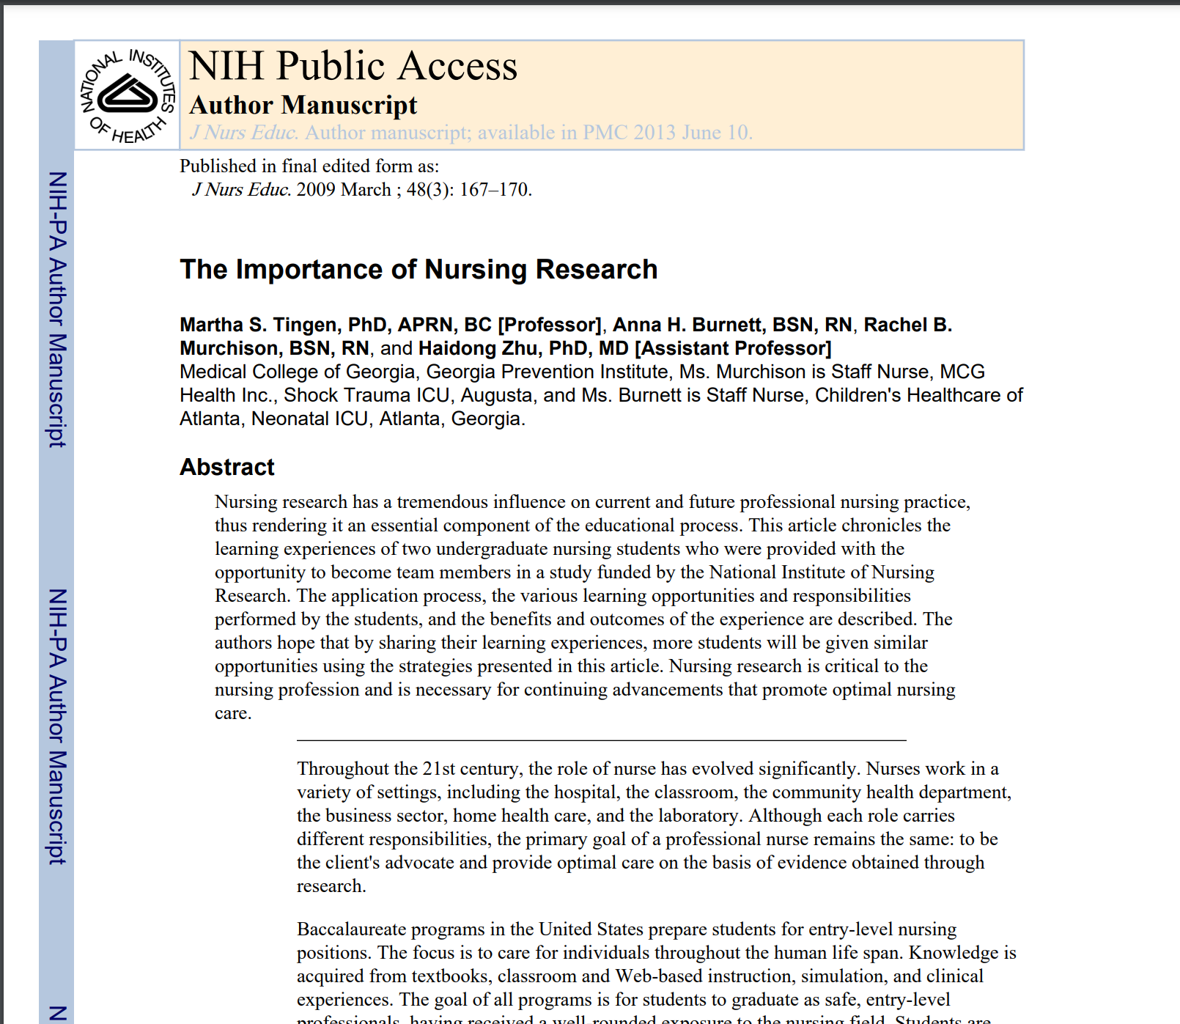
Citation: (Tingen et al., 2009) / Tingen et al, (2009) state that
Reference: Tingen, M.S., Burnett, A.H., Murchison, R.B. and Zhu, H. (2009) ‘The importance of nursing research’, Journal of Nursing Education, 48(3), pp. 167–170.
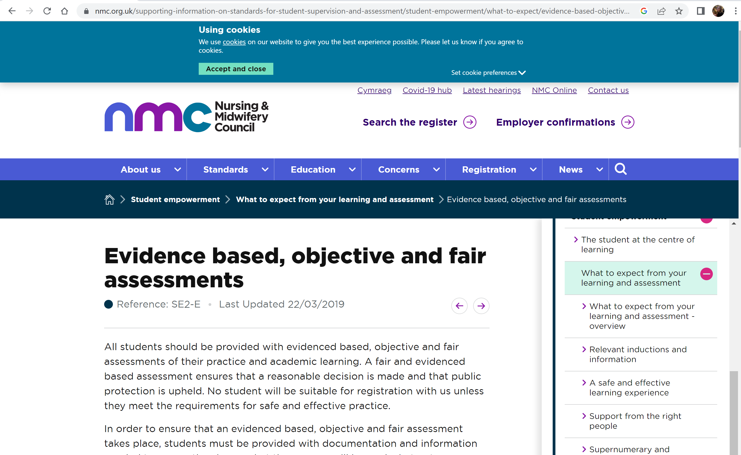
Citation: (Nursing and Midwifery Council, 2019) / The Nursing and Midwifery Council (2019) says that
Reference: Nursing and Midwifery Council (2019) ‘Evidence based, objective and fair assessments’. Available at: https://www.nmc.org.uk/supporting-information-on-standards-for-student-supervision-and-assessment/student-empowerment/what-to-expect/evidence-based-objective-and-fair-assessments/ (Accessed: 24 September 2026).
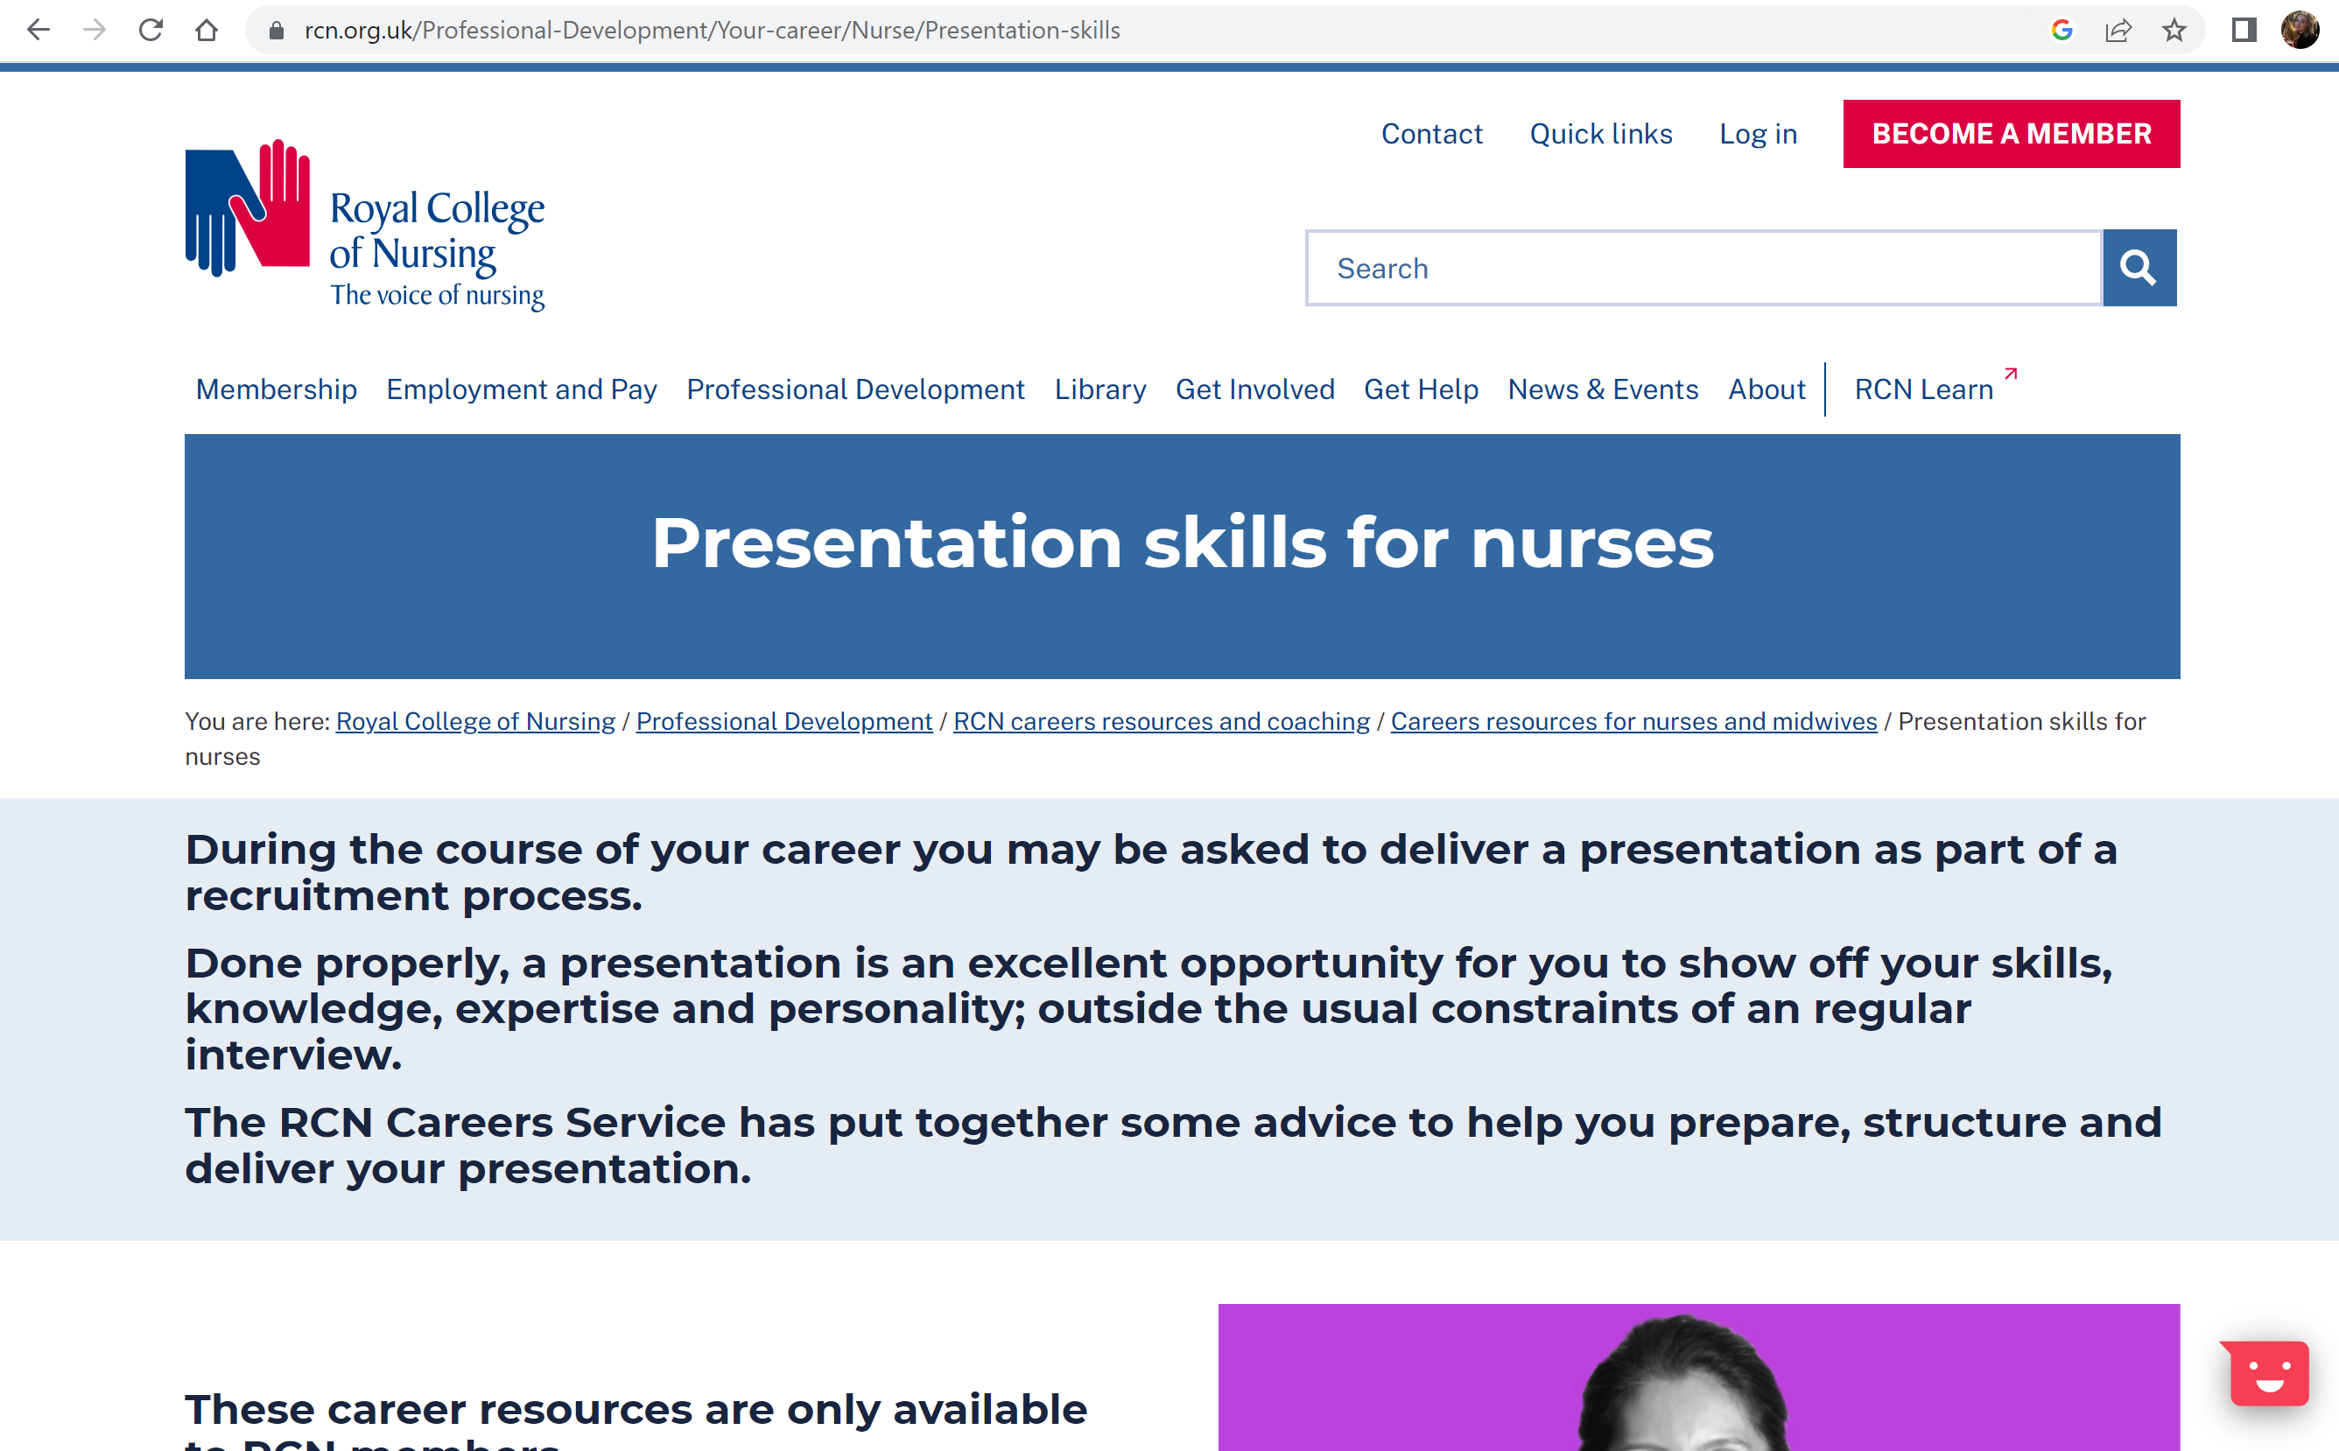
Citation: (Royal College of Nursing, 2026) / the Royal College of Nursing (2026) advises that
Reference: Royal College of Nursing (2026) ‘Presentation skills for nurses’. Available at: https://www.rcn.org.uk/Professional-Development/Your-career/Nurse/Presentation-skills (Accessed: 24 September 2026).

