Ways of Thinking – Jasmine E. Flores
Portfolio of Writing

Observational Writing
Massive Attack – Blue Lines (album cover)
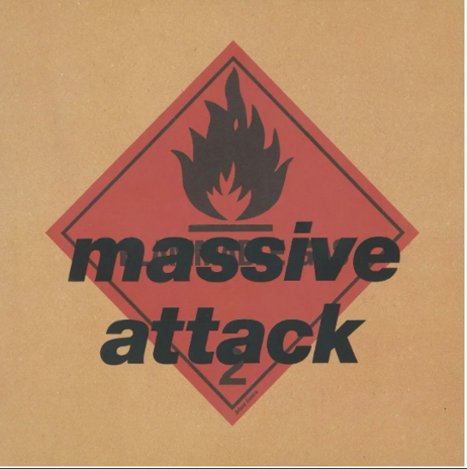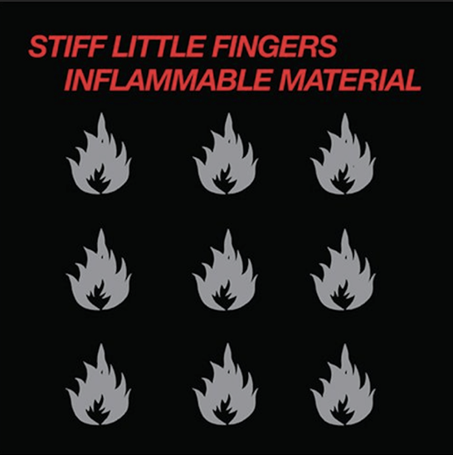
Figure 1: Blue Lines (Robert del Naja, 1991) Figure 2: Inflammable Materials (Stiff Little Fingers, 1979)

I chose the album cover Blue Lines by Massive Attack (figure 1) because I know the album and the graphic design contains interesting visual language. The three key aspects of semiotics I chose were semantic, symbolic and cultural.
The denotation of colours in the design are very simple brown, red and black. The brown aesthetic has a sense of empty visual space around the outside which makes you look to the center point of the design. To me it has a deeper connotation because its visual appearance is an everyday cardboard box, which makes this image commercially accessible to everyone. It’s not glossy for rich people only it’s familiar to everyone and has an informal feeling.
The red geometric diamond shape in the center is simple in design, and the red tone signifies a sense of danger and warning. The symbol used within this is a black flame. This is a signifier for flammable materials, and it suggests something dangerous or exciting, like the music inside is going to explode.
The typeface is modern and minimalistic. It is entirely black with no capital letters for the band’s name massive attack and this intensifies the informal feeling. The black typeface gives a sense of mystery. The size of the album title Blue Lines is minute and barely visible to the naked eye and laid diagonally along the edge of the red diamond. The black and red hues suggest that the music is dangerous new, exciting and unknown. When you look closer, there is a hidden text under it that says flammable. The overlaid text has the appearance of rough graffiti that you might see on the street which is a cultural reference to the singer and artist Robert Del Naja’s background as a graffiti artist (Shaw, 2008). The text and the symbol of the flame are both culturally significant references to the album cover Flammable Materials that he loves (figure 2).
When I first looked at the design, I thought its denotation was quite simplistic yet when I analysed it with Barthes semiotic theory I understood the difference between the denotative and connotative signs utilised within the design (Fisher, 2018). This design holds many hidden connotations such as an urban industrial symbol, deep cultural graffiti and musical references for creative influences providing a very a simple yet deeply powerful aesthetic. I appreciated this album for years but I did not realise the many cultural references and meanings that are hidden within it. It’s a very clever image and suits the creativity of the band and because the designer is also the band’s singer, I think that he can really express who the band is in a powerful visual format.

Bibliography
Dickson, M. (2024) An Intro to Semiotics for Art and Design Students. Available at: https://www.youtube.com/watch?v=DOZLIkiUQz8 (Accessed: 22 November 2025).

Fisher, M. (2018) Media Studies - Roland Barthes' Semiotic Theory - Simple Guide for Students and Teachers. Available at: https://www.youtube.com/watch?v=bow0Y9QUlBU (Accessed 22 November 2025).
Graphic Design Nerd (2025) What is Visual Semiotics? Available at: https://www.youtube.com/watch?v=s0TuJjtTmAo (Accessed: 20 November 2025).

Shaw, A. (2008) From the street to the Southbank. Available at:
https://www.theguardian.com/artanddesign/2008/jun/13/art.electronicmusic (Accessed: 30 November 2025).

Manifesto Writing
Manifesto statements:
- The purpose of design is to communicate concepts in a visual manner.
- Minimalistic approaches to design provide clarity
- Strong design considers cultural contexts and cultural boundaries.
- Typography is a way to enhance visual design.
- Colour hues evoke mood and emotions through design to the observer.
- White space helps to balance design on the page; it’s empty for a purpose.
- Research is important to understand your audience.
- Experimentation is essential but should be considered.

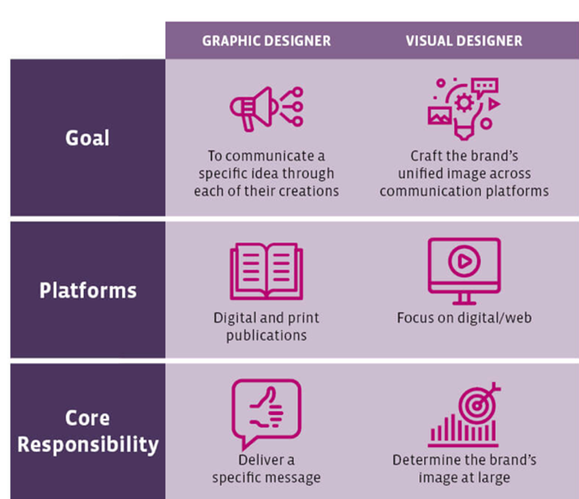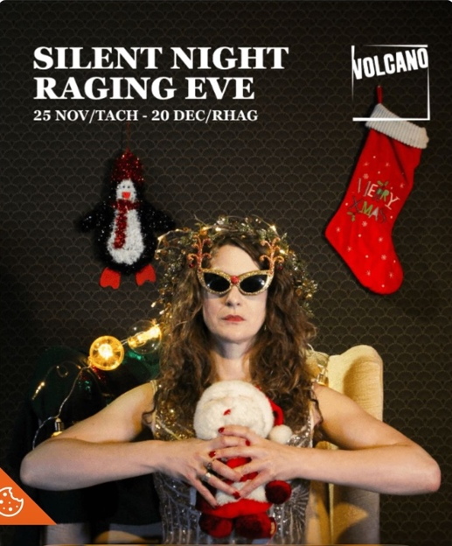
Figure 3 : Graphic design (Pinterest 2025) Figure 4 : Silent Night, Raging Eve, 2025
(Volcano Theatre, 2025)

My first manifesto statement is ‘the purpose of design is to communicate concepts in a visual manner’. This is important to me as I learn more about the process of graphic design from first being given a task or a brief to trying to understand how to use my graphic design skills to represent a variety of concepts. It is a massive process and there may be so many different concepts that we need to communicate. As Ingledew (2011) states “communication is fundamental to creativity in the art and commercial world” (p.8). It’s important to research first, then create a vision of how you want to express and communicate your ideas visually (Gregory, 2015). The graphic design infographic (figure 3) clearly communicates three different categories for graphic design and visual design. The final image (figure 4) also displays another very different example of how graphic design is used to communicate concepts in a visual manner for the Christmas theme.

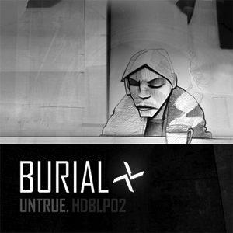
Figure 5 : Untrue, (Burial, 2009) Figure 6: PM2.5 (Swimful, 1994)

The next manifesto statement I chose is ‘minimalistic approaches to design provide clarity.’ This approach fits with my beliefs from a visual and personal viewpoint as both a designer and as the audience. When images are too busy or fussy I think it’s difficult to see or understand the message being portayed. I enjoyed my research into Bodoni for this reason as he was not interested in having any unnecessary decoration in his designs (Britannica Editors, 2025). The examples that demonstrate this statement are two different music albums by two British music artist living in two different cities, London and Shanghai. The Burial album Untrue as a very unique simplistic and elongated typeface with a hand drawn illustration. The Swimful album (figure 6) has very small typeface with a cultural connotation for its title PM2.5 and a blown up image of an toxic air particle. This references life in Shanghai where the artist lives as the air quality index would be checked daily by people who live in the. Both of these albums use a minimalistic monotone grey-scale colour pallet. In my opinion, this adds depth to the minimalistic approach to design which resonates with me.

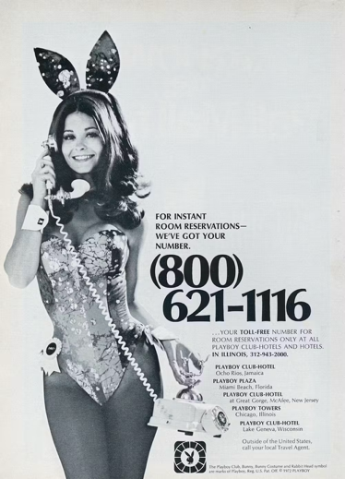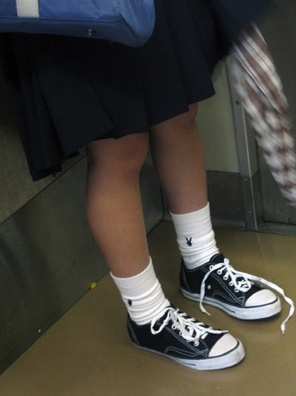

Figure 7: Playboy magazine advertisement Figure 8: Playboy socks; Hiroshima, Japan
(Patti McConville, 1973) (Christopher Lance, 2006)
My final chosen manifesto statement is ‘strong design considers cultural contexts and cultural boundaries.’ I think that this is an essential belief for me as I have been raised in a variety of vastly different cultural backgrounds within my own family; I have lived in Wales, The Philippines and in China. Growing up I learnt that simple signs and communication styles could have different meanings within different cultural contexts. As Meyer (2015) states, Western and Asian communication styles can be described as high context to low context. The issue therefore is to be aware of these and how this may translate visually. For example, different colours are used to show joy or death. In Wales we would use red to symbolise romanticism but in China they would often use white. In Philippines white is not worn for weddings but it is worn for funerals. Another example would be within western culture, the iconic playboy bunny logo signifies a highly sexualised content (figure 1), however the same logo signifies something innocent and cute within a Japanese cultural context (figure 2).

Bibliography
Britannica Editors (2025). Giambattista Bodoni. Available at: https://www.britannica.com/biography/Giambattista-Bodoni (Accessed: 29 November 2025).
Conville, P. (1973) Playboy Magazine Advertisement. Available at: https://theconversation.com/how-the-playboy-bunny-suit-went-from-uniform-to-halloween-costume-215734 (Accessed: 1 December 2025).
Gregory, D (2015). Art Before Breakfast: A Zillion Ways to be More Creative No Matter How Busy You Are. Published Chronicle Books.
Ingledew, J. (2011) The A-Z of Visual Ideas: How to Solve any Creative Brief. Lawrence King.

Guardian,B. (2009) Album of the Decade No10: Burial Untrue. Available at:
https://www.theguardian.com/music/musicblog/2009/nov/23/burial-untrue
(Accessed: 4 December 2025)

Lance, C. (2006) Playboy Socks; Hiroshima, Japan. Available at: https://www.flickr.com/photos/91673635@N00/248151095/ (Accessed: 1 December 2025).

Meyer, E. (2015) The Culture Map. International Edition. Public Affairs.
Rinse, S. (1994) Swimfu New sounds from Shanghai. Available at: https://www.rinse.fm/shows/swimful (Accessed: 4 December 2025)
Pinterest, H.(2025) University people.edu. Available at: https://uk.pinterest.com/pin/visual-designer-vs-graphic-designer-differences-you-should-know--928726754377881442/ (Accessed: 4 December 2025).
Volcano Theatre. (2025) Silent Night, Raging Eve. Joanna Simpkins. Available at: https://volcanotheatre.wales/whats-on/ (Accessed: 4 December 2025

Practice-based Writing
Typography Task- Bodoni Font
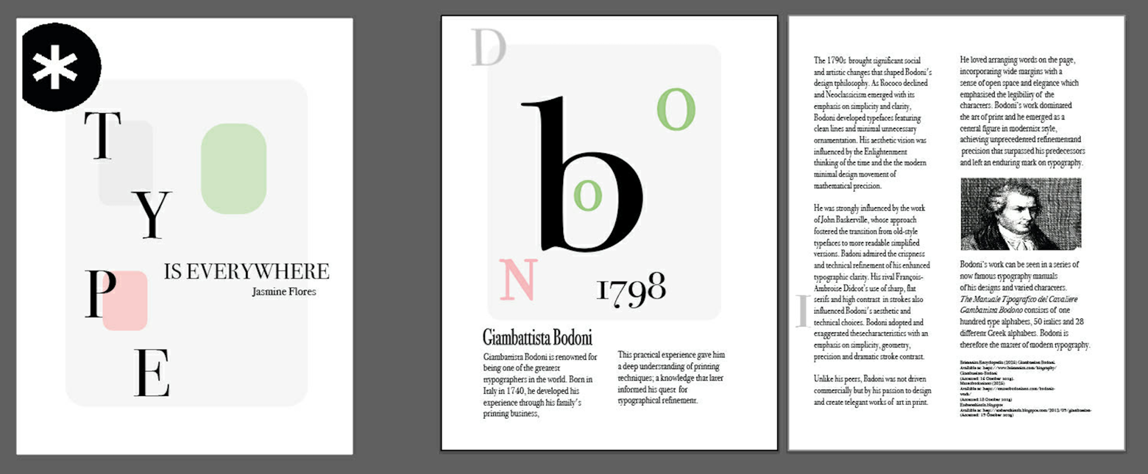
Figure 1: Giambattista Bodoni (Personal Collection, 2025).

I chose my typography task for this writing based on the work of Giambattista Bodoni. I didn’t know anything about his work when I was assigned his name and so I had to complete lots of research to fully understand his creative style. I know that it is important to “get to know the subject of the brief” (Ingledew, 2011, p19) so I started by reading about his life and his work and his style that he developed within his work. I was really excited by the minimalistic style of his work as I also appreciate a simplistic approach as the basis of my own design ethos. His philosophy was ‘to create true works of art in print’ (Museo Bodoniano, 2018).
For my title page, I wanted to develop a simplistic concept and utilise the Bodoni typeface in bold. I experimented with the layout of the letters on the page. For colour I tried to bring a cultural reference into my design to represent Bodoni’s Italian background. As I wanted to keep a minimalistic style, I thought that I could use some subtle colour hues from the Italian flag to add cultural reference. The colours are red, green and white. I tried different background colours and text boxes, however I thought it was too overwhelming and I didn’t think it was the right choice. I kept looking at my work and tried multiple different ideas to resemble the same style as Bodoni on the page. I needed “to simplify, not complicate” (Ingledew, 2011, p17) to keep it simplistic and reflective of the content.
For the layout of my task, I tried to incorporate the same minimal approach into both my title page and the double page spread. In the double page spread I first put the text too close to the edge then I reflected on Bodoni’s style as discussed by Museo Bodoniano (2018) which is to use wide margins and omit any unnecessary detail in keeping with his style as Bodoni had a simplicity throughout all of his work.
As I researched Bodoni more, I found out that his typography has a simple geometric form (Museo Bodoniano, 2018) so then I experimented by adding some simple geometric shapes filled with colour hues on my title page. I experimented lots to get the right position on the page because I didn’t want it to distract from the typeface lettering that was on the title page. There’s a hint of this concept carried through to the double page spread. I also incorporated the Italian colour hues within the type.
I think my final submission was true to Bodoni’s style. According to Britannica (2025) Bodoni was heavily influenced by Pierre Didot and his work became almost devoid of decoration. I utilised his minimalistic style creating a sense of space and simplicity, with the Bodoni typeface on the title and kept this bold to stand out. The geometry of my shapes was simple and subtle and I used colours as a cultural visual language. I think I understand his style and for the text layout I only incorporated one photograph of Bodoni within the double spread. I learnt the importance of placing shapes and images centrally so that they are in line for the observer to see. My research and layout skills improved a lot throughout this task.

Bibliography
Bodoni’s work - Museo Bodoniano (2018) Bodoni’s Work. Available at: https://museobodoniano.com/bodonis-work/ (Accessed: 23 November 2025).

Britannica Editors (2025). Giambattista Bodoni. Available at: https://www.britannica.com/biography/Giambattista-Bodoni (Accessed: 29 November 2025).
Ingledew, J. (2011) The A-Z of Visual Ideas: How to Solve any Creative Brief. Lawrence King.

