

Programme Name: MSc Cybersecurity & Digital Forensics
Module Name : MASTER PROJECT
Module code: ACFA7003_LON
Lecturer: Anees Baqir

Student Name: Patel Aryan Kamleshbhai
Student ID: 2503854

Topic: AUTONOMOUS SERVICE INVESTIGATION FRAMEWORK FOR NETWORK SECURITY

ABSTRACT
Traditional automated vulnerability scanners can find open ports and operating services, but usually stop where a human analyst is still needed to determine if an identified service version is really susceptible. Here is the Autonomous Service Investigation Framework (ASIF), a protocol-aware layer between traditional discovery scanning and vulnerability reporting. ASIF combines automated port and service detection with dedicated investigation modules for five services (SSH, FTP, HTTP/S, SMB and DNS), correlates the evidence with CVE/NVD data and produces a structured report that is evidence-based rather than a dump of version-matched alerts. The structure is organized in eight phases from initial discovery to evidence correlation and report creation, with an explicit authorization gate guiding the more intrusive Phase 5 inquiry stage. The evidence-weighted correlation of ASIF on a single lab host (a Metasploitable2 instance) identified 15 potential CVEs and assigned lower confidence to 5 other candidates without supporting evidence and the reporting pipeline produced both JSON and HTML outputs that were immediately traceable to the underlying evidence. One Phase 5 discovery was manually verified and corroborated the automated result. The project shows that the manual follow-up burden that is typically left to an analyst after a standard scan can be lessened by coupling protocol aware service exploration with evidence-based correlation, and that findings are easier to trust because they are supported by evidence rather than only version string matching. The key limitation is scale, with the planned multi-host comparison against a manually confirmed ground truth, and a baseline OpenVAS scan, not accomplished within the project timetable, and recognized as the most immediate piece of future work.

ACKNOWLEDGEMENT
I would like to thank my project supervisor, Anees Baqir for their direction, input and assistance throughout the development of this project. I would also like to thank the faculty and staff at University of Wales Trinity St David for providing the resources and environment that made this effort possible. Finally, I would want to thank my family and friends for their patience and encouragement during this effort.

Table of Contents
Abstract 2
Acknowledgement 3
List of Figures 5
List of Tables 6
CHAPTER 1: INTRODUCTION 8
1.1 Problem statement 8
1.2 Research gap 9
1.3 Research question 10
CHAPTER 2: LITERATURE REVIEW 12
2.1 First category — Network scanning and protocol standards 12
2.2 Second category — Vulnerability assessment frameworks 14
2.3 Third category — Automated testing and reporting 16
CHAPTER 3: METHODOLOGY 20
3.1 Step 1 — Discovery and baseline assessment (Phases 1–4) 21
3.2 Step 2 — Protocol investigation, correlation, and evaluation (Phases 5–8) 22
CHAPTER 4: IMPLEMENTATION 26
4.1 Design and build process 26
CHAPTER 5: RESULTS 34
5.1 Findings by research question 34
CHAPTER 6: CONCLUSION 43
CHAPTER 7: REFLECTION 45
References 47
A1. Appendix 50
Ethical considerations 50
Assumptions and constraints 51
Risks and mitigations 52
Project repository 52
A2.1 Environment setup 53
A2.2 Command-line interface 53
A2.3 Execution walkthrough 55
A2.4 Generated report 56
A2.5 Manual verification of a Phase 5 finding 56

List of Figures
Figure 1: Eight-phase pipeline overview 21
Figure 2: Confidence escalation model applied between Phase 4 and Phase 6 23
Figure 3: ASIF entry point (main.py), showing the phase imports and supported invocation patterns 27
Figure 4: Common internal pattern shared by each Phase 5 investigation module 29
Figure 5: Report-generation functions in generate.py, producing plain-text and JSON output 30
Figure 6: ASIF CLI at startup, showing the mandatory authorization prompt 32
Figure 7: Host-selection menu (_select_hosts, main.py) implementing the HOST SELECTION prompt used in Appendix A2.3 32
Figure 8: Phase 7 per-port audit trail, generated during the lab run against 192.168.29.101 33
Figure 9: ASIF tools final result 41
Figure 10: Cover page and headline metrics of the generated HTML report 42
Figure 11: Open-port and service table from the generated HTML report 42
Figure 12: Detailed findings for port 21/tcp and 22/tcp, showing severity and confidence together 43

List of Tables
Table 1: Phase-by-phase results on 192.168.29.101 35
Table 2: Executive summary metrics from the generated report 35
Table 3: ASIF output versus a Nmap-equivalent scan and the planned OpenVAS baseline 35

CHAPTER 1: INTRODUCTION
Essential network scans are a critical part in building the fundamental picture of a network. They can detect live hosts, open ports, and what services are listening on those ports. But that is usually as far as the automated probing gets.
Usually, further checks are necessary to get a whole picture. These can range from collecting service banners, testing for anonymous or default access, reviewing the authentication settings and correlating the observed behavior with known vulnerabilities. These follow-up procedures generally are done manually, which might slow an evaluation and result in variation between analysts or repeated assessments.
The project introduces an Autonomous Service Investigation Framework (ASIF) that extends traditional scanning with protocol-aware service investigation, automatic correlation with open source vulnerability information from CVE/NVD sources, and structured reporting. The primary goal is to lessen the amount of redundant manual probing while boosting the quality of vulnerability finds and eliminating unnecessary false positives.
The practical explanation is that good assessment guidelines underlie the framework. For instance, NIST SP 800-115 [16] contains processes such as planning, information gathering, vulnerability analysis, and reporting. Although these processes are evident for a human tester, they do not describe how the same operations should be done automatically without constant interaction with the analyst. Thus, our research fills one part of that gap, the transition from information gathered during reconnaissance, to usable evidence to enable vulnerability assessment, rather than trying to automate entire security assessment.
This framing also explains why the project adds protocol-aware investigation for five services rather than building a faster port scanner or a better CVE database client. A faster scanner still hands the analyst an unconfirmed version string, and a better database client still returns CVEs with no indication of whether the vulnerable state exists on the host. Building a follow-up investigation layer, though less impressive, follows directly from where the problem in Section 1.1 sits: not in discovery or the vulnerability database, but in the step between them.

1.1 Problem statement
Current security assessment tools are targeting different parts of the workflow. Nmap is wonderful for discovering live hosts and ports and services, but the scan output doesn't necessarily inform you the configuration of a service, or even if a particular weakness is really there. Detected software versions can be cross-referenced against vulnerability databases using tools like OpenVAS or Nessus. But version based matching is not necessarily the real case for a service. A system can be patched, modified, or otherwise secured but still report a supposedly vulnerable version. This can result in findings that require further human verification as there is no live protocol level validation.
Another issue is the presentation of severity of vulnerability. CVSS [17] provides a common approach of describing the severity of a vulnerability, but a CVSS score does not imply that the susceptible condition occurs on the specific host under evaluation. Therefore, a high CVSS score and a version match should not be taken as definitive proof that the host is vulnerable. This gap is addressed by the concept separating severity from confidence. Severity is the possible consequence and the evidence at the protocol level is used to judge the strength of the finding to the target.
Research on automated penetration testing has also mostly focused on activities that occur after a vulnerability has been discovered, especially exploit chaining and automated attack-path development. The first stage of studying a found service and collecting preliminary evidence has been less studied. The proposed framework gives priority to the earlier time.
This gap between detection and confirmation is not unique to ASIF's target protocols. Any signature or version-matching method describes what software claims to be, not how it is currently configured. A web server reporting an old Apache version may have the vulnerable module disabled, or may sit behind a reverse proxy that strips the revealing header. A scanner may therefore miss a real weakness because a banner was modified, or flag one that a patch has already fixed without changing the version string. Resolving either case requires interacting with the service itself, not just comparing it against a database entry.

1.2 Research gap
The research gap is between automated discovery and subsequent investigation that a human analyst would ordinarily perform. Existing tools can find services and generate vulnerability candidates, but there is little open source software that combines protocol aware service testing, evidence collection and CVE correlation into a single structured workflow. This is the space ASIF is supposed to be in. It is not meant to replace existing vulnerability scanners or exploitation frameworks, but to add an inquiry layer between service discovery and final vulnerability report.
A related challenge is how much of that inquiry can be safely automated without turning the framework into an exploitation tool. The gap targeted here sits deliberately on the investigative side of that line: gathering enough protocol-level data to judge whether a candidate CVE is plausible, without attempting to trigger or exploit it. Maintaining this boundary keeps the project deliverable within its timeline and avoids the different ethical and legal questions a full exploitation framework would raise (Section 3.1 and Appendix A1).
The targeted gap is intentionally narrow. The project does not aim to invent new detection techniques for SSH, FTP, HTTP/S, SMB or DNS; its checks, such as anonymous FTP testing, SMB share enumeration and DNS exposure queries, are standard testing tasks. The contribution is relating these observations to the candidate vulnerabilities generated earlier, so that protocol-level evidence raises or lowers confidence in a CVE match instead of becoming another item for an analyst to assess manually.
This manual follow-up is slow and inconsistent. Two analysts with identical scan results may ask different questions and record different levels of detail, and one analyst may not apply a check consistently across every host under time pressure. ASIF does not remove the analyst; it makes the repeatable part of the follow-up, such as attempting an anonymous FTP login or reading the key-exchange algorithms a server offers, consistent and recorded, so that the analyst's judgment is spent interpreting evidence rather than gathering it.

1.3 Research question
The approach, implementation plan and evaluation technique are based on four research questions:
RQ1: How much additional context information can be added using protocol aware automated investigation (SSH, FTP, HTTP/S, SMB, DNS) as compared to standard port/service scanning?
RQ2: How can CVE correlation be designed to reduce false-positive matches over naive version-string-to-CVE lookups?
RQ3: “How fast and consistent is security assessment with structured and automated reporting compared to an equivalent manual assessment?”
RQ4: What are the practical and ethical limits (authorization, scope, rate-limiting) that characterize the acceptable use of autonomous service interaction in real-world assessments?
RQ1 and RQ2 are the key technical questions, answered in Phases 5 and 6. RQ3 examines the operational benefit of reporting, measured in Phase 8 through report-generation time and the quality of findings. RQ4 is treated separately because it concerns appropriate use rather than technical performance: whatever the gain in speed or accuracy, active investigation should not proceed without sufficient authorization and scope controls.
The questions are arranged so that RQ1 and RQ2 are answered from the same pipeline run, RQ3 from the report it produces, and RQ4 from the run's operational record, namely the authorization acknowledgment and audit trail described in Sections 3 and 4. One well-documented run on the lab host could therefore provide evidence for all four questions, rather than requiring four separate experimental setups.
SSH, FTP, HTTP/S, SMB and DNS were chosen, rather than a longer list including RDP, SNMP or database protocols, because of project scope, not because they are more significant. All five are common on the kind of general-purpose host used in the Phase 8 evaluation, each has a mature, well-documented specification against which the modules could be validated, and each supports low-risk checks, such as an anonymous login attempt or a header inspection, that do not require triggering an exploit. RDP and SNMP were considered and discarded for the reason given in Section 1.2. Section 6 treats further protocols as an extension rather than a fixed limit of the method.

CHAPTER 2: LITERATURE REVIEW
The literature pertinent to this subject can be divided into three main sections. The first one is related to network scanning and the protocol standards describing desirable service behavior. Second is Vulnerability Assessment including CVE/NVD matching, CPE IDs and Severity Scoring. The third covers testing and security reporting automation. The domains are examined to see what is already given by existing tools and approaches and where the proposed framework can make a focused contribution.

2.1 First category — Network scanning and protocol standards
Nmap is commonly referenced for network scanning and provides a strong foundation for host discovery and service/version detection [1]. The protocol specifications of SSH [5], FTP [6] and DNS [7] can be validated to the anticipated behavior of the research modules of the framework. These standards themselves do not define a behavior as secure or insecure, they describe how the protocols are supposed to work. Roy et al. [11] further on reconnaissance strategies and show that information gathering is typically treated as a separate discovery activity. This remark is important for our project, as ASIF wants to proceed from discovery to a more in-depth research, and not stop after identifying a service.
Another similar line of reconnaissance activity focuses outward, not at one target, but is internet-wide scanning services such as Shodan which index the banners of millions of internet-facing devices and make them searchable by service, port or area [26]. Such large-scale passive reconnaissance is complementary, not a replacement, to what ASIF does: a service like Shodan can inform an analyst that a particular host exposes an out-dated FTP banner on a public IP address, but it does not attempt a login against that service or record what happens if it is successful. ASIF’s five investigation modules pick up just where this sort of broad, shallow indexing leaves off, at the point when an analyst has already identified a particular host and now requires more in-depth, protocol-level data on it.
Roy et al.'s distinction between reconnaissance and follow-up inquiry also gives a practical test for whether functionality belongs in Phases 1-4 or Phases 5-8. Anything answerable by a single passive observation, such as a banner, a version string or an open port, belongs to discovery. Anything requiring the framework to act on the target and observe a response, such as an anonymous login attempt, a directory listing or a header check, belongs to investigation. This test was applied informally throughout the design in Sections 3 and 4, and is one reason the eight-phase split held up during implementation.
It is crucial to understand the role of the RFCs. A protocol specification typically describes compliant behavior, not all behaviors that could be a security risk. For example, accepting an anonymous FTP login, or allowing password authentication over SSH, may not necessarily mean that the server has violated the corresponding RFC [5], [6]. The importance of security varies with the target scenario. If the host does not allow anonymous access, the observed behavior is useful as evidence of security. That is one reason why protocol-aware checks are added into the scanning process, because it is impossible to acquire such contextual judgment from a basic version string match.
SMB and HTTP/S behave similarly. SMB does not forbid shares that can be listed without credentials, and HTTP does not require a server to send Strict-Transport-Security or X-Frame-Options headers; both behaviors are permitted by the specifications yet widely regarded as weak configuration. Compliance and security posture are therefore separate problems, and a conformance check alone cannot judge the latter. ASIF's SMB and HTTP/S modules accordingly record what the service actually allows, and it is this recorded behavior, not the specification, that Phase 6 weighs against the candidate CVE list.
The RFCs also shaped how conservative the Phase 5 modules were kept. RFC 4253 [5] permits a server to offer obsolete key-exchange and cipher algorithms for backward compatibility, so a server offering diffie-hellman-group1-sha1 alongside current algorithms remains conformant. The SSH module therefore treats a weak offered algorithm as a configuration fact to be weighed in Phase 6, rather than a verdict issued by Phase 5. Similarly, RFC 959 [6] includes the 'anonymous' USER identity as a normal feature for public file distribution, so whether anonymous FTP access is a problem depends on what the server exposes afterwards. This is why the FTP module also records a directory listing (Appendix A2.5), giving Phase 6 an indication of what an anonymous user could reach.
2.2 Second category – Frameworks for vulnerability assessment
OpenVAS and other vulnerability scanners [2], [3] use CVE/NVD information to map discovered software versions to known vulnerabilities. This is handy when there are large quantities of systems to assess, but could result in false positives if the version provided does not appropriately reflect the current security situation of the service. Holm [12] analyzed seven network vulnerability scanners and showed that the detection rate and the false-positive rate are related: greater detection may lead to more wrong findings. Moreover, Benthin Sanguino and Uetz [13] mention problems with the alignment of CPE and CVE data, stating that automatic CPE assignment can be additional source of error. Therefore, ASIF first generates candidates via version matching and then adds evidence at the protocol level before giving the final confidence level.
This source of error matters because it sits upstream of everything ASIF does later. If Phase 3 assigns the wrong CPE, Phase 4 queries the NVD API for the wrong product, Phase 6 has no relevant Phase 5 evidence to weigh, and Phase 7 reports a vulnerability unrelated to the host. Because Phase 5 checks are chosen according to the service identified in Phases 2 and 3, protocol-aware evidence cannot correct a wrong CPE assignment. This is one instance of the propagation limitation discussed in Section 3.2, and the reason CPE assignment carries a confidence value rather than being treated as fact.
Commercial scanners such as Nessus and Qualys follow the same version-matching principle, differing mainly in the breadth and update frequency of their proprietary signature databases rather than in detection approach. The gap identified in Section 1.2 therefore concerns version matching as a technique, not OpenVAS or open-source tooling specifically. A larger signature database may reduce missed detections, but it cannot distinguish a version match that reflects a service's live configuration from one that does not; that requires the protocol-level interaction performed in Phase 5. OpenVAS was chosen as the Phase 8 baseline in Section 3.2 because its detection logic is inspectable, making it possible to explain why a given finding was or was not produced, which a closed-source scanner would not allow.
Another complication discussed in this category of literature is that vulnerability scanners themselves are often tested against each other with limited common ground truth (since each vendor has different detection logic and cadence for updates, and a controlled comparison would require labeling every finding as true or false positive by hand). For this reason, Phase 8 of the technique (Section 3.2) is built upon a manually confirmed ground truth for the lab host, rather than taking either the output of ASIF or that of a rival scanner as the reference answer.
The purpose of CVSS is different. It provides a consistent way of describing the potential severity of a verified vulnerability [17]. But the score doesn't tell you if the risky condition is on a certain host. CVSS is being used in the proposed framework in phase 7 for prioritization of discoveries. This is different from the confidence choice in Phases 5 and 6. For example a high severity CVE based only on a version match should not be presented as confidently as a high severity CVE that is also backed by live protocol evidence.
One consequence of separating severity and confidence is that they may point in opposite directions for the same finding, and the framework is intended to reveal this rather than resolve it automatically. A critical-severity CVE with version-only confidence and a medium-severity CVE with confirmed confidence are both valid Phase 6 outputs, but they call for different responses: the first warrants a closer manual look because the automated evidence could not settle it, while the second can be prioritized on the strength of the framework's own findings. A single combined score would flatten this distinction. Section 2.4 returns to how ASIF's confidence axis relates to schemes such as EPSS, but the rationale is established here: how bad a vulnerability would be, and how sure we are that it applies, are separate questions that need not rest on the same evidence.
2.3 Third category — Automated testing and reporting
Much research on automated penetration testing has focused on what happens after vulnerability detection, such as exploit chaining and attack-path planning [10]. Chen et al.'s [15] survey traces automated penetration path planning from classical planning to reinforcement learning and LLM-based methods. The earlier reconnaissance and investigation phase receives less attention. The OWASP Testing Guide [4] and NIST SP 800-115 [16] provide structured guidance for security testing, but are written for human testers. Stallings [8] emphasizes translating technical findings into decision-relevant knowledge, a notion ASIF adopts by building its output around an evidence chain linking service, observed behavior, matched CVE and confidence level. Valenza et al. [14] add that targets can return malicious responses that harm scanners, supporting the decision to keep the protocol-aware modules contained and tightly controlled.
Two further points of comparison mark the boundary of what ASIF attempts. The Penetration Testing Execution Standard (PTES) [27] covers the full assessment lifecycle, treating reconnaissance and vulnerability analysis as stages leading to exploitation. ASIF deliberately stops before exploitation: its Phase 5 modules collect evidence about a potential flaw, such as a successful anonymous FTP login, but do not exploit it. The Metasploit Framework [28] is the clearest example of a tool for that later stage, providing a large library of attack modules for use once a vulnerability is known with sufficient confidence. ASIF is intended to produce the confidence-rated findings that would justify reaching for a tool like Metasploit, not to replace it.
Stallings makes this point about security management generally rather than automated tooling, which is why it transfers so directly to ASIF: a technical finding, such as a weak SSH algorithm, an open port or a matched CVE, only supports a decision once someone can judge how much weight to give it. Sections 2.2 and 2.4 make the same point about CVSS scores and prioritization schemes, suggesting the problem is a general property of presenting technical facts without an indication of how confidently each can be acted on.
A second point from this literature is that automated report output is not automatically useful. Stallings' [8] argument about translating technical findings into decision-relevant information applies to a report's format as much as its content: a report listing CVE identifiers and CVSS scores without stating the assessor's confidence returns the burden of interpretation to the reader, which is precisely the burden the framework aims to reduce. Phase 7 therefore structures every finding around the same chain of service, observed behavior, matched CVE and confidence. The OWASP Testing Guide [4] and NIST SP 800-115 [16] also treat reporting and authorization as related but distinct issues, which is why RQ3 and RQ4 are evaluated separately in Section 5, with neither result allowed to compensate for the other.
Summary table of literature review
Category | Key sources | Main contribution | Gap for this project
Network scanning & protocol standards | Lyon [1]; RFC 4253 [5]; RFC 959 [6]; RFC 1035 [7]; Roy et al. [11] | Sets protocol assumptions for the investigation modules, establishes a baseline for host and service discovery, and details how reconnaissance information is gathered. | The emphasis is on the discovery with minimal follow-up questioning after a service is discovered.
Vulnerability assessment | Greenbone/OpenVAS [9]; MITRE CVE [2]; NIST NVD [3]; Holm [12]; Benthin Sanguino & Uetz [13]; FIRST CVSS [17] | It provides large-scale version to CVE mapping, proof of detection and false-positive trade-offs, information regarding CPE/CVE data quality and a consistent severity model. | Version only matching can be noisy because live evidence of protocols is not often included. CPE assignment can be wrong. CVSS is an indicator of severity and not a confirmation that a vulnerability is there.
Automated testing & reporting | OWASP Testing Guide [4]; NIST SP 800-115 [16]; Denis et al. [10]; Stallings [8]; Valenza et al. [14]; Chen et al. [15] | Provides systematic manual testing instructions, research into automated exploitation paths, approaches to security reporting, discussion of scanner-side concerns, and evidence that reconnaissance is not often further studied after detection. | Much advice is written for human testers, reporting is not often arranged as an evidence chain, and automated scanning has its own dangers.

2.4 Fourth category — vulnerability prioritization beyond CVSS
As Phase 6 and Phase 7 were being constructed in greater depth, it became relevant to consider a fourth strand of literature that was not originally scoped in the project proposal. Some of this research points at challenges adjacent to the confidence model employed in this project. The number of CVEs published each year has grown to become an operational concern for the NVD, which has reported record growth in submissions and consequent processing backlogs [18], and the same database exposes a public API for querying its records programmatically [19]; the latter is the mechanism ASIF's Phase 4 and Phase 6 rely on for correlation, and the former is part of the reason a purely manual triage of candidate CVEs does not scale well even for a single host with 22 open ports, as Section 5 shows.
CVSS is not the only prioritization tool available. CVSS v4.0 [20] refines the severity model but, as noted in Section 2.2, severity still describes potential impact rather than the likelihood of exploitation in practice. The Exploit Prediction Scoring System (EPSS) [21] instead estimates the probability that a CVE will be exploited in the wild within a given period, using observed exploitation data. CISA's Known Exploited Vulnerabilities catalog [22] offers a simpler, binary signal: evidence of active exploitation. Academic work on context-aware prioritization, including Jung et al.'s CAVP model [23], Ahmadi Mehri et al. [24] and Reyes et al. [25], argues for combining base severity with information about the specific environment, exposure or asset value rather than ranking on CVSS alone.
The framework does not implement these techniques, but they inform its design. ASIF's confidence levels (version-only, corroborated, confirmed; Section 3.2) are conceptually related: rather than predicting exploitation in the wild like EPSS or checking a known-exploited list like KEV, they describe the strength of evidence gathered for a specific target during a specific run. This is a smaller, more local signal, but one that offline scoring cannot provide because it depends on live protocol interaction. As noted in Section 6, a natural extension would combine the two, using ASIF's evidence to decide whether a CVE applies to a host and EPSS to prioritize among confirmed findings.
A related but separate classification is the Common Weakness Enumeration (CWE) [29], which lists generic categories of weakness, such as faulty authentication or exposure of sensitive information, rather than individual vulnerabilities as CVE does. One CWE category can span many CVEs, and knowing a finding's category says nothing about whether that instance exists on a given host, which is what ASIF's evidence is designed to determine. As Section 6 notes, tagging each Phase 6 finding with its CWE category would allow reports to be read at the level of weakness class as well as individual CVEs.

CHAPTER 3: METHODOLOGY
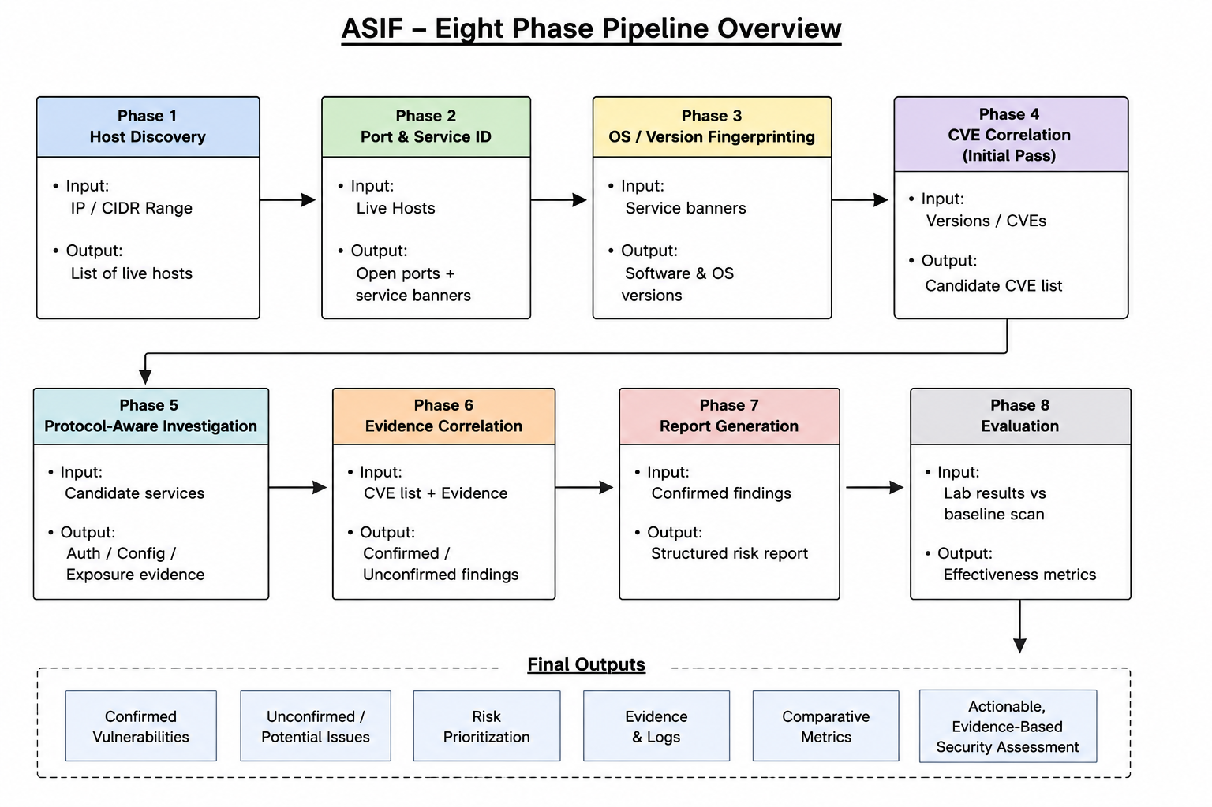
This project followed a design-and-build approach, where a working tool (ASIF) was designed, implemented and run against a real host, and the observed behavior was used to evaluate the research questions in Section 5, rather than testing a hypothesis through a pure observational or survey-based study. The framework is organized as an eight-phase pipeline as shown in Figure 1 below.

Figure 1: Eight-phase pipeline overview
Each step has a specified output from the previous phase and generates information to be used by the next phase. Breaking out the steps means that individual elements can be evaluated separately and Section 5 can be linked back to a specific stage . We went for the linear structure because it is simple to implement, test and explain. We selected Python as the implementation language because its ecosystem (Paramiko, dnspython, requests) supports all five investigated protocols without any external tools, as detailed in Section 4.
For the sake of clarity, the eight phases are grouped into two sections, however the pipeline itself is executed as a single execution once the operator has specified a target and verified authorization. Phase 1 focuses on Phases 1–4, which identify what’s on the network and what it may be running. Phase 2 focuses on Phases 5–8, which turn that initial picture into confirmed, evidence-backed findings and a report. This grouping reflects the two sides of the research gap mentioned in Section 1.2. Step 1 is the discovery capability that existing tools already provide well, and Step 2 is the follow-up inquiry that this project provides.

3.1 Step 1 — Discovery and baseline assessment (Phases 1–4)
Phase 1 starts with host discovery using ICMP echo requests, TCP SYN probes and ARP requests as appropriate to the local network segments. The target is defined by the operator, which might be an IP address or CIDR range, and the framework provides a validated list of live hosts. The technique also satisfies RQ4 as the subsequent investigation is limited within the scope provided by the operator. A scan that results in an address that is out of scope will not be added automatically. The concept is that the user has full control of the start and end of the examination.
Phase 2 includes scanning TCP/UDP ports and identifying services on the active hosts that were discovered. Information on programs listening on open ports is collected using banner gathering and protocol handshakes. Phase 3 uses operating-system fingerprinting and service-banner analysis to identify OS and software versions, and produce CPE-formatted identifiers for future CVE queries. Since the CPE assignment can be erroneous [13], each identification is provided with a confidence value. Low confidence results are not quietly accepted or rejected, but retained for further assessment. In phase 4 the produced IDs are queried with the NVD API to obtain an initial list of candidate CVEs. These match-ups are purely theoretical at this point, mostly based on version info.
One design choice to note specifically here is that the CVE list of Phase 4 is treated as provisional during Step 1 and is never delivered to the operator as a stand-alone final result. This is a direct consequence of the problem described in Section 1.1 and Section 2.2. A version match is the start of an investigation, not the finish. The list is of course marked as provisional within the framework's own data structures and not only in the wording around a report, and there is a reason that it is plausible to adjust the confidence of each candidate later in Phase 6 without re-running Phase 4.

3.2 Step 2 — Protocol investigation, correlation, and evaluation (Phases 5–8)
Phase 5 moves beyond simple discovery to protocol-specific interrogation. Modules are designed to collect SSH banner, authentication methods and algorithms supported; examine FTP for anonymous access and directory exposure; analyze HTTP/S headers, technologies and common resource paths; enumerate SMB shares; and execute DNS record and zone-exposure checks. Each module has a defined request rate and outputs structured evidence, not unstructured notes. This enables the results to be validated using the candidate CVEs generated in Phase 4. The five protocols were chosen as they are known and relatively low-risk checks that may be replicated in a controlled context. Services not in this group are not covered by the core protocol-aware coverage.
Phase 6 revisits probable CVEs from Phase 4 based on the evidence gathered in Phase 5. Direct evidence of exposure may increase confidence, although a version match may be given lesser weight if the observed configuration has a mitigation that the CVE anticipates is not present. Each result is a combination of two pieces of information, the CVSS severity and a project specific confidence level such as confirmed, corroborated or version only. In Phase 7, the results are grouped by evidential chain of service, observed behavior, matched CVE and confidence. The output is a JSON report and a human-readable summary. The result is the basis for the comparison of time and consistency for RQ3.
Figure 2 summarizes how a candidate CVE moves through this confidence model between Phase 4 and Phase 6. A candidate enters as version-only evidence from the CPE match. It is promoted to corroborated if Phase 5 records behavior consistent with the CVE but not a direct demonstration of it, such as a configuration that would allow the flaw. It is promoted to confirmed only where Phase 5 evidence directly demonstrates the condition the CVE describes, such as a successful anonymous FTP login for an anonymous-access CVE. If Phase 5 has no evidence either way, a candidate remains version-only, as with the ProFTPD findings in Section 5.
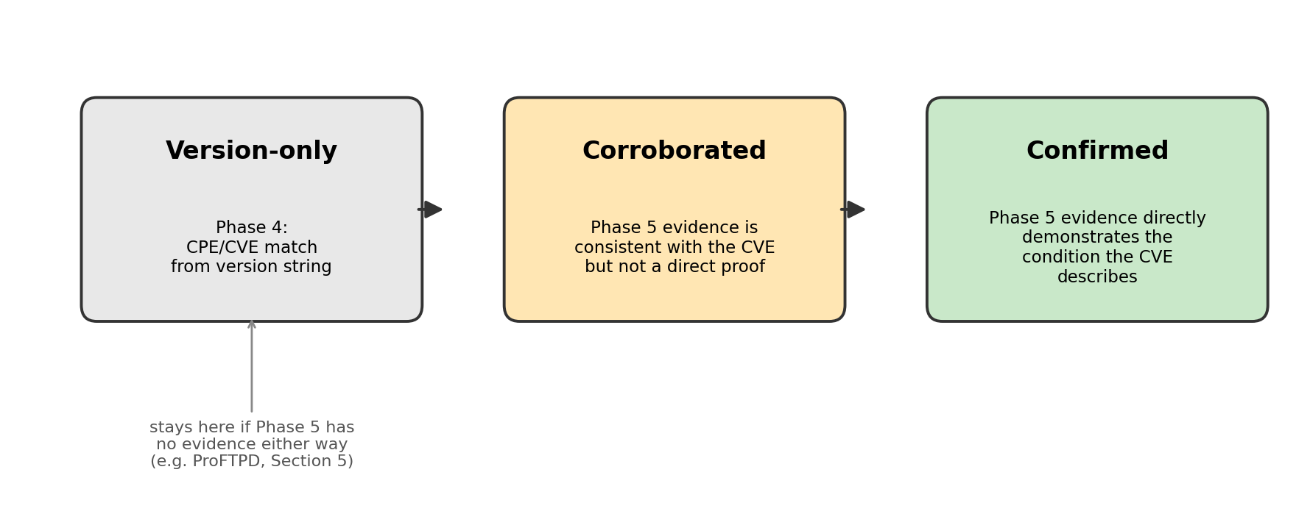
Figure 2: Confidence escalation model applied between Phase 4 and Phase 6
This structure purposely retains severity (from CVSS) and confidence (from the framework itself) as two different axes instead of combining them into a single combined score. Section 2.4 discusses this choice further in relation to external prioritization schemes such as EPSS . The short version is that ASIF’s confidence axis is a statement about the evidence gathered for this host in this run, and is not intended to replace a broader exploitation-likelihood score computed from external data.
Phase 8: Test of the framework . We evaluate the framework in a controlled and permitted lab setting utilizing purposefully vulnerable hosts of a Metasploitable-class environment. We examine the same objectives using a baseline Nmap and OpenVAS technique. We measure three main things: how much fresh information we get each host, the rate of false positives against carefully validated ground truth, and how long it takes to put the report together. The ground truth is created beforehand by physically examining the same lab hosts using OWASP Testing Guide [4]. This means that the proposed framework and the baseline can be compared to the same reference rather than each other. As designed, this Phase 8 evaluation was intended to run across multiple hosts of varying hardening levels; within the project timetable only the single-host run reported in Section 5 was completed, so the multi-host, ground-truth-verified comparison remains outstanding and is carried forward as the primary item of future work in Section 6.
The three Phase 8 metrics map directly to RQ1, RQ2 and RQ3, so that each addresses a single research question rather than acting as a general quality score. Information yield is the number of unique protocol-level evidence items Phase 5 records for a host that a plain Nmap-equivalent scan does not produce; it is a coarse count, since not all evidence is equally significant. False-positive rate is calculated against the manual ground truth described above, with a Phase 6 "confirmed" finding counted as a false positive only if the ground-truth check explicitly contradicts it. Time-to-report runs from the start of Phase 1 until Phase 7 writes its output, and is compared with the time taken by a manual OWASP Testing Guide [4] pass over the same host.
The ground truth was prepared independently in advance of the ASIF run to reduce the risk of the evaluator accidentally interpreting ambiguous ASIF output in ASIF's favor. The OWASP Testing Guide checklist was applied against the lab host first, and only the notes, not the ASIF output, were used to determine what was a true finding for comparison purposes.
Ethical considerations: Autonomous service engagement is an active form of probing and is not passive observation hence has better controls than simple port scanning. • The framework is used only on systems owned by the operator or on which the operator has received explicit written permission to test, all investigation runs inside an isolated laboratory network, each protocol module uses conservative per-host rate limits, and Phase 5 will not run until the operator has confirmed authorization, which is recorded with the run. A comprehensive list of ethical issues is included in Appendix A1.
Explicit authorization before active investigation also reflects the legal position in most jurisdictions that unauthorized access to or interference with a computer system is an offense regardless of intent, as under the UK's Computer Misuse Act 1990 [30]. ASIF's gate cannot determine whether an engagement is lawful, since that depends on facts outside the software's knowledge, such as who owns the target network, but recording an acknowledgment on every run ensures the question is asked and answered before Phase 5 proceeds. ISO/IEC 27001 [31] likewise treats authorization and scope control as a baseline requirement for security testing; Section 3.2 and Appendix A1 enforce the same requirement at the level of a single tool.
The rate limits are set conservatively rather than tuned for speed, on the basis that a slower but predictable assessment is better than a faster one that risks disturbing the target. A more aggressive limit would shorten the run and improve the Phase 8 time-to-report metric (Section 3.2), but would undermine the safety margin on which these ethical considerations rest. This is treated as a deliberate trade-off, since the framework is only useful if assessors trust it to be cautious by default on real infrastructure.
Limitations: There are two main issues with this practice. For example, the eight-step linear architecture means that an error in an early phase (e.g., an incorrect CPE identifier from step 3) can propagate into later stages, instead of being discovered and fixed mid-pipeline. Second, the design-and-build approach evaluates the framework mainly against its own research questions, not against an external benchmark; this is what makes the Phase 8 comparison with a manual, ground-truth verified baseline (Section 5) externally valid; without it the results describe what the tool does, rather than how much better it does than existing practice.
A third, lesser limitation is that the pipeline currently runs each phase to completion before the next begins for a given host. This was a reasonable simplification for the single-host evaluation in Section 5, but it means Phase 5 modules are not parallelized across hosts, which would matter more for the multi-host Phase 8 comparison described in Section 6.

Phase | Name | Input | Output
1 | Host Discovery | User-supplied IP / CIDR range | Verified list of live hosts
2 | Port & Service ID | Live hosts | Open ports + service banners
3 | OS / Version Fingerprinting | Service banners | CPE-formatted software/OS identifiers
4 | CVE Correlation (initial pass) | CPE identifiers | Candidate CVE list (provisional)
5 | Protocol-Aware Investigation | Candidate services | Structured auth/config/exposure evidence
6 | Evidence Correlation | Candidate CVEs + Phase 5 evidence | Re-scored, confidence-rated findings
7 | Report Generation | Confirmed findings | Structured report (JSON + summary)
8 | Evaluation | Lab results vs. baseline Nmap+OpenVAS scan | Effectiveness metrics

CHAPTER 4: IMPLEMENTATION
4.1 Design and build process
This section describes how the eight-phase design from Chapter 3 was implemented in practice: the language and library choices, the shared module pattern used across the five Phase 5 investigators, and the testing strategy used to build and validate ASIF. ASIF is developed in Python. The choice was mostly based on the maturity of protocol libraries (Paramiko for SSH, dnspython for DNS, requests for HTTP/S and the default socket library for FTP and SMB testing) that were sufficient to support all five protocols studied without additional tooling. Figure 1 shows the eight phases.Each phase is a self-standing module.The input and output format of each phase is defined according to the CLI structure described in Appendix A2.2. This separation allowed us to test each phase in isolation and to execute and analyze a partial pipeline (e.g. with --skip-nvd flag) while later phases are still being developed .
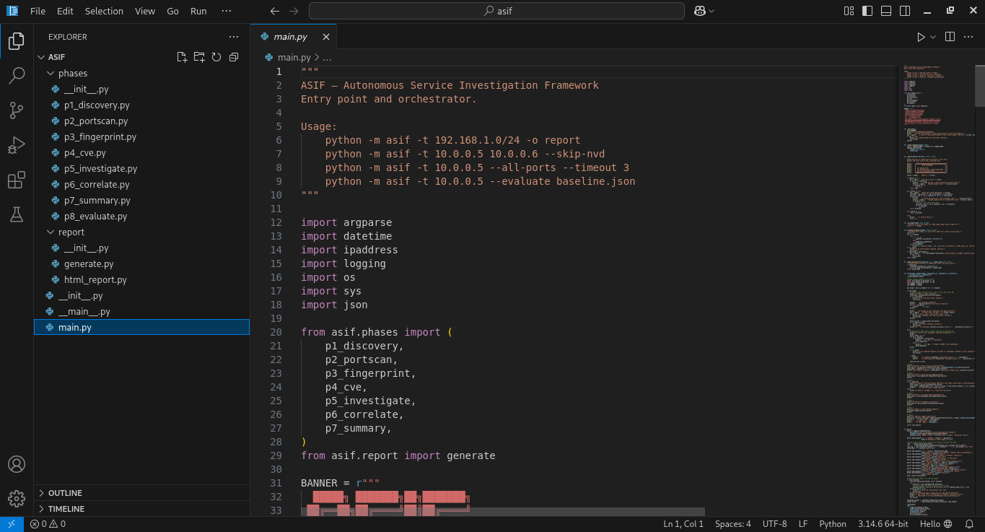
Figure 3: ASIF entry point (main.py), showing the phase imports and supported invocation patterns
- The module docstring lists the supported invocation patterns, including a full-subnet scan, an all-ports scan and the standalone --evaluate comparison mode used for the Phase 8 baseline comparison in Section 6.
- The eight phase modules are imported as a single ordered tuple from asif.phases, which is what enforces the fixed pipeline order described earlier in this section: a phase cannot be invoked out of sequence because main.py is the only place they are wired together.
For example, the unit tests for the FTP module tested a mock server that accepted anonymous login, a mock server that rejected it, and a mock server that returned an unexpected format for the banner, to verify that the module recorded a structured negative result in the latter case, instead of throwing an unhandled exception. The SSH module was also tested against a small set of algorithm lists, one of which was intentionally populated with only the weak algorithms identified in the CLI walkthrough of Appendix A2.3 (diffie-hellman-group1-sha1, arcfour, 3des-cbc, none), so as to verify that the weak-algorithm check identified the expected set and did not also identify algorithms not present in the module's RFC 4253 [5] reference list.
All modules follow the same basic pattern: validated input is given, a number of network operations are done, within the pace restrictions of the project, and a structured evidence object is returned. This universal architecture meant the latter stages did not need to know the implementation specific details of each protocol module, they only needed to handle the defined evidence format. The configuration file contains settings that are specific to a run ( target scope, rate limits, NVD API credentials, and output destinations), and offers a single place to record the authorization acknowledgment specified below.
Network activity is less predictable than the rest of the pipeline, so each module treats a failed connection, timeout or unusual banner as a normal result to record rather than an exception that halts the run. For example, an SSH timeout is logged as a structured evidence item stating that the service did not respond within the defined window, instead of raising an unhandled exception that would stop the remaining Phase 5 modules for that host. This proved more important than expected: an early version of the FTP module crashed on a malformed banner, taking the rest of that host's run with it, which is why the unit tests include a mock server returning one. Treating network failure as data prevents one unresponsive service from silently truncating the evidence available to Phase 6 for every other port.
The shared pattern also simplified the authorization gate described below. All five modules read their target scope and rate limit from the same configuration object, so the gate is enforced once, centrally, before Phase 5 begins, rather than re-implemented in each module with the risk of one being missed. The configuration is a small JSON document rather than a set of command-line flags, so that a complete run configuration, including scope, rate limits, output paths and the recorded authorization acknowledgment, can be saved and reused unchanged for repeat runs, which mattered for the testing described below and would matter for the multi-host Phase 8 comparison in Section 6. Rate limiting uses a per-host, per-module token count rather than a fixed delay, so a module making few requests, such as the FTP investigator's three actions in Figure 8, is not slowed to match one that needs more, such as the HTTP investigator's path probing. The overall run can therefore be quick while the conservative per-host bound described in Appendix A1 is still enforced.
Figure 4 is possible because all modules expose the same shape of output (a list of observations, each containing a module name, a target, a timestamp and a structured result), regardless of protocol. The uniformity of this evidence format means Phase 6 can be written just once against this shape instead of once per protocol. Figure 4 illustrates this typical module layout with the FTP investigator discussed in Appendix A2.5 as a particular instance of the generic design that was common to all five of the Phase 5 modules.
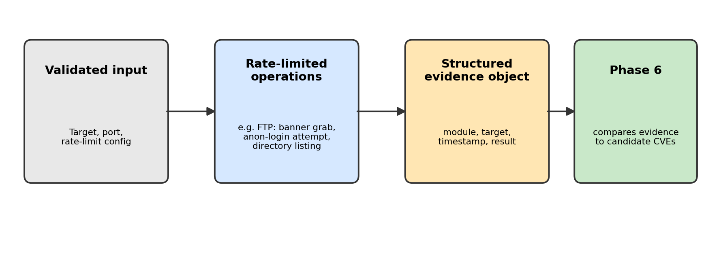
Figure 4: Common internal pattern shared by each Phase 5 investigation module
The authorization gate is before Phase 5 and all following active-investigation phases. As discussed in Appendix A2.3, the CLI will not proceed unless the operator enters an explicit "yes" to a scope-and-authority confirmation prompt, and that acknowledgment is captured with the run. Rate limiting is done per host and per module so that one protocol check cannot influence another. All modules have a uniform JSON evidence structure so that Phase 6 can compare protocol observations with CVE candidates without format conversion. Development followed the phase order given in Section 3 broadly, but the initial plan to build all eight phases before testing any of them did not hold in practice: once phases 1-4 yielded usable CVE candidates, it was more effective to build phase 5 FTP module first and validate the whole evidence-correlation path end-to-end on one protocol before extending coverage to SSH, HTTP, SMB and DNS. This showed the port coverage gap discussed in Section 5 earlier than a phase-by-phase build order would have done.
This deviation from the original build order is also the reason why the FTP module is used as the worked example in Figure 4 and Appendix A2.4 rather than one of the other four: it was the first module built against the real evidence schema, the first one whose output Phase 6 was tested against and therefore the one most representative of how the shared module pattern actually took shape in practice, rather than how it was originally specified on paper before any module existed.
JSON was chosen over a custom binary format or a stricter schema language for pragmatic reasons: the libraries used by the Phase 5 modules (Paramiko, dnspython, requests and the standard socket library) produce Python structures that serialize to JSON directly, and JSON is also what the NVD API in Phase 4 and the Phase 7 report writers consume and produce. Using one format throughout the pipeline eliminated a class of format-conversion bugs at phase boundaries, as well as the schema-stabilisation problem described in Section 7.
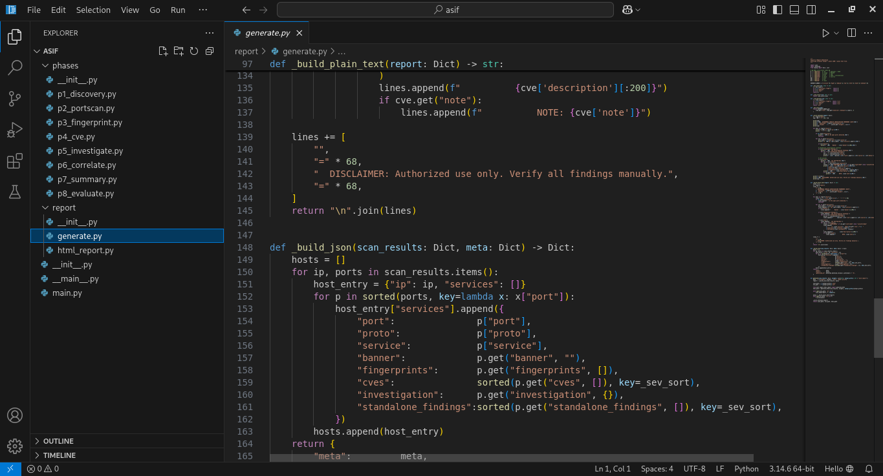
Figure 5: Report-generation functions in generate.py, producing plain-text and JSON output
- _build_plain_text assembles the human-readable summary and appends a fixed disclaimer reminding the reader to verify all findings manually before acting on them.
- _build_json walks the same scan_results structure host by host and port by port, attaching the CVEs and Phase 5 investigation findings sorted by severity, which is what keeps the JSON, plain-text and HTML reports in Figure 9, Figure 10 and Figure 11 consistent with each other.

Stage | Focus
Weeks 1–2 | Phases 1–2: develop host discovery and port/service identification, and the shared evidence schema for subsequent stages.
Weeks 3–4 | Phases 3–4: OS and version fingerprinting and first stage NVD based CVE correlation.
Weeks 5–7 | Phase 5: create and unit-test the investigation modules for SSH, FTP, HTTP/S, SMB and DNS one protocol at a time.
Weeks 8–9 | Phases 6–7: Build evidence correlation and structured reporting engine.
Weeks 10–12 | Phase 8: Setup the lab, run the nmap + openvas baseline, collect comparison metrics, and write up.

The testing was done at three levels. Unit tests exercised each protocol module against controlled or mocked services (a local SSH service with a known banner, a purposely misconfigured FTP service, etc.) so the parsing and decision logic could be tested without ever reaching a real target. The integration tests used the real output from the previous phase, e.g., the CPE identities generated in Phase 3 were fed into Phase 4, to catch schema and data-flow issues early. Finally, the finished pipeline was performed against the Metasploitable2 host revealed in Section 5. This lab host was kept for the evaluation runs instead of normal debugging, therefore its status was the same in the run indicated there.
The FTP and SSH modules had the largest unit-test suites because they were built first and used to validate the common evidence schema; much of their test structure was reused once the schema stabilized, reducing the effort needed for the SMB, HTTP/S and DNS modules. Integration testing revealed two schema errors that unit tests had missed: inconsistent timestamp formats between FTP and SSH evidence objects, and a missing confidence field on DNS evidence that Phase 6 expected from every module. Both were fixed by strengthening the common schema (Section 4.1) rather than adding special cases to Phase 6, keeping Phase 6 simple at the cost of stricter requirements on each module.
As a deliberate precaution, the reported evaluation run used a separate, undisturbed host rather than the hosts used for debugging during Weeks 5-9. A debugging session that changed the target's state, for example by leaving a file behind while testing FTP directory listing, would silently alter what a later evaluation run found. ASIF audits its own actions but cannot independently audit the target's state, so such drift would simply produce a different, equally confident-looking result. Reserving one host for evaluation and using disposable copies for development ruled this out without adding target-state verification to the framework.
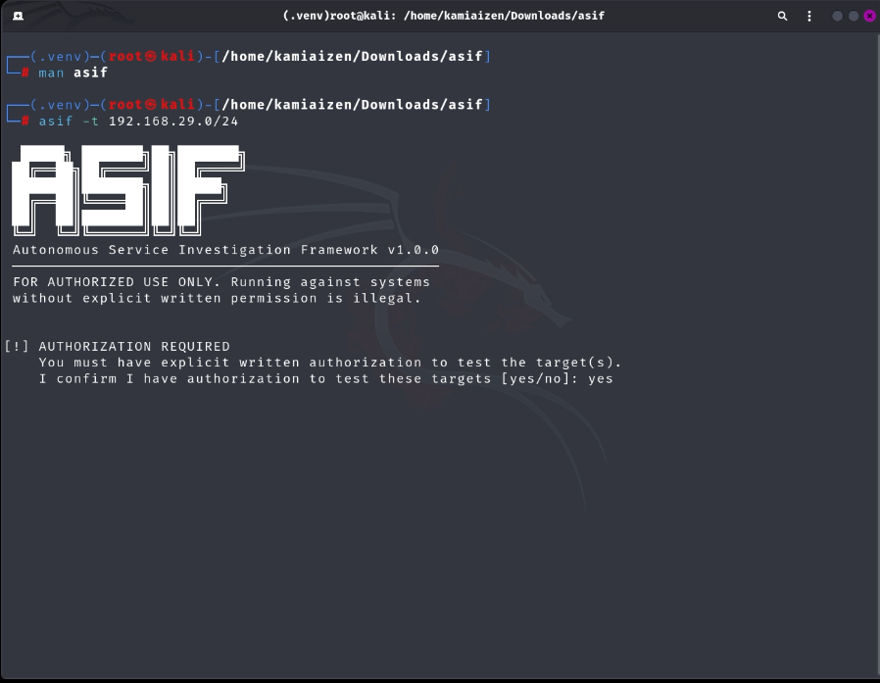
Figure 6: ASIF CLI at startup, showing the mandatory authorization prompt
- The screenshot in Figure 6 shows the ASIF CLI when Phase 1 is ready to start against the lab subnet 192.168.29.0/24.
- The banner states the framework and version (ASIF v1.0.0) and repeats the authorized-use warning before any active phase may be started.
- The authorization question seen at the bottom is the previously mentioned gate. The program advances beyond this stage only when the operator has typed “yes”.
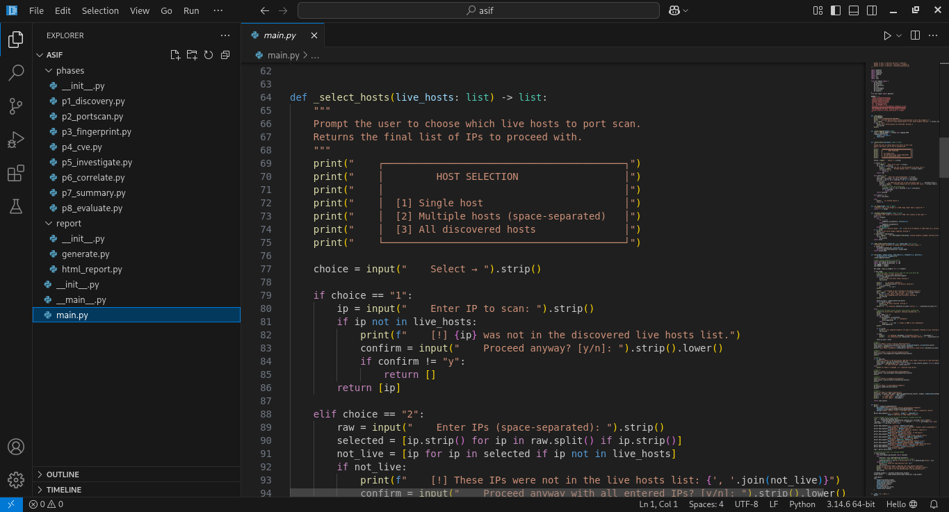
Figure 7: Host-selection menu (_select_hosts, main.py) implementing the HOST SELECTION prompt used in Appendix A2.3
- The function offers three selection modes, a single host, a space-separated list, or all discovered hosts, matching the menu transcribed in the execution walkthrough in Appendix A2.3.
- Any IP typed by the operator that was not part of Phase 1's live-host list triggers an explicit “Proceed anyway?” confirmation, a smaller instance of the same explicit-consent pattern used for the authorization gate shown in Figure 6.

Logging was built in from the start, not added later. Each active-investigation request records time, target, module and authorization acknowledgment. Successful and unsuccessful requests are recorded in the same way. Appendix A2.3 provides an example of an audit entry for a single port and it is this recorded trail that makes the accountability criteria specified in Section 3 part of the real behavior of the system and not just a design objective.
Recording the audit trail per port rather than per run allows it to answer a more specific question than "did the assessment behave ethically": for each port, what exactly was attempted and what did the target return. This matters if, for example, a system administrator later asks why a service logged an unknown connection attempt at a certain time. A run-level log could only show that ASIF was active in that window; a per-port record shows which module made the connection and what it was looking for, which is the level of detail the ethical considerations in Appendix A1 are meant to support.

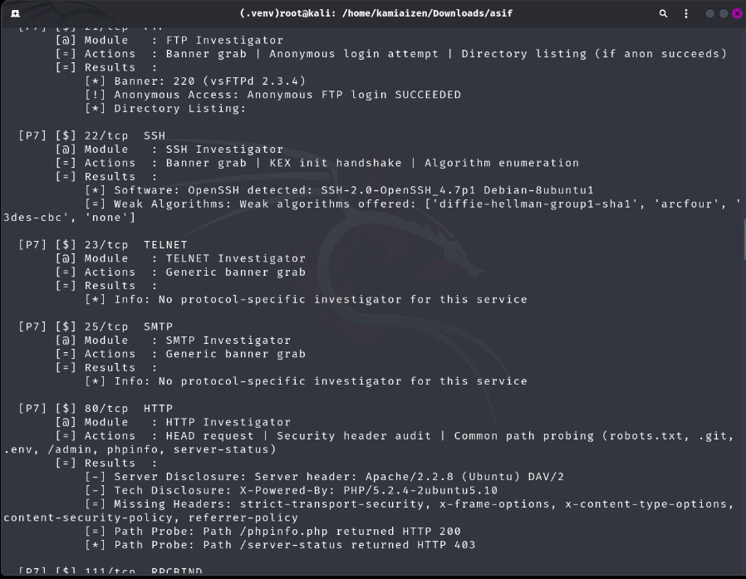
Figure 8: Phase 7 per-port audit trail, generated during the lab run against 192.168.29.101
- The terminal extract shown in Figure 8 is taken from the summary of the Phase 7 inquiry mentioned in Section 3.2 and Table 1.
- Each block represents one port. The module utilized, the particular actions that module did and the outcomes those actions produced are all displayed together. This is the audit-trail record referred to in Section 4 and Section 5.
- The FTP block (21/tcp) at the top shows the anonymous login succeeding, the SSH block (22/tcp) below it shows the weak key-exchange algorithms recorded for that host. The TELNET and SMTP blocks show what a module records when no protocol-specific investigator exists yet for that service, which is itself useful evidence that the module coverage described in Section 3.2 is not complete for every open port.

CHAPTER 5: RESULTS
5.1 Findings by research question
- The results below are ordered by research topic, not phase, because Section 3 already covers the stages in order, and replicating that structure here would contribute nothing the reader does not already have. The evidence used to answer each research question is created by a particular phase or phases, stated in Section 1.3 and, where useful, is presented using the report screen captures reprinted later in this section and the terminal captures reproduced in Section 4. The deliberate reading together of the two sets of numbers, terminal and report, is to catch the instant evidence is produced in the terminal and how that evidence is ultimately given to a reader who wasn’t seeing the tool operate in the report.
- ASIF was built and run against a lab host (192.168.29.101, a Metasploitable2 instance) within the isolated assessment network described in Section 3. We provide the actual observations taken throughout that run, as per the 4 research questions described in Section 1.3. The project schedule did not permit the full controlled comparison with a manually-verified ground truth over numerous hosts that was originally scoped for Phase 8. This is highlighted as a deficiency below and passed on to Section 6 as future work. This gap bears most directly on RQ3: the speed-and-consistency comparison for RQ3 depends on exactly the manual, ground-truth-verified baseline that was not completed, so the RQ3 finding below should be read as evidence that the reporting pipeline works end-to-end rather than as a validated efficiency claim over manual assessment.
- RQ1 -- contextual info gain: The Phase 5 probing of the live host’s SSH, FTP, HTTP and NetBIOS services was not reported in the Phase 2 port/service scan. This contains an anonymous FTP login, a list of weak SSH key exchange algorithms allowed by the server, and per-port notes of investigation in the audit trail. The protocol aware query did increase the contextual yield for this host which was not available from the Phase 2 banner capture alone. The outcome is for a single host only, so more to explain the process than to see how much the improvement is. A good negative situation here is the audit trail entry for port 23/tcp (TELNET) and port 25/tcp (SMTP), in Figure 8: as there is no protocol-specific investigator yet for those two services, the framework appropriately indicates that it has nothing to add for those, instead of making a guess. This is intended as part of the confidence design (Section 3.2): a module without evidence should say so, not just silently fall back to a default confidence level.
- RQ2 — CVE correlation weighted by evidence: Phase 4 generated 20 candidate CVEs. Five SSH-related and ten Apache/PHP-related CVEs were promoted to confirmed confidence after Phase 6 matched them to live Phase 5 evidence on ports 22/tcp and 80/tcp. Five candidates for ProFTPD 1.3.1 remained unconfirmed: Phase 2 identified the ProFTPD banner on port 2121/tcp, whereas the Phase 5 FTP module examined the main FTP service on port 21/tcp (vsFTPd). With no live evidence for that port, Phase 6 correctly left the ProFTPD CVEs at version-only confidence. This is the intended behavior of the confidence model: under-confirming an unsupported finding is more informative than giving it the same confidence as a confirmed one. It also exposes a specific gap: the FTP module should cover non-standard ports identified in Phase 2 rather than defaulting to the principal service port. The resulting 15 of 20 confirmed candidates (Table 2) may not hold on a hardened host, which the multi-host comparison in Section 6 is designed to test. The evidence behind one promotion, the anonymous FTP login on port 21/tcp, was independently repeated by hand (Appendix A2.5), supporting the reliability of the automated evidence.
- RQ3—Automated reporting structure: Phase 7 generated a JSON report, a plain text report and an HTML report for the same run, all following the service–behaviour–CVE evidence chain described in Section 3.2. In the HTML report executive summary, there is 1 host scanned, 22 ports found open and 15 CVEs that were validated. The results were broken down by port and annotated with CVSS score and confidence status. This validates the reporting pipeline is end-to-end and provides a consistent, ordered output without the need for manual compilation. The benefit in speed and consistency over a manual review cannot be guaranteed as the planned quantitative comparison against the time spent by a manual tester following the OWASP Testing Guide was not completed and is stated as a limitation below. Since all three output formats (JSON, plain-text and HTML) are generated from the same underlying findings structure in Phase 7 and not three independent renderers, they cannot disagree with each other on the substance of a finding, only on presentation. The HTML report shown in Figure 9, Figure 10 and Figure 11 and the plain-text summary referred to in Table 1 report the same 15 confirmed CVEs and the same risk distribution.
- This also provides a smaller, but useful benefit for repeated assessments: because the plain-text and JSON output contain the same findings as the HTML report, a report from an earlier run can be diffed programmatically against a later one for the same host to determine which findings changed confidence or disappeared without having to interpret the HTML. This was not one of the four research objectives, and not investigated here, but is a direct consequence of generating all three forms from one findings structure, rather than three independent renderers, and is the sort of usage a purely narrative report would not support.
- RQ4 - scope of authority and control: The CLI required the user to affirm authorization (“I confirm I have authorization to test these targets [yes/no]”) before Phase 5 or any subsequent active-investigation phase could be executed, and this confirmation was logged with the run. For each port inspected, an item in the per-port audit trail (module, actions performed, result) was created to give a recorded basis for later review. This means that the permission gate and audit logging as described in Section 4 are working as intended, but as highlighted in Section 3, the software can only log that an operator has acknowledged it and cannot check independently that the authorization is legitimate. The circumstance of the operator refusing authorization did not happen during the lab run. The negative path of the gate, i.e. the behavior of the CLI when the operator answers “no”, was exercised only during the unit testing (Section 4.1) and not during the evaluation run reported here.

Table 1 summarises what each phase produced for the assessed host.
Phase | Observed result on 192.168.29.101
1 — Host Discovery | 192.168.29.0/24 6 hosts up; 192.168.29.101 chose to continue the complete inquiry.
2 — Port & Service ID | 22 open ports including: ftp (vsFTPd 2.3.4), ssh (OpenSSH 4.7p1), telnet, smtp (Postfix), http (Apache/2.2.8), rpcbind, netbios-ssn, microsoft-ds, mysql, postgresql, vnc, unauthenticated port reporting root shell banner.
3 — OS & Version Fingerprinting | OS: Linux Distro: Ubuntu source: banner
4 — CVE Correlation | Used the NVD API to query for 5 CPEs (vsftpd 2.3.4, OpenSSH 4.7p1, Apache 2.2.8, PHP 5.2.4, ProFTPD 1.3.1); got back 20 candidate CVEs (0 for vsftpd, 5 each for SSH, Apache, PHP, and ProFTPD).
5 — Protocol-Aware Investigation | FTP module: banner capture, anonymous login attempt, directory listing – anonymous access successful. Modules for SSH, telnet, SMTP, HTTP, rpcbind and NetBIOS were run against their respective ports.
6 — Evidence Correlation | 5 SSH-related CVEs upgraded low->high confidence [CONFIRMED] with live evidence on 22/tcp 10 Apache/PHP CVEs upgraded low->medium [CONFIRMED] on 80/tcp 5 ProFTPD CVEs on 2121/tcp not confirmed (no live evidence)
7 — Report Generation | Colorized terminal summary and 3 report files written to reports/: HTML report, JSON report, plain-text report, all prefixed with 192-168-29-0_24_report_20260711_140600.
8 — Evaluation | Per-port audit trail printed for each service investigated (e.g. for 21/tcp: module = FTP Investigator, actions = banner grab | anonymous login attempt | directory listing, outcome = anonymous access succeeded), and ASIF’s results for this host compared against a Nmap-equivalent scan (Table 3); the planned multi-host comparison against a manually confirmed ground truth and an OpenVAS baseline was not completed within the project timetable (Section 6).
Table 1: Phase-by-phase results on 192.168.29.101
One further observation from the run, outside the four intended Phase 8 measures, is how time was distributed across phases. Phases 1-4, from host discovery to initial CVE correlation, took well under a minute across the 22 open ports on the lab host, as they need few network round-trips per port. Phase 5 dominated the run's wall-clock time, as expected given the conservative per-host rate limit (Section 3.2 and Appendix A1), which trades speed for a lower risk of disrupting the target. Phase 7 reporting was almost immediate, since it only formats results already computed. This suggests that, when time-to-report is properly measured, most of any difference between ASIF and a manual tester will come from the pacing of the protocol-aware checks rather than the discovery or reporting stages.

Table 2 shows the report’s executive-summary metrics.
Metric | Value
Risk distribution | Critical: 1, High: 1, Medium: 3, Low: 1
Hosts assessed | 1
Open ports | 22
Confirmed CVEs | 15
Table 2: Executive summary metrics from the generated report

- Table 2 shows the result of ASIF for this host, compared to a plain Nmap-equivalent scan (the port/service output of Phase 2, which is what an unmodified Nmap scan would report). No OpenVAS run against the same host was performed during the project period, hence that column is left for a future controlled comparison rather than filled with unverified values.

Table 3 ASIF output versus a Nmap-equivalent scan and the planned OpenVAS baseline
Capability | ASIF | Nmap (port/service scan only) | OpenVAS baseline
Open ports / services identified | 22 (Phase 2 scan) | 22 (same underlying scan) | Not run
Anonymous FTP access confirmed by live check | Yes — FTP module logged in and listed the directory | No — Nmap reports the port as open but does not test credentials | Not run
Weak SSH key-exchange algorithms flagged | Yes — diffie-hellman-group1-sha1, arcfour, 3des-cbc, none | No — not part of a standard port/service scan | Not run
Candidate CVEs generated from versions | 20 | N/A — Nmap does not perform CVE matching | Not run
CVEs confirmed with live protocol evidence vs. version-only | 15 confirmed, 5 left as version-only | N/A | Not run
Structured, evidence-linked report produced | Yes — JSON, HTML and plain-text reports | No — raw port list only | Not run
Table 3: ASIF output versus a Nmap-equivalent scan and the planned OpenVAS baseline

Reading Table 3 row by row supports the argument that the tools are complementary rather than competing: ASIF and Nmap agree exactly on the open-port count because they use the same underlying scan. The difference lies entirely in the three protocol-aware rows, the investigation layer that ASIF adds and a plain port/service scan cannot produce. The OpenVAS column is deliberately left blank, rather than filled with an estimate, because it reflects a real gap in the evaluation and should not imply that a controlled comparison was made.
Our intention was to do a thorough Phase 8 review against three measures: information yield, false positive rate against a manually validated ground truth and time-to-report compared to a human tester using the OWASP Testing Guide [4], but this was not achieved within the project deadline. The single-host run described above demonstrates that each mechanism (protocol-aware investigation, evidence-weighted confidence and structured reporting) operates as predicted, but does not reflect the degree of improvement that the metrics were intended to assess. The only remaining thing is to finish the multi-host, ground-truth-verified comparison. The most important remaining piece of work is taken up in Section 6.
This project is not intended to be a better OpenVAS with more detections. Holm [12] examined seven scanners and found that the detection rate and the false positive rate can increase simultaneously. The more particular question we are exploring here is that we can reduce false positives, with equal level of detection, by adding confidence based on the protocol evidence. The proposed contribution is therefore mainly concerning the making of the findings more reliable and usable, not to replace the vulnerability database or the scanner itself.
This implies several limitations. The experiment used a single intentionally vulnerable Metasploitable-class host, so it cannot reflect the variety of a hardened production network, and no statistical claim can be made from it. No comparison with manually verified ground truth or a baseline OpenVAS scan was performed, so the false-positive-rate and time-to-report metrics remain unvalidated. The FTP port-coverage gap identified under RQ2 shows that protocol-aware investigation can miss services on non-standard ports even for supported protocols. Protocol-aware inspection covers only SSH, FTP, HTTP/S, SMB and DNS; other services rely on version matching alone. Finally, CVE correlation depends on the continued availability and currency of the NVD API, a dependency shared with many existing tools.
This is a gap in validation, not evidence that the underlying mechanisms are unreliable. Section 5 shows that each mechanism produced plausible, internally consistent output on the host tested. What is missing is independent confirmation, across a broader set of hosts, that Phase 6 confirmed findings are correct as often as their label suggests, and that ASIF's time-to-report genuinely beats a manual OWASP Testing Guide pass. Both are measurable claims, and they are stated here as constraints of the evaluation rather than folded into the RQ1-RQ4 findings.
None of the following constraints invalidates the four methods discussed previously in this section, protocol-aware investigation, evidence-weighted confidence, structured reporting and the authorization gate each performed as designed for this host. What they do is restrict the extent to which that single conclusion may be generalized, which is precisely the distinction Section 6 returns to, in differentiating what this effort has demonstrated from what it has not yet proved.

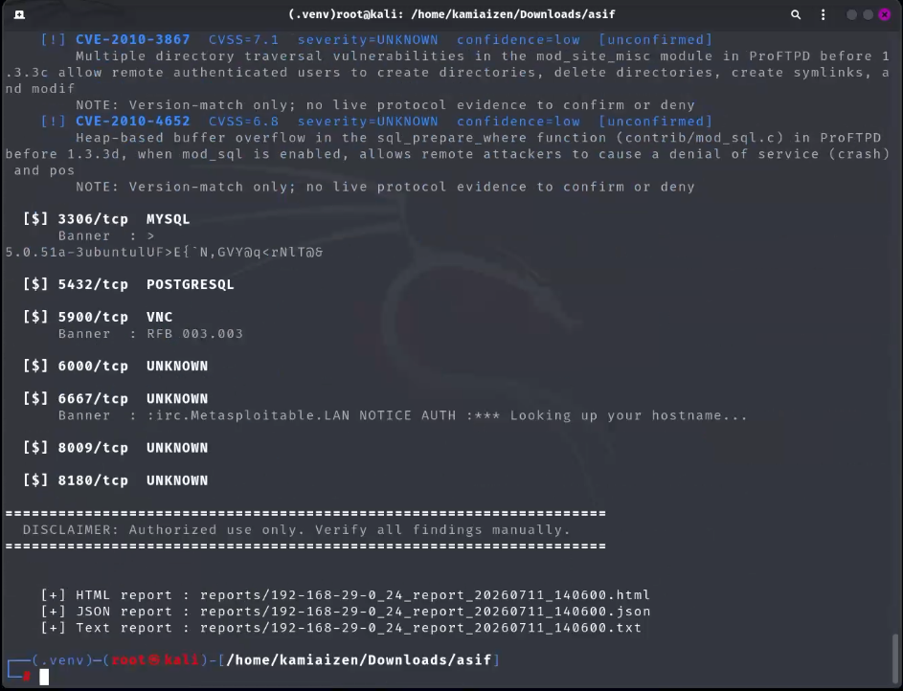
Figure 9: ASIF tools final result

- This is a screenshot of the output of a vulnerability scanning tool (“asif”) on a Kali Linux system scanning a target machine (probably a Metasploitable VM at 192.168.29.0/24) for open ports (MySQL, PostgreSQL, VNC, IRC, etc.) and known CVE vulnerabilities (e.g., ProFTPD directory traversal and buffer overflows).
- It creates and saves scan reports in HTML, JSON and Text forms at the end for review/documentation later -- this looks like it is for a cybersecurity/pentesting project, perhaps a college assignment or portfolio demo.

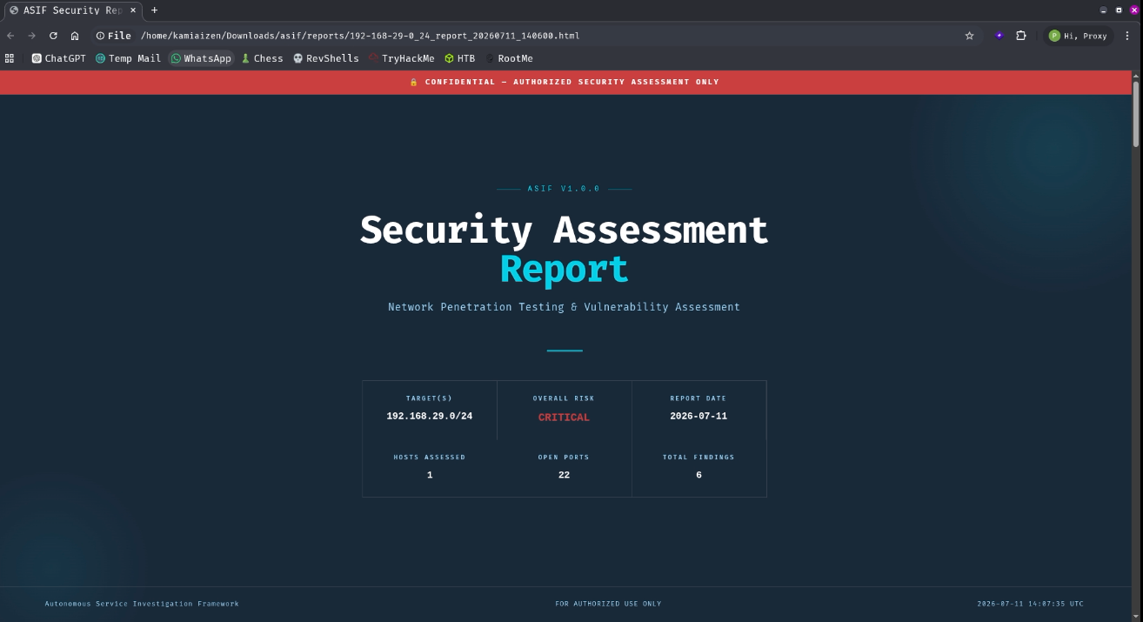
Figure 10: Cover page and headline metrics of the generated HTML report
- This is the initial perspective a reader of the report sees: goal scope, overall risk rating, host and port counts, and total findings (which match the executive-summary metrics in Table 2).

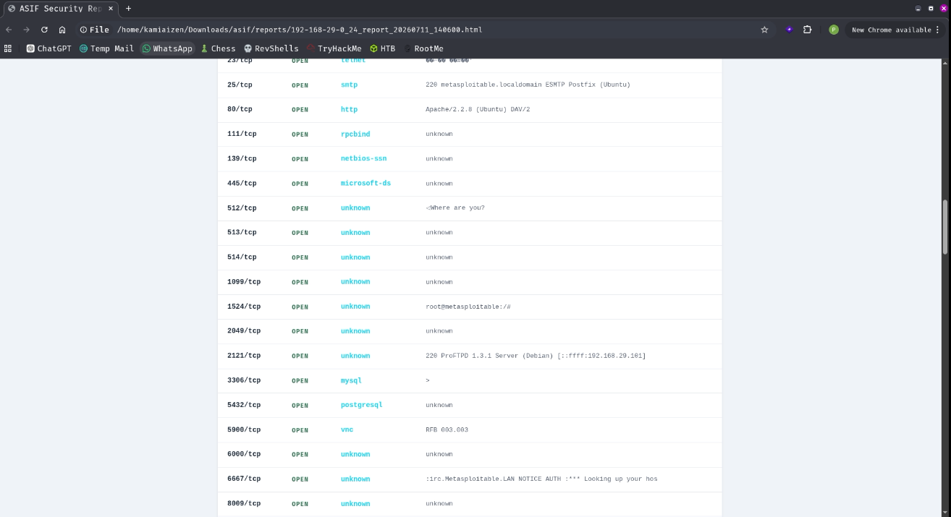
Figure 11: Open-port and service table from the generated HTML report
- This is the Phase 2/Phase 3 output as rendered in the final report. It lists each open port, and the banner or service string that the framework managed to capture for it. The ProFTPD banner on the non-standard port 2121/tcp is the one detailed under RQ2 above.

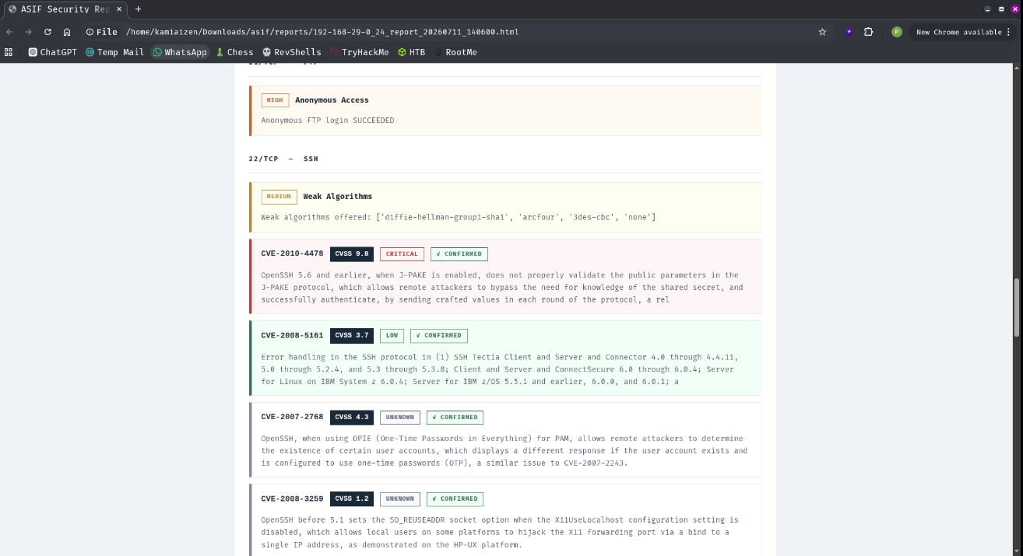
Figure 12: Detailed findings for port 21/tcp and 22/tcp, showing severity and confidence together
- This is the evidence-chain view hinted at throughout Section 3.2 and Section 5. As seen in each CVE card, the CVSS severity band is shown on the left and the confidence status (in this case CONFIRMED) on the right, so the two axes described in Figure 2 are present side-by-side for each finding, rather than collapsed into one number.

CHAPTER 6 CONCLUSION
The work addressed a particular challenge in traditional automated assessment. Discovery tools can tell what services are exposed, but they don’t always provide the additional research needed to determine what those services are actually doing. ASIF is built and designed as a dedicated layer between discovery and reporting with protocol aware checks, evidence based CVE correlation and reports that link findings back to the evidence that supports those results. In the single-host run of Section 5, all four mechanisms performed as expected: protocol-aware investigation provided contextual information beyond a port scan (RQ1), evidence-weighted correlation validated 15 CVEs and assigned low confidence to 5 others instead of overstate (RQ2), the reporting pipeline automatically generated structured output with evidence linkage (RQ3), and the authorization gate and audit logging behaved as designed (RQ4). The project has not yet set a scale. Yet to be done: the intended multi-host comparison against a humanly confirmed ground truth and a baseline OpenVAS scan, which would show how far these methods improve on existing practice rather than just that they work.
Because Section 5 is based on a single lab host, “worked as expected” should be read narrowly: each of the four mechanisms produced the output the design in Section 3 predicted for this host. Protocol modules returned structured evidence rather than free text; the confidence model changed a candidate's status only when Phase 5 evidence justified it; the reporting pipeline produced three consistent formats from one findings structure; and the authorization gate blocked Phase 5 until the operator responded. None of this shows how often, across a more varied set of hosts, evidence-weighted confidence correctly promotes real vulnerabilities and withholds promotion from false ones. That is what the deferred Phase 8 comparison and the future work below are for.
ASIF does not attempt to automate all of penetration testing. It addresses one transition, making reconnaissance information more useful for vulnerability evaluation, and this narrower focus allows its contribution to be judged on its own terms. The most immediate next step is the multi-host Phase 8 comparison against manually confirmed ground truth and a baseline OpenVAS scan, which this single-host run was intended to lead to. The ProFTPD port-coverage gap in Section 5 suggests a second concrete step: extending each protocol module to non-standard ports detected in Phase 2. The evidence-correlation design could also be extended beyond SSH/FTP/HTTP/S/SMB/DNS; database services (e.g. MySQL, PostgreSQL) and message-queue protocols were open on the evaluated host but fell outside current coverage, making them natural next modules.
In this light it is easier to precisely state the contribution of the project than it would be to make a more general claim about automating penetration testing. ASIF takes the output of an ordinary port and service scan and adds a second, narrower stage that turns a subset of that output into evidence-backed, confidence-rated findings for five well-understood protocols. It produces that result as a structured report, rather than a list of raw observations. Everything else in the design—the phase boundaries, the shared evidence format, the authorization gate, the audit trail—is there to make that one addition dependable and safe to operate, not to extend what the framework claims to achieve.
Adding these protocols would also test whether the module pattern in Section 4.1 generalizes beyond the five protocols it was designed for. MySQL and PostgreSQL pose a different investigation problem: what an analyst most wants to know, such as whether authentication is required or a default account is active, involves attempting a connection without credentials rather than reading a banner, which is closer to the FTP module's approach than to the HTTP module's header inspection. Whether the shared evidence structure and rate-limiting design carry over cleanly is an open question that building such a module would answer.

CHAPTER 7: REFLECTION
This project changed my view of vulnerability assessment. I initially assumed that finding more vulnerabilities meant doing better, but building and evaluating the framework showed me that good evidence for a finding matters more. The five unconfirmed ProFTPD CVEs illustrated this: the version information suggested vulnerabilities, but there was no real proof. In contrast, the framework found the anonymous FTP login, which I then validated manually. I only fully understood this distinction when I started coding ASIF's confidence levels rather than describing them in the proposal. Saying that severity and confidence should be separate is easy; deciding whether a specific piece of FTP evidence is corroborated or confirmed is harder, and it made me look much more closely at what a 'finding' in a security report actually claims. The manual FTP verification in Appendix A2.5 was a small step, but it changed how I think about validating automated tools. Until then I had mostly checked ASIF by reading its code and JSON output, assuming that correct-looking logic meant correct results. Repeating one finding by hand showed me that code review and independent verification are not substitutes: a module can be logically correct but check the wrong thing, or rest on a wrong assumption about the target. If I did it again, I would build in this kind of spot-checking much earlier.
If I repeated the project, I would test each technique more thoroughly on its own before integrating them, taking one protocol from first scan to final report and confirming it worked before moving to the next. I would also save the Nmap and OpenVAS output from every test, not just the final results, and repeat tests from clean lab snapshots, which would make comparisons more credible and reveal coverage problems earlier. Time management was another lesson. The plan in Section 4.1 allocated Weeks 5–7 to all five Phase 5 modules, but the FTP module alone, built first to validate the evidence-correlation path end to end, took about as long as I had planned for two, because the evidence schema needed several revisions once the SSH module began using it. The remaining modules went faster, but Phase 8 (Weeks 10-12) had less slack than planned, which is a direct reason the multi-host, ground-truth comparison was not completed. Next time I would change the plan itself by adding an explicit schema-stabilisation checkpoint, rather than absorbing it into the first module's time budget.
The big takeaway for me from this is that automation is not simply about finding a ton of vulnerabilities. Results should also be interpretable and based on evidence. Working with protocol checks, CVE matching and confidence levels let me see how an automated tool may support an analyst and not just spit out a vast list of alarms. I also learned that unexpected outcomes are valuable in research as they point to where the system needs improvement and a clear path for the next stage of development.
From a technical point of view, this project also marked the first time that I had to build a data format (the shared evidence structure detailed in Section 4.1) that other code I had not yet written would depend on. It was tougher than I thought to figure out what should go in that structure before Phases 6 and 7 were there to eat it, and I amended it twice, once after I started the SSH module, and once after I started Phase 6, since in each case a field I thought was optional turned out to be needed by a later phase. This is a very typical experience in software projects in general, but it was new to me, and it is probably the single practical skill from this project that I intend to utilize most directly outside of a security context especially.
Finally, this project transformed not only the way I constructed my own security tooling and reports, but also the way I read others’. I now see, in tools I did not design, whether a finding is provided with any hint of how it was acquired, or whether severity and confidence are discreetly collapsed into one number as discussed in Section 2.2 and Section 2.4. It is a minor thing, but it is the sort of habit I would not have got without having to make the opposite decision, consciously, within the design of ASIF itself.
Looking back, the most time-consuming parts were rarely the ones I expected when writing the proposal. Opening an SSH connection or querying the NVD API from Python was straightforward. What took far longer was deciding what a piece of evidence was actually allowed to claim, and keeping that claim narrow even when a broader one would have looked more impressive. This is what I would point to first if asked what I learned from building ASIF.

References
[1] G. Lyon, Nmap Network Scanning. Sunnyvale, CA, USA: Nmap Project, 2009.
[2] MITRE Corporation, "Common Vulnerabilities and Exposures (CVE)," [Online]. Available: https://cve.mitre.org. [Accessed: Aug. 2026].
[3] National Institute of Standards and Technology, "National Vulnerability Database (NVD)," [Online]. Available: https://nvd.nist.gov. [Accessed: Aug. 2026].
[4] OWASP Foundation, OWASP Testing Guide v4.2, 2020.
[5] T. Ylonen and C. Lonvick, "The Secure Shell (SSH) Protocol Architecture," RFC 4253, Jan. 2006.
[6] J. Postel and J. Reynolds, "File Transfer Protocol (FTP)," RFC 959, Oct. 1985.
[7] P. Mockapetris, "Domain Names — Implementation and Specification," RFC 1035, Nov. 1987.
[8] W. Stallings, Network Security Essentials: Applications and Standards, 6th ed. Boston, MA, USA: Pearson, 2017.
[9] Greenbone Networks, "OpenVAS — Open Vulnerability Assessment Scanner," [Online]. Available: https://www.openvas.org. [Accessed: 2026].
[10] M. Denis, C. Zena, and T. Hayajneh, "Penetration testing: Concepts, attack methods, and defense strategies," in Proc. IEEE Long Island Systems, Applications and Technology Conf. (LISAT), 2016.
[11] S. Roy, N. Sharmin, J. C. Acosta, C. Kiekintveld, and A. Laszka, "Survey and Taxonomy of Adversarial Reconnaissance Techniques," ACM Computing Surveys, vol. 55, no. 6, article 112, pp. 1–38, 2023.
[12] H. Holm, "Performance of automated network vulnerability scanning at remediating security issues," Computers & Security, vol. 31, no. 2, pp. 164–175, 2012.
[13] L. A. Benthin Sanguino and R. Uetz, "Software Vulnerability Analysis Using CPE and CVE," arXiv:1705.05347, 2017.
[14] A. Valenza, G. Costa, and A. Armando, "Never Trust Your Victim: Weaponizing Vulnerabilities in Security Scanners," in Proc. 23rd Int. Symp. Research in Attacks, Intrusions and Defenses (RAID 2020), San Sebastian, Spain, 2020, pp. 17–29.
[15] Z. Chen, F. Kang, X. Xiong, and H. Shu, "A Survey on Penetration Path Planning in Automated Penetration Testing," Applied Sciences, vol. 14, no. 18, article 8355, 2024.
[16] K. Scarfone, M. Souppaya, A. Cody, and A. Orebaugh, "Technical Guide to Information Security Testing and Assessment," NIST Special Publication 800-115, National Institute of Standards and Technology, Sept. 2008.
[17] FIRST.Org, Inc., "Common Vulnerability Scoring System v3.1: Specification Document," Forum of Incident Response and Security Teams, 2019.
[18] National Institute of Standards and Technology, "NIST Updates NVD Operations to Address Record CVE Growth," Apr. 15, 2026. [Online]. Available: https://www.nist.gov/news-events/news/2026/04/nist-updates-nvd-operations-address-record-cve-growth. [Accessed: Aug. 2026].
[19] National Institute of Standards and Technology, "Vulnerability APIs," National Vulnerability Database, 2023–2026. [Online]. Available: https://nvd.nist.gov/developers/vulnerabilities. [Accessed: Aug. 2026].
[20] FIRST.Org, Inc., "CVSS v4.0 Specification Document," Forum of Incident Response and Security Teams, 2024. [Online]. Available: https://www.first.org/cvss/v4-0/. [Accessed: Aug. 2026].
[21] J. Jacobs, S. Romanosky, B. Edwards, M. Roytman, and I. Adjerid, "Exploit Prediction Scoring System (EPSS)," Digital Threats: Research and Practice, vol. 2, no. 3, 2021, doi: 10.1145/3436242.
[22] Cybersecurity and Infrastructure Security Agency, "Known Exploited Vulnerabilities Catalog," 2024–2026. [Online]. Available: https://www.cisa.gov/known-exploited-vulnerabilities-catalog. [Accessed: Aug. 2026].
[23] B. Jung, Y. Li, and T. Bechor, "CAVP: A context-aware vulnerability prioritization model," Computers & Security, vol. 116, p. 102639, 2022, doi: 10.1016/j.cose.2022.102639.
[24] V. Ahmadi Mehri, P. Arlos, and E. Casalicchio, "Automated Context-Aware Vulnerability Risk Management for Patch Prioritization," Electronics, vol. 11, no. 21, p. 3580, 2022, doi: 10.3390/electronics11213580.
[25] J. Reyes, W. Fuertes, P. Arévalo, and M. Macas, "An Environment-Specific Prioritization Model for Information-Security Vulnerabilities Based on Risk Factor Analysis," Electronics, vol. 11, no. 9, p. 1334, 2022, doi: 10.3390/electronics11091334.
[26] J. Matherly, "Shodan: The Search Engine for the Internet of Things," [Online]. Available: https://www.shodan.io. [Accessed: 2026].
[27] The Penetration Testing Execution Standard, "PTES Technical Guidelines," [Online]. Available: http://www.pentest-standard.org. [Accessed: 2026].
[28] Rapid7, "Metasploit Framework Documentation," [Online]. Available: https://docs.rapid7.com/metasploit/. [Accessed: 2026].
[29] MITRE Corporation, "Common Weakness Enumeration (CWE)," [Online]. Available: https://cwe.mitre.org. [Accessed: 2026].
[30] UK Government, "Computer Misuse Act 1990," [Online]. Available: https://www.legislation.gov.uk/ukpga/1990/18/contents. [Accessed: 2026].
[31] International Organization for Standardization, "ISO/IEC 27001:2022 Information security management systems — Requirements," 2022.

A1. Appendix

Ethical considerations
- This is an active engagement of the service as opposed to a passive monitoring of network activity. Examples of probes include anonymous FTP login attempts and SMB share enumeration. So it needs additional legal, ethical and operational limitations than basic port scanning.
- The framework will only be used to operator owned systems or systems where express written consent has been granted. This criteria is based on scope and planning principles provided in OWASP Testing Guide [4] and NIST SP 800-115 [16].
- All development and Phase 8 evaluation will be performed on an isolated laboratory network. The lab shall be fully separated from the production systems and any other 3rd party infrastructure.
- Each protocol module will have conservative rate limits and a predetermined maximum number of requests per host. This is to reduce the possibility of automated tests creating too much bandwidth or inadvertent denial-of-service implications.
- An specific acknowledgment of authorization will not be obtained before Phase 5 or any future stage of active research is undertaken. The target scope and acknowledgment will also be noted, so you have an audit trail to go with each run.
- The framework does not include credential brute forcing and exploitation. The system is meant to end at evidence collection, correlation and reporting, not to try to take advantage of found flaws.
- Protocol modules shall treat banners, headers and other data returned by targets as untrusted input. This is in line with the concern raised by Valenza et al. [14] that a security scanner could be possibly influenced by malicious reactions of a target.

Assumptions and constraints
- This idea rests on a number of assumptions. Stating these assumptions in plain language can assist draw attention to the parts of the project that may be affected by things outside the framework.
- Prior to using Phase 5, the operator shall obtain legal and documented authority for each target range. The software may require an acknowledgment but it cannot check whether the supposed authorization is real.
- It is believed that the lab environment for phase 8 will be kept separate and accessible during the intended evaluation time. If the environment is not available the evaluation schedule will have to be rescheduled.
- During development and review, the NVD API is deemed to be available within its current circumstances and rate limits. Part of the risk plan is to have a response to the service being unavailable or changing behavior.
- A controlled comparison of the five selected protocols is considered as a typical subset: SSH, FTP, HTTP/S, SMB and DNS. As already mentioned in the restrictions section, they are not meant to duplicate all the services one could find in a real network.

Risks and mitigations
The following risks are considered the most likely to affect either project delivery or the reliability of the Phase 8 evaluation. Each risk is paired with a planned mitigation.
Risk | Impact if it occurs | Planned mitigation
NVD API rate limits or downtime during evaluation | Phase 4/6 correlation stalls or falls back to stale cached data | Local caching of NVD responses with a documented refresh interval; Phase 8 runs are scheduled with buffer time around API calls
Protocol module misidentifies a service (e.g. non-standard port) | Phase 5 investigates the wrong module, producing irrelevant evidence | Phase 2/3 confidence scores are carried into Phase 5 so low-confidence identifications trigger a broader, generic check instead of a single protocol-specific one
Lab environment drifts from a clean baseline between runs | Phase 8 comparison metrics become inconsistent across repeated evaluation runs | Lab hosts are reset from a fixed snapshot before each comparison run; changes to the lab are version-controlled alongside the code
Protocol-aware modules cause unintended side effects on a target | Denial-of-service risk on a live host, safety and ethical concern | Per-host, per-module rate limiting and a bounded request count, enforced in code rather than left as guidance (Section 7)
Timeline slippage in Phase 5 (the largest single phase) | Less time available for Phase 8 evaluation and write-up | Weeks 5–7 are scoped as one protocol module at a time so a partial Phase 5 (e.g. four of five protocols) still yields a testable, if smaller, evaluation

Project repository
The source code, documentation and evaluation results will be hosted in a public github repository. The proposed structure divides the implementation in /src, the proposal and design material in /docs, laboratory configuration in /lab and sample findings in /reports. When the repository is created, it gives the address to the supervisor.
Each phase will have a folder under /src. Unit tests for the module will be stored with the module. For example, the investigation code of the phase5 protocol will be located at /src/phase5_protocol_investigation. This method takes the independent testing approach outlined above, and allows for tracking of implementation progress. The /lab directory will contain the configuration to generate the Metasploitable class of environment, not the virtual machines themselves. Use a rebuildable setup and clean snapshots to reduce environment drift between assessment runs.

A2.1 Environment setup
The prototype was extracted and put in a specific python virtual environment and then installed as command line utility. A man page was also added so the major commands and settings could be detailed with the install.

$ unzip asif_tool.zip
$ cd asif
$ python3 -m venv .venv
$ source .venv/bin/activate (.venv)
$ make install [*] Installing ASIF... pip3 install . --break-system-packages 2>/dev/null || pip3 install . ... [+] Installed. Run 'asif --help' to begin.
[+] Man page: asif(1)
The package directory structure follows the eight-phase concept mentioned above. Phase modules range from p1_discovery.py to p8_evaluate.py . Report generation is done using the reporting modules, which include generate.py and html_report.py . This structure maintains the implementation boundaries consistent with the methodology in Section 3 and the module plan in Section 4.1.

A2.2 Command-line interface
When installed, the man page describes the command syntax and specifies the possible phases and arguments. The core command is target-centric, operator-supplied input driven, and features options for output processing, port selection, timeouts, NVD correlation and assessment.

ASIF(1) Autonomous Service Investigation Framework
ASIF(1)

NAME
asif - Autonomous Service Investigation Framework
SYNOPSIS
asif -t TARGET [TARGET...] [-o OUTPUT] [--output-dir DIR] [--all-ports] [-p PORT [PORT ...]] [--timeout SECONDS] [--skip-nvd]
--evaluate BASELINE.json [-v]

DESCRIPTION
asif is an 8-phase autonomous network security assessment framework.
It builds on traditional port scanning with protocol-aware service probing, auto CVE correlation using the NIST NVD API, and structured report production.

FOR OFFICIAL USE ONLY. The program prompts the user to acknowledge the authorization request before performing any active research phase.
The primary command-line options are summarized below: They are the inputs and controls stated in the technique.
Option | Purpose
-t, --targets TARGET[...] | One or more target IPs or CIDR ranges to scan (Phase 1 input).
-o, --output NAME | Output file name prefix (default: asif_report); produces NAME.json and NAME.txt.
--output-dir DIR | Directory to write reports into; created automatically if missing.
--all-ports | Scan all 65535 TCP ports instead of the default top 1000 (Phase 2).
--skip-nvd | Skip Phase 4 CVE correlation against the NVD API.
-v | Verbose output.

A2.3 Execution walkthrough
The environment was prepared, then ASIF was run against the lab subnet. Phase 1 was utilized to detect live systems and one host was chosen to go through the entire eight-phase workflow. The execution took place in the controlled lab conditions described in the proposal.

(.venv) # asif -t 192.168.29.0/24
FOR AUTHORIZED USE ONLY. Running against systems without explicit written
permission is illegal.

[!] AUTHORIZATION REQUIRED
I confirm I have authorization to test these targets [yes/no]: yes

[*] Phase 1 - Host Discovery
[=] Discovery complete - 6 live host(s) found: 192.168.29.1, .29, .30,
.89, .101, .215

HOST SELECTION
[1] Single host [2] Multiple hosts [3] All discovered hosts
Select -> 1
Enter IP to scan: 192.168.29.101
The chosen IP, 192.168.29.101, was identified as a Metasploitable2 machine by using the service banners gathered in Phase 2 and the operating-system fingerprint created in Phase 3. This was consistent with the purposefully susceptible host type selected for laboratory study. Phase-wise results and the generated report with the manual verification are presented below in section 5.

A2.4 Generated report
The resulting HTML report displays the Phase 7 findings as an evidence-chain assessment rather than simply a list of open ports; the executive summary metrics may be found in Section 5.

The Detailed Findings section then groups individual results by host and port. Each element contains the CVE name, CVSS score, and confidence status, in the same service-to-behaviour-to-CVEstructure proposed for Phase 7.

A2.5 Manual verification of a Phase 5 finding
After the automatic run was completed, a manual FTP session was conducted to independently verify the anonymous-access discovery flagged as confirmed by Phases 5 and 6. The manual check employed the same host laboratory and was to serve as a small-scale verification of the automated evidence.

(.venv) # ftp 192.168.29.101
Connected to 192.168.29.101.
220 (vsFTPd 2.3.4)
Name (192.168.29.101:kamiaizen): anonymous
331 Please specify the password.
Password:
230 Login successful.
Remote system type is UNIX.
ftp> ls
229 Entering Extended Passive Mode (|||57338|).
150 Here comes the directory listing.
226 Directory send OK.
ftp> exit
221 Goodbye.
The manual session successfully got the ‘230 Login successful’ response using the anonymous account without password. This was the same result produced by the automated FTP investigation module. This is simply a single finding, but it gives a first manual assessment of the evidence-upgrading approach put forward for Phase 6 and shows how the automatic observation can be validated independently.

